3d Print Air Quality Tests

Dany Veilleux

Table Of Content
Setup 3
PLA 3
Quality Reference 4
TVOC Level mg/m3: Level of Concern 4
PM 2.5 Level ug/m3: Level of Concern 4
PM 10 Level ug/m3: Level of Concern 4
PM 1.0 Level ug/m3: Level of Concern 4
HCHO 5

Introduction
I started my journey in 3D printing in January 2023 with an Ender 3 S1 that I replaced in May 2023 for a Bambu Lab X1C. In my learning process, I started to be interested on the toxicity of the fumes that 3d printing emits and I read some articles about this subject (See reference below). Some research have been done but results are vague and not clear options on how to improve the situation except for « being in a well ventilated environment ».
Reference :
- https://all3dp.com/3d-printing-toxic-emissions-everything-need-know/
- https://www.forbes.com/sites/mishagajewski/2020/12/15/3d-printers-may-be-toxic-to-humans/?sh=45c53bd94338
- https://3dsolved.com/is-3d-printing-toxic/

Goal
My objective is to understand the toxicity with the different filaments that I’m using and find behavior to improve the situation.

Setup
- Bambu Lab X1C
- Sensor is a Stellate AQ-2000
  - I know this is not a high quality monitoring but should be good enough to give indications to achieve my goals.
- Bento Box v 2.0
  - https://www.printables.com/model/272525-bentobox-v20-carbon-filter-for-bambu-lab-x1c-enclo
- Room with a fan directing the air oustide

PLA

Test #1 - 2023-08-26

Printer Parameters
- PEI Texture plate
- Fan
  - Part =
  - Aux =
  - Chamber =
- PolyLite Blue Silk
For a print that lasted 15 minutes
Status | Sensor location | TVOC | HCHO | PM1.0 | PM2.5 | PM10
Before printing | On the printer | 0,252 | 0,036 | 001 | 003 | 004
While printing | On the printer | 0,6 |  | 001 | 003 | 004
 | In the enclosure | 4,5 |  | 001 | 003 | 004

After print
 | In the enclosure | 9,999 (00h00)  6,355 (00h15)  6.00 (00h25)  5.9 (00h35)  4,4 (01h14) | 0,844  0,811  0,770  0,450  N/A | 001 | 003 | 004

PETG

Test #1 - 2023-08-26

Printer Parameters
- PEI Texture plate
- Fan
  - Part = 90%
  - Aux = 0%
  - Chamber = 70%
- Matreio3D White

Measurements
For a print that lasted 15 minutes
I activated the Chamber Fan to 100% after the print
After 9 minutes, I activated the Aux Fan to 100%
Status | Sensor location | TVOC | HCHO | PM1.0 | PM2.5 | PM10
Before printing | On the printer | 0,252 | 0,036 | 001 | 003 | 004
While printing | On the printer | 0,266 | 0,04 | 001 | 003 | 004
 | In the enclosure | 4,620 | 0,729 | 001 | 003 | 004
After print
 | In the enclosure | 6,227 (0h00)  15h18  4,620 (00h05)  4,567 (00h09)  1,462 (00h12) | 0,787  0,729  0,469  0,287 | 001 | 003 | 004
 | On the printer | 0,768 (00h12)  0,476 (00h15) | N/A  0,066

Quality Reference

TVOC Level mg/m3: Level of Concern
- Less than 0.3 mg/m3: Low
- 0.3 to 0.5 mg/m3: Acceptable
- 0.5 to 1 mg/m3: Marginal
- 1 to 3 mg/m3: High
Reference = https://tecamgroup.com/what-are-acceptable-voc-levels-in-the-air/

PM 2.5 Level ug/m3: Level of Concern
Air quality category | PM2.5 µg/m3 averaged over 1 hour | PM2.5 µg/m3 averaged over 24 hours
Good | Less than 25 | Less than 12.5
Fair | 25–50 | 12.5–25
Poor | 50–100 | 25–50
Very poor | 100–300 | 50–150
Extremely poor | More than 300 | More than 150
Reference = https://www.epa.vic.gov.au/for-community/environmental-information/air-quality/pm25-particles-in-the-air

PM 10 Level ug/m3: Level of Concern
Air quality category | PM10 µg/m3 averaged over 1 hour
Good | Less than 40
Fair | 40–80
Poor | 80–120
Very poor | 120–300
Extremely poor | More than 300
Reference = https://www.epa.vic.gov.au/for-community/environmental-information/air-quality/pm10-particles-in-the-air

PM 1.0 Level ug/m3: Level of Concern
With average PM1 concentrations across all 26 cities measured by researchers at 42.5 µg/m3, study data suggested that emergency room visits increased significantly for every rise in PM1 of 10 μg/m3, with effects lasting up to 2 days after the initial spike in PM1 concentrations.
Rerence = https://www.iqair.com/us/newsroom/pm1

HCHO
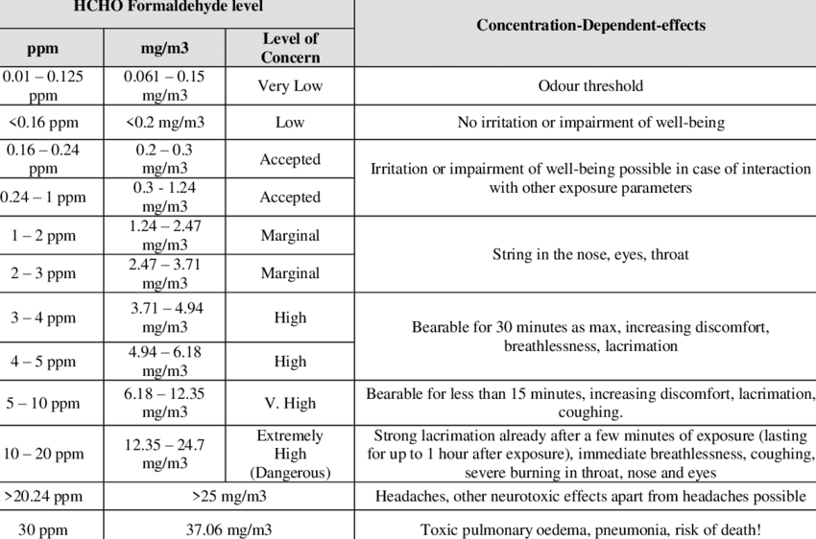
Reference = https://www.researchgate.net/figure/HCHO-Formaldehyde-level-of-emissions-and-side-effect-in-ppm-mg-m3-Reference-Alsarrag_tbl2_339028205

