University of Information Technology – VNU-HCM
Faculty of Computer Engineering
CSBU102 – Computer System
LAB 02
Accessing Main Memory: Words, Arrays, Bytes and Strings
Full name | Nguyễn Lê Mai Thư | Student ID | 26560061
Class | CSBU102.R11.KHBC | Practice date | 11/11/2026
Self-assessed score | 100 | GitHub link | https://github.com/immt-vn/CSBCU102_26560061_LAB1.git

1. LAB OVERVIEW
Purpose. In LAB 1 every value lived in one of the 32 registers. Real programs use far more data than that, such as a list of scores or a line of text, and keep it in main memory (RAM); a processor can calculate only on registers. In this session you will learn how a program finds data in memory, brings it into a register and writes a result back, for whole words (arrays) and for single bytes (characters). Every new idea is explained first and then practised.
Situation: a lecturer’s score sheet
A lecturer keeps the scores of a class and the students’ names in a small program. Even five scores and one name are too much to keep in registers, so the program stores them in main memory and moves one value at a time into a register to read, change or add it. All names and scores are fictitious.

After this session, you can:
- explain address, word and the alignment rule, and declare data with .word, .byte and .asciiz;
- read and write words with lw and sw (base register + offset) and compute the address of array element i as base + 4 × i, also when i is held in a register;
- read and write bytes with lb, lbu and sb, and explain sign extension and byte order from your own observations;
- change data in memory: swap two elements, update an element, edit characters of a string;
- predict, observe and explain what a short program does with memory, including what happens when it goes wrong.
Table 1. Structure of the session
Part | Content | Score
0 | Getting started: the memory panes of MARS | –
1 | Experiment 1 – Words and addresses | 30
2 | Experiment 2 – Arrays: reading and writing elements | 30
3 | Experiment 3 – Bytes, characters and strings | 25
4 | Wrap-up and submission | 15
 | Total | 100
Ext | Extension – A 3 × 3 board in memory (optional) | +10

Working conventions
• A yellow cell is where you write an answer or a value (your text appears in red). A dashed frame is where you paste a screenshot. Listings are in grey frames; a line that starts with # >>> marks a place where you write code.
• Questions are labelled Understand, Apply, Analyze or Evaluate. Many activities follow PREDICT → OBSERVE → EXPLAIN: write down what you expect, run the program and record what happens, then explain any difference. A wrong prediction is never penalised; the explanation earns the marks.
• Save every program you submit as Lab02_<StudentID>_<Part>.asm, for example Lab02_22520001_TN2.asm (parts TN1 to TN3 and EXT), and start it with a comment block with your name, student ID and a one-line purpose.

PART 0. GETTING STARTED: THE MEMORY PANES OF MARS
You already know how to assemble, run and step through a program. This time you also use the Data Segment, the MARS pane that shows main memory (Table 2).
Table 2. Skills checklist
☐ | Skill | Hint
☐ | Check the settings | Settings: tick Permit extended (pseudo) instructions and Initialize Program Counter to global ‘main’.
☐ | Read the Data Segment | Each row starts with an address; the columns Value (+0), Value (+4), … show the words that follow. Tick Hexadecimal Values / Addresses or ASCII to change the display.
☐ | Find the address of a label | Settings → Show Labels Window (symbol table).
☐ | Set a breakpoint | Tick the Bkpt box of an instruction in the Text Segment; Go stops just before it.
Step 0 – Quick check. Type Listing 0, assemble and run it (it prints one number read from memory). Then find the label x in the Labels window and the number 7 in the Data Segment.
Listing 0
# Listing 0 - quick check
.data
x: .word 7
msg: .asciiz "Value read from memory: "
nl: .asciiz "\n"

.text
.globl main
main:
li $v0, 4
la $a0, msg
syscall
la $t0, x
lw $a0, 0($t0)
li $v0, 1
syscall
li $v0, 4
la $a0, nl
syscall
li $v0, 10
syscall
Text in the Run I/O pane:
Value read from memory: 7

EXPERIMENT 1. WORDS AND ADDRESSES (30 points)
Situation
Before the program can add two scores it must find them. A processor sees not a list of named scores but a very long row of numbered storage cells. This experiment shows how a program names a cell, brings its contents into a register and writes a result back.

Background: main memory, addresses and words
Main memory is a long row of bytes (8 bits). Every byte has its own number, its address. A MIPS register holds one word of 4 bytes, which occupies four consecutive addresses; the address of a word is the address of its first byte and must be a multiple of 4 (the alignment rule). In MARS, declared data begins at 0x10010000 (Figure 1).
The processor calculates only with registers, so a program loads a value into a register and stores a result back: lw $t0, 8($s0) copies the word at address $s0 + 8 into $t0, and sw $t0, 8($s0) copies $t0 into that word. The constant 8 is the offset (in bytes), $s0 is the base register, and base + offset is the effective address. A label names an address, and la $s0, scores copies the address of scores into $s0. Table 3 lists the directives that place data in memory.
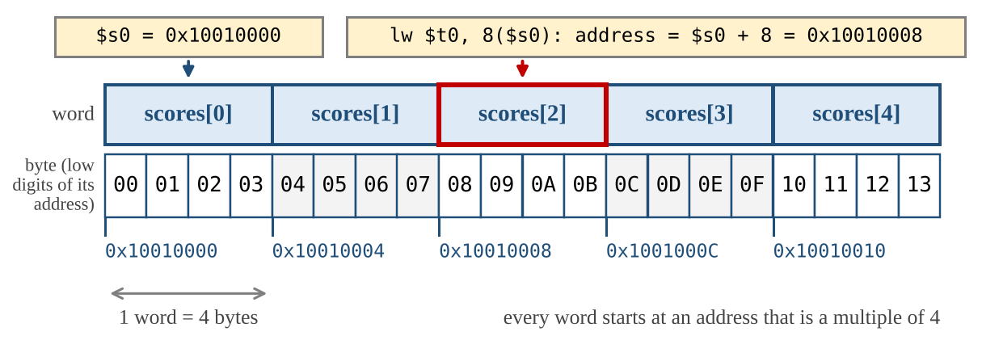
Figure 1. An array of five words in memory and the effective address of lw $t0, 8($s0)
Table 3. Data declarations
Directive | Example | What is placed in memory
.word | a: .word 40, 55, 70 | Consecutive 32-bit words (an array); the label is the address of the first one.
.byte | b: .byte 65 | One byte with the value 65.
.asciiz | s: .asciiz "Hi" | One byte per character, then one extra byte of value 0 that marks the end of the string.

Step 1.1 – Variables in memory (10 points)
In LAB 1, a = b + c was a single add on registers. Now the variables live in memory. Type Listing 1, assemble it, PREDICT the values in Table 4, then run it (decimal display) and OBSERVE. Also read the addresses in Table 5 (pc and $sp from the Registers pane right after assembling).
Listing 1
# Listing 1 - varA = varB + varC, with all three variables in memory
.data
varB: .word 25
varC: .word 17
varA: .word 0

.text
.globl main
main:
la $t0, varB # $t0 = address of varB
lw $t1, 0($t0) # $t1 = varB
lw $t2, 4($t0) # $t2 = varC
add $t3, $t1, $t2 # $t3 = varB + varC
sw $t3, 8($t0) # varA = $t3
li $v0, 10
syscall
Table 4. Predict and observe Listing 1
Item | PREDICT (decimal) | OBSERVE (decimal)
$t3 | 42 | 42
Word at label varA in the Data Segment | 42 | 42
Table 5. Addresses in the program
Item | Address (hex)
pc before the program runs | 0x00400000
Label varB / varC / varA | 0x10010000/ 0x10010004/ 0x10010008
$sp before the program runs | 0x7fffeffc
Question 1.1 (Understand) Why do the addresses of varB, varC and varA differ by that number of bytes? The instructions, the declared data and the stack are kept in three different regions: which address belongs to which region, and which region has the highest addresses?
The variables differ by 4 bytes because each .word occupies 4 bytes. The pc is in the text segment, varB/varC/varA are in the data segment, and $sp is in the stack segment. The stack segment has the highest addresses.

Step 1.2 – Base plus offset (10 points)
Type Listing 2 (an array of five scores). For each instruction in Table 6, work out the effective address and PREDICT the value that ends up in the destination register; run the program and record the observed value. Row (4) is an addi: its result is an address (hexadecimal).
Listing 2
# Listing 2 - addresses and offsets
.data
scores: .word 40, 55, 70, 85, 100

.text
.globl main
main:
la $s0, scores # $s0 = address of scores[0]
lw $t0, 0($s0) # (1)
lw $t1, 4($s0) # (2)
lw $t2, 16($s0) # (3)
addi $s1, $s0, 8 # (4) $s1 = $s0 + 8
lw $t3, 0($s1) # (5)
lw $t4, -4($s1) # (6)
li $v0, 10
syscall
Table 6. Effective addresses and loaded values
# | Instruction | Effective address (hex) | PREDICT value | OBSERVE value
(1) | lw $t0, 0($s0) | 0x10010000 | 40 | 40
(2) | lw $t1, 4($s0) | 0x10010004 | 55 | 55
(3) | lw $t2, 16($s0) | 0x10010010 | 100 | 100
(4) | addi $s1, $s0, 8 | –
(5) | lw $t3, 0($s1) | 0x100100008 | 70 | 70
(6) | lw $t4, -4($s1) | 0x100100004 | 55 | 55
Question 1.2 (Apply) Write the formula for the address of element i of an array of words in terms of the address of element 0, and use it for scores[3]. Why does 4 appear in the formula, and not 1?
Adress[i]=4 x i

The 4 appears because each word occupies 4 bytes, and memory addresses are measured in bytes.

Step 1.3 – Break it on purpose (10 points)
For each change in Table 7, PREDICT what will happen, change instruction (2) of Listing 2 (one change at a time), run the program and OBSERVE. In (a), also note the message that MARS shows. Restore the program afterwards.
Table 7. Controlled experiments
Change | PREDICT | OBSERVE
(a) lw $t1, 2($s0) | Error | Error
(b) lw $t1, 20($s0) | 0 | 0
Question 1.3 (Analyze) Explain (a) and (b). Which one does the processor detect, and which does it not? What does this say about who is responsible for keeping an access inside an array?
The processor detects this error in change (a) because the address violates the alignment requirement for a word load. A word (lw) must be loaded from an address that is a multiple of 4.
The processor did not detect (b) because it does not know where the array begins or ends. It simply loads the word stored at the requested address.
It means that the compiler is responsible for keeping accesses inside the array bounds, not the processor.

EXPERIMENT 2. ARRAYS: READING AND WRITING ELEMENTS (30 points)
Situation
The lecturer finds a mistake in the score sheet. Two scores must be exchanged, one score must be corrected, and the total of the five scores must be recalculated. All of this happens in memory, element by element.

Background: the address of element i
The elements of an array are words stored one after another, so element i is at base + 4 × i (Experiment 1). When the index is a constant, you write 4 × i yourself as the offset of lw or sw. When the index is held in a register, the program must compute the address: sll $t1, $s1, 2 shifts $s1 left by two bits, which multiplies it by 4, and add $t1, $t1, $s0 adds the base address. Then lw or sw uses 0($t1).

Step 2.1 – Swap two scores (10 points)
Complete Listing 3 so that it exchanges scores[0] and scores[4] in memory, using only lw and sw. After the run, the Data Segment must show 100, 55, 70, 85, 40 (decimal).
Listing 3
# Listing 3 - swap two scores in memory
.data
scores: .word 40, 55, 70, 85, 100

.text
.globl main
main:
la $s0, scores # $s0 = address of scores[0]
# >>> load scores[0] into $t0
# >>> load scores[4] into $t1
# >>> store $t1 into scores[0]
# >>> store $t0 into scores[4]
li $v0, 10
syscall
Screenshot of the Data Segment after the run:
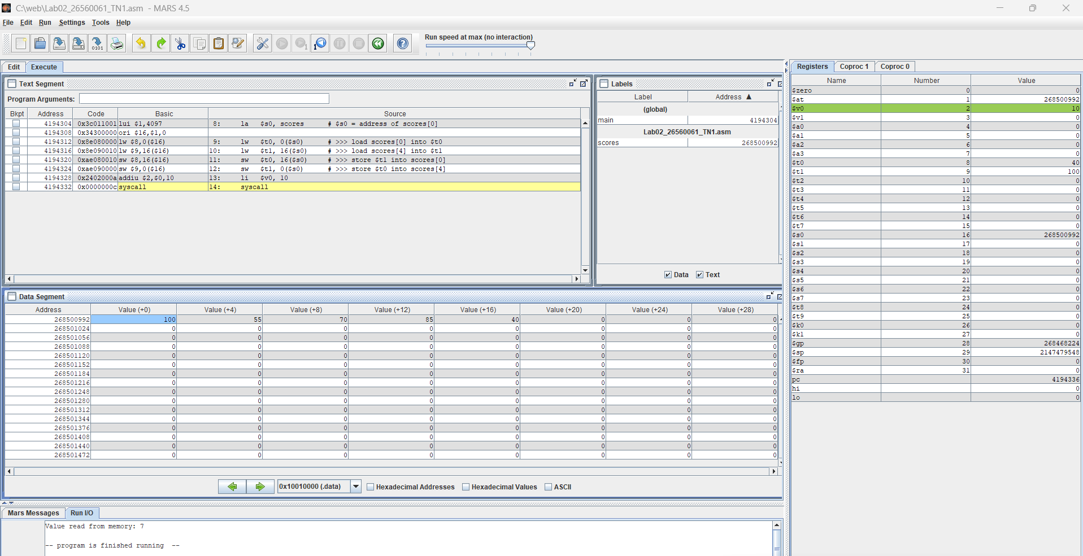
Question 2.1 (Analyze) Why did you need two registers? Could one temporary register be enough? Explain.
We need two registers because when we swap two values, we must keep both original values available until both stores are finished.
One temporary register is not enough when using only lw and sw, because loading the second value would destroy the first one before the swap is completed.

Step 2.2 – The index in a register (10 points)
Listing 4 computes the address of scores[i] from the index i in $s1 and prints the element. Type it and run it with i = 3 to see how it works. Then, for each variant in Table 8, PREDICT the result (for (a) to (c): $t1 in hexadecimal and $t2; for (d): what happens), change the program, run it and OBSERVE. Restore the original program after each variant.
Listing 4
# Listing 4 - the index of the element is held in a register
# Register plan: $s0 = address of scores[0] $s1 = i
.data
scores: .word 40, 55, 70, 85, 100
msg: .asciiz "scores[i] = "
nl: .asciiz "\n"

.text
.globl main
main:
la $s0, scores # $s0 = address of scores[0]
addi $s1, $zero, 3 # i = 3
sll $t1, $s1, 2 # $t1 = 4 * i
add $t1, $t1, $s0 # $t1 = address of scores[i]
lw $t2, 0($t1) # $t2 = scores[i]
li $v0, 4
la $a0, msg
syscall
li $v0, 1
add $a0, $t2, $zero
syscall
li $v0, 4
la $a0, nl
syscall
li $v0, 10
syscall
Table 8. Variants of Listing 4
Variant | PREDICT | OBSERVE
(a) i = 0 | 0x10010000 | 0x10010000
(b) i = 2 | 0x10010008 | 0x10010008
(c) i = 4 | 0x100100010 | 0x10010010
(d) i = 3 and sll $t1, $s1, 1 | address not aligned on word boundary | address not aligned on word boundary
Question 2.2 (Analyze) Why does the shift amount have to be 2? Explain what happened in (d) and which part of the computer detected the problem.
In MIPS, shifting left by 2 bits is the same as multiplying by 4.
The shift must be 2 because each array element is 4 bytes, and i × 4 gives the correct byte offset.
CPU detected the misaligned memory access and generated an alignment error.

Step 2.3 – Your own data (10 points)
Let D be the last digit of your student ID. In Table 9, find the index k and the new score V. Write a program, starting from Listing 4, that (1) puts k in $s1 and V in a register and stores V into scores[k] with sw, using the address computation of Step 2.2; (2) adds up the five scores in $s3, loading each one with lw and a constant offset; (3) prints Total: followed by the total and a new line. First run it without step (1): the total of the original scores is 350. Then PREDICT the total for your own data by hand, run the program and complete Table 10.
Table 9. Personal data (D = last digit of the student ID)
D | k | V | D | k | V
0 | 0 | 15 | 5 | 0 | 62
1 | 1 | 28 | 6 | 1 | 77
2 | 2 | 33 | 7 | 2 | 84
3 | 3 | 46 | 8 | 3 | 91
4 | 4 | 59 | 9 | 4 | 98
Table 10. Results for your own data
My D | Result | Total | scores[k] in the Data Segment
1 | PREDICT | 323 | 28
1 | OBSERVE | 323 | 28

EXPERIMENT 3. BYTES, CHARACTERS AND STRINGS (25 points)
Situation
The score sheet also contains students’ names. Text is stored one character per byte, so the program must read and write single bytes, not only whole words.

Background: characters, bytes and byte order
A character is stored as a small number, its ASCII code (Table 18): A is 65 (0x41), a is 97 (0x61), the digit 0 is 48. A string declared with .asciiz is a sequence of codes followed by a byte of value 0. Three instructions work on single bytes (Table 11); a byte address can be any number.
A word occupies four consecutive bytes, so a computer must decide which byte of the number goes to the lowest address. In little-endian order the least significant byte comes first; in big-endian order the most significant byte comes first. Both are used in real computers, and the lecture slides show both. Step 3.2 shows which one MARS uses.
Table 11. Instructions that move single bytes
Instruction | Example | Meaning
lb | lb $t0, 1($s0) | Load the byte at address $s0 + 1; the upper 24 bits are filled with copies of the byte’s top bit (sign extension).
lbu | lbu $t0, 1($s0) | Load the byte at address $s0 + 1; the upper 24 bits are filled with zeros.
sb | sb $t0, 1($s0) | Store the lowest 8 bits of $t0 in the byte at address $s0 + 1.

Step 3.1 – The bytes of a string (6 points)
Type Listing 5 and assemble it; tick ASCII in the Data Segment. Using Table 18, PREDICT the hexadecimal code of each byte of "Hi!"; then run and complete Table 12 and the answer below it.
Listing 5
# Listing 5 - the bytes of a string
.data
word1: .asciiz "Hi!"

.text
.globl main
main:
la $s0, word1 # $s0 = address of the first byte
lb $t0, 0($s0)
lb $t1, 1($s0)
lb $t2, 2($s0)
lb $t3, 3($s0)
li $v0, 11 # service 11: print one character
add $a0, $t1, $zero # the byte that was loaded into $t1
syscall
li $v0, 10
syscall
Table 12. The bytes of word1
Offset | Address (hex) | PREDICT byte (hex) | OBSERVE byte (hex) | Character
0 | 0x10010000 | 0x48 | 0x48 | H
1 | 0x10010001 | 0x69 | 0x69 | i
2 | 0x10010002 | 0x21 | 0x21 | !
3 | 0x10010003 | 0x00 | 0x00 | Nul terminator
PREDICT – character printed in the Run I/O pane:
i
Question 3.1 (Understand) How many bytes does "Hi!" occupy, and why one more than the number of visible characters? What is the address of the last byte?
It occupies 4 bytes.
.asciiz automatically adds a null terminator at the end of the string so that add an extra byte.
0x10010003 is the address of the last byte

Step 3.2 – Which byte comes first? (6 points)
Listing 6 stores the word 0x41424344 and reads its four bytes one by one. Decide which byte order you expect MARS to use and PREDICT the four bytes; then run it and complete Table 13.
Listing 6
# Listing 6 - one word, four bytes
.data
w: .word 0x41424344

.text
.globl main
main:
la $s0, w
lb $t0, 0($s0) # byte at offset 0
lb $t1, 1($s0) # byte at offset 1
lb $t2, 2($s0) # byte at offset 2
lb $t3, 3($s0) # byte at offset 3
lw $t4, 0($s0) # the whole word
li $v0, 10
syscall
Table 13. Reading the bytes of one word
Item | PREDICT (hex) | OBSERVE (hex)
Byte at offset 0 ($t0) | 0x00000044 | 0x00000044
Byte at offset 1 ($t1) | 0x00000043 | 0x00000043
Byte at offset 2 ($t2) | 0x00000042 | 0x00000042
Byte at offset 3 ($t3) | 0x00000041 | 0x00000041
Whole word ($t4) | 0x41424344 | 0x41424344
Question 3.2 (Analyze) Which byte of 0x41424344 is at the lowest address in MARS, and which byte order is that? Does it match your prediction? Why does $t4 still hold 0x41424344, and why does a program that uses only lw and sw never notice the byte order?
The least significant byte (0x44) is stored at the lowest address, which is little-endian order. $t4 still contains 0x41424344 because lw reassembles the four bytes into the original 32-bit value. Programs that use only lw and sw do not notice the byte order because the hardware handles the byte arrangement automatically.

Step 3.3 – Signed and unsigned bytes (6 points)
Listing 7 stores one byte of value 0xF0 and loads it twice. PREDICT $t0 and $t1 in hexadecimal and decimal, run it, and complete Table 14.
Listing 7
# Listing 7 - lb and lbu
.data
b1: .byte 0xF0

.text
.globl main
main:
la $s0, b1
lb $t0, 0($s0)
lbu $t1, 0($s0)
li $v0, 10
syscall
Table 14. lb and lbu compared
Instruction | PREDICT (hex) | PREDICT (dec) | OBSERVE (hex) | OBSERVE (dec)
lb $t0, 0($s0) | 0xfffffff0 | -16 | 0xfffffff0 | -16
lbu $t1, 0($s0) | 0x000000f0 | 240 | 0x000000f0 | 240
Question 3.3 (Analyze) Explain the difference in terms of sign extension (compare LAB 1, Question 2.4). Which instruction would you use to read the brightness of a pixel stored as a number from 0 to 255, and why?
lb and lbu both load a byte, but they treat that byte differently when expanding it to a 32-bit register.
lb (load byte) uses sign extension. If the most significant bit of the byte is 1, the upper 24 bits of the register are filled with 1s.
lbu (load byte unsigned) uses zero extension. The upper 24 bits are filled with 0s.

Pixel brightness values range from 0 to 255, so they are unsigned numbers. Therefore, you should use lbu, because it preserves values such as 128–255 correctly. If you used lb, values above 127 would be interpreted as negative numbers due to sign extension.

Step 3.4 – Capital letters by hand (7 points)
A capital letter has a code 32 below the matching lower-case letter (Table 18). Complete Listing 8 so that it changes the letters at offsets 0, 7 and 11 of str1 into capital letters: for each one, load the byte with lb, subtract 32 and store it back with sb. The program must print Nguyen Van An. Then change .asciiz to .ascii in the declaration of str1, PREDICT the output, run it and OBSERVE (Table 15). Restore .asciiz afterwards.
Listing 8
# Listing 8 - capital letters at chosen positions of a string
# Register plan: $s0 = address of the first byte of str1
.data
str1: .asciiz "nguyen van an"
tag: .asciiz " [end]"
nl: .asciiz "\n"

.text
.globl main
main:
la $s0, str1 # $s0 = address of str1
# >>> make the byte at offset 0 a capital letter
# >>> make the byte at offset 7 a capital letter
# >>> make the byte at offset 11 a capital letter
li $v0, 4 # service 4: print the string that starts at $a0
add $a0, $s0, $zero
syscall
li $v0, 4
la $a0, nl
syscall
li $v0, 10
syscall
Screenshot of the Run I/O pane (with .asciiz):
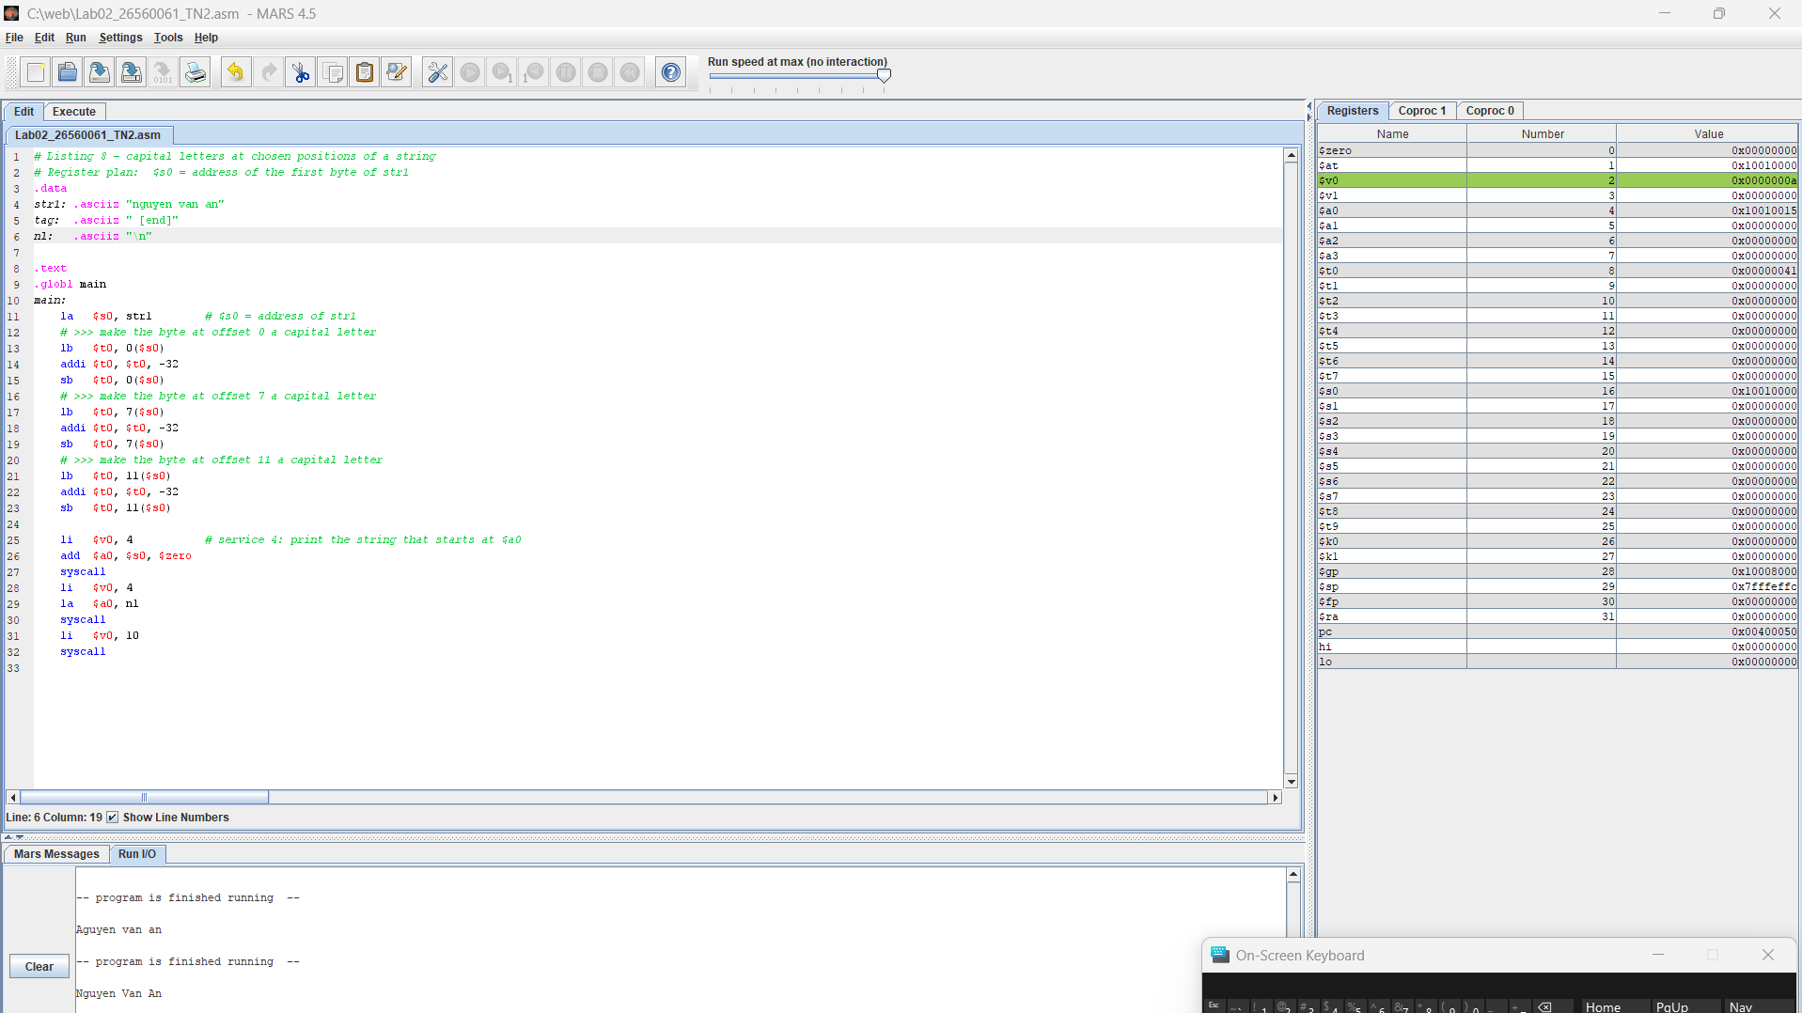
Table 15. A string without the terminating zero
Change | PREDICT | OBSERVE
.ascii instead of .asciiz | Prints Nguyen Van An and then continues printing extra characters until a zero byte is found | Nguyen Van An [end]
Question 3.4 (Analyze) Explain the output you observed with .ascii. Where did the extra text come from, and how does the print service know where a string ends?
With .ascii, the string does not end with a null byte (0x00), so printing continues into the next data in memory until a 0x00 is found.

EXTENSION. A 3 × 3 BOARD IN MEMORY (optional – up to 10 bonus points)
A game board with 3 rows and 3 columns is stored in memory as nine words, row by row: board: .word 0, 0, 0, 0, 0, 0, 0, 0, 0. The cell in row r and column c (both counted from 0) is word number 3 × r + c, so its address is board + 4 × (3 × r + c). Write a program that keeps r in $s1 and c in $s2, computes this address with sll and add (3 × r is r + 2 × r), and stores the value 1 (mark X) into the cell (1, 2) and the value 2 (mark O) into the cell (2, 0). After the run, the Data Segment must show 1 and 2 in two of the nine words and 0 in all the others.
Question E.1 (Analyze) Which two words of board changed, at which addresses, and why does the formula give these words?
Which two words of board changed: Cell (1,2) corresponds to word 5 at 0x10010014 and Cell (2,0) corresponds to word 6 at 0x10010018
because the formula $3r+c$converts the row and column numbers into the correct position in the one-dimensional array stored in memory.

PART 4. WRAP-UP AND SUBMISSION (15 points)
Question 4.1 (Understand) Explain why varA = varB + varC needs two loads and one store in addition to the add when the variables are in memory. Use the terms register, main memory, load and store. (5 points)
varB and varC are in main memory, so they must be loaded into registers before the add can use them. After the addition, the result must be stored back to main memory as varA.

Question 4.2 (Apply) Write the MIPS instructions for scores[3] = scores[1] + scores[2]. Assume $s0 holds the address of scores[0] and use only $t registers. (5 points)
lw $t0, 4($s0)
lw $t1, 8($s0)
add $t2, $t0, $t1
sw $t2, 12($s0)

Question 4.3 (Evaluate) lw and sw need an address that is a multiple of 4, but lb and sb accept any address. Explain why, and name one task from this LAB where a byte instruction is the right choice and one where a word instruction is. (5 points)
lw and sw work with a word (4 bytes), so the address must be a multiple of 4 to keep the word properly aligned in memory.
lb and sb work with a single byte (1 byte), so they can access any address.
A byte instruction is the right choice when working with characters in a string, such as changing "nguyen van an" to "Nguyen Van An" using lb and sb in Listing 8.

Table 16. Submission checklist
☐ | Item
☐ | The files Lab02_<StudentID>_TN1.asm to _TN3.asm (and _EXT.asm if you did the extension) are saved with the correct names, begin with a comment block and assemble without errors.
☐ | Every # >>> marker is replaced by your own code and the register plan is documented in comments.
☐ | This document is complete: all yellow cells are filled and every dashed frame contains a screenshot.
☐ | The .asm files are pushed to your GitHub repository, the link is written on the first page, and everything is submitted as announced by your instructor.

APPENDIX. REFERENCE
Table 17. Instructions and system calls used in this LAB
Instruction | Example | Meaning
lw / sw | lw $t0, 8($s0) | $t0 = word at address $s0 + 8 / word at that address = $t0 (address a multiple of 4)
lb / lbu | lb $t0, 1($s0) | $t0 = byte at address $s0 + 1, sign-extended / filled with zeros
sb | sb $t0, 1($s0) | byte at address $s0 + 1 = lowest 8 bits of $t0
la, li | la $s0, label | pseudo-instructions: $s0 = address of label; li $t0, 7: $t0 = 7
add, addi | addi $t0, $t1, 20 | $t0 = $t1 + 20 (add uses two registers)
sll | sll $t1, $s1, 2 | $t1 = $s1 shifted left by 2 bits (4 × $s1)
syscall | $v0 = 1, 4, 10 | print integer ($a0); print string ($a0 = address); exit
Table 18. ASCII codes used in this LAB
Character | Decimal | Hexadecimal | Remark
end of string | 0 | 0x00 | terminator of .asciiz
space; ! | 32; 33 | 0x20; 0x21
digits 0 to 9 | 48 – 57 | 0x30 – 0x39 | consecutive
capital letters A to Z | 65 – 90 | 0x41 – 0x5A | consecutive
lower-case letters a to z | 97 – 122 | 0x61 – 0x7A | consecutive

