Interactive Serology Plate Inspector: A Guide for Data Uploading

Background and Objective
The Interactive Serology Plate Inspector (I-SPI) developed at Immunoodle/Immunoplex, is designed to streamline quality control and quality assurance for multiplex bead assays starting from raw assay data. Raw bead array data, including assays from Luminex, require careful preparation for the data to be processed uniformly. The purpose of this document is to provide a guide to ensure data is loaded correctly and to show reveal any inconsistencies in plate labelling and study design.
The Interactive Serology Plate Inspector allows users to import multiple plate files from multiplex immunoassays, and uses interactive methods to parse the datasets uploaded into tidy data with consistent, reliable linkages to independent variables including:
a. categories across groups of subjects,
b. timepoint and tissue classification within subjects
c. multiple sample dilutions
Anatomy of Raw Assay Data
Raw assay data from multiplex bead assays consists of two primary components, the plate metadata and the raw assay MFI measurements and bead count values for antigens by specimen type on the plate. The system accepts Excel files (.xlsx, .xls) exported from Bio-Plex or similar instruments. Each file contains:
Header Section (Rows 1-7):
- File Name (full path)
- Acquisition Date (format: DD-MMM-YYYY, HH:MM AM/PM)
- Reader Serial Number
- RP1 PMT (Volts)
- RP1 Target
- Plate ID
Additional header information is not currently processed in I-SPI.

Data Section (Row 8+):
Column | Description
Well | Well position (e.g., A1, B2, H12)
Type | Specimen type code (X, S, B, C) with optional number
Description | Delimited string containing sample metadata
Antigen columns | MFI values with bead counts in format: `value (count)`
% Agg Beads | Percentage of aggregated beads
Sampling Errors | Error count during acquisition

Specimen Type Codes
Code | Meaning | Description Field Format
X | Sample | PatientID_GroupA_GroupB_TimePeriod_DilutionFactor`
S | Standard | `Source_DilutionFactor` (e.g., `NIBSC06140_40`)
B | Blank | `Source_DilutionFactor` (e.g., `PBS_1`)
C | Control | `Source_DilutionFactor` (e.g. ‘Multigam_12500’)
In the main dataset with MFI values, the specimen type must be a string from one of the following options: X (samples), S (standard curve samples), C (controls), and B (blanks).

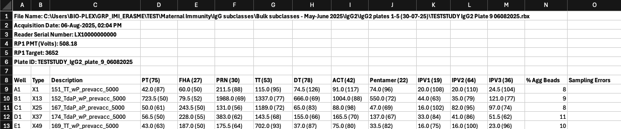
Figure 1: An example of a raw file from a multiplex bead assay including the plate metadata bolded in the first 6 rows and the beginning of the raw assay measurements with a header beginning on row 8. The first 3 columns of the main dataset are consistent across all plates and are Well, Type, and Description. The next columns are the antigens on the plate with the bead region associated with the antigen uniquely identifying the headset being read by the detector with the antigen. The last 2 columns which follow the antigen columns are the % Agg Beads and the Sampling Errors.

Batch Upload Workflow
A. Before uploading batch plate files, ensure you have:
1. Created or loaded a Project - Navigate to "Create, Add, and Load Projects" in the sidebar
2. Created or selected a Study - Type a new study name (up to 15 characters) or select an existing one.
3. Selected the sidebar option to Import Plate Data.
4. Created or selected an Experiment - Each experiment represents a specific assay run or feature (e.g., "IgG_total", "FcgR2a")
5. Selected Layout Template as the file format.

B. Upload Experiment Files
1. Click "Select all experiment raw data files"
2. Select all plate files (.xlsx) for this batch
3. Enter a Feature name (up to 15 characters) - this identifies the assay type (e.g., "IgGtot", "FcgR2a")

C. Configure Plate Settings
1. Number of Wells:
Select the plate format (6, 12, 24, 48, 96, 384, or 1536 wells)
2. Description Delimiter:
If your Description field contains data, select the character that separates elements:
`_` (underscore) - most common
`|` (pipe)
`:` (colon)
`-` (hyphen)

3. Optional Elements: Check/uncheck to include group assignments:
- ☑ SampleGroupA
- ☑ SampleGroupB
4. Element Order: Drag and drop to match your Description field structure:
Default order: PatientID → TimePeriod → DilutionFactor
With groups: PatientID → SampleGroupA → SampleGroupB → TimePeriod → DilutionFactor

D. Generate Layout Template
1. Click "Generate a Layout file"
2. Save the Excel file to your computer
3. The template contains pre-populated sheets based on your plate data

E. Review and Edit Layout Template
Open the generated Excel file and verify/edit each sheet:
Sheet: `plate_id`
Column | Description
study_name | Study identifier
experiment_name | Experiment identifier
number_of_wells | Plate format (96, 384, etc.)
plate_number | Internal plate identifier
plateid | Plate ID from instrument
plate_filename | Original file path

Sheet: `subject_groups`
Column | Description
study_name | Study identifier
subject_id | Unique patient/subject identifier
groupa | First categorical grouping
groupb | Second categorical grouping

Sheet: `timepoint`
Column | Description
study_name | Study identifier
imepoint_tissue_abbreviation | Short timepoint code
tissue_type | e.g., "blood"
tissue_subtype | e.g., "serum"
description | Full timepoint description
min_time_since_day_0 | Minimum days from baseline
max_time_since_day_0 | Maximum days from baseline

Sheet: `antigen_list`
Column | Description
antigen_label_on_plate | Column name from plate file
antigen_abbreviation | Short name for analysis
antigen_family | Grouping category
standard_curve_max_concentration | Upper limit for curve fitting

Sheet: `plates_map`
Column | Description
study_name | Study identifier
plate_number | Plate identifier
well | Well position
specimen_type | X, S, B, C, or empty
specimen_source | Source material identifier
specimen_dilution_factor | Numeric dilution
subject_id | Links to subject_groups
biosample_id_barcode | Sample barcode
timepoint_tissue_abbreviation | Links to timepoint sheet

F. Upload Completed Layout
1. Click "Upload a completed layout file"
2. Select your edited layout template
3. Review the plate layout visualization
4. Configure Blank and Empty Well Handling:
- "Skip Empty Wells" - removes blank entries
- "Use as Blank" - treats as background controls

G. Validate and Upload
1. Check the Batch Validated badge appears (green checkmark)
2. If validation fails, review error messages and correct issues
3. Click "Upload Batch" to store data in database
4. Verify Batch Uploaded badge appears

Preparing Assay Data for Smooth Parsing
The primary dataset for the plate from the raw assay data contains a column named “description”. This column is not tidy since it contains specific information that corresponds to the type of column and can contain a combination of distinct information. When more than one piece of information is present in the description it is delimited with an underscore.
Type X contains the patient id, study groupa, study groupb, timepoint and serum dilution factor.
Type S contains the standard curve source followed by the dilution factor.
Type C contains the source of the control followed by the dilution factor.
Type B contains the source of the blanks followed by the dilution_factor.

For the controls (Type C), examples include P2 and P5 where P is short for Pooled. The numbers are not dilutions but rather different pooled samples. This can be dependent on the lab protocols as well. A string that does not contain an underscore is suggested so data does not separate in unexpected ways during parsing and assigning source to the controls.
The patient identifier is a numeric integer as well as the dilutions in each of the specimen types outlined above. The study group, timepoint, and all the sources are characters and not solely numbers. I-SPI is designed to handle serum dilutions ranging from 1 to 100000.
To ensure a bead count is processed for the antigens the reported bead count should be in parenthesis following the name of the antigen. I-SPI will store this information to the PostgreSQL database.
When the Interactive Serology Plate Inspector parses data it separates the description field into multiple columns, so each variable is in its assigned column. If there are additional underscores in the name of a field such as the source which takes one component this separates out the source into two columns which increases difficulty in source assignment. It is recommended that unneeded underscores are avoided.
The following are examples of descriptions of sources that will pass the plate validation step in the application: SD_20, NIBSC_120, NIBSC140_20. In the last case, NIBSC140 will be identified as the source and the standard curve serum dilution will be identified as 20.
Examples of descriptions that will cause downstream issues in source assignment include NIBSCO_140_20. In this case, there is an additional underscore resulting in three components instead of two when the value is split via the underscore. When assigning the source, it may be NIBSCO instead of the intended NIBSCO_140. A similar result occurs if there is a slash in the source such as in NIBSCO/140_20.
Handling Missing Information
In the raw spreadsheet for the plate, it is important for information to be filled into the description column. Blanks can still be processed if assignment of the source and dilutions are assigned to columns with data. The dilution for the blanks should be set to 1. If the dilutions are not 1 the records can be modified in the data parser after assignment of the columns corresponding to the data and before uploading to the PostgreSQL database.
In addition to the dilution of the blanks, for the cleanest data uploading, ensure that the description contains the relevant information including the source, such as PBS, and that it follows the outline provided in the previous section.
When samples are missing and blanks are used in wells of the plates instead of samples, they should be treated as blanks. Figure 2 shows an example where blanks are used in sample wells before correcting for importing. To do this change the X_{n} to a B_{n} , where n is an integer, in the type column and use the description format for Blanks outlined in “Preparing Assay Data for Smooth Parsing” (Figure 3).
Figure 2: An example that will not upload. The blanks are used in sample wells but are of type X. Description is also Blank and does not correspond to a valid description for a type.
Figure 3: An example of correcting data in Figure 2 for successful data upload. The Blanks are assigned B followed by a unique number in the type column and the description have the source of the blank (PBS) followed by the dilution of 1.
Ensure that to the right of the antigen’s MFI value there the bead count in the form of an integer for the antigen in parenthesis. If this is missing a bead count would be missing for the antigen in that well.
Assigning and Saving Data
When data is parsed and assigned if multiple columns are selected, which can be the case for assigning timepoints and study group, underscores are used to separate that information. When saving components the strings created in the assignment process must have a length less than or equal to the maximum length that is indicated for that variable.

Plate Validator
To validate a plate before completing the upload I-SPI, the file can be validated using the rules outlined. The following is pseudocode for the validator.
Validation and Error Handling
Pre-Upload Validation Checks plate_validator_functions.R
The system performs these validations before allowing upload:
Metadata Validation:
- ✓ All uploaded files listed in layout's plate_id sheet
- ✓ File paths are valid format
- ✓ RP1 PMT (Volts) is numeric
- ✓ RP1 Target is numeric
- ✓ Acquisition date matches format: DD-MMM-YYYY, HH:MM AM/PM
Bead Array Data Validation:
- ✓ All antigens in layout exist in plate data
- ✓ % Agg Beads column present
- ✓ Bead counts in format: value (count)
- ✓ Blank descriptions follow format: Source_Dilution
Common Validation Errors plate_validator_functions.R
Error | Cause | Solution
"ANTIGEN MISMATCH" | Layout antigens don't match plate columns | Verify antigen names exactly match column headers
"LAYOUT MISMATCH" | Uploaded files not in plate_id sheet | Add missing files to plate_id sheet
"INVALID ACQUISITION DATE" | Wrong date format | Use format: 01-Oct-2025, 12:12 PM
"BEAD COUNT FORMAT ERROR" | Missing or malformed bead counts | Ensure format: 123.45 (50)
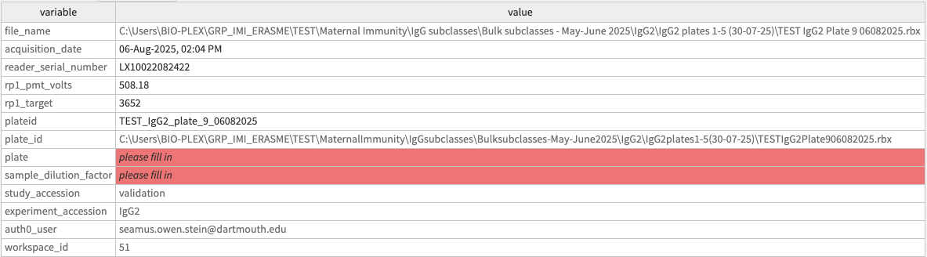
Figure 4: An example of parsed metadata that will not upload to I-SPI. This metadata will not upload since the sample dilution factor variable has a blank value and the plate has a blank value. Blank values are highlighted in red with the italicized text “please fill in”. The user can either correct this in the raw file ensuring plate and the number is in lowercase and include a dilution factor in the file name or the easier way is to enter the appropriate plate value and the correct sample dilution factor. The study accession and experiment accession is read in from what the user has selected as the study and experiment from the UI in the application.
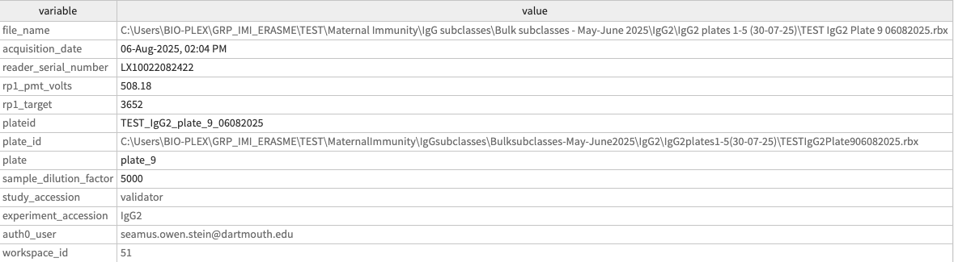
Figure 5: An example of parsed metadata that will upload to I-SPI. All values associated with the variables are correctly parsed and filled in. A user can correct editable fields that are not greyed out, such as the plate and sample dilution factor by typing the desired value into the field before uploading the plate metadata.
Data Inconsistencies Revealed by I-SPI
When there are inconsistencies in the data such as variations in the names of antigens and timepoints, they are revealed and can be seen places including study-level overview figures. When antigens have slightly different names including underscores or a variant number from another, they are treated as different though the intention may be that the antigens are the same. The same concept is applicable for timepoints.
Discussion
This document serves as a companion to the Interactive Serology Plate Inspector and outlines the importance of careful preparation and loading raw assay data from multiplex immunoassays into I-SPI and provides guidance so when uploaded data is stored in a consistent way following the practice of tidy data.

References
Wickham, H. . (2014). Tidy Data. Journal of Statistical Software, 59(10), 1–23. https://doi.org/10.18637/jss.v059.i10

