TASK 1 – CREATE A DIGITAL LITERACY AWARENESS INFOGRAPHIC
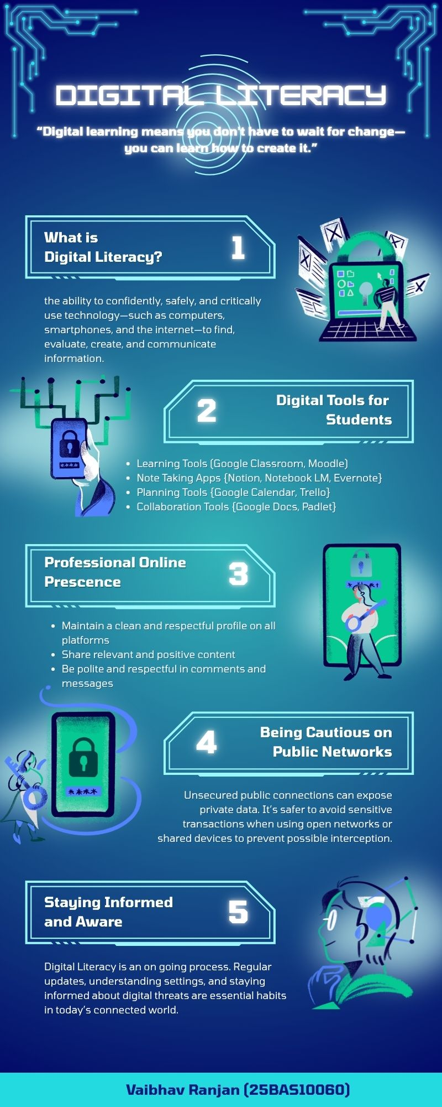

DESCRIPTION
This canva made infographic highlights the importance of digital literacy in today’s technology driven world. It explains what digital literacy is and explains it as the ability to use digital tools confidently, safely, and critically to find, evaluate, create, and communicate information. The infographic outlines key areas such as essential digital tools for students, maintaining a professional online presence, staying cautious on public networks, and continuously updating knowledge about digital trends and security. Overall, it emphasizes that digital literacy is an ongoing process that empowers individuals to navigate and succeed in the modern digital environment.

