TASK 2 – BUILD YOUR STUDENT DIGITAL PORTFOLIO

Profile Screenshot - GitHub

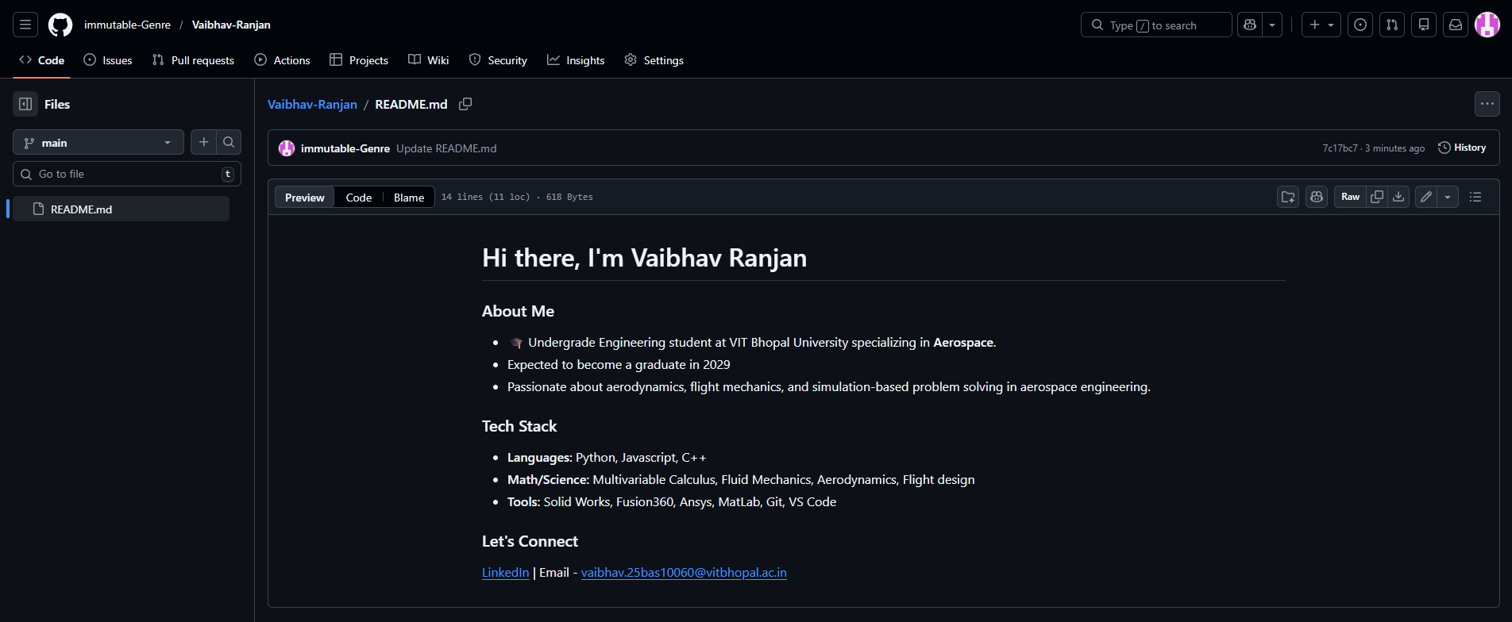
Screenshot of the GitHub Readme file

GitHub - It is web-based platform that allows real time collaboration. Developers or individuals can store, manage and collaborate on code built around Git system. It lets the developer have full control over their code repositories. It is easy to use platform and provides access to many open source software. This website serves a very useful purpose for individuals by maintaining an online portfolio inclusive of all project which they person has made.

