TASK 2 – BUILD YOUR STUDENT DIGITAL PORTFOLIO

Profile Screenshot - LinkedIn
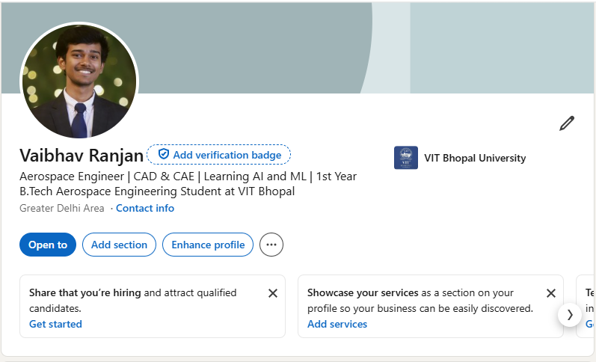
Screenshot of my LinkedIn profile

LinkedIn - It is a networking platform having billions of users across the globe. It is designed for career development, job searching and connections with colleagues, employers, industry experts. It acts as a digital resume for individuals, as it allows them to showcase their skills, achievements and work experience.

