TASK 2 – BUILD YOUR STUDENT DIGITAL PORTFOLIO

Profile Screenshot - ResearchGate
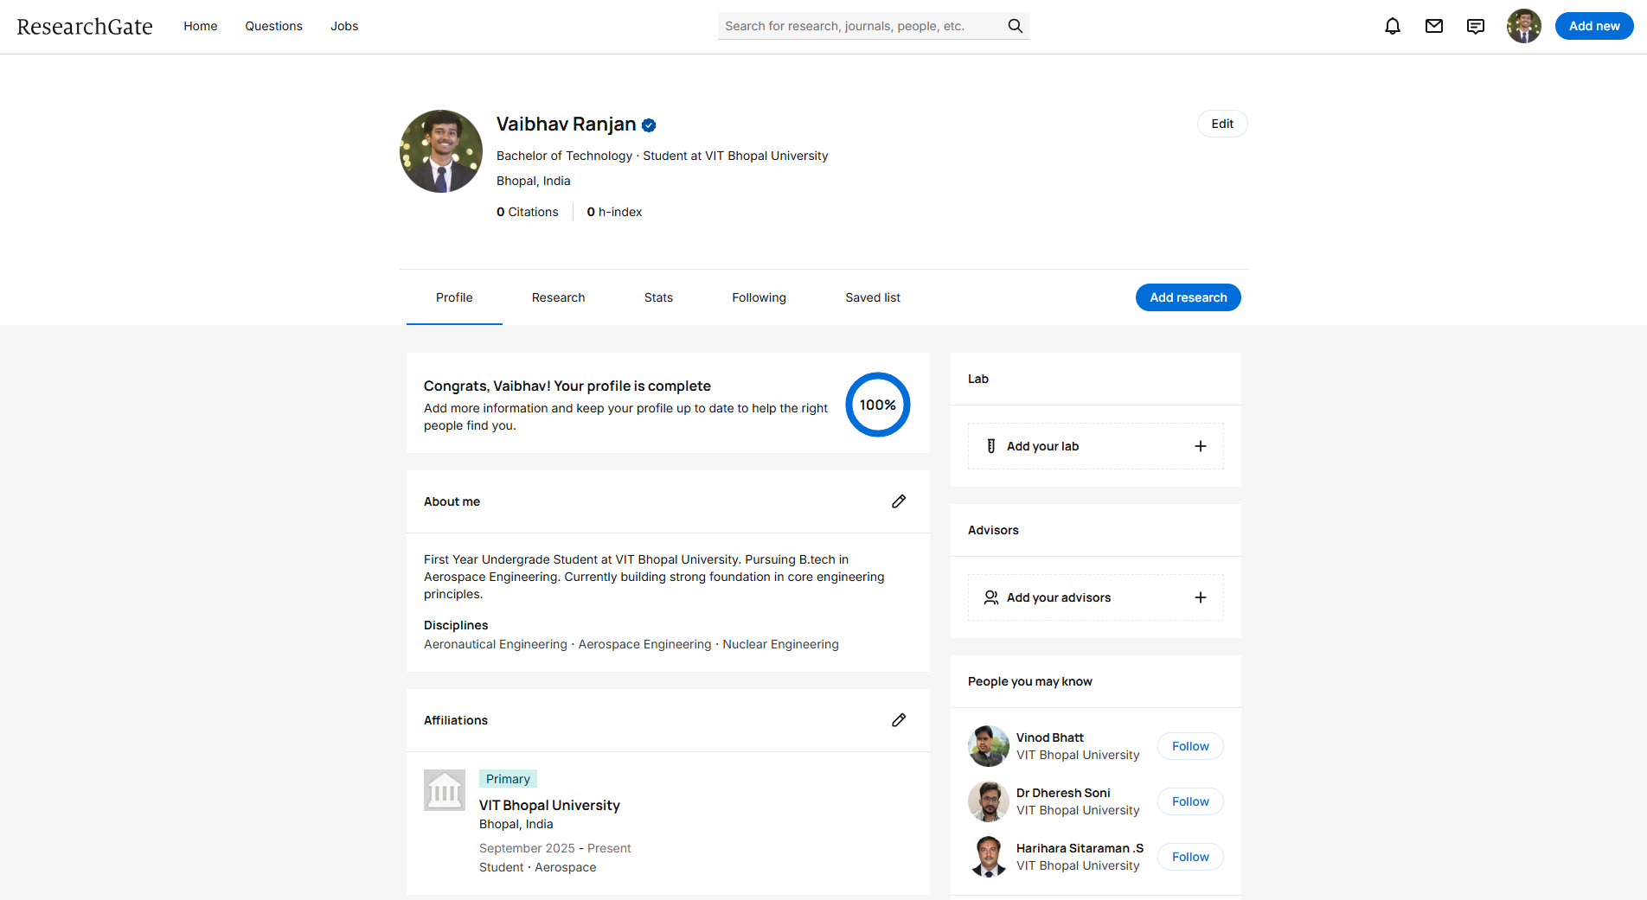
Screenshot of my ResearchGate Profile

ResearchGate – It is a free to use academic social networking platform designed for scientist, researchers and academicians. It allows users to share their research papers, find people to collaborate and get answer to questions if any. To someone like me, i.e. a student such platforms are of great use as it would help me to be aware of latest researches, even the ones that are less prominent.

