TASK 3 - EXPLORE CODING & COLLABORATION PLATFORMS

PART A – Coding Practice
Coding platform explore – Hackerrank (https://www.hackerrank.com/)
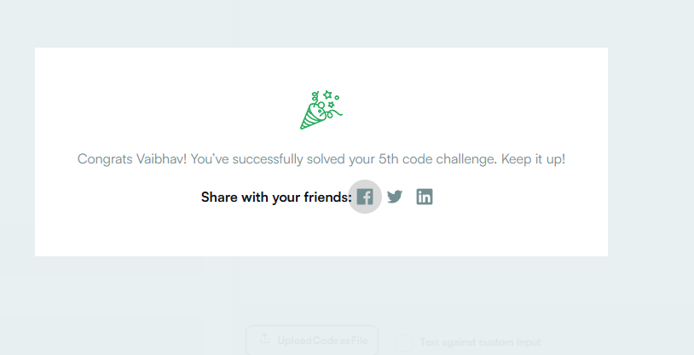
Screenshot showing completion of code challenge number 5
The project required me to create an account on coding platforms like Hackerrank, HackerEarth or CodeChef to get out their and start solving the challenges on different programming languages, be it python, java script or C++ etc. Started with solving some basic problems in python by writing the necessary code.

