TASK 3 - EXPLORE CODING & COLLABORATION PLATFORMS
PART B – Google Workspace Collaboration
Google Form with 5 question quiz on awareness on digital literacy. Link to the form
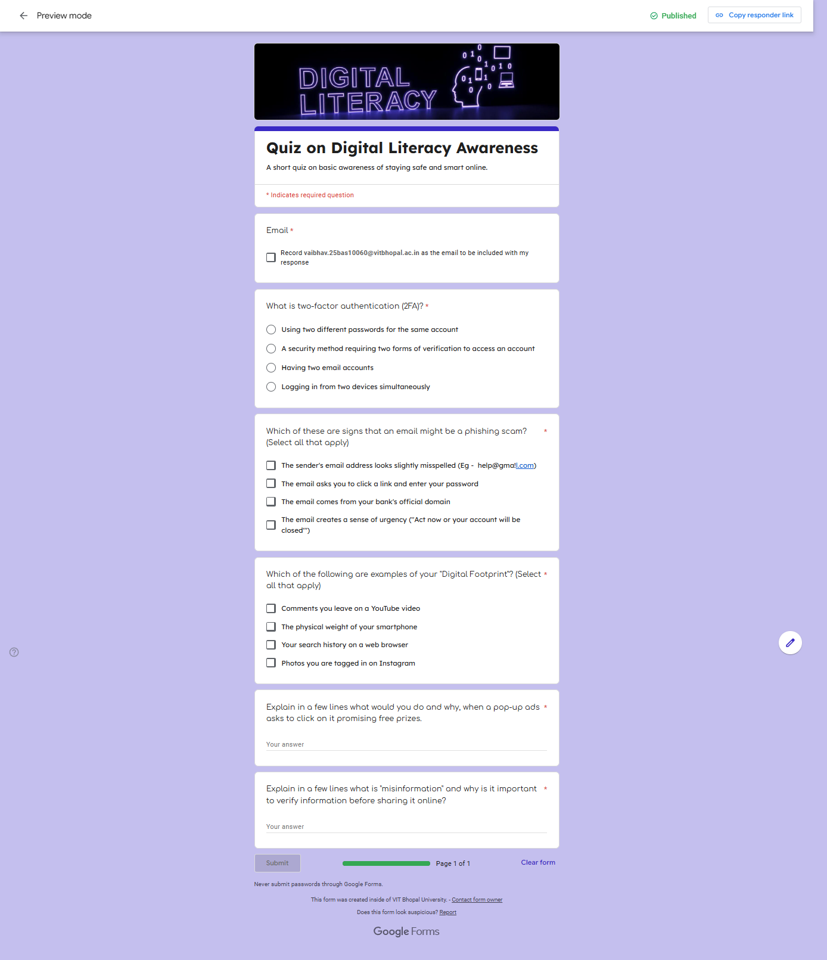
Screenshot of the Google Form
A quiz circulated amongst the batchmates on awareness of digital literacy. The responses have been cumulated in a sheet. The Response Sheet is linked HERE.

