# Game Overview

## Brief Description

*Devious Retention* is a real-time strategy (RTS) game set in the present, through to a few hundred years in the future. Two or more competing factions, possibly organised into teams, are struggling for dominance of a newly discovered land. The goal of the game is to ensure one’s faction’s dominance through the destruction of all other factions.

## Intended Gameplay

Initially, the player begins with few resources and buildings. They also have almost no initial military capabilities, save for a few weak initially available units. Due to the defensive capabilities that the player’s headquarters provides, these initially available units are not meant to be able to defeat another player, merely to harass them as they expand.

The first several minutes of a game will usually therefore be focussed around creating infrastructure for the player’s base and “scouting” around the map. Resources must be spent in order to do pretty much anything, however the player can gather resources through specific buildings. These will provide a constant stream of resources, and so setting them up early is essential for thriving in the later game.

As the game progresses, players’ military capabilities will both become more powerful and diversify. There will be meaningful choices in what the player chooses to be able to build, so that various offensive and defensive strategies can be viable. For example, players will eventually have access to powerful long-ranged artillery which can easily destroy buildings if not countered by fast-moving strike units.

# Interfaces

## Menu Interface

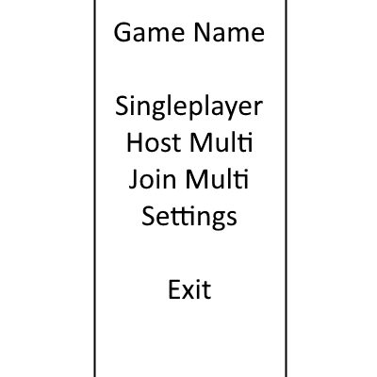

Figure 1: Main Menu

The player will, upon opening the game, be greeted by a list of options. These are: create a single or multi player lobby, join a multiplayer lobby, edit game settings, or exit the game. Obviously, *Fig. 1* is a mock-up and the real menu will have an image behind it and generally look far more attractive.

Upon pressing single player or host multi button, the player is sent into a game lobby. The lobby is slightly different depending on which they chose. Upon pressing join multi, they are prompted to enter an IP address, and the game will attempt to connect to the resulting machine.

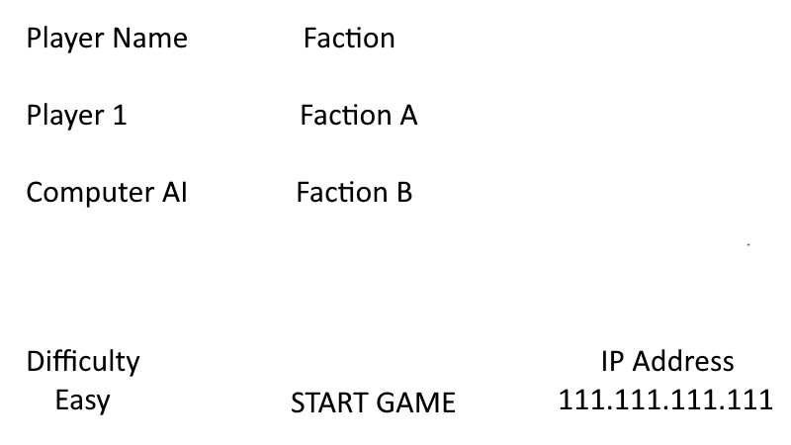

Figure 2: Game Lobby

In the single player game lobby, the IP address does not appear, and player 2 is automatically a computer AI. They can also change the computer player’s difficulty level in a drop down list, and both factions. Pressing start game launches a game with these settings.

In the multiplayer game lobby, the difficulty setting does not appear, and player 2 will not show up until another player joins the game. The game can only be started once another player joins.

## In-game Interface

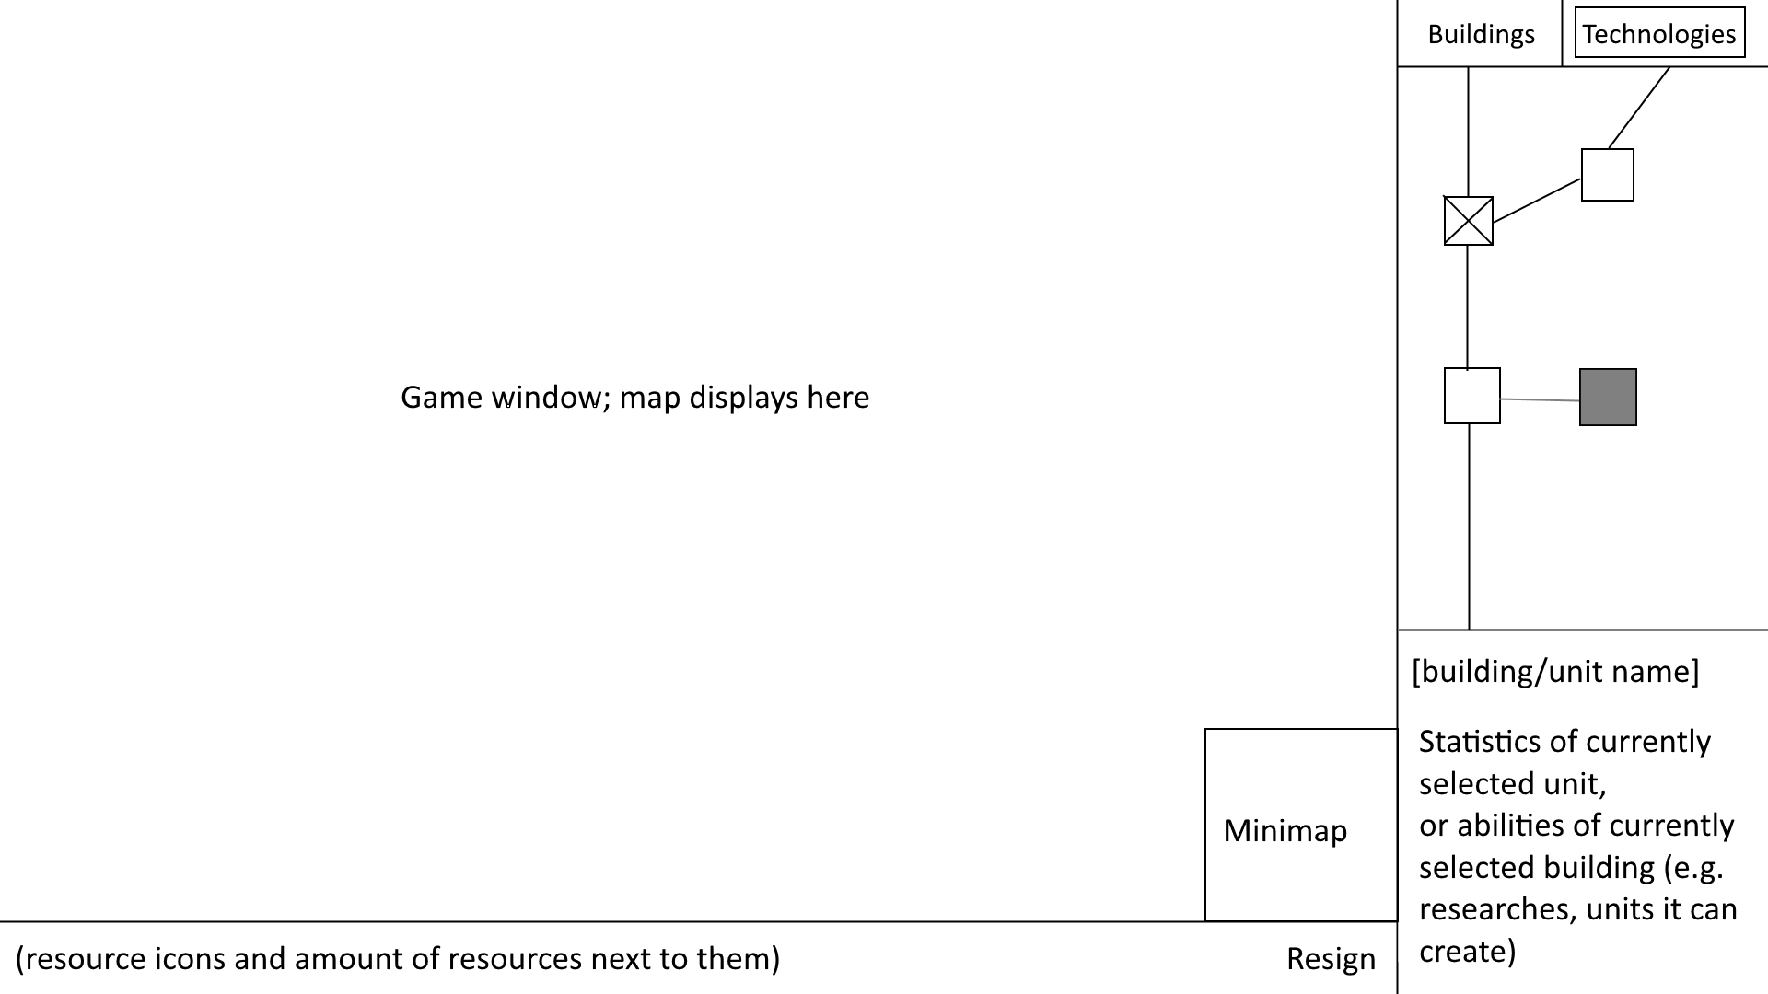

Figure 3: In-game Interface

As seen in *Fig. 3*, most of the area of the in-game interface is dedicated to actually displaying the tiles and the entities on them. The player can move their mouse cursor to any edge of the screen in order to move this view around the map, and a minimap – a smaller display that shows all of the map in lesser details – is present in the bottom right of this section.

Along the bottom of the screen, the player can view how many of each resource they have stockpiled. There is also a button at the bottom right to resign, resulting in the other player winning and the game ending.

On the right of the screen at the top are two tabs. In the building tab, the player can select from available buildings to place building foundations. Civilians will then have to be assigned to these foundations in order to actually build them. At the bottom, the player can view and activate the abilities of their selected building (such as researching technologies at it), or the statistics of their selected unit.

In the technology tab, the player can view the technology web. This is a web of interconnected icons, showing technologies and their prerequisites. Scrolling over a technology will display its costs and effects. The player can move around the web by dragging across this section in the opposite direction. Technologies which the player has already researched have a cross through them, while technologies that they can’t research due to not having the prerequisites are greyed out. The player can click on a technology to begin researching it, making a percentage indicator appear on the technology icon while it’s being researched.

Players each have a different colour assigned to them, and units and buildings have some of this colour on them for identification purposes.

# Map & Tiles

Every game is played on a different map, which is procedurally generated. This map is comprised of a 2-dimensional grid of tiles.

Tiles can’t be modified at all, and so remain the same from the beginning to the end of each game. Each type of tile has different types of units that can’t move on it and buildings that can’t be built on it. For example, infantry units can walk through grassland tiles. However, they can’t walk onto water tiles, whereas water units are the opposite. Flying units can usually move through all tiles.

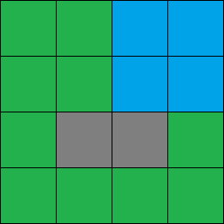

Figure : Example of 4x4 Map

Although maps are far larger than 4 tiles by 4, *Fig. 3* is an example of the concept of the tiles in a map, where the green tiles represent grass, the gray tiles mountains, and the blue tiles water. There would also be entities generated along with the tiles – in this case, it is likely that one player’s headquarters would be generated in the top left of the map, and the others in the bottom right.

# Entities

Entities are things which sit “on top of” tiles. They can have non-integer coordinates, and different sizes.

## Buildings

Buildings are immoveable entities that belong to a player. They three main functions for that player: creating units, gathering resources and helping to defend the area around them.

Buildings that gather resources can do it in one of two ways. They can either passively gather resources, in which case they will gather the resource infinitely at the same rate until destroyed, or they can actively gather it, in which case they must be built on top of a resource entity and drain from it. Buildings can only gather one type of resource.

## Units

Units are moveable entities that belong to a player; different units move at different speeds. They are created from buildings using resources. All units can engage in combat with enemy units and buildings, however different types of unit have different purposes within this.

## Resources

Resource deposits are initially common all over the map. Each one can provide a definite amount of a certain resource if the appropriate buildings are built on it before running out and no longer being able to provide that resource. Resources can’t be created by the player.

# Collision

## Buildings and Tiles or Entities

Buildings can’t be placed on some tiles, usually tiles that land infantry can’t move on. There are some exceptions, however. They can be played on resources, however they can’t be placed on other buildings or units. Instead, the building foundation will turn red when the mouse is hovered over these places, and it will not be able to be placed.

## Units and Tiles or Entities

Units simply can’t move onto some tiles, e.g. land infantry units can’t move onto water tiles. If the player attempts to move a unit onto such a tile, the unit will stop on the tile before (assuming that it can move onto the tile before, otherwise repeat this process).

Units treat buildings and resources the same as tiles.

Every unit has a size, and units can’t move within this radius of it (assuming that the two unit types collide; some don’t, e.g. air units and land infantry units).

## Resources

No check is made that resources aren’t in an invalid position, as they can’t be placed by the player or moved.

# Combat

Every unit has a few vital statistics needed for combat – hitpoints (HP), which determine how much damage they can take before dying, and damage, which determines how much damage they deal per shot to enemy units. Most units will also have a range, however those which have an extremely short (melee) range will not have it appear to the player. All buildings will also have HP, and some defensive buildings will have damage and range.

Every unit, and some defensive buildings (the attacker), can be commanded to attack an enemy unit or building (the defender). The attacker will then attempt to move to the closest accessible point within range of the defender (unless they can’t move, in which case they will do nothing if out of range). Once the attacker is within range, or if they were already within range, they will engage with the defender, lowering the defender’s HP periodically by the attacker’s damage. Some attackers will also have splash damage, which causes damage to enemies around the defender.

# Resources

There are various constraints to the player performing tasks, e.g. creating units, buildings or researching technologies. These take the form of resources (not to be confused with resource entities, although they belong to the same concept). Two properties shared by all resources are that they can be gathered over time in various ways, and that they can be spent; they work on a stockpiling principle. Things requiring them can’t be done if there isn’t enough of the resource.

## Metal

Metal is an important resource in creating most units and buildings. It is found as a natural resource, from which it can be gathered quickly, but it can also be gathered slowly and renewably from certain buildings. Metal is required for both early and late game units and buildings, and so must be gathered for all points of the game.

## Oil

Some units require oil to be made. Oil is reasonably rare compared to the other resources, and it *can’t be made renewably.* Mostly, however, units used earlier in the game use oil. Units from later in the game will not require any.

## Energy

A lot of buildings require energy constantly, and some units require energy to be created. Energy can be created from oil early in the game, however the player will quickly have to resort to renewable sources from buildings. The units which require energy to be created occur later in the game, and renewable sources should be set up by then.

## Science

Science is used to research new technologies. It can only be created slowly at research buildings, using a lot of energy.

# Technologies

In the game, there are a variety of technologies that can be researched in the technology tree. Some can be researched from the very start of the game, however most have at least one prerequisite technology, which must be researched beforehand.

The technology tree is a tab in the top right of the screen. Technologies which the player does not have the prerequisite for are greyed out, while technologies the player has already researched are crossed out instead, and technologies which the player *can’t* research due to having researched a conflicting technology are shaded with red.

Technologies will always cost science, however some also cost different resources. They take some time to research, similar to the creation time of a unit.

Some technologies provide a simple benefit, such as increasing the statistics of a certain unit type or class of unit. Others are used as a prerequisite for certain unit or building types, or other technologies. While these cases cover the majority of technologies, there are also some that have complicated or unique effects.

# AI

Initially, there will be no AI present in the game; AI will be the last, and no doubt most difficult, aspect to be developed. There will be two aspects to the AI: enemy computer players, and unit AI. The unit AI will cause all units except some buildings to automatically attack nearby enemy units and buildings if they haven’t been specifically assigned to attack something or move somewhere.

Games will be able to be played against an enemy computer player, controlled by an AI. It is unlikely that realistic gameplay will be attained in this AI, so the computer players will receive bonuses, such as more resources and faster building times, to compensate.

# Factions

Each player chooses the faction they belong to in the game lobby, out of a defined list. Each faction has a set of bonuses that apply to their player (only one player can belong to each faction), such as having specific types of units being stronger. Different factions are intended to have different viable strategies and dominant units, e.g. one faction might have very cheap melee infantry units, making them more powerful than their ranged infantry units.