WebDAV for Unity

**Publisher**: Sagui Itay ([saguiitay@hotmail.com](mailto:saguiitay@hotmail.com))

**Website**: <http://www.saguiitay.com>

# Overview

WebDAV for Unity is a full WebDAV client for Unity, with support for many operations, and various WebDAV services.

## Supported operations:

* List
* Get file/folder details
* Download files
* Upload full/partial files
* Move file/folder
* Copy file/folder
* Delete file/folder

## The client has been tested with many WebDAV services, including:

* Yandex
* 4share
* DriveHQ
* Jungle Disk
* HiDrive
* many more...

# How to use WebDAV for Unity

## Create a new WebDAV Client object

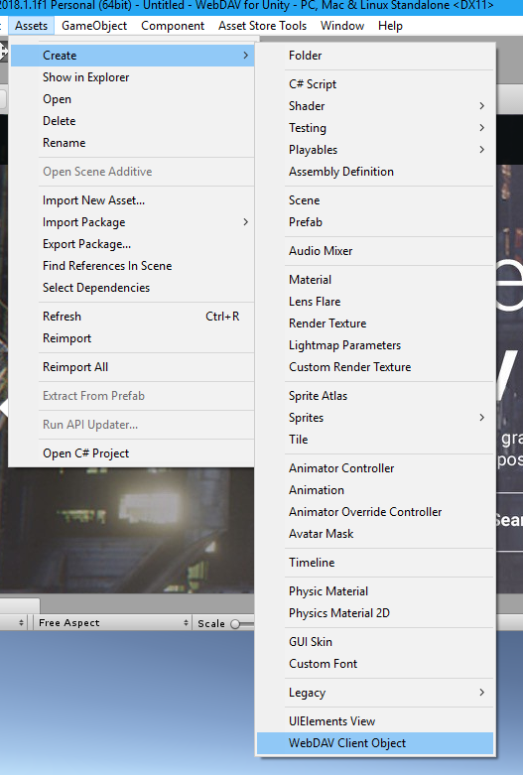

## Enter your connection details

Select the newly created WebDAV Client object, and in the inspector, enter the connection details:

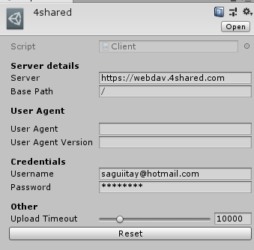

## Add a WebDAV Client property to your scripts

// Create a field of type Client, and assign it in the Editor

public WebDAVClient.Client webDAVClient;

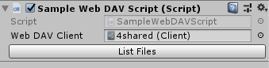

## Use the WebDAV Client

// Use the WebDAV client to list the files in the root folder

var res = webDAVClient.List("/");

# FAQ

## How do I access multiple WebDAV services?

You can create multiple WebDAV Client objects, each dedicated to a single WebDAV service:

