Abellera, Joshua Beaver Q,

Meneses, James Joash

ECE 2112

**Machine Problem 2**

Screenshots (Matlab)

* Script file

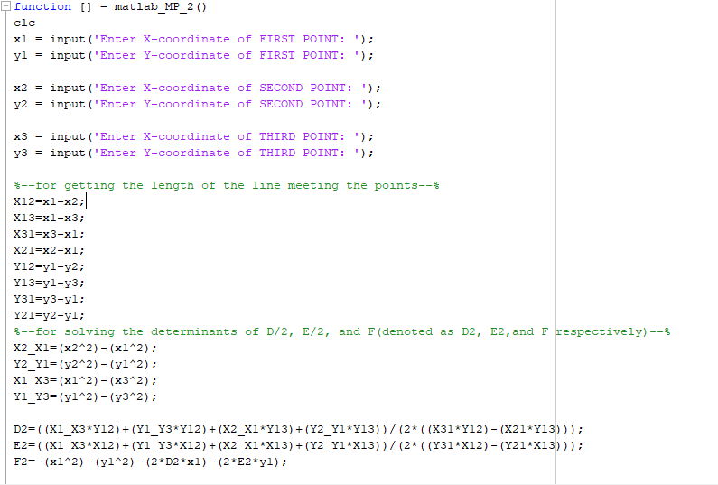

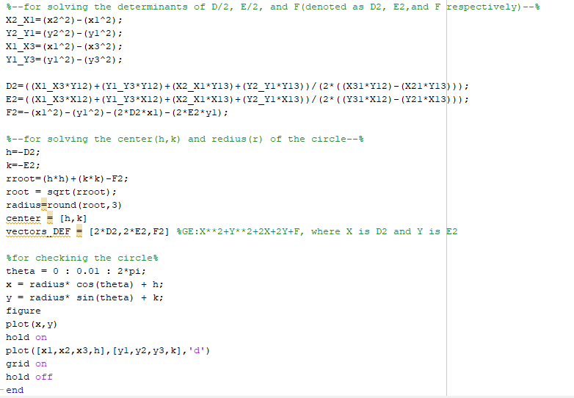

* *Testing the program*

