Abellera, Joshua Beaver Q,

Meneses, James Joash

ECE 2112

**Machine Problem 4**

Screenshots (Matlab)

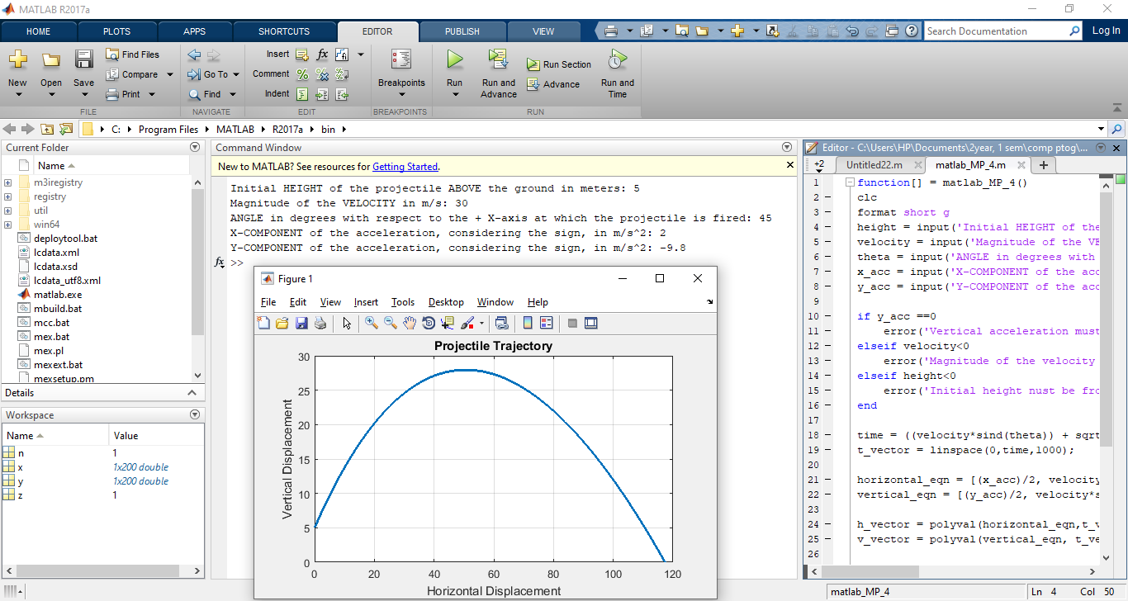

* *Projectile trajectory of an object with negative acceleration and theta >90 degrees*

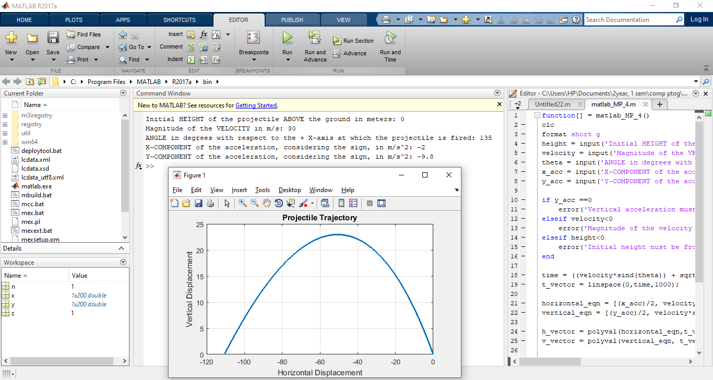

* *testing the error function*

