Abellera, Beaver Q.

2ECE-D

**Experiment 8 – Pandas Screenshots**

Problem 1

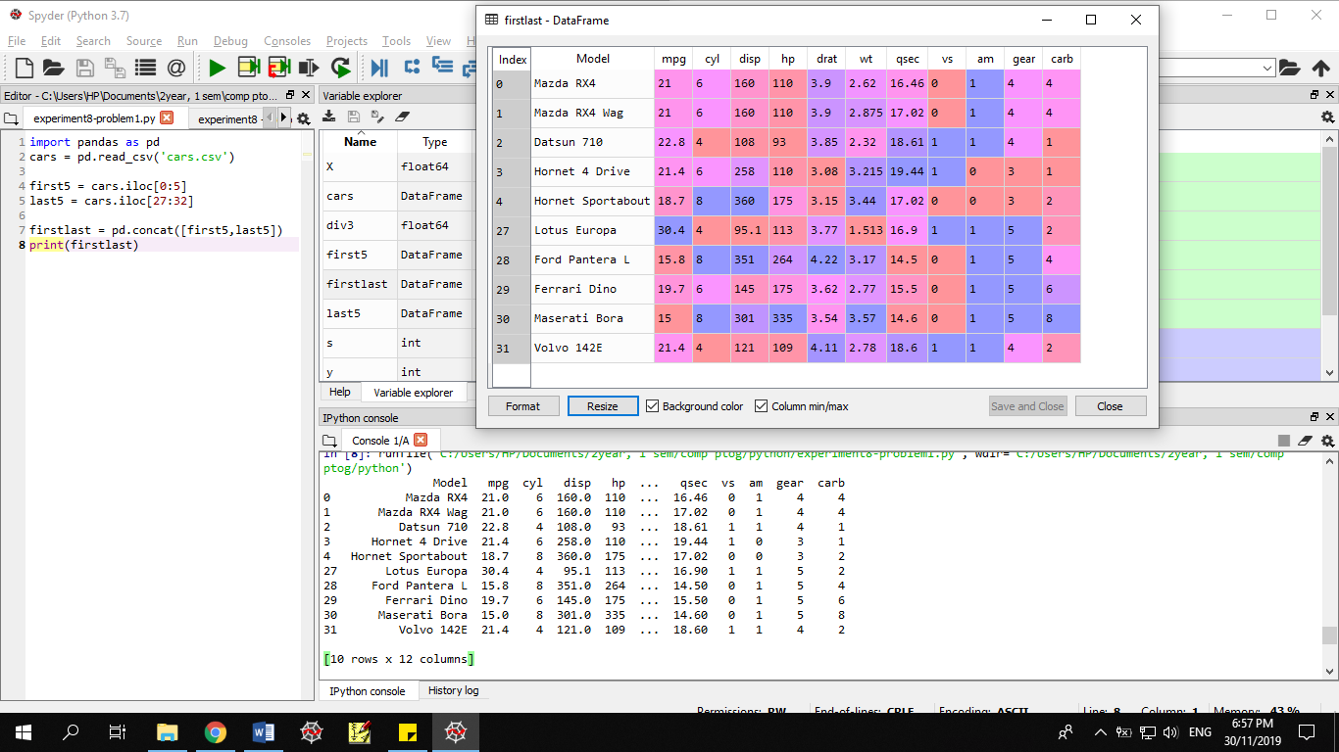

Problem 2

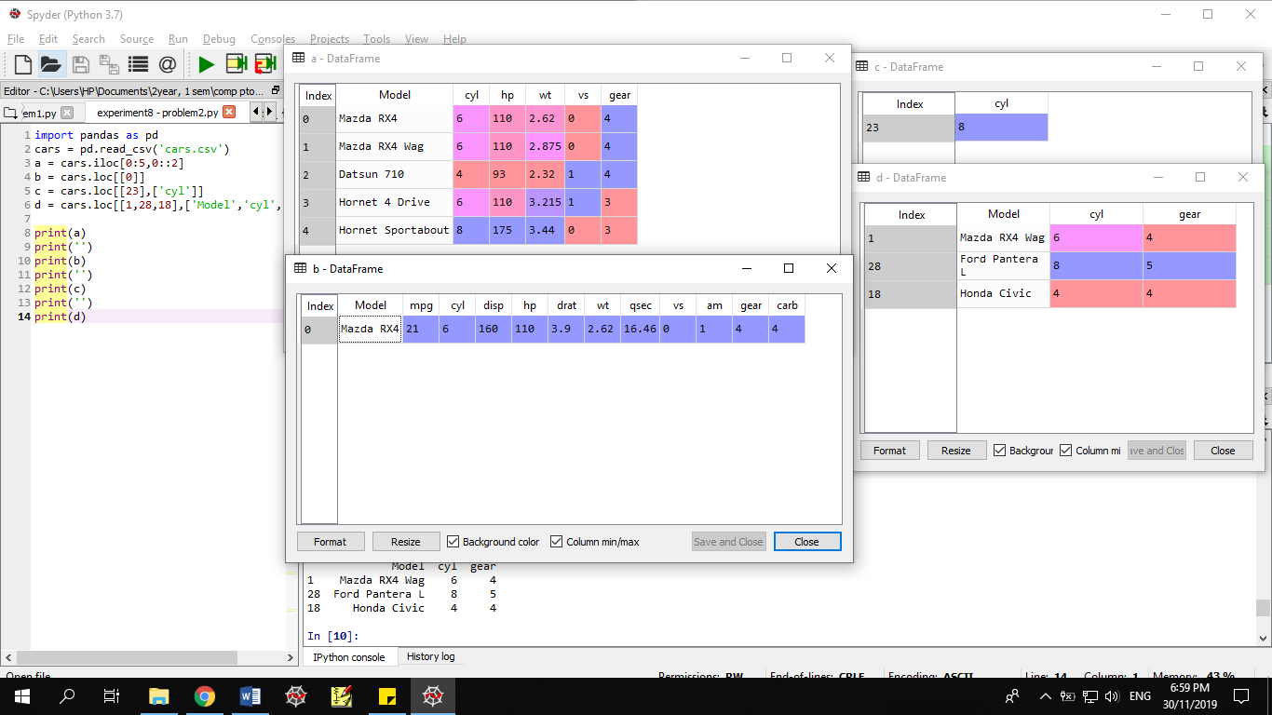

* *Printed values*

