3GPP TR 36.839 V11.0.0 (2012-09)
Technical Report
3rd Generation Partnership Project;
Technical Specification Group Radio Access Network;
Evolved Universal Terrestrial Radio Access (E-UTRA);
Mobility enhancements in heterogeneous networks
(Release 11)



The present document has been developed within the 3rd Generation Partnership Project (3GPP TM) and may be further elaborated for the purposes of 3GPP.
The present document has not been subject to any approval process by the 3GPP Organizational Partners and shall not be implemented.
This Report is provided for future development work within 3GPP only. The Organizational Partners accept no liability for any use of this Specification.
Specifications and Reports for implementation of the 3GPP TM system should be obtained via the 3GPP Organizational Partners' Publications Offices.

Keywords
<keyword[, keyword]>
3GPP
Postal address

3GPP support office address
650 Route des Lucioles - Sophia Antipolis
Valbonne - FRANCE
Tel.: +33 4 92 94 42 00 Fax: +33 4 93 65 47 16
Internet
http://www.3gpp.org
Copyright Notification
No part may be reproduced except as authorized by written permission.
The copyright and the foregoing restriction extend to reproduction in all media.

© 2012, 3GPP Organizational Partners (ARIB, ATIS, CCSA, ETSI, TTA, TTC).
All rights reserved.

UMTS™ is a Trade Mark of ETSI registered for the benefit of its members
3GPP™ is a Trade Mark of ETSI registered for the benefit of its Members and of the 3GPP Organizational Partners
LTE™ is a Trade Mark of ETSI registered for the benefit of its Members and of the 3GPP Organizational Partners
GSM® and the GSM logo are registered and owned by the GSM Association

Contents
Foreword 4
1 Scope 5
2 References 5
3 Definitions, symbols and abbreviations 6
3.1 Definitions 6
3.2 Symbols 6
3.3 Abbreviations 7
4 General 7
5 HetNet mobility performance evaluation 7
5.1 Simulation study phases 7
5.2 General Simulation assumptions 8
5.2.1 Handover Failure Modelling 8
5.2.1.1 Definition of Handover states 8
5.2.1.2 RLF modelling and definition of RLF states 8
5.2.1.3 Handover/PDCCH failure modelling 8
5.2.2 Ping-pong Modelling 11
5.2.3 Typical Radio Parameter Configurations 12
5.2.4 HetNet mobility specific parameters 13
5.2.5 Modelling of additional features 14
5.3 Specific assumptions for Hotspot simulation 14
5.3.1 UE Placement and Trajectories for hotspot simulation 14
5.3.2 Additional Simulation assumptions for Hotspot calibration 15
5.4 Additional assumptions for large area system simulations 15
5.4.1 Improved HO failure and RLF modelling 15
5.4.2 Handover performance metrics for HetNet large area evaluation 16
5.4.3 The Definition of Short-ToS Rate 17
5.4.4 UE Placement and Trajectories and cell placement for large area simulation 17
5.4.5 Additional Simulation assumptions for Large area calibration 18
5.4.5.1 UE Placement and Trajectories and cell placement for large area simulation calibration 18
5.5 Simulation results 19
5.5.1 Hotspot calibration 19
5.5.1.1 RLF results discussion 19
5.5.1.2 HO failures results discussion 21
5.5.1.3 Ping-pong results discussion 23
5.5.2 Large area calibration 23
5.5.2.1 RLF performance for HetNet and legacy systems 24
5.5.2.2 Handover failure performance for HetNet and legacy systems 25
5.5.2.3 Short Time of Stay performance 26
5.5.3 Overall observations from calibration simulations 28
5.5.4 Multiple picocell deployments 28
5.5.4.1 Multiple picocell deployment under full system load 28
5.5.4.1.1 Observations from Multiple picocell deployment simulations under full system load 30
5.5.4.2 Multiple picocell deployment under constant system load 30
5.5.4.2.1 Observations from Multiple picocell deployment simulations under constant system load 30
5.5.5 Performance with DRX 30
5.5.5.1 Simulation study for Handover and RLF performance with DRX for HetNet relative to macro only systems 30
5.5.5.1.1 Simulation assumptions and definitions 30
5.5.5.1.2 Simulation results with DRX for HetNet relative to macro only systems 31
5.5.5.2 Simulation study for Handover and RLF performance with DRX for different HO types in HetNet 33
5.5.5.2.1 Simulation assumptions and definitions 33
5.5.5.2.2 Simulation results with DRX for different HO types in HetNet 36
5.5.5.3 Overall observations on Handover performance in HetNet with DRX 38
5.5.6 Performance with eICIC 38
5.5.6.1 Simulation assumptions 39
5.5.6.2 Simulation results 39
5.5.6.3 Conclusions on mobility performance with eICIC 42
5.6 Performance benefits of enhanced UE mobility state estimation 42
5.6.1 Mobility speed estimation 42
5.6.2 Overall observations on Mobility speed estimation 44
6 Strategies for improved small cell discovery/identification 44
6.1 Deployment scenarios 44
6.2 Objectives for inter-frequency small cell measurements 45
6.3 Analysis of existing inter-frequency measurements 45
6.4 Potential enhancements for improved small cell discovery/identification 46
6.4.1 Solution 1: Longer measurement period [20] 46
6.4.3 Solution 9: UE MSE based measurements [21,32] 46
6.4.4 Solution 10: Small cell signal based control of measurements [22] 46
6.4.5 Solution 4: Measurements without gap assistance [23] 46
6.4.6 Solution 2: Small cell discovery signal in macro layer [24] 46
6.4.7 Solution 6: UE based proximity detection [25, 33] 46
6.4.8 Solution 5/ 7: Proximity detection based on macro/pico cell listening [26, 27] 46
6.4.9 Solution 8: Proximity detection with broadcast assistance [28, 33] 47
6.5 Evaluation results 47
7 Automatic Re-establishment procedures for mobility robustness 48
8 Mobility enhancements for Multi-Carrier (including CA) in HeNBs with potentially different CSGs 48
9 Overall observations from the study on HetNet mobility 48
Annex A: Detailed evaluation results on potential enhancements for inter-frequency small cell measurements 50
Annex B: Change history 53

Foreword
This Technical Report has been produced by the 3rd Generation Partnership Project (3GPP).
The contents of the present document are subject to continuing work within the TSG and may change following formal TSG approval. Should the TSG modify the contents of the present document, it will be re-released by the TSG with an identifying change of release date and an increase in version number as follows:
Version x.y.z
where:
x the first digit:
1 presented to TSG for information;
2 presented to TSG for approval;
3 or greater indicates TSG approved document under change control.
y the second digit is incremented for all changes of substance, i.e. technical enhancements, corrections, updates, etc.
z the third digit is incremented when editorial only changes have been incorporated in the document.

1 Scope
The present document is intended the capture the output of the Study Item on HetNet mobility improvements for LTE.
The study aims to look at various mobility improvements such as possible improvements to support seamless and robust mobility of users between LTE macro to pico cells in Heterogeneous networks, better strategies to identify and evaluate small cells, handover performance with and without eICIC features, improvements to re-establishment procedures etc. It is also expected to consider these in the context of Carrier aggregation in Home eNodeBs.

2 References
The following documents contain provisions which, through reference in this text, constitute provisions of the present document.
[1] 3GPP TR 21.905: "Vocabulary for 3GPP Specifications".
[2] 3GPP TS 36.133: "Evolved Universal Terrestrial Radio Access (E-UTRA); Requirements for support of radio resource management".
[3] 3GPP TS 36.300: "Evolved Universal Terrestrial Radio Access (E-UTRA) and Evolved Universal Terrestrial Radio Access Network (E-UTRAN); Overall description; Stage 2".
[4] 3GPP TS 36.814: "Evolved Universal Terrestrial Radio Access (E-UTRA); Further advancements for E-UTRA physical layer aspects"
[5] 3GPP TS 36.331: "Evolved Universal Terrestrial Radio Access (E-UTRA); Radio Resource Control (RRC); Protocol specification"
[6] R2-116122:-Attachment “Email discussion [75#36]: HetNet Mobility Hotspot Calibration Results”, TSG-RAN WG2 meeting #76
[7] R2-116103: Way forward with HetNet simulations; Renesas Mobile Europe Ltd., TSG-RAN WG2 meeting #76
[8] R2-115917: Cell detection delay in HetNet; Huawei, HiSilicon, TSG-RAN WG2 meeting #76
[9] R2-121706: Email discussion: [76#20] - LTE: HetNet mobility calibration simulations, RAN WG2 meeting #77bis
[10] R2-121660: Impact of DRX to HetNet Mobility Performance, Renesas Mobile Europe Ltd., TSG-RAN WG2 meeting #77bis
[11] R2-120348: Large Area System Simulation results for HetNet mobility, Renesas Mobile Europe Ltd., TSG-RAN WG2 meeting #77
[12] R2-121163: HetNet mobility and DRX with keep alive traffic, Nokia Corporation, Nokia Siemens Networks, TSG-RAN WG2 meeting #77bis
[13] R2-122522: Investigating pico deployments under high system load; Ericsson, ST-Ericsson, TSG-RAN WG2 meeting #78
[14] R2-122804: HetNet mobility performance with eICIC, Intel Corporation, TSG-RAN WG2 meeting #78
[15] R2-122814: Impact of random pico cell deployment on the performance, Intel Corporation, TSG-RAN WG2 meeting #78
[16] R2-122726: HetNet Mobility Performance with Cell Range Expansion and ABS, Research In Motion UK limited, TSG-RAN WG2 meeting #78
[17] R2-122268: Performance evaluation for mobility in HetNet with TD-ICIC, New Postcom
[18] R2-122685: Hetnet mobility performance with eICIC, Renesas Mobile Europe Ltd
[19] R2-116151: Small cell detection in HetNet environment, Nokia Siemens Networks, Nokia Corporation, TSG-RAN WG2 meeting #76
[20] R2-123102: Background search for small cell detection, Nokia Siemens Networks, Nokia Corporation, NTT DOCOMO, INC., TSG-RAN WG2 meeting #78
[21] R2-122368: Enhanced MSE based small cell detection, Nokia Siemens Networks, Nokia Corporation, TSG-RAN WG2 meeting #78
[22] R2-121621: Small cell signal based control of inter-frequency measurements, Nokia Siemens Networks, Nokia Corporation, TSG-RAN WG2 meeting #77bis
[23] R2-120277: Enhanced cell identification and measurements for CA, NTT DOCOMO, INC., TSG-RAN WG2 meeting #77
[24] R2-120654: Inter-frequency Small Cell Identification, Qualcomm Incorporated, TSG-RAN WG2 meeting #77
[25] R2-121665: Using proximity indication for small-cell discovery, Renesas Mobile Europe Ltd., TSG-RAN WG2 meeting #77bis
[26] R2-121417: Small Cell Detection, Ericsson, ST-Ericsson, TSG-RAN WG2 meeting #77bis
[27] R2-121248: Small Cell Discovery in HetNet, Huawei, HiSilicon, TSG-RAN WG2 meeting #77bis
[28] R2-121538: Pico cell detection issues, Samsung, TSG-RAN WG2 meeting #77bis
[29] RP-110437: Work Item Description: Carrier based HetNet ICIC for LTE, TSG-RAN meeting #51
[30] R2-120523: Enhancements for Small Cell Detection, Nokia Siemens Networks, Nokia Corporation, TSG-RAN WG2 meeting #77
[31] R2-124027: Mobility State Estimation and HetNet, Nokia Siemens Networks, Nokia Corporation TSG-RAN WG2 meeting #79]
[32] R2-120652: On UE-speed-based methods for improving the mobility performance in HetNets, Alcatel-Lucent, TSG-RAN WG2 meeting #77
[33] R2-114362: On Network-Assisted Pico Cell Discovery in LTE HetNets, Alcatel-Lucent, TSG-RAN WG2 meeting #75

3 Definitions, symbols and abbreviations

3.1 Definitions
For the purposes of the present document, the terms and definitions given in TR 21.905 [1] and the following apply. A term defined in the present document takes precedence over the definition of the same term, if any, in TR 21.905 [1].
<defined term>: <definition>.

3.2 Symbols
For the purposes of the present document, the following symbols apply:
<symbol> <Explanation>

3.3 Abbreviations
For the purposes of the present document, the abbreviations given in TR 21.905 [1] and the following apply. An abbreviation defined in the present document takes precedence over the definition of the same abbreviation, if any, in TR 21.905 [1].
HetNet Heterogeneous Networks
HO_CMD Handover Command
HOF HandOver Failure
ISD Inter Site Distance
MSE Mobility Speed Estimation
MTS Minimum-time-of-stay
RLF Radio Link Failure
ToS Time of Stay

4 General
Seamless and robust mobility of users from LTE macro to small BTS-layer, and vice versa, should be supported to enable offload benefits. The objectives of the study as captured in the study item description document [RP-110438] are:
- Identify and evaluate strategies for improved small cell discovery/identification. (RAN2)
- Identify and evaluate HetNet mobility performance under established Rel-10 eICIC features e.g., Almost Blank Subframe (RAN2, RAN1 if requested by RAN2)
- Further study and define automatic re-establishment procedures that can help improve the mobility robustness of HetNet LTE networks. Evaluate performance benefits of enhanced UE mobility state estimation and related functionalities, and other possible mobility solutions to take different cell-sizes into account. (RAN2, RAN3)
- Robust mobility functionality under various supported assumptions for the availability of UE measurements (including DRX functionality) shall be ensured/taken into account as well as UE power consumption and complexity (RAN2, RAN4)
- Further study and define mobility enhancements for Home eNodeBs with multiple carriers (or CA) with CSGs (potentially different CSG on different carriers) (RAN2, RAN3)
The study shall consider both network centric solutions and possible UE assisted enhancements.

5 HetNet mobility performance evaluation

5.1 Simulation study phases
The simulation study will be conducted in different phases:
In the first phase, a small area focusing on the hotspot around a pico cell is simulated. UE’s are either randomly placed inside this small area or on the edge of the small area. This corresponds to the Hotspot simulation (see section 5.3). With this simple model, large number of different configurations can be simulated within acceptable time.
In the second phase, a larger area focusing on the system as a whole with a number of macro and pico cells will be simulated for evaluating the impact of the pico cell deployment to the system. This corresponds to large area system model for the UE movement and trajectory (see section 5.4).
Simulation calibration is done initially for both Hotspot and Large area phases with a pre-defined set of simulation assumptions. These parameters are captured in sections 5.3.2 and 5.4.5 respectively.
The calibration phase of the study was completed in RAN2#77.
After calibration, companies have the freedom of using different simulator modelling and parameters than used during calibration provided the differences in the modelling and metrics are described. The checklist provided in [7] may be taken into account for further HetNet simulations.
The following areas of study have been identified after calibration:
- The study should consider more pico cell deployments e.g., with pico cells placed within the macro cell coverage and with more pico cells per macro cell.
- Impact of DRX setting on HO performance will also be investigated.
- Impact of CRE/eICIC will be further studied
- Evaluate the impact of different load levels and ensure that HO performance is good for all realistic load levels.

5.2 General Simulation assumptions
This section captures the simulation assumptions that are in general applicable for both Hotspot and Large area simulations unless explicitly modified in the respective sections.

5.2.1 Handover Failure Modelling
For the purpose of HetNet mobility performance evaluations, the Radio Link Failure (RLF) criterion and procedures are employed to determine the handover failure and the following definitions apply:

5.2.1.1 Definition of Handover states
For purpose of modelling, the handover procedure is divided into 3 states as shown in Figure 5.2.1.3.1.
State 1: Before the event A3 entering condition, as defined in [5], is satisfied;
State 2: After the event A3 entering condition, as defined in [5], is satisfied but before the handover command is successfully received by the UE; and
State 3: After the handover command is received by the UE, but before the handover complete is successfully sent by the UE

5.2.1.2 RLF modelling and definition of RLF states
Definition 1: The occurrence of RLF can be categorized into two distinctive states: state 1 and state 2 of the handover process.
RLF occurrences in states 1 and 2 should be logged and labelled with the state identifier for studying the impact of the handover related parameter configurations on RLFs and for handover failure calculation. Optionally, the RLFs logged in state 1 maybe further differentiated as true RLF events (due to shadowing or UE out of radio coverage) or handover failure events. RLFs in state 1 under conditions that other suitable cell(s) is available (signal strength (i.e., SINR) stronger than -8dB) may be accounted as a handover failure.
Definition 2: The RLF performance metric is defined as: the average number of RLF occurrences per UE per second. RLF performance in states 1 and 2 are logged separately.
Note that the final results can be the total number of RLFs averaged over the total simulated UE moving time of all the simulated UEs. It is equivalent to the RLFs per UE divided by averaged total moving time per UE. The time lasted in state 1 and state 2 should not be treated separately.
For the purpose of RLF monitoring, the basic L1 processing configurations in non-DRX mode should be: L1 sample rate is once every 10ms (i.e. radio frame), with the L1 samples filtered linearly over a sliding window of 200ms (i.e. 20 samples) for Qout and 100 ms (i.e. 10 samples) for Qin, respectively.

5.2.1.3 Handover/PDCCH failure modelling
Definition 3: A handover failure is counted if a RLF occurs in state 2, or a PDCCH failure is detected in state 2 or state 3.
For calculating the handover failures for the two states:
- In state 2: when the UE is attached to the source cell, a handover failure is counted if one of the following criteria is met:
1) Timer T310 has been triggered or is running when the HO_CMD is received by the UE (indicating PDCCH failure) or
2) RLF is declared in the state 2
- In state 3: after the UE is attached to the target cell a handover failure is counted if the following criterion is met:
- target cell downlink filtered average (the filtering/averaging here is same as that used for starting T310) wideband CQI is less than the threshold Qout (-8 dB) at the end of the handover execution time (Table 5.1.4.1) in state 3.
For the purpose of PDCCH failure condition monitoring in state 2: The L1 sample rate is once every 10ms and the L1 samples are filtered by a linear filter with a sliding window of 200ms (i.e. 20 samples).
For the purpose of PDCCH failure condition monitoring in state 3: The L1 sample rate should be at least two samples during the 40ms (i.e. the handover execution time) and averaged over the number of samples.
NOTE 1: The handover failure definition 3 above is different from the handover failure definition in TS 36.331 [5]. It serves the purpose of evaluating the handover performance at both serving and target cell while the definition in TS 36.331 [5] is from the UE point of view which only captures the failures in target cell.
NOTE 2: PDCCH failure condition detection is based on power measurement with the simplified model for saving simulation time to allow the calibration with various sets of configurations and more efficient simulations.
Definition 4: The handover failure rate is defined as: Handover failure rate = (number of handover failures) / (Total number of handover attempts).
The total number of handover attempts is defined as: Total number of handover attempts = number of handover failures + number of successful handovers. The number of handover failures is in Definition 3.
Figure 5.2.1.3.1 and Figure 5.2.1.3.2 show examples of the triggering of the handover failures due to detected PDCCH failure condition and RLF condition.
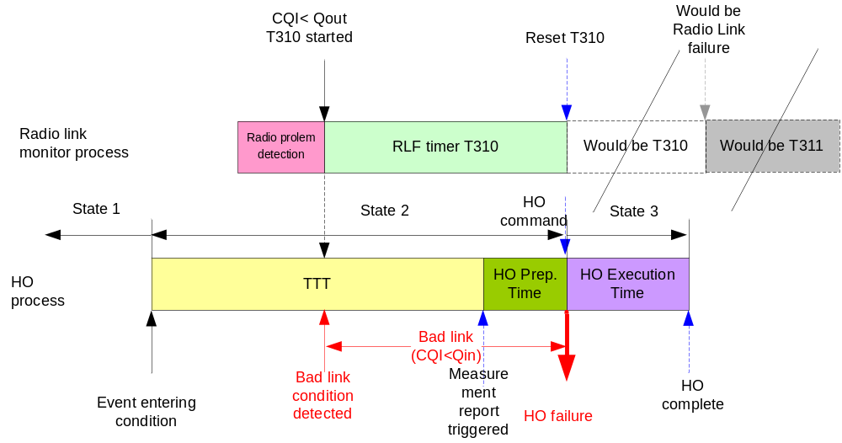
Figure 5.2.1.3.1: A handover failure is declared when the criterion 1) is met in state 2.

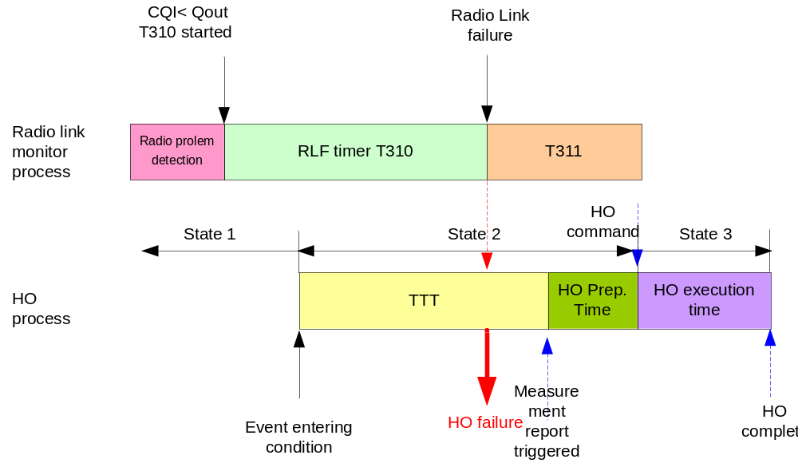
Figure 5.2.1.3.2: A handover failure is declared when the criterion 2) is met in state 2.
When a UE tracks RLFs according to TS 36.300 [3], Qout is monitored with a 200ms window and Qin is monitored with a 100ms window (as specified in TS 36.133 [2]). Both windows are updated once per frame, i.e. once every 10 ms with the measured wideband CQI value.
The RLF and HO failure modelling related parameters are shown in the table 5.2.1.3.1 below:
Table 5.2.1.3.1: The parameters for determine the RLFs and the PDCCH failures.
Items | Description
Qout | -8 dB
Qin | -6 dB
T310 | 1s (the default value in 36.331)
N310 | 1
T311 | Not used for calibration (since RLF recovery is not simulated in the calibration)
N311 | 1

5.2.2 Ping-pong Modelling
The time that a UE stays connected with a cell after a handover is used as the metric to evaluate the ping-pong behaviour. The “Time of stay” in a cell A is the duration from when the UE successfully sends a “handover complete” (i.e. RRCConnectionReconfigurationComplete)-message to the cell A, to when the UE successfully sends a “handover complete” - message to cell B. The minimum time of stay connected with a cell models the time needed to allow a UE to establish a reliable connection with the cell, plus the time required for conducting efficient data transmission. If a UE makes a handover from cell B to cell A and then makes a handover back from cell A to cell B (i.e. the original source cell in the first handover), and the time connected to the cell A was less than the minimum-time-of-stay (MTS), it is considered as a ping-pong. In general, if the UE’s time-of-stay in a cell is less than MTS, the handover may be considered as an un-necessary handover.
Definition 5: A handover from cell B to cell A then handover back to cell B is defined as a ping-pong if the time-of-stay connected in cell A is less than a pre-determined MTS.
The examples of counting the Ping-pongs are shown in the Figure 5.2.2.1.
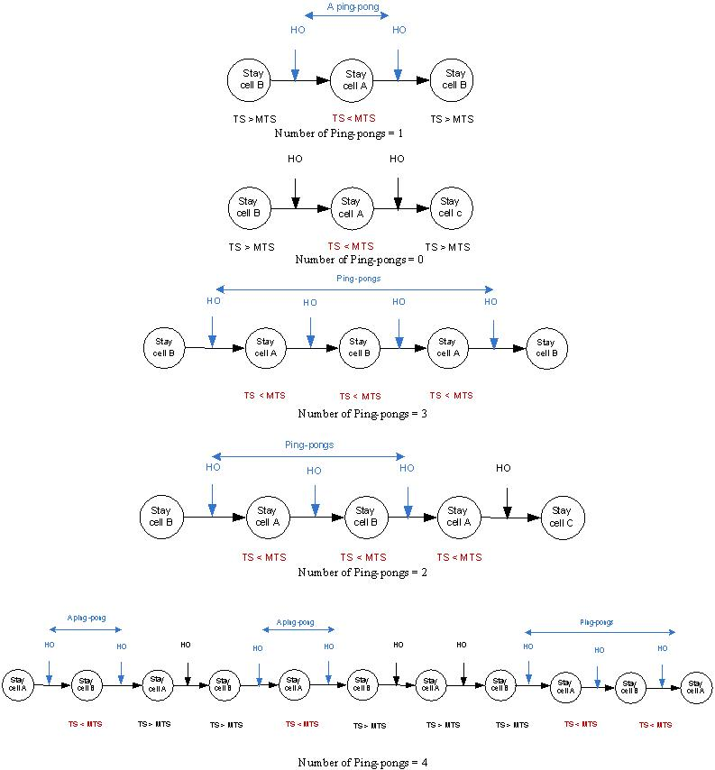
Figure 5.2.2.1: Ping-pong modelling.
Definition 6: Ping-pong rate is defined as (number of ping-pongs)/(total number of successful handovers excl. handover failures).
Recommended MTS value to be used for the simulation is 1 second.
The distribution of “time-of-stay” (CDF) should be collected for study of the ping-pong behaviour.
Whenever there is a handover failure, the time of stay should not be logged.

5.2.3 Typical Radio Parameter Configurations
The recommended simulation parameter values are based on TS36.814 [4] and are shown in the following Table 5.2.3.1.
Table 5.2.3.1: Basic radio configurations for the HetNet mobility simulation
Items | Macro cell | Pico cell
ISD | 1.732 km, 500m
Distance-dependent path loss | TR 36.814 [4] Macro-cell model 1 | TR 36.814 [4] Pico cell model 1
Number of sites/sectors | 19/57 | 1
BS Antenna gain including Cable loss | 15dB | 5dB
MS Antenna gain | 0 dBi | 0 dBi
Shadowing standard deviation | 8 dB | 10 dB
Correlation distance of Shadowing  NOTE: this is the distance where correlation is 0.5 (not 1/e as defined in TR 36.814 B.1.2.1.1) | 25 m | 25 m
Shadow correlation | 0.5 between cells/ 1 between sectors | 0.5 between cells
Antenna pattern | The same 3D pattern as is specified in TR 36.814, Table A.2.1.1-2 [4] | Omni, as is specified in TR 36.814, Table A.2.1.1.2-3 [4]
Carrier Frequency / Bandwidth | 2.0Ghz/ 10Mhz | 2.0Ghz/ 10Mhz
BS Total TX power | 46 dBm | 30dBm
Penetration Loss | 20dB | 20dB
Antenna configuration | 1x2 | 1x2
Minimum distance | The same requirements as specified in TR 36.814 [4].

5.2.4 HetNet mobility specific parameters
The following table captures the additional recommended HetNet mobility specific parameters:
Table 5.2.4.1: HetNet mobility specific parameters
Items | Description
Pico cell placement | At fixed location(s) e.g., at 0.5 ISD, 0.3 ISD on the boresight direction. Or randomly placed.
Cell loading (NOTE 1) | 100%, 50%
UE speed | 3 km/h, 120km/h, 30km/h, 60km/h
Channel model | Either one of the models, TU or ITU, could be used. (fast fading included)
TimeToTrigger [ms] | 40, 80, 160, 480
a3-offset [dB] | -1, 0, 1, 2, 3
T_{Measurement_Period, Intra,} L1 filtering time in TS36.133 [2] | 200ms (other values could be added later)
Layer3 Filter Parameter K | 4, 1, 0
measurement error modelling | To obtain the 90% bound for +/- 2 dB, a normal distribution with deviation = 2 dB / (sqrt(2)*erfinv(0.9)) = 1.216 dB can be used (ref: TS36.133 [2]). The RSRP measurement error can be added before or after L1 filter as long as the error requirement mentioned above is met at the input of L3 filter.  For calibration purposes, there is no measurement error modelling with wideband CQI for radio link monitoring and HOF decision.
Handover preparation (decision) delay | 50ms
Handover execution time | 40ms
NOTE 1: The percentage of cell loading means the percentage of the total resource blocks being used in a cell during a given period of time. There is no difference between DL interference generated by full buffered background users and full power transmission in all the RBs of the system bandwidth.
Fast fading is included in the simulation since it may have a big impact to low speed UE’s handover performance.
It should be noted that TS36.331 [5] requires that the time characteristics of the L3 filter to be preserved by scaling the K value when the sample period is less than 200ms.

5.2.5 Modelling of additional features
Suitable models for DRX, eICIC, RLF recovery, traffic patterns etc. could be considered by companies in further simulations. Solutions that will enable the use of long DRX periods for improved UE power savings and user experience, while still ensuring controlled mobility in a robust manner is identified as an important topic for study.
The model provided in [8] is considered as one suitable model for analyzing the impact of non DRX intra-frequency cell identification delay.
[Editors Note: Models for DRX, eICIC, RLF recovery, traffic patterns etc should be contribution driven and not limit allowed simulation models.]

5.3 Specific assumptions for Hotspot simulation

5.3.1 UE Placement and Trajectories for hotspot simulation
Regarding to the UE placement and trajectories, two different approaches are allowed for small area simulation (Hotspot model):
1) In a trial, a UE is randomly placed on the edge of the hotspot around the pico cell. Then the UE moves straight in a randomly picked direction within an angle toward the pico cell. A trial is finished when the UE hit the circle on the other side.
2) Alternatively, UEs are initially randomly dropped within the hotspot around the pico cell. Then the UE moves in a random direction in a straight line. When UEs reach the edge of the hotspot it will bounce back in a random direction but UE movement is restricted to be within the hotspot.
As an example of the first approach shown in Figure 5.3.1.1, the pico cell is placed at the 0.3 ISD from the eNB on the bore sight direction. A circle is drawn with pico cell centre location as its centre and 200m as the diameter. A UE is placed randomly on the circle and let it move towards the pico cell at random angle with in +/- 45 degrees with the radius. The UE doesn’t change the direction and the speed until it reaches the circle then start another trial (equivalent to that the UE is initially placed in the circle at any location then moves straight in a random direction and bounces back at the circle with a random angle).
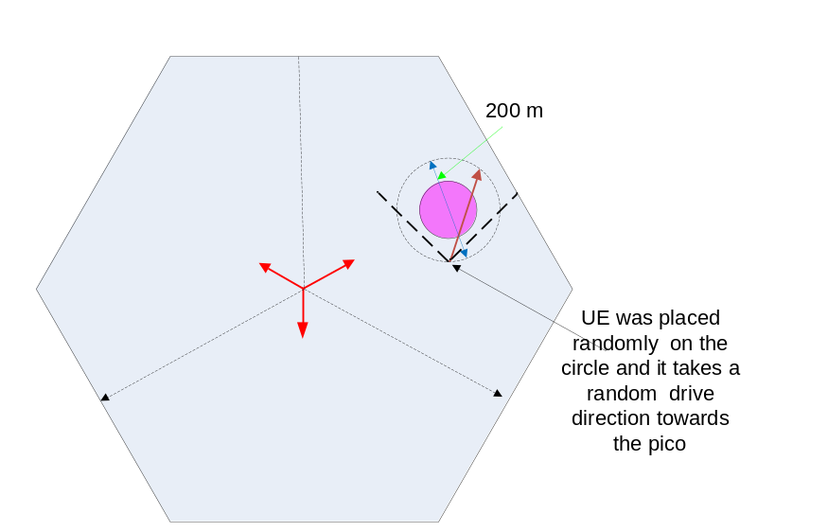
Figure 5.3.1.1: Pico cell placement and the mobile trajectories for mobility simulation at hot spot.

5.3.2 Additional Simulation assumptions for Hotspot calibration
The calibration for the hotspot is conducted to ensure companies adopting the same basic simulation assumptions such that the simulation results are comparable and repeatable.
For simulator calibration purposes, the following sets of the configuration parameters in Table 5.3.2.1 are used for the first phase of simulation. The simulation results will be captured in this TR document for reference.
Table 5.3.2.1: Configuration parameter sets for simulation calibration
Profile | Set 1 | Set 2 | Set 3 | Set 4 | Set 5
UE speed [km/h] | {3, 30, 60, 120} | {3, 30, 60, 120} | {3, 30, 60, 120} | {3, 30, 60, 120} | {3, 30, 60, 120}
Cell Loading [%] | 100 | 100 | 100 | 100 | 100
TTT [ms] | 480 | 160 | 160 | 80 | 40
A3 offset [dB] | 3 | 3 | 2 | 1 | -1
L1 to L3 period [ms] | 200 | 200 | 200 | 200 | 200
RSRP L3 Filter K | 4 | 4 | 1 | 1 | 0

In the Table 5.2.3.-1, the number of pico cells in the sector of interest is 1. Pico cell placement for simulation calibration: 0.5 ISD on the boresight direction.
For calibration purpose, although the macro-to-macro handovers should be simulated, logging the macro-to-macro handover related metrics is not required. However, it is allowed to log macro-to-macro handover results separately from the macro/pico results, but the macro-to-macro handovers shall not be included into the total number of handovers for macro/pico HO failure rate calculation.
For calibration purposes, a hotspot diameter of 200 m will be used.
T311 is not used since RLF recovery is not simulated in the calibration.
When either a HO failure or a RLF is detected, the UE will be removed from the simulation. Essentially, here this means that the UE is generated again (as a new call) after a failure.

5.4 Additional assumptions for large area system simulations

5.4.1 Improved HO failure and RLF modelling
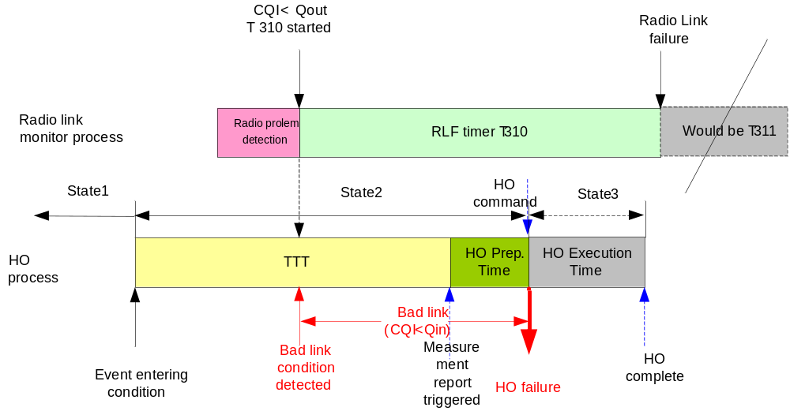
Figure 5.4.1.1: Modelling of Handover failure in state 2 for large area simulations
HO failure in state 2 can have two reasons; this text focuses on the first criterion in Definition 3, Section 5.2.1.3 (i.e., Timer T310 has been triggered or is running when the HO_CMD is received by the UE (indicating PDCCH failure)). When this criteria happens, the UE is not removed from the simulation and T310 is kept running. Until expiry of T310, if the RLM measurement is above Qin, the UE will be back to state 1 with the source cell and have its T310 stopped and reset to zero. If the RLM measurement is not above Qin, T310 will expire and cause an RLF (see Figure 5.4.1.1). This RLF will have a reason code of HO failure. Note that this is in addition to the HO failure counting as per definition 3 in section 5.2.1.3. In large scale simulation, the RLFs with the reason code of HO failure should be logged separately from the conventional RLFs.
RLF recovery should eventually be modelled in large area simulation after the calibration. Companies should have the flexibility to choose a realistic RLF recovery model.

5.4.2 Handover performance metrics for HetNet large area evaluation
In general, the performance evaluation metrics adopted for hot spot simulation can be also used for large area system simulation.
In the large area simulation, the impact of the handover failures to the system performance depends on how often the handover and handover failure occurred. If handover rarely occur, even if handover failure rate is high, the impact of the handover failure to the system is still very limited. On the other hand, if the frequency of handovers and handover failures are high, the impact to the system performance will be much bigger. Therefore, time factor should be introduced as the large area simulation performance metric. The generic metrics are defined as the follows:
Definition 7: The total number of handover failures per UE per second is defined as the total number of handover failures averaged over the total travel time of all the simulated UEs.
Definition 8: The total number of successful handovers per UE per second is defined as the total number of successful handovers averaged over the total travel time of all the simulated UEs.
NOTE: Based on definitions 7, 8 the relative handover failure rate defined in definition 4 can be derived as:
The handover failure rate = (The total number of handover failures per UE per second) / (The total number of handover failures per UE per second + The total number of successful handovers per UE per second). In order to observe the HetNet mobility behaviour thoroughly, handover performance results should be logged separately for macro to macro (macro-macro), macro to pico (macro-pico), pico to macro (pico-macro) and pico to pico (pico-pico) handovers. The overall aggregated results should also be obtained. More specifically the following additional metrics for large area HetNet mobility simulation should be used:
1. The number of macro-pico handover failures per UE per second.
2. The number of pico-macro handover failures per UE per second.
3. The number of macro-macro handover failures per UE per second.
4. The number of pico-pico handover failures per UE per second.
5. The total number of handover failures per UE per second.
6. The number of successful macro-pico handovers per UE per second.
7. The number of successful pico-macro handovers per UE per second.
8. The number of successful macro-macro handovers per UE per second.
9. The number successful of pico-pico handovers per UE per second.
10. The total number of successful handovers per UE per second.
11. The macro-pico handover failure rate = (The number of macro-pico handover failures per UE per second) / (The number of macro-pico handover failures per UE per second + The number of successful macro-pico handovers per UE per second).
12. The pico-macro handover failure rate = (The number of pico-macro handover failures per UE per second) / (The number of pico-macro handover failures per UE per second + The number of successful pico-macro handovers per UE per second).
13. The macro-macro handover failure rate = (The number of macro-macro handover failures per UE per second) / (The number of macro-macro handover failures per UE per second + The number of successful macro-macro handovers per UE per second).
14. The pico-pico handover failure rate = (The number of pico-pico handover failures per UE per second) / (The number of pico-pico handover failures per UE per second + The number of successful pico-pico handovers per UE per second).
15. Overall handover failure rate = (Total number of handover failures per UE per second) / (Total number of handover failures per UE per second + Total number of successful handovers per UE per second).
It is beneficial to simulate the macro only system and the results could be used as the reference for comparison with the results from HetNet simulation. The relative results against the macro only system is useful. Comparing the absolute results among the companies is also important to minimize the variance.

5.4.3 The Definition of Short-ToS Rate
The "Time of stay" in a cell A (as captured in section 5.2.2) is the duration from when the UE successfully sends a "handover complete" (i.e. RRCConnectionReconfigurationComplete)-message to the cell A, to when the UE successfully sends a "handover complete" message to another cell B. A UE-stay with a cell where the condition ToS < MTS is met regardless of the cell from which UE was handed in or the cell to which it was handed out, is considered a short time of stay (Short ToS).
The more generic Short ToS metrics are defined as follows:
Definition 9: A Short ToS is counted when a UE’s time-of-stay in a cell is less than a predetermined minimum time-of-stay parameter (MTS), i.e. a UE with ToS<MTS.
Definition 10: A Short ToS rate is defined as the number of Short ToS occurrences divided by the number of successful handovers. I.e.
Short ToS rate = (number of Short ToS occurrences)/(total number of successful handovers)
Definition 11: Short ToS per UE per second is defined as the total number of Short ToS occurrences divided by total number of the UEs simulated and averaged over the total simulation time.
It is mandatory to log the CDF of ToS for large area simulation. The CDF of ToS should be logged separately for the ToS with pico cells and macro cells.

5.4.4 UE Placement and Trajectories and cell placement for large area simulation
Companies are allowed to use either wrap-around or bouncing-circle model. When submitting results, companies should state which model is used.
For wrap-around approach, the simulation area (within the contour of wrap-around area) should include at least 2 tiers of macro sites.
For the bouncing-circle approach, the simulation area within the bouncing-circle should include at least 1 tier of complete macro sites. Only the results from the inner tiers of the macro sites will be logged, including all the outer border area of the sites and complete pico cells on the macro cell border if any.
For both wrap-around model and bouncing-circle model, a UE at any cell in the simulation area should experience the interference from two tiers of macro cells.
After initially dropped at a random location, the UE will randomly select a direction and move in straight line at a constant speed till hitting the simulation border.
For the wrap-around model, when the UE hit the simulation border (the wrap-around contour), it will wrap around and enter the simulation area from a different point on the wrap-around contour
For the bouncing-circle model, when the UE hit the simulation border (the bouncing-circle), it will bounce back with a random angle.

5.4.5 Additional Simulation assumptions for Large area calibration
This section provides additional simulation assumptions for Large area calibration. Companies have freedom to choose different/additional configurations after calibration.

5.4.5.1 UE Placement and Trajectories and cell placement for large area simulation calibration
For the calibration of large area HetNet mobility simulation, a fixed pico cell placement pattern is adopted as is shown in Figures 5.4.5.1.1 and 5.4.5.1.2, with each macro site associated with 6 pico cells. Each of the pico cells are placed at the centre point on the border between two macro sites at 0.5 ISD. This pico cell placement leads to an average of 1 pico cell per macro cell. It duplicates the pico cell placement for the hotspot calibration over the entire simulation area. The change compared to hotspot calibration is the smallest. It will be easier for data comparison. The random pico cell placement could be chosen by companies later on.
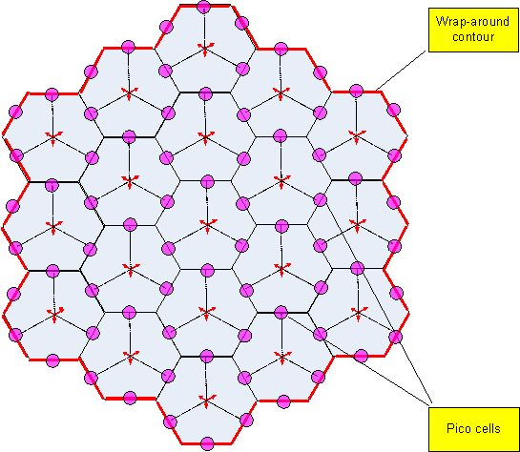
Figure 5.4.5.1.1: Macro and pico cell placement in the wrap-around model for calibration.
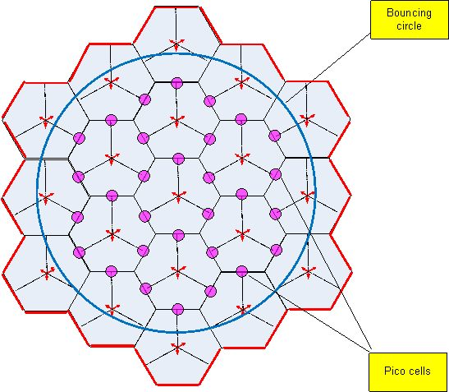
Figure 5.4.5.1.2: Macro and pico cell placement in the bouncing-circle model for calibration.
The macro and pico cell placement shown in Figure 5.4.5.1.1 is adopted for calibration with the wrap-around model. A simple macro and pico cell placement is suggested for calibration/common approach. The ‘2 tiers’ model of 19 macro sites is used where pico cells are placed at the middle of macro/macro cell borders.
The macro and pico cell placement shown in Figure 5.4.5.1.2 is adopted for calibration with the bouncing-circle model. For the bouncing-circle approach, to save the simulation time, it is suggested to have the simulation circle size of 1.8 ISD. The time-of-stay when a bounce occurs is not logged.
The macro cell ISD is 500 m.
For large area simulation calibration, when a simulation is started, a UE is randomly placed in the simulation area initially. It is assumed that UEs are uniformly distributed over the simulation area.
Since RLF recovery is not modelled for large area calibration, a UE is taken away when HO failure occurs in state 3 or a RLF (both with and without the reason code of HO failure) occurs.
The set 3 of the configuration parameters used in hotspot calibration (in Table 5.3.2.1) is adopted for large area simulation calibration. A UE speed of 30 km/h is adopted for calibration of large area HetNet mobility simulation. Companies are free to choose additional configuration sets or speeds after the calibration phase.

5.5 Simulation results

5.5.1 Hotspot calibration
The calibration results averaged over the results from all the participating companies are captured in the following sections. The detailed calibration results from specific companies can be found in [6].
Some initial observations are also made from the averaged results. However, it should be noted that these are initial findings and no definite conclusions should be drawn from it now

5.5.1.1 RLF results discussion
Table 5.5.1.1.1: Average RLF/UE/s simulation data in state 1 and state 2.
 | State | Speed | Set1 | Set2 | Set3 | Set4 | Set5
Total Average of all the companies' results | 1 | 3 | 1.2E-04 | 1.0E-04 | 4.5E-05 | 2.2E-05 | 1.2E-05
Total Average of all the companies' results | 1 | 30 | 2.8E-04 | 3.7E-04 | 5.3E-05 | 4.7E-05 | 2.8E-05
Total Average of all the companies' results | 1 | 60 | 4.1E-04 | 5.5E-04 | 1.2E-04 | 8.0E-05 | 4.3E-05
Total Average of all the companies' results | 1 | 120 | 6.4E-04 | 8.5E-04 | 1.4E-04 | 1.0E-04 | 6.4E-05
Total Average of all the companies' results | 2 | 3 | 5.3E-05 | 1.1E-05 | 1.1E-06 | 3.4E-06 | 6.8E-06
Total Average of all the companies' results | 2 | 30 | 9.3E-04 | 1.7E-04 | 7.6E-05 | 1.9E-05 | 2.0E-05
Total Average of all the companies' results | 2 | 60 | 2.1E-03 | 5.7E-04 | 4.5E-05 | 1.7E-05 | 3.9E-05
Total Average of all the companies' results | 2 | 120 | 5.9E-03 | 1.5E-03 | 1.0E-04 | 7.1E-05 | 3.3E-05

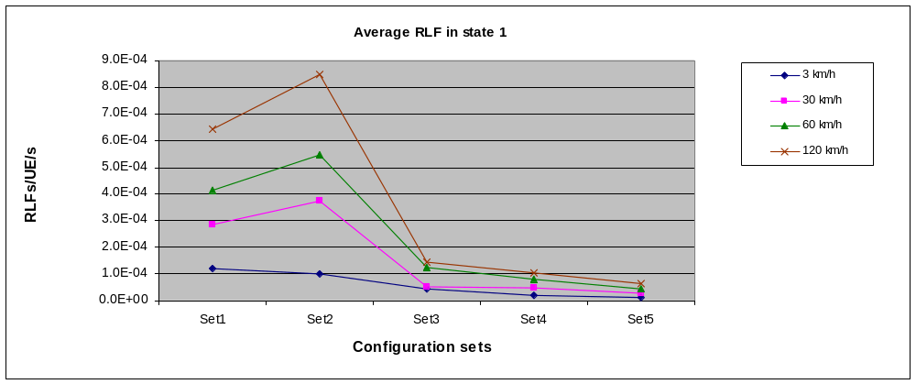
Figure 5.5.1.1.1: Average RLFs/UE/s curves in state 1.

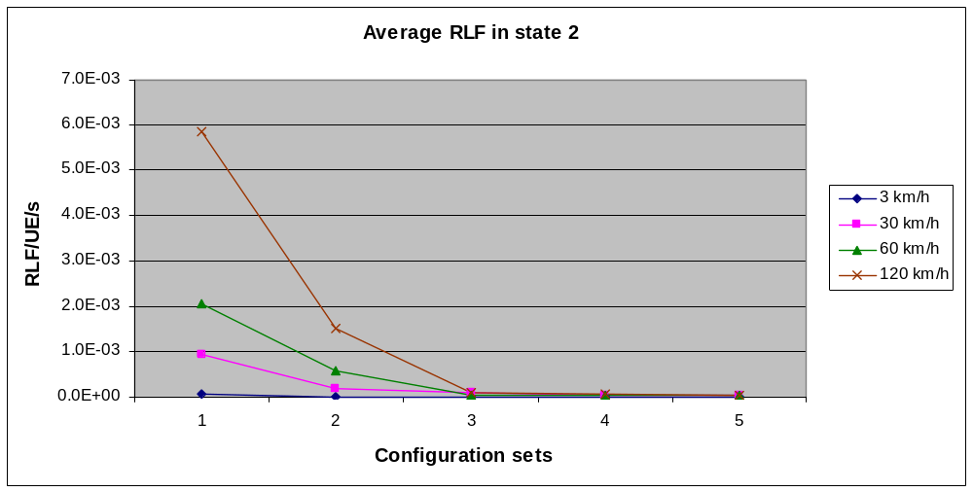
Figure 5.5.1.1.2: Average RLFs/UE/s curves in state 2.
From the simulation results, the following initial findings are observed:
1. Majority of the companies observed very few RLFs occurrences in most cases. The relatively long T310 timer setting makes the RLF rarely occurring. Many HO failures in state 2 may eventually lead to RLF in the real system but currently they are just logged as HO failures.
2. The average RLF/UE/s of the all the companies’ results is higher for the higher UE speed.

5.5.1.2 HO failures results discussion
Table 5.5.1.2.1: Average handover failure rate simulation data in state 2, state 3 and average overall handover failure rate simulation data.
 | State | Speed | Set1 | Set2 | Set3 | Set4 | Set5
Average of all the companies' results | 2 | 3 | 7.448 | 3.705 | 2.322 | 0.853 | 0.192
Average of all the companies' results | 2 | 30 | 36.357 | 19.146 | 8.393 | 2.935 | 0.870
Average of all the companies' results | 2 | 60 | 52.261 | 34.502 | 14.959 | 6.227 | 2.040
Average of all the companies' results | 2 | 120 | 57.158 | 48.127 | 29.121 | 13.749 | 4.863
Average of all the companies' results | 3 | 3 | 0.058 | 0.113 | 0.217 | 0.310 | 0.455
Average of all the companies' results | 3 | 30 | 0.868 | 0.188 | 0.466 | 0.519 | 0.851
Average of all the companies' results | 3 | 60 | 2.555 | 0.445 | 0.727 | 1.046 | 1.680
Average of all the companies' results | 3 | 120 | 7.200 | 1.115 | 1.610 | 2.764 | 3.370
Average of all the companies' results | OVERALL | 3 | 7.506 | 3.818 | 2.539 | 1.163 | 0.647
Average of all the companies' results | OVERALL | 30 | 37.225 | 19.334 | 8.859 | 3.453 | 1.720
Average of all the companies' results | OVERALL | 60 | 54.809 | 34.945 | 15.683 | 7.273 | 3.718
Average of all the companies' results | OVERALL | 120 | 64.260 | 49.196 | 30.708 | 16.498 | 8.219

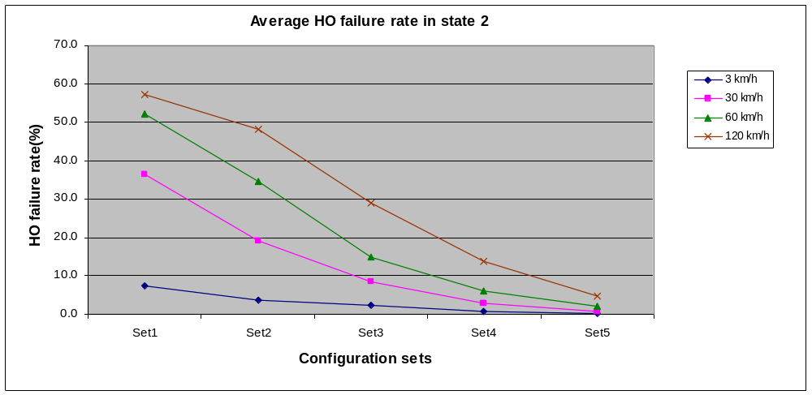
Figure 5.5.1.2.1: Average handover failure rate curves in state 2.

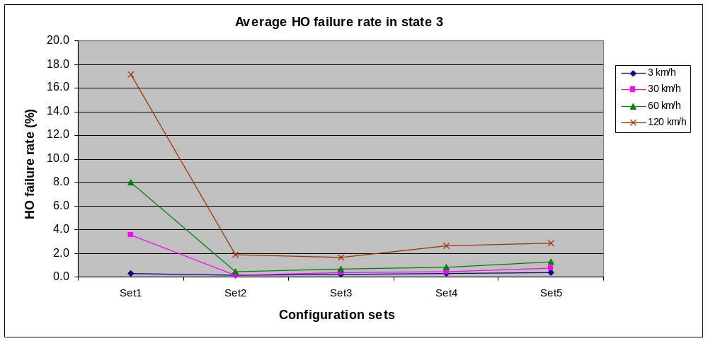
Figure 5.5.1.2.2: Average handover failure rate curves in state 3.

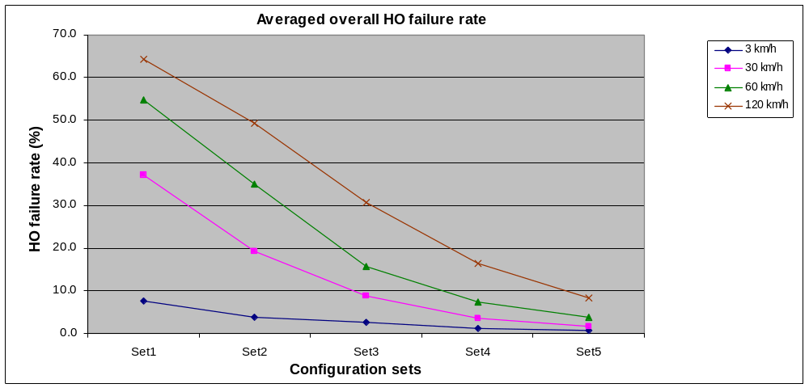
Figure 5.5.1.2.3: Average overall handover failure rate curves.
From the simulation results, the following initial findings are observed:
1. Majority of the companies observed the same trend of the simulation results. The variance of some calibration results from different companies is still big.
2. The UE speed has a significant impact on the HO performance. The trend of simulation results indicated that high speed UEs suffer much higher HO failure rate than low speed UEs.

5.5.1.3 Ping-pong results discussion
Table 5.5.1.3.1: Average ping-pong rate data from calibration
 | Speed | Set1 | Set2 | Set3 | Set4 | Set5
Average over all companies' results | 3 | 0.115 | 1.841 | 14.386 | 31.661 | 79.960
Average over all companies' results | 30 | 0.960 | 3.370 | 10.345 | 20.517 | 64.489
Average over all companies' results | 60 | 1.383 | 4.671 | 11.222 | 19.733 | 53.256
Average over all companies' results | 120 | 3.369 | 9.911 | 16.802 | 24.724 | 45.651

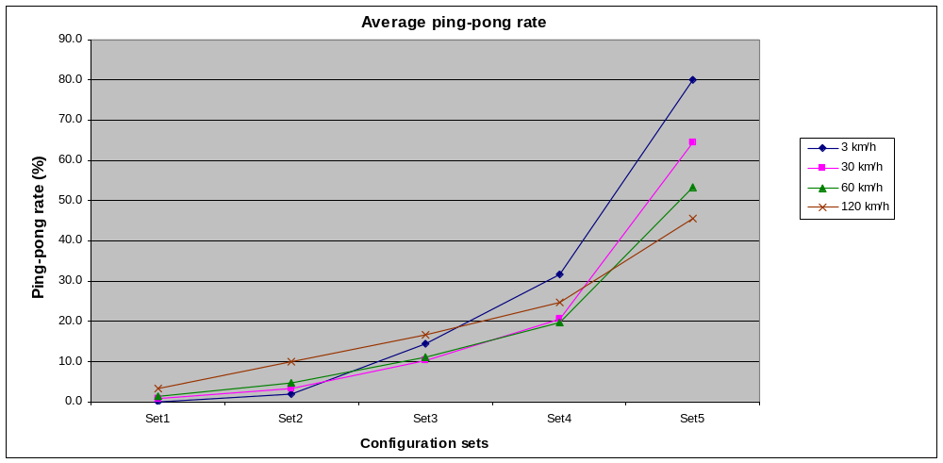
Figure 5.5.1.3.1: Average ping-pong rate curves.
From the simulation results, the following initial findings are observed:
The trend of average simulation results are as expected: the ping-pong rate is relatively high for low speed UEs with configuration set 5. While the ping-pong rate is relatively low for the low speed UEs with configuration set 1 & 2.
Note: the reason of the some of the differences is known. For example, there are some differences on CDF results due to that some companies does not log the ToS whenever the UE hits the bouncing circle while some other companies allow the ToS time continue running and log the ToS when there is bouncing. If when there is bouncing the ToS is still logged, very long unreal ToS could be logged.

5.5.2 Large area calibration
The calibration results averaged over the results from all the participating companies are captured in the following sections. The detailed calibration results from specific companies can be found in [9].

5.5.2.1 RLF performance for HetNet and legacy systems
Table 5.5.2.1.1: RLF performance for HetNet and legacy systems from calibration
 | State 1 | State 2_Normal | State 2_HOF | Overall
Average for HetNet | 0.000018 | 0.000001 | 0.003460 | 0.003477
Average for macro/macro only | 0.000013 | 0.000000 | 0.001223 | 0.001236

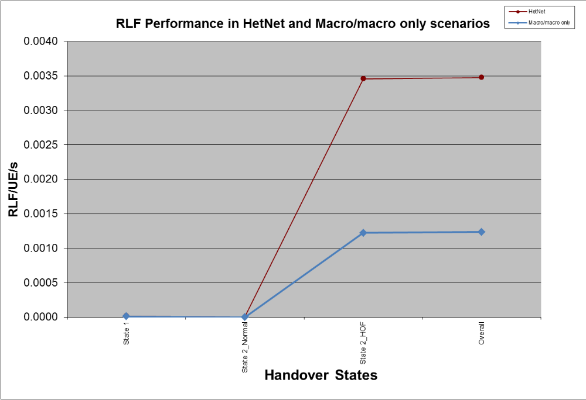
Figure 5.5.2.1.1: RLF performance for HetNet and legacy systems from calibration

5.5.2.2 Handover failure performance for HetNet and legacy systems
Table 5.5.2.2.1: Average Handover performance for HetNet and legacy systems from calibration
 |  | Handover performance in HetNets |  |  |  |  | legacy macro only system
Handover state | Handover metrics | macro-pico | pico-macro | macro-macro | pico-pico | Overall | macro-macro
2 | HOFs/UE/s | 0.000443 | 0.001544 | 0.001779 | 0.000009 | 0.003823 | 0.001772
2 | HO failure rate [%] | 3.718587 | 8.084919 | 2.681814 | 2.489887 | 3.747914 | 2.048109
3 | HOFs/UE/s | 0.000298 | 0.000110 | 0.000769 | 0.000012 | 0.000987 | 0.000539
3 | HO failure rate [%] | 0.971877 | 1.205913 | 0.780786 | 1.406523 | 0.808520 | 0.507133
Total | Successful HOs/UE/s | 0.013475 | 0.012736 | 0.072154 | 0.000237 | 0.098603 | 0.087906
Total | HOFs/UE/s | 0.000735 | 0.001622 | 0.002413 | 0.000021 | 0.004617 | 0.002234
Total | HO failure rate [%] | 4.675501 | 10.453351 | 3.461802 | 4.076629 | 4.629233 | 2.446505

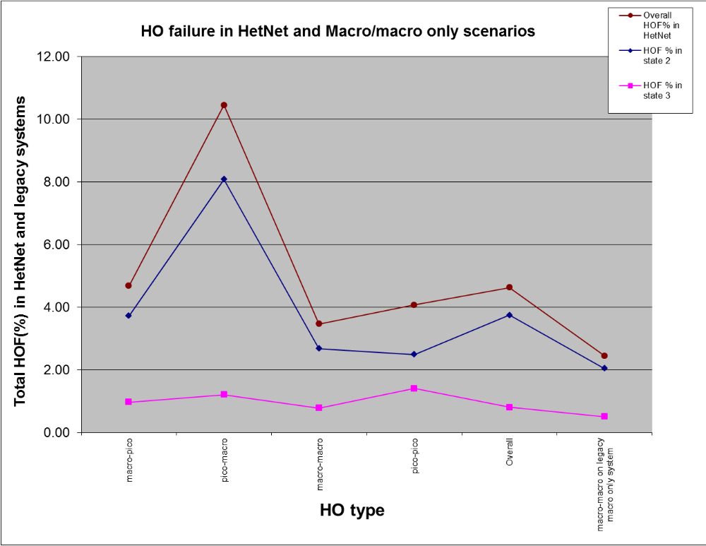
Figure 5.5.2.2.1: Handover failure (%) performance for HetNet and legacy systems from calibration
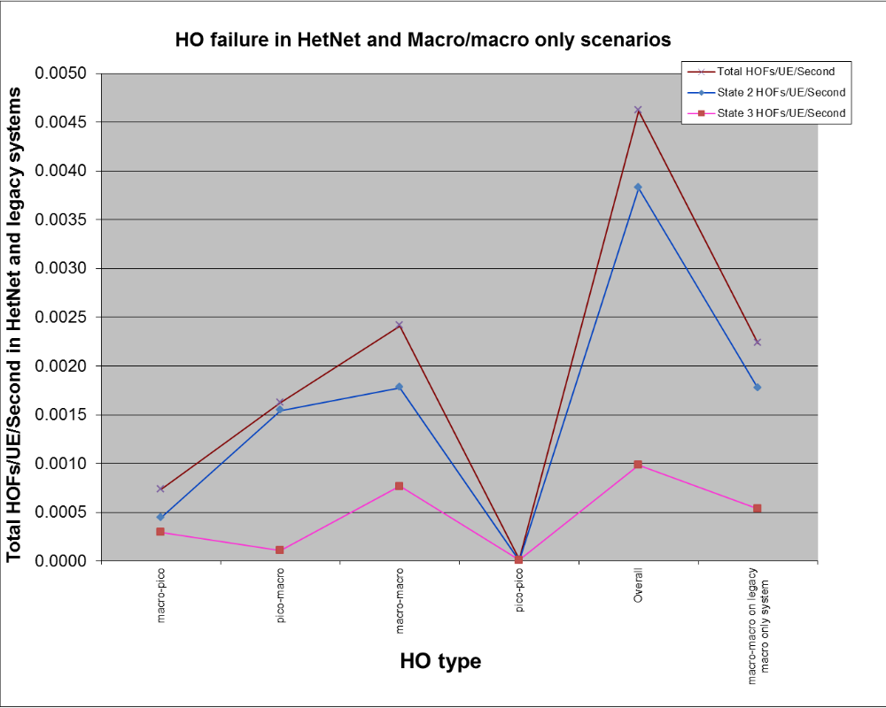
Figure 5.5.2.2.2: Handover failure (HOF/UE/second) performance for HetNet and legacy systems from calibration

5.5.2.3 Short Time of Stay performance
Table 5.5.2.3.1: Short Time of Stay performance for HetNet and legacy systems from calibration
 | HetNet (with mixed macros and picos) | legacy macro only system
Short ToS rate [%] | 16.851251 | 14.221092
Short ToS/UE/s | 0.016113 | 0.013471

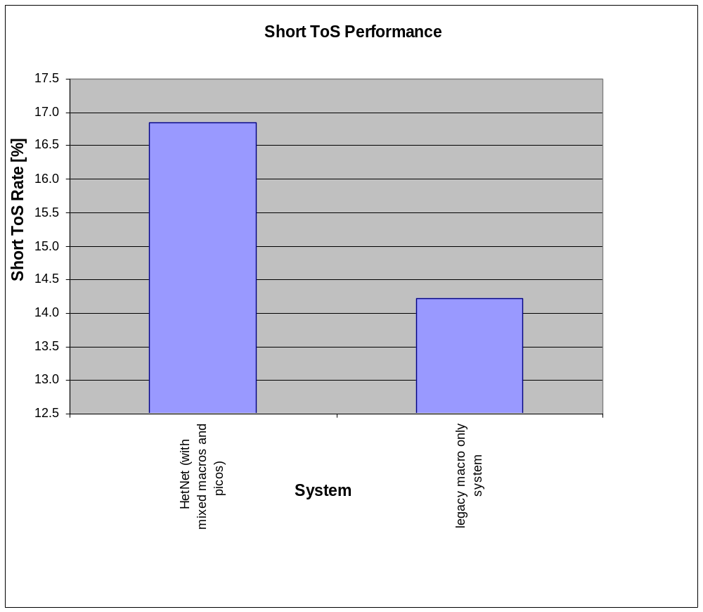
Figure 5.5.2.3.1: Short Time of Stay (rate) performance for HetNet and legacy systems from calibration
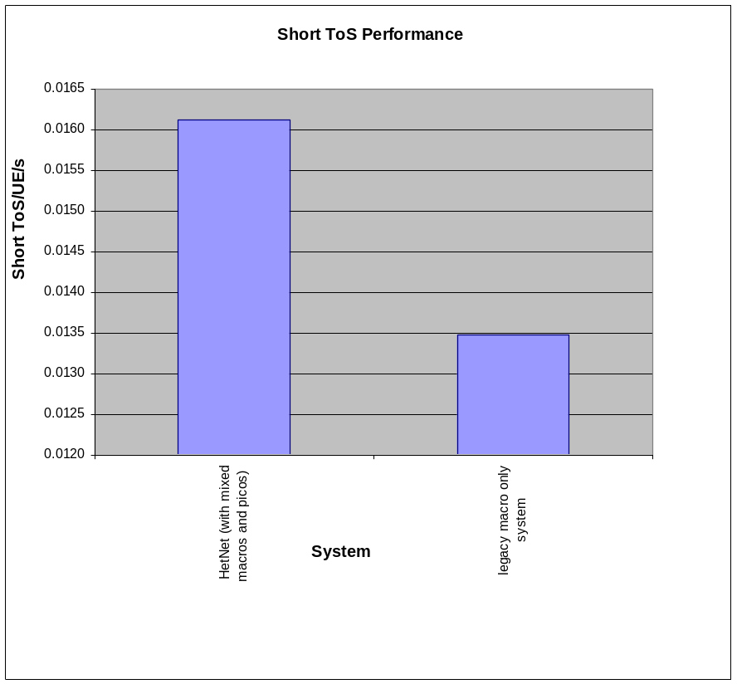
Figure 5.5.2.3.2: Short Time of Stay (ToS/UE/second) performance for HetNet and legacy systems from calibration

5.5.3 Overall observations from calibration simulations
The following observations are made from the overall calibration simulations:
1) Results indicate that handover performance in HetNet deployments is not as good as in pure macro deployments. Of the different HO types, Pico to Macro handover performance showed the worst performance.
2) For low mobility UEs (i.e., speed < 30km/hr), no significant problems have been observed in terms of HOF and loss of connectivity (some issues with Short ToS have been identified).

5.5.4 Multiple picocell deployments

5.5.4.1 Multiple picocell deployment under full system load
In this section, Handover performance in terms of HOF and Short ToS for multiple random pico cells deployments (with 1, 2, 4 and 10 pico cells per macro) is studied. Several contributions were provided in RAN2#78 and the following results are from Tdoc R2-122814 [15].With the exception of pico cell placement, the simulation assumptions are as in Table 5.2.3.1 and Table 5.2.4.1 using TU channel model, 500m ISD and 100% cell loading. Figures 5.5.4.1.1 to 5.5.4.1.4 show HOF and Short ToS for different UE speeds using several A3 offset and TTT configuration parameters including parameter sets for simulation calibration in Table 5.3.2.1.

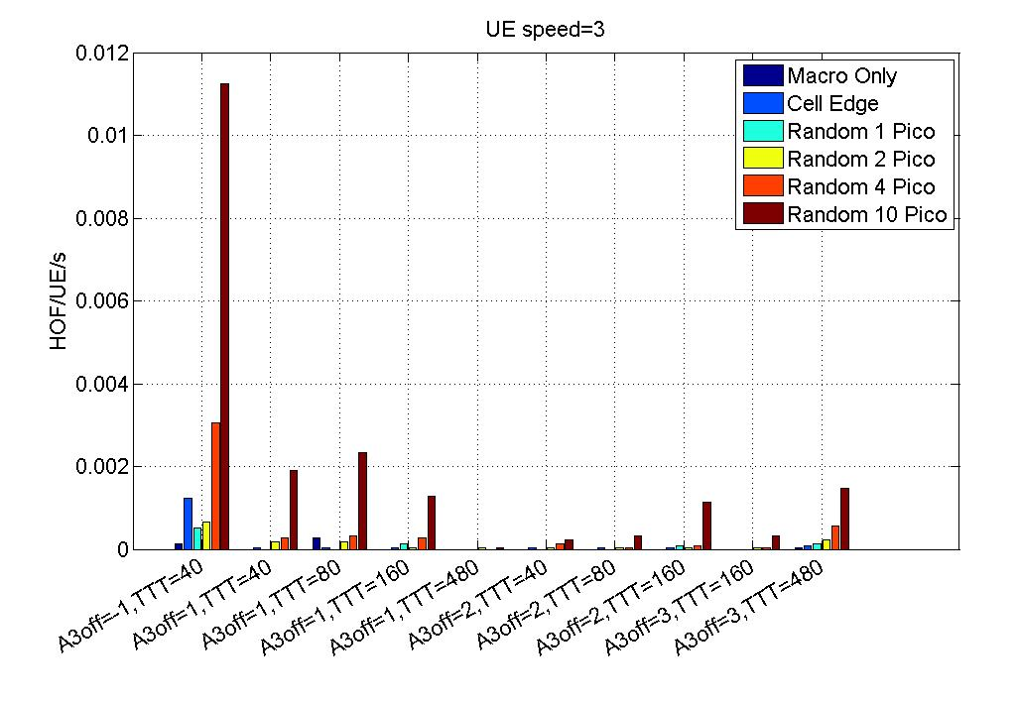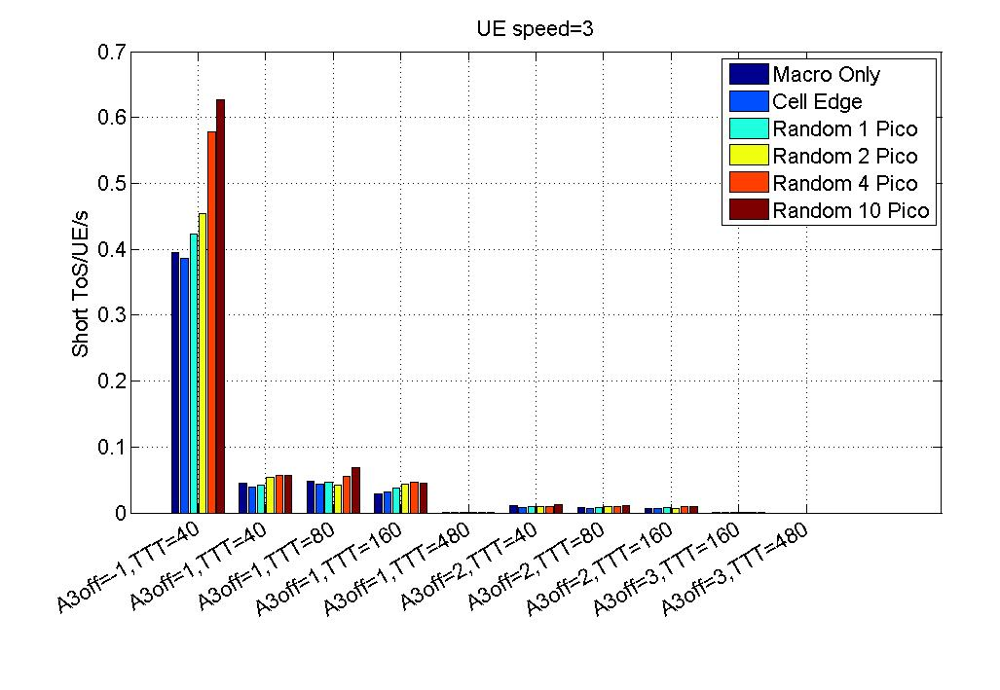
Figure 5.5.4.1.1: HOF and Short ToS for UE speed = 3km/h with different pico cell(s) placement.
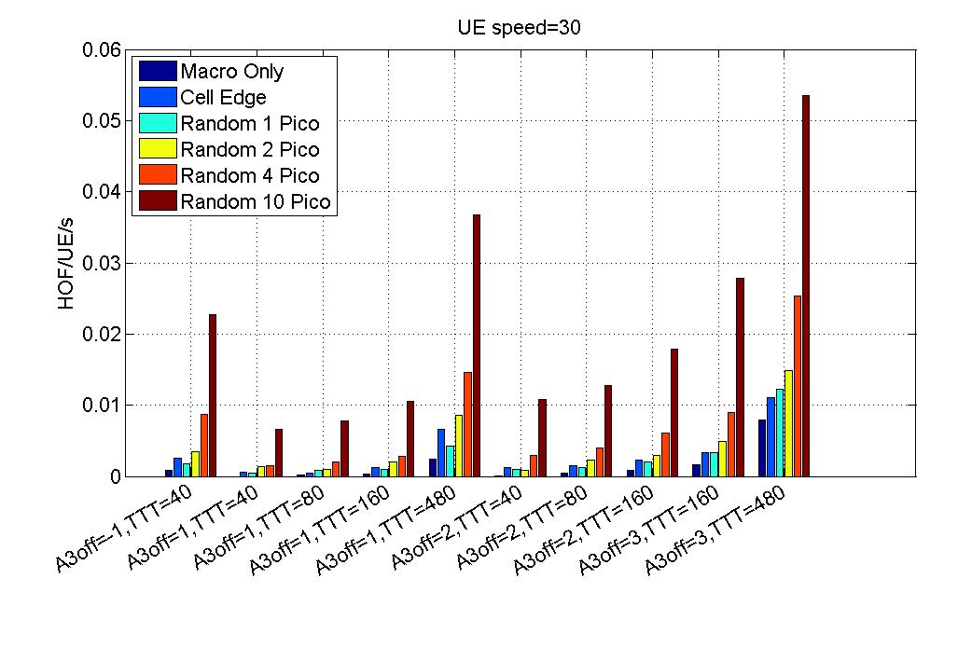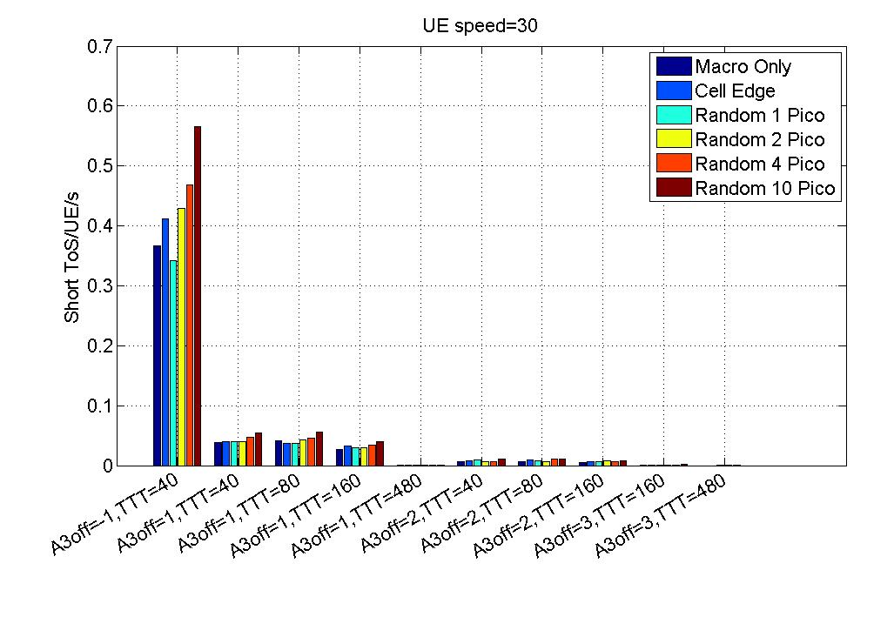
Figure 5.5.4.1.2: HOF and Short ToS for UE speed = 30km/h with different pico cell(s) placement.
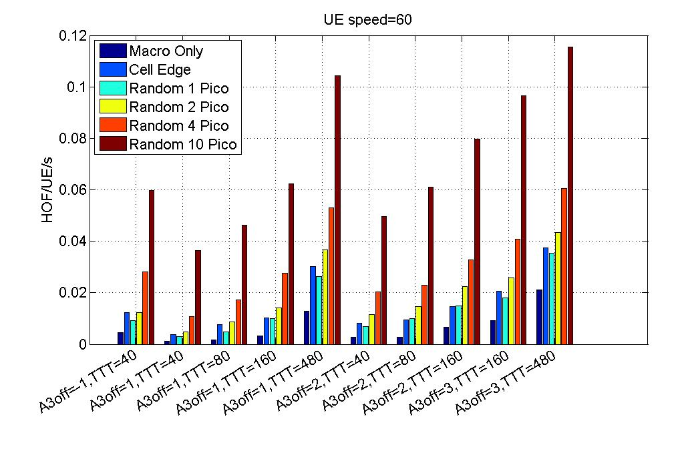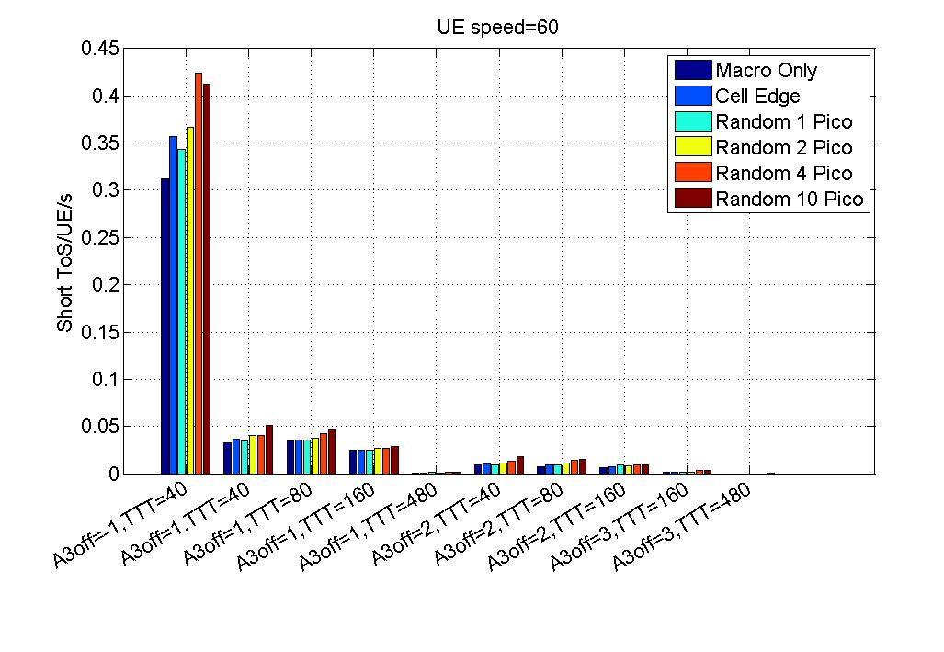
Figure 5.5.4.1.3: HOF and Short ToS for UE speed = 60km/h with different pico cell(s) placement.
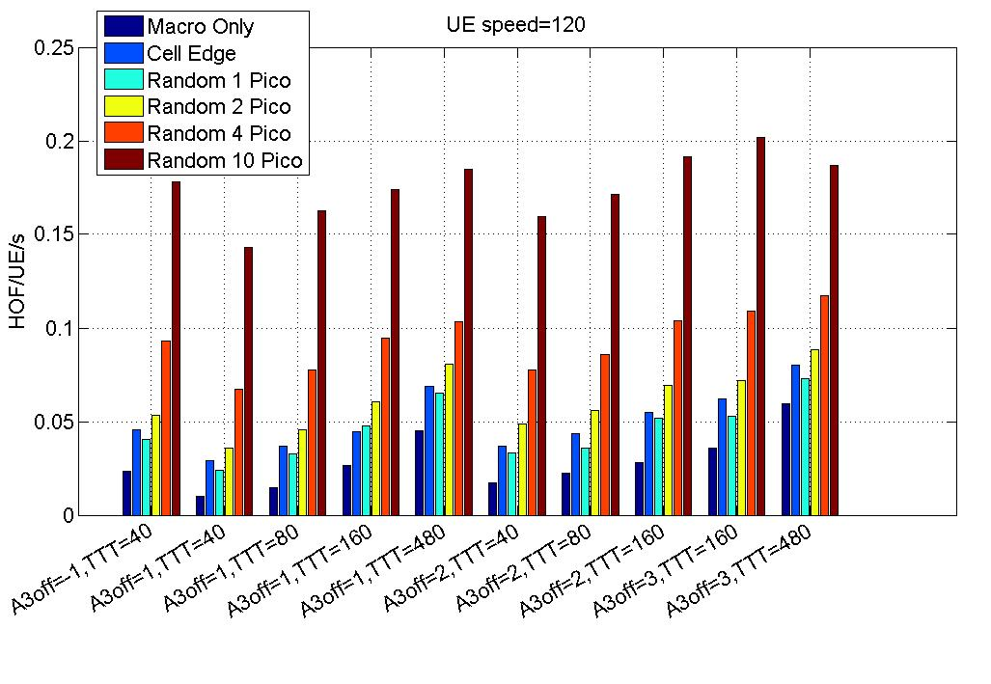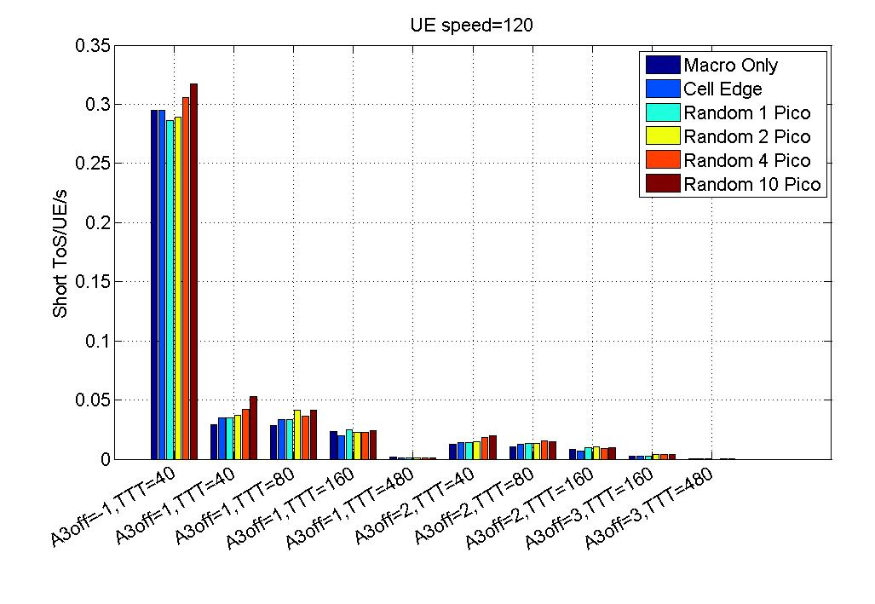
Figure 5.5.4.1.4: HOF and Short ToS for UE speed = 120km/h with different pico cell(s) placement.

5.5.4.1.1 Observations from Multiple picocell deployment simulations under full system load
Based on the simulation results provided above and the other contributions into RAN2#78, the following observation was made:
- For full system load with full buffer traffic model, the number of HOF/UE/s increases with the number of pico cells.

5.5.4.2 Multiple picocell deployment under constant system load
Investigation of the impact of varying the number of pico cells under a macro cell with constant system load was also done [13]. With constant system load, increase in the number of pico cells results in the system load being shared by all the cells and thereby reducing the load on the macro cell (i.e. cell loading is not 100%). In [13] a scenario involving two groups of users, where one is a static group of background users that were deployed along the edge of the macro cell and the second is a group of focus users that were randomly deployed and moving in straight lines in random direction at medium speed, were used. No DRX or eICIC were employed.

5.5.4.2.1 Observations from Multiple picocell deployment simulations under constant system load
It was also noted that in general better handover performance can be expected if the load in the system is lower. Therefore, at constant system load, addition of pico cells (that is, when more pico cells are added without any increase in oveall system load) may have a positive effect on the mobility performance if their deployments result in reducing the load per cell and thereby reducing the interference and the number of HOF/RLF.

5.5.5 Performance with DRX
Simulations were provided by many companies on HetNet mobility performance with DRX in RAN2#77bis. For a relative comparison, mobility performance with DRX in a macro-only system was also evaluated. The results were provided for several DRX settings and UE speeds and also for different HO types.

5.5.5.1 Simulation study for Handover and RLF performance with DRX for HetNet relative to macro only systems
This section includes the results from one of the Tdoc R2-121660 [10] on relative comparison of macro only systems with HetNet.

5.5.5.1.1 Simulation assumptions and definitions
Basic radio configurations are as given in Table 5.2.3.1 for the HetNet mobility simulation. Configuration set 3 given in Table 5.3.2.1: Configuration parameter sets for simulation calibration is used. The simulation scenario was the HetNet scenario but without the PDCCH failure model. Instead, the sending of HO command and measurement reports were modelled realistically (i.e. sent as RRC PDUs). The full model for this is described in Section 3.5 of Tdoc R2-120348 [11]. 300 UEs were distributed in the simulation area at the beginning of the simulation. UE velocities 30 km/h, 60 km/h and 120 km/h were considered in different DRX simulation cases.
The traffic model and DRX parameters are listed in Table 5.5.5.1.1.1. The UE traffic profile was a background traffic profile consisting of single packet data bursts with mean inter-arrival rate of 3.4 seconds and mean packet size of 170 bytes. Since the traffic profile results in rather infrequent packet transmissions, the calls were configured to be very long to accommodate the “always-on” type of application paradigm. The traffic would not cause much load to the network, and therefore, all sites were configured with enough background traffic so that each site was fully loaded to produce an interference-limited simulation scenario.
The long DRX cycle length parameter varied from 80 to 640 TTI. The short DRX cycle length was configured to 40 TTI cycle and the time duration to follow the short DRX pattern was ½ of the long DRX cycle length after the last received data packet. The on duration timer in all DRX cases was set to 5 TTIs and the inactivity timer was set to 10 TTIs. RLF Qin and Qout windows were scaled according to the DRX cycle length as described in TS 36.133 [2]. Cell detection and intra-frequency neighbour cell measurements were done once per DRX cycle during the On duration. Note that during the long DRX e.g., cycle length > 40ms, the periodicity of the intra-frequency measurements depends upon the DRX cycle in use as specified in TS 36.133 [2].
In this simulation, the handover success rate is defined by dividing the total number of successful handovers with the total number of handover attempts. Since RLFs were observed to occur only in the handover situations the total number of handover attempts consists of successful handovers and RLFs.
Table 5.5.5.1.1.1: Traffic model
Feature/Parameter | Notes | Value/Description
UE traffic model | Estimated from trace measurement | Fitted single distribution
Packet inter-arrival rate [s] | Geometric distribution | mean 3.41 seconds
Packet size [B] | Geometric distribution | mean 170 B
A3 margin [dB] | UE measurement reporting parameters | 2 dB
A3 time to trigger [ms] | UE measurement reporting parameters | 160 ms
L3 filtering (coefficient) | UE measurement reporting parameters | k=1
Long DRX cycle length [ms] | DRX configuration parameters | 80, 160, 320, 640
Short DRX cycle length [ms] | DRX configuration parameters | 40
Short DRX cycle duration [ms] | DRX configuration parameters | 1/2 of the long DRX cycle length.
OnDuration timer [ms] | DRX configuration parameters | 5
Inactivity timer [ms] | DRX configuration parameters | 10

Other parameters differing from the assumptions provided in section 5.2:

Feature/Parameter | Notes | Value/Description
Pico cell layout | Distance to eNB | 250m in boresight direction
UE placement | Proportion of UEs placed inside the pico hotspot(s) for each cell | 1
RSRP Measurement | L1 measurement period  Measurement bandwidth  Measurement error standard deviation  L1 sliding window size | 40 ms  6 RBs  2 dB  5
Number of calls/simulation |  | 300 calls, maximum call length 3 minutes.

5.5.5.1.2 Simulation results with DRX for HetNet relative to macro only systems
Numbers of RLF and handover events per UE per second for a macro-only scenario are shown in Figures 5.5.5.1.2.1 and HetNet scenario performance is in Figure 5.5.5.1.2.2.
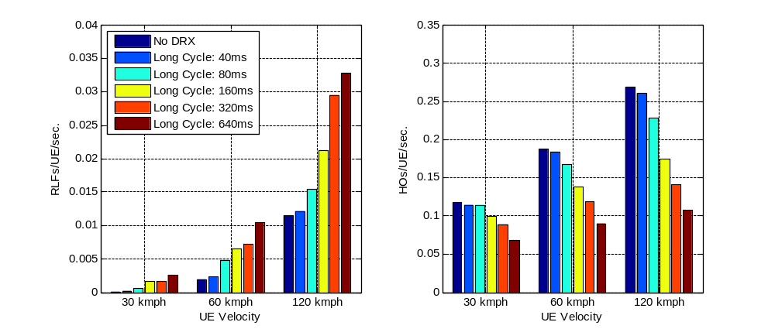

Figure 5.5.5.1.2.1: Handover and RLF events in Macro scenario
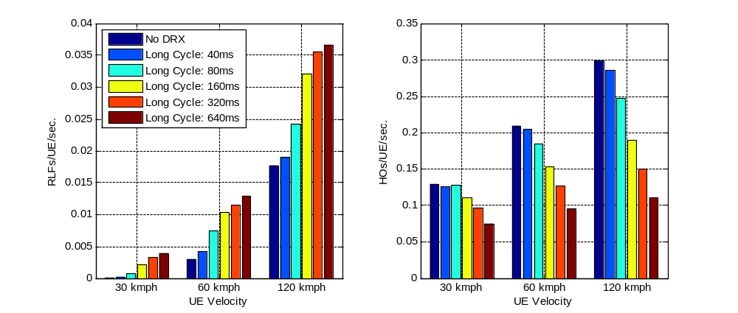
Figure 5.5.5.1.2.2: Handover and RLF events in HetNet scenario
Handover success rate results in Macro and HetNet scenario are shown in Figures 5.5.5.1.2.3 and Figure 5.5.5.1.2.4 respectively.
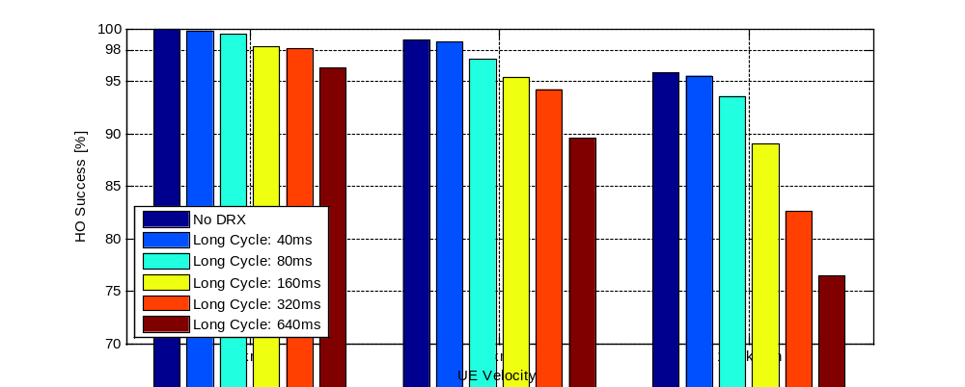
Figure 5.5.5.1.2.3: Handover success rate in Macro scenario
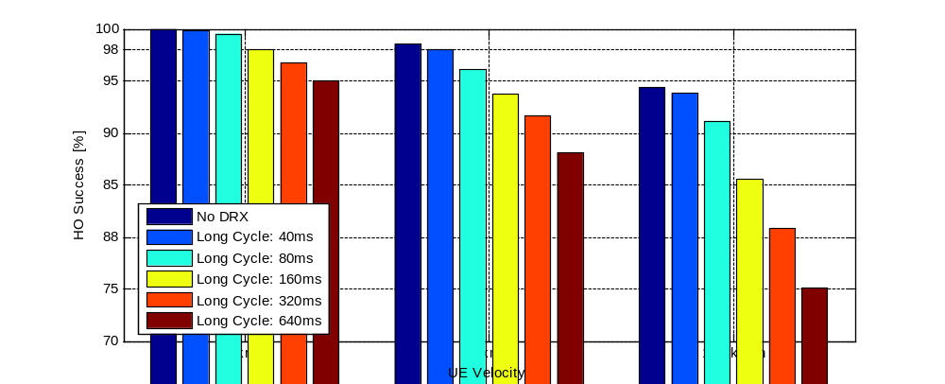
Figure 5.5.5.1.2.4: Handover success rate in HetNet scenario

5.5.5.2 Simulation study for Handover and RLF performance with DRX for different HO types in HetNet
This section includes the results from one of the Tdoc R2-121163 [12] on Handover and RLF performance in HetNet with DRX for the different HO types. The simulation assumptions for these results is given below and they differ from the ones used in the previous section 5.5.5.1.

5.5.5.2.1 Simulation assumptions and definitions
Configuration set 3 given in Table 5.3.2.1 for simulation calibration is used.
The used simulation scenario has been similar to the large area scenario with wrap-around specified in configuration set 3 given in Table 5.3.2.1: Configuration parameter sets for simulation calibration is used. Also basic radio configuration parameters have been adapted. The detailed simulation assumptions and settings are listed in table 5.5.5.2.1.1. The simulation shown in this paper includes the simulation case where there is no data transmission except what is needed for control signalling for mobility – i.e. looking only at mobility. The network is fully loaded regardless of the minimal transmission for the DRX users to investigate worst case scenario interference wise.
Although the scenario and parameters have been adapted from [9], the modelling of RRC messages, re-establishment and handover failure has been enhanced with details provided in Table 5.5.5.2.1.2.
In the simulations three different measurement reporting parameters were used:
1) Baseline scenario uses the same handover parameters in all cells (Macro and Pico cells) used in the deployment (Baseline),
2) Two cell specific scenarios using different handover parameters depending on whether the serving cell is a Macro cell or whether the serving cell is a Pico cell (Cell type specific 1 and 2).
Table 5.5.5.2.1.3 illustrates the different parameters settings used.

Table 5.5.5.2.1.1: Traffic model
Feature/Parameter |  | Value/Description
DRX | Long cycle length  Short cycle length  Short cycle duration  Inactivity timer  On duration timer | 80, 160, 320, 640, 1280, 2560 ms  40 ms  ½ long cycle length (max 640 ms)  10 ms  5 ms
Handover parameters | Handover criteria  A3 baseline offset  A3 baseline time-to-trigger | Event A3 RSRP  2 dB  160 ms
Traffic parameters | Traffic type “keep-alive”:  Packet interval | Constant 20 seconds
Bandwidth |  | 10 MHz
IFFT/FFT length |  | 1024
Duplexing |  | FDD
Number of sub-carriers |  | 600
Sub-carrier spacing |  | 15 kHz
Resource block bandwidth |  | 180 kHz
Sub-frame length |  | 1 ms
Reuse factor |  | 1
Number of symbols per TTI |  | 14
Number of data symbols per TTI |  | 11
Number of control symbols per TTI |  | 3
3GPP Macro Cell Scenario | Cell layout | 57 sectors/19 BSs
 | Inter site distance (ISD) | 500 m
Pico cell layout | Distance to eNB | 0.5 ISD
 | Location | Bore sight location
 | Picos/macro cell | 1
Macro-pico deployment type |  | Intra-frequency
Distance-dependent path loss | Macro cell model (TS 36.814, Model 1) | 128.1 + 37.6log10(r)
 | Pico cell model (TS 36.814, Model 1) | 140.7 + 36.7log10(r)
BS Tx power | Macro  Pico | 46 dBm  30 dBm
Shadowing standard deviation | Macro  Pico | 8 dB  10 dB
Shadowing correlation between cells/sectors |  | 0.5 / 1.0
Shadowing correlation distance | Macro  Pico | 25 m  25 m
Multipath delay profile |  | Typical Urban
UE velocity |  | 3, 30 km/h
RSRP Measurement | L1 measurement cycle  Measurement bandwidth  Measurement error standard deviation  L1 sliding window size  L3 filtering | 40 ms or DRX cycle length  6 RBs  2 dB  5  Disabled
Handover preparation time |  | 50 ms
Handover execution time |  | 40 ms
Radio link failure monitoring | Qout threshold  Qin threshold  T310 | -8 dB  -6 dB  1000 ms
Cell identification |  | Enabled
Receiver diversity |  | 2RX MRC
Number of calls |  | 1000 of 140 second calls
DL Interference load | Macro, Pico | 100% RBs loaded

Table 5.5.5.2.1.2: Other parameters differing from the assumptions provided in section 5.2
Feature/parameter | Differences:
Radio link failure:  Detection  Action | Same modelling for detection thresholds  UE remains in simulation and RRC re-establishment procedure is attempted
Handover failure:  Detection  Action | RLF during handover process  UE remains in simulation and RRC re-establishment procedure is attempted after RLF
HO command:  Retransmissions  Failure | Both HARQ and RLC retransmissions modelled with maximum of 7 HARQ and 3 RLC retransmissions  Maximum number of RLC retransmissions reached
Measurement report:  Retransmissions  Failure | Both HARQ and RLC retransmissions modelled with maximum of 7 HARQ and 3 RLC retransmissions  Maximum number of RLC retransmissions reached
PDCCH:  Failure | Link level tables used in RRC message transmission process for PDCCH detection/failure

Table 5.5.5.2.1.3: Different Measurement Reporting parameters used
Parameter sets | Parameters when serving cell is Macro cell | Parameters when serving cell is Pico cell
Baseline:  (TTT:160 Offset:2) | Time-to-trigger: 160 ms  A3 offset: 2dB | Time-to-trigger: 160 ms  A3 offset: 2dB
Cell type specific 1:  (CTSTTT:40 CTSOffset:0) | Time-to-trigger: 160 ms  A3 offset: 2dB | Time-to-trigger: 40 ms  A3 offset: 2dB+0dB = 2dB
Cell type specific 2:  (CTSTTT:40 CTSOffset:-4) | Time-to-trigger: 160 ms  A3 offset: 2dB | Time-to-trigger: 40 ms  A3 offset: 2dB-4dB = -2dB

5.5.5.2.2 Simulation results with DRX for different HO types in HetNet
Handover failure rate is for pico to macro handovers is shown in Figure 5.5.5.2.2.1.
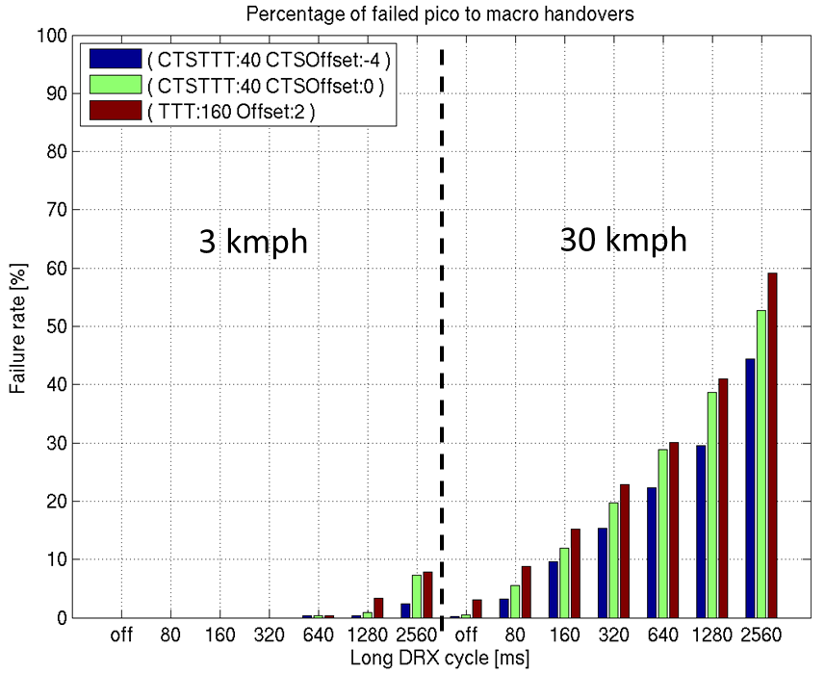
Figure 5.5.5.2.2.1: Handover failure rate in pico to macro mobility
In Figure 5.5.5.2.2.2 a comparison of handover failure rates is shown for different cell types. The parameters here are the same except for the short cycle duration, which is here 640 ms regardless of the long cycle length. Handover setting in these cases is baseline with TTT 160 ms and A3 offset of 2 dB for all cells.

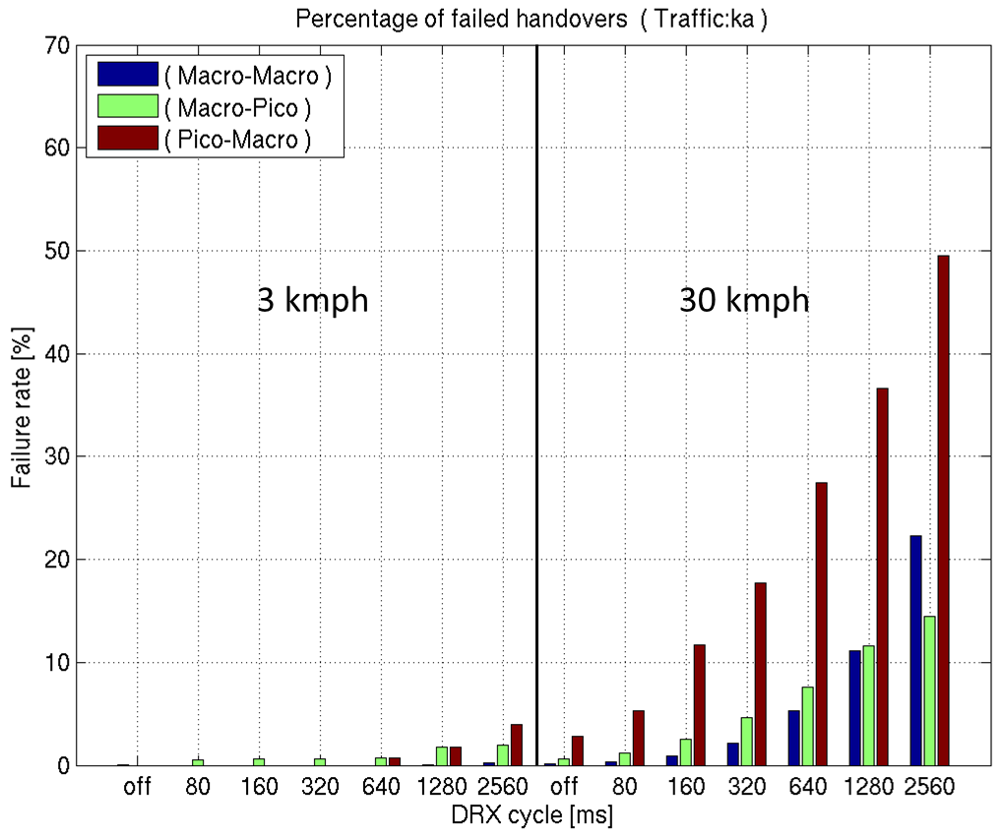
Figure 5.5.5.2.2.2: Handover failure rate between different cell types

5.5.5.3 Overall observations on Handover performance in HetNet with DRX
For this Study item, slightly higher HOF rates in HetNet, relative to macro-only scenarios, at least for background traffic, are considered acceptable. The following observations were reached with respect to HO performance for HetNets with DRX:
1) The simulations indicate that for low speed UEs (3 km/h) acceptable HO performance rates can be ensured at least for background traffic in HetNets if the network avoids too long DRX settings inside pico cells.
2) In general while longer DRX combined with higher UE velocity provides challenges to mobility robustness, adding small cells in combination with longer DRX, even medium velocity provides challenges to mobility robustness especially for pico outbound mobility.
Simulations showing UE power consumption were also discussed in many Tdocs in RAN2#77bis. They showed that:
1) DRX is essential for battery saving and doubling the DRX cycle almost halves the power consumption for keep-alive traffic with 20s inter-arrival time. However, no significant differences between battery saving in DRX in HetNet and macro-only scenarios was observed for the same DRX parameters (e.g., in Tdoc R2-121660 [10]).
2) Simulation results also show that Ping-pong rates are lower with DRX and that there is a trade off between amount of Ping-pongs and aggressive handover parameter use.

5.5.6 Performance with eICIC
Impact of eICIC/CRE was studied through simulations. An example set of simulation results from R2-122804 [14] is captured below. Simulations results from other companies have shown similar trends and were considered to provide the same observations in terms of the eICIC/CRE impact on HetNet mobility performance.

5.5.6.1 Simulation assumptions
The basic simulation assumption used is as captured in Table 5.2.3.1 with ISD of 500m and Table 5.5.6.1.1, which is almost in line with the basic configuration described in Table 5.2.4.1, but some specific configuration set (e.g. channel model, Pico cell placement) was selected.
Table 5.5.6.1.1: RRM/RLM configurations
Items | Description
Pico cell placement | Random placement, one per sector, as per TR 36.814
Cell loading | 100%
UE speed | 30km/h
Channel model | TU (fast fading included)
TimeToTrigger [ms] | 160
A3-offset [dB] | 2
T_{Measurement_Period, Intra,} L1 filtering time in TS36.133 | 200ms
Layer3 Filter Parameter K | 1
measurement error modelling | To obtain the 90% bound for +/- 2 dB, a normal distribution with deviation = 2 dB / (sqrt(2)*erfinv(0.9)) = 1.216 dB can be used (ref: TS36.133 [2])
Handover preparation (decision) delay | 50ms
Handover execution time | 40ms
Two different ABS configurations for eICIC as described below were looked at but it is to be noted that ABS patterns were not explicitly modelled in the simulation.
Ideal ABS coordination (denoted as “perfect eICIC” in the figures):
The ABS patterns of all the macro cells are synchronized in time, i.e. the ABS from all macro cells occur at the same subframes and all the macro cells are subframe-aligned. It is assumed that a UE served by a pico cell does not observe interference from any macro cell in terms of radio link monitoring (i.e. RLM pattern is assumed to be configured and no CRS collision between macro and pico cells is assumed).
Non-ideal ABS coordination (denoted as “imperfect eICIC” in the figures):
The ABS patterns of the macro cells are not synchronized in time. The ABS from the overlay macro cell is assumed to protect a pico UE from the interference of the overlay macro cell only. Thus the radio link monitoring of the pico UE is affected by interference from all other neighbour macro cells.

5.5.6.2 Simulation results
Simulation results for RLF events, HOF events, HOF rates, short ToS events, and short ToS rates are shown in Figure 5.5.6.2.1, 5.5.6.2.2, 5.5.6.2.3, 5.5.6.2.4, and 5.5.6.2.5 respectively.
It can be seen that in comparison to the baseline HetNet without eICIC, the eICIC with ideal ABS coordination can improve mobility performance across different CRE bias values. The performance gain increases as CRE bias becomes larger. It has been observed (e.g. in R2-122726 [16]) that with eICIC the reduced interference from macro cells improves the pico-to-macro handover performance due to the HO command being more reliably delivered from the source pico cell. The reduced interference also improves the macro-to-pico handover performance due to the more reliable RACH process to the target pico cell.
The eICIC with non-ideal ABS coordination can also reduce RLF and HOF events when CRE bias is smaller. However when CRE bias is larger (i.e. 4 or 6 dB), the mobility performance becomes worse than that of the baseline HetNet without eICIC. It is considered that the performance degradation is due to increased interference from macro cells that the UEs in pico cells would experience in the CRE region with large bias.

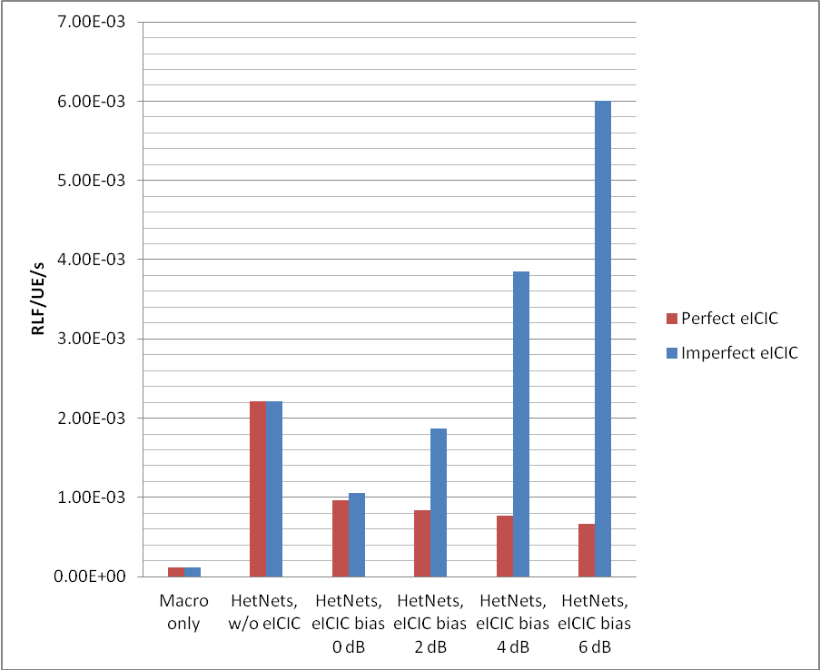
Figure 5.5.6.2.1: RLF events

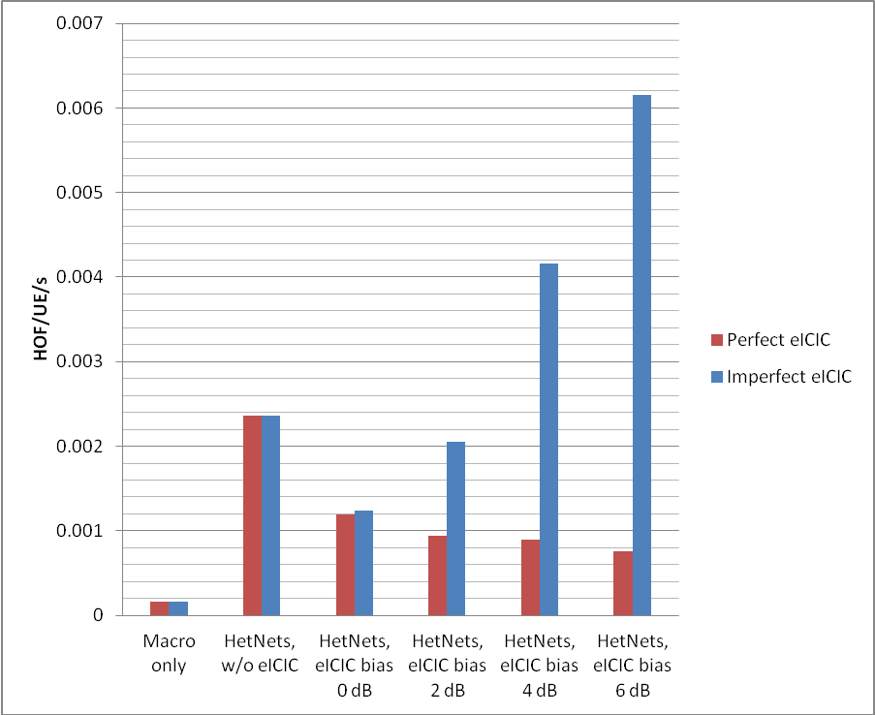
Figure 5.5.6.2.2: HOF events
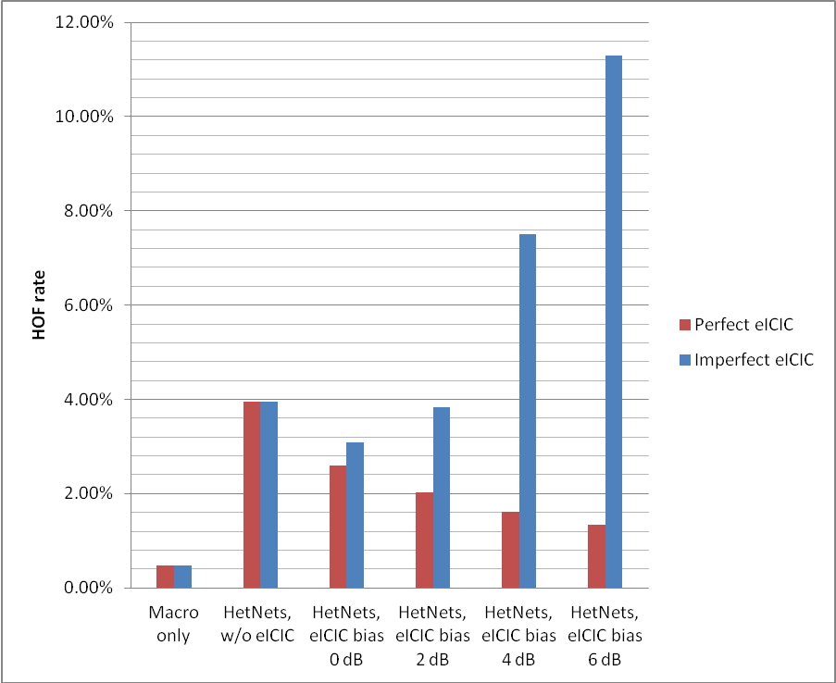
Figure 5.5.6.2.3: HOF rate

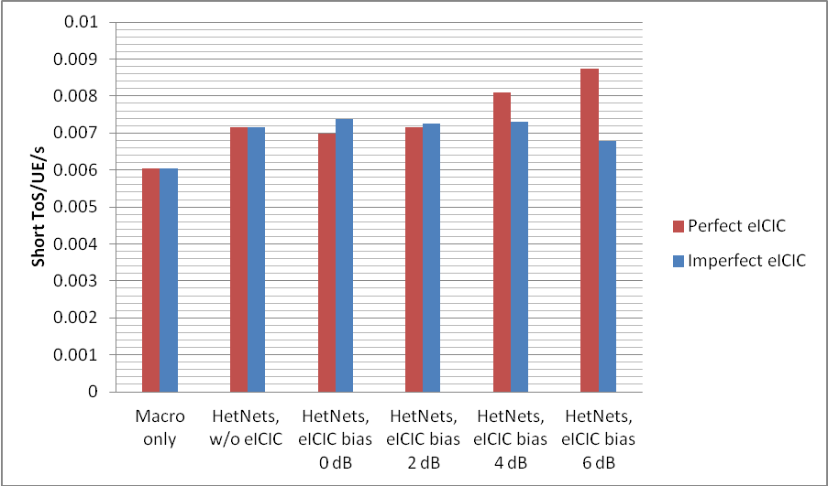
Figure 5.5.6.2.4: Short ToS events

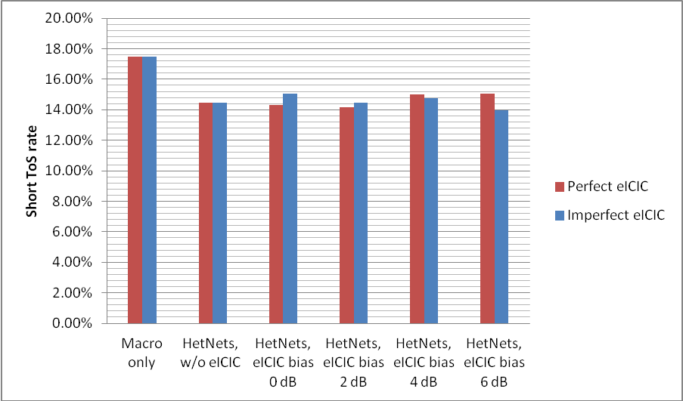
Figure 5.5.6.2.5: Short ToS rate

5.5.6.3 Conclusions on mobility performance with eICIC
Based on the study, the following conclusions were reached on HetNet mobility performance with eICIC.
1) eICIC (Time domain resource partitioning based on ABS) with 0dB CRE bias does not cause a negative effect on mobility performance in HetNet
2) eICIC can improve mobility performance in HetNet when ideal ABS pattern coordination among macro cells is used even with a large CRE bias (e.g. 6dB)
3) Use of a large CRE bias (e.g. 6dB) with non-ideal ABS pattern coordination among macro cells can lead to mobility performance degradation
4) Even with ideal eICIC the mobility performance in HetNet is not as good as macro only network.
NOTE 1: The non-ideal ABS coordination assumption used in the current simulation is just a special case. Other different cases of non-ideal ABS coordination and CRS collision modelling are not represented by the results.
NOTE 2: The simulation has been focused on mobility performance, with simplification on the modelling of load and PDCCH transmission/reception. The impact of the number of UE in the system does not get reflected in the amount of control resource required to send their PDCCH. For example, the blocking issue of PDCCH transmission is not examined with respect to the amount of ABS allocated in the simulation. In addition, the loss of throughput due to the use of ABS is not modelled either, for example 0dB CRE would result in capacity loss at macro without pico offloading gain.
NOTE 3: In the simulations, the CRS interference from the macro cells during ABS was not modelled.
NOTE 4: DRX was not used in these simulations.

5.6 Performance benefits of enhanced UE mobility state estimation

5.6.1 Mobility speed estimation
This section considers the distribution of Mobility Speed Estimation (MSE) counter values in a regular macro-only and HetNet network. An MSE observation window, TCR_{max}, of 120 s is used in the simulations (Tdoc R2-124027 [31]). The simulation parameters when different from those in tables 5.2.3.1 and 5.2.4.1 are also given in Table 5.6.1.1.
Table 5.6.1.1: Summary of Mobility related simulation parameters for the MSE
HO Parameter | Value
Time To Trigger (TTT) | Dynamic, 480 ms in normal Mobility
TTT Scaling factors | Sf_medium = 0.5, sf_high = 0.25
N_CRMedium, limit to enter medium state for macro only scenario | 7
N_CRHigh, limit to enter high state for macro only scenario | 13
N_CRMedium, limit to enter medium state for HetNet scenario | 10
N_CRHigh, limit to enter high state for HetNet scenario | 16
T_CRmaxHyst, hysteresis back to normal state | 0s (demonstrate the immediate impact of enhanced MSE)
A3 Offset | 3 dB Macro and Pico
Ping-Pong-Time | 1 s
Measurements Rate | 0.2 s
HO Execution Time (including Preparation) | 0.15 s
RSRP error – zero mean Gaussian | 1 dB std
Filtering Factor K | 4
RLF: Qout Threshold | - 8 dB
RLF: Qin Threshold | - 6 dB

The Figure 5.6.1.1 and Figure 5.6.1.2 (Tdoc R2-124027 [31]) show the distribution of MSE counter in macro-only and HetNet network respectively for MSE window (TCR_max) of 120s.

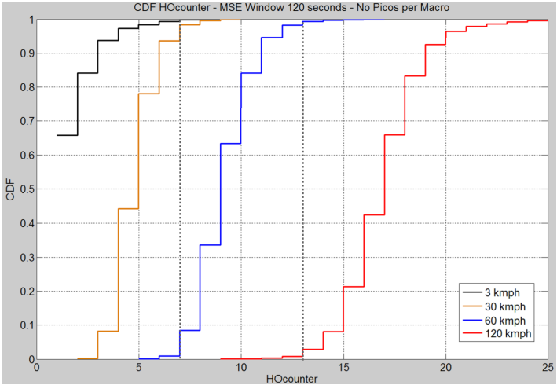
Figure 5.6.1.1: Distribution of MSE counter in macro-only network for MSE observation window TCR_{max} of 120s. The dotted lines illustrate example mobility state thresholds.

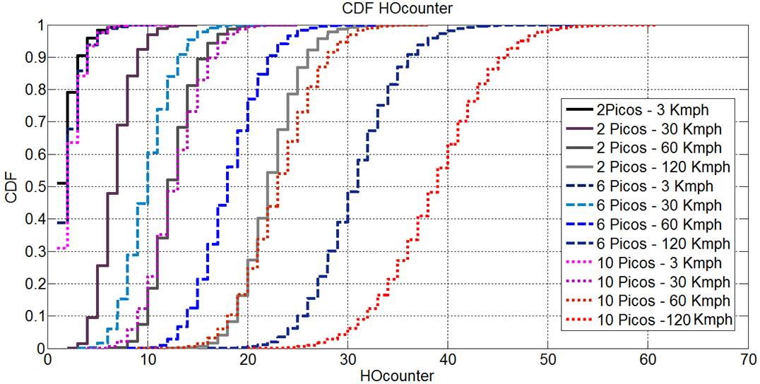
Figure 5.6.1.2: Distribution of MSE counter in HetNet network with different number of picos for MSE observation window TCR_{max} of 120s.
As can be seen in Figure 5.6.1.1, in the macro only network the MSE performs well, and there is good correlation between MSE count and speed of movement. Here it is easy to choose appropriate MSE thresholds, N_CRMedium and N_CRHigh, for MSE function to distinguish the UE mobility states. But, in a heterogeneous network (Figure 5.6.1.2) using the current MSE algorithm produces an MSE event count that is positively biased by the density of pico cells. That is, MSE count for a given UE speed increases with increase in number of pico cells. In HetNet with cells of different cell sizes and varying pico cell densities it is challenging to find one set of appropriate MSE thresholds that would accurately work for different HetNet deployments.

5.6.2 Overall observations on Mobility speed estimation
On mobility state estimation (MSE) and its impact on mobility performance, it was observed that the MSE is not as accurate in HetNet environments as in macro only deployments since it does not take into account cell sizes.
It was however agreed that possible enhancements to the UE-based MSE should serve the purpose of enhanced mobility performance (not only for the sake of enhancing the MSE estimate). There is consensus that enhancements should be considered to improve the mobility performance of HetNet. This includes UE and network based mechanisms.

6 Strategies for improved small cell discovery/identification

6.1 Deployment scenarios
Small cells can be deployed for various reasons, resulting in a heterogeneous network comprising small cells of different sizes/types (e.g. micro, pico, femto). One expected scenario is the offloading of users from macro layer to small cell layer where the macro layer and small cell layer are on different carrier frequencies. The study focussed on a scenario where one macro frequency provides full coverage and where pico cells are provided on second frequency layer for offloading purposes including means to improve perceived QoS on hot spot locations. For inter-frequency small cell detection, the study will focus on the following use case where the UE does inter-frequency small cell measurements for a carrier that is expected to have non-uniform coverage (e.g. hotspot deployment) for offloading/load balancing purposes.

6.2 Objectives for inter-frequency small cell measurements
The objective is to optimize the data offloading potential (e.g. maximize the amount of data that is transmitted in pico cells rather than in macro cells; maximize the time a UE stays out of the macro cell) with the following criteria:
Criteria 1) UE power consumption for inter-frequency small cell measurements in HetNet deployments should be minimised.
Criteria 2) Any interruptions on the serving cell(s) due to inter-frequency small cell measurements should be minimised.
Criteria 3) Inter-frequency mobility performance should not be degraded by measuring inter-frequency small cells.
Criteria 4) Mobility performance of legacy UEs should not be degraded to improve inter-frequency small cell detection by Rel-11 UEs.
The impact to UE power consumption depends on how often and for how long a UE performs inter-frequency measurements. The study evaluates, in particular, UE power consumption relative to how much offloading opportunity and QoS benefit is lost e.g., due to delayed detection of the small cell.
The study also investigates whether the same findings apply also to detection of candidate SCells on the second frequency layer.
Enhancements were evaluated against mechanisms that can be realized with available functionality.

6.3 Analysis of existing inter-frequency measurements
In the target use case described in Section 6.1, small cells provide hot spot coverage overlapping with macro cells providing continuous coverage. Since the UE would not know when the small cell coverage is available, the UE may always have to do inter-frequency measurements for identifying small cells. If the UE is always required to perform measurements, significant UE power consumption is expected. Figure 6.3.1 shows simulation results on 95th percentile energy used for inter-frequency small cell measurements [19]. If the existing gap pattern (e.g., 6ms measurement gap every 80ms period) is applied, approximately 1000J energy consumption is observed when the number of measured cells is less than 20.

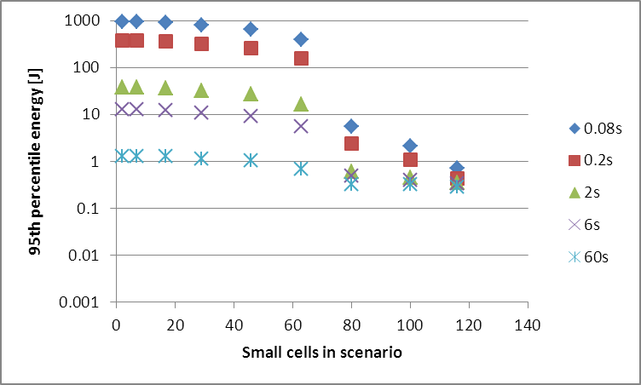
Figure 6.3.1: Energy used on small cell scan as a function of amount of small cells in 14 hours [19].
The following conclusion was drawn from the study on inter-frequency small cell discovery:
1) It was concluded that continuously performing measurements according to existing performance requirements results in very high battery consumption without showing significant impact on offloading potential.

6.4 Potential enhancements for improved small cell discovery/identification

6.4.1 Solution 1: Longer measurement period [20]
Longer measurement period is applied for inter-frequency small cell measurements.

6.4.2 Solution 3: Relaxed side condition [23]
Side conditions for measurements, such as SCH_RP, SCH Ês/Iot, RSRP and RSRQ Ês/Iot can be relaxed for small cell measurements.

6.4.3 Solution 9: UE MSE based measurements [21,32]
Fast-moving UE (high and possibly medium mobility state) may suspend inter-frequency measurements that are configured for offloading/load balancing purposes.

6.4.4 Solution 10: Small cell signal based control of measurements [22]
If UE detects a sufficiently strong small cell (stronger than a signal quality threshold configured by the network), it can suspend inter frequency search of other small cells. If the small cell becomes weaker, the UE would resume inter-frequency search of other small cells whereas the search for the frequency of the found small cell would be less frequent.

6.4.5 Solution 4: Measurements without gap assistance [23]
For Carrier Aggregation cases, measurements without gap assistance are mandated for CA capable UE.

6.4.6 Solution 2: Small cell discovery signal in macro layer [24]
Discovery signal formed by legacy control channels (PSS, SSS, System information) is transmitted on the macro layer at the location of inter-frequency small cell. The UE identifies the discovery signal as a regular intra-frequency cell and report the cell to the serving eNB according to the measurement configuration. The eNB can either immediately trigger a handover to the inter-frequency small cell (if the discovery signal is known to represent the coverage of the inter-frequency small cell) or request the UE to perform inter-frequency measurement.

6.4.7 Solution 6: UE based proximity detection [25, 33]
Autonomous cell search and proximity indication, which UE already applies to CSG cell detection and measurement, can be extended to hotspot small cell discovery with minimum impact on the specifications. For example, similar to the white list of the CSG cells maintained in a UE, a list of most frequently visited cells with associated radio information could be maintained in the UEs to support an autonomous search of those pico cells.

6.4.8 Solution 5/ 7: Proximity detection based on macro/pico cell listening [26, 27]
Proximity detection for inter-frequency open access small cells (picos and open HeNBs) is performed by the eNB, and the macro eNB activates inter-frequency measurement for the concerned UE(s). The details of the proximity detection can be left to eNB implementation, but it can be based on location information or a fingerprint based on the signal levels of neighbouring (macro) cells that UEs experience while connected to the small cell, which can be gathered from the measurement reports of UEs that are involved in HO to/from the pico cell.
Alternatively, a pico cell can discover that a Macro UE is nearby if uplink signal from the UE is detected. Similar methods are also being discussed to address the issue of UL interference to small cell in the work item Carrier-based HetNet ICIC for LTE lead by RAN3 [29].

6.4.9 Solution 8: Proximity detection with broadcast assistance [28, 33]
In order to indicate the presence of Pico cells in the Macro cell vicinity, the network could indicate the presence of Pico cells through a broadcast bit or the location range of the alert zone of the pico cell(s) overlaid with the macro cell. The network could also publish the frequencies where the pico cells could be found. The UE could then start background measurements on these frequencies if it supports these frequencies in DRX. Periodicity could be left to UE implementation. When UE sees Pico cells, it sends a "proximity report" and then the Network configures normal measurements and UE reports normal measurement report. The UE could stop the background search after being handed over into a Pico cell.

6.5 Evaluation results
Table 6.5.1 and 6.5.2 show the evaluation results by the criteria described in Section 6.2. Yes/ No in the Tables means the indicated solution meet/ does not meet the indicated criterion. Detailed evaluation results can be found in Annex A.
Table 6.5.1 Evaluation results on potential enhancements (1)
 | Relaxed measurement configuration (Solution 1 & 3) | UE MSE based measurements (Solution 9) | Small cell signal based control of measurements (Solution 10) | Measurements without gap assistance (Solution 4)
Criterion 1 | Yes | Yes for high speed UE | Yes, with Solution 1 & 3 | No
Criterion 2 | Yes | Yes for high speed UE | Yes, with Solution 1 & 3 | Yes
Criterion 3 | Yes, if applied for small cell discovery purposes | Yes for high speed UE | Yes, with Solution 1 & 3 | Yes
Criterion 4 | Yes | Yes | Yes | May have an impact
Specification impact | [FFS] | [FFS] | [FFS] | Already available for some CA band combinations
Note |  | Complementary solution with relaxed measurement configuration | Complementary solution with relaxed measurement configuration | Only applicable to CA capable UEs

Table 6.5.2 Evaluation results on potential enhancements (2)
 | Small cell discovery signal in macro layer (Solution 2) | UE based proximity detection (Solution 6) | Proximity detection based on macro/pico cell listening (Solution 5& 7) | Proximity detection with broadcast assistance (Solution 8)
Criterion 1 | Yes | Up to UE implementation | Yes | Up to implementation
Criterion 2 | Yes | Yes | Yes | Yes
Criterion 3 | Yes | Yes | Yes | May have an impact
Criterion 4 | Yes, if UE is served on the small cell. Otherwise, No. | Yes | Yes | Yes
Specification impact | No impact | Reuse of the CSG cell solution. Performance requirements and test cases are required. | For macro cell listening, no impact.  For pico cell listening, X2 signalling is required | Broadcast indication for small cell presence or the location range of the pico cell alert zone.
Note | RF unit for macro carriers is required for Pico eNB. |  | For pico cell listening, X2 connection between macro and pico eNB is required. RF unit for macro carriers is also required.

7 Automatic Re-establishment procedures for mobility robustness
Contributions on enhancements to Re-establishment were provided in RAN2#77 through RAN2#79. Details of the solutions were not treated as part of the study item and deferred to Work Item phase.

8 Mobility enhancements for Multi-Carrier (including CA) in HeNBs with potentially different CSGs
There were no input documents on this topic.

9 Overall observations from the study on HetNet mobility
The sections above provide the overall observation on each of the different topics studied as part of this SI and are summaried again here:
From the small area calibration simulation results, the following observations were made:
- Majority of the companies observed the same trend of the simulation results. The variance of some calibration results from different companies is still big.
- The UE speed has a significant impact on the HO performance. The trend of simulation results indicated that high speed UEs suffer much higher HO failure rate than low speed UEs.
The following observations are made from the overall calibration simulations:
- Results indicate that handover performance in HetNet deployments is not as good as in pure macro deployments. Of the different HO types, Pico to Macro handover performance showed the worst performance.
- For low mobility UEs (i.e., speed < 30km/hr), no significant problems have been observed in terms of HOF and loss of connectivity (some issues with Short ToS have been identified).
Observations from Multiple picocell deployments simulations for full system load
- For full system load with full buffer traffic model, the number of HOF/UE/s increases with the number of pico cells.
Observations from Multiple picocell deployments simulations for constant system load
- It was also noted that in general better handover performance can be expected if the load in the system is lower. Therefore, at constant system load, addition of pico cells (that is, when more pico cells are added without any increase in oveall system load) may have a positive effect on the mobility performance if their deployments result in reducing the load per cell and thereby reducing the interference and the number of HOF/RLF.
The following observations were reached with respect to HO performance for HetNets with DRX:
- The simulations indicate that for low speed UEs (3 km/h) acceptable HO performance rates can be ensured at least for background traffic in HetNets if the network avoids too long DRX settings inside pico cells.
- In general while longer DRX combined with higher UE velocity provides challenges to mobility robustness, adding small cells in combination with longer DRX, even medium velocity provides challenges to mobility robustness especially for pico outbound mobility
- Simulations showing UE power consumption showed that DRX is essential for battery saving and doubling the DRX cycle almost halves the power consumption for keep-alive traffic with 20s inter-arrival time. However, no significant differences between battery saving in DRX in HetNet and macro-only scenarios was observed for the same DRX parameters.
- Simulation results also show that Ping-pong rates are lower with DRX and that there is a trade off between amount of Ping-pongs and aggressive handover parameter use.
The following Conclusions were made on mobility performance on HetNet mobility performance with eICIC.
- eICIC (Time domain resource partitioning based on ABS) with 0dB CRE bias does not cause a negative effect on mobility performance in HetNet
- eICIC can improve mobility performance in HetNet when ideal ABS pattern coordination among macro cells is used even with a large CRE bias (e.g. 6dB)
- Use of a large CRE bias (e.g. 6dB) with non-ideal ABS pattern coordination among macro cells can lead to mobility performance degradation
- Even with ideal eICIC the mobility performance in HetNet is not as good as macro only network with the pico-macro handover failures continuing to dominate the HOF results
- However, non ideal ABS coordination among macro cells and larger CRE bias were proven to lead to increased interference from macro cells, which in turn can result in mobility performance degradation.
Overall observations on Mobility speed estimation
- The MSE is not as accurate in HetNet environments as in macro only deployments since it does not take into account cell sizes.
- It was however agreed that possible enhancements to the UE-based MSE should serve the purpose of enhanced mobility performance (not only for the sake of enhancing the MSE estimate). Enhancements should be considered to improve the mobility performance of HetNet. This includes UE and network based mechanisms.
The following conclusion was drawn from the study on inter-frequency small cell discovery:
- It was concluded that continuously performing measurements according to existing performance requirements results in very high battery consumption without showing significant impact on offloading potential.
In addition, the following general observations were made:
- There is consensus that enhancements should be considered to improve the mobility performance of HetNet. This includes UE and network based mechanisms
The study has not compared individual enhancement proposals and therefore do not exclude any of those at this point in time (selection of enhancements to be done in the Work Item phase)

Annex A:
Detailed evaluation results on potential enhancements for inter-frequency small cell measurements

Table A-1 Evaluation results on relaxed measurement configuration
# | Relaxed measurement configuration (longer measurement period and relaxed side condition (Solution 1 & 3)
Criterion 1 | UE power consumption can be reduced by performing inter-frequency measurements less frequently. More than 90% power saving can be achieved by applying 1s measurement period and more, compared with 80ms period [30]. In addition, UE power consumption can be reduced by relaxed side conditions, since UE is not required to be able to measure cells at the lower SIR. The gain and to what extent the side condition can be relaxed needs to be consulted by RAN4.
Criterion 2 | Since the measurement (with gap assistance) is performed less frequently, interruptions on the serving cell(s) can also be reduced.
Criterion 3 | Handover initiation will be delayed due to the longer measurement period. However, this would not result in HO failure in the target use case. This is because the source cell radio quality would be still good, even if the handover initiation is delayed. Note that if we use the longer measurement period and the relaxed side condition only for small cell discovery purposes but make actual handover decisions based on measurement done using existing gap patterns and side conditions there is no impact to inter-frequency mobility performance.
Criterion 4 | Mobility performance of legacy UE is not at all degraded by this Solution since only REL-11 UE and mainly for the purpose of small cell discovery will be configured with this longer measurement gap and relaxed side condition. Legacy UEs will ignore the new REL-11 measurement configuration.

Table A-2 Evaluation results on UE MSE based measurements
# | UE MSE based inter-frequency small cell measurements (Solution 9)
Criterion 1 | This is a complementary solution that could be used along with Solution 1. As this provides an additional criterion of using the mobility state of the UE it filters further as to which REL-11 UEs perform small cell discovery measurements. Since fast-moving UE suspends inter-frequency measurements it helps those UEs in reducing the power consumption.
Criterion 2 | Since this solution involves suspending small cell discovery measurements depending on UE MSE, for those UEs for which measurements are suspended there is no need to use measurement gaps to perform measurements. Hence the interruption on the serving cell(s) is not increased compared to not employing this enhancement. In contrast, the interruption on the serving cell for some population of the REL-11 UE is actually reduced.
Criterion 3 | Fast-moving UE should in general not connect to small cells. This is because the UE travels through the cell coverage so quickly that sufficiently long connections cannot be established [13,14]. Since this solution is actually avoiding inter-frequency mobility for some population of the REL-11 UEs there is no impact to inter-frequency mobility performance for those UEs as well as to other UEs in the same cell.
Criterion 4 | As this solution is not applicable for legacy UEs there is no impact to legacy UE at all. Only REL-11 UEs based on MSE will know when to suspend small cell discovery measurements. Any signalling defined for this method will be ignored by legacy UEs

Table A-3 Evaluation results on small cell signal based control of inter-frequency measurements
# | Small cell signal based control of inter-frequency measurements (Solution 10)
Criterion 1 | This is a complementary solution that could be used along with Solution 1. When small cells are deployed in more than one carrier frequencies this solution allows UE to suspend inter-frequency measurements for small cells on other carrier frequencies if the UE had already found a small cell with signal conditions about the configured threshold in one carrier frequency. UE resumes inter-frequency measurements for small cells on other carrier frequencies only if the UE cannot find any small cells with signal conditions about the configured threshold in the earlier detected carrier frequency. Since this allows UE to perform inter-frequency measurements in a specific frequency and since it can use the background measurements as in Solution 1, it helps reduce the UE power consumption.
Criterion 2 | Similar to Solution 1, since the measurement (with gap assistance) is performed less frequently, interruptions on the serving cell(s) can also be reduced.
Criterion 3 | Similar to Solution 1, Handover initiation will be delayed due to the longer measurement period. However, this would not result in HO failure in the target use case. This is because the source cell radio quality would be still good, even if the handover initiation is delayed.
Criterion 4 | As this solution is not applicable for legacy UEs there is no impact to legacy UE at all. Any signalling defined for this method will be ignored by legacy UEs.

Table A-4 Evaluation results on measurements without gap assistance
# | Measurements without gap assistance (Solution 4)
Criterion 1 | The solution does not help to minimise UE power consumption.
Criterion 2 | Interruption on the serving cells can be avoided.
Criterion 3 | The solution will not degrade the mobility performance, as measurement report is not delayed by the additional measurement.
Criterion 4 | If the number of simultaneous measured carriers (three carriers) are kept as it is there could be an impact to existing measurement requirements.

Table A-5 Evaluation results on Small cell discovery signal in macro layer
# | Small cell discovery signal in macro layer (Solution 2)
Criterion 1 | Inter-frequency measurement is performed only when the UE is near the vicinity of the small cell coverage area. Thus the number of measurements is reduced.
Criterion 2 | Because inter-frequency measurements are only performed in the vicinity of the small cell coverage area and we do not argue for any longer measurement gaps, the number of interruptions to the serving cell is minimised.
Criterion 3 | As it is possible to perform only at the targeted place (and time) the measurement of the frequency on which small cell resides, the impact is minimized on the mobility performance on macro cell carriers and the number of inter-frequency measurement UE has to perform.
Criterion 4 | From the view point of inter-frequency small cell identification, the solution 2 works also for legacy UEs since it relies on existing channels and procedures.  From the view point of intra-frequency mobility at macro layer, potential impact of pilot pollution needs to be considered. For UEs in the coverage of the small cell, it is expected that service will be provided by the “small cell layer”, and hence the pilot pollution caused on the layer of the macro cell is not a concern. Interference cause to UEs outside the coverage of the small cell is limited because discovery signals consist of common channels only, and their power can be set to prevent leakage outside the intended coverage of the small cell.  One case where the discovery signal transmitted by the small can be unacceptable is when a UE does not have the RF capability to operate in the layer of the small cell, because the UE cannot be moved to the small cell layer while discovery signal can cause unacceptable interference on the macro layer as the UE moves very close to the small cell.

Table A-6 Evaluation results on UE based proximity indication
# | UE based proximity detection (Solution 6)
Criterion 1 | Whether UE power consumption is reduced is up to UE implementation scheme for RF fingerprint measurements.
Criterion 2 | Because inter-frequency measurements are only performed in the vicinity of the small cell coverage area and we do not argue for any longer measurement gaps, the number of interruptions to the serving cell is minimised.
Criterion 3 | As it is possible to perform only at the targeted place (and time) the measurement of the frequency on which small cell resides, the impact is minimized on the mobility performance on macro cell carriers and the number of inter-frequency measurement UE has to perform.
Criterion 4 | There is no impact to legacy UE.

Table A-7 Evaluation results on Proximity detection based on macro/pico cell listening
# | Proximity detection based on macro/ pico cell listening (Solution 5 & 7)
Criterion 1 | Inter-frequency measurement is performed only when the UE is near the vicinity of the small cell coverage area. Thus the number of measurements is reduced.
Criterion 2 | Because inter-frequency measurements are only performed in the vicinity of the small cell coverage area and we do not argue for any longer measurement gaps, the number of interruptions to the serving cell is minimised.
Criterion 3 | As it is possible to perform only at the targeted place (and time) the measurement of the frequency on which small cell resides, the impact is minimized on the mobility performance on macro cell carriers and the number of inter-frequency measurement UE has to perform.
Criterion 4 | There is no impact to legacy UE.

Table A-8 Evaluation results on Proximity detection with broadcast assistance
# | Proximity detection with broadcast assistance (Solution 8)
Criterion 1 | Power consumption may be reduced as the periodicity could be left to UE implementation.
Criterion 2 | No interruption to serving cell as scan periodicity is UE implementation.
Criterion 3 | Pico discovery could be delayed but then again it is subject to UE implementation and the periodicity of the background scans.
Criterion 4 | No impact to the legacy UEs.

Annex B:
Change history
Change history
Date | TSG # | TSG Doc. | CR | Rev | Subject/Comment | Old | New
2011-05 | R2-74 | R2-113643 | - | - | v0.0.1 summarizing agreements of RAN WG2 #74 |  | 0.0.1
2011-06 | R2-74 | R2-113696 | - | - | v0.1.0 as agreed by email after RAN WG2 #74 | 0.0.1 | 0.1.0
2011-09 | R2-75 | R2-114834 | - | - | v0.2.0 as agreed by email after RAN WG2 #75 summarising the agreements | 0.1.0 | 0.2.0
2011-10 | R2-75bis | R2-115529 | - | - | Result of email discussion [75b#04] after RAN2 #75bis | 0.2.0 | 0.2.1
2011-10 | R2-75bis | R2-115651 | - | - | TR 36.839 v0.3.0 as agreed by email discussion [75b#04] after RAN2 #75bis | 0.2.1 | 0.3.0
2011-11 | R2-76 | R2-116517 | - | - | Result of email discussion [76#11] after RAN2 #76 | 0.3.0 | 0.3.1
2011-11 | R2-76 | R2-116545 | - | - | TR 36.839 v0.4.0 as agreed by email discussion [76#11] after RAN2 #76 | 0.3.1 | 0.4.0
2012-02 | R2-77 | R2-121028 | - | - | Result of email discussion [77#08] after RAN2 #77 | 0.4.0 | 0.4.1
2012-02 | R2-77 | R2-121054 | - | - | TR 36.839 v0.5.0 as agreed by email discussion [77#08] after RAN2 #77 | 0.4.1 | 0.5.0
2012-05 | R2-78 | R2-123107 | - | - | TR 36.839 v0.6.0 as agreed in RAN2 #78 | 0.5.0 | 0.6.0
2012-07 | R2-79 | R2-123931 | - | - | TR 36.839 v0.6.1 as agreed in email discussion [78#53] after RAN2#78 | 0.6.0 | 0.6.1
2012-08 | R2-79 | R2-124329 | - | - | TR 36.839 v0.7.0 as agreed in RAN2 #79 | 0.6.1. | 0.7.0
2012-08 | R2-79 | R2-124331 | - | - | TR 36.839 v0.7.1 as agreed in email discussion [79#18] after RAN2#79 | 0.7.0 | 0.7.1
2012-08 | R2-79 | R2-124356 | - | - | TR 36.839 v2.0.0 as agreed in RAN2 #79 | 0.7.1 | 2.0.0
2012-09 | RP-57 | RP-121155 | - | - | Approved at TSG RAN #57 and put under Change Control | 2.0.0 | 11.0.0

This models a radio link/PDCCH failure occurring in source cells. This criterion is equivalent to the CQI measurement criterion for triggering the T310 and keeping T310 running. As a result, the UE measurement report and/or the handover command will fail due to the bad radio conditions and hence a handover failure is declared. If before HO_CMD is issued the long term average wideband CQI is above Qin, we consider the radio link is recovered (equivalent to N311 is set to 1).
This represents the DL PDCCH failure occurring at the handover target cell. As a result, the UE may not receive the DL RACH response messages after the receiving window is expired; hence, handover failure may occur.

