Лабораторная работа №2 “ЗАПРОСЫ”

Выполнил: студент группы ПМИ-РКС-20 Седрысев Александр

2.2)

select \*

from customers

where city != 'Ковров'

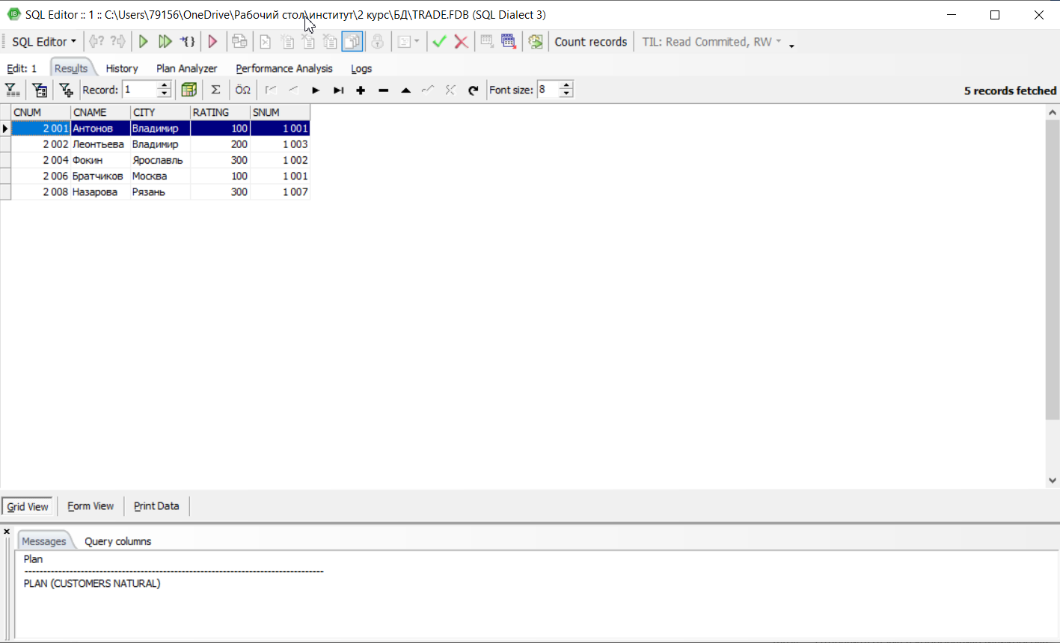

2.5)

select \*

from orders

where ODATE = '03.10.2006' or ODATE = '04.10.2006'

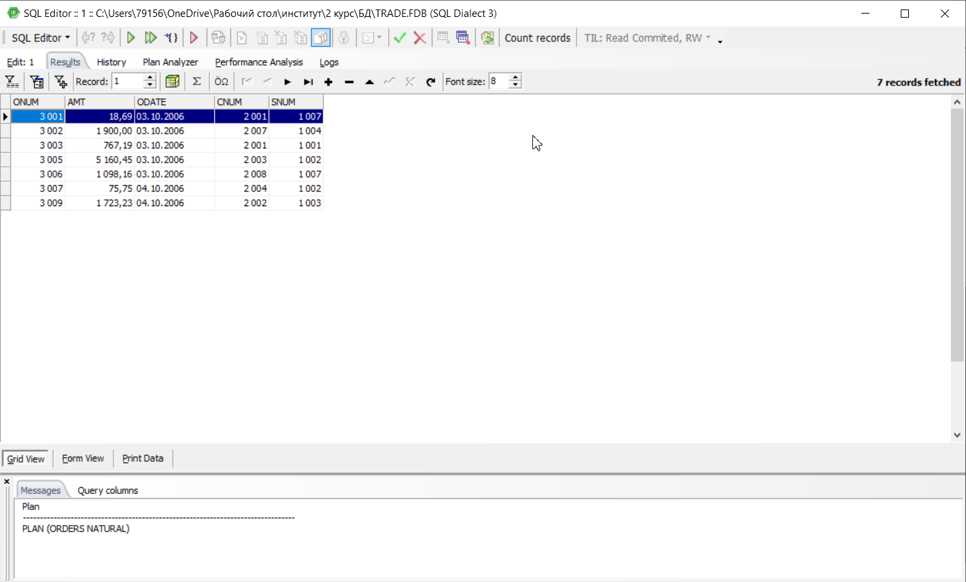

3.3)

select min(amt)

from orders

where CNUM = 2008

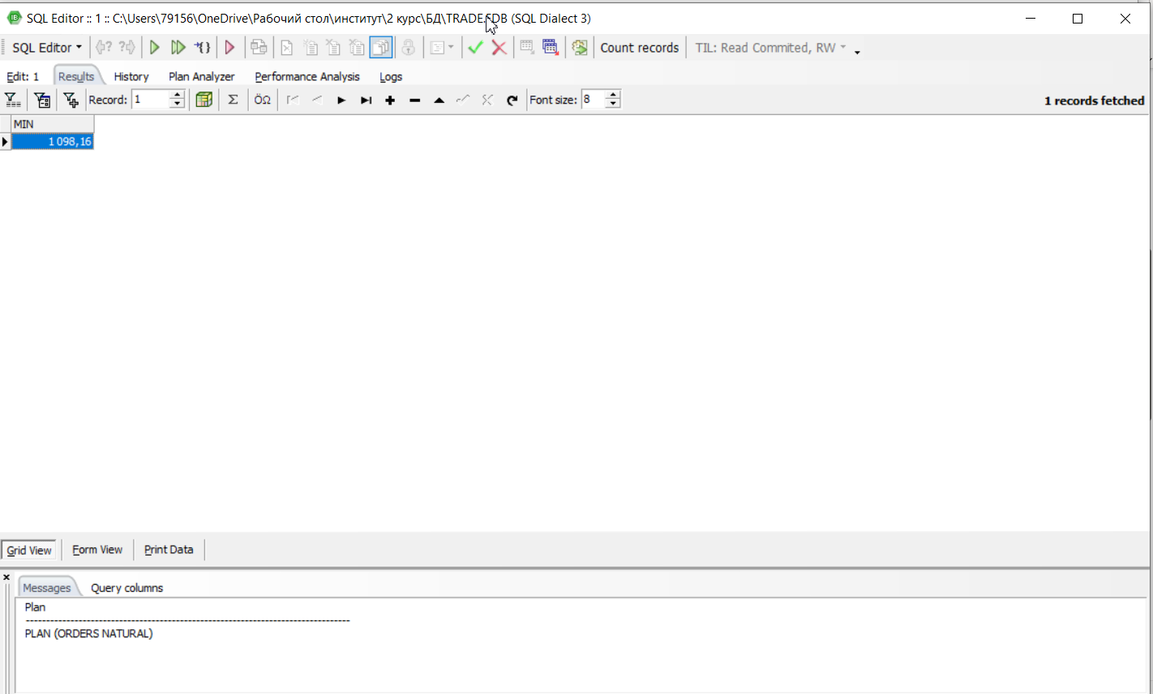

3.4)

select avg(amt)

from orders

where CNUM = 2003 or CNUM = 2007

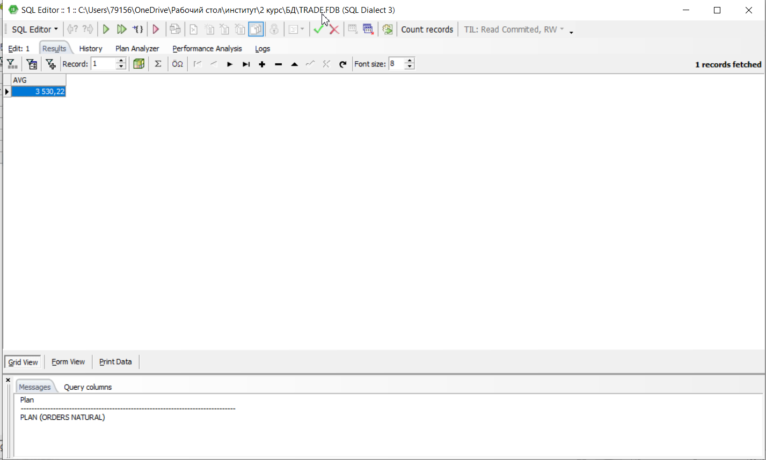

4.2)

select count(CNUM), SNUM

from orders

group by SNUM

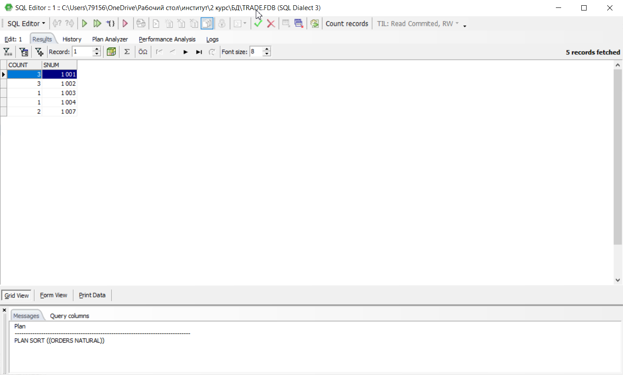

5.3)

select salespeople.sname, max(orders.amt)

from salespeople

left outer join orders on salespeople.snum = orders.snum

group by salespeople.sname

order by salespeople.sname

