Лабораторная работа №3  
Бушуев Андрей  
Глава 9  
1.

SELECT s1.snum, s1.sname, s2.snum, s2.sname

FROM Salespeople s1 inner join Salespeople s2 on s1.city = s2.city

WHERE s1.snum < s2.snum

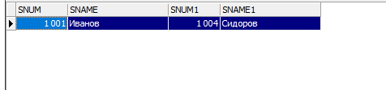

2.

select customers.cname, o1.onum, o2.onum

from orders o1, orders o2, customers

where (o1.onum < o2.onum and o1.cnum = o2.cnum and o1.cnum = customers.cnum)

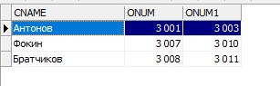

3.

select c1.cname, c1.city

from customers c1, customers c2

where (c2.cnum = '2003' and c1.rating = c2.rating)

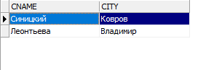

Глава 10

1.

select onum, odate, amt

from orders where

cnum = (

select cnum

from customers

where cname = 'Фокин'

)



2.

select distinct cname, rating

from customers, orders

inner join (

select cnum, count(onum) as count_orders

from orders

group by cnum

)

o1 on o1.cnum = customers.cnum

where o1.count_orders > (

select avg(count_orders)

from (

select cnum, count(onum) as count_orders

from orders

group by cnum

)

)

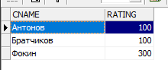

3.select snum, sum(amt)

from orders

group by snum

having sum(amt) > (

select max(amt)

from order )

