Лабораторная работа №3

Каньшин Владислав, ПМИ-РКС-20

**Глава 5.**

1.

select *

from customers

where CNAME between 'А' AND 'О'

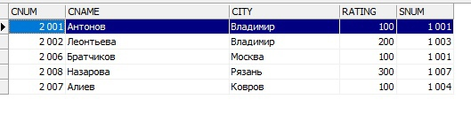

2.

select *

from customers

where CNAME like 'И%'

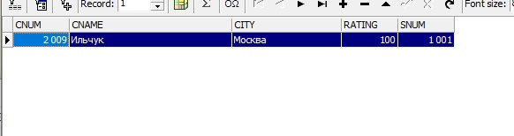

3.

SELECT *

FROM Orders

WHERE (amt = 0 OR amt IS NULL)

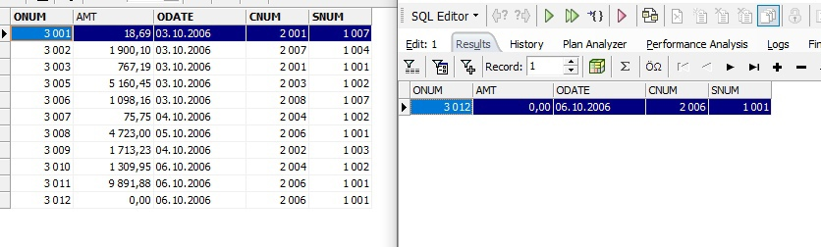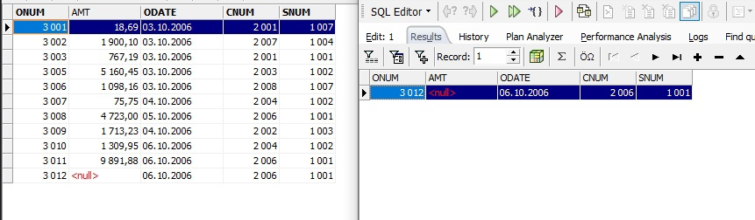(Изменял AMT на 0 и null для наглядности)

**Глава 6.**

1.

select city, count(*)

from customers

group by city

order by city

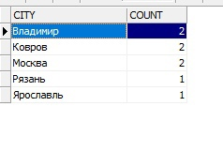

2.

select customers.cname, min(orders.amt)

from orders

left join customers on orders.cnum = customers.cnum

group by cname

order by cname

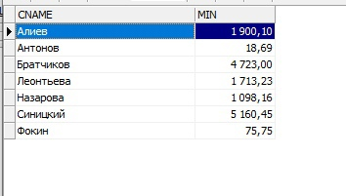

3.

select first 1 cname

from customers

where cname like 'Н%'

order by cname

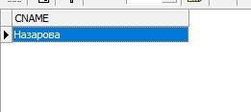

4.

select city, max(rating)

from customers

group by city

order by city

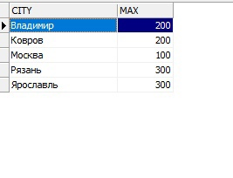

**Глава 8.**

1.

select orders.onum, customers.cname

from orders

left join customers on orders.cnum = customers.cnum

order by onum

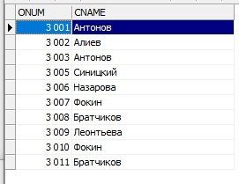

2.

select orders.onum, salespeople.sname, customers.cname

from orders

left join customers on orders.cnum = customers.cnum

left join salespeople on orders.snum = salespeople.snum

order by onum

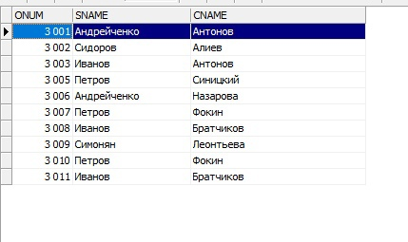

3.

select onum, comm*amt

from customers, orders, salespeople

where rating > 100

and orders.cnum = customers.cnum

and orders.snum = salespeople.snum

