**Отчёт о выполнении домашнего задания**

Выполнил: студент Шушпанов Алексей ПМИ-РКС-20

1.1

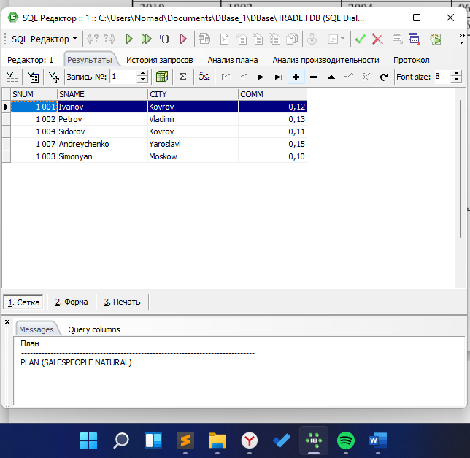

1.2

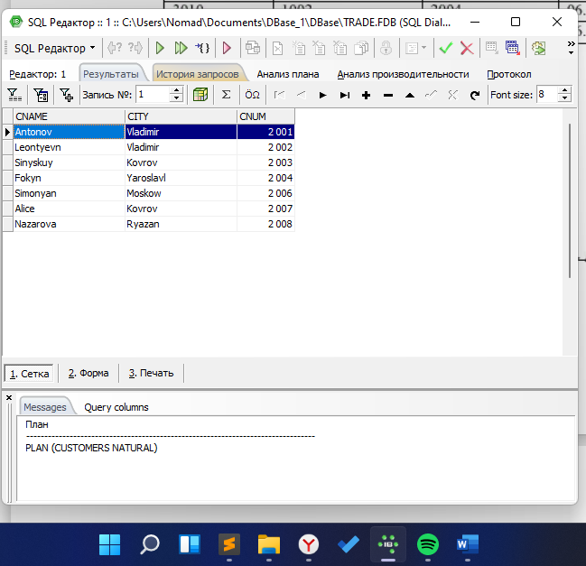

1.3

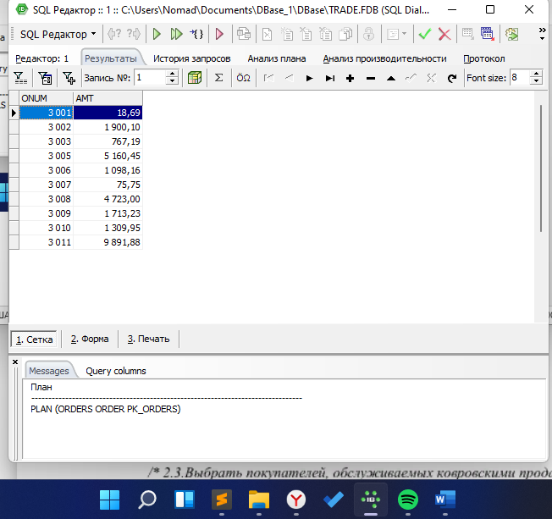

1.4

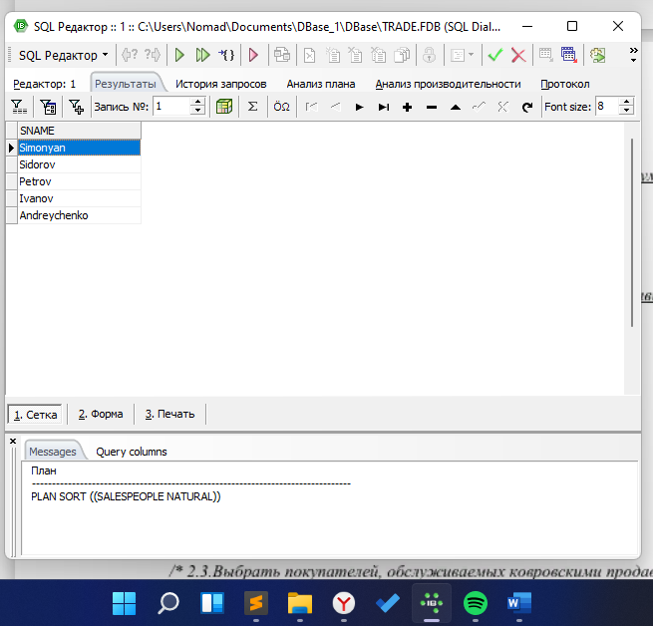

2.1

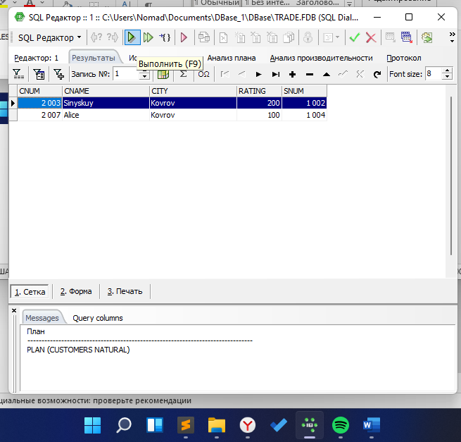

2.2

select *

from customers

where city != 'Kovrov'

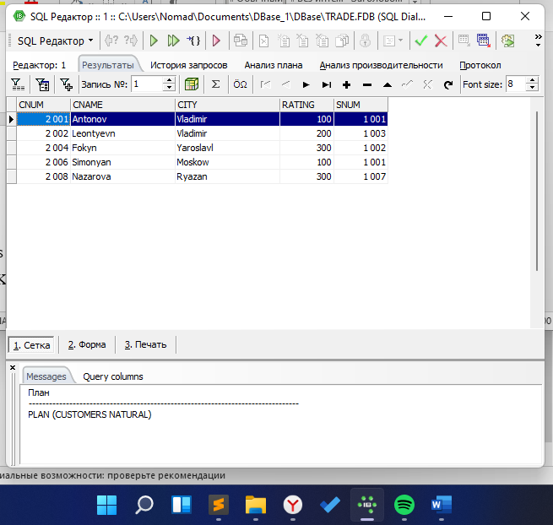

2.3

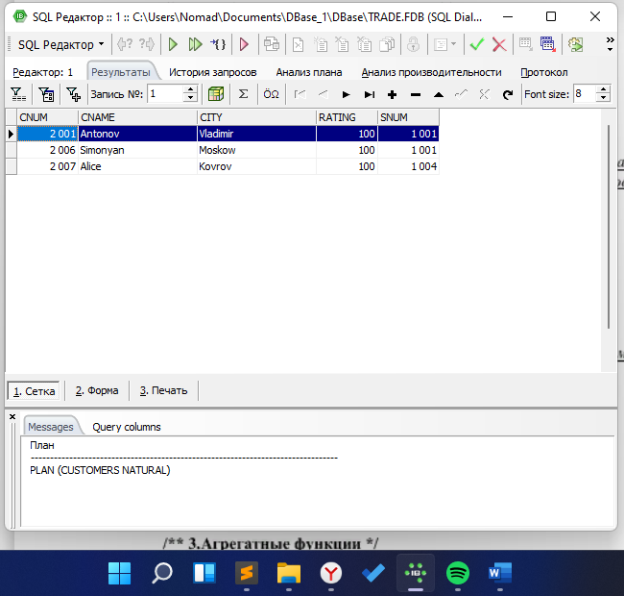

2.4

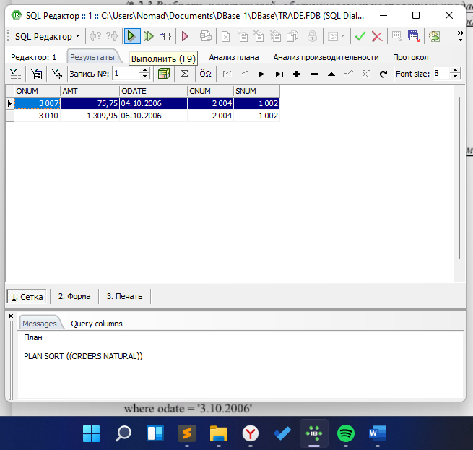

2.5

select *

from orders

where odate = '2006-10-03' or odate = '2006-10-04'

select *

from orders

where odate in ('2006-10-03', '2006-10-04')

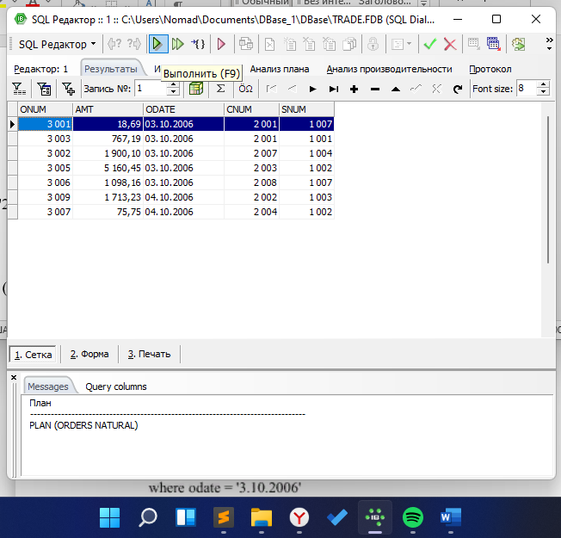

3.1

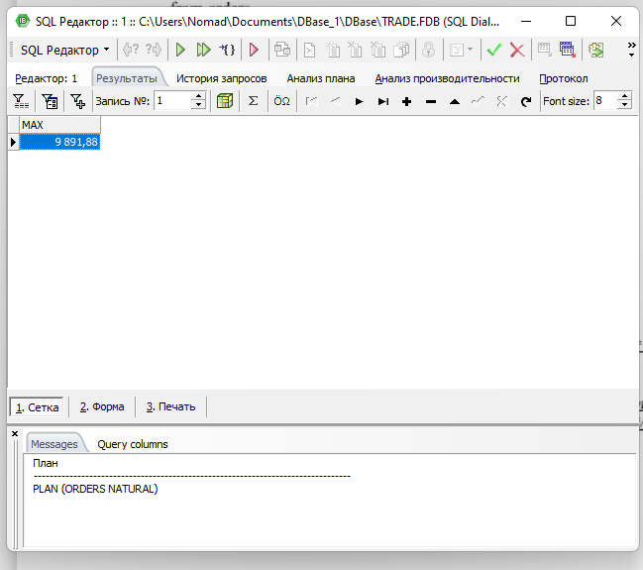

3.2

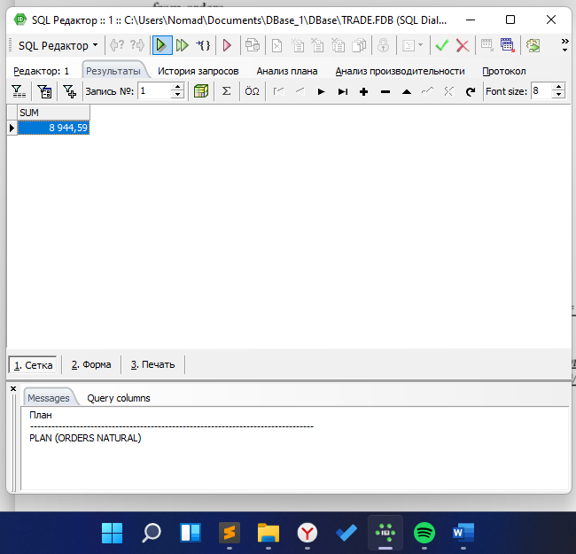

3.3

select min(amt)

from orders

where cnum = 2008

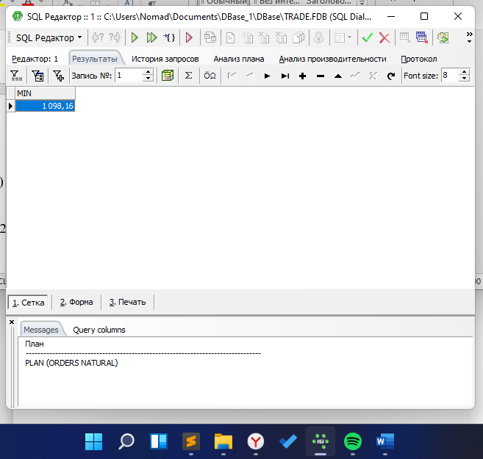

3.4

select avg(amt)

from orders

where cnum in(2003,2007)

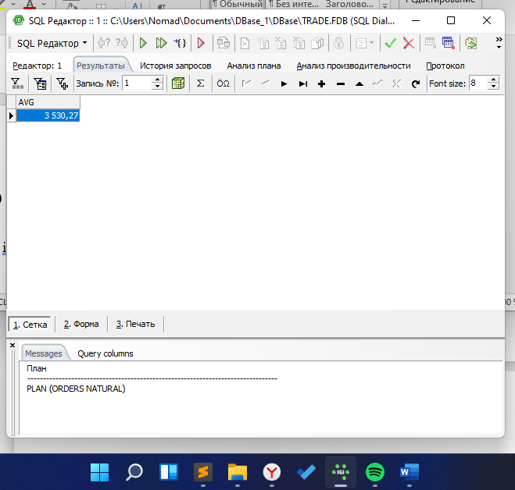

4.1

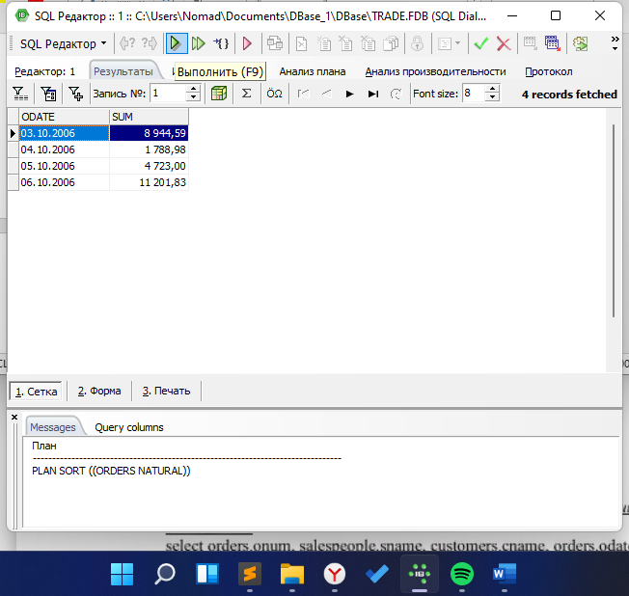

4.2

select snum, count(cnum)

from orders

group by snum

order by snum

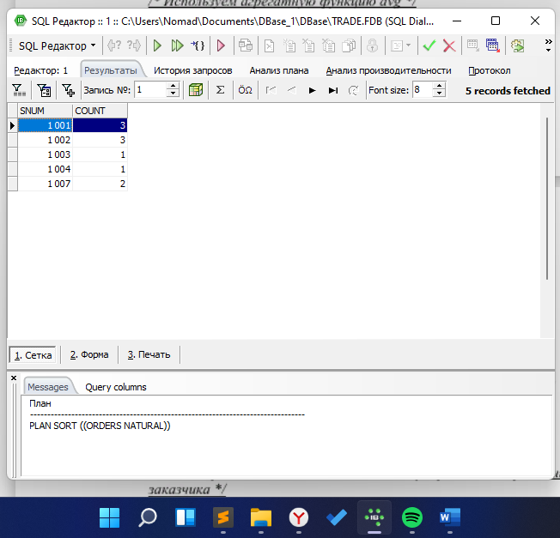

5.1

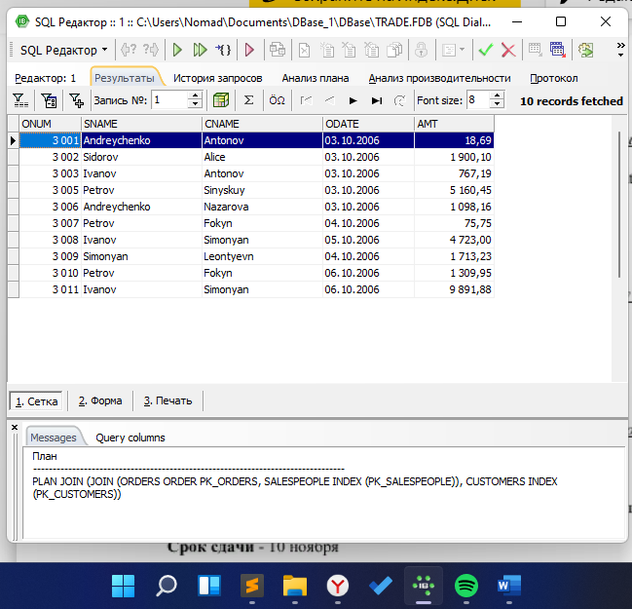

5.2

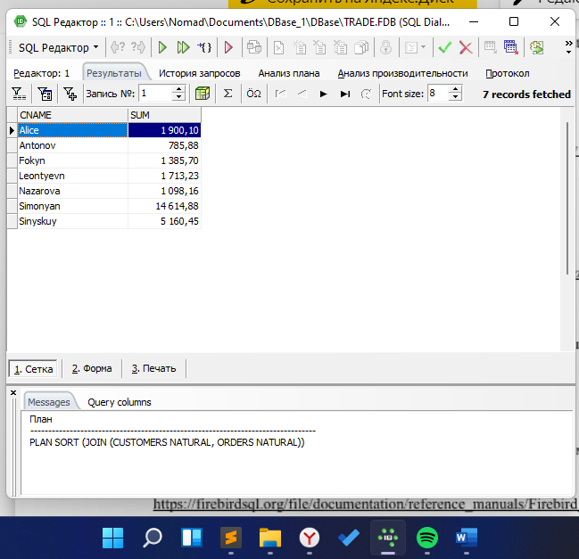

5.3

select salespeople.sname, max(orders.amt)

from salespeople

left outer join orders on salespeople.snum = orders.snum

group by salespeople.sname

order by salespeople.sname

