Лабораторная работа №3

Выполнил: студент группы «ПМИ-РКС-20» Студенов В.Ю.

**Глава 11**

№2.1

select salespeople.snum, salespeople.sname

from salespeople

left outer join customers on customers.snum = salespeople.snum

and customers.city = salespeople.city

where customers.cnum is null

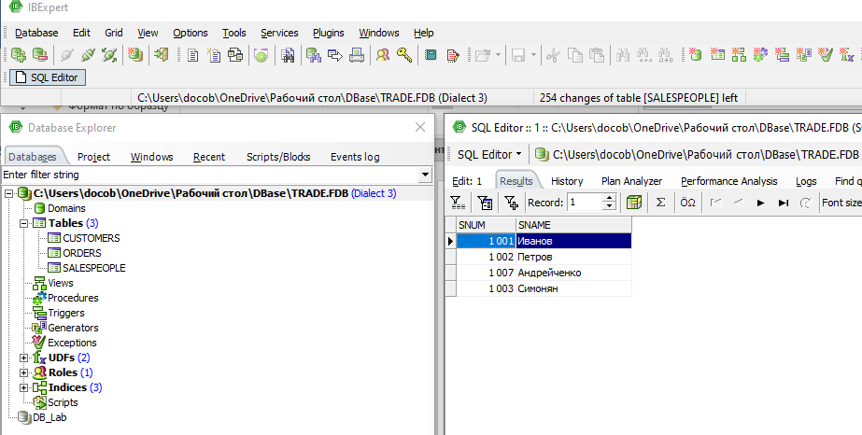

№2.2

select *

from salespeople

where salespeople.city not in (

select customers.city

from customers

where customers.snum = salespeople.snum

)

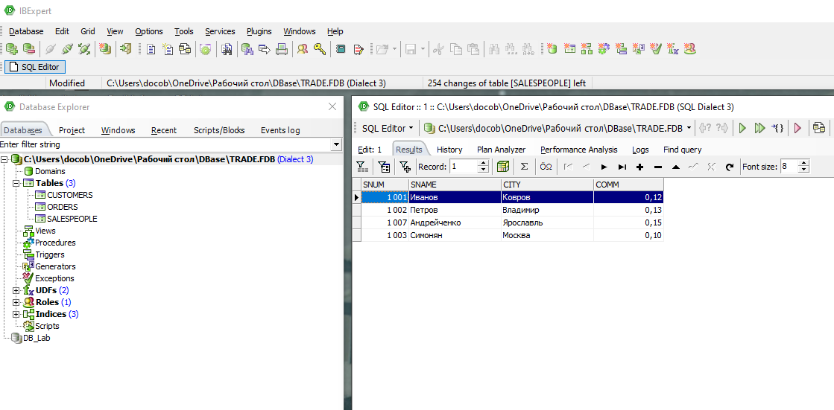

**Глава 15**

№1

INSERT INTO salespeople VALUES (1100, 'Стеблов', 'Мытищи', NULL)

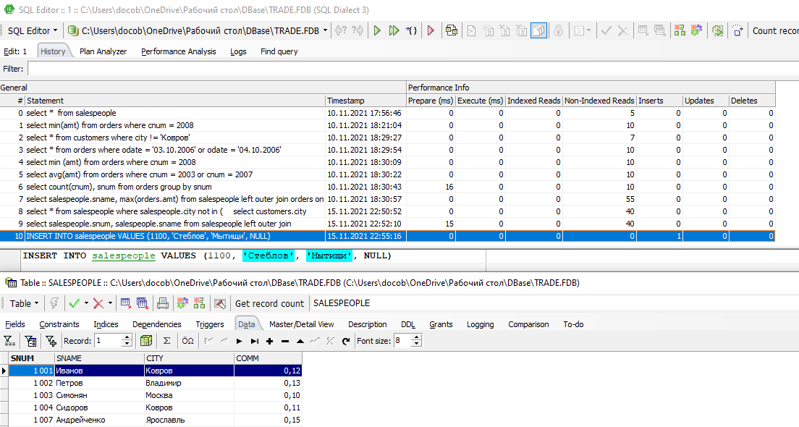

№2

delete from orders

where cnum = 2001;

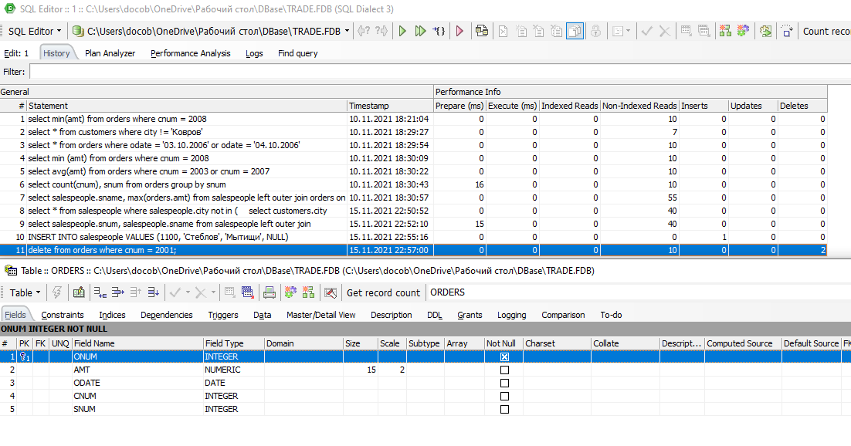

№3

update customers

set rating = rating + 100

where city = 'Владимир'

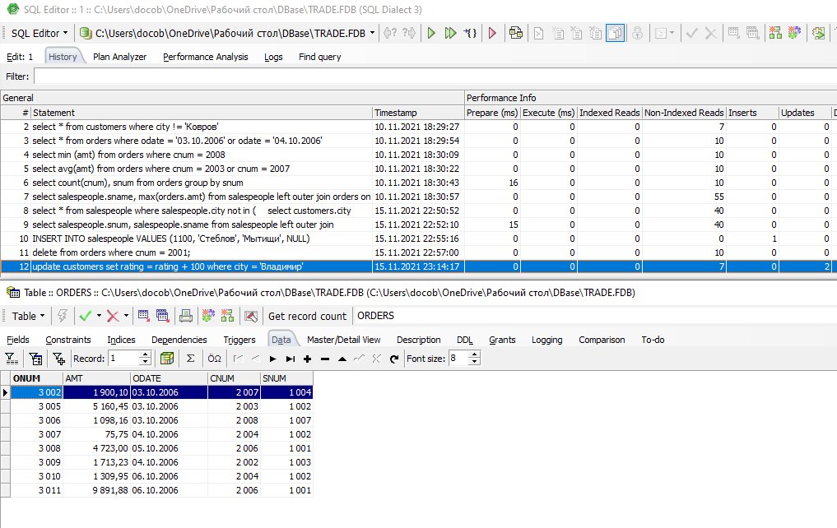№4

update salespeople

set sname = 'Иванов', city = 'Ковров', comm = 0.13

where snum = 1001

