Лабораторная работа №2 «Запросы»

Выполнил: студент группы «ПМИ-РКС-20» Студёнов В.Ю.

№1 (2.2)

select \*

from customers

where city != ‘Ковров’

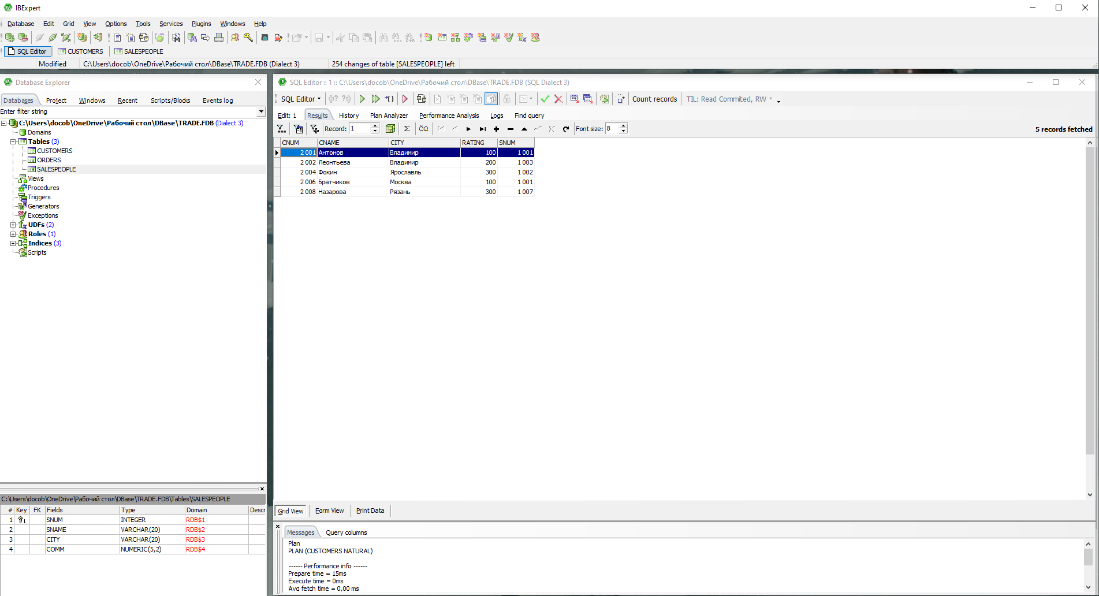

№2 (2.5)

select \*

from orders

where odate = '03.10.2006' or odate = '04.10.2006'

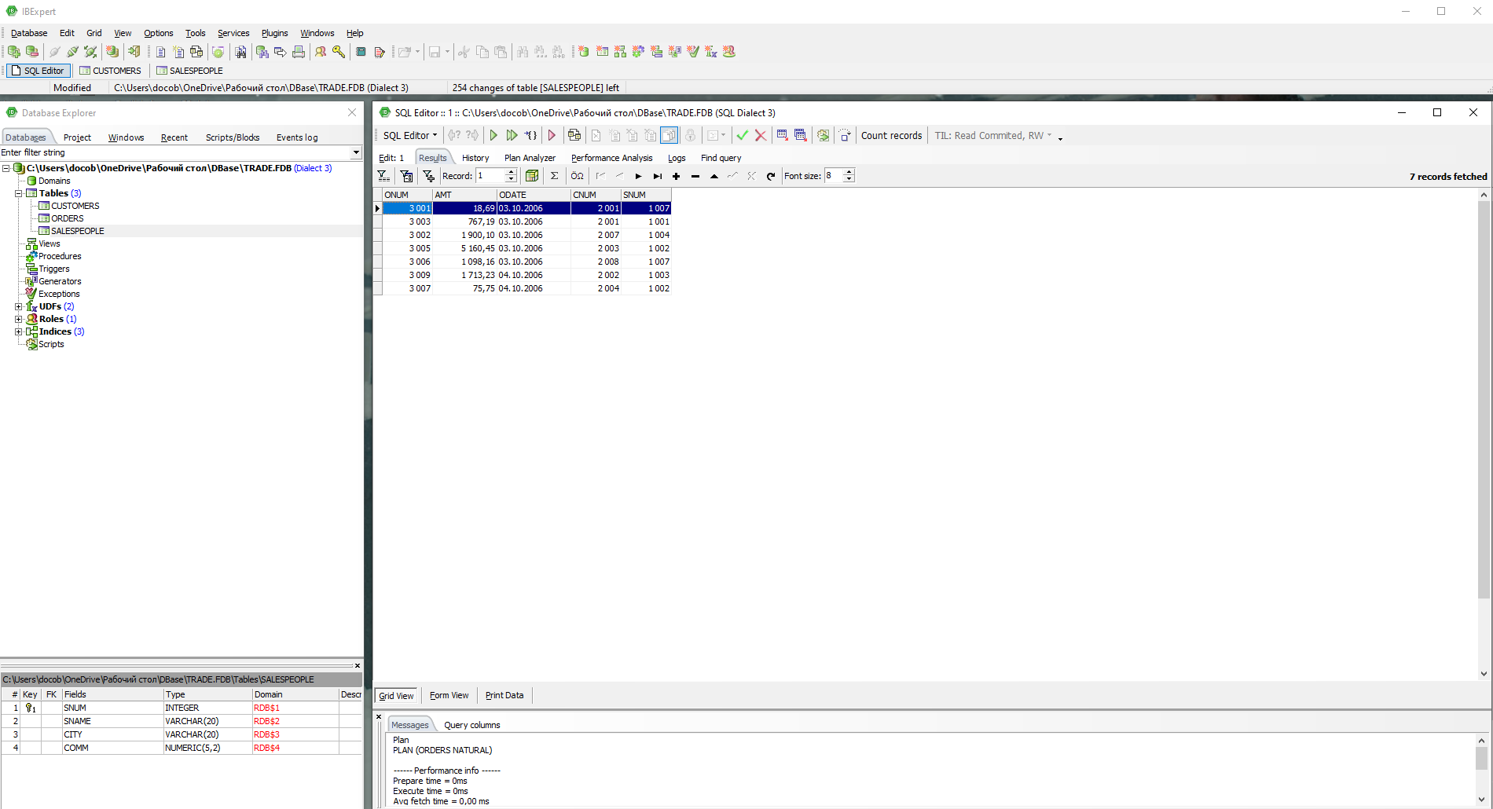

№3 (3.3)

select min (amt)

from orders

where cnum = 2008

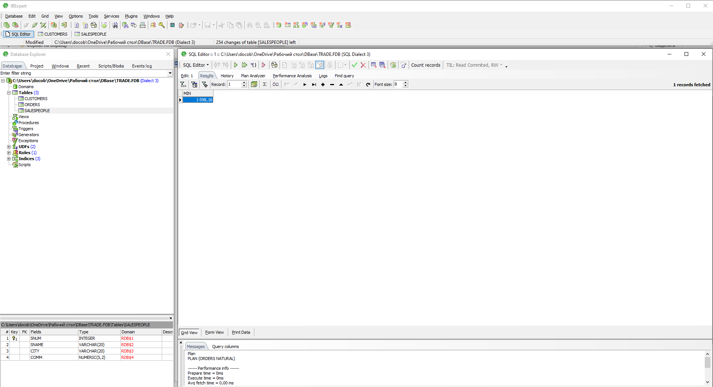

№4 (3.4)

select avg(amt)

from orders

where cnum = 2003 or cnum = 2007

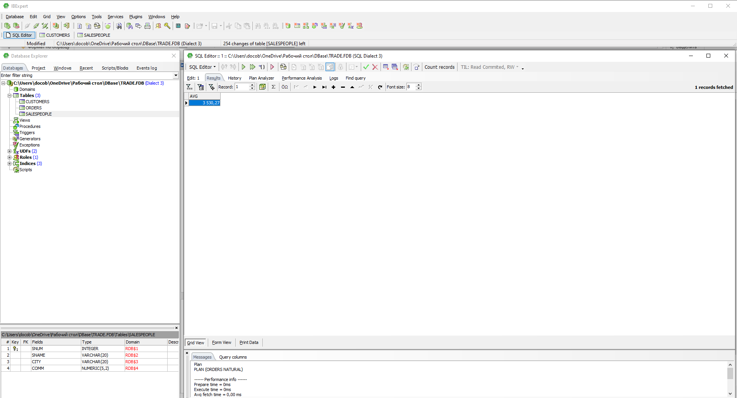

№5

select count(cnum), snum

from orders

group by snum

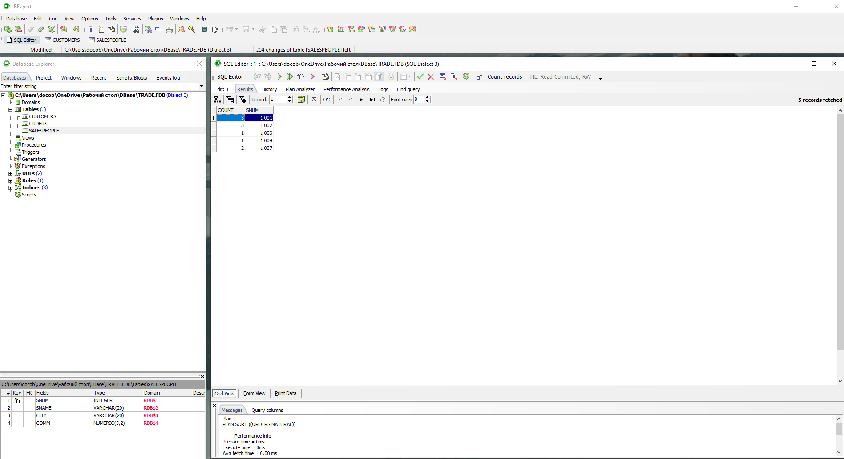

№6 (5.3)

select salespeople.sname, max(orders.amt)

from salespeople

left outer join orders on salespeople.snum = orders.snum

group by salespeople.sname

order by salespeople.sname

