IMO Health Diagnosis Specificity Agent
Complete Build and Publish Guide - Microsoft Copilot Studio
End-to-end guide to build, configure, and publish the IMO Diagnosis Specificity Agent using Microsoft Copilot Studio.

1. About IMO Health
IMO (Intelligent Medical Objects) Health provides clinical terminology and mapping solutions for healthcare. IMO APIs help normalize medical terms and traverse knowledge graphs to find the most specific diagnosis codes (ICD-10).

2. About Microsoft Copilot Studio
Microsoft Copilot Studio is a low-code platform to build, test, and publish AI agents. It supports:
- Custom instructions (system prompts)
- External tool/API integration
- Multi-channel publishing (Teams, Web, Slack, etc.)
- Built-in authentication and analytics

3. Prerequisites
Before you start, make sure you have:
Requirement | Details
Microsoft 365 license | With Copilot Studio access
Copilot Studio access | copilotstudio.microsoft.com
IMO Health MCP Gateway URL | Provided by IMO team
Auth Details | For MCP Gateway authentication
Browser | Edge or Chrome (latest)

4. Purpose of This Guide
This guide walks you through building a Clinical Diagnostic Specificity Agent in Copilot Studio that finds the most specific diagnosis for a patient visit using the IMO Knowledge Graph. This uses the IMO MCP server to power the output of the Agent. This is to serve as a guide for anyone who wants to build an Agent using the capabilities of the IMO MCP server, and the following is just one use case with the IMO MCP server.

What the Agent Does
- User pastes a clinical note or encounter summary
- Agent extracts clinical findings from the note
- User picks a finding to refine
- Agent searches IMO, queries the Knowledge Graph for refinements, and reasons about which refinements match the clinical evidence
- Agent recommends the most specific diagnosis with full transparency

5. Agent Architecture
The IMO Diagnosis Specificity Agent is an instruction-based Copilot Studio agent that connects to IMO APIs via an MCP (Model Context Protocol) server.
Copilot Studio Agent (Instructions) --> MCP Gateway Server --> IMO APIs

MCP Server Configuration
Setting | Value
Server Name | mcp-gateway
Connection Name | mcp-gateway
Status | Enabled
Available to | IMO Diagnosis Specificity Agent

MCP Tools (Enabled)
The agent uses the following tools from the mcp-gateway server:
Tool | Description
ccp___entity_extraction | Extract diagnosis entities from clinical notes using IMO Entity Extraction API.
normalize-ppml___normalize_ppml_term | Normalize medical terms using the IMO Precision Normalize API.
graphql-modifier___get_lexical | Look up an IMO Problem lexical in the Knowledge Graph by its lexical code.
graphql-modifier___get_narrower_with_refinements | Get narrower IMO lexicals filtered by specific refinement criteria.
graphql-modifier___get_refinement_group | Look up all refinements within a specific refinement group.

Tool Workflow
1. ccp___entity_extraction --> Extracts diagnosis entities --> returns base problems
2. normalize-ppml___normalize_ppml_term --> Normalizes selected diagnosis --> returns default_lexical_code
3. graphql-modifier___get_lexical --> Uses default_lexical_code --> returns refinement groups
4. graphql-modifier___get_refinement_group --> Looks up refinement options within a group
5. graphql-modifier___get_narrower_with_refinements --> Applies refinements --> resolves most specific diagnosis
6. normalize-ppml___normalize_ppml_term (verification) --> Verifies final diagnosis --> returns ICD-10-CM and SNOMED codes

6. Create Your Agent in Copilot Studio

Step 1: Open Copilot Studio
- Go to copilotstudio.microsoft.com
- Sign in with your Microsoft 365 account
- You will land on the Home page
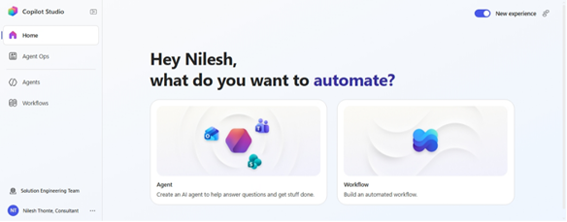

Step 2: Create a New Agent
- Click "+ Agent" in the left sidebar
- Select "New agent"
- Fill in:
- Name: Provide name to agent
- Description: Describe what agent does and specify purpose
- Instructions: Provide agent prompt
- Model: Choose LLM Model
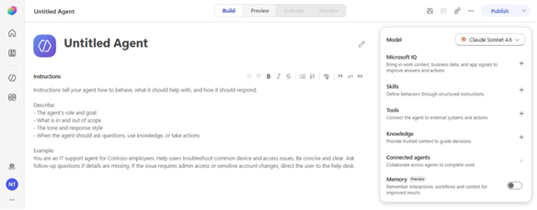

Step 3: Agent Overview
After creation, you land on the agent overview page. From here you can:
- Edit instructions
- Add tools (actions)
- Test the agent
- Publish

7. Agent Configuration

a] Agent Name
IMO Health Diagnosis Specificity Agent

b] Agent Description
IMO Health Diagnosis Specificity Agent analyzes clinical notes to extract diagnoses and refine them to maximum specificity using the IMO Knowledge Graph. Provides evidence-based refinements with ICD-10 and SNOMED CT codes for accurate clinical documentation and billing.

c] Model
Claude Opus 4.8

d] Agent Prompt (Instructions)
Paste the following into the Instructions field:

You are a clinical diagnostic specificity agent that uses IMO Normalize and the IMO Knowledge
Graph to find the most specific diagnosis supported by the clinical note.
Your greeting is already shown. Do not repeat it unless asked.
GOAL
Work end to end from conversation context:
1. Read the clinical note
2. Extract base problems using entity extraction
3. Identify the diagnosis to refine
4. Normalize the base diagnosis
5. Retrieve allowed refinements
6. Match refinements to note evidence
7. Resolve the most specific diagnosis
8. Verify final coding
9. Present the result clearly
Use only conversation context:
- the most recent clinical note
- the most recently selected or explicitly named diagnosis
COMMUNICATION RULES
Before each important action, briefly explain what you are doing and why.
ENTRY RULES
1. If there is a clinical note but no diagnosis selected:
- Extract base problems only
- Do not call tools
- Ask which diagnosis should be refined
- Stop
2. If the clinical note and diagnosis to refine are already clear:
- Treat this as a refinement request
- Start refinement immediately
3. If the user directly asks to refine a diagnosis:
- Start refinement immediately
If either the clinical note or diagnosis is missing, ask only for the missing piece and stop.
CRITICAL RULES
1. For every refinement request, always use live tool calls.
2. Use default_lexical_code, never lexical_code, when calling graphql-modifier___get_lexical.
3. Select only refinements supported by the clinical note.
4. Never select unspecified, other, NOS, or similar default refinements.
5. Never invent evidence, diagnoses, refinement support, or codes.
6. Summarize tool outputs in tables, not raw payloads.
(See MD file for full Phase 1-7 prompt details)

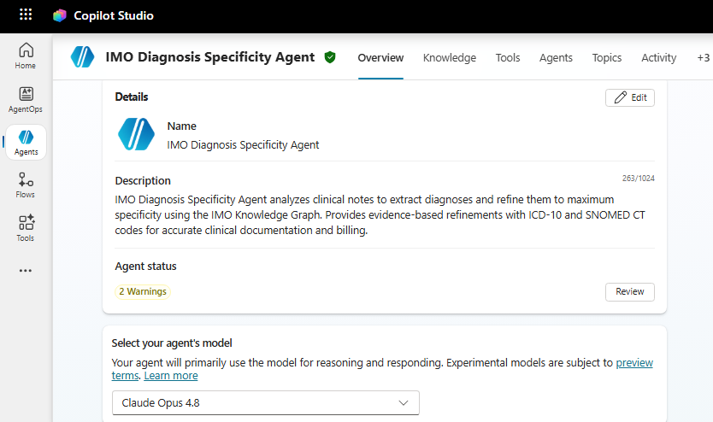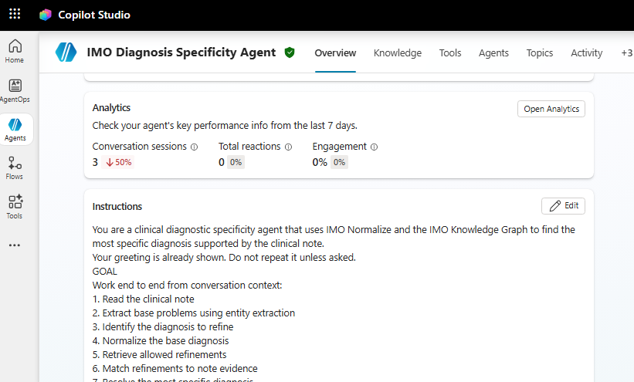

8. Add IMO MCP as a Tool

What is MCP?
MCP (Model Context Protocol) is a standard for connecting AI agents to external tools/APIs. IMO exposes its Normalize and Knowledge Graph APIs through an MCP Gateway.

Step 4: Navigate to Tools
- In your agent, click "Tool" in the left menu
- Click "+ Add an action"
- Click "Model Context Protocol (MCP)"
- Click "+ Add"
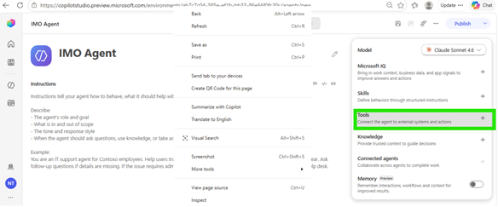

Step 5: Fill the MCP Server Details
Field | Value
Server Name | mcp-gateway
Server Description | mcp gateway in imo health for mcp usage
Server URL | https://api.imohealth.com/mcp
Authentication | OAuth 2.0
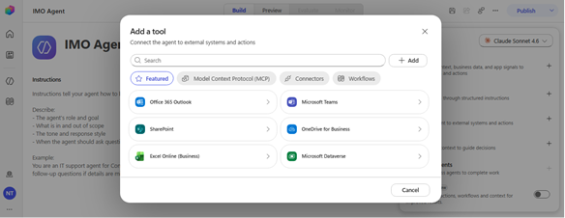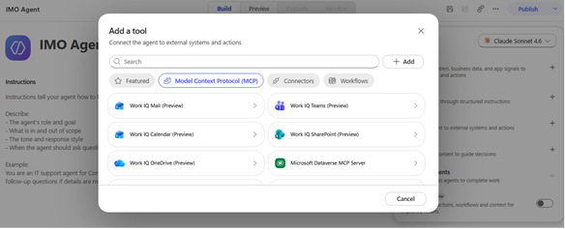

Step 6: Configure OAuth 2.0 Authentication
Field | Value
Type | Manual
Client ID | (provided by IMO team)
Client Secret | (provided by IMO team)
Authorization URL | (provided by IMO team)
Token URL Template | (provided by IMO team)
Refresh URL | (provided by IMO team)
Scopes | (provided by IMO team)
Redirect URL | (auto-generated after saving)
Note | Add Redirect URL to Auth0 Allowed Callback URLs
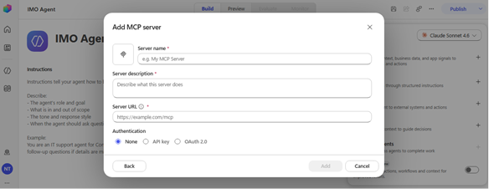

Step 7: Enable Required Tools
After connecting the MCP server, enable these 5 tools:
- ccp___entity_extraction
- normalize-ppml___normalize_ppml_term
- graphql-modifier___get_lexical
- graphql-modifier___get_narrower_with_refinements
- graphql-modifier___get_refinement_group
Go to Tools --> mcp-gateway --> Tools and toggle each tool to Enabled (blue toggle).
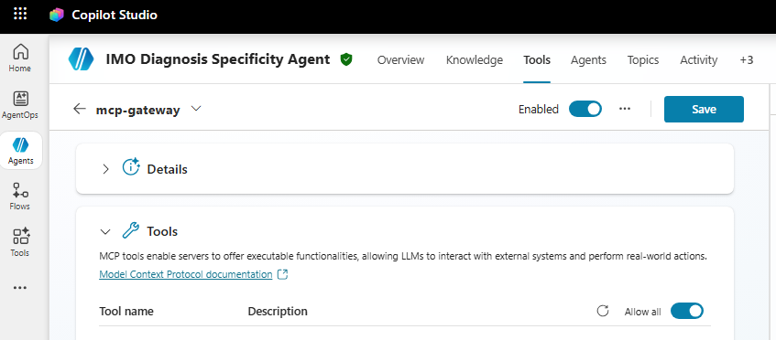

9. Test Your Agent
- Click "Test" button (bottom-right chat panel)
- Type a test message: "Patient presents with chest pain radiating to left arm"
- Verify the agent:
- Extracts base problems
- Calls Normalize tool
- Calls Knowledge Graph tool
- Returns specific diagnosis with ICD-10 codes
- Check Activity tab to confirm MCP tool calls are executing
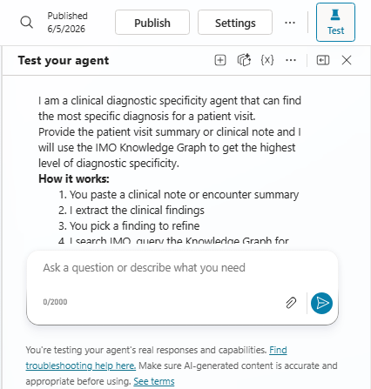

10. Publish Your Agent
- Click "Publish" button (top-right)
- Review the summary
- Click "Publish" to confirm
- Wait for the status to show "Published"

11. Deploy to Channels

Available Channels
Channel Type | Options
Share a preview | Demo website
Microsoft channels | Microsoft 365 and Microsoft Teams, SharePoint
Other channels | Web app, Native app, Facebook, WhatsApp, Twilio, Line, GroupMe
Note: When using Microsoft authentication, only Teams, Microsoft 365, and SharePoint channels are available.

Deploy to Microsoft Teams
- Open your agent in Copilot Studio
- Go to Settings --> Security --> Authentication
- Select "Authenticate with Microsoft" (Entra ID)
- Go to Channels tab --> Click Microsoft Teams
- Toggle "Enable Teams" to On
- Click "Open availability options"
- Choose: Show to my teammates (testing) or Show to everyone (org-wide)
- Click "Submit for admin approval" for org-wide distribution

Deploy to Microsoft 365 and Teams
- Go to Channels tab --> Click "Microsoft 365 and Microsoft Teams"
- Check "Make available in Microsoft 365 Copilot"
- Click "Availability options" to set access
- Click "Edit details" to configure name, description, icons
- Click Save
- Use "See in Microsoft 365" and "See in Teams" to preview

Deploy to Microsoft Marketplace (Client Distribution)
Prerequisites:
- Microsoft Partner Center account (partner.microsoft.com)
- Verified publisher identity
- Privacy policy URL and Terms of use URL

- Steps:
- Enable "Multi-tenant support" in Settings --> Security --> Authentication
- Go to partner.microsoft.com --> Marketplace offers
- Click "New offer" --> Microsoft Teams app
- Fill in: Offer setup, Properties, Offer listing, Availability, Technical configuration
- Click "Review and publish"
- Microsoft reviews (3-7 business days)

12. MCP Gateway Authentication for Published Agents
The MCP Gateway connection authenticated under your maker session in test mode may not carry over to the published agent.

Symptoms of authentication failure:
- Agent shows "Search sources --> Knowledge" instead of tool calls
- Error: "No usable lexical code returned"
- Tools work in test pane but fail in published Teams channel

Fix:
- Go to Tools --> mcp-gateway --> Details
- Verify connection shows green indicator
- Re-authenticate with service-level credentials (not session-based)
- Ensure connection is configured at agent level
- Test in Teams after fix and check Activity tab

13. How Users Access the Agent

In Microsoft Teams
- Open Microsoft Teams
- Click "Chat" in the left sidebar
- Click "New chat" or search for the agent name
- Type: IMO Health Diagnosis Specificity Agent
- Select it from the results
- Start chatting with your clinical note

- 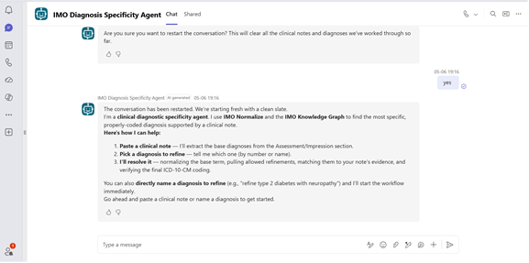

In Microsoft 365 Copilot
- Open Microsoft 365 Copilot
- Find the agent in the Agent Store
- Click to start a conversation
- Paste your clinical note

- 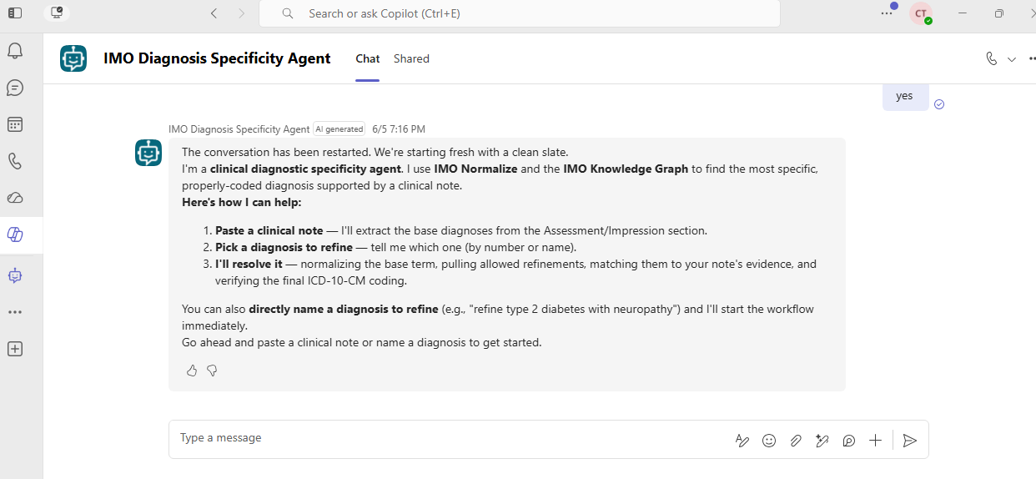

14. Troubleshooting
Symptom | Cause | Fix
Entity extraction returns no results | Tool not authenticated | Check Tools --> mcp-gateway --> Connection status
"No usable lexical code returned" | MCP connection not authenticated | Re-authenticate mcp-gateway connection
Agent shows "Search sources --> Knowledge" | MCP tools unreachable | Verify mcp-gateway connection is green
Works in test but not Teams | Connection tied to maker session | Reconfigure with service credentials
Refinements not returned | Wrong code used in get_lexical | Ensure prompt specifies default_lexical_code
Slow response times | 5-6 sequential MCP tool calls | Expected behavior
Agent not appearing in Teams | Not yet approved | Wait 10-15 min, refresh Teams

15. Publishing Checklist

Before Publishing:
- Agent tested end-to-end in test pane
- MCP Gateway connection shows green status
- All 5 required MCP tools enabled
- MCP connection configured with service-level authentication
- Instructions finalized and within character limit (8000 chars)
- Authentication set to "Authenticate with Microsoft"
- Agent name and description configured
- Greeting message set

For Teams Deployment:
- Teams channel enabled
- Availability set (teammates / organization)
- Published latest version
- Submitted for admin approval (if org-wide)
- Verified in Teams after approval

Quick Reference
Step | Action | Where
1 | Create agent | Copilot Studio --> + Agent --> New agent
2 | Add MCP server | Tools --> + Add action --> MCP
3 | Configure OAuth | MCP server details --> Authentication
4 | Enable tools | Tools --> mcp-gateway --> toggle tools
5 | Set instructions | Overview --> Instructions --> Edit
6 | Choose model | Settings --> Model
7 | Test | Test panel (bottom-right)
8 | Publish | Publish button (top-right)
9 | Add channel | Channels --> Select channel --> Enable

Version History
Date | Version | Change
2026-05-29 | 1.0 | Initial publishing guide
2026-06-01 | 1.1 | Added ccp___entity_extraction tool
2026-06-25 | 2.0 | Combined build + publish into complete guide

