**Introduction to Information & Communication Technology**

**Name: Mohib Ismail**

**Student ID: cs201063**

**Department & Section: CS-1B1**

**Lab Assignment (Table)**

Coding Screenshot

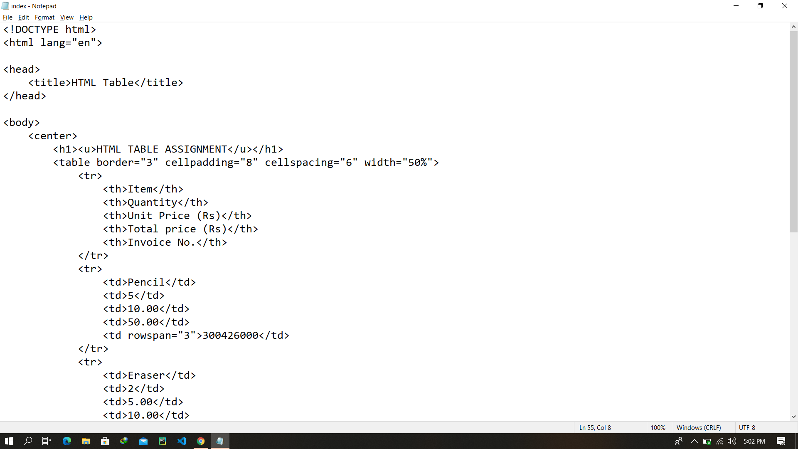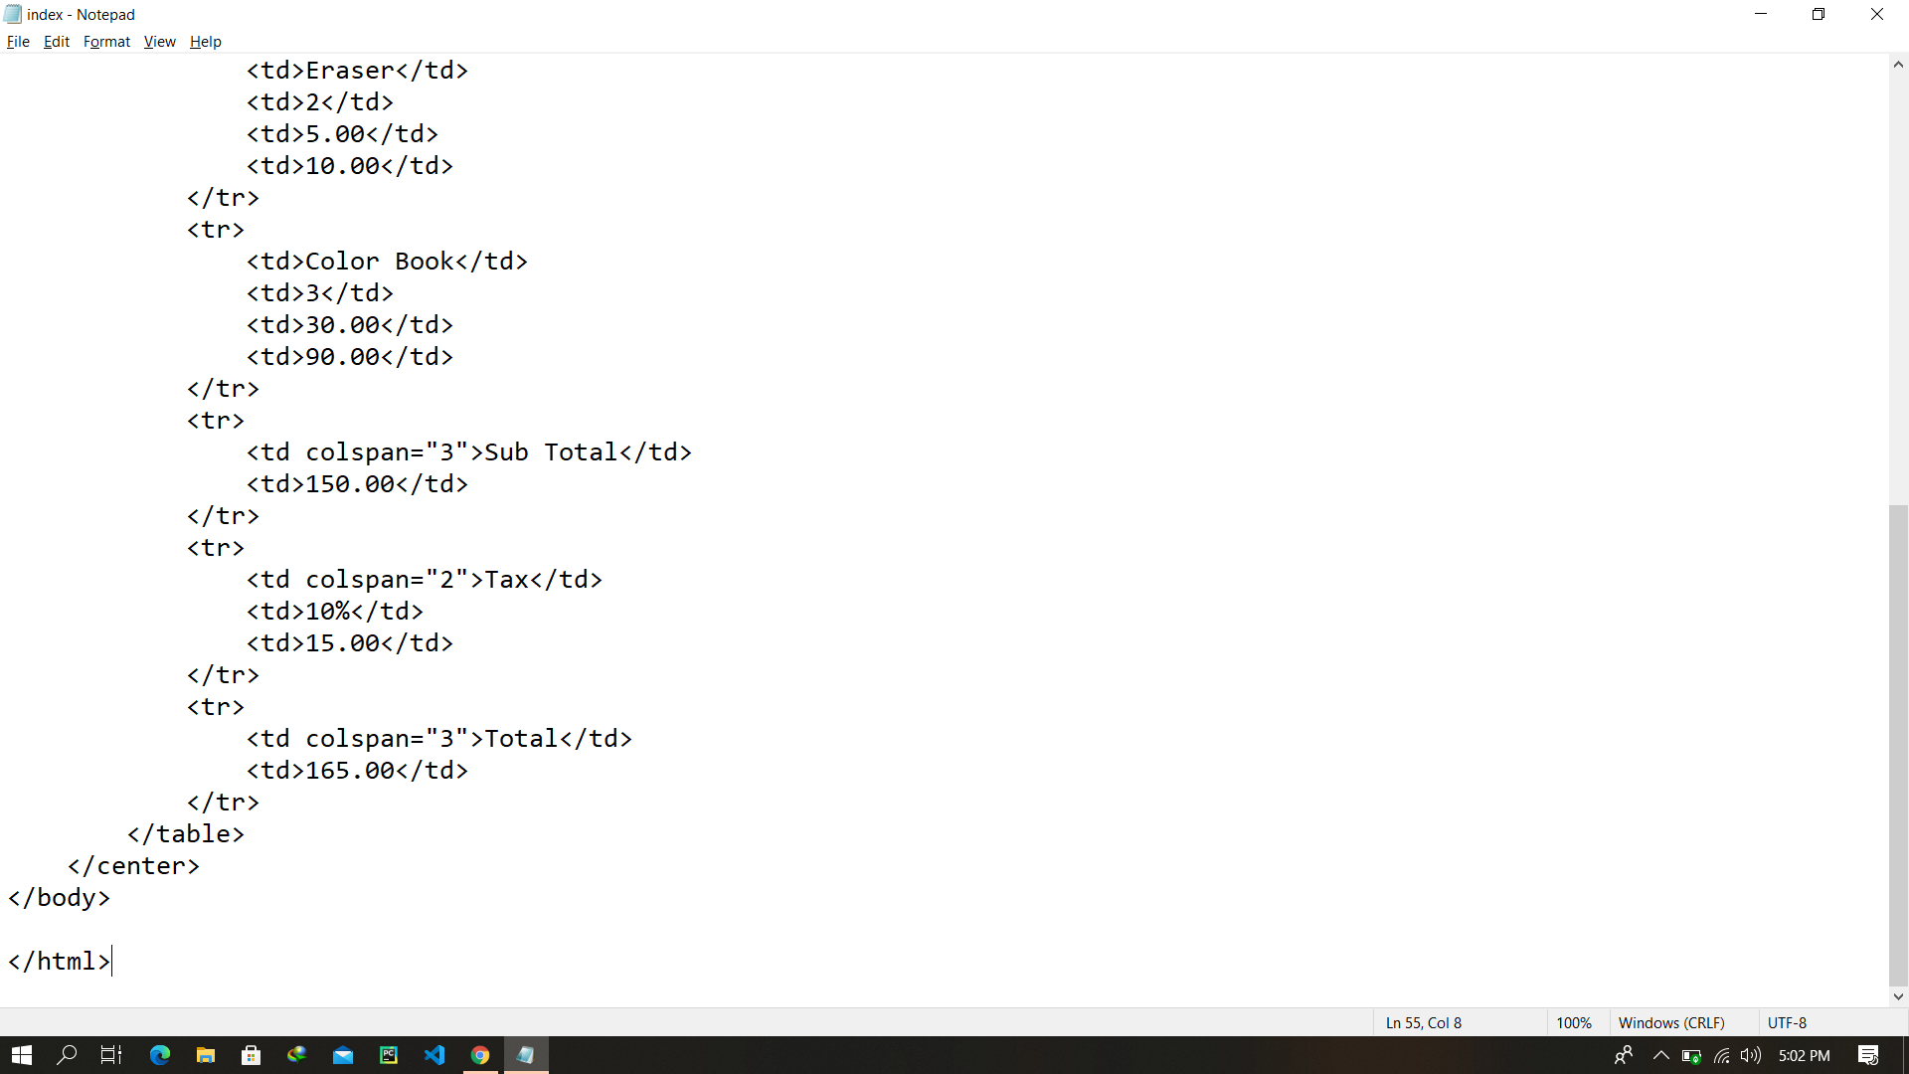

Final Output After rendering

