**Introduction to Information & Communication Technology**

**Name: Mohib Ismail**

**Student ID: cs201063**

**Department & Section: CS-1B1**

**Lab Assignment**

Coding Screenshot

Assignment: 01

**HTML file:**

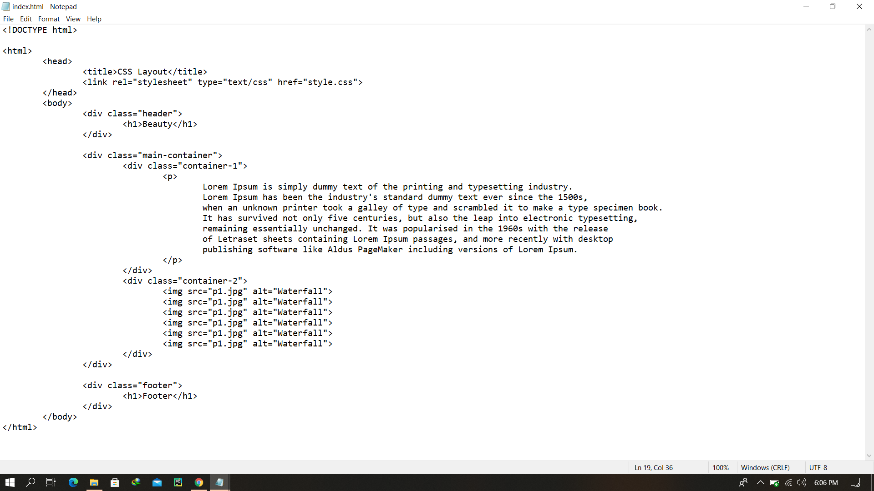

**CSS file:**

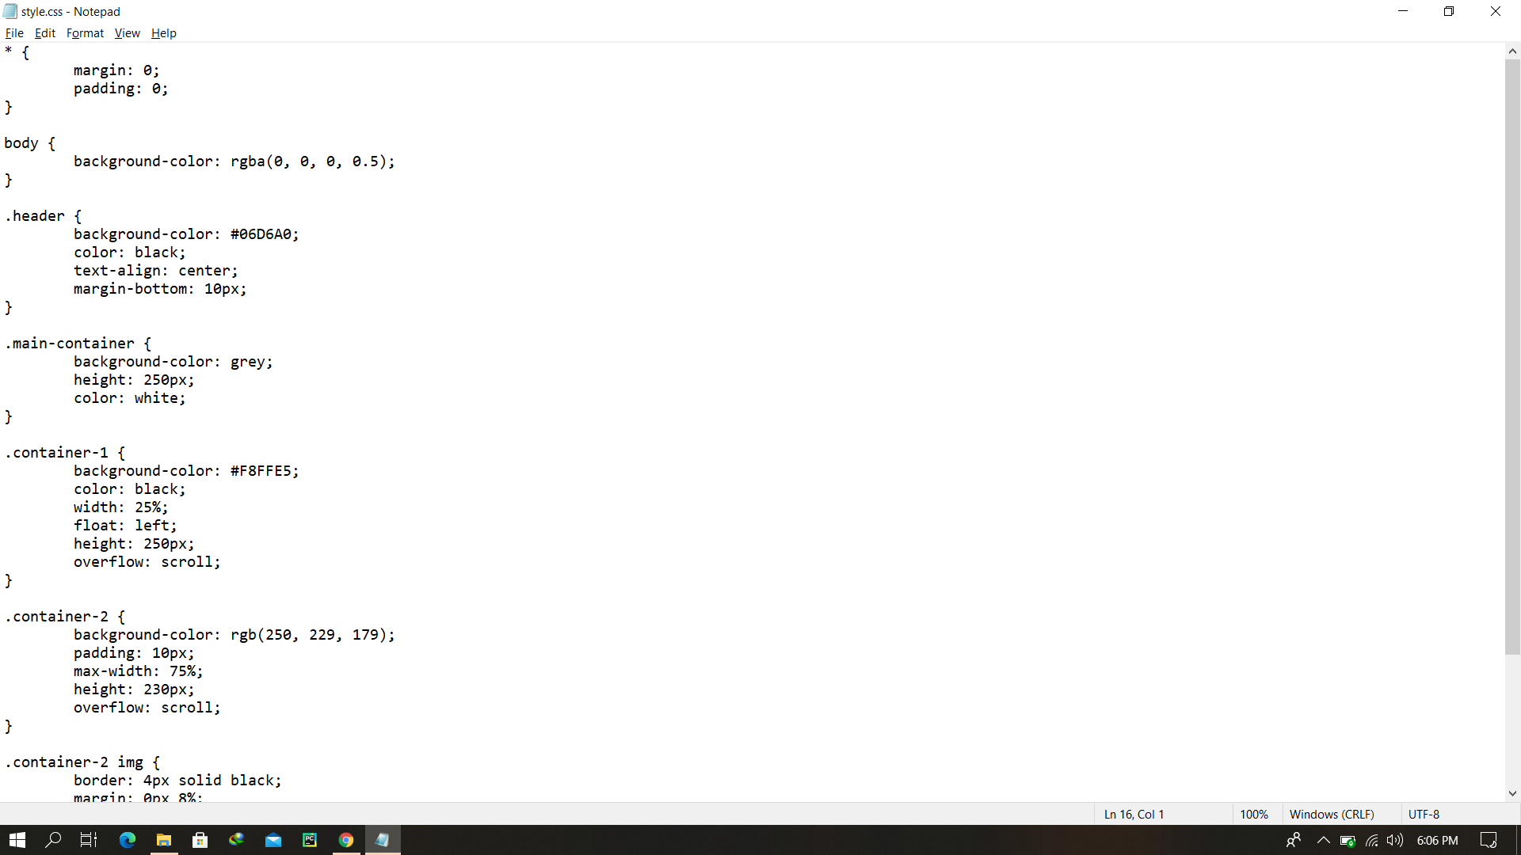

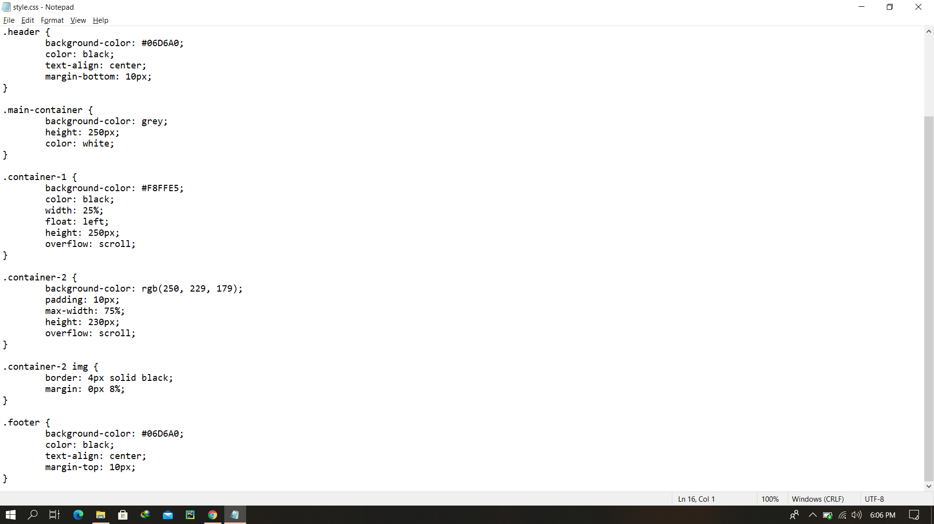

Final Output After rendering

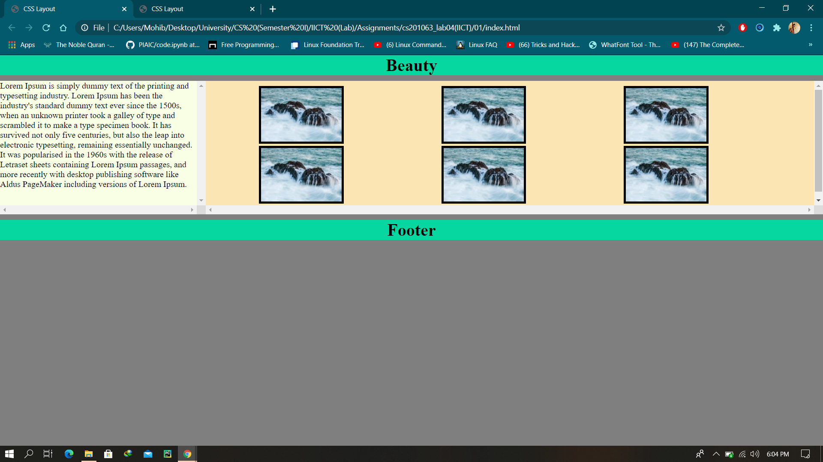

Coding Screenshot

Assignment: 02

**HTML file:**

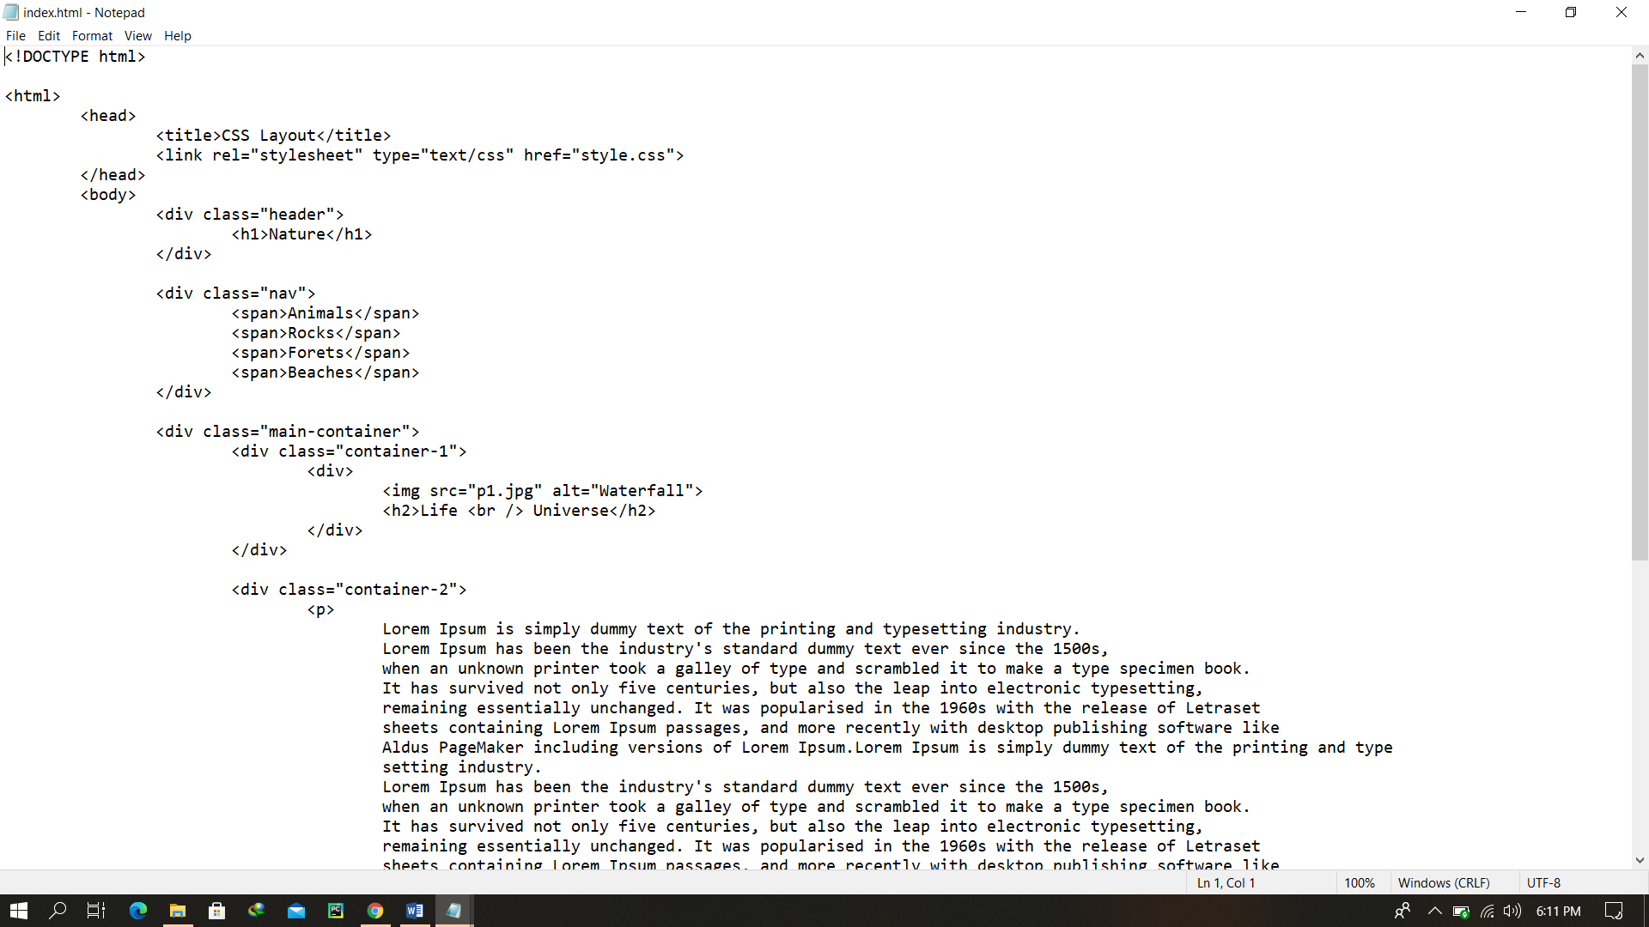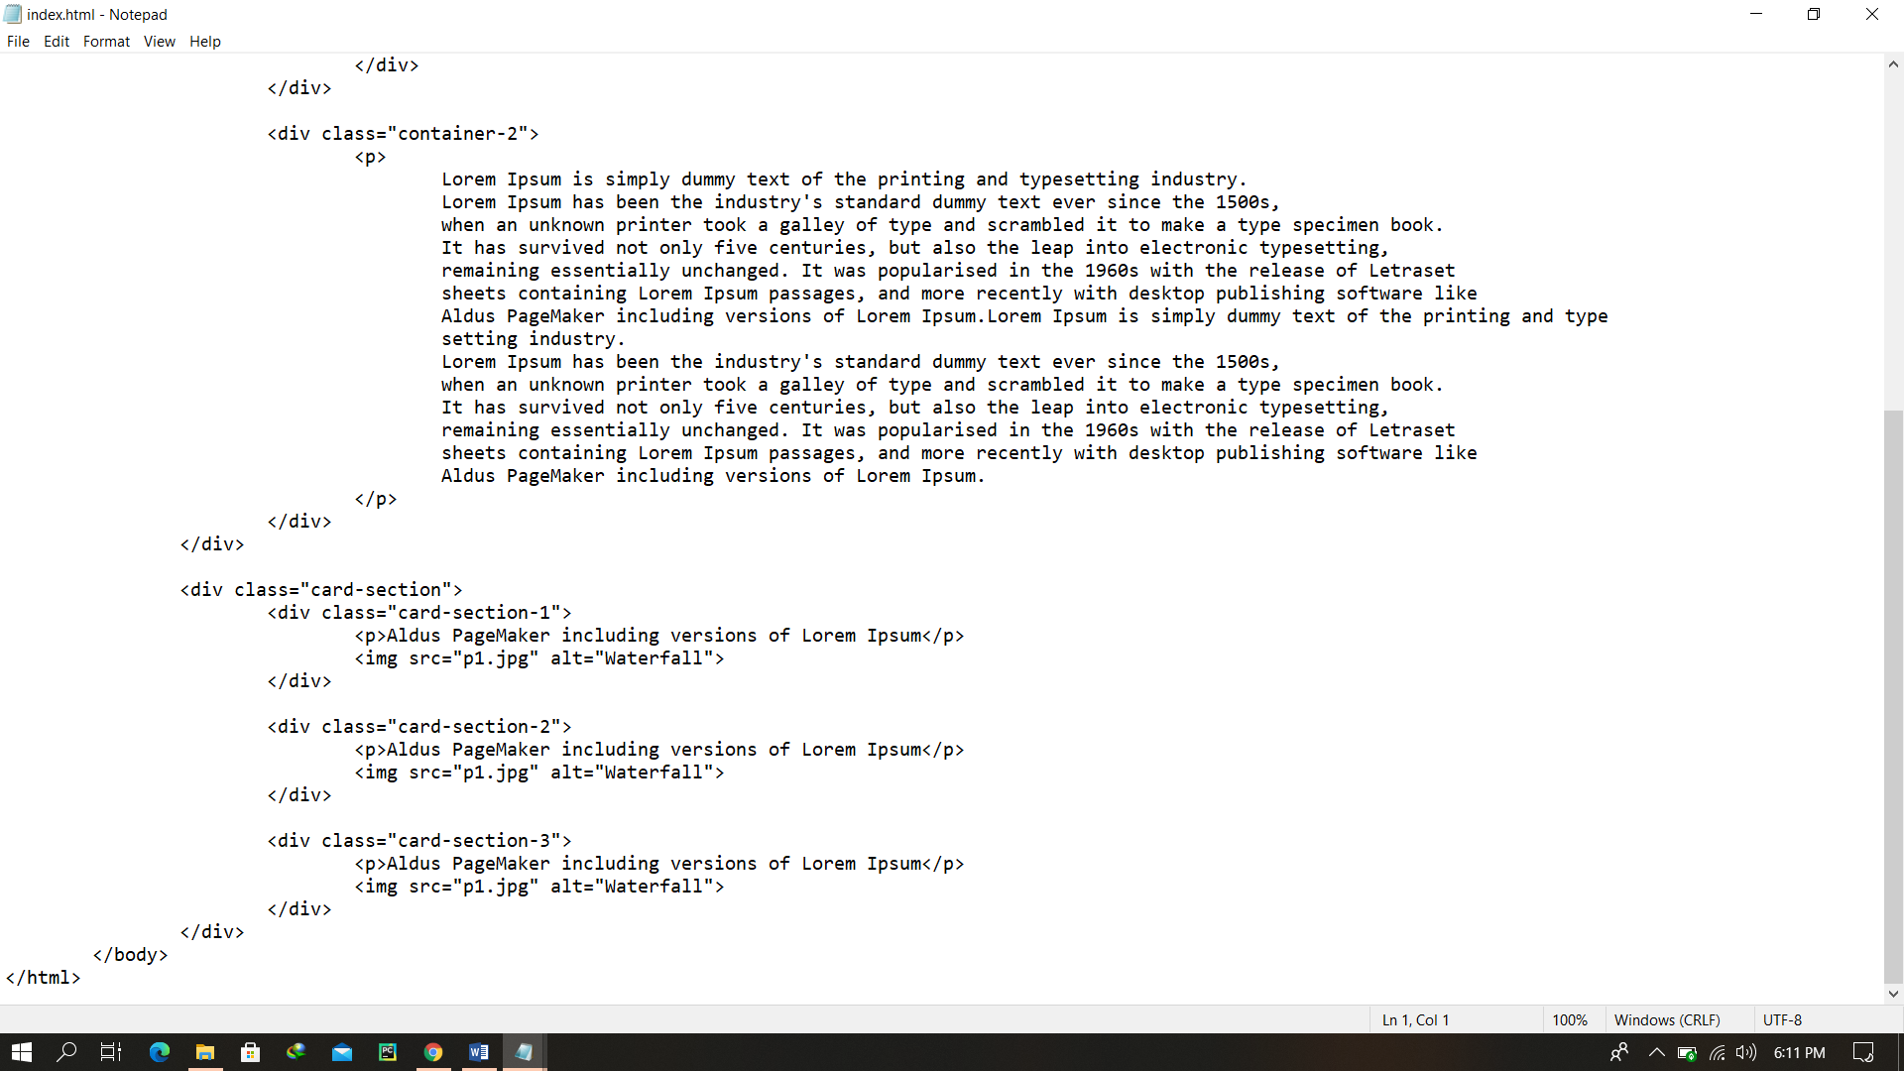

**CSS file:**

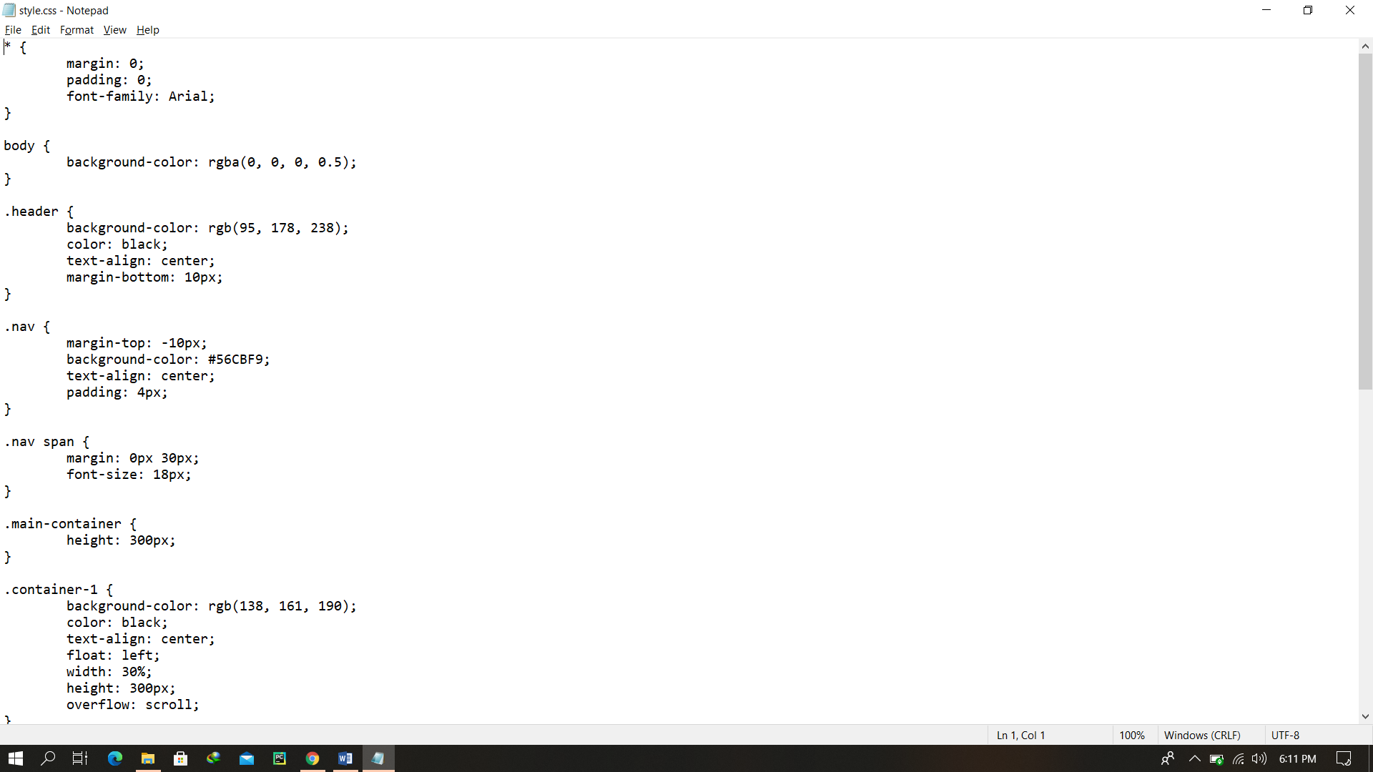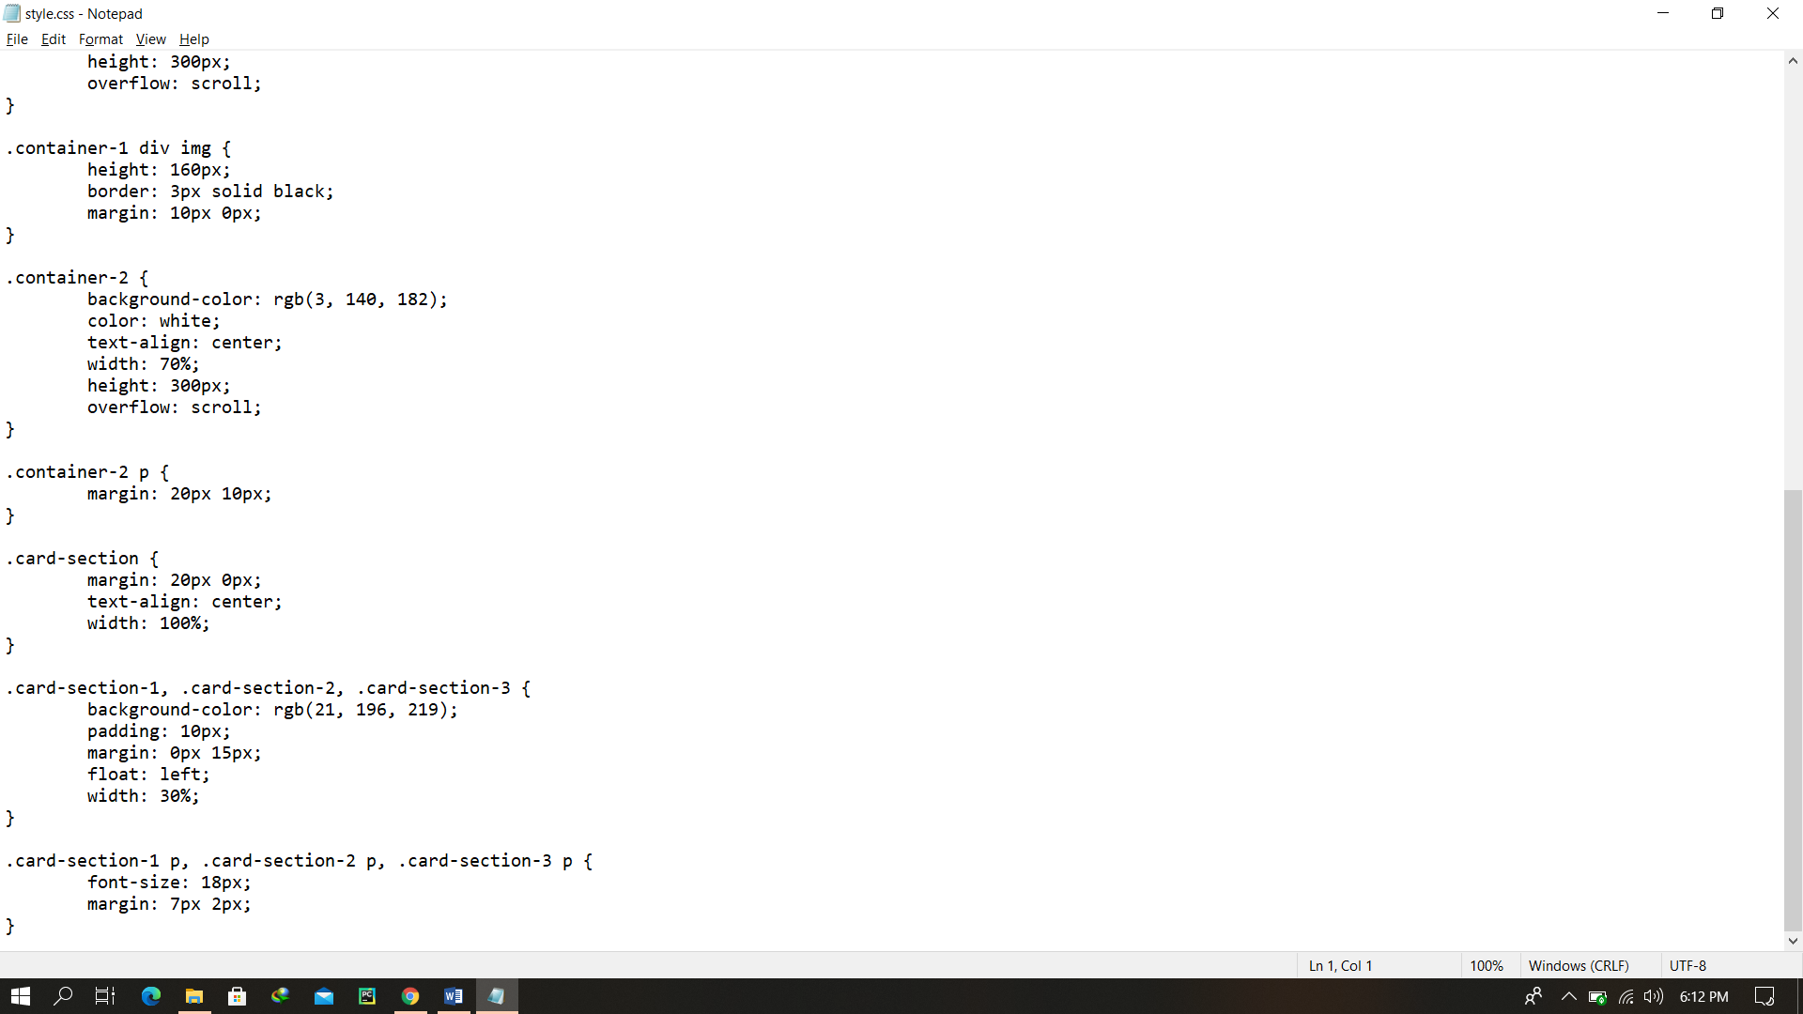

Final Output After rendering

