**Introduction to Information & Communication Technology**

**Name: Mohib Ismail**

**Student ID: cs201063**

**Department & Section: CS-1B1**

**Lab Assignment**

Coding Screenshot

Assignment: 06

Question: 01 (iframe)

**HTML file:**

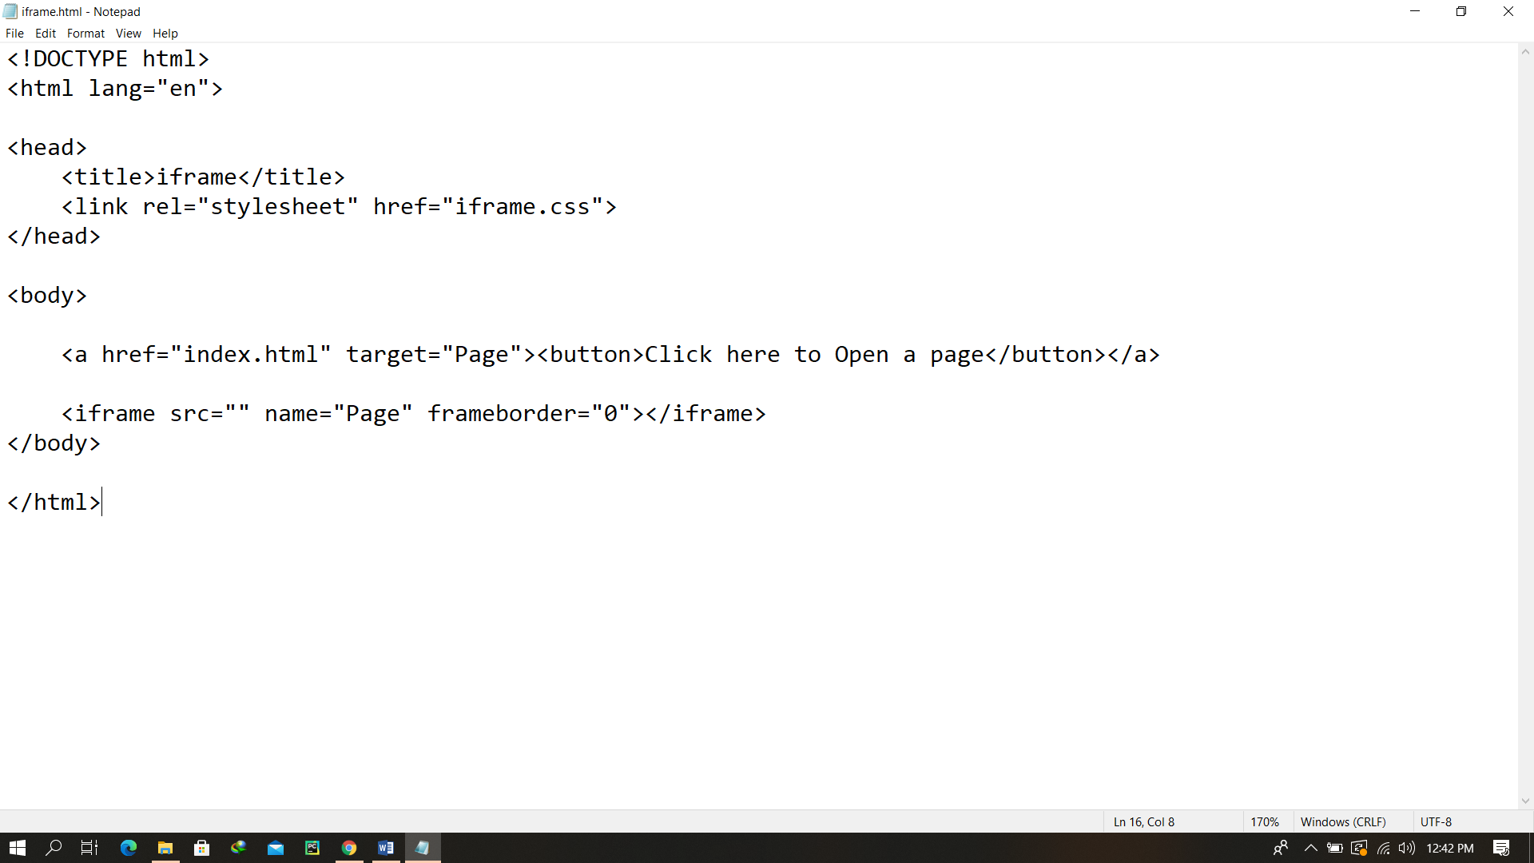

Final Output After rendering

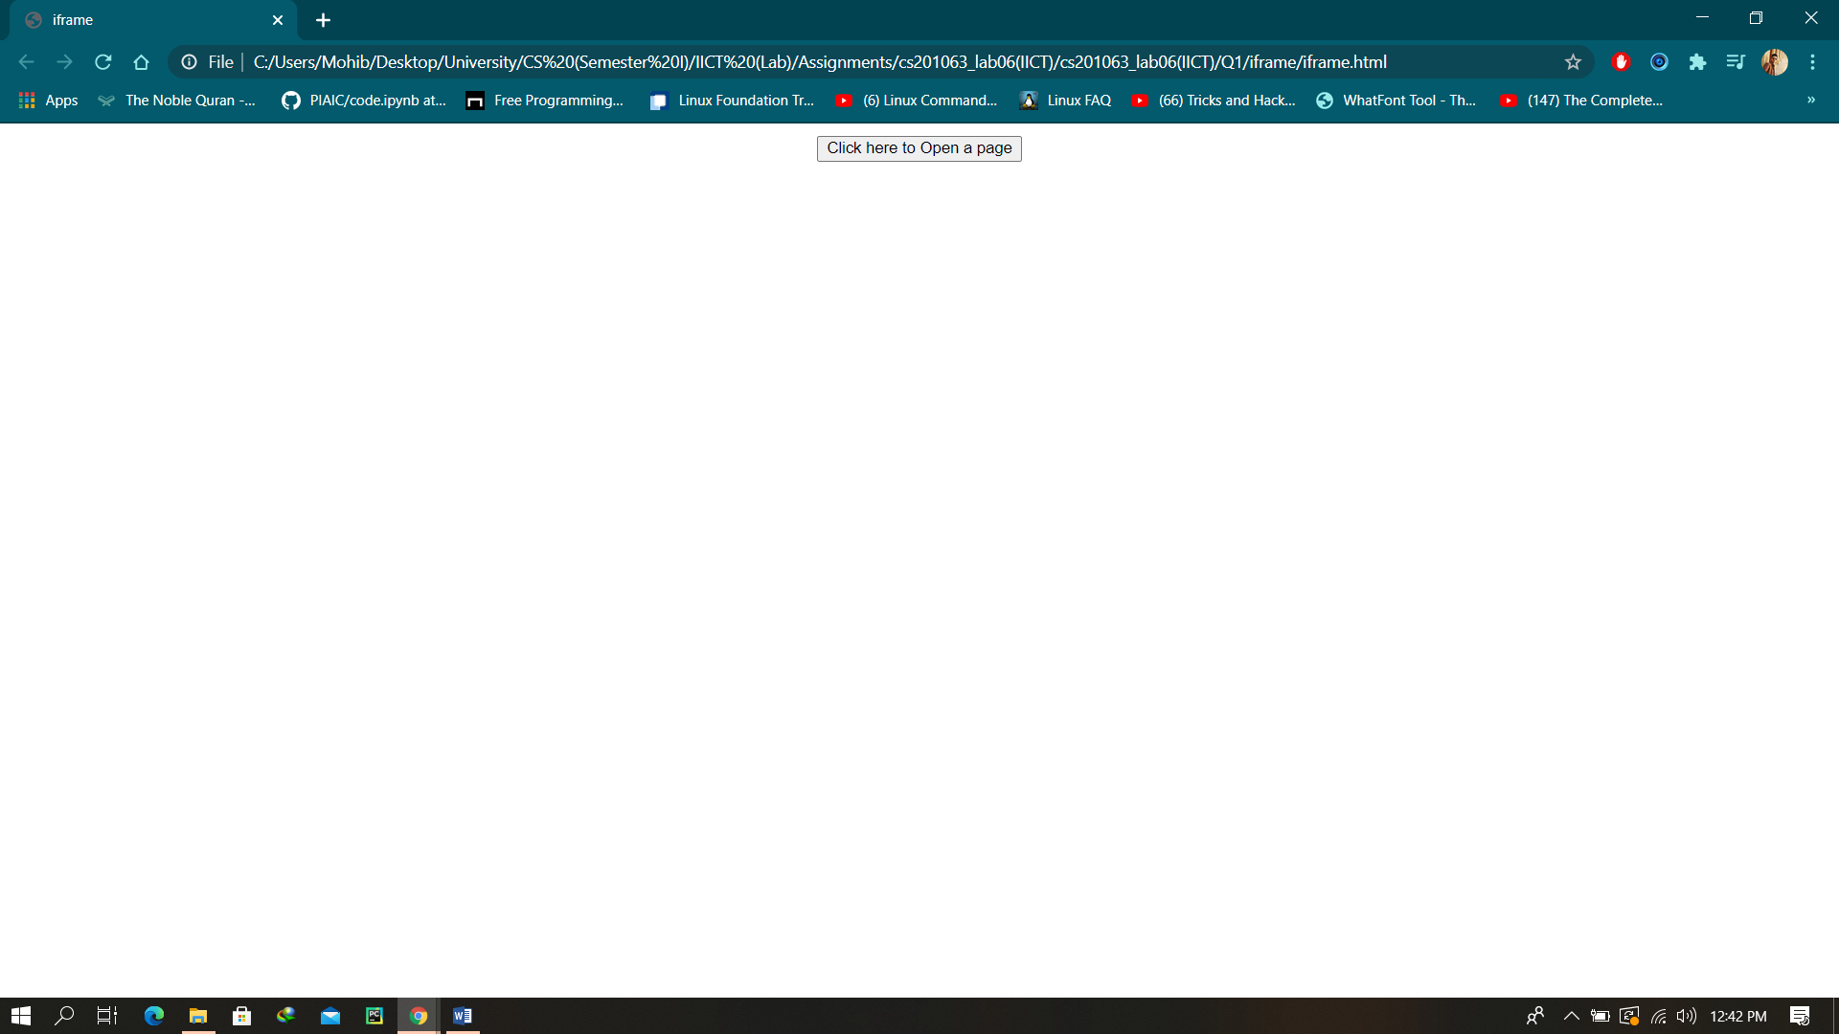

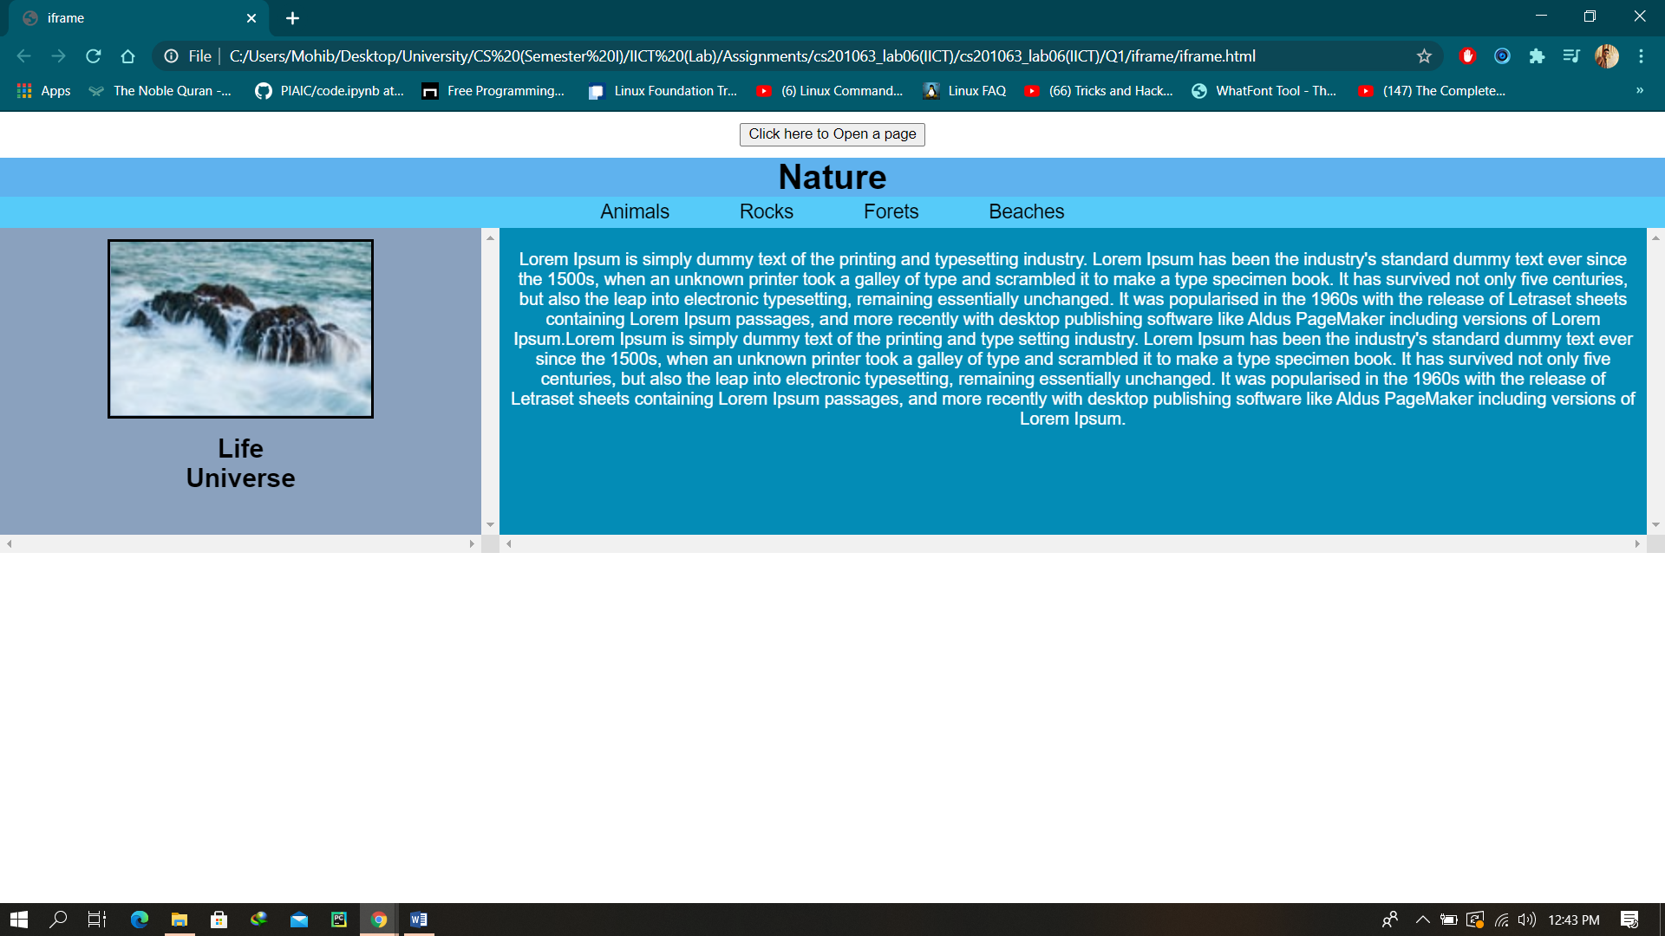

Question: 02 (A)

**HTML file:**

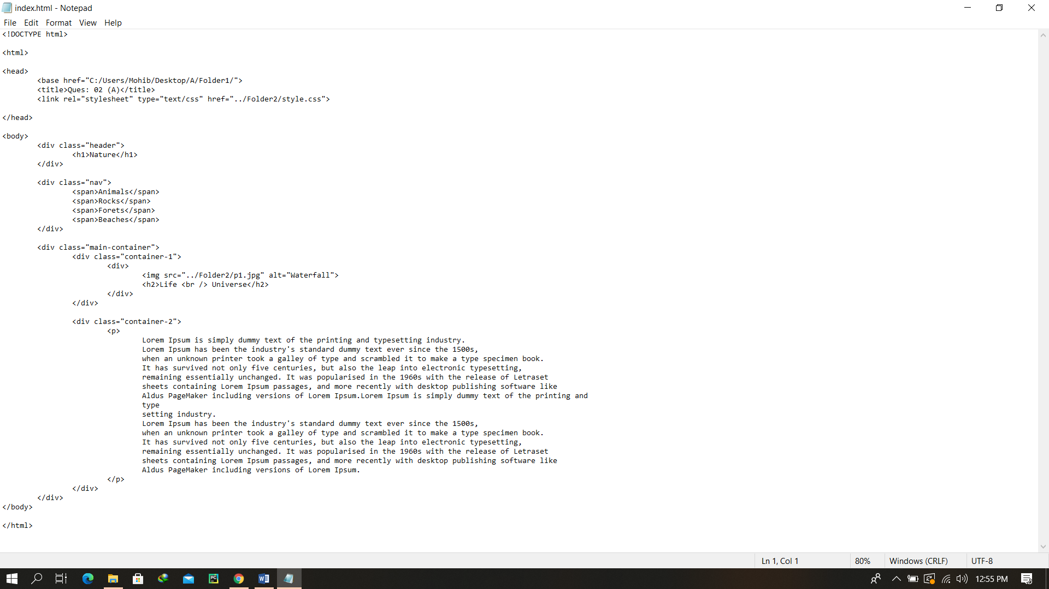

Final Output After rendering

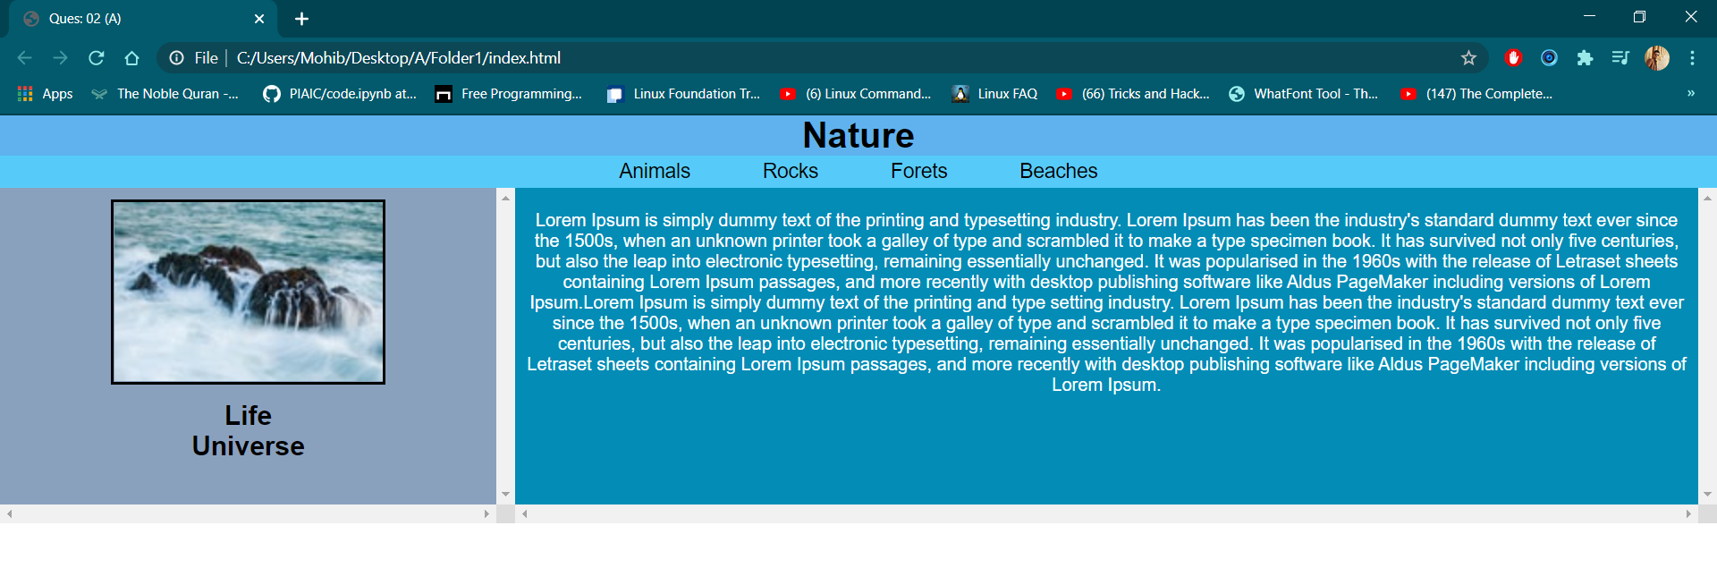

Question: 02 (B)

**HTML file:**

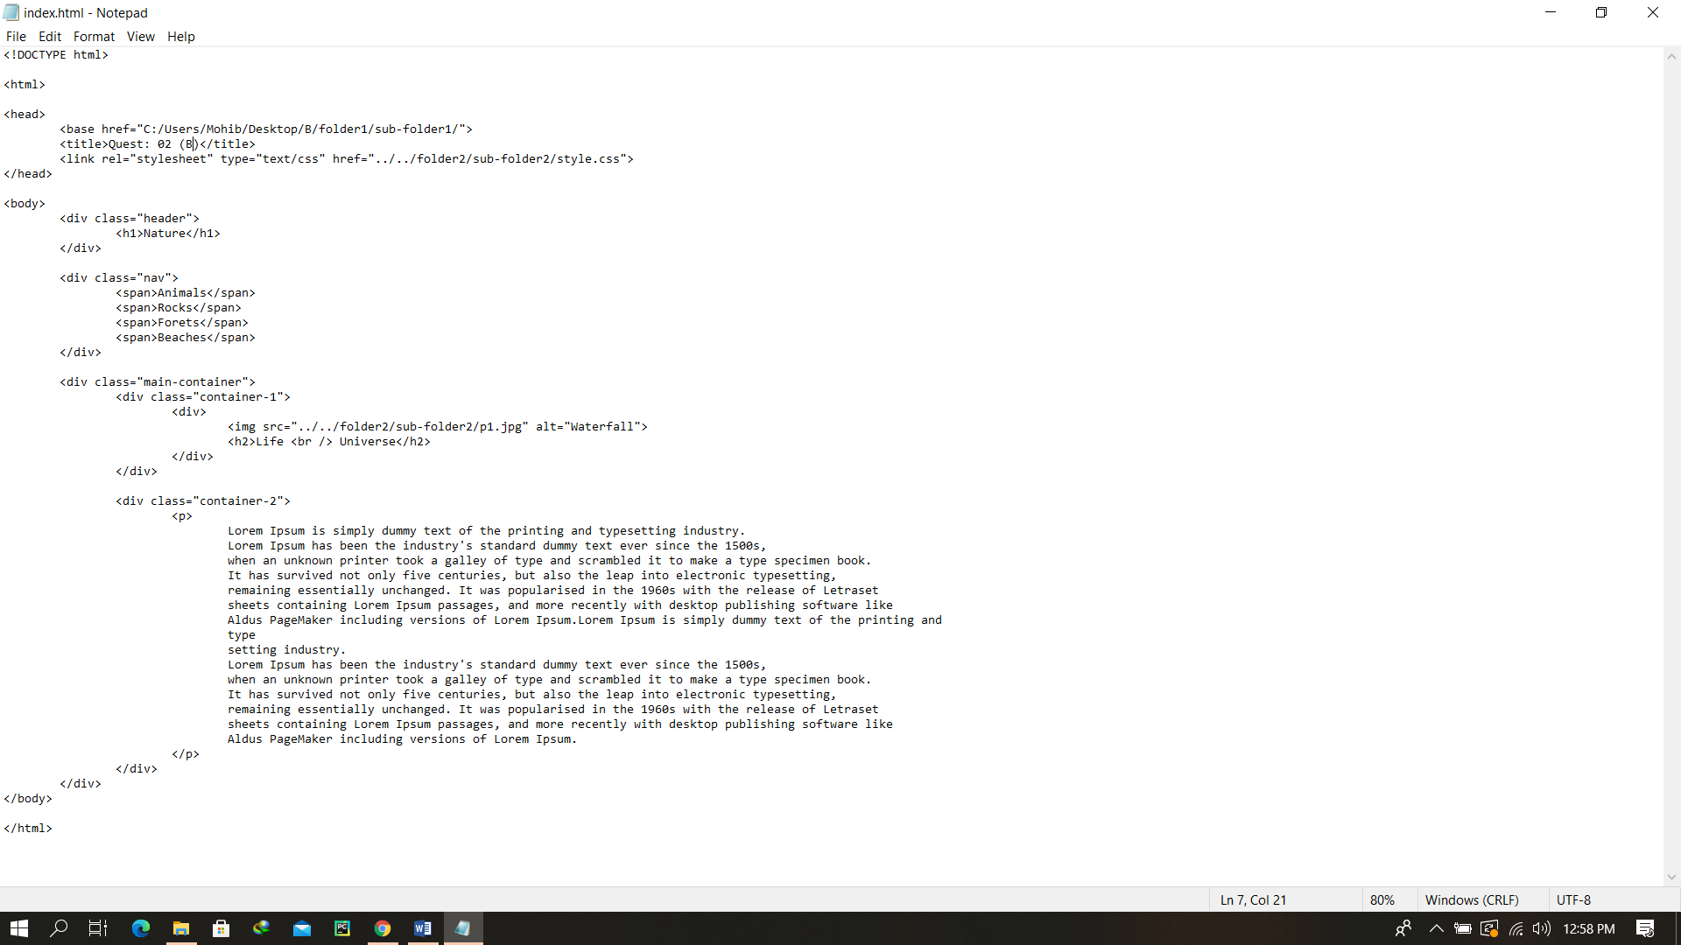

Final Output After rendering

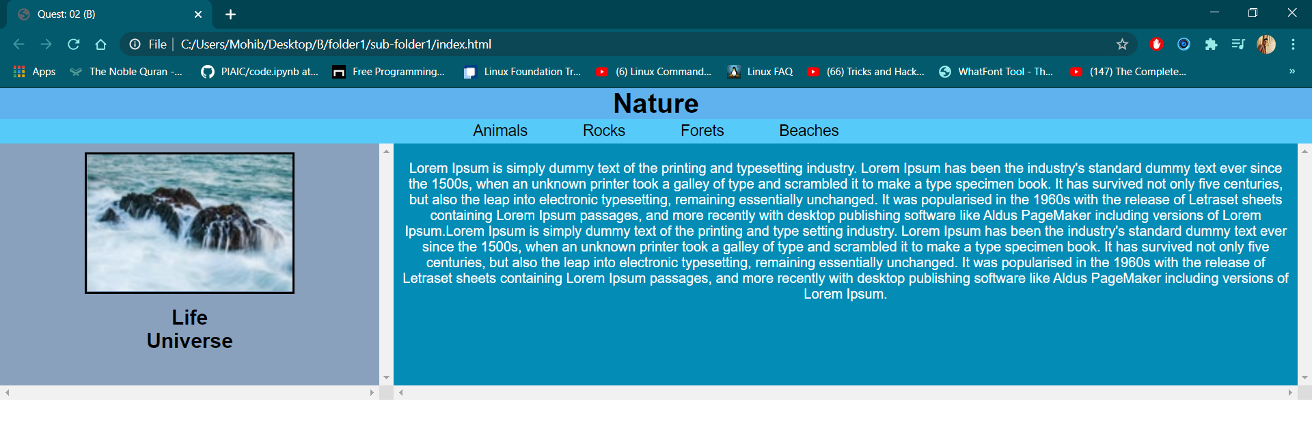

Question: 02 (C)

**HTML file:**

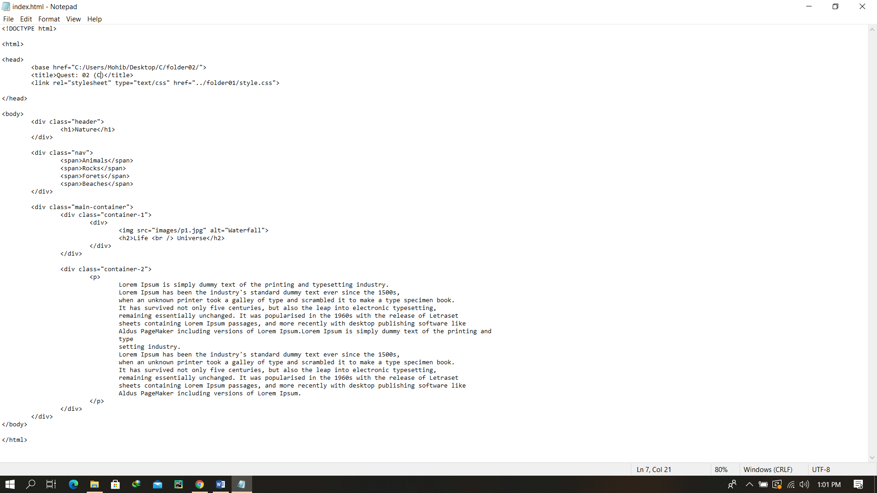

Final Output After rendering

