**­Introduction to Information & Communication Technology**

**Name: Mohib Ismail**

**Student Id: “cs201063_lab01”**

**Department & Section: CS-1B1**

**Question: 01**

**Coding:**

**<!DOCTYPE html>**

**<html>**

**<head>**

**<title>Biryani Recipe</title>**

**</head>**

**<body style="background-color: antiquewhite;">**

**<center>**

**<h1><u> <mark>Biryani Recipe</mark> </u></h1>**

**</center>**

**<center>**

**<u>**

**<h2>Biryani Ingredients</h2>**

**<h3> <em>If you want to cook Biryani you should need these items first.!</em> </h3>**

**</u>**

**</center>**

**<p style="line-height: 20px;">**

**<strong> 4 tablespoons vegetable oil, </strong>**

**<strong> 4 small potatoes, peeled and halved, </strong>**

**<strong> 2 large onions, finely chopped, </strong>**

**<br>**

**<strong> 2 cloves garlic, minced, </strong>**

**<strong> 1 tablespoon minced fresh ginger root, </strong>**

**<strong> ½ teaspoon chili powder, </strong>**

**<br>**

**<strong> ½ teaspoon ground black pepper, </strong>**

**<strong> ½ teaspoon ground turmeric, </strong>**

**<strong> 1 teaspoon ground cumin, </strong>**

**<br>**

**<strong> 1 teaspoon salt, </strong>**

**<strong> 2 medium tomatoes, peeled and chopped, </strong>**

**<strong> 2 tablespoons plain yogurt, </strong>**

**<br>**

**<strong> 2 tablespoons chopped fresh mint leaves, </strong>**

**<strong> ½ teaspoon ground cardamom, </strong>**

**<strong> 1 (2 inch) piece cinnamon stick, </strong>**

**<br>**

**<strong> 3 pounds boneless, skinless chicken pieces cut into chunks, </strong>**

**<strong> 1 large onion, diced, </strong>**

**<strong> 1 pinch powdered saffron, </strong>**

**<br>**

**<strong> 5 pods cardamom, </strong>**

**<strong> 3 whole cloves, </strong>**

**<strong> 1 (1 inch) piece cinnamon stick, </strong>**

**<br>**

**<strong> ½ teaspoon ground ginger, </strong>**

**<strong> 1 pound basmati rice, </strong>**

**<strong> 4 cups chicken stock, </strong>**

**</p>**

**<center>**

**<u>**

**<h2> How to Cook Biryani? </h2>**

**<h3> <em>Below are the steps you should follow to cook a delecious Biryani</em> </h3>**

**</u>**

**</center>**

**<p style="line-height: 22px;">**

**In a large skillet, in 2 tablespoons <strong>vegetable oil</strong> fry potatoes until <u>brown</u>, drain and**

**reserve the potatoes.**

**Add remaining 2 tablespoons <strong>oil</strong> to the skillet and fry onion, <u>garlic and ginger until onion**

**is soft and**

**golden</u>. Add chili, pepper, turmeric, cumin, salt and the tomatoes. Fry, stirring constantly for 5**

**minutes.**

**<strong>Add yogurt, mint, cardamom and cinnamon stick. </strong> Cover and cook over low heat, stirring**

**occasionally until the**

**tomatoes are cooked to a pulp. <u>It may be necessary to add a little hot water</u> if the mixture becomes too**

**dry**

**and starts to stick to the pan. <br>**

**When the mixture is thick and smooth, <strong><u>add the chicken pieces and stir well to coat them with the**

**spice**

**mixture</u></strong>. Cover and cook over very low heat until the chicken is tender, approximately 35 to**

**<u>45 minutes</u>.**

**There should only be a <u>little very thick gravy left when chicken is finished cooking</u>. If necessary cook**

**uncovered for a few minutes to reduce the gravy. <br>**

**<u>Wash rice well and drain in colander for at least 30 minutes</u>. <br>**

**In a large skillet, heat vegetable oil (or ghee) and fry the onions until they are golden. Add saffron,**

**cardamom, cloves, cinnamon stick, ginger and rice. Stir continuously until the rice is coated with the**

**spices. <br>**

**In a medium-size pot, heat the chicken stock and salt. <u>When the mixture is hot pour it over the rice and**

**stir well.</u> Add the chicken mixture and the potatoes; gently mix them into the rice. Bring to boil. Cover**

**the**

**saucepan tightly, <strong>turn heat to very low and steam for 20 minutes.</strong> Do not lift lid or stir while**

**cooking.**

**Spoon biryani onto a warm serving dish. <br>**

**</p>**

**<center>**

**<u>**

**<h3> <em>Here are the 3 best recipes of Biryani you should also check.</em> </h3>**

**</u>**

**</center>**

**<p>**

**<a href="https://www.sooperchef.pk/bombay-biryani-recipe-urdu/" target="_blank">Sooperchef</a> <br>**

**<a href="https://hamariweb.com/recipes/chicken_biryani_rid3464.aspx" target="_blank">Hamari Web</a> <br>**

**<a href="https://norecipes.com/chicken-biryani-recipe/" target="_blank">No Recipes</a> <br>**

**</p>**

**</body>**

**</html>**

**Coding Screenshot:**

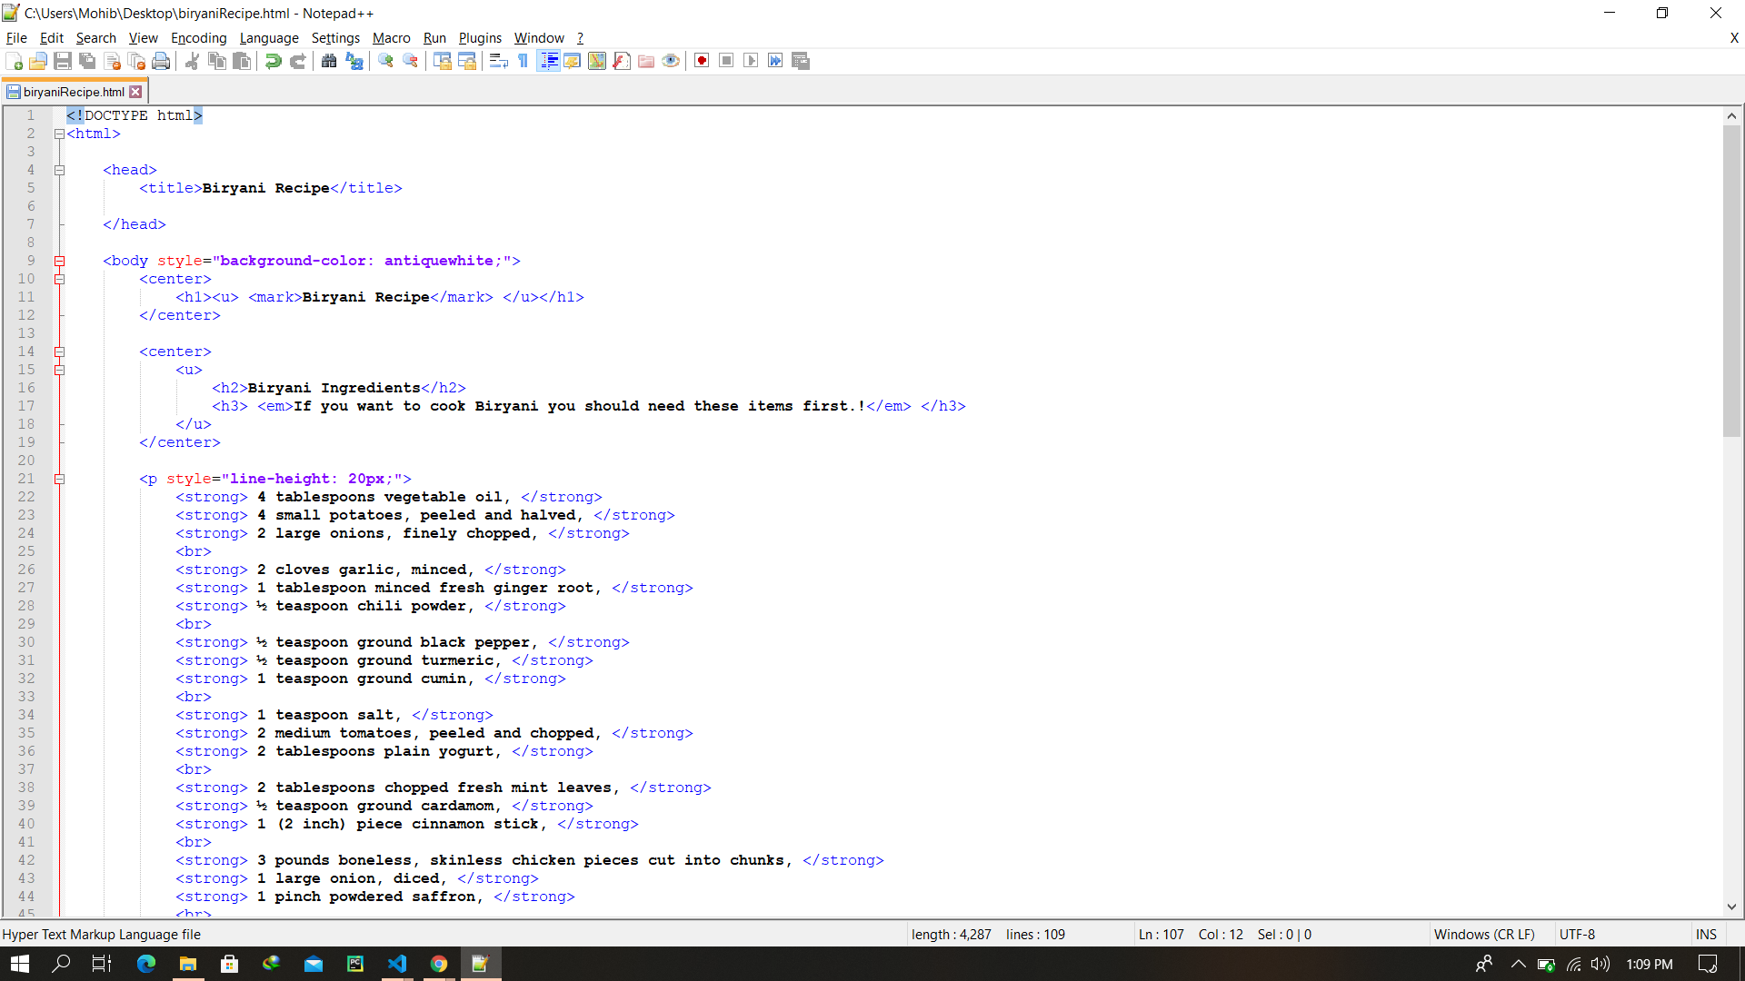

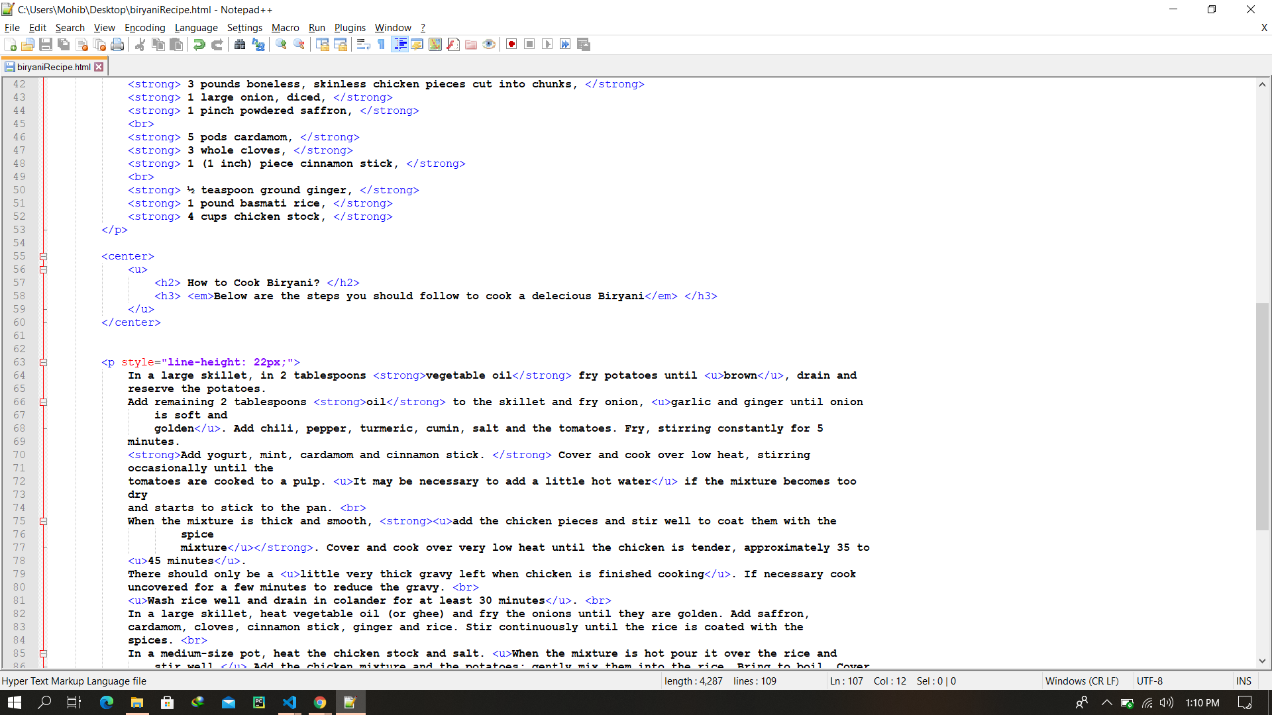

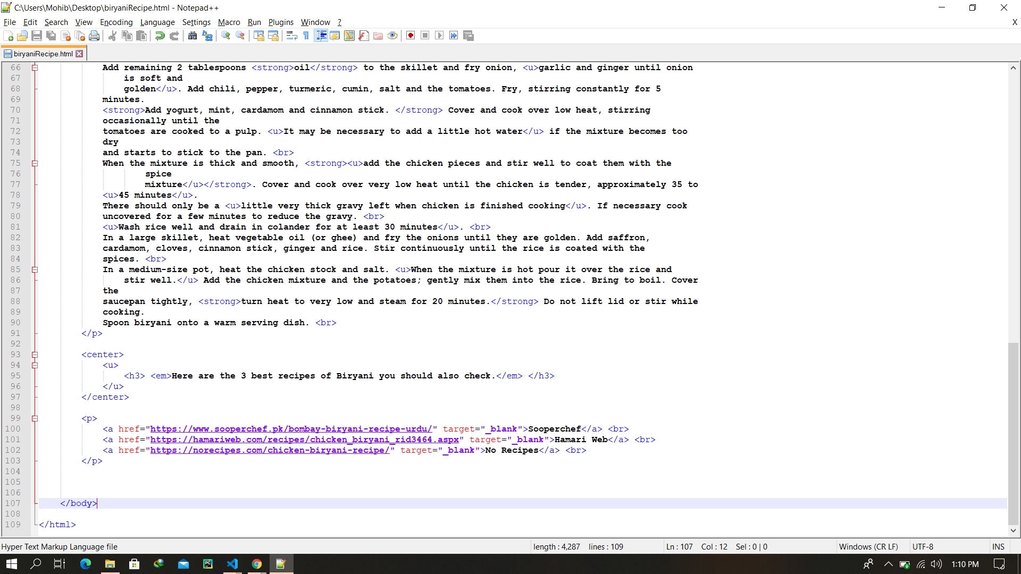

**Final Output of Question: 01 after rendring:**

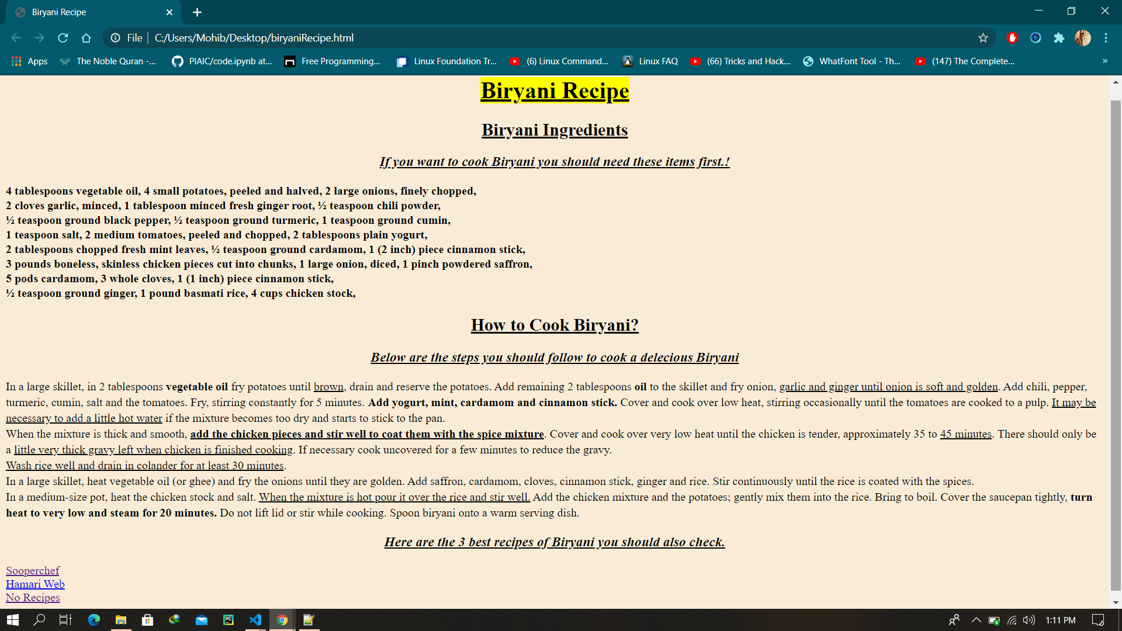

**Question: 02**

**Coding:**

**<!DOCTYPE html>**

**<html>**

**<head>**

**<title>Lab Assignmet: 01</title>**

**</head>**

**<body>**

**<dl>**

**<dt> <u>Products:</u> </dt>**

**<dd>**

**<ul style="list-style-type: upper-alpha;">**

**<li> <mark> <u>Fresh Produce: </u> </mark> </li>**

**<ul style="list-style-type: disc;">**

**<li>Blueberry</li>**

**<li>Capsicum</li>**

**<li>Fenugreek</li>**

**<li>Cilantro</li>**

**</ul>**

**<li> <mark> <u>Snack Foods: </u> </mark> </li>**

**<ul style="list-style-type: lower-roman;">**

**<li> <u> <strong>Choco</strong> </u> </li>**

**<ul>**

**<li>Crepe Choclate wafers</li>**

**<li>Cadbury Dairy Milk</li>**

**<li>Crunchy Oats & Honey Bar</li>**

**<li>Kitkat Crunchy</li>**

**</ul>**

**<li> <u> <strong>Snake</strong> </u> </li>**

**<ul type="circle">**

**<li>Cheez-it</li>**

**<li>Doritos</li>**

**<li>Popcorn</li>**

**</ul>**

**</ul>**

**</ul>**

**</dd>**

**</dl>**

**</body>**

**</html>**

**Coding Screenshot**

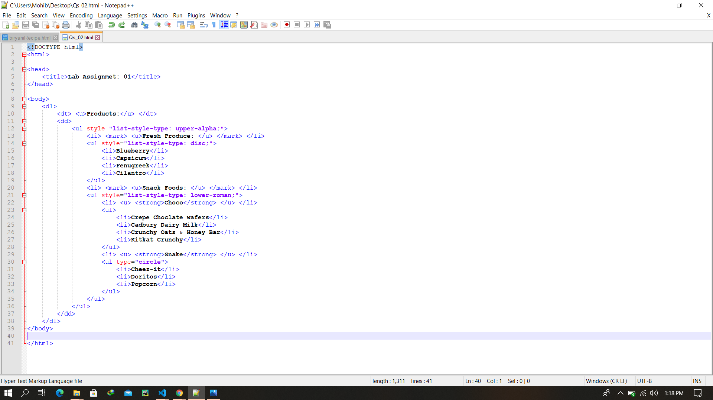

**Final Output of Question: 02 after rendring:**

