|  |
| --- |
| Information software technology |
| Web App |
| Design Documentation |
|  |
| **Jack Gifford** |
| **10/20/2014** |

|  |
| --- |
| [Type the abstract of the document here. The abstract is typically a short summary of the contents of the document. Type the abstract of the document here. The abstract is typically a short summary of the contents of the document.] |

Journal

# 17/10/14

I was originally going to build a static website using Dreamweaver, mainly because the assignment doesn’t require anything more than that. However I also need to add my calculator to the assignment, the easiest way to do this is to create an ASPX file and then port the code over from the original Win32 project, I don’t think there will be any issues with this. I’m using two frameworks, Bootstrap because it’s going to allow me to make my website look great without writing a lot of CSS, it makes it easy to write great looking sites on mobile too. I’ll also use JQuery, I don’t know a lot of JavaScript so I’d rather reference code that already works, I want to make something’s interactive like the navbar on mobile sites. I’m using Visual Studio and the ASP.NET framework too, again for simplicities sake, it’s than rewriting the code in python and it means I can work on it from school. Today I designed the site map, this keeps my code clean and concise throughout, files are grouped together, and it would make it look nicer on servers too. I started implementing my calculator. I redesigned it to look nicer on the web and make it easier to use on touch based phones, at large sizes the calculator is spread out but on small devices the content is small and placed together neatly, this makes it look and function great on small and large devices. I also created a Git Repository for my code which can be accessed at bitbucket.org/imonchair/workingwebapp, I used Git because of its version control, should I need to revert back at any point there are no issues.

# 18/10/14

I finished copying over the files from the Win32 EXE and of course it doesn’t work, I don’t know why, most of it works, as in everything but the processing works, if I press 9 then the string “9” is displayed, it’s just when you press equals nothing happens. I’m not entirely sure what the issue is, maybe I’m missing a Library Reference, or the code isn’t compiling server end? It’s extremely frustrating, visually it looks great but only on large screens, I’m going to rewrite it into a table.

Issue:

HTML Data looks like garbage

Solution:

I added a new branch so called now with tables! If the tables works I’ll merge it back into master otherwise, I’m just going to delete it. Tables will work, Bootstrap will make them look great too!

Fix?

I rewrote the script with tables inside each column, now the tables pop from left to right on big screens and stack on small screens, the code is also much cleaner as we now use one row instead of 4 and each set of buttons is grouped together, the buttons looked to far apart, so the left most entries are aligned to the right of their table and the ones on the right are at the right most side of their table.

At the end of the today I’m still stumped as to why that calculator script won’t work, I tried to find a solution at stack overflow but was still unable to fix it. I might try and work on some other pages, and then come back to it, I plan to finish designing the front page and school work page by tomorrow night.

# 19/10/14

I started watching the essential ASP.NET Training at Lynda.com. I ran out of time today, working on other assignments, so I pushed the finish of the school work page back to Tuesday.

# 20/10/14

While I’m working out a solution for the calculator.aspx page I’m going to start work on the other pages, I started with work.html, this is a resource filled paged with all my assignments from the year as well as my OneNote entries, I have an intro paragraph followed by tables, which are filled with links to a separate folder named Assignments, which has subfolders of the subjects name:

* Assignments
  + English
  + IST
  + Science
  + Etc

The page is responsive and looks quite good, on smaller devices the tables stack on each other.

# 21/10/14

I did some tidying and commenting on the webpages today, all of the pages connect to each other and everything is performing as it should. I am going to start on the code page today which will provide links to all of my projects this year, this is easy because they are all hosted on GitHub and BitBucket, only downside is the user will need to know how to use Git, I must write a tutorial, or at least provide a link to one.

I finished the basic structure of the code page in class today, it’s quite simple, there are 3 tables one for Python, one for C# and one for C++, I need to dig up some old code, that I wrote earlier this year from the NAS at home though, as the C++ table will be lacking. I found the Fork Me on GitHub BBCode so I added that too I put it at the bottom so the website can continue to function whilst that loads, this makes the page feel more responsive. I just need to add some links to the GitHub GUI app and the sourceTree App, so the user has the ability to clone all the projects, I’m going to provide a link to all the files on this page too so Ms Hadley can mark it.

I looked at hosting options today, I’m thinking about using Azure, I’ll still need to provide Ms Hadley the source but this way I can ensure the calculator.aspx page runs as it should, Microsoft has a free option, providing it doesn’t exceed more than 1Gb of bandwidth, that’s not an issue.

I need to decide how I want the index page to look and write the final page, maybe I could put a sitemap? I also need to decide how I want my footer to look on each page, I’m currently working on a mock up in Photoshop, I don’t like the bootstrap footer so I’ll need to make some extra entries to custom.css

# 28/10/14

I haven’t really done much with the site in the last week, I’ve been busy working on other assignments, designing a commerce solution for a friend, and running the Wiki of my parent’s business. I’ve done a few things to the site like changing the way the work.html file looks, instead of columns each item in this page is now a thumbnail, it looks a little bit nicer. I also added a slider for graphics on the calculator.aspx page this is used to showcase the native calculator that was built earlier this year, screenshots are taken with Puush. The site is really coming together now. I also revamped the entire index.html page; this now uses a jumbotron and three columns.

# 31/10/14

One week to go, I’m worried I won’t be able to get the calculator finished, I’ve placed a sign stating it’s in beta, I recorded a video on how it operates and I created a manual for the win32 app, these are available as YouTube videos and downloads respectively.

4/11/14

The navbar is slicker now, contrasts nicely with the rest of the page. I added two pages, one on cryptography a subject I’m really interested in, the other is an empty shell on hobbies, I’m yet to write anything in it. I miss Git, not being able to used it on the school laptop is a huge pain, I don’t want to have to reupload files all the time.

# 5/11/14

All Done! The website is finished so I’m pretty happy everything works as it should, now I just have to get it running on Azure.

# 6/11/14

All running at jgif.azurewebsites.net/Pages it looks great and I’m happy with it

Design

# Sitemap

* Index.html
* Calculator.aspx
  + Calculator.cs
* Code.html
* Crypto.html
* Social.html
* Work.html
* Static
  + CSS
    - Bootstrap.min.css
  + js
    - Bootstrap.min.js
    - Jquery.min.js
* Img
  + Code

This is the simplest way; it is easy to reference all my required files such as static/css/bootstrap.min.css

# Sketches

I sketched each webpage, there are some variation between sketches and final code, but overall I aimed to allow the design to look as close as possible, I sketched both desktop and mobile websites:

Index

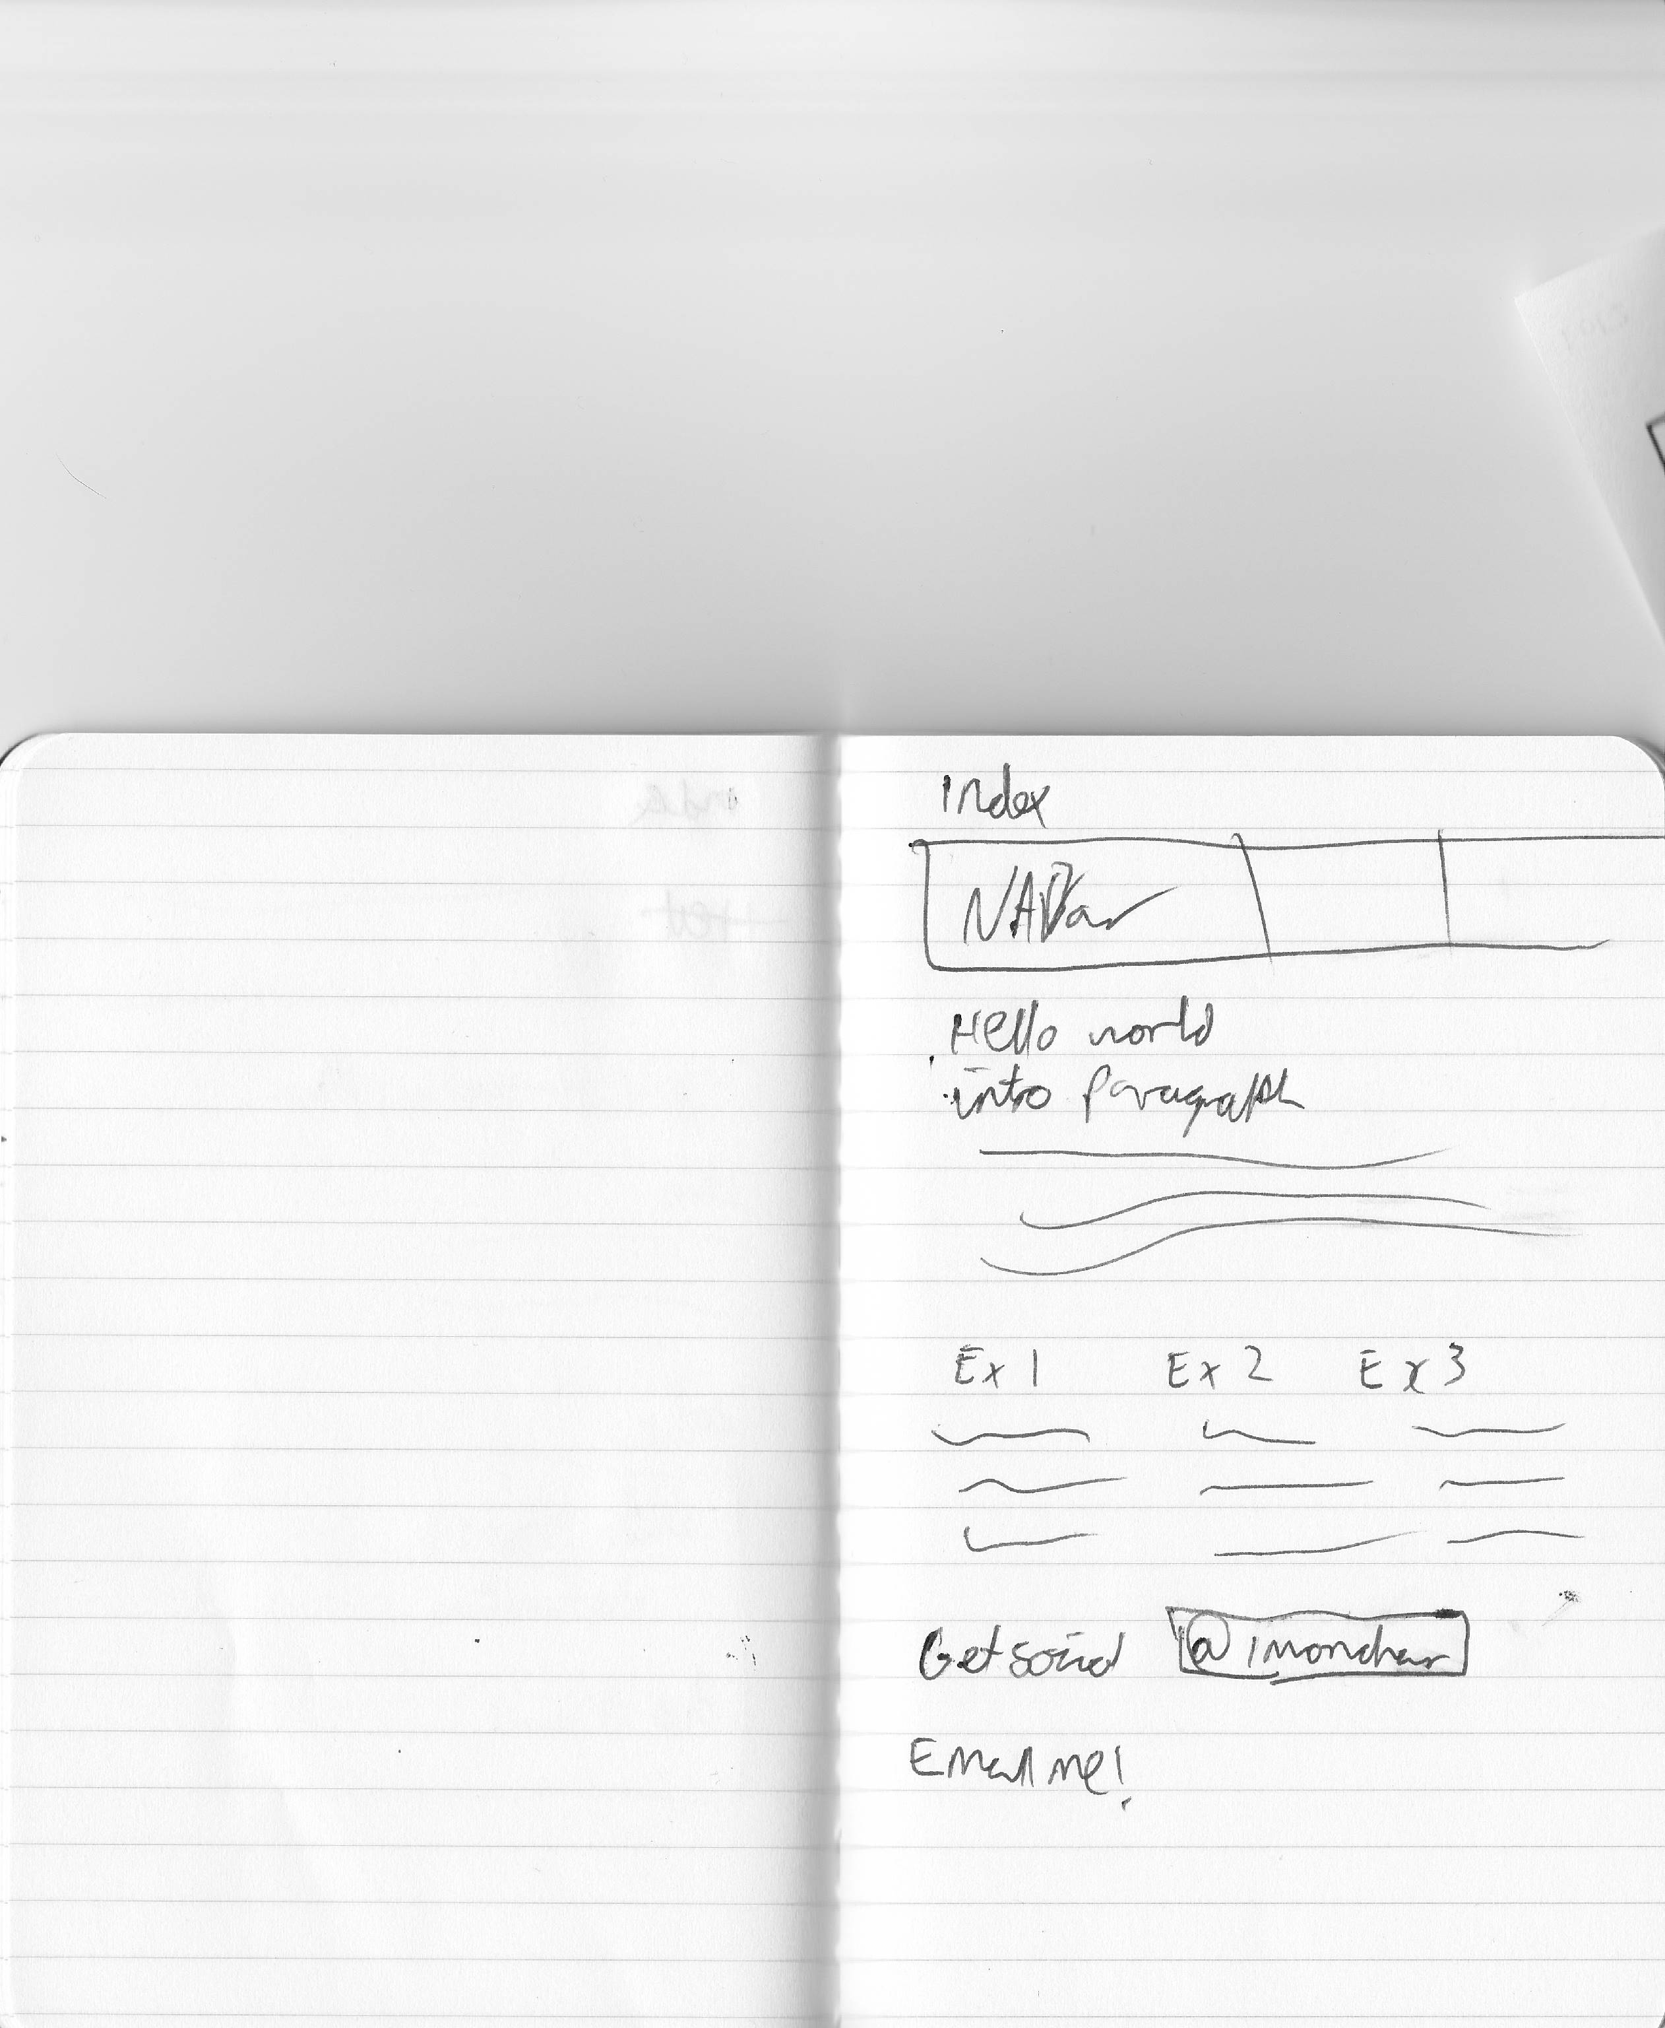

## 

## School Work

## C:\Users\Jack\AppData\Local\Microsoft\Windows\INetCache\Content.Word\IMG_20141106_0002.jpg

## Calculator

## 

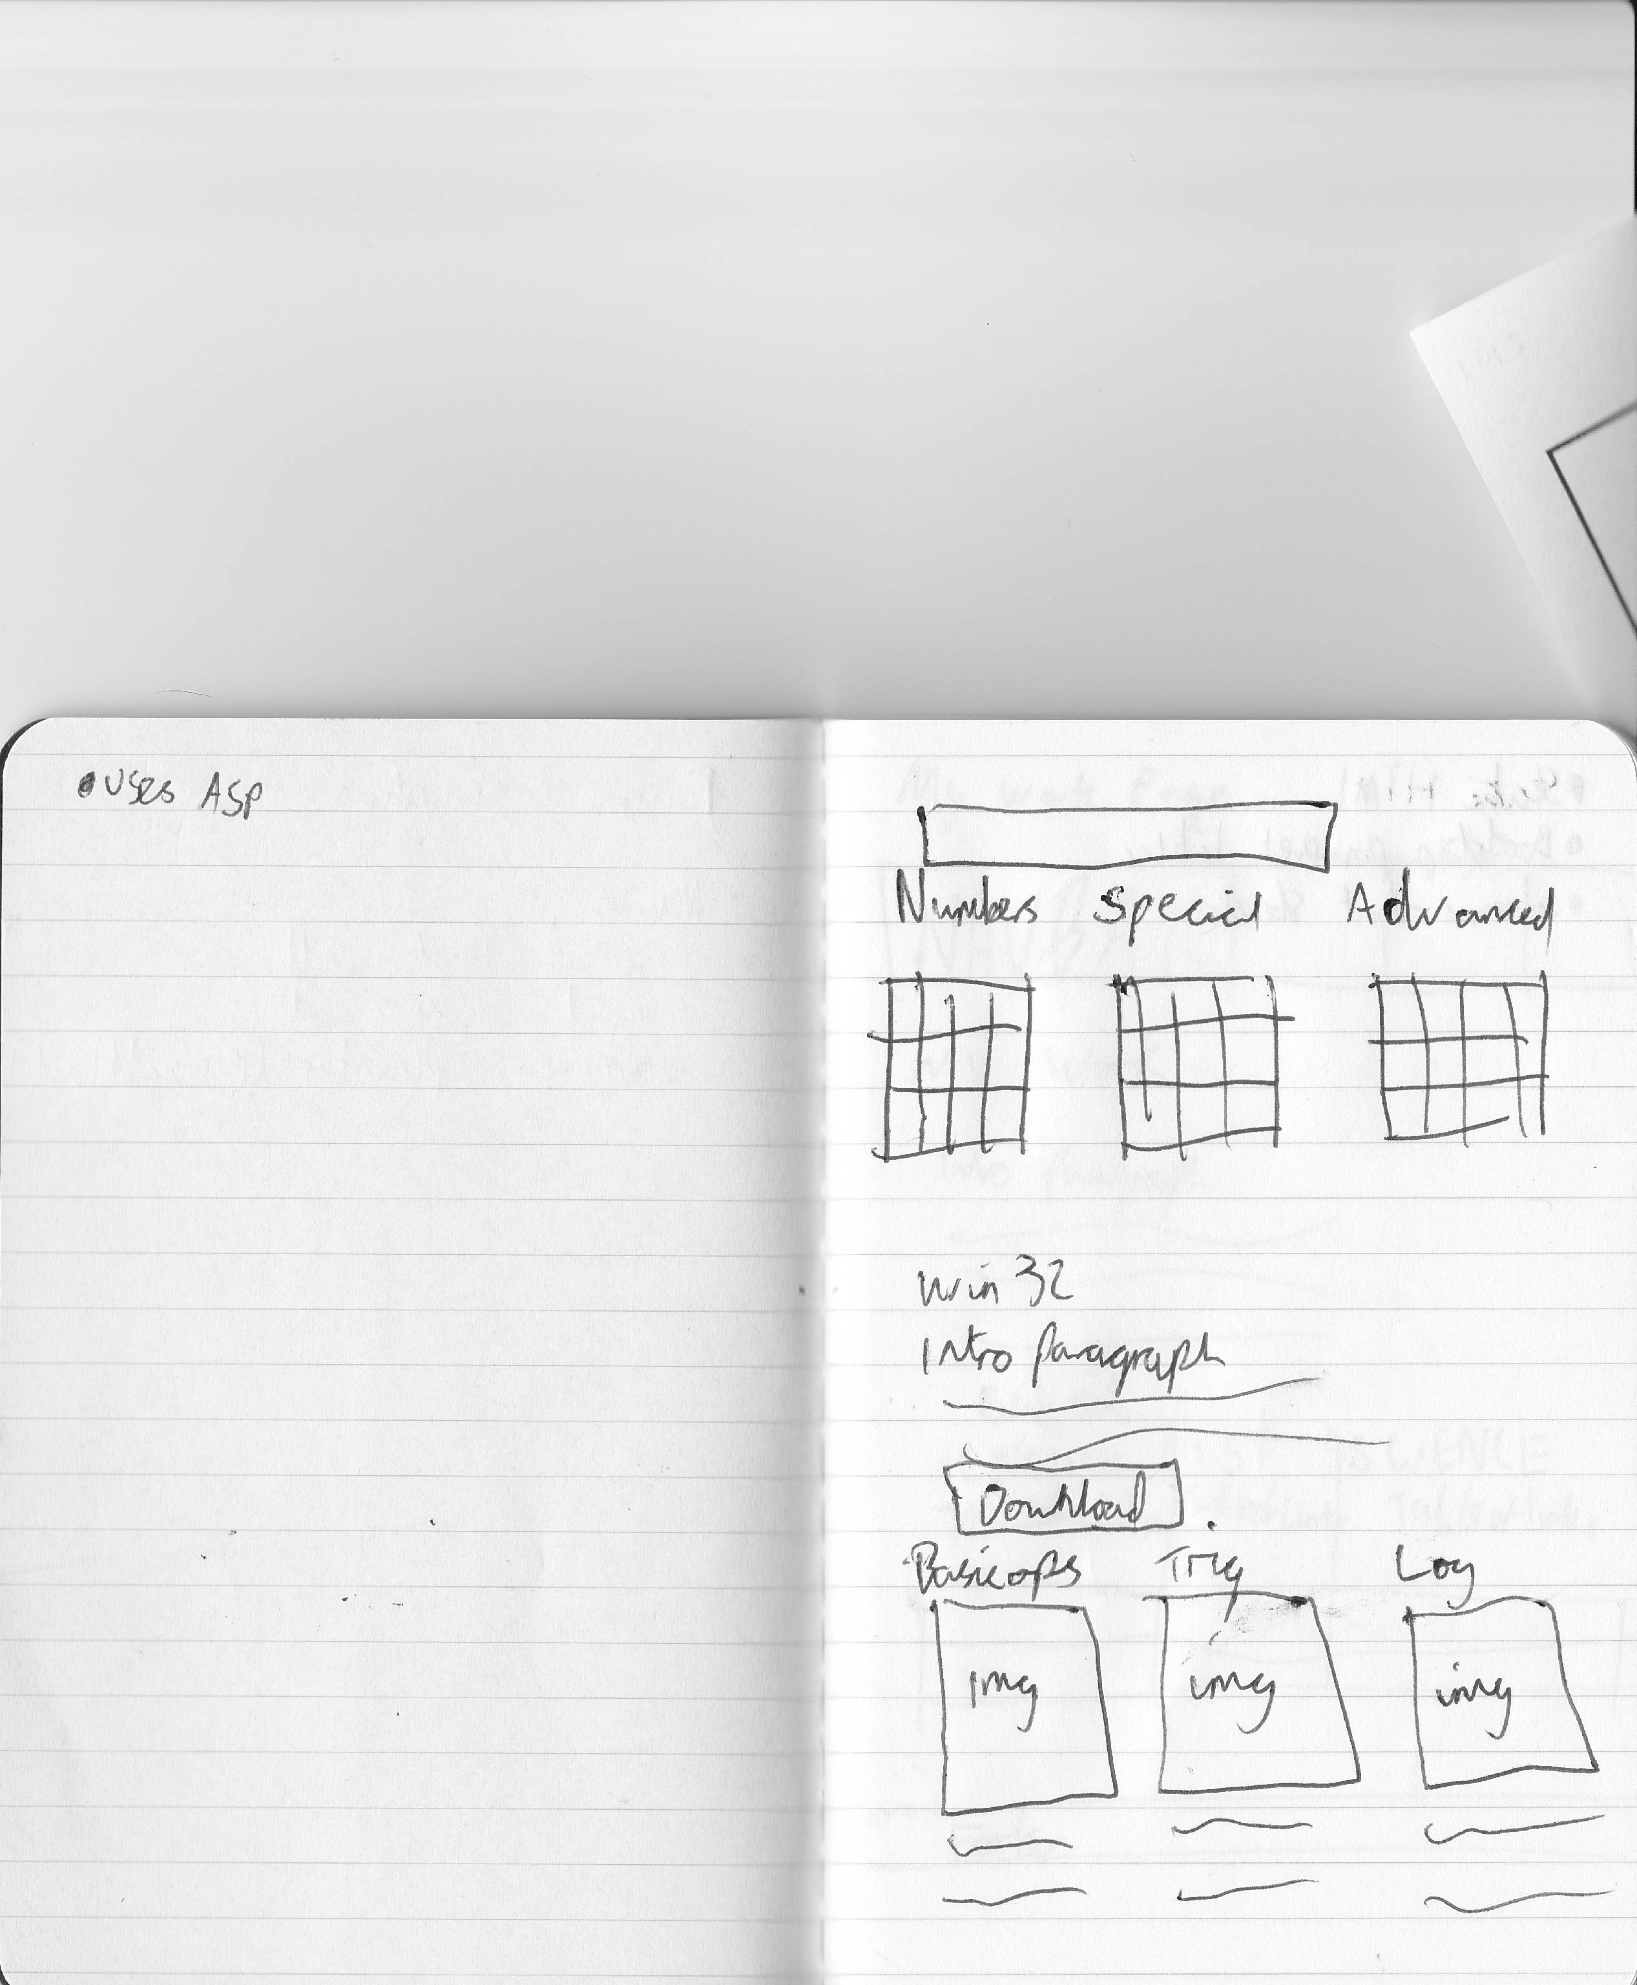

## Code

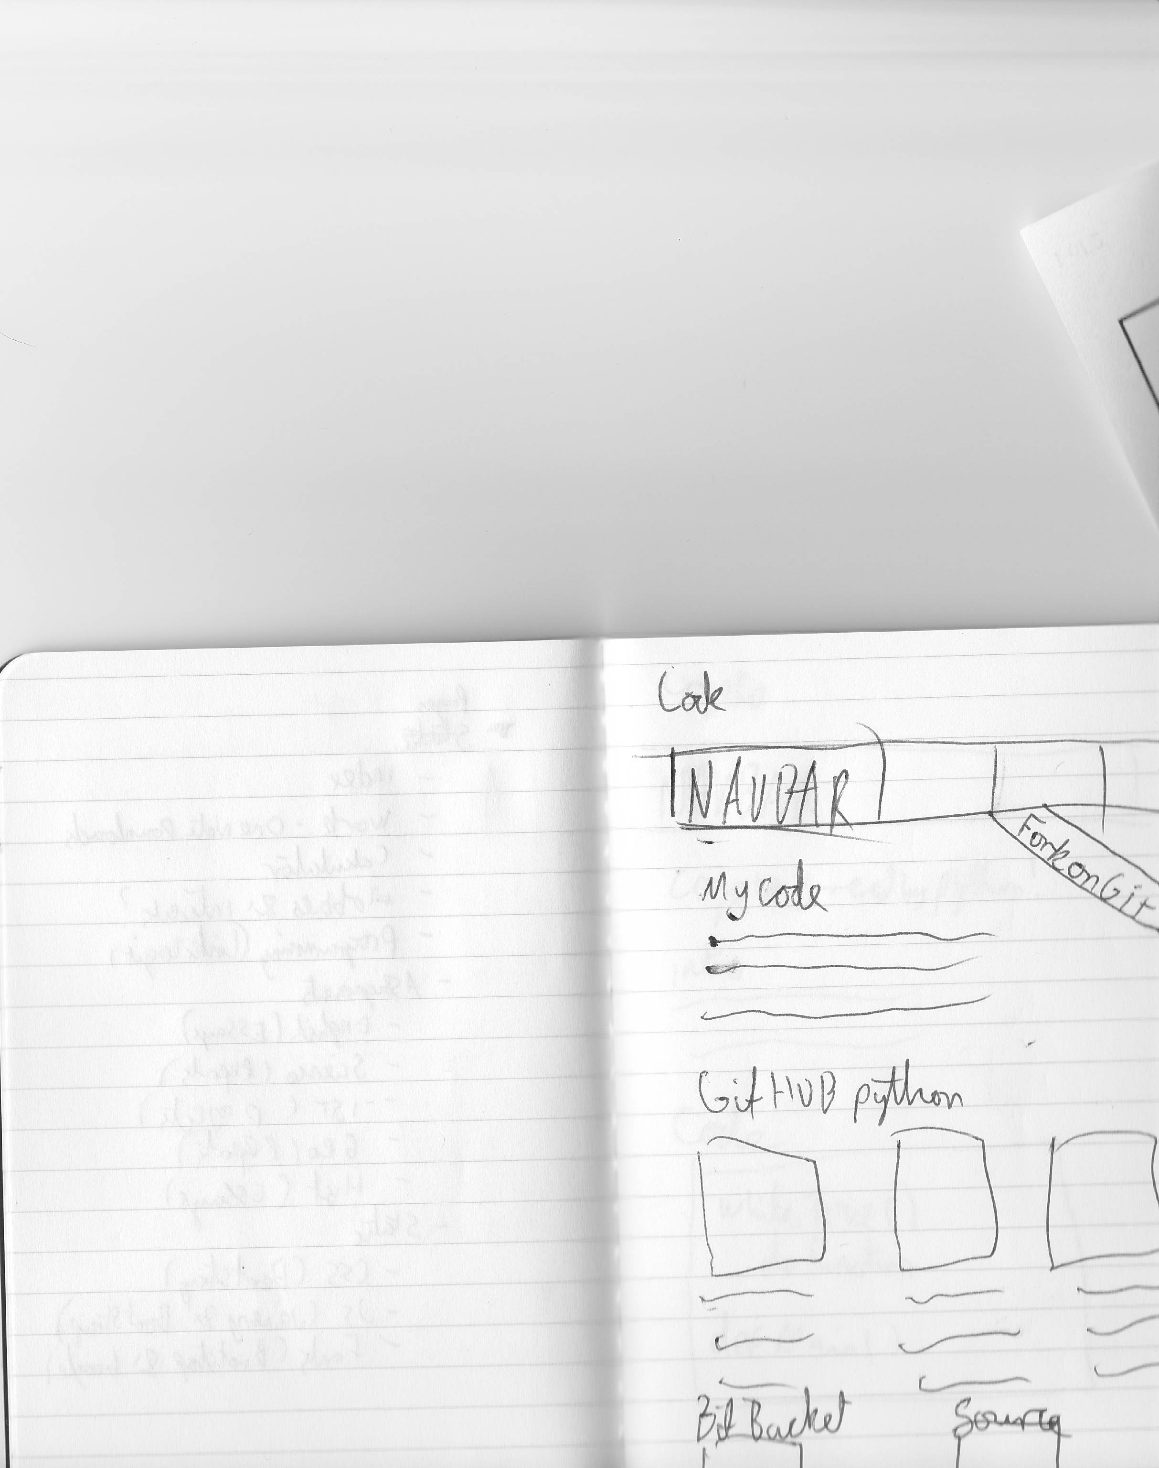

## Crypto

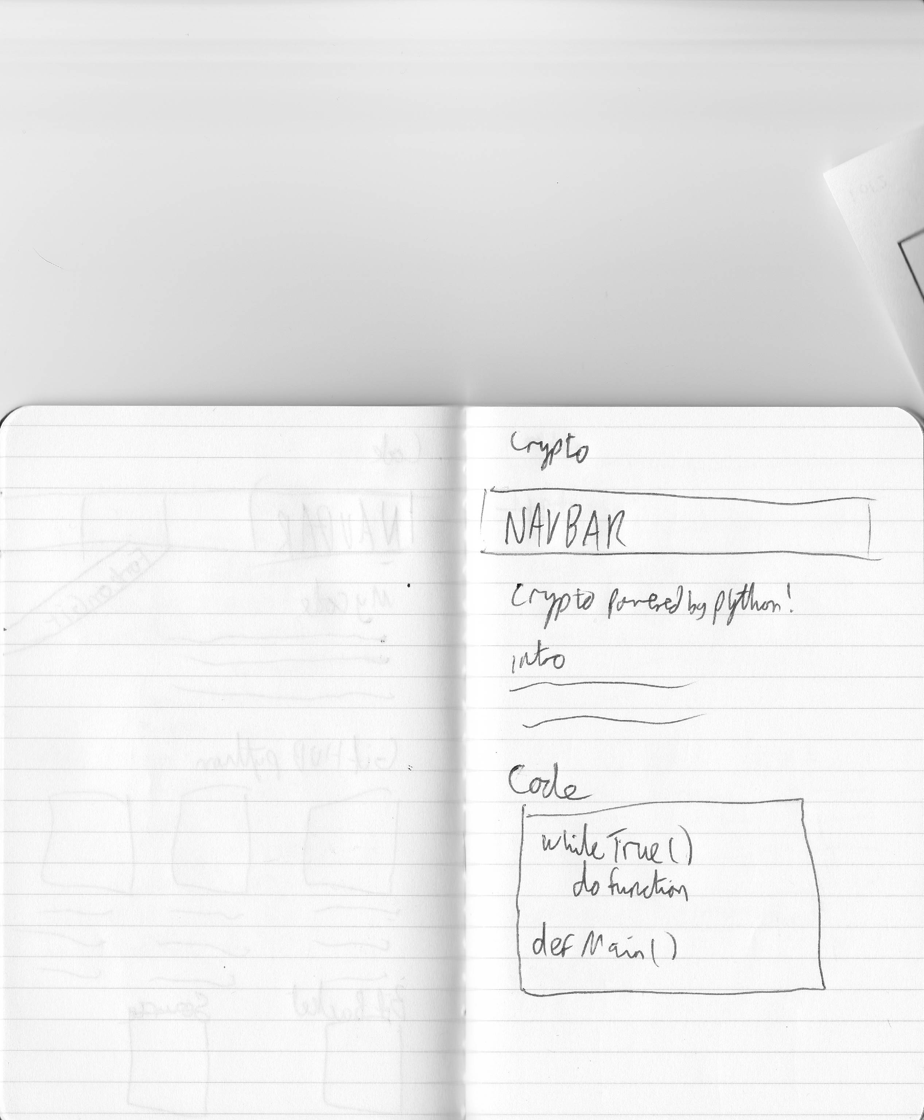

# HTML

Most of my pages are .HTML with the exception of the calculator page which is .ASPX and .ASPX.CS, this is the same as .HTML except is able to work with the Common Language Runtime and other Microsoft Software, as the rest of my webpages are static and do not rely on Microsoft’s framework I’m using .HTML files. Flowcharts

I needed a flowchart to figure out how the calculator.aspx file would act:

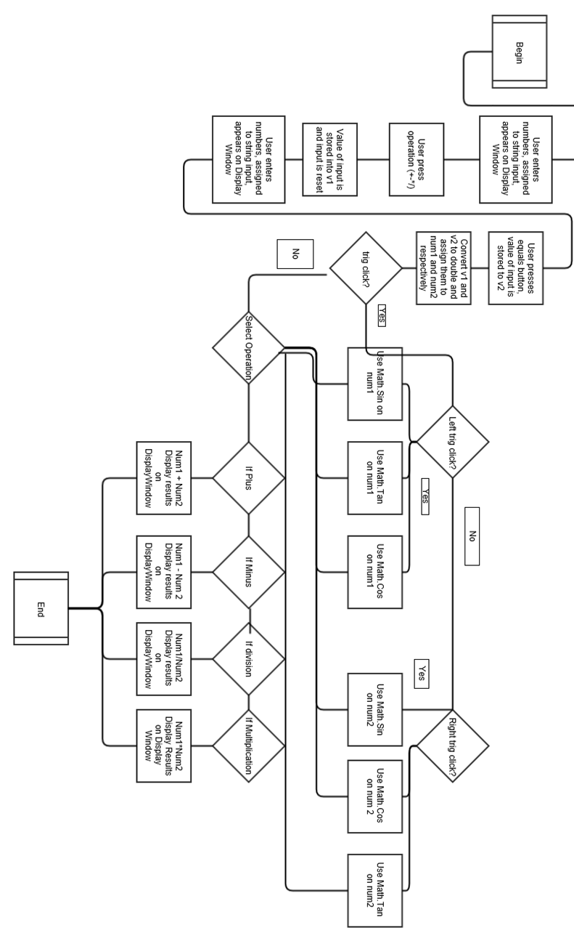

Frameworks

# Bootstrap

As we only have three weeks to complete the assignment all animation and styling is being handled with Bootstrap, I’ve used Bootstrap in the past, it is incredible for building great scalable websites fast, since it’s responsive I can focus development on a mobile website and it will continue to look great on both tablets and desktops with very little modification of the code.

# ASP.NET

ASP.NET is Microsoft’s framework for building web applications, I would prefer to write the webpage using Python, however since Python is not running on the school machines and I have already written a calculator in C# and the .NET framework, it makes the most sense to continue to use ASP, I have had a couple of issues getting it to perform correctly, I am slowly following the ASP.NET tutorials on Lynda.com.

# JavaScript

Whilst disgusting it’s an important part of websites, and I’ll need it for dropdown menus on mobile sites, I’m using the JQuery Framework so I can just reference the parts I need, instead of downloading it I’ve referenced the JQuery.min.js file off of the internet, this cuts down on loading times providing the user has visited another site that has JQuery enabled.