# Markdown

Nota:

Markdown is not LaTeX.

To compile me, run this in R:

library(knitr)  
knit('001-minimal.Rmd')

## code chunks

A *paragraph* here. A code chunk below (remember the three backticks):

1+1

## [1] 2

.4-.7+.3 # what? it is not zero!

## [1] 5.551115e-17

## graphics

It is easy.

plot(1:10)

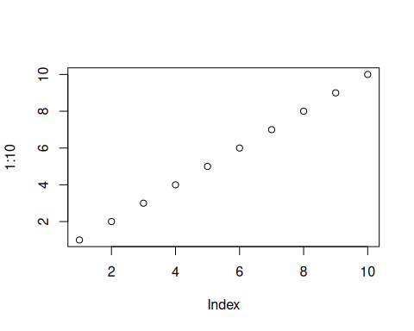

hist(rnorm(1000))

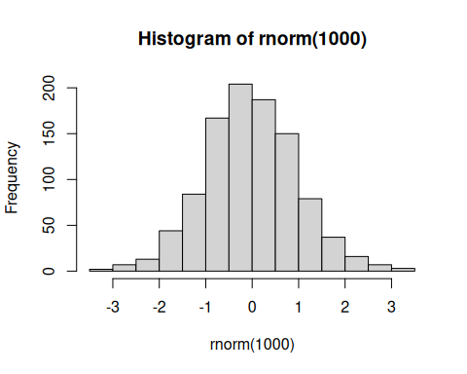

## inline code

Yes I know the value of pi is 3.1415927, and 2 times pi is 6.2831853.

## math

Sigh. You cannot live without math equations. OK, here we go: $α+β=γ$. Note this is not supported by native markdown. You probably want to try RStudio, or at least the R package **markdown**, or the function knitr::knit2html().

## nested code chunks

You can write code within other elements, e.g. a list

1. foo is good

* strsplit('hello indented world', ' ')[[1]]
* ## [1] "hello" "indented" "world"

1. bar is better

Or inside blockquotes:

Here is a quote, followed by a code chunk:

x = 1:10  
rev(x^2)

## [1] 100 81 64 49 36 25 16 9 4 1

## conclusion

Nothing fancy. You are ready to go. When you become picky, go to the [knitr website](http://yihui.org/knitr/).