Procedural Transparency in AI Agents:
A Relevance-Theoretic and Vygotskian Framework for Trust Calibration
A Position Paper

Abstract
AI systems increasingly provide transparency information to help users assess the reliability of generated content. Current approaches—citation systems, confidence scores, source percentages—share a common paradigm: providing users with quantitative or referential information about sources, leaving the cognitive work of interpretation to the user. We argue that this paradigm is fundamentally misaligned with how humans process communicative signals. Drawing on Sperber and Wilson’s Relevance Theory and Vygotsky’s theory of mediated cognition, we propose procedural transparency: a system of colour-coded indicators that guide users on how to process each section of an AI response, rather than adding quantitative content about sources. We present a three-level system—Verified data, AI Commentary, and Unverified—grounded in communicative pragmatics and developmental psychology. We provide theoretical justification for why three levels are necessary and sufficient, and illustrate the framework through TOMMI, a multi-agent research platform developed by the authors and deployed at the University of Málaga.. We argue that this approach improves trust calibration and user experience by reducing cognitive load while maintaining transparency.
Keywords: AI transparency, Relevance Theory, Vygotsky, procedural meaning, cognitive scaffolding, trust calibration, cognitive load, explainable AI, AI Agents

1. Introduction
The rapid deployment of AI-powered assistants in professional domains—research, healthcare, legal, education—has created an urgent need for transparency mechanisms that help users understand when to trust AI-generated content and when to verify it independently. This need is amplified by the well-documented tendency of large language models (LLMs) to hallucinate: generating plausible but fabricated information (Lewis et al., 2020; Min et al., 2023).
Current transparency approaches can be grouped into three families. First, citation-based systems display numbered source references alongside generated text, requiring users to click through and verify each claim against its source. Second, evaluation frameworks (FActScore, RAGAS, SelfCheckGPT) compute aggregate reliability scores that can be displayed as confidence indicators. Third, documentation approaches (Model Cards, Datasheets for Datasets) provide system-level transparency about training data and capabilities.
These approaches share a common paradigm: providing users with quantitative or referential information about sources, leaving the cognitive work of interpreting that information to the user. Information overload research (Eppler & Mengis, 2004) demonstrates that beyond a threshold, additional information degrades decision quality. In the context of AI transparency, it has been suggested that users may face a transparency paradox (Hu et al., 2023): providing more transparency information can actually reduce effective communication by overwhelming users with data they cannot meaningfully process.
We argue that effective AI transparency should function as procedural meaning: rather than adding quantitative content about sources, it should guide users on how to process each section of the response. This paper develops this argument in two stages. First, we present the theoretical framework (Section 2), drawing on Relevance Theory and Vygotsky’s theory of mediation to derive principles for AI transparency design. Second, we show how these principles are instantiated in TOMMI (Section 3), a multi-agent platform developed by the authors, illustrating how theory translates into concrete design decisions.

1.1 Contributions
- A theoretical framework linking AI transparency design to Relevance Theory and Vygotsky’s theory of mediation, generating design principles for any AI agent
- The concept of procedural transparency: three-level indicators that function as processing instructions rather than source information
- A theoretical justification for why three levels are necessary and sufficient, grounded in both communicative pragmatics and developmental psychology
- An argument that trust is dynamic and context-dependent, and that transparency tools should be user-controlled rather than assigned by user-type classification
- An illustration of the framework through a production multi-agent platform (TOMMI)

2. Theoretical Framework
This section develops the theoretical basis for procedural transparency without reference to any specific system. We draw on two complementary traditions: Sperber and Wilson’s Relevance Theory, which addresses communication efficiency, and Vygotsky’s theory of mediated cognition, which addresses cognitive support. Together, they provide a principled basis for designing transparency mechanisms in AI agents.

2.1 Relevance Theory and the Transparency Paradox
Sperber and Wilson’s Relevance Theory (1986; Wilson & Sperber, 2004) proposes that human cognition is oriented toward maximizing relevance—the ratio of cognitive effects to processing effort. An input is relevant when it connects with background information to yield positive cognitive effects: strengthening existing assumptions, contradicting and eliminating them, or combining with them to yield new implications.
Grice's Cooperation Principle (1975) holds that communicators follow conversational maxims, including Quantity ("make your contribution as informative as required, but not more informative than required") and Manner ("be brief; avoid ambiguity"). Sperber and Wilson's Relevance Theory subsumes these maxims under a single principle: every act of ostensive communication carries a presumption of its own optimal relevance — the communicator guarantees that the stimulus is worth the audience's processing effort.
For AI agents, this has a direct implication: every transparency indicator the system displays is an act of communication that must be worth the user's processing effort. For instance, showing source percentages that the user cannot act on violates both Grice's Quantity maxim and Sperber and Wilson's relevance criterion. Consider a typical quantitative transparency indicator: "Faithfulness: 0.83, Answer Relevancy: 0.91" (Es et al., 2024). This is an act of communication—but does it achieve cognitive effects that justify the effort of interpreting those numbers? What should a user do differently at 0.83 vs. 0.79? The numbers provide conceptual content (quantitative facts about the response) but no procedural guidance on how to act. The user must (a) understand what "faithfulness" means in this context, (b) interpret what 0.83 implies for reliability, and (c) decide how to adjust their trust accordingly. Each step requires processing effort that may not yield proportional cognitive effects.
This is the transparency paradox in Relevance-Theoretic terms: adding more transparency information increases processing effort without necessarily increasing cognitive effects. Beyond a threshold, it may actually reduce effective transparency by violating the principle of optimal relevance.

2.2 Procedural vs. Conceptual Meaning
A central distinction in Relevance Theory is between conceptual and procedural meaning (Blakemore, 1987; Wilson & Sperber, 1993). Conceptual expressions encode concepts that contribute to the propositional content of an utterance. Procedural expressions do not encode concepts—instead, they constrain the inferential process by which the hearer interprets the utterance.
Natural languages are rich in procedural markers: discourse connectives such as however, therefore, moreover (Blakemore, 1987), evidential markers such as apparently, reportedly, certainly (Wilson, 2012), attitudinal markers such as frankly, unfortunately (Wilson & Sperber, 1993), and prosodic cues (Wilson & Wharton, 2006). These markers do not add propositional content—they guide the hearer on how to process the propositional content that accompanies them.
We propose that AI transparency mechanisms should function as procedural markers. Rather than encoding conceptual content about sources (percentages, scores, citation counts), they should encode processing instructions: "treat this as verified fact," "evaluate this interpretation critically," "verify this independently before use.”

This shift—from telling users about the data to telling users how to process the data—is the core of our proposal.

2.3 Evidentiality and Degrees of Commitment
Relevance Theory provides a framework for understanding how speakers signal their commitment to the truth of their propositions (Sperber & Wilson, 1986, Chapter 4; Wilson, 2012). Speakers use evidential markers to indicate the source and reliability of their information: "I know that...", "It appears that...", "Reportedly..." These markers encode different degrees of speaker commitment.
AI agents face a unique problem: LLMs produce all output with the same surface-level confidence. A hallucinated paper title is generated with the same fluency as a real one. The text alone carries no evidential marking. This means the burden of commitment signalling must be externalized—built into the interface rather than encoded in the text.
Cross-linguistic research on evidentiality (Aikhenvald, 2004; Willett, 1988) has shown that languages commonly grammaticalize three categories of evidence: direct evidence ("I saw it"), inferential evidence ("I deduce it from what I observed"), and reportative evidence ("I was told"). These correspond to decreasing degrees of speaker commitment (Wilson, 2012):
- Strong commitment: the system vouches for this content (analogous to "I know that...")
- Hedged commitment: the data is real but the interpretation is the AI’s (analogous to "It appears that...")
- No commitment: the system cannot vouch for this content (analogous to "It is suggested that...")
We propose that a transparency system for AI agents should encode at least three degrees of commitment.

2.4 Interpretive Resemblance
Sperber and Wilson (1986) distinguish between descriptive and interpretive use of language. An utterance used descriptively represents a state of affairs in the world. An utterance used interpretively resembles another representation—a thought, a statement, a norm. Interpretive use comes in degrees of interpretive resemblance—how closely the utterance resembles the original source.
In AI agents that combine retrieval with generation (RAG systems), the output naturally varies in interpretive resemblance to the source data:
- Maximal resemblance: the output directly renders database content (e.g., a list of papers matching a query)
- Moderate resemblance: the AI summarizes or interprets source content (e.g., a topic analysis based on retrieved papers)
- Minimal resemblance: the AI reasons beyond the data or outside the knowledge domain (e.g., gap analysis, off-topic suggestions)
A transparency system should make these degrees of resemblance visible to the user, enabling differential trust calibration within a single response.

2.5 Vygotsky: Psychological Tools and Mediated Action
Vygotsky’s framework provides a complementary perspective, focusing not on communicative efficiency but on cognitive support. Three concepts are central: psychological tools, the Zone of Proximal Development (ZPD), and the trajectory from other-regulation to self-regulation.
Vygotsky distinguishes between technical tools (which transform the external world) and psychological tools or signs (which transform internal cognitive processes). Language, diagrams, notation systems, and maps are all psychological tools—they mediate the relationship between the person and the task.
Transparency indicators in AI agents function as psychological tools. Without them, users process all AI output through a single undifferentiated channel—they either trust the whole response or distrust it. With appropriate indicators, users engage in differential evaluation: treating some sections as fact, others as interpretation, others as hypothesis. This is a qualitatively different and more sophisticated cognitive activity—enabled by the mediating tool.

2.6 The Zone of Proximal Development (ZPD) and Scaffolding
Lev Vygotsky introduced the concept of Zone of Proximal Development (ZPD) to describe the gap between what learners can do alone and with guidance The ZPD is the distance between what a person can do independently and what they can do with guidance. Later, Bruner, Wood, and Ross (1976) defined scaffolding as a teaching strategy where instructors provide temporary, adjustable support to help learners accomplish tasks just beyond their independent abilities. In the context of interaction with AI Agents, the end-user would be a learner and the Agent would be the educator. So, the concepts of independent capability, ZPD and scaffolding:
- Independent capability: reading and understanding the text (skills that the user has)
- ZPD: assessing which parts are from the database and which are AI-generated—impossible from the text alone, but achievable with appropriate indicators
- Beyond the ZPD: evaluating the correctness of the underlying data itself (e.g., whether a bibliographic database correctly attributed a paper)
Transparency is especially relevant within the ZPD: it provides the minimum scaffolding needed to enable trust judgments that users could not make independently. Too little scaffolding (no indicators) leaves users unable to differentiate. Too much scaffolding (e.g. detailed source percentages) overwhelms them with information they cannot act on—what Vygotsky would call over-scaffolding, which is equally harmful to under-scaffolding.

2.7 The Role of the Tester as Vygotskian Diagnostician
In Vygotsky’s framework, scaffolding must be calibrated by a more knowledgeable other who diagnoses the learner’s needs. In AI agent development, the tester plays this role. The tester probes the agent’s capabilities, identifies where it produces reliable output and where it fails, and prescribes the appropriate level of scaffolding for each type of response.
This diagnostic process produces what we might call a reliability map: a classification of the agent’s outputs into zones of reliability. Some outputs (e.g., metadata queries) are consistently reliable—within the agent’s "zone of independent capability." Others (e.g., researcher attribution) require guidance—within the ZPD. Others (e.g., gap analysis) are beyond reliable capability and must be flagged as such.
The transparency indicators are the encoded result of this diagnostic assessment, made visible to the end user. Each indicator is a Vygotskian prescription: "for this type of content, you need this level of critical engagement."

2.8 From Other-Regulation to Self-Regulation
Vygotsky’s developmental trajectory moves from other-regulation (behaviour guided by external agents) to self-regulation (behaviour guided by internalized tools). From our perspective, this same can serve to describe how users may be trained to use AI Agents:
- Initially, the user relies on transparency indicators to calibrate trust (other-regulation)
- Over time, the user learns which types of queries produce reliable vs. unreliable results (internalization)
- Eventually, the user may choose to disable indicators because they have internalized the trust patterns (self-regulation)
This implies that a well-designed transparency system should offer the option to disable scaffolding. Forcing indicators on an expert is over-scaffolding; removing the option from a novice is under-scaffolding. The system should respect the user’s developmental trajectory.

2.9 Dynamic Trust vs. Static User Types
Ali et al. (2024) advocate for "tailoring explanation content to specific user types," reflecting a common assumption that users can be classified into fixed categories (e.g., domain expert, novice, developer) and that each category requires a specific type of explanation.
We depart from this paradigm. Trust is dynamic and context-dependent: the same user may need full scaffolding when exploring an unfamiliar domain but none when querying their own area of expertise. A senior researcher asking about their own publications does not need the same guidance as when they explore a new field. The static user-type model cannot capture this variability because it ties transparency to the person rather than to the interaction.
Both Relevance Theory and Vygotsky support this dynamic view. Relevance Theory predicts that optimal relevance depends on the hearer’s cognitive environment at the moment of processing—not on a stable category. Vygotsky’s ZPD describes a relationship between the learner and a specific task, not a fixed property of the learner. A user may be within their ZPD for one type of query and beyond it for another.
The practical implication: rather than building user models that predict what explanation each user needs (which requires data collection, inference, and risks being wrong), transparency systems should provide user-controlled instruments that can be dynamically adapted. The cognitive cost of toggling a setting is negligible compared to the cost of receiving a mismatched explanation from an incorrect user model.

2.10 Design Principles
From the theoretical framework above, we derive five design principles for AI transparency:
- Procedural over conceptual: transparency indicators should encode processing instructions, not quantitative facts about sources.
- Three levels of commitment: indicators should distinguish strong commitment (verified), hedged commitment (AI interpretation of data), and no commitment (unverified). Fewer levels lose meaningful distinctions; more levels increase processing effort without proportional benefit.
- Context-sensitive text: the same commitment level should carry different explanatory text depending on the type of query, providing actionable rather than generic guidance.
- User-controlled scaffolding: users should be able to enable or disable indicators based on their current needs, not based on an assigned user profile.
- Removable scaffolding: the system should support both full transparency (for novices or unfamiliar domains) and no transparency (for experts or familiar domains), respecting the trajectory from other-regulation to self-regulation.

3. Instantiation

3.1. The TOMMI Platform
This section shows how the theoretical principles from Section 2 are instantiated in TOMMI, a multi-agent conversational AI platform developed by the authors and deployed across European universities. TOMMI allows the creation of multiple types of AI agents—including RAG-based research assistants, Text-to-SQL database agents, data analysis agents, and general-purpose conversational agents—each with configurable transparency and prompt settings. The procedural transparency framework applies across all agent types, though the specific badge assignments vary by architecture. To illustrate, we use two types of agents: (a) a Metadata+RAG Vectorless research assistant that answers questions about research publications, funded projects, and researcher profiles by combining keyword-based BM25 retrieval with structured metadata, and (b) a Text-to-SQL agent that converts natural language questions into database queries. The first illustrates the full badge system; the second shows how procedural badges adapt when the AI and database contributions are architecturally distinct. Where applicable, we link design decisions to the theoretical principles that motivated them.
All TOMMI agents share a common six-stage pipeline for answering queries. The pipeline structure is general; the specific operations within each stage vary by agent type. We describe the general pipeline here, noting where the Metadata+RAG Vectorless and Text-to-SQL agents differ:
- Query classification: The system analyses the user’s message to determine the query type. This classification drives both context retrieval and badge assignment. In the Metadata+RAG agent, categories include topic search, figure request, researcher lookup, gap analysis, project query, follow-up, and general question. In the Text-to-SQL agent, the main distinction is whether the question can be converted to a database query.
- Context retrieval: Based on the query type, the system retrieves relevant context from one or more data sources. In the Metadata+RAG agent, these include structured metadata (paper lists, researcher profiles, project data), document text via BM25 retrieval, or both. For some query types (e.g., topic search), a factual section is generated programmatically from metadata with no LLM involvement. In the Text-to-SQL agent, the context is the database schema.
- System prompt construction: The system prompt is assembled from three layers—identity, rules, and strict constraints—depending on the current Data Sources setting (Curated / Mixed / Open). At the “Curated” level, all three layers are active; at “Open,” only the identity layer is used. This stage is common to all agent types.
- LLM generation: The language model generates a response using the system prompt and retrieved context. In the Metadata+RAG agent, topic queries produce a split response: a programmatic factual section and an LLM commentary section. In the Text-to-SQL agent, the LLM generates a SQL query, which is then executed against the database to produce results.
- Post-processing: The system verifies the response before delivery. In the Metadata+RAG agent, this includes hallucination detection (verifying paper references against the database), off-topic detection (splitting refusal from suggestions), and researcher attribution verification (cross-checking author lists). In the Text-to-SQL agent, this includes SQL verification (checking tables and columns against the schema) and semantic alignment (checking that the SQL matches the user’s intent).
- Badge assignment: Based on the query type, context sources, and post-processing results, the appropriate procedural badge (🟢 Verified / 🟡 AI Commentary / 🔴 Unverified) is assigned to each section of the response. The assignment is deterministic—it depends on the query type and data sources used, not on the LLM’s output. This means the badges are themselves reliable: the system knows whether it used metadata, RAG context, or unconstrained generation.

[Figure 1: Agent workflow from user query to badged response. The diagram should show: User Query → Query Classification → Context Retrieval (Metadata / BM25 / Both) → Prompt Construction (Identity + Rules + Strict) → LLM Generation → Post-processing (Hallucination detection, Off-topic detection, Attribution verification) → Badge Assignment (🟢/🟡/🔴) → Badged Response to User]

[Figure 2: Badge Assignment Rules]

3.2 Agent example

3.2.1 Data and Agent Workflow
The illustrative agent—Responsible AI (Vectorless)—operates on a curated dataset covering research on AI and Responsibility across the UNINOVIS European university alliance (8 universities from 8 countries). The dataset comprises three components:
- Researcher index: 651 researchers across 8 universities, automatically derived from the paper metadata, with paper-researcher links based on authorship data from OpenAlex.
- Funded European projects: 16 EU research projects involving UNINOVIS partners, with grant ID, funder, programme, budget, participants, and project summaries stored as structured Markdown documents.
- Research papers: 226 papers harvested from OpenAlex, with full metadata (title, authors, affiliations, publication date, topics, abstract). Each paper is assigned to one UNINOVIS university based on author affiliation.
The full text of available papers and funded projects is chunked and indexed using BM25 keyword retrieval (no vector embeddings), providing a retrieval-augmented generation (RAG) capability for content-based queries.

3.2.2. The Three-Level Badge System (Principles 1, 2, 3)
Implementing Principles 1 (procedural over conceptual) and 2 (three levels of commitment), TOMMI uses colour-coded banners that appear inline within the AI’s response, immediately before the content they describe:
- 🟢 Verified data (green): Content generated programmatically from structured databases, with no AI model involvement. Implements strong commitment—the system vouches for this content. Examples: paper lists, publication figures, metadata summaries.
- 🟡 AI Commentary (yellow): AI model output that interprets or presents verified data. Implements hedged commitment—the data is real but the presentation involves AI selection and inference. Examples: topic analysis, researcher profiles.
- 🔴 Unverified (red): AI output that cannot be directly verified against the database. Implements no commitment—the user should verify independently. Examples: gap analysis, off-topic suggestions.
Implementing Principle 3 (context-sensitive text), the banner text adapts to each query type. For researcher queries, the yellow banner reads: "Papers and projects come from the database, but links to specific researchers may contain errors due to name disambiguation." For gap analysis, the red banner reads: "The content below identifies potential research gaps by reasoning about what is absent from the database." This provides actionable guidance rather than generic warnings.
Figure X

[…]
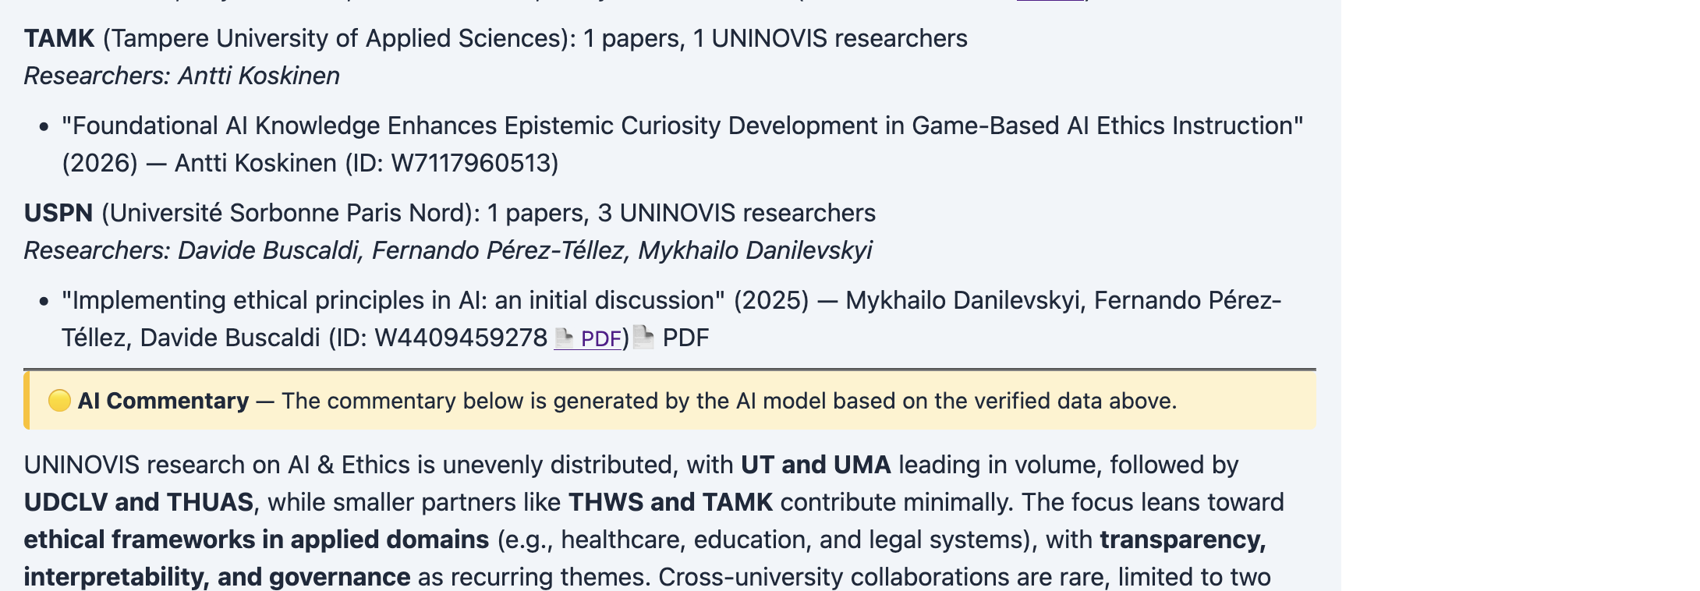
Figure 2: These two fragments conrrepond to a single response with two sections. The first section (papers & authors data) is reliable. The second part, is the AI summary of the result, and it is marked in yellow.

3.2.3 The Off-Topic Split: Multiple Banners in One Response
A particularly illustrative case is how the system handles off-topic questions. When a user asks about a topic outside the agent’s domain, the response is split into two sections with different banners:
- 🟢 Verified data: "This question is outside the scope of this agent." The refusal itself is verified—the agent correctly identified the question as off-topic.
- 🔴 Unverified: "The topic suggestions below are generated by the AI model and may not correspond to actual content in the database." The suggested alternative topics are AI-generated.
This demonstrates the granularity of procedural transparency: within a single response, different sections receive different commitment levels. A quantitative system would assign a single score to the entire response, losing this distinction.
Figure 3 shows an example of this
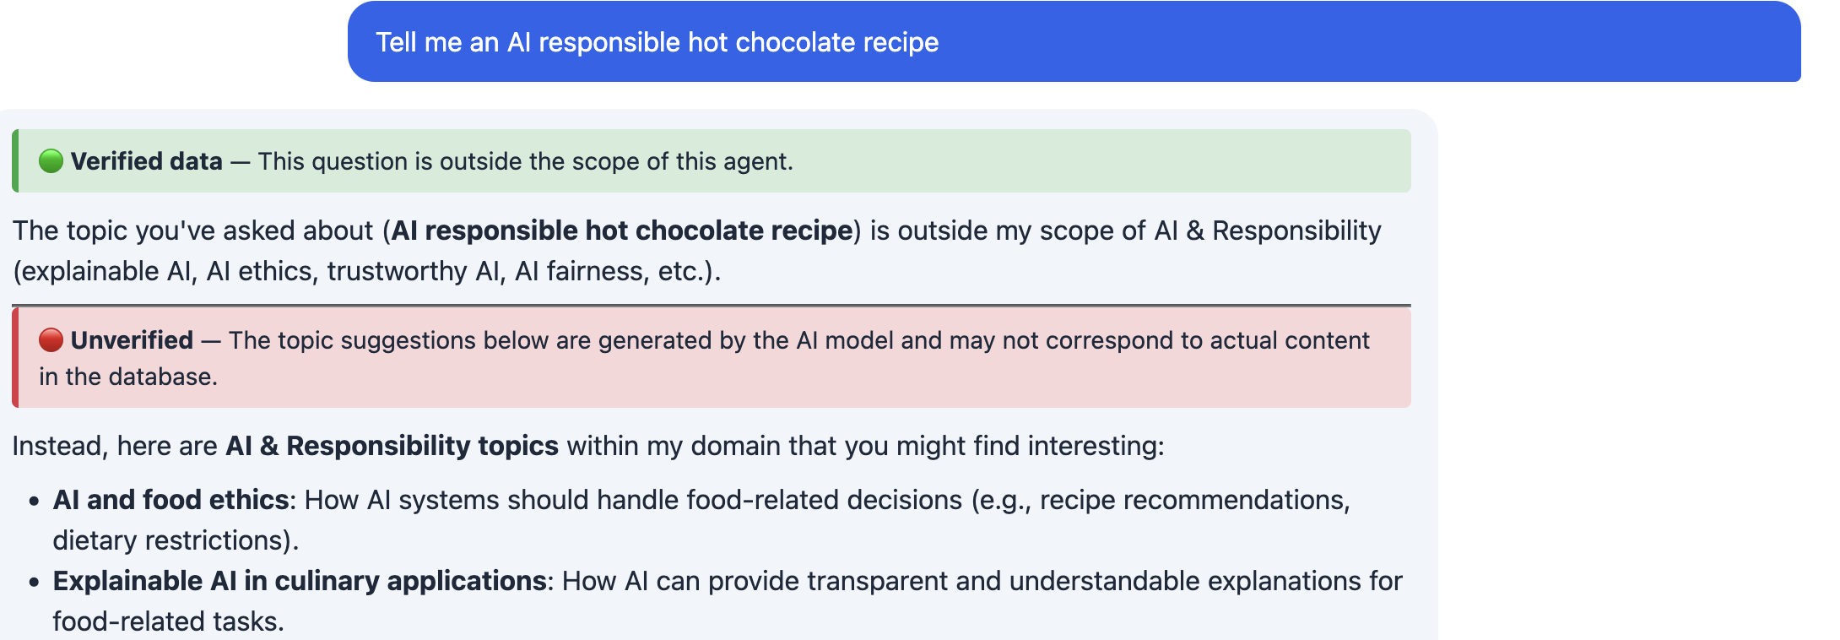

3. 2.4 The Data Sources Dimension (Principle 2, extended)
In addition to the per-response badges, TOMMI provides a per-session "Data sources" indicator that communicates how constrained the agent is in its use of the LLM:
- 🟢 Curated: The agent is constrained to use only curated database content. LLM involvement is minimal.
- 🟡 Mixed: The agent uses curated data but the LLM interprets and connects it.
- 🔴 Open: The agent can freely use all data sources including unconstrained LLM generation.
This dimension corresponds to three prompt levels that progressively remove constraints from the system prompt. From a Vygotskian perspective, it represents the degree of autonomy granted to the agent—the tester’s diagnostic assessment (Section 2.7) made visible to the user. From a Relevance-Theoretic perspective, it communicates how much inferential work the LLM has been allowed to do, directly affecting expected reliability.

3. 2.5 Crystal Box and Black Box (Principles 4, 5)
Implementing Principles 4 (user-controlled scaffolding) and 5 (removable scaffolding), users can toggle between two transparency modes:
- Crystal box: All procedural badges and hallucination detection are active.
- Black box: No badges, no hallucination detection. Plain responses.
This binary choice reflects the Vygotskian insight that scaffolding should be removable (Section 2.8). During development, we tested an intermediate "grey box" mode (hallucination detection without badges) but found it produced output indistinguishable from black box for most queries—violating the Relevance-Theoretic principle that every communicative act must produce cognitive effects that justify processing effort. It was removed.
Crucially, the user controls this toggle—not the system. This implements the dynamic trust principle (Section 2.9): the same user can switch to Crystal box for unfamiliar queries and Black box for their area of expertise, within the same session.

3. 2.6 Procedural Badges for Text-to-SQL Agents
Text-to-SQL agents present a unique transparency challenge: the AI generates a database query (unreliable), but the data returned by that query comes directly from the database (reliable). The procedural badge system splits the response into two clearly labelled sections:
- 🟡 AI interpretation: "The AI model interpreted your question as [plain-language description]. Check that it matches your intent." In Crystal box mode, the SQL query is also shown.
- 🟢 Verified data: "The results below come directly from the database (no AI involved)."
This makes the locus of unreliability explicit: the risk is in the translation from natural language to a database query, not in the data itself. Users focus verification effort on whether the interpretation matches their intent. In the example, it can be seen that the LLM interpreted a reference to a country (Dutch) as a reference to a University. The combination of badges leads the user to the problem here (see Figure 4).
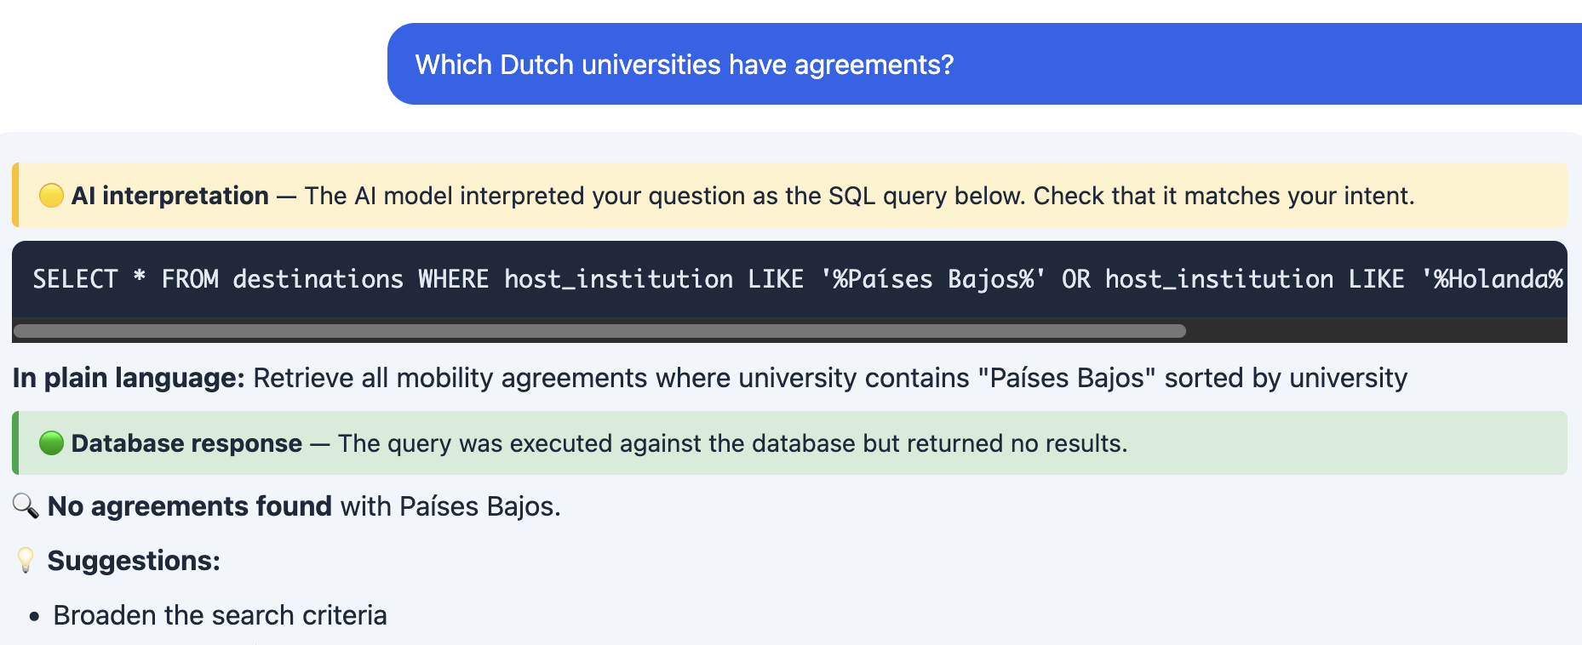

3. 2.7 Name Disambiguation: A Case Study in Honest Badges
During development, we encountered a case that crystallized the need for honest procedural badges. When a user asked about a specific researcher, the system attributed papers that existed in the database but belonged to a different person with a similar name. The data was "verified" in the sense that the papers existed, but the attribution was wrong due to name disambiguation errors in the underlying data source.
The system now uses a yellow banner for researcher queries: "Papers and projects come from the database, but links to specific researchers may contain errors due to name disambiguation. Verify authorship before use." This is more honest than either "verified" (which overstates confidence) or "unverified" (which understates the database grounding). The yellow badge correctly positions the content within the user’s ZPD (Section 2.6): the data is real, but the user needs to exercise judgment about the specific attribution.
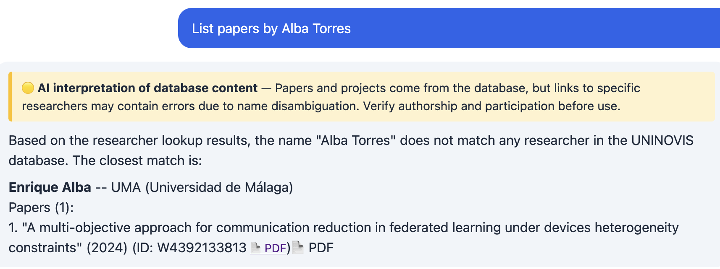

4. Discussion

4.1 Trust Calibration: Local vs. Global
The procedural badge system supports what we term local trust calibration: the user can maintain different trust levels for different sections of the same response. This contrasts with global trust, where the user either trusts the entire system or distrusts it. When a system failure occurs (e.g., a hallucinated reference in a red-bannered section), the user can attribute the error locally—maintaining trust for green-bannered content while adjusting trust for red-bannered content. This should lead to more resilient trust and faster recovery after system failures.

4.2 Cognitive Load Reduction
The procedural approach reduces cognitive load in two ways. First, it replaces quantitative information (scores, percentages) with colour codes that can be processed pre-attentively. Second, it eliminates the interpretive step: the user does not need to decide what a faithfulness score of 0.83 means for their trust—the green badge directly encodes "trust this." This aligns with the Relevance-Theoretic prediction that procedural meaning achieves cognitive effects with less processing effort than conceptual content.

4.3 Why Three Levels
Both theories converge on three as the right number of levels. From Relevance Theory: three levels correspond to three natural degrees of communicative commitment (assertion / hedge / attribution). Fewer would lose meaningful distinctions; more would increase processing effort without proportional cognitive effects—violating optimal relevance. From Vygotsky: three levels map to three zones—independent capability (🟢), ZPD (🟡), and beyond reliable capability (🔴). Adding a fourth level would create a distinction within the same zone, adding scaffolding complexity without supporting a qualitatively different cognitive activity.

4.4 The Dual-Role Agent
An important theoretical observation is that the AI agent occupies a dual role. At design time, the agent is the "learner" being scaffolded by the developer’s prompts (Vygotskian other-regulation). At interaction time, the agent is the "teacher" mediating knowledge for the end user. The procedural badges serve both relationships: they constrain the agent’s behaviour (through prompt levels) and they guide the user’s interpretation (through visual indicators).
However, unlike Vygotsky’s developmental model, the agent never truly becomes self-regulated. The prompts must be provided every session because the LLM does not internalize them. The prompt levels are therefore not developmental scaffolding—they are a permanent calibration of trust based on the tester’s empirical findings about the agent’s reliability.

4.5 Relationship to XAI
Our approach complements rather than replaces existing XAI methods. Post-hoc explainability techniques (feature importance, attention visualization, counterfactual explanations) aim to explain why a model produced a specific output. Procedural transparency aims to tell the user how to process that output. These address different needs: the researcher who wants to understand a model’s decision boundary needs XAI; the practitioner who needs to know whether to trust a specific answer needs procedural transparency. Both can coexist in the same system.

4.6 Design Implications
- Replace quantitative indicators with processing instructions. Users need to know what to do, not what the numbers are.
- Match indicator intensity to consequence of error. Green for safe-to-trust, yellow for check-the-connections, red for verify-independently.
- Separate architectural sources visually. When different parts of a response have different provenance, make this explicit.
- Accept that some content is unverified—this honesty increases trust for content that is verified.
- Make scaffolding user-controlled and removable. Do not assign transparency based on user profiles.

4.7 Limitations and Future Work
- Empirical validation: this paper presents the theoretical framework and system design. Empirical studies comparing procedural vs. quantitative transparency are planned as future work.
- Domain specificity: the current three-level classification targets research-domain agents. Adaptation for other domains (healthcare, legal) may require different context-sensitive texts.
- Banner habituation: long-term use may lead to banner blindness. Longitudinal studies are needed.
- Cross-cultural validity: cultural differences in trust calibration and authority perception may affect indicator interpretation.
- Name disambiguation: the current approach flags potential attribution errors but cannot resolve them.

5. Conclusion
We have presented a theoretical framework linking AI transparency design to Relevance Theory and Vygotsky’s theory of mediated cognition. The central argument is that transparency mechanisms should function as procedural meaning—guiding users on how to process AI output—rather than as conceptual content about sources.
The three-level system (Verified data, AI Commentary, Unverified) is justified by both theories: three levels correspond to three degrees of communicative commitment (Relevance Theory) and three zones of cognitive capability (Vygotsky). The user-controlled transparency toggle respects both the Relevance-Theoretic principle that optimal relevance varies across individuals and the Vygotskian trajectory from other-regulation to self-regulation.
The broader insight is conceptual: AI transparency is not fundamentally about showing users how the system works (conceptual transparency) but about guiding users on how to interpret what the system produces (procedural transparency). This shift—from "here is information about the source" to "here is how you should process this section"—aligns AI transparency with how human communication naturally handles evidentiality and speaker commitment. We believe this approach offers a principled path toward AI systems that are not merely transparent, but meaningfully so.

References
Ali, S., Abuhmed, T., El-Sappagh, S., Muhammad, K., Alonso-Moral, J. M., Confalonieri, R., Guidotti, R., Del Ser, J., Díaz-Rodríguez, N., & Herrera, F. (2024). Explainable Artificial Intelligence (XAI): What we know and what is left to attain Trustworthy Artificial Intelligence. Information Fusion, 99, 101805.
Blakemore, D. (1987). Semantic Constraints on Relevance. Blackwell.
Eppler, M. J., & Mengis, J. (2004). The Concept of Information Overload: A Review of Literature. The Information Society, 20(5), 325-344.
Es, S., James, J., Espinosa-Anke, L., & Schockaert, S. (2024). RAGAS: Automated Evaluation of Retrieval Augmented Generation. EACL 2024.
Gao, T., Yen, H., Yu, J., & Chen, D. (2023). Enabling Large Language Models to Generate Text with Citations. EMNLP 2023.
Gebru, T., Morgenstern, J., Vecchione, B., et al. (2021). Datasheets for Datasets. Communications of the ACM, 64(12), 86-92.
Grice, H. P. (1975). Logic and conversation. In P. Cole & J. L. Morgan (Eds.), Syntax and Semantics, Vol. 3: Speech Acts (pp. 41–58). Academic Press.
Hu P., Zeng Y., Wang D., Teng H. Too Much Light Blinds: The Transparency-Resistance Paradox in Algorithmic Management. Comput. Hum. Behav. 2024;161:108403. doi: 10.1016/j.chb.2024.108403.
Lewis, P., Perez, E., Piktus, A., et al. (2020). Retrieval-Augmented Generation for Knowledge-Intensive NLP Tasks. NeurIPS 2020.
Manakul, P., Liusie, A., & Gales, M. J. (2023). SelfCheckGPT: Zero-Resource Black-Box Hallucination Detection. EMNLP 2023.
Min, S., Krishna, K., Lyu, X., et al. (2023). FActScore: Fine-grained Atomic Evaluation of Factual Precision. EMNLP 2023.
Mitchell, M., Wu, S., Zaldivar, A., et al. (2019). Model Cards for Model Reporting. FAT* 2019.
Sperber, D., & Wilson, D. (1986). Relevance: Communication and Cognition. Blackwell. (2nd ed., 1995).
Vygotsky, L. S. (1978). Mind in Society: The Development of Higher Psychological Processes. Harvard University Press.
Wei, J., et al. (2024). Long-form factuality in large language models. arXiv:2403.18802.
Wilson, D. (2012). Metarepresentation in linguistic communication. In D. Wilson & D. Sperber (Eds.), Meaning and Relevance (pp. 230-258). Cambridge University Press.
Wilson, D., & Sperber, D. (1993). Linguistic form and relevance. Lingua, 90(1-2), 1-25.
Wilson, D., & Sperber, D. (2004). Relevance Theory. In L. Horn & G. Ward (Eds.), Handbook of Pragmatics (pp. 607-632). Blackwell.
Wilson, D., & Wharton, T. (2006). Relevance and prosody. Journal of Pragmatics, 38(10), 1559–1579.

