# ansible_icinga2_cron

Run at the terminal to cfeate other files and directories
:~$ ./main.sh

AUTOMATED SETUP OF ICINGA2 ON AWS EC2 INSTANCE
I intend to setup a monitoring solution using Icinga2. Icinga2 will monitor Apache Web Server and Mysql Database server and send logs to Amazon S3 dynamically using Bash Scripting.

Functional Requirements
An organization runs Linux servers and requests you to setup/configure the following infrastructure:

The automation will achieve the following deliverables:
- Setup Amazon web services ec2 instance.
- Installation of prerequisite software for Icinga 2, Icinga Web 2 and Docker.
- Installation and configuration of Icinga2 solution on the server.
- Installation and configuration of Docker CE.
- Install Apache web server and a Mysql Database on different Docker containers
- Ensuring that all logs that are generated by the Apache Web Server and Mysql Database are collected dynamically through a Bash Script.
- Create Amazon s3 bucket
- Those logs will be automatically sent to Amazon s3 at 7 pm daily.
- Ensuring backups of host(ec2 instance) mysql database for Icinga2 master and mysql database server backup on a container are optimally taken and sent to Amazon S3 bucket as well
- Write Ansible Playbook to automate this process.

This deployment will involve three major installations
- AWS instance installation.
- Icinga2 Monitoring Server
- Docker Community Edition
NB: This Deployment document remains valid for use on Ubuntu 14.04.4 LTS (Trusty Tahr) and Ubuntu 16.04 (Xenisl).

The concept of my final setup could be depicted as below within an Amazon aws ec2 instance.

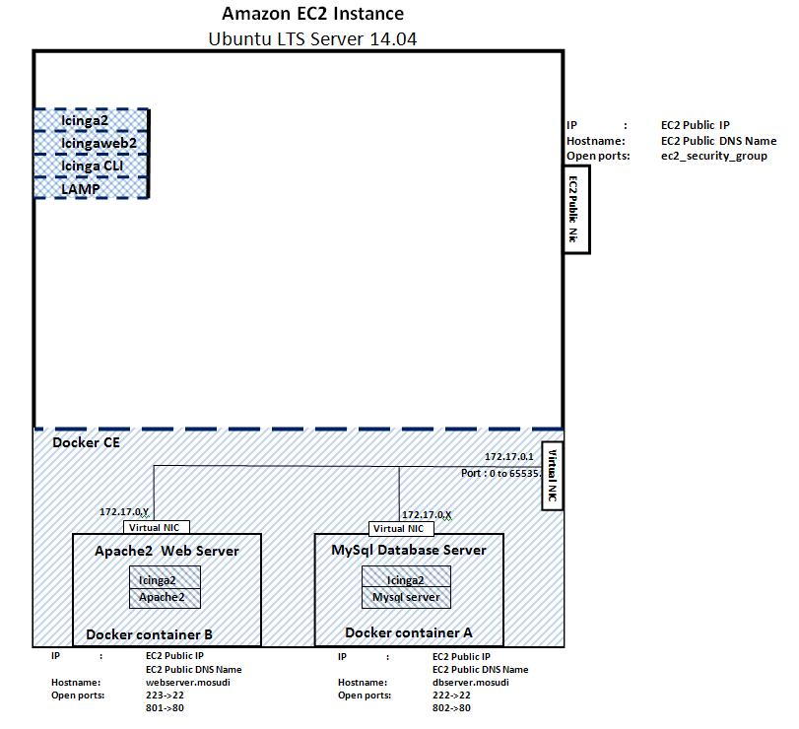
Abstracting the two(2) docker containers, we will end up having three servers:
Icinga2 Master:
- Ubuntu LTS server 14.04 running Icinga2
Icinga2 Clients
- Ubuntu LTS server 14.04 running Apache web server
- Ubuntu LTS server 14.04 running Mysql database server

Ansible
Provision of Amazon EC2 Server, Docker, Icinga2, Icingaweb2 as well as other system maintenance procedures were carried out using Ansible for process automation.
Using Ansible saves time but it requires setup on a local system
Setting up Ansible involves its installation as well as required python libraries. My local system is Ubuntu 16.04

The automation will achieve the following deliverables:
1AWS ec2 server provisioning
- Ubuntu Server repository update and system upgrade
- Creation and activation of swap space to compensate for low RAM available on the ec2 instance
- Requisite Software Installation
- Apache2 Web Server, Mysql Server, Mysql Client, phpmyadmin and PHP installation
- Local PHP timezone and tzdata local time configuration
- Addition of both Docker CE, Icinga2 and Icingaweb2 Ubuntu repositories
- Docker CE, Icinga2 and Icingaweb2, Icinga2 CLI Installation
- Setup two(2) Docker containers(Web Server and Database Server)
- Installation of Nagios plugins and Icinga Web2 directory configurations
- Enable Icinga2 features
- Create Amazon s3 bucket
- Setup CRON job for 7pm daily backup of logs that generated by Icinga 2 master monitoring of the Apache Web Server and Mysql Database server, also datase backups from Icinga 2 master and mysql datase of icinga 2 client
- Generate Icinga2 Web Token and make it available at the console
- Extract IDO mysql database details and make available at the console for easy Icinga Web 2 configuration

GETTING THE JOB DONE
Getting the job done requires setup of Ansible control machine, aka Ansible Master. Ansible will try to use native OpenSSH for remote communication when possible but will fallback into using a high-quality Python implementation of OpenSSH called ‘paramiko’. Whereas, the best implementation of Ansible requires use of SSH keys, I will be using " --ask-sudo-pass " for my sudo features along the implementation process.

Configure the Ansible Master
I will be using Ubuntu LTS 16.04 Desktop for the Ansible implementation.
mosud@serverafrica ~> uname -a
Linux serverafrica 4.8.0-54-generic #57~16.04.1-Ubuntu SMP Wed May 24 16:22:28 UTC 2017 x86_64 x86_64 x86_64 GNU/Linux
mosud@serverafrica ~> cat /etc/issue
Ubuntu 16.04.2 LTS \n \l

mosud@serverafrica:~$ lsb_release -cds
Ubuntu 16.04.2 LTS
xenial

Installation:
mosud@serverafrica:~$ apt-get -y install python-software-properties
mosud@serverafrica:~$ apt-get -y install software-properties-common
mosud@serverafrica:~$ sudo apt-get install -y ansible python-boto
mosud@serverafrica:~$ sudo mv /etc/ansible/hosts /etc/ansible/hosts_backup
mosud@serverafrica:~$ sudo echo “
[local]
127.0.0.1

Localhost
[ec2hosts]

” > /etc/ansible/hosts

mosud@serverafrica:~$ cd ~
mosud@serverafrica:~$ mkdir deployment
mosud@serverafrica:~$ cd deployment/
mosud@serverafrica:~/deployment$

Installed alongside Ansible is python-boto. This is the Python interface to Amazon Web Services. I also replaced the Ansible hosts file, /etc/ansible/hosts
Then, creating the deployment ansible playbook

$ ansible --version
ansible 2.0.0.2
config file = /etc/ansible/ansible.cfg
configured module search path = Default w/o overrides

With this, I am in no doubt the version of Ansible installed from the repository as this has to do with it underlying ansible commands and syntax

Installed alongside Ansible is python-boto. This is the Python interface to Amazon Web Services. I also replaced the Ansible hosts file, /etc/ansible/hosts
Then, creating the deployment ansible playbook

mosud@serverafrica:~$ vi deployment.yml

Using Ansible for the deployment.
mosud@serverafrica:~$ sudo ansible-playbook –i hosts deployment.yml -–ask-sudo-pass

But nott, until I create required scripts, dockerfile and configuration files.

Directory Structure
We end up with a directory structure like this
deployment/
create_icinga2db.sh
deployment.yaml
main.sh
backup_scripts/
aws_cli.sh
cron_job
dbserverbackup.sh
icinga2master_dbbackup.sh
s3backupscript.sh
dbserver/
create_icinga2db.sh
DBDockerfile
dbhosts.conf
db_lab_server.sh
dbservices.conf
webserver/
WebDockerfile
webhost.conf
web_lab_server.sh
webservices.con
The script, main.sh creates/update every other script, dockerfile and configuration as well ast the Ansible playbook, deployment.yaml. Therefore, our main focus will be on the making of the playbook and main.sh.

Now lets deploy

mosud@serverafrica:~$ sudo ansible-playbook –i hosts deployment.yml -–ask-sudo-pass

Should run the playbook but for this assignment, I will call the playbook within main.sh. This will make it easier for main.sh to insert and remove the aws security key id and secret. Initially, the deployment directory structure looks like this:
deployment/
deployment.yaml
main.sh
Running main.sh will prompt for aws security key id and secret to you for connection Amazon aws account.
mosud@serverafrica:~/deployment$ ./main.sh

Now you have your playbook success story
TASK [Icinga2 Web Token] *******************************************************
ok: [35.160.118.12] => {
"out.stdout_lines": [
"19279d5ab200071f"
]
}

TASK [Ido-mysql database username] *********************************************
ok: [35.160.118.12] => {
"ido_db_username.stdout_lines": [
" \"icinga2\""
]
}

TASK [Ido-mysql database dbname] ***********************************************
ok: [35.160.118.12] => {
"ido_db_name.stdout_lines": [
" \"icinga2\""
]
}

TASK [Ido-mysql database password] *********************************************
ok: [35.160.118.12] => {
"ido_db_password.stdout_lines": [
" \"1WsDnvZmULZU\""
]
}

TASK [Ido-mysql database host] *************************************************
ok: [35.160.118.12] => {
"ido_db_host.stdout_lines": [
" \"localhost\""
]
}
RUNNING HANDLER [update timezone] **********************************************
changed: [35.160.118.12]
PLAY RECAP

*********************************************************************
35.160.118.12 : ok=70 changed=47 unreachable=0 failed=0
localhost : ok=9 changed=8 unreachable=0 failed=0

mosud@serverafrica:~/deployment$

Icinga Web 2 Configuration
Finally visit Icingaweb2 in your browser to access the setup wizard and complete the installation: http://35.160.118.12/icingaweb2

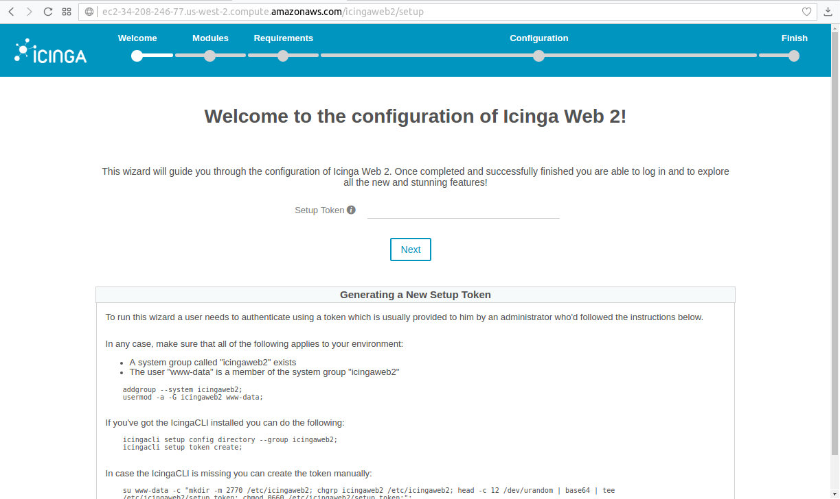

Copy Icinga2 Web setup token available at the console as provided by the Ansible playbook output

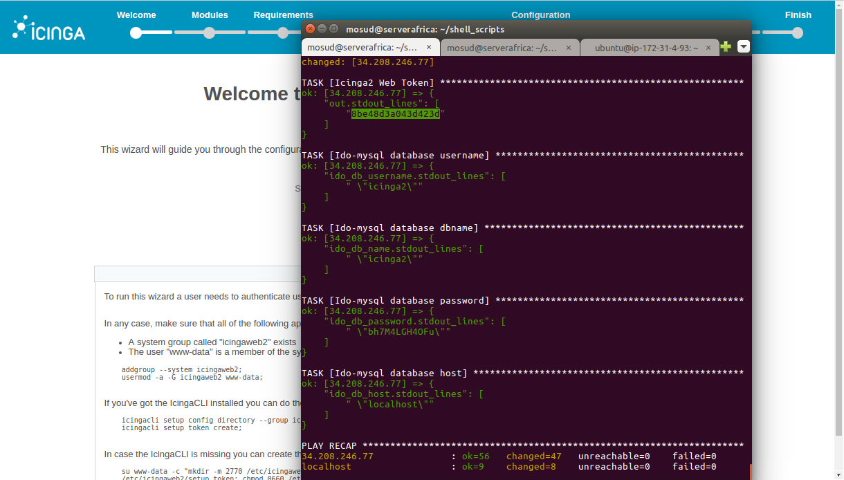

Paste the setup token and click “Next”
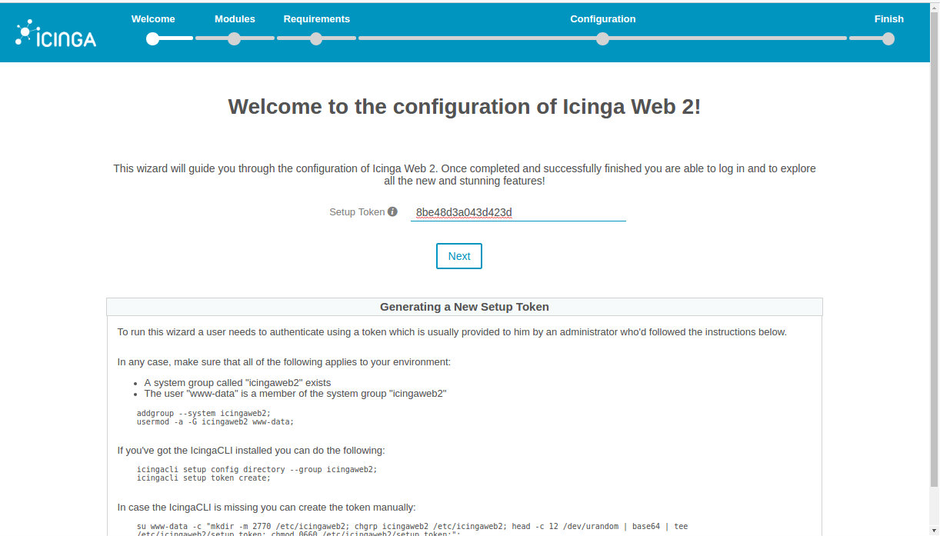

The available Icinga Web 2 modules installed using the Ansible playbook
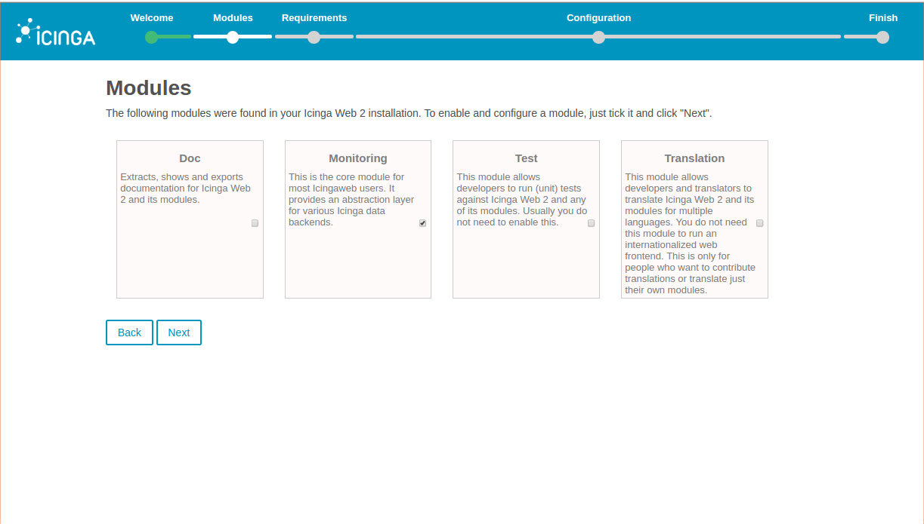

Select the required module to enable configuration and click “Next”
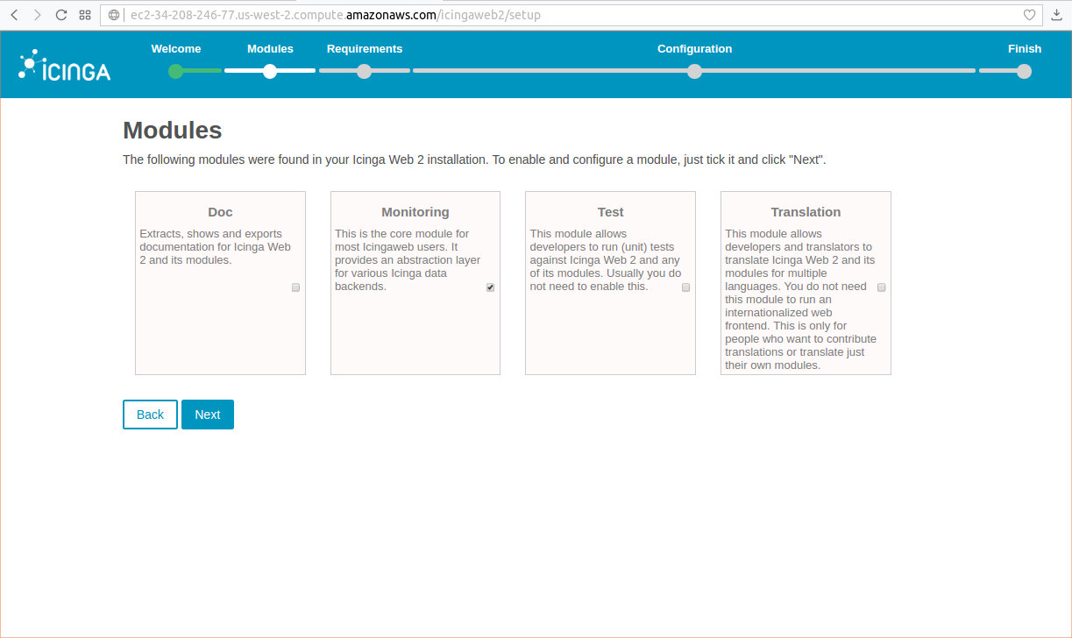

Icinga Web 2 requirements are satisfied as indicated in list
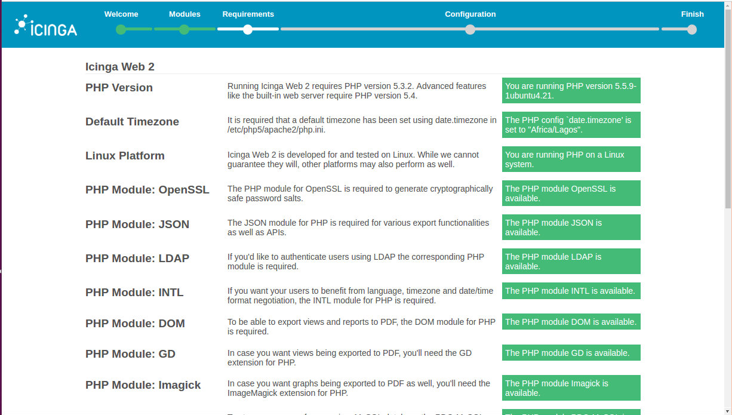

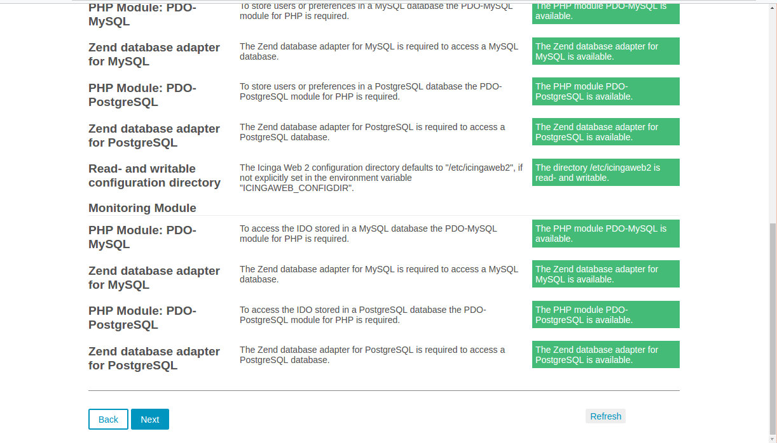

Click “Next”

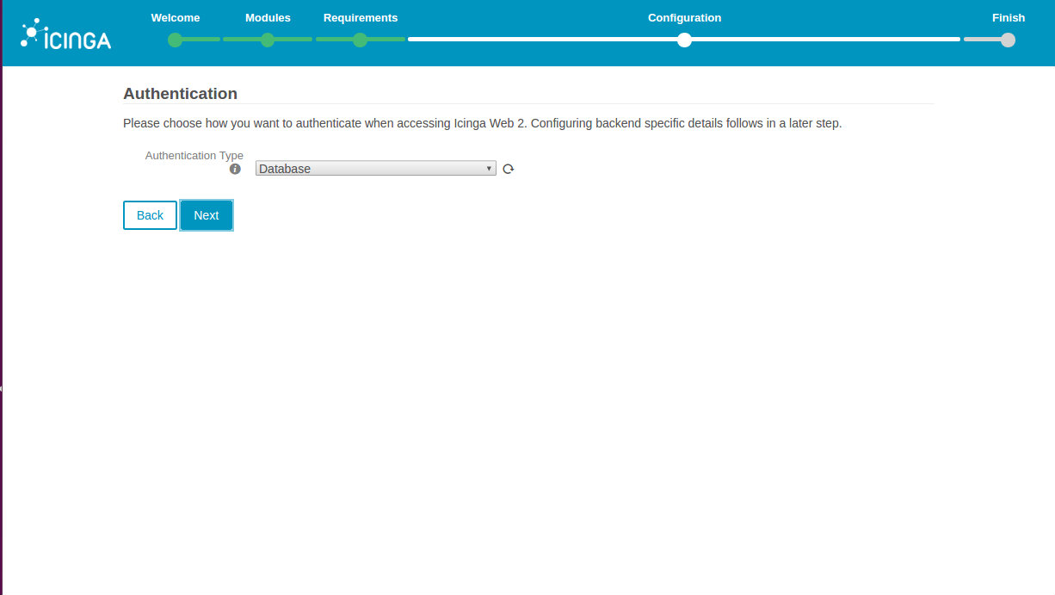

Click “Next” without changing the “Authentication Type” except for “Database”

Provide the necessary Icinga Web 2 database details then click “Validate Configuration”
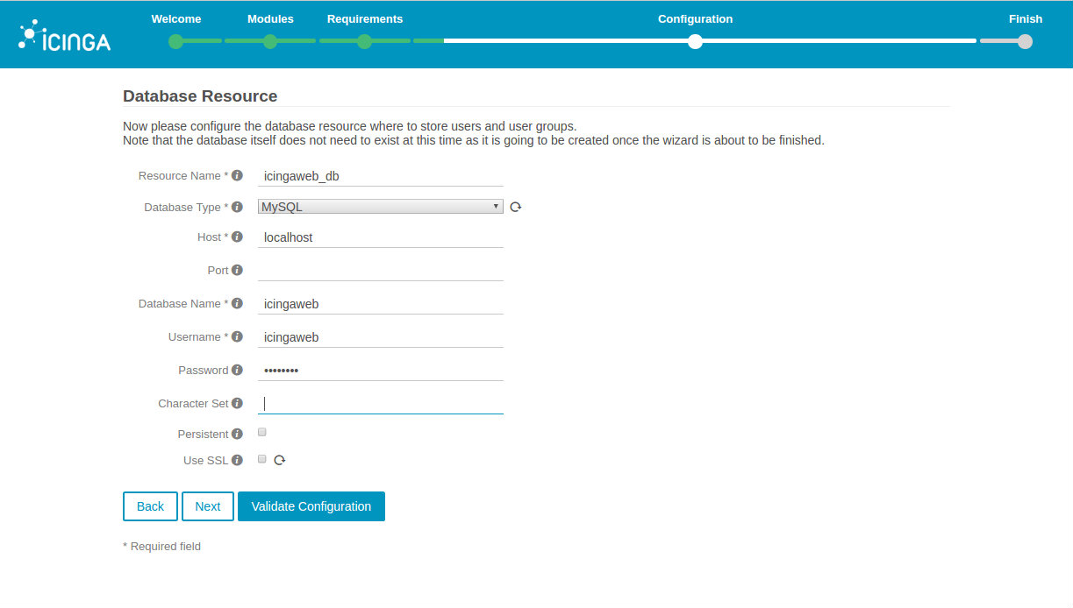

Click “Next” after successful validation
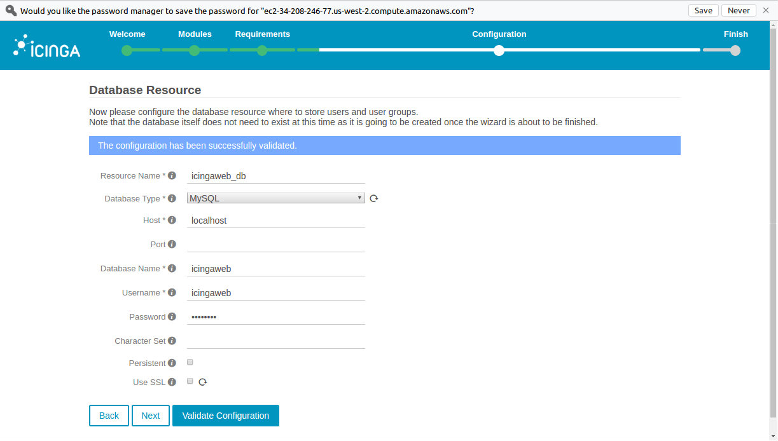

Provide database access credentials with appropriate privileges to create Icinga2 Web database details.
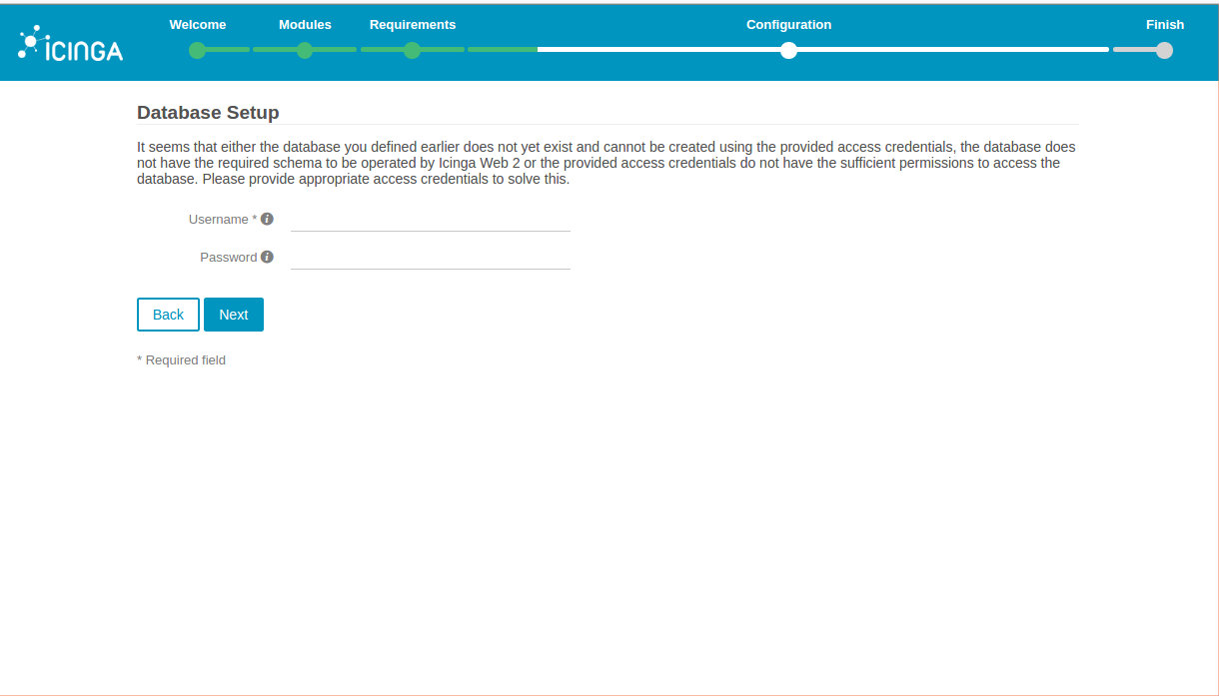

I intend to use the database root username. The main.sh script created the script used my the playbook to update mysql database root paasword. Copy the password as available in the script.
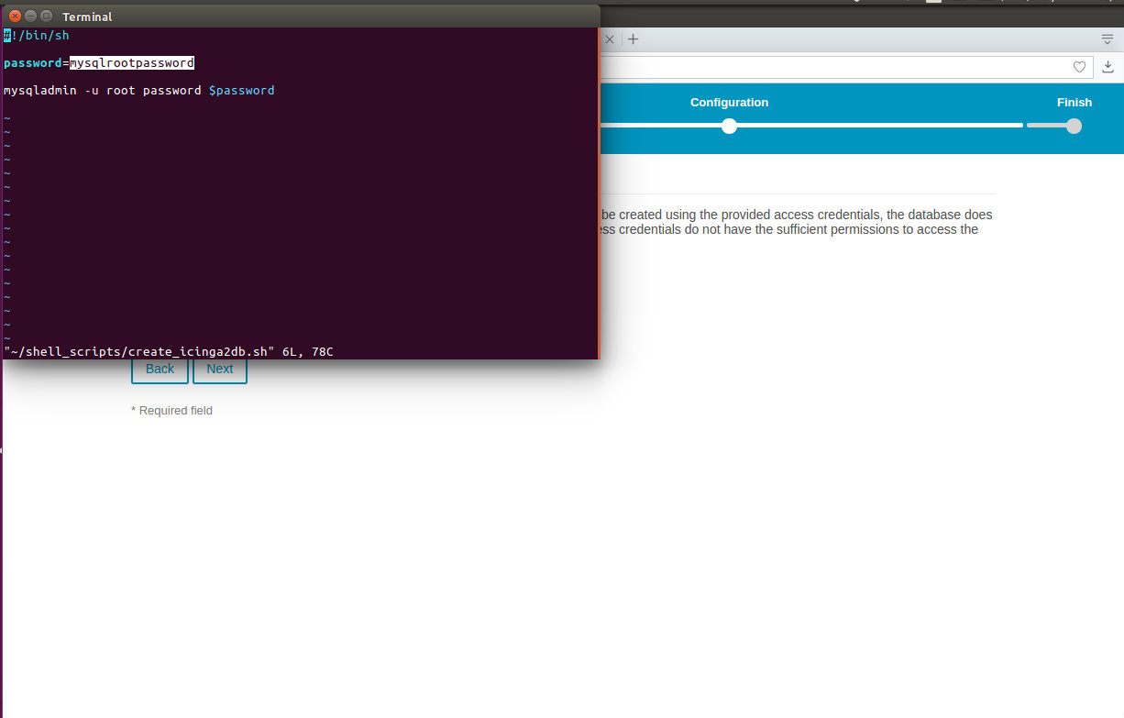

Complete the details and click “Next”
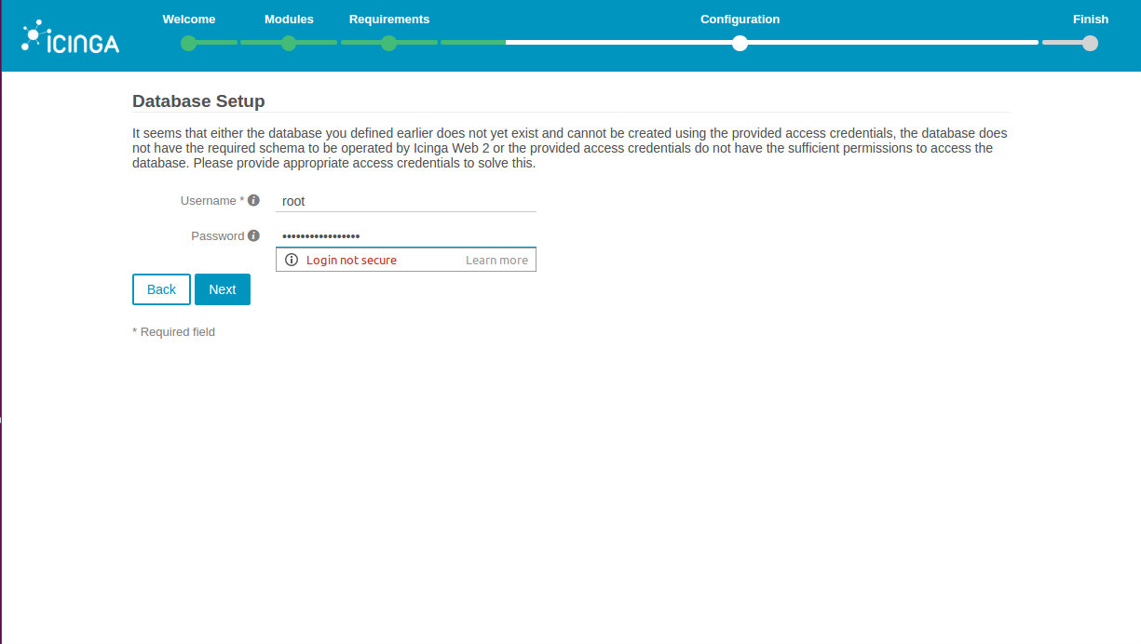

Name the authentication backend earlier choosen. Then click “Next”
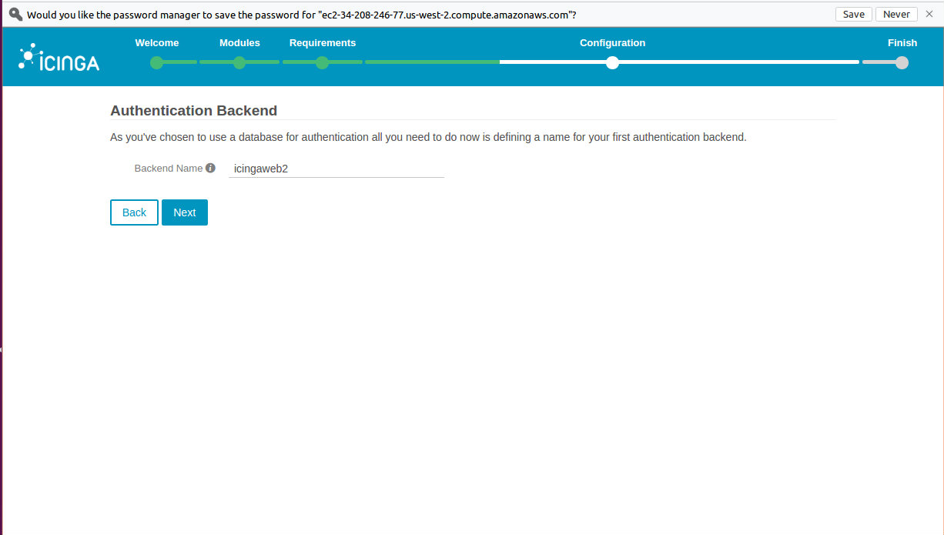

Provide Icinga2 Web administrator username and password for the configuration wizard
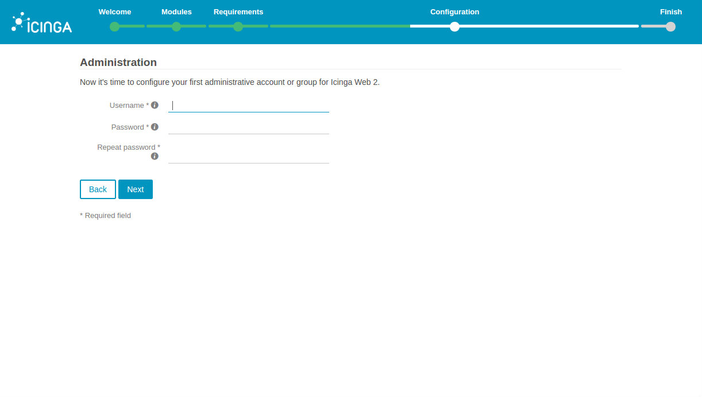

Click “Next”
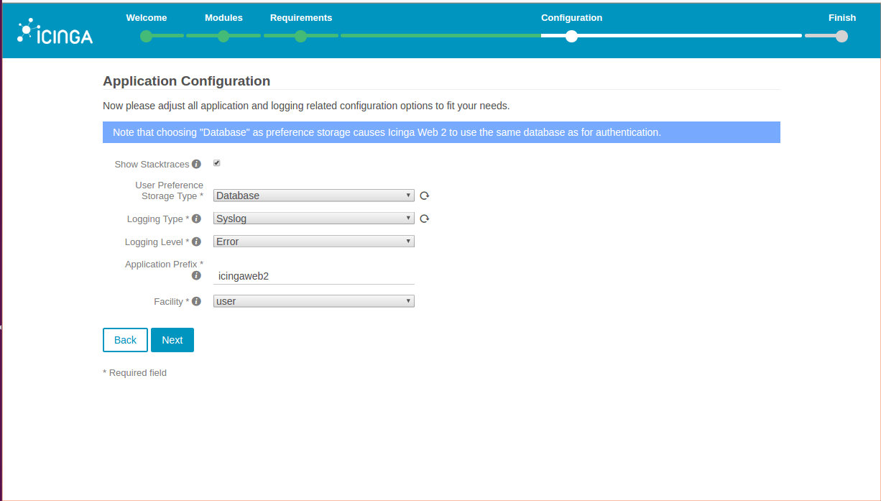

Succesful configuration of Icinga Web 2, Scroll down the page.
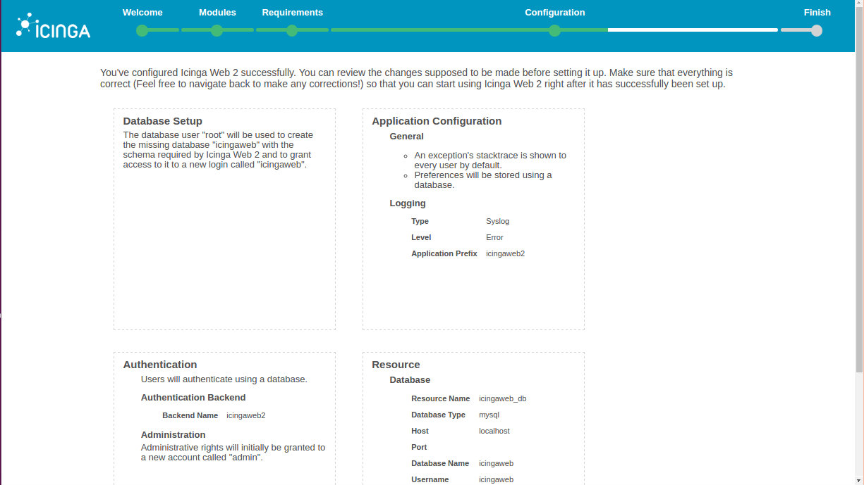

Click “Next”
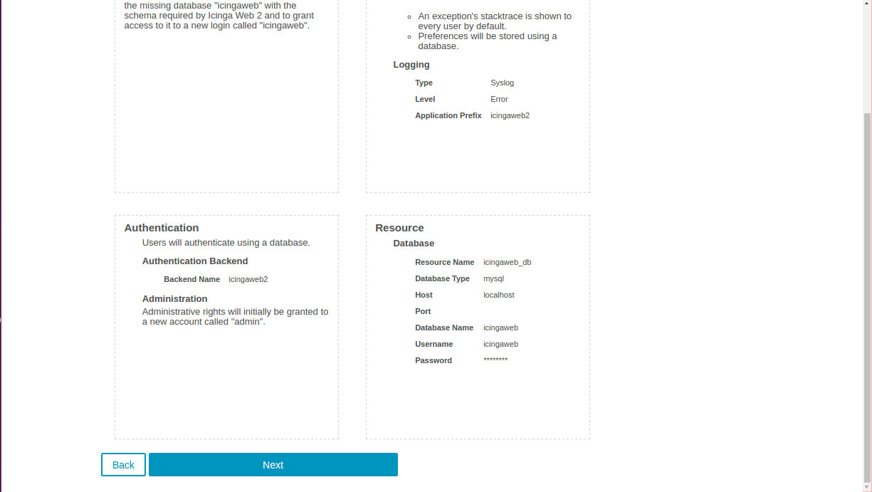

Begin the configuration of Icinga Web 2 monitoring module
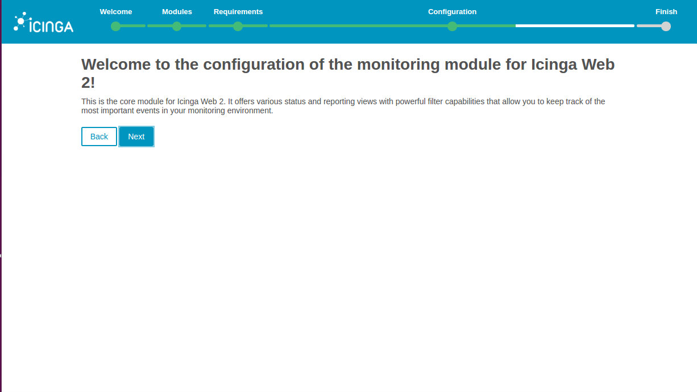

Configuring the way Icinga Web 2 retrieves information. The backend type is Icinga Data Output.. Click “Next” without changing the Backend type , IDO
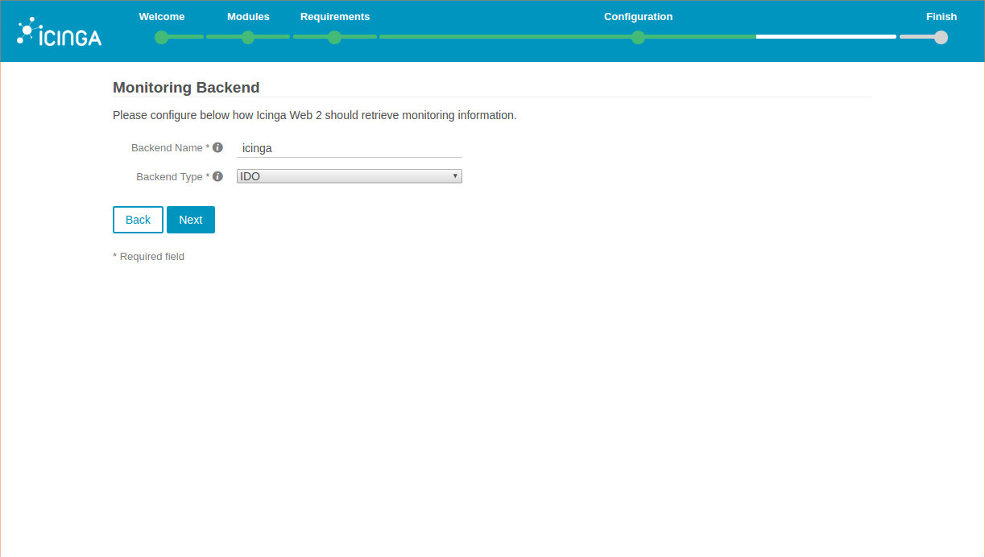

Using the Ansible playbook output details available at the console..
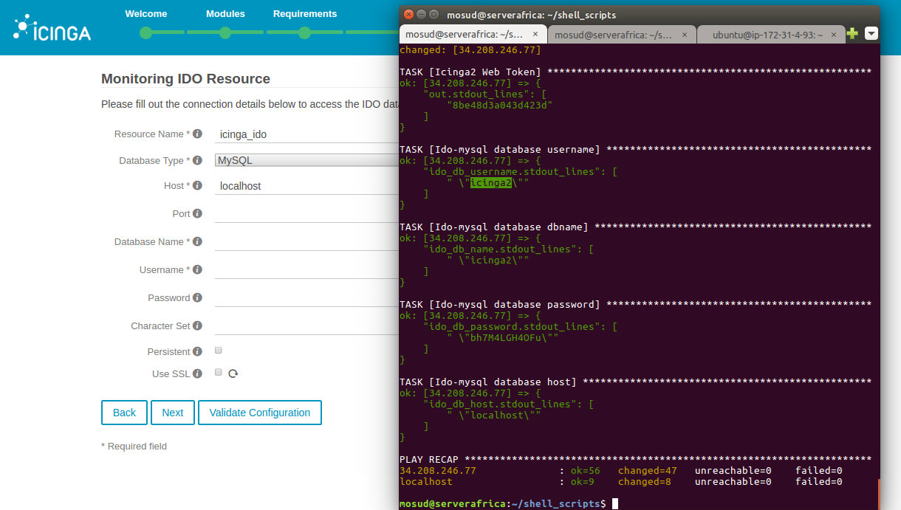

Fill in the database username, database name and the password. It goes without saying that the default character set is utf8. Click “Validate Configuration”
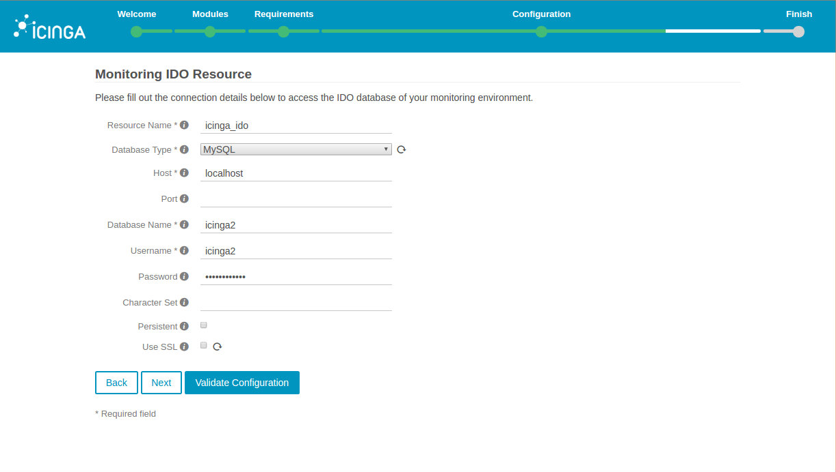

Click “Next” after successful validation.
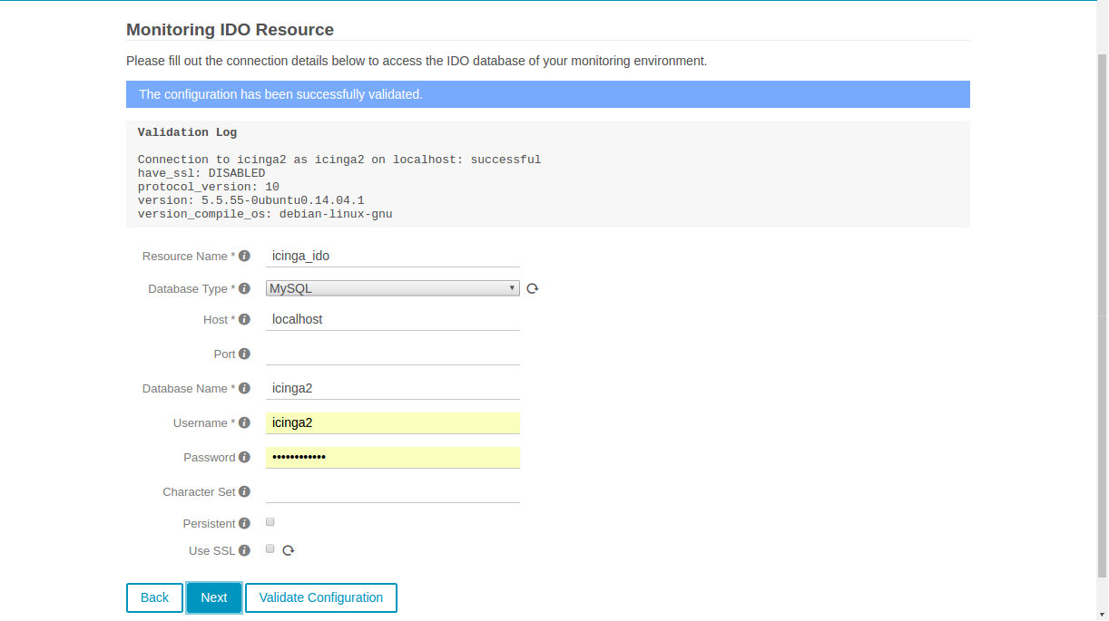

The command transport type should be left at “Local Command File”. Click “Next”
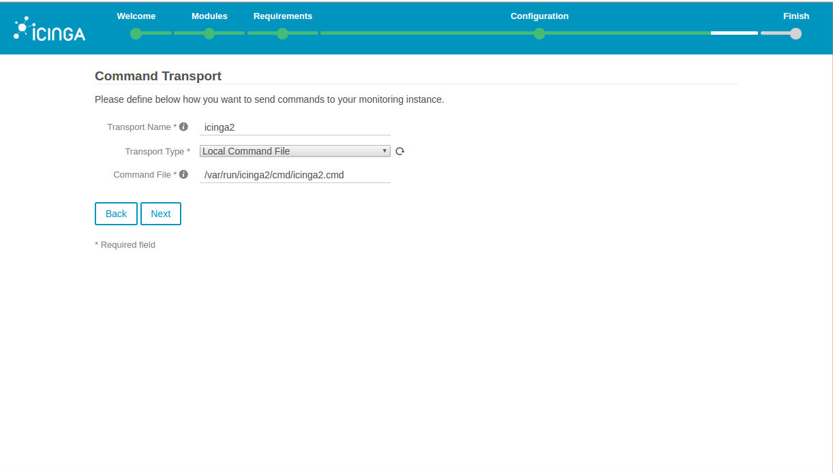

Click “Next” without making changes to the “Monitoring Security” section
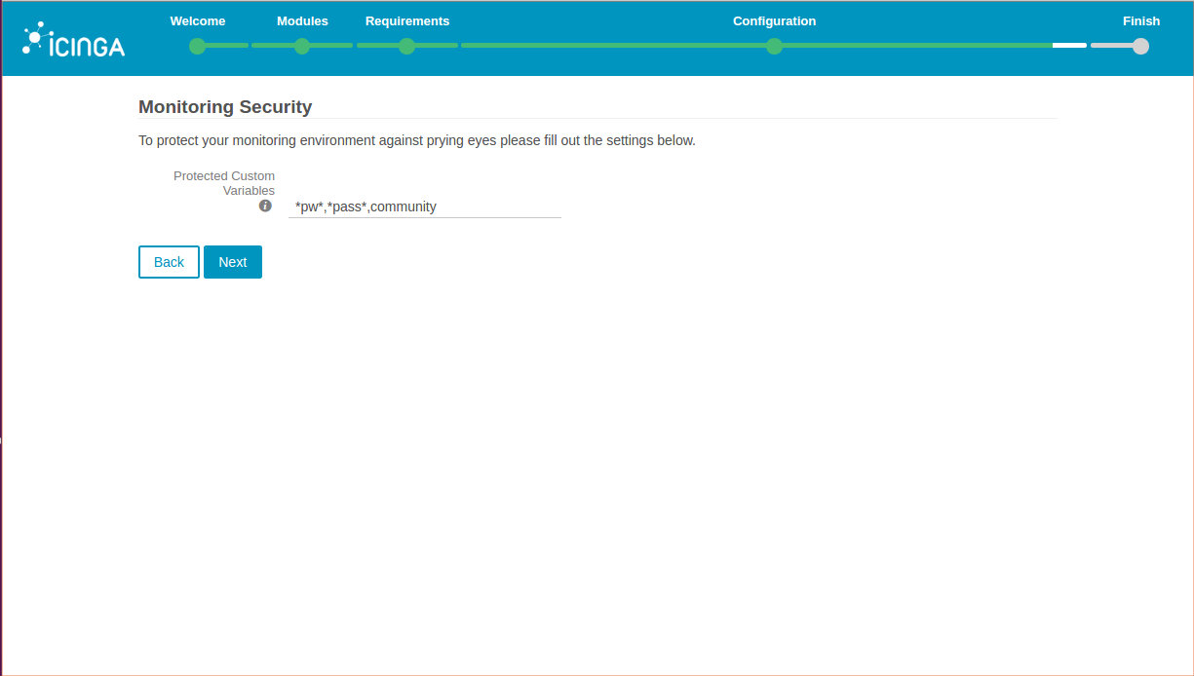

The module configuration successful page. Scroll down the page.
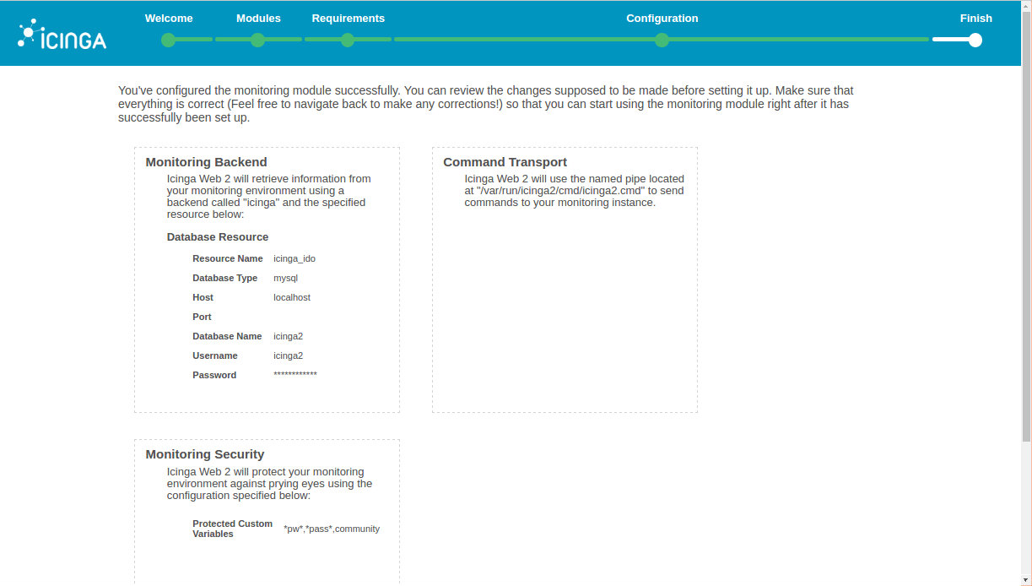

Review and click “Next” except there is need to make corrections you might want to click “Back”
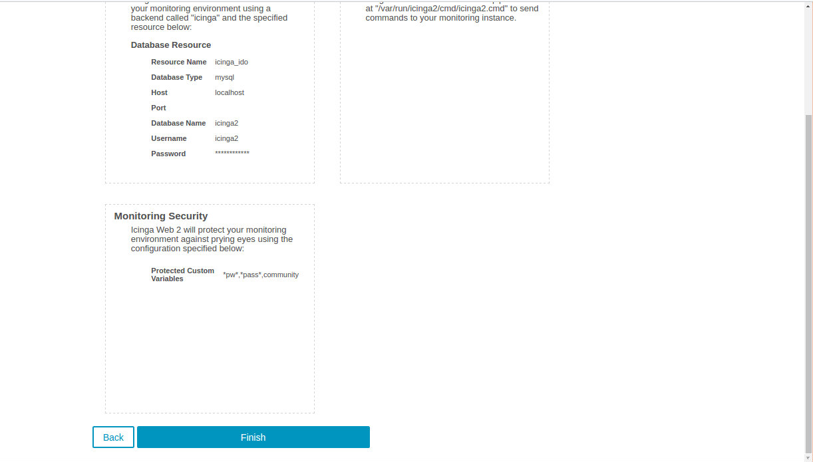

Icinga Web 2 configuration page. The configurationis successful. There is nothing else to do than to exit the page or click “Login to Icinga Web 2”
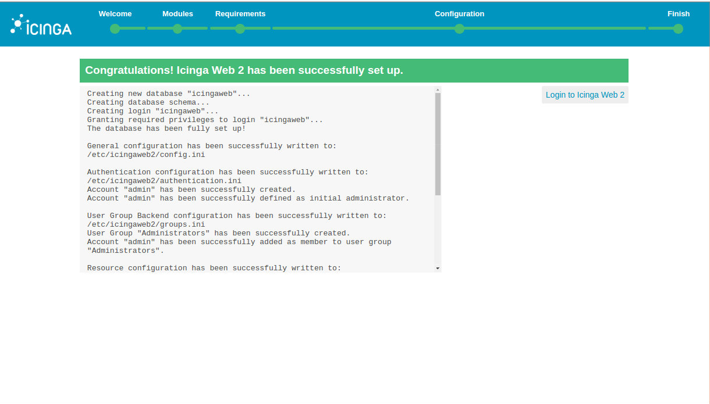

Icinga Web 2 login interface. Provide the administrator details to login.
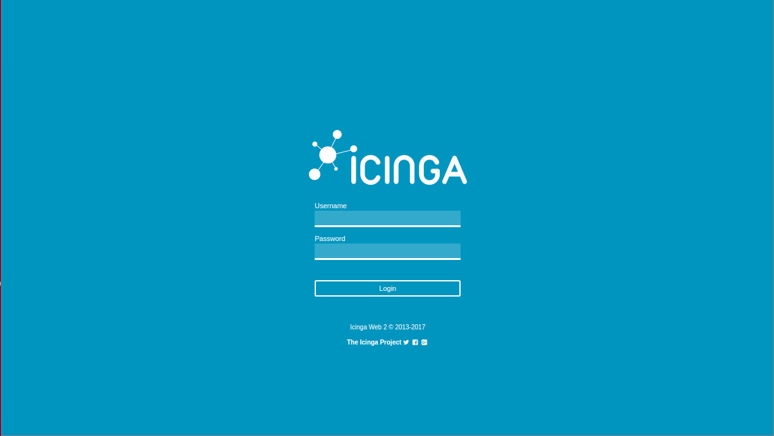

Voila! The first login.

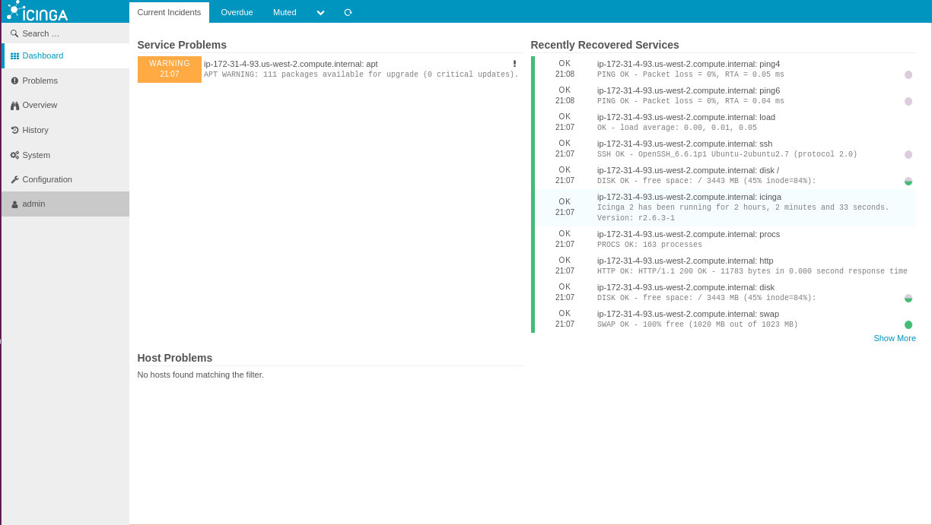

Lets continue with Icinga 2 master and client configurations, the reason we have to go through all the lengthy installation procedures.
CONFIGURE ICINGA 2 MASTER AND CLIENTS
Like I indicated earlier on page 2, we now have three(3) Ubuntu servers that could be, seemingly, independly administered though in reality it is a single aws ubuntu intsance with two docker containers. While the ec2 instance is the Icinga 2 master, the containers are the the two(2) Icinga 2 client/satellite
node.
Icinga 2 Master -AWS EC2 instance – Ubuntu LTS Server 14.04
Icinga 2 Clients -
- Ubuntu LTS server 14.04 running Apache web server
- Ubuntu LTS server 14.04 running Mysql database server

ICINGA 2 MASTER
Login to aws ec2 instance using either its public dns name or public IP address:
ssh -i "mioemi2000.pem" ubuntu@35.160.118.125. The making of a node to become Icinga masteror or satellite starts at the configuration via the console. After login to to the aws instance run icinga2 node wizard utility. Notwitstanding, the effort made running Icinga 2 via the automation process. Confirm the icinga 2 service status, perhaps there is a need to start the service. The configuration of icinga 2 requires privilege level.

mosud@serverafrica:~/Desktop/crossover_assignment$ sudo ssh -i mioemi2000.pem ubuntu@35.160.118.125
ubuntu@ip-172-31-31-123:~$ sudo -i
root@ip-172-31-31-123:~#

oot@ip-172-31-31-123:~# service icinga2 status
* icinga2 is running
root@ip-172-31-31-123:~# icinga2 node wizard
Welcome to the Icinga 2 Setup Wizard!

We'll guide you through all required configuration details.

Please specify if this is a satellite setup ('n' installs a master setup) [Y/n]: n
Starting the Master setup routine...
Please specify the common name (CN) [ip-172-31-31-123.us-west-2.compute.internal]:
Checking for existing certificates for common name 'ip-172-31-31-123.us-west-2.compute.internal'...
Certificates not yet generated. Running 'api setup' now.
information/cli: Generating new CA.
information/base: Writing private key to '/var/lib/icinga2/ca/ca.key'.
information/base: Writing X509 certificate to '/var/lib/icinga2/ca/ca.crt'.
information/cli: Generating new CSR in '/etc/icinga2/pki/ip-172-31-31-123.us-west-2.compute.internal.csr'.
information/base: Writing private key to '/etc/icinga2/pki/ip-172-31-31-123.us-west-2.compute.internal.key'.
information/base: Writing certificate signing request to '/etc/icinga2/pki/ip-172-31-31-123.us-west-2.compute.internal.csr'.
information/cli: Signing CSR with CA and writing certificate to '/etc/icinga2/pki/ip-172-31-31-123.us-west-2.compute.internal.crt'.
information/pki: Writing certificate to file '/etc/icinga2/pki/ip-172-31-31-123.us-west-2.compute.internal.crt'.
information/cli: Copying CA certificate to '/etc/icinga2/pki/ca.crt'.
Generating master configuration for Icinga 2.
information/cli: Adding new ApiUser 'root' in '/etc/icinga2/conf.d/api-users.conf'.
information/cli: Enabling the 'api' feature.
Enabling feature api. Make sure to restart Icinga 2 for these changes to take effect.
information/cli: Dumping config items to file '/etc/icinga2/zones.conf'.
information/cli: Created backup file '/etc/icinga2/zones.conf.orig'.
Please specify the API bind host/port (optional):
Bind Host []:
Bind Port []:
information/cli: Created backup file '/etc/icinga2/features-available/api.conf.orig'.
information/cli: Updating constants.conf.
information/cli: Created backup file '/etc/icinga2/constants.conf.orig'.
information/cli: Updating constants file '/etc/icinga2/constants.conf'.
information/cli: Updating constants file '/etc/icinga2/constants.conf'.
information/cli: Updating constants file '/etc/icinga2/constants.conf'.
Done.

Now restart your Icinga 2 daemon to finish the installation!

root@ip-172-31-31-123:~# service icinga2 restart

ICINGA 2 CLIENT(Web Server)
$ ssh root@35.160.118.125 -p223

[ root@webserver.mosudi:~ ]$ hostname -f
webserver.mosudi

[ root@webserver.mosudi:~ ]$ service icinga2 start

[ root@webserver.mosudi:~ ]$ icinga2 node wizard
Welcome to the Icinga 2 Setup Wizard!

We'll guide you through all required configuration details.

Please specify if this is a satellite setup ('n' installs a master setup) [Y/n]:
Starting the Node setup routine...
Please specify the common name (CN) [webserver.mosudi]:
Please specify the master endpoint(s) this node should connect to:
Master Common Name (CN from your master setup): ip-172-31-31-123.us-west-2.compute.internal
Do you want to establish a connection to the master from this node? [Y/n]: y
Please fill out the master connection information:
Master endpoint host (Your master's IP address or FQDN): 172.17.0.1
Master endpoint port [5665]:
Add more master endpoints? [y/N]:
Please specify the master connection for CSR auto-signing (defaults to master endpoint host):
Host [172.17.0.1]:
Port [5665]:
information/base: Writing private key to '/etc/icinga2/pki/webserver.mosudi.key'.
information/base: Writing X509 certificate to '/etc/icinga2/pki/webserver.mosudi.crt'.
information/cli: Fetching public certificate from master (172.17.0.1, 5665):

Certificate information:

Subject: CN = ip-172-31-31-123.us-west-2.compute.internal
Issuer: CN = Icinga CA
Valid From: Jul 25 17:44:52 2017 GMT
Valid Until: Jul 21 17:44:52 2032 GMT
Fingerprint: B0 8F 17 D4 0E A3 D0 85 10 F2 50 2C F5 D8 13 25 E3 4D 63 45

Is this information correct? [y/N]: y
information/cli: Received trusted master certificate.

Please specify the request ticket generated on your Icinga 2 master.
(Hint: # icinga2 pki ticket --cn 'webserver.mosudi'): 41caa4e47b8c927edc5ccf136ad1fb72f310f8f6

root@ip-172-31-31-123:~# icinga2 pki ticket --cn 'webserver.mosudi'
41caa4e47b8c927edc5ccf136ad1fb72f310f8f6

information/cli: Requesting certificate with ticket '41caa4e47b8c927edc5ccf136ad1fb72f310f8f6'.

information/cli: Created backup file '/etc/icinga2/pki/webserver.mosudi.crt.orig'.
information/cli: Writing signed certificate to file '/etc/icinga2/pki/webserver.mosudi.crt'.
information/cli: Writing CA certificate to file '/etc/icinga2/pki/ca.crt'.
Please specify the API bind host/port (optional):
Bind Host []:
Bind Port []:
Accept config from master? [y/N]: y
Accept commands from master? [y/N]: y
information/cli: Disabling the Notification feature.
Disabling feature notification. Make sure to restart Icinga 2 for these changes to take effect.
information/cli: Enabling the Apilistener feature.
Enabling feature api. Make sure to restart Icinga 2 for these changes to take effect.
information/cli: Created backup file '/etc/icinga2/features-available/api.conf.orig'.
information/cli: Generating local zones.conf.
information/cli: Dumping config items to file '/etc/icinga2/zones.conf'.
information/cli: Created backup file '/etc/icinga2/zones.conf.orig'.
information/cli: Updating constants.conf.
information/cli: Created backup file '/etc/icinga2/constants.conf.orig'.
information/cli: Updating constants file '/etc/icinga2/constants.conf'.
information/cli: Updating constants file '/etc/icinga2/constants.conf'.
Done.

Now restart your Icinga 2 daemon to finish the installation!

[ root@webserver.mosudi:~ ]$ service icinga2 restart

root@ip-172-31-31-123:~# icinga2 node update-config

root@ip-172-31-31-123:~# service icinga2 restart

ICINGA 2 CLIENT(Database Server)
$ ssh root@35.160.118.125 -p223

[ root@webserver.mosudi:~ ]$ hostname -f
dbserver.mosudi

[ root@dbserver.mosudi:~ ]$ service icinga2 start

[ root@dbserver.mosudi:~ ]$ icinga2 node wizard
Welcome to the Icinga 2 Setup Wizard!

We'll guide you through all required configuration details.

Please specify if this is a satellite setup ('n' installs a master setup) [Y/n]: y
Starting the Node setup routine...
Please specify the common name (CN) [dbserver.mosudi]:
Please specify the master endpoint(s) this node should connect to:
Master Common Name (CN from your master setup): ip-172-31-31-123.us-west-2.compute.internal
Do you want to establish a connection to the master from this node? [Y/n]:
Please fill out the master connection information:
Master endpoint host (Your master's IP address or FQDN): 172.17.0.1
Master endpoint port [5665]:
Add more master endpoints? [y/N]:
Please specify the master connection for CSR auto-signing (defaults to master endpoint host):
Host [172.17.0.1]:
Port [5665]:
information/base: Writing private key to '/etc/icinga2/pki/dbserver.mosudi.key'.
information/base: Writing X509 certificate to '/etc/icinga2/pki/dbserver.mosudi.crt'.
information/cli: Fetching public certificate from master (172.17.0.1, 5665):

Certificate information:

Subject: CN = ip-172-31-31-123.us-west-2.compute.internal
Issuer: CN = Icinga CA
Valid From: Jul 25 17:44:52 2017 GMT
Valid Until: Jul 21 17:44:52 2032 GMT
Fingerprint: B0 8F 17 D4 0E A3 D0 85 10 F2 50 2C F5 D8 13 25 E3 4D 63 45

Is this information correct? [y/N]: y
information/cli: Received trusted master certificate.

Please specify the request ticket generated on your Icinga 2 master.
(Hint: # icinga2 pki ticket --cn 'dbserver.mosudi'):

root@ip-172-31-31-123:~# icinga2 pki ticket --cn 'dbserver.mosudi'
1620094f3a919b2f5c4a424e8a579d6bfc3fdaab

Please specify the request ticket generated on your Icinga 2 master.
(Hint: # icinga2 pki ticket --cn 'dbserver.mosudi'): 1620094f3a919b2f5c4a424e8a579d6bfc3fdaab

root@ip-172-31-31-123:~# icinga2 object list --type Service

root@ip-172-31-31-123:~# icinga2 object list --type Host

root@ip-172-31-31-123:~# icinga2 node update-config

root@ip-172-31-31-123:~# service icinga2 restart

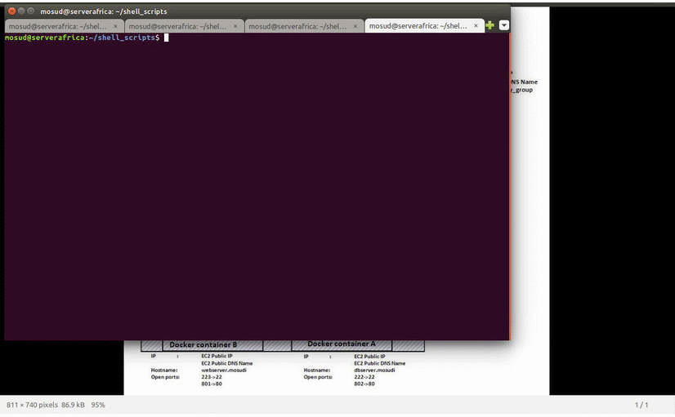
This animation depicts the configuration of Icinga 2 master and clients configurations.

