IMPACT-Z User Document Version 2.7

Ji Qiang

Lawrence Berkeley Nation Laboratory

Copyright @The Regents of the University of California
July 16, 2025

Contents
1. Introduction 1
2. Programs to prepare input files 1
3. Input Files 1
1.1. ImpactZ.in 2
1.1.1. Beam Section 2
1.1.2. Lattice Section 4
1.2. rfdataN.in 9
1.3. particle.in 10
4. Run IMPACT-Z 10
2.1. Run IMPACT-Z 10
2.2. Console 11
2.3. Stop IMPACT-Z 12
5. Output Files 12
5.1. File fort.18: reference particle information 12
5.2. File fort.24 (for X) fort.25 (for Y), fort.26 (for Z) : RMS size information 13
5.3. File fort.27: maximum amplitude information 13
5.4. File fort.28: load balance and loss diagnostic 13
5.5. File fort.29: cubic root of 3rd moments of the beam distribution 13
5.6. File fort.30: square root, square root of 4th moments of the beam distribution 13
5.7. File fort.32: number of particles for each charge state 14
5.8. Particle distribution coordinate unit 14

Introduction
IMPACT-Z is a 3D parallel/serial Particle-In-Cell (PIC) code based on multi-layer object-oriented design. The present version of IMPACT-Z can treat intense beams propagating through drifts, magnetic quadrupoles, magnetic solenoids, bending magnet, multipoles, and rf cavities, using map integrator or nonlinear Lorentz integrator. (Warning: some elements such as 3D EM field, can be used ONLY for Lorentz integrator.) It has a novel treatment of rf cavities, in which the gap transfer maps are computed during the simulations by reading in Superfish rf fields. The goal is to avoid time-consuming (and unnecessary) fine-scale integration of millions of particles through the highly z-dependent cavity fields. Instead, fine-scale integration is used to compute the maps (which involve a small number of terms), and the maps are applied to particles. If you are familiar with magnetic optics, then you will recognize that this is analogous to the technique used to simulate beam transport through magnets with fringe fields.
The version of IMPACT-Z (v2.2) currently has a 3D space-charge model that assumes a 3D open boundary conditions. The other boundary conditions and more functions will be added later on in the new versions. The error studies can include the field errors, misalignment errors, and rotation errors.

Programs to prepare input files
Engscan.py: does a single cavity phase scan.
RFcoef.f90: prepares Fourier expansion coefficients of RF or solenoid field to be used in the simulation (with Lorentz nonlinear integrator.)
phaseOptZ.py: sets up the RF driven phase of the cavities with the user specified design phases.

Note:
1) The current version of the code is for serial single processor computer with Fortran90 compiler. To run the code on a parallel computer with MPI, the user has to comment out the line "use mpistub" in Contrl/Input.f90, DataStruct/Data.f90, DataStruct/Pgrid.f90, DataStruct/PhysConst.f90, and Func/Timer.f90. The user also has to remove the mpif.h file under the Appl, Control, DataStruct, and Func directories. The user also has to modify the Makefile to remove the mpistub.o inside the file and to use the appropriate parallel Fortran90 compiler such as mpif90.
2) The subroutines in FFT.f90: realft, four1, and sinft, can be replaced with functions from the Numerical Recipe or some equivalent 1D FFT functions.
3) To compile the code on Windows PC without "make" function, one needs to move all *.f90 files to one directory and use a compiler (g95 or gfortran) to compile the code in a single line.
4) There is a ImpactTv2.pdf document contains more detailed physics description.

Input Files
The main IMPACT input file is called ImpactZ.in. The programs which will help you prepare the input file ‘ImpactZ.in’ are list in section 2. If you need to read field, the file ‘rfdataN.in’ is needed. (The number N is the filed ID which is set in the element input information). For the initial distribution, you can not only choose distributions in the code, e.g. Gaussian, Waterbag, KV and so on, but also read distribution file ‘particle.in’.
WARNING: The / at the end of each line below is important: the read statement in IMPACT that reads all the beamline element info wants to read in a lot of numbers. In a Fortran free-format read statement, you can make it ignore the rest by using / at the end of the line.
So, if you neglect this, the code will crash. Also, any line starting with ! will be treated as a comment line.

ImpactZ.in
The twelfth line of the ‘ImpactZ.in’ file starts with ‘!’ means a comment line. And this line divides the file as two sections, beam section and lattice section. The code will not read this line.

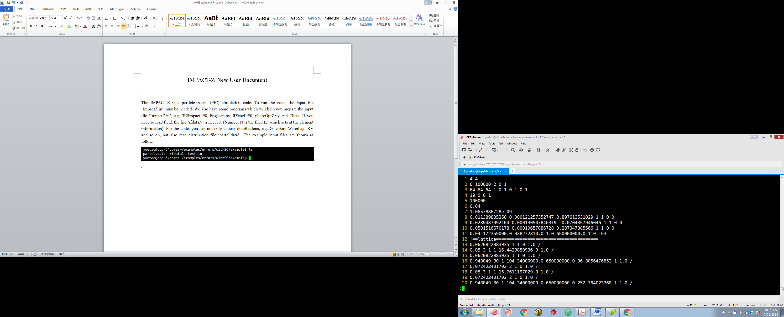

Beam Section
The beam section consists of 11 lines. Please see the example test.in as follow:

① 4 4
② 6 100000 2 0 1
③ 64 64 64 1 0.1 0.1 0.1
④ 19 0 0 1
⑤ 100000
⑥ 0.04
⑦ 1.0657886728e-09
⑧ 0.011389835258 0.000121257352747 0.897613531029 1.0 1.0 0.0 0.0
⑨ 0.0239487992104 0.000130507846319 -0.0704357946046 1.0 1.0 0.0 0.0
⑩ 0.0501516670178 0.00010657886728 0.287347885566 1.0 1.0 0.0 0.0
⑪ 0.04 172359000.0 938272310.0 1.0 650000000.0 110.163

The 1st line: processor layout in y and z dimension, the product of these numbers must equal the number of processors (4, 4) that you run on.

The 2nd line: “6” for random seed of simulation, “100000” for macro particles used in simulation, "2" for nonlinear Lorentz integrator, ("1" for linear map integrator), “0” for no error study ("1" for error studies) and “1” for standard output ("2" for 90%, 95%, 99% emittance, radius output, otherwise no output).

The 3rd line: 64x64x64 space-charge grid, “1” for 3D open all mesh numbers have to a power of 2, i.e. 2^n; "2" for transverse open, longitudinal periodic(the 3rd mesh number has to 2^n+1), "3" for transverse finite, longitudinal open round pipe (in this case, the 2nd mesh number has to be 2^n+1), "4" for transverse finite, longitudinal periodic round pipe (in this case, the 2nd and the 3rd mesh number has to be 2^n+1), "5" for transverse finite, longitudinal open rectangular pipe (in this case, the 1st and the 2nd mesh number have to be 2^n+1),"6" for transverse finite, longitudinal periodic rectangular pipe (in this case, all mesh number have to be 2^n+1)) (Note: in the current version, only 3D open BC available), x pipe width "0.1" m, y pipe width "0.1" m, period length "0.10" m.

The 4th line: distribution “type 19”, Here is what the distributions mean: 1=rectangle in 6D phase space (for single charge), 2=6D Gaussian (single charge), 3=6D Waterbag (single charge), 4=Semi-Gaussian [uniform position, Gaussian momentum,sc], 5=KV transverse, uniform longitudinal (sc), 16=6D Waterbag for multiple charge state (mc), 17=6D Gaussian for multiple charge state (mc), 19=Read coords/momenta from external file "particle.in" in ImpactZ format. 199=Parallel read in macroparticles from “fort.x+myid” files (x is an input positive integer from the 2nd number of the initial distribution parameter line, myid is the processor ID. All files are in binary format with the # of particles nptlocal as the 1st line, the particle data file pts(1:9,1:nptlocal) as the second line), 22=Read coords/momenta from external file "particle.in" in Elegant format. 35=Read coords/momenta from external file "particle.in" in ImpactT output format. [this is undergoing tests in Testing directory. More later.]) "0" means no restart ("1" means to restart from some point after stop), "0" means no sub-cycle ("1" means sub-cycle). "1" for # of charge states = 1.

The 5th line: particle list for each charge stateset 1000000.

The 6th line: current for each charge state 0.04A.

The 7th line: q/m for each charge state. Here, we normalized each charge by the mass of reference particle so that the reference particle has 1 AMU mass, but less charge. For example, for a proton, 1/ 938.23e6 = 1.0657886728e-09.

The 8th – 10th line: Twiss parameters of initial distribution.
(Explanation of preceding 3 lines: They are
Alpha_x beta_x emit_x mismatchx mismatchpx offsetX offsetPx
Alpha_y beta_y emit_y mismatchy mismatchpy offsetY offsetPy
Alpha_z beta_z emit_z mismatchz mismatchE offsetPhase offsetEnergy

The distribution in each plane is a quadratic form. There is no coupling among planes. Alpha_, beta_(in meters for x and y, and degree/MeV for z) are Twiss parameters, emit_ is normalized emittance (in m-rad for x and y, and degree-MeV for z).

The 11th line: current averaged over rf period (0.04A, I=Q*freq), initial kinetic energy (172.359MeV), particle mass (938.272MeV/c^2), charge (1), scaling frequency (650MHz) and initial phase of the reference particle (110.163).

Lattice Section
In the lattice section, each line denotes one beam line element (can be marker element) except the line starting with ! character. The line starting with ! is a comment line. It will be skipped during the simulation. The 1st number denotes the element length. The 2nd and 3rd numbers are used to set numerical integration steps across the element and the number steps to calculate transfer map between each step or substeps. The example lattice structure is Drift + Quad + Drift + RF Cavity + Drift + Quad + Drift + RF Cavity.

① 0.0620822983935 1 1 0 1.0 /
② 0.05 3 1 1 16.4423850936 0 1.0 0. 0. 0. 0. 0. /
③ 0.0620822983935 1 1 0 1.0 /
④ 0.948049 80 1 104 34000000.0 650000000.0 96.8056476853 1 1.0 /
⑤ 0.072423401702 2 1 0 1.0 /
⑥ 0.05 3 1 1 15.7611197029 0 1.0 /
⑦ 0.072423401702 2 1 0 1.0 /
⑧ 0.948049 80 1 104 34000000.0 650000000.0 252.764023368 1 1.0 /

The 4th number of each line denote the element type.
“0” for drift, (example element ①) length=0.0620822983935m, 1 "step" where each step through the beamline element consists of a half-step +a space-charge kick + a half-step. Each half-step involves computing a map for that half-element, computed by numerical integration with 1 "map step", pipe radius is 1 m.

“1” for quadrupole, (example element ②), length=0.05m, 3 "steps," 1 "map steps", gradient=16.4423850936 Tesla/m, input gradient file ID (if >0, read in fringe field profile; if<-10 use linear transfer map of an undulator, if >-10 but <0, use k-value (i.e. Gradient/Brho) linear transfer map; if=0 linear transfer map using gradient), radius = 1.0, x misalignment error=0.0m, y misalignment error=0.0m, rotation error x, y, z = 0.0, 0.0, 0.0 rad.

“2” for 3D constant focusing, (e.g. 0.30 4 20 2 9.8696 9.8696 9.8696 0.014 / )
length=0.3m, 4 "steps", " 20 "map steps",kx0^2=9.8696, ky0^2=9.8696, kz0^2=9.8696, radius=0.014m. Note, it does not work for Lorentz integrator option.)

“3” for solenoid, (e.g. 0.30 4 20 3 5.67 0. 0.014 0. 0. 0. 0. 0. /)
length=0.3m, 4 "steps," 20 "map steps", Bz0=5.67 Tesla, input field file ID 0., radius=0.014m, x misalignment error=0.0m, y misalignment error=0.0m, rotation error x, y, z=0.0, 0., 0. rad.
Note: For the Lorentz integrator, the length includes two linear fringe regions and a flat top region. Here, the length of the fringe region is defined by the 2*radius. The total length = effective length + 2*radius.)

“4” for dipole, (e.g. 1.48524 10 20 4 0.1 0.0 150. 0.014 0.0 0.0 0.0 0.0 0.0 0.0 0.0 0.0 0.0 0.0 / )
length=1.48524m, 10 "steps", 20 "map steps", bending angle 0.1rad, k1=0.0, input switch 150., if > 200, include 1D CSR, half gap = 0.014m, 0.0 = entr. pole face angle(rad), 0.0 = exit pole face angle, 0.0 = curvature of entr. face, 0.0 = curv. of exit face, 0.0 = integrated fringe field, 0.0 = x misalignment error, 0.0 = y misalignment error, 0.0 = x rot. error, 0.0 = y rot. error, 0.0 = z rot error.

“5” for thick lens multipole, (e.g. 0.5 10 20 5 2.0 10.0 0.0 0.02 0.0 0.0 0.0 0.0 0.0 / ) (work for Lorentz integrator only).
length=0.5m, 10 "steps", 20 "map steps", 2.0 is id for sextupole (octupole (3), decapole (4)), 10.0 T/m^2 field strength, 0.0 no read-in fringe field, 0.02 aperture size, 0.0 = x misalignment error, 0.0 = y misalignment error, 0.0 = x rot. error, 0.0 = y rot. error, 0.0 = z rot error.

“6” for wiggler/undulator, (e.g. 0.5 10 20 6 1.0 10.0 0.0 0.02 0.0 0.05 0.0 0.0 0.0 0.0 0.0 / ) (work for Lorentz integrator only).
length=0.5m, 10 "steps", 20 "map steps", 1.0 is id for planar undulator (helical (2),), 10.0 T maximum field on axis, 0.0 no read-in fringe field, 0.02 aperture size, 0.0 = kx, 0.05 m wiggler period length, 0.0 = x misalignment error, 0.0 = y misalignment error, 0.0 = x rot. error, 0.0 = y rot. error, 0.0 = z rot error.

“101” for DTL, (e.g. 1.48524 10 20 101 1.0 700.0e6 30. 1.0 0.014 0.01 1.0 0.01 1.0 0.0 0.0 0.0 0.0 0.0 0.0 0.0 0.0 0.0 0.0 / )
length=1.48524m, 10 "steps", 20 "map steps", field scaling=1.0, RF frequency=700.0e6, driven phase=30.0 degree, input field ID=1.0 (if ID<0, uses simple sinusoidal model, only works for the map integrator, phase is design phase with 0 for maximum energy gain), radius=0.014m, quad 1 length=0.01m, quad 1 gradient=1.0T/m, quad 2 length=0.01m, quad 2 gradient, x misalignment error=0.0m, y misalignment error=0.0m, rotation error x, y, z=0.0, 0., 0. rad for quad, x displacement, y displacement, rotation error x, y, z for RF field.

“102” means CCDTL, (e.g. 1.48524 10 20 102 1.0 700.0e6 30. 1.0 0.014 0. 0. 0. 0. 0. / )
length=1.48524m, 10 "steps", 20 "map steps", field scaling=1.0, RF frequency=700.0e6, driven phase=30.0 degree, input field ID=1.0 (if ID<0, use simple sinusoidal model, only works for the map integrator, phase is design phase with 0 for maximum energy gain), radius=0.014m, x misalignment error=0.0m, y misalignment error=0.0m, rotation error x, y, z=0.0, 0., 0. Rad.

“103” for CCL, (e.g. 1.48524 10 20 103 1.0 700.0e6 30. 1.0 0.014 0. 0. 0. 0. 0. / )
length=1.48524m, 10 "steps", 20 "map steps", field scaling=1.0, RF frequency=700.0e6, driven phase=30.0 degree, input field ID=1.0 (if ID<0, use simple sinusoidal model, only works for the map integrator, phase is design phase with 0 for maximum energy gain), radius=0.014m, x misalignment error=0.0m, y misalignment error=0.0m, rotation error x, y, z=0.0, 0., 0. Rad.
e.g. 1.037743e+000 2 1 103 0.1090744783E+08 1.3e9 -0.1743982832E+02 -1.01 1.0 /
("-1.01" for simple sinusoidal RF cavity model.)
“104” for superconducting cavity, (example element ④) , length=0.948049m, 80 "steps", 1 "map steps", field scaling=34000000.0, RF frequency=650.0e6, driven phase=96.8056476853 degree, input field ID=1.0 (if ID<0, use simple sinusoidal model, only works for the map integrator, phase is design phase with 0 for maximum energy gain), radius=1.0 m, x misalignment error=0.0m, y misalignment error=0.0m, rotation error x, y, z=0.0, 0., 0. Rad.

“105” for solenoid with RF cavity, (e.g. 1.48524 10 20 105 1.0 700.0e6 30. 1.0 0.014 0. 0. 0. 0. 0. 1. 0. 0. 0. / ) (use Fourier coefficients for Ez(z), not for map integrator).
length=1.48524m, 10 "steps", 20 "map steps", field scaling=1.0, RF frequency=700.0e6, driven phase=30.0 degree, input field ID=1.0, radius=0.014m, x misalignment error=0.0m, y misalignment error=0.0m, rotation error x, y, z=0.0, 0., 0. rad, Bz0=1.0 Tesla, 0. "aperture size for wakefield", 0. "gap size for wk", 0. "length for wk". RF structure wakefield only turned with length of wk>0.

“106” for traveling wave RF cavity, (e.g. 1.48524 10 20 106 1.0 700.0e6 30. 1.0 0.014 0. 0. 0. 0. 0. 0.5 0. 0. 0. / ) (use Fourier coefficients for Ez(z), not for map integrator).
Traveling wave RF cavity, length=1.48524m, 10 "steps", 20 "map steps", field scaling=1.0, RF frequency=700.0e6, driven phase=30.0 degree, input field ID=1.0, radius=0.014m, x misalignment error=0.0m, y misalignment error=0.0m, rotation error x, y, z=0.0, 0., 0. rad, (pi - beta * d) phase difference B and A, 0. "aperture size for wakefield", 0. "gap size for wk", 0. "length for wk". RF structure wakefield only turned with length of wk>0.

“110” for user defined RF cavity. (e.g. 1.48524 10 20 110 1.0 700.0e6 30. 1.0 0.014 0.014 0. 0. 0. 0. 0. 1.0 2.0 / )
length=1.48524m, 10 "steps", 20 "map steps", field scaling=1.0, RF frequency=700.0e6, driven phase=30.0 degree, input field ID=1.0, Xradius=0.014m, Yradius=0.014m, x misalignment error=0.0m, y misalignment error=0.0m, rotation error x, y, z=0.0, 0., 0. rad), 1.0 (using discrete data only, 2.0 using both discrete data and analytical function, other using analytical function only), 2.0 (field in Cartesian coordinate, 1.0 in Cylindrical coordinate). The format of 3D field on Cartesian grid is:
read(14,*,end=33)tmp1,tmp2,tmpint
XminRfg = tmp1
XmaxRfg = tmp2
NxIntvRfg = tmpint !number of grid cells in x dimension
read(14,*,end=33)tmp1,tmp2,tmpint
YminRfg = tmp1
YmaxRfg = tmp2
NyIntvRfg = tmpint !number of grid cells in y dimension

read(14,*,end=33)tmp1,tmp2,tmpint
ZminRfg = tmp1
ZmaxRfg = tmp2
NzIntvRfg = tmpint !number of grid cells in z dimension
…
allocate(Exgrid(NxIntvRfg+1,NyIntvRfg+1,NzIntvRfg+1))
allocate(Eygrid(NxIntvRfg+1,NyIntvRfg+1,NzIntvRfg+1))
allocate(Ezgrid(NxIntvRfg+1,NyIntvRfg+1,NzIntvRfg+1))
allocate(Bxgrid(NxIntvRfg+1,NyIntvRfg+1,NzIntvRfg+1))
allocate(Bygrid(NxIntvRfg+1,NyIntvRfg+1,NzIntvRfg+1))
allocate(Bzgrid(NxIntvRfg+1,NyIntvRfg+1,NzIntvRfg+1))
…
read(14,*,end=77)tmp1,tmp2,tmp3,tmp4,tmp5,tmp6
n = n+1
k = (n-1)/((NxIntvRfg+1)*(NyIntvRfg+1))+1
j = (n-1-(k-1)*(NxIntvRfg+1)*(NyIntvRfg+1))/(NxIntvRfg+1) + 1
i = n - (k-1)*(NxIntvRfg+1)*(NyIntvRfg+1) - (j-1)*(NxIntvRfg+1)
Exgrid(i,j,k) = tmp1
Eygrid(i,j,k) = tmp2
Ezgrid(i,j,k) = tmp3
Bxgrid(i,j,k) = tmp4
Bygrid(i,j,k) = tmp5
Bzgrid(i,j,k) = tmp6

“-1” shift the centroid of beam to the axis. e.g. 0. 0 0 -1 /

“-2” write the particle distribution into fort.N. e.g. 0. 0 N -2 0.0 10 /
NOTE: N must not equal 5 or 6 (Fortran code), or 24, 25, 26, 27, 29, 30, 32. This prints the data set with 10 as sample frequency (i.e. every 10 particles outputs 1 particle). Those particle data are dimensionless in IMPACT internal unit. The normalization constants are described in the following paritcle.in. If sample frequency is negative, the output would be in the ImpactT particle format (except that the longitudinal z is not absolute position but delta z, and pz is gamma instead of gamma beta z).

“-3” write the accumulated density along R, X, Y into file Xprof.data, Yprof.data, RadDens.data . e.g. 0. 0 0 -3 0.014 0.02 0.02 0.02 0.02 0.02 0.02 /
radius=0.014m, xmax=0.02m,pxmax=0.02 mc,ymax=0.02m,pymax=0.02 mc, zmax=0.02 rad,pzmax=0.02 mc^2, if no frame range is specified, the program will use the maximum amplitude at given location as the frame.

“-4” write the density along R, X, Y into file Xprof2.data, Yprof2.data, RadDens2.data.
e.g. 0. 0 0 -4 0.014 0.02 0.02 0.02 0.02 0.02 0.02 /
radius=0.014m, xmax=0.02m,pxmax=0.02 mc,ymax=0.02m,pymax=0.02 mc, zmax=0.02 rad,pzmax=0.02 mc^2, if no frame range is specified, the program will use the maximum amplitude at given location as the frame.

“-5” write the 2D projections of 6D distribution in XY.data, XPx.data, XZ.data, YPy.data, YZ.data, ZPz.data. e.g. 0. 0 0 -5 0.014 0.02 0.02 0.02 0.02 0.02 0.02 /
radius=0.014m,xmax=0.02,pxmax=0.02mc,ymax=0.02,pymax=0.02mc,zmax=0.02rad,pzmax=0.02 mc^2, if no frame range is specified, the program will use the maximum amplitude at given location as the frame.

“-6” write the 3D density into the file fort.8. e.g.0. 0 0 -6 0.014 0.02 0.02 0.02 0.02 2 0.02 /
radius=0.014m,xmax=0.02m,pxmax=0.02mc,ymax=0.02m,pymax=0.02mc,zmax=2degree,pzmax=0.02 mc^2, if no frame range is specified, the program will use the maximum amplitude at given location as the frame.)

“-7” write the 6D phase space information and local computation domain information into files fort.1000, fort.1001, fort.1002,...fort.(1000+Nprocessor-1). e.g. 0. 0 1000 -7 /
This function is used for restart purpose.

“-8” write slice info. into file fort.202 using 101 slices. e.g. 0.0 0 202 -8 101.0 0.1 1.0 0.2 2.0 /
The fort.202 contains: bunch length coordinate (m), # of particles per slice, current (A) per slice, X normalized emittance (m-rad) per slice, Y normalized emittance (m-rad) per slice, dE/E, uncorrelated energy spread (eV) per slice, <x> (m) of each slice, <y> (m) of each slice, X mismatch factor, Y mismatch factor. Here, the Twiss parameters at that location are alphaX = 0.1, betaX = 1.0 (m), alphaY=0.2, betaY = 2.0(m). If those parameters are not provided, the mismatch factor should be neglected.

“-10” scale/mismatch the particle 6D coordinates. e.g. 0. 0 0 -10 0.014 0.1 0.2 0.3 0.4 0.5 0.6 / radius=0.014m (not used), 0.1 = xmis, 0.2 = pxmis, 0.3 = ymis, 0.4 = pymis, 0.5 = tmis, 0.6 = ptmis.

“-12” apply instant linear transfer matrix kick from input file fort.10. e.g. 0. 0 10 -12 0.014 / radius=0.014m (not used), 10 is for the filename fort.10. The transfer matrix is in (x, x’, y, y’, z, dp/p) coordinates.

“-13” collimate the beam with transverse rectangular aperture sizes. e.g.0. 0 0 -13 0.014 -0.02 0.02 -0.04 0.04 / radius=0.014m (not used), xmin = -0.02m, xmax = 0.02m, ymin = -0.04m, ymax = 0.04m.

“-14” switch off/on space-charge effects e.g. 0. 0 1 -14 0.014 0.0 / radius=0.014m (not used), 0.0 = off, 1.0 = on.

“-16” rotate the beam with respect to the horizontal x axis.. e.g. 0. 0 0 -18 0.014 0.5 / radius=0.014m (not used), rotation angle = 0.5 rad. (counter-clockwise for beam, i.e. clockwise for reference coordinates system)

“-17” rotate the beam with respect to the vertical y axis.. e.g. 0. 0 0 -18 0.014 0.5 / radius=0.014m (not used), rotation angle = 0.5 rad.

“-18” rotate the beam with respect to the longitudinal axis.. e.g.0. 0 0 -18 0.014 0.5 / radius=0.014m (not used), rotation angle = 0.5 rad.

“-19” shift the beam longitudinally to the bunch centroid so that <dt>=<dE>=0.

“-20” increase the beam energy spread. e.g.0. 0 0 -18 0.014 1000.0 / radius=0.014m (not used), increased energy spread = 1000.0 eV.

“-21” shift the beam centroid in 6D phase space. e.g.0. 0 0 -21 0.014 0.02 0.02 0.02 0.02 0.02 0.02 / radius=0.014m (not used), xshift=0.02m,pxshift=0.02rad,yshift=0.02m,pyshift=0.02rad, zshift=0.02deg,pzshift=0.02MeV.

“-25” switch the integrator type using the “bmpstp” the 3rd number of line. hift the beam centroid in 6D phase space. e.g.0. 0 1 -25 0.01 / radius=0.01m (not used), use linear map integrator, 0. 0 2 -25 0.01 / use the nonlinear Lorentz integrator for complicated external fields where transfer maps are not available.

“-40” kick the beam longitudinally by the rf nonlinearity (the linear part has been included in the map integrator and substracted.) drange(3) - vmax (V), drange(4) - phi0 (degree), drange(5) - harm number of rf. e.g.0. 0 0 -40 0.014 1.e6 -60.0 1 / radius=0.014m (not used), maximum voltage = 1.0e6 eV, -60 degrees, and harmonic number (with respect to reference frequency) = 1.

“-41” read-in RF cavity structure wakefield from rfdata41.in. e.g. 0.0 0 1 -41 1.0 41 1.0 /
Or 0.0 0 1 -41 1.0 41 -1.0 / “1.0” not used, “41” is the file ID, “1.0” turn on or "-1.0" turn off RF wakefield (if <10 no transverse wakefield effects included). In wakefield data file rfdata41, there are 4 columns corresponding to longitudinal bunch length (m), longitudinal wake function, x, and y wake functions.

“-44” apply thin lens RF deflection. e.g. 0.0 0 1 -44 2.0 1 /
2.0 strength, 1 switch for horizontal (>=0) or vertical deflection (<0)

“-52” add energy modulation (emulate laser heater). e.g. 0.0 0 10 -52 0.0895d-03 1030.0d-9 7000.0 / uncorrelated energy spread by "7000.0" eV using laser wavelength 1030d-9 m and the matched beam size "0.0895d-3" m)

“-55” kick the beam using thin lens multipole. e.g. 0.0 0 10 -55 1.0 0.0 1.0 2.0 3.0 4.0 5.0 / “1.0” not used, 0.0 – dipole (k0), 1.0 – quad. (k1), 2.0 – sext. (k2), 3.0 – oct. (k3), 4.0 – dec. (k4), 5.0 – dodec. (k5).

“-99” halt execution at this point in the input file. e.g. 0 1 1 -99 /
This is useful if you have a big file want to run part-way through it without deleting a lot of lines.

rfdataN.in
Using RFcoef.f90 to prepare Fourier expansion coefficients of RF cavity or solenoid.
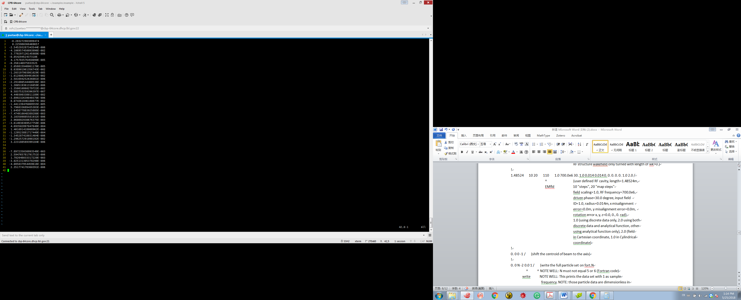

particle.in
Do not forget the first line total particle number.
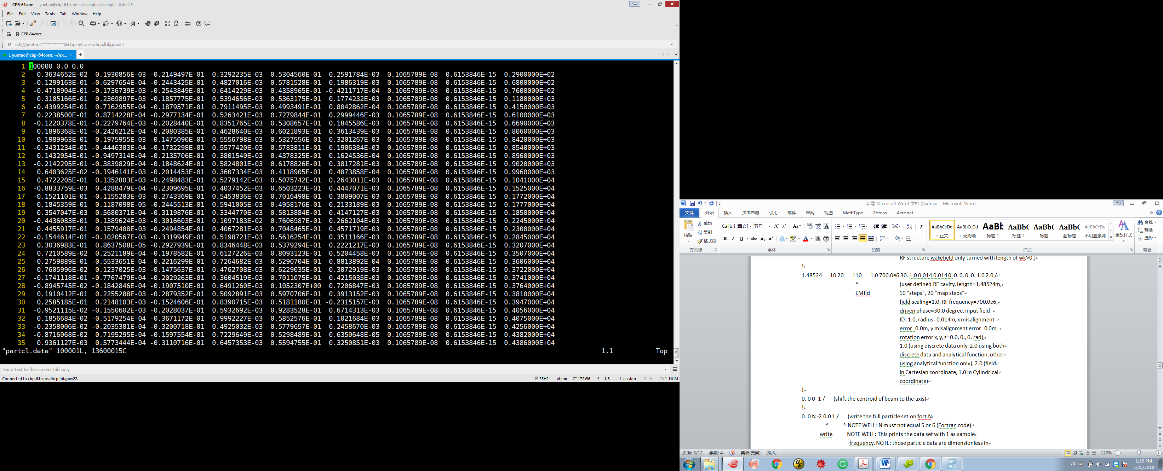

Run IMPACT-Z

Run IMPACT-Z
mpirun –n 16 ImpactZexe (processors same with set in ImpactZ.in)
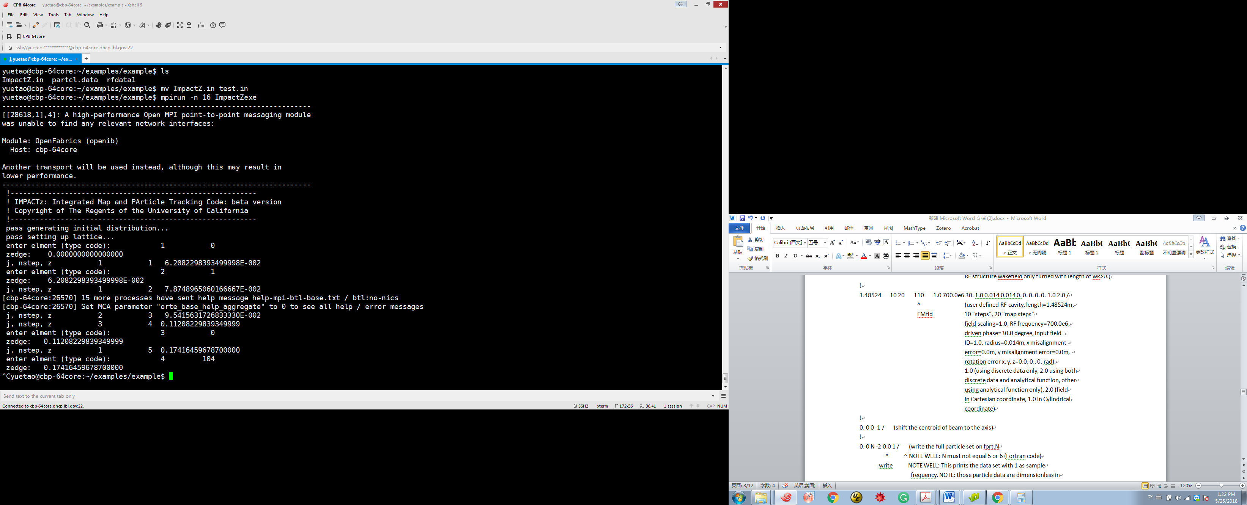

Console
When the code is running, the console shows the order of elements, elements type, position Z, element steps and total steps.

The order of the element:

Element type:

Position Z:

Element steps:

Total steps:


Stop IMPACT-Z
Ctrl + C


Output Files
There are some output files, fort.18, fort.24, fort.25, fort.26, fort.27, fort.28, fort.29, fort.30 and fort.32.
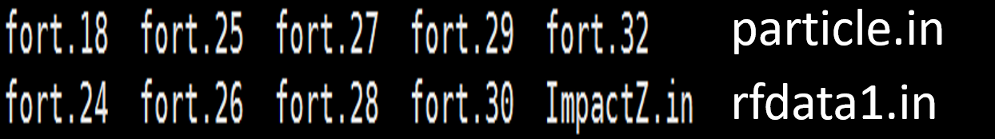

File fort.18: reference particle information
1st col: distance (m)
2nd col: absolute phase (radian)
3rd col: gamma
4th col: kinetic energy (MeV)
5th col: beta
6th col: Rmax (m) R is measured from the axis of pipe

File fort.24 (for X) fort.25 (for Y), fort.26 (for Z) : RMS size information
1st col: z distance (m)
2nd col: centroid location (m)
3rd col: RMS size (m) (degree for fort.26)
4th col: Centroid momentum (rad for fort.24 and fort.25, MeV for fort.26)
5th col: RMS momentum (rad for fort.24 and fort.25, MeV for fort.26)
6th col: Twiss parameter, alpha
7th col: normalized RMS emittance (m-rad for transverse and degree-MeV for fort.26)

File fort.27: maximum amplitude information
1st col: z distance (m)
2nd col: Max. X (m)
3rd col: Max. Px (rad)
4th col: Max. Y (m)
5th col: Max. Py (rad)
6th col: Max. Phase (degree)
7th col: Max. Energy deviation (MeV)

File fort.28: load balance and loss diagnostic
1st col: z distance (m)
2nd col: min # of particles on a PE
3rd col: max # of particles on a PE
4th col: total # of particles in the bunch

File fort.29: cubic root of 3rd moments of the beam distribution
1st col: z distance (m)
2nd col: X (m)
3rd col: Px (rad)
4th col: Y (m)
5th col: Py (rad)
6th col: phase (degree)
7th col: Energy deviation (MeV)

File fort.30: square root, square root of 4th moments of the beam distribution
1st col: z distance (m)
2nd col: X (m)
3rd col: Px (rad)
4th col: Y (m)
5th col: Py (rad)
6th col: phase (degree)
7th col: Energy deviation (MeV)

File fort.32: number of particles for each charge state
1st col: z distance (m)
2nd col: number of particles for each charge state

Particle distribution coordinate unit
if you use the "-2" type code (described in the explanation of test.in) to print the data at various locations, the resulting data will be in columns of the form x,px,y,py,t,pt, q/m, charge/per particle, id.
------------------------------------
1st col: x normalized by c/omega
2nd col: Px normalized by mc, here this column has to be divided by gamma beta to convert to unit radian
3rd col: y normalized by c/omega
4th col: Py normalized by mc, here this column has to be divided by gamma beta to convert to unit radian
5th col: phase (radian)
6th col: kinetic energy deviation (E0 -E) normalized by mc^2
7th col: q/m, for an electron, q = -1, m = 0.511001e6
8th col: charge per macro-particle (Coulomb per particle)
9th col: particle id

