**Prototype of a Conversational Chatbot with built with a Natural Language Toolkit**

A Chatbot built with Convolutional Neural Networks for a fictitious pizza restaurant called ReadyPizza

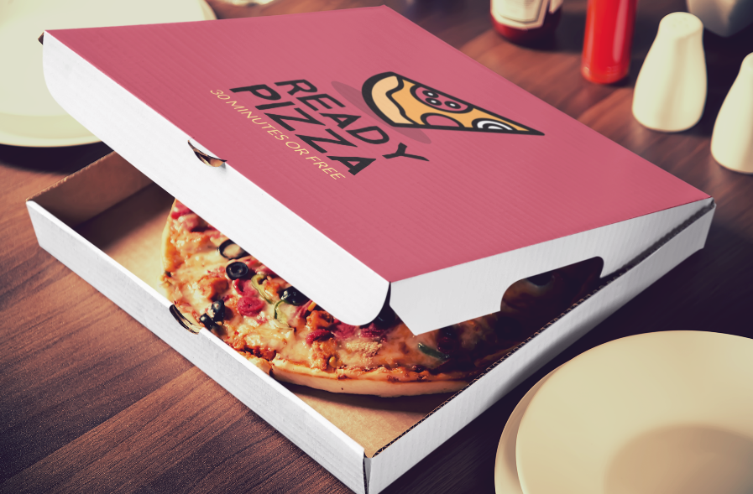

By :

**Faith Haruna**

**Fontys University of Applied Sciences, Eindhoven, The Netherlands**

Contents

1 Introduction 3

2 Methods 3

a) Setting up Git 3

b) Setting up and activating a deployment virtual environment 4

c) Setting up project directory structure 5

i. Dataset 5

ii. Images 6

iii. Model Artifacts 6

d) Scripting 7

i. Requirements Text file 7

ii. Pre-processor Python file 7

iii. App Python file 8

e) Deploying with Streamlit 8

3 Results 8

4 Conclusion 8

5 References 9

# Introduction

The motivation of this project is to demo a Conversational chatbot built with NLTK and Tensorflow on a collection of linguistic data compiled as written texts.

This project utilizes cutting-edge tools, frameworks and libraries such as Tensorflow, Streamlit tools to build an intelligent conversational chatbot centered around a pizza ordering restaurant called ReadyPizza.

# Methods

## Setting up Git

Git was used for version control to manage all the files and folders for easier future updates and changes. A repository called “PizzaRestaurantChatbot”[1] was created in GitHub from which a cloned local copy will be used for development.

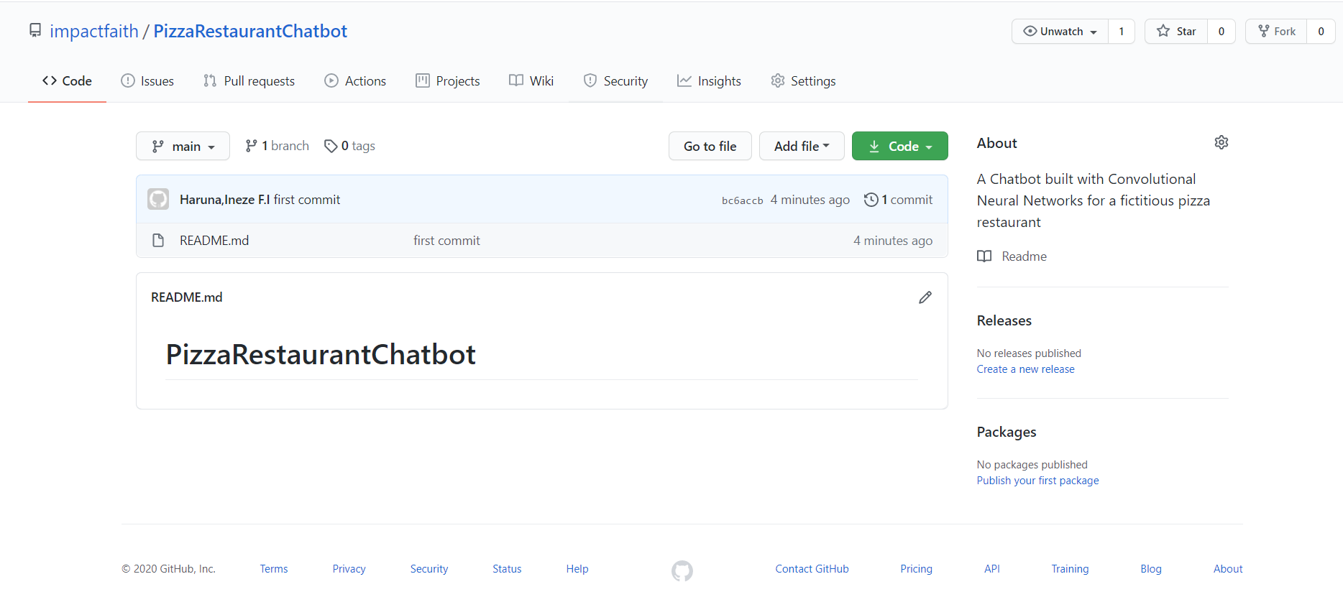

## Setting up and activating a deployment virtual environment

First step was to create an isolated python environment mainly to prevent problems like dependency issues. All packages or modules required for this project would be installed and available only in this environment.

Using an anaconda CMD shell, a python environment called “pizzaenv” was created and activated using the following commands:

# Create Environment

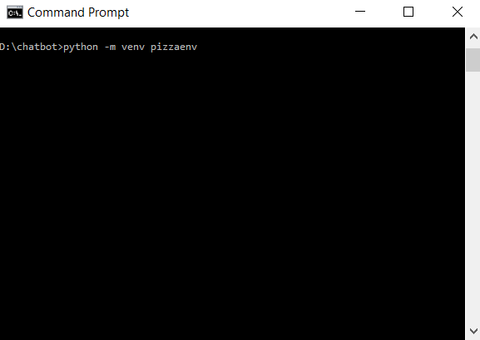

# Activate the Environment (pizzaenv\Scripts\activate)

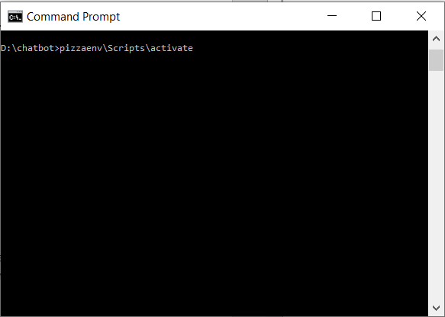

## Setting up project directory structure

After setting up GIT and the python environment, for proper organization of the several files and resources used in this project, a directory structure was created as shown below

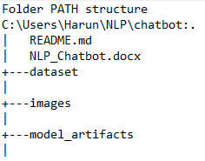

Inside the structure, there is the main root of the directory which will contain resources related to Git and this document you are currently reading, a folder to store datasets, folder for images used in the live view and a folder that stores the artifacts of the prebuilt model.

### Dataset

Inside the dataset folder are 2 files, the “intents.json” and “response.csv”.

The “**intents.json**” is the dataset written by me which was used to train the model. Since it is a simple chatbot, there was no need to download massive datasets. It is a bunch of messages that the user is likely to type in and mapping them to a group of appropriate responses. The tag on each dictionary in the file indicates the group that each message belongs too. With this data we will train a neural network to take a sentence of words and classify it as one of the tags in our file. Then we can simply take a response from those groups and display that to the user. The more tags, responses, and patterns you provide to the chatbot the better and more complex it will be. A snippet from the json file is shown below

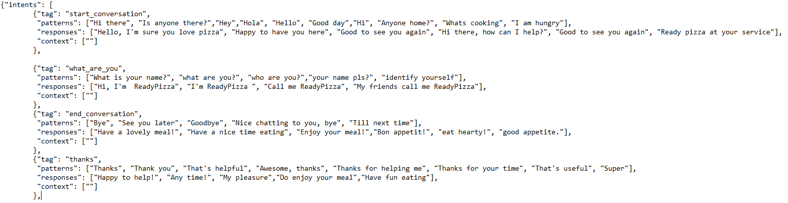

The “**response.csv**” is a file generated during modelling stage which contains predefined responses for each tag in the dataset from which the model can choose to respond to a particular question.

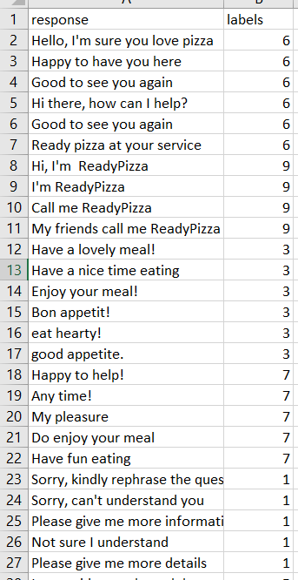

### Images

The images folder contains all the images used in the final hosted chatbot web application to give a familiar feeling that the user is interacting with a pizza ordering chatbot.

### Model Artifacts

This folder contains the artifacts generated from the modelling/training stage of the project. They are 4 files that where generated and stored in this folder. Since this project is not about the modelling stage, I will not discuss the details here.

As shown below is the directory structure after populating the folders with their appropriate files.

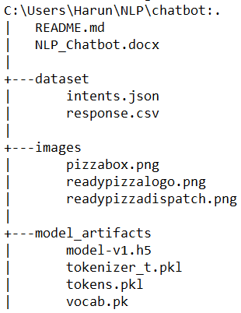

## Scripting

### Requirements Text file

Next step is to create the various scripts required to deploy, but first up some required packages for the project must be installed. For this a “**requirements.txt**” file was created and placed in the root of the directory, which lists the various libraries and their corresponding versions which will then be installed as a batch in the virtual environment created earlier.

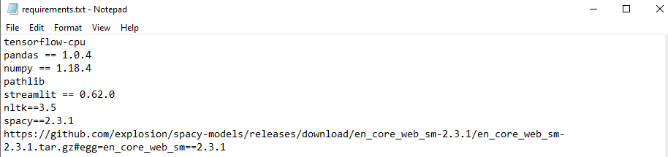

To install the requirements file:

* Create requirements.txt file with required libraries and versions in the root of the project
* Activate the environment with the command “***pizzaenv\Scripts\activate***”
* Install the file and all its included packages with the command “***pip install -r requirements.txt***”
* is to add the pre-processor python file which was used to pre-process the dataset. It essentially

### Pre-processor Python file

Next is to add the pre-processor python file which was used to pre-process the dataset. It essentially contains functions to tokenize, remove stop words and encode the dataset. The file should be added to the root of the project.

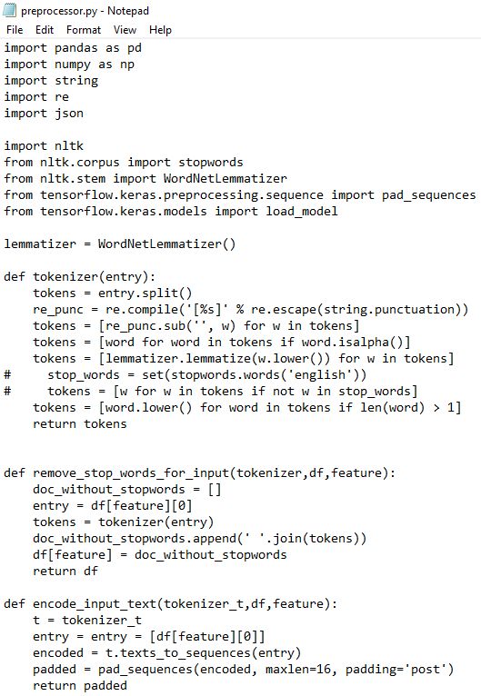

### App Python file

The starting point of the program is the **app.py** which is created and added to the project root. Lines 1–8 import the necessary libraries. Using “**Pathlib**” module which can deal with absolute as well as relative paths, you can specify the frontend images and the model artifacts paths. This makes it possible to run the app on any kind of operating system without any directory or path issues.

We load the images using the image script in the library, load the model artifacts using “**joblib**”, and the model using the “**load_model**” function from the “**tensorflow.keras.models”** script. Other chatbot related functions are defined in this file for instance functions that gets the model or gets the chatbot response.

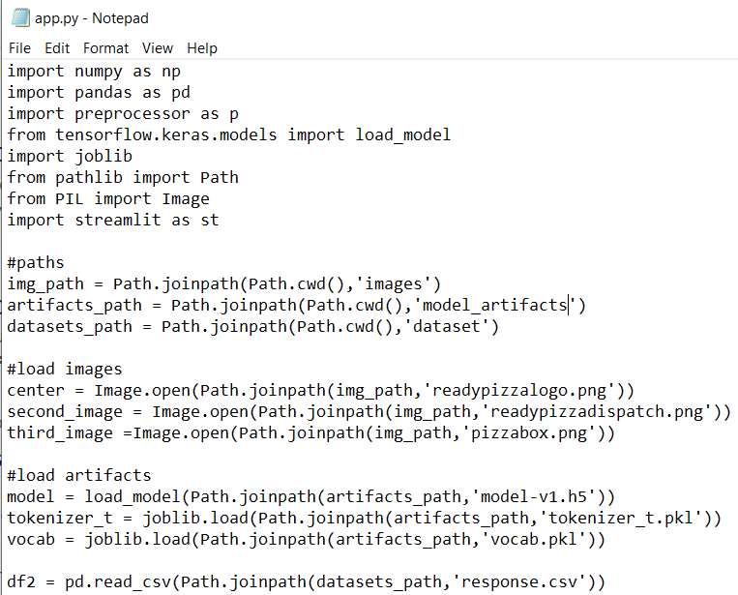

## Deploying with Streamlit

# Results

Ddddd

# Conclusion

Ddddd

# References

1. https://github.com/impactfaith/PizzaRestaurantChatbot