Impact trump cards
cheat sheet

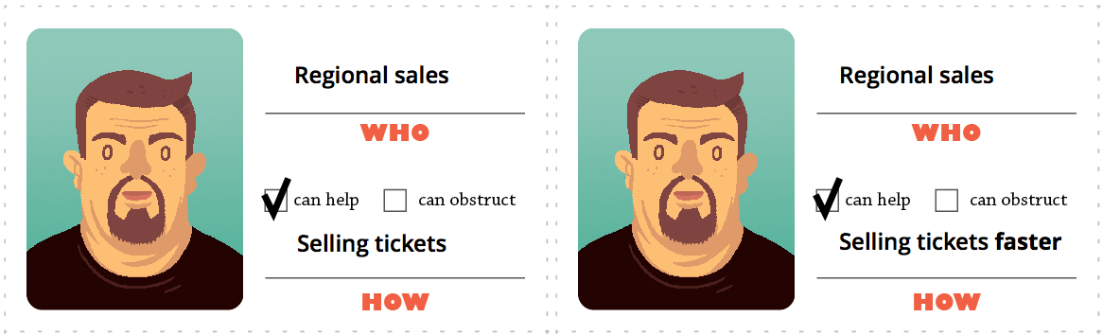
BAD: “Selling tickets” is a behaviour GOOD: Selling faster is a change

Behaviour changes
- Start doing something (they are not doing currently)
- Stop doing something
- Do something differently (faster, slower, better, cheaper, more accurately…)

Trumping rules
A card can trump another card if:

- it is related to the same actor but a different behaviour change
- the same behaviour change was not used before
- the behaviour change can plausibly impact the key objective/goal set out before the game
- the rest of the group accepts it by majority vote

The magnitude or importance of behaviour changes is irrelevant for trumping.

Voting rules
Once a player places a card on the top of the stack, the rest of the group quickly votes on it:

- make sure it's plausible
- make sure it's a behaviour change
- make sure it's not been mentioned before

