The Effects of Voting, Marital Status and Religion on Political Party Affiliation in Latin Americans

Northern Illinois University

Tim Baker

The Effects of Voting, Marital Status and Religion on Political Party Affiliation in Latin Americans

From 2015 to 2065 Latinos will make up the largest percent of population growth, 88%, and will the increase will be equal to 103 million people in 2065 of an estimated population of 441 million people. That does not include the 55.4 million Latinos that are already living in the United States (Pew Research, 2015). That equals 35.9% of voters in 2065. This goes to show that Latino voting habits in the United States are becoming more important to the shape of US politics every year. Because this population is the fastest growing demographic of voters (Griffin & Newman, 2007), it is important to politicians and political activists to know where exactly this large group of voters will stand in the coming years elections. The ability to identify what party and where these voters stand can make or break politicians and thus researchers are encouraged to provide as much useful data as they can to help work with this group of people to meet their needs and help them flourish in our nation.

Voting has traditionally not been something that a majority of Latinos will be involved in. This can been seen as making it not a good predictor for political party affiliation. In 2010, 31.2% of Latino voters casted a ballot (Pew Research, 2014). That number is about normal for participation in voting with Latinos. It would be very helpful to be able to get this number up to help increase Latino representation in Congress and thus increase the group’s ability to have their desires heard and acted upon.

Representation for this group will become more and more important as time progresses. Latinos will demand for representation that they can identify with and will seek to elect officials they feel not only feel similar to them but also come from the same backgrounds. Right now, Latinos are not as well represented in the US Congress as they should be. In districts with Latino populations it is often not likely that they will be represented by a Latino. Further, in districts with 40% or greater Latino populations it is even less likely that they are currently represented be a Latino (Griffen & Newman, 2007). With this disparity in place, it is no wonder that Latinos often do not participate in political activities such as voting, unless they specifically relate to something that they see as effecting their life.

One factor that other studies have been shown to be significant when it comes to Latinos party affiliation and political activities is that they do tend to participate in groups that are similar to their peers. The most powerful of these predictors of affiliation that Claassen observed was socio-economic status. Latinos tend to be most closely affiliated politically with peers that they are also similar to in socio-economic status (2004). This would mean that Latinos would probably most likely prefer to vote for candidates who they also felt came from the same background as them. This would probably help to make them feel more connected to the candidate and be more likely to be involved in their campaign.

Religious affiliations of Latinos in the United States has been traditionally hard to access (Perl, Greely and Gray, 2006). This is because until recently, most surveys that were given were only administered in English. This makes it impossible for the many families who live in the United States and whose primary respondent does not speak English as their language of choice to participate. This is important because many Latinos coming from to the United States are traditionally religious people and so when we do not include them we cannot determine how their religion effects their political views.

**Methods**

The data for this study was gathered from a study conducted by the Pew Research Center and Henry J. Kaiser Family Foundation’s 2004 National Survey of Latinos: Education (Pew Research Center & Henry J. Kaiser Family Foundation, 2004). The survey itself was conducted from August, 7th 2003 until October, 15th 2003. The study has a total of 3,421 respondents that were 18 years of age or older and was a nationally representative sample of the US Latin American population. “The sample design employed a highly stratified disproportionate RDD sample of the 48 contiguous states” (Pew Research, 2004). The results are weighted to represent the actual distribution of adults throughout the United States The primary purpose of this study conducted by Pew and the Kaiser Foundation was to look at the No Child Left Behind law and the feelings of the Latin American community about their schools.

This study is looking specifically at four variables within the Pew Research and Kaiser Foundation study. The dependent variable in question for this study is the self-identified political party affiliation of Latin Americans that responded to the survey. The independent variables in question were whether the respondent had voted in a US election, the respondent’s marital status and the respondent’s self-identified religious preference. The questions from the survey were worded:

* Have you ever voted in an election in the U.S., or not? (Yes, No)
* In politics today, do you consider yourself a Republican, a Democrat, or an Independent?
* Are you currently married, living with a partner, widowed, divorced, or have you never been married?
* What is your religious preference? Are you Protestant, Catholic, Jewish, or no religion?

The study was to determine if any of the three independent variables had an effect on the dependent variable and what were the odds that the variable had an effect. The statistical analysis that was used for this study was a multinomial logistic regression. This was used because the dependent variable was nominal, but was not binary.

**Results**

The multinomial study was completed using the dependent variable of self-identified political party affiliation of Latin Americans that responded to the survey. The independent variables that were used were whether the respondent had voted in a US election, the respondent’s marital status and the respondent’s self-identified religious preference. An alpha of .05 was used for the study. The first result to look at was model fitting. We want to see if the model used fits better with the variables included instead of just the constant only version of the model.

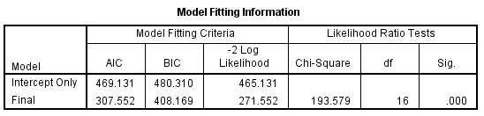

This table shows that the p-value of the likelihood ratio is less than the alpha level of .05 and thus the model using the independent variables fits better than the model using the constant only. The model fitting criteria using AIC and BIC shows that there was a decrease in both values from the intercept only model to the final model and thus the final model with the independent variables in place fits better than the intercept only model. The other fitting method, Pearson Goodness-of-Fit test showed a p-value of less than .05 and thus failed to be significant.

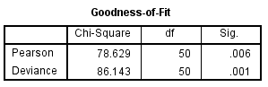

Which means that this test failed and did not show a good fit. However, it is very likely that it did not fit because of the 14.7% of dependent variable cells that showed a zero value.

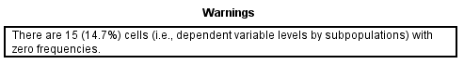

This tends to make the Pearson Goodness-of-Fit test unreliable and so we will assume a good fit of the final model because the previous two test showed that it did in fact fit well.

The next test to be performed is to determine if the independent variables, predictors, are good predictors the dependent variable. This will show us how well each of the variable does at predicting the political party affiliation of the respondents.

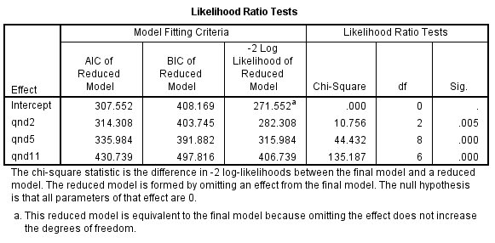

The results of this analysis is determined using the alpha of .05. If the p-value is less than .05 then the variable in question is a good predictor of the political party affiliation of the respondent. Because all three of the predictors show a p-value of less than .05 they are all significant and thus good predictors.

The final analysis is the Parameter Estimates. This analysis looks more closely at the predictors and determines which responses from the independent variable questions are the best predictors of dependent variable. It also give the odds ratio so that we can predict which of the independent variable responses is a better predictor of the dependent variable responses. The comparison used is between an independent and either a republican or democratic self -identification of political party affiliation.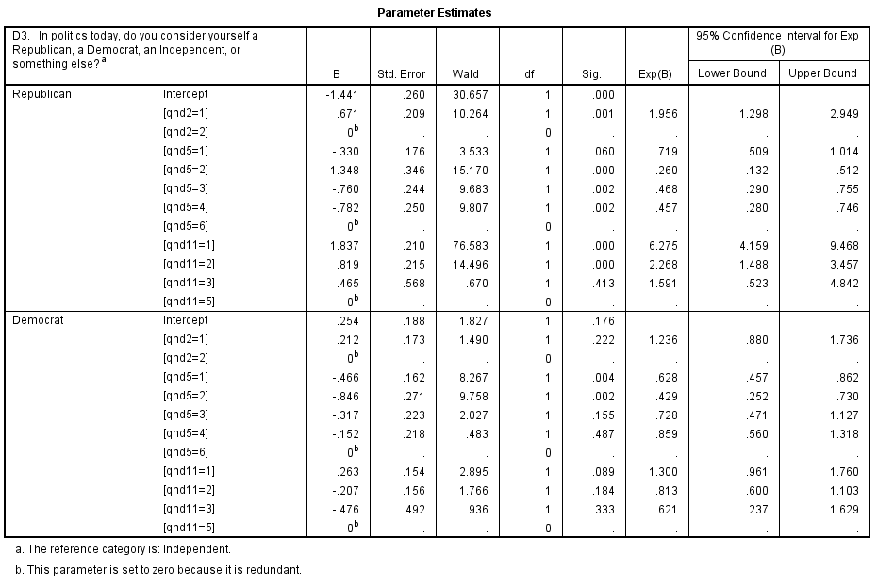

The results show us that having voted and being a protestant or catholic are good predictors of being a republican in respondents. All of the marital statuses are good predictors of being independent self-identifying. The results also show us the following odds ratios based on the variables:

* It is 1.956 times more likely that a Latino has voted and is Republican than independent.
* It is 3.846 times more likely that a Latino is living with a partner and independent than Republican.
* It is 2.137 times more likely that a Latino will widowed and independent than Republican.
* It is 2.19 times more likely that a Latino will divorced and independent than Republican.
* It is 6.275 times more likely that a Latino is Protestant and Republican than independent.
* It is 2.268 times more likely that a Latino is Catholic and Republican than independent.
* It is 1.592 times more likely that a Latino will be married and independent than a Democrat.
* It is 2.33 times more likely that a Latino will be living with a partner and independent than a Democrat.

**Discussion**

There are a couple of important conclusions that can be drawn from this study. Each tells something about how Latinos in the United States self-identifies when it comes to political party affiliation. Because Latinos are the fastest growing voting group in the United States, this is of particular interest to many that are hoping to swing the Latino vote their way in upcoming elections.

The first topic of interest is if the survey respondent had voted in a US election at any time before they were given the survey. Voting proved to not be a significant predictor when looking at respondents who self-identified as democrats versus independents. However, it was a good predictor if they had self-identified as republican versus independent. The respondent was more likely to be a republican if they had voted in a US election and there were strong odds ratio that this was so with a 1.956 odds of having voted and being republican versus independent. Up until this point in US election history, Latinos often had seemed to be disillusioned from the political process in the US. This was mostly the case except for those that identified as republicans. It is important to consider that before the election of Barack Obama in 2008, Latino voters had often only voted on social issues and only if they felt it affected their family values. This will come further into play later with another variable.

When it comes to marital status, this was a significant predictor for being an independent versus both republican and democrat self-identifying respondents. Respondents were more likely to identify as independent versus republican if they were either living with a partner, widowed or divorced. Respondents were more likely to identify as being independent versus republican if they were married or living with a partner. These predictors are not as telling socially one way or the other since they do not really show an important correlation between either of the main political parties and a certain few marital statuses. It is, however, possible to draw a few conclusions based of these results. It would seem that being an independent is a fairly strong identity for many Latinos in the United States. This is because no matter what living situation the respondent was in, they were more likely to identify as an independent.

The final variable is religion. Religion was a strong predictor, but only for republican self-identifying respondents. Both identifying as Protestant and Catholic were good predictors of being having a republican self-identification. Latinos were 6.275 times more likely to identify as Protestant and Republican than independent. Latinos were 2.268 times more likely to identify as Catholic and Republican. Thus, identifying as religious was more likely to show an identification as republican. Judaism however did not show to be a good predictor for republican or democrat self-identification.

**Conclusion**

When looking at the results as a whole once conclusion can be drawn that is fairly visible. Latinos who voted and were religious were more likely to self-identify as republican. This is not surprising since at this time many of the republican candidates were talking a lot about values issues in their campaigns. This was the time period that the “compassionate conservative” term was coined. Family values was on the tip of all of the republican candidates and this is a topic that resonates with religious people. Thus, why it is likely that the Latinos that had voted were more likely than not to be religious and more likely than not to be republican.

However, one question that still remains after this study. In other studies, such as one cited in the first section of this paper by Kelly and Kelly, it was identified that Latinos were more likely to vote for the Democratic Party than any other party. This study showed that a lot of Latinos were more likely to self-identify as independent. So, when given the choice it can be assumed that Latino’s values often tend to lean more towards the Democratic Parties values. Further, because of the decline in Catholic identifying Latinos in the United States, this trend should continue and Latinos will continue to vote for the Democratic Party mostly. This could have a lot more to do with socio-economic status than religion, marital status or other identifiers. Other studies, as mentioned in the first section of this paper, have shown this to be a good predictor and Latinos tend to vote with other Latinos from the same socio-economic status.

Further studies on the topic of Latino voting and party affiliation could look at how socio-economic status effects their choices. It would be very helpful to compare socio-economic statuses effect versus others, such as education level, religion, region of residence (rural, suburban, urban) and language spoken at home to determine which of these is the best predictor of voting habits and party affiliation.

References

Claassen, R. (2004). Political Opinion and Distinctiveness: The Case of Hispanic Ethnicity. *Political Research Quarterly,* *57*(4), 609-609.

Griffin, J., & Newman, B. (2007). The Unequal Representation of Latinos and Whites. *The Journal of Politics,* *69*(4), 1032-1046.

Kelly, N., & Kelly, J. (2005). Religion and Latino Partisanship in the United States. *Political Research Quarterly,* *58*(1), 87-87.

Perl, P., Greely, J., & Gray, M. (2006). What proportion of adult Hispanics are catholic? A review of survey data and methodology. *J Scientific Study of Religion Journal for the Scientific Study of Religion,* *45*(3), 419-436.

Pew Hispanic Center, Henry J. Kaiser Family Foundation. (2004) *2004 National survey of Latinos: education*. Washington, DC.

Pew Research Center. (2014). *Hispanic voters in the 2014 election.* Washington, DC: J. Krogstad & M. Lugo.

Pew Research Center. (2015). *Hispanic population reaches 55 million, but growth has cooled.* Washington, DC: J. Krogstad & M. Lugo.

Pew Research Center. (2015). *Modern immigration wave brings 59 million to U.S., driving population growth and change through 2065: views of immigration’s impact on U.S. Society Mixed*. Washington, DC.