Gender Differences in the Workload of Faculty

Tim Baker

Northern Illinois University

Gender Differences in the

Workload of Faculty

The “ivory tower” of academia is often thought to be a place where people can meet and exchange ideas freely without fear of being treated differently because of their gender. It is also well known that there is a difference in the types of pay and tasks men and women are assigned in the workplace. These differences are a source of friction within our society that has been ongoing for many generation. Because this is something that is brought up in the politics of the nation on a fairly common basis it made the research begin to question if this was also so of faculty in higher education. The basis for this study is simply that. To determine if there is a difference in the tasks assigned to faculty based on their gender. Another questions is raised in this study, but is not the main focus, is there a difference in tasks assigned to faculty based on their attainment of a doctoral degree or not.

**Purpose**

The purpose of this study is important because without knowing so, one would assume that all things are equal in higher education faculty task assignments. That would seem to be the fair thing to do. Theoretically that would also seem wise so that no one person is given special treatment and their tasks are assignment based on merit. If we look at the concept of equity theory Adams postulated that employees thrive in knowing that their inputs will receive a fair reward from it (1965). Students who are working towards becoming faculty members very well would like to know if they are entering a place of employment that is fair to their gender or not.

**Definitions**

In this paper, when the topic of workload is discussed it is meant to mean the tasks to which the faculty member is assigned to spend the most hours on each week. The tasks that will be discussed include four things; research & development, teaching, management & administration, and professional services to individuals. When it is discussed whether that faculty member has a doctorate or not, this means that the faculty member has either a Ph.D., DSc. or Ed.D. or does not. The does not have a Ph.D., DSc. or Ed.D. category can include faculty members with M.S., M.A., J.D., M.D., or other professional degrees that are considers of masters level or higher in education.

**Literature Review**

At first glance of the literature of this data, it seems that it could be hard to tell if gender does have a specific role on which tasks are assigned to faculty. One problem is that when you look at the aggregate data of many studies they sometimes show that faculties where more females and less males are less productive in the amount of research that they produce. But, then when you break the data down to the individual level the numbers do not look the same and females in the faculty might actually be more productive (Porter & Umbach, 2000).

In 2005 Pyke noted that in every faculty rank at the universities with the highest levels of research activity women accounted for only 36% of the faculty. Women only help 7% of the full professor positions of the whole faculty where as men help 28% of the full professor positions of the whole faculty. This seems to show that women are not as prevalent in these types of institutions and also are not promoted at the same levels as men to positions higher up in faculty.

Another study made a point that is very important to this study. Bellas and Toutkoushian noted in that based on their research women were more likely than men to have more dependents (students to advise) and thus often had less time for research or completed research at a slower pace (1999). With more students to advise it would be much more difficult to be able to complete research and thus why these faculty members are relegated to teaching and other tasks besides research. Further, women are more likely to have family responsibilities at home which further inhibits their career growth and slow research (Ramirez, 2010), thus requiring them to be assigned other tasks.

Finally, Gander and Pyke both noted that many female faculty members are given a larger portion of the maintenance jobs, such as mentoring an institutional housekeeping (1999, 2011). They did not specifically say teaching and this leaves that question still left unanswered. One further thought on the topic, a survey completed by Short in 2006 showed that 95% of women contributed teaching to be one of the factors of job satisfaction. Whereas only 75% of men said the same thing. So, it may not necessarily be negative for more women to be assigned roles in teaching as their primary task. This could lead to greater job satisfaction.

**Methodology**

The first hypothesis for this study is to what extent the gender effects the tasks a faculty member must spend most of their time. The second hypothesis is to what extent does the level of degree a faculty member has attained effect the tasks they spend most of their time. The dependent variable (DV) is the workload (task) at which the faculty spend most of their time per week working on. The first independent variable (IV A) is the gender of the faculty member. The second independent variable (IV B) is whether the faculty member has a conferred doctorate degree (either a Ph.D., DSc., or Ed.D.). The data was gathered from Inter-University Consortium for Political and Social Research’s survey entitled, A Data-Based Assessment of

Research-Doctorate Programs in the United States, 2005-2006. The target population for this study was all doctorate granting universities in the United States of America. The survey was sent out to all faculty members of these institutions. There were a 169,600 surveys that were sent out. Of those surveys 115,550 had data that was usable for this study. To reach a power of .80 the sample would have to have been 92,440. I calculated this by taking the power at 115,550, which was 1.0 and take out the difference to get that power down to .80.

**Limitations**

There were several limitations to this study and its data. First, the surveys were only sent out to universities that grant doctoral degrees in the United States. This was part of the purpose of this original study from which this data collected. However, it limits this study to only those institutions and does not include data from every other university and community college in the United States. This data does also not include information from the doctoral granting institutions of the for-profit industry since they are generally not considered research institutions.

**Research Design**

The design that was chosen for this study is a two way factorial analysis of variance (ANCOVA). This was chosen because the dependent variable of this study is has four levels and each of the two independent variable has two levels. The statistical methods that will be need to be used to complete the analysis of this data will first be Levene’s Test of the Equality of Error Variances. This test will be used because there is more than one variable and in a two way ANOVA it is assumed that the variances that of the populations that the samples are taken from are equal. Next, a test of between-subjects effects will be performed. This test will tell us if there is a statistically significant interaction between each of the independent variables and the dependent variable. It will also tell us if the interaction between the two independent variables and the dependent variable was statistically significant and the error in the model. Finally, there will be two different charts showing the interactions between the independent variables. The first, a profile plot, will show if there was an interaction between the independent variables and also if they had a significant effect. The second chart, an error bar, will show if there was an interaction between the two independent variables and which one of the size of the independent variables. The hypothesis for the first independent variable is:

$$H0=μ_{1j}=μ_{2j}=μ_{3j}=μ_{4j}$$

$$H1=At least 2 means of the factor A ≠0$$

The hypothesis for the second independent variable is as follows;

$$H0= μ_{k1}=μ_{k2}=μ_{k3}=μ_{k4}$$

$$H1=At least 2 means of the factor B ≠0$$

The hypothesis for the interaction is as follows;

$$H0=μ_{JK}=μ_{jk}…=μ_{jk}=0$$

$$H1=At least one μ_{jk}≠0$$

The alpha level that will be used for this study is .05.

**Statistical Data Analysis**

**Descriptive Statistics**

When looking at the descriptive statistics for this study there are a few conclusions to be drawn. First, there are 113,430 faculty members that have an earned doctorate degree while only 2,124 in the study did not. This shows a very large difference. Further, there are 87,461 total men in the study and 28,093. This means that women only make up slightly less than a quarter of the sample of this study.

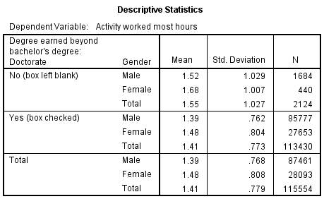

**Levene’s Test**

The Levene’s Test of Equality of Error Variances for this test showed that the assumption for equality was violated with a $p=.001$. Thus, we did not fail to reject the null hypothesis that population variances would be equal. Thus, population variances are not equal. Although looking at the descriptive statistics it is fairly clear why Levene’s test was not meant. 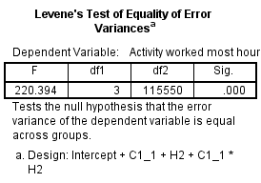

It was decided to run a Kolmogorov-Smirnov test. Based on this test we see that our data is not normally distributed. 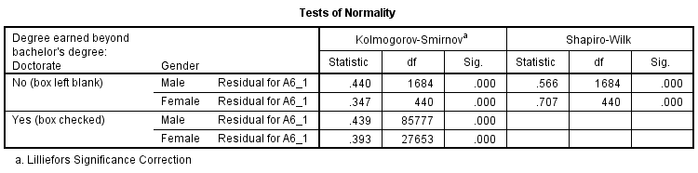

**Test of Between-Subject Effects**

When looking at the results for the test of between-subjects effects the results were as expected based off of the literature that was reviewed. The first thing looked at is the interaction between the two independent variables, gender and if the faculty have an earned doctorate, and the dependent variable of the tasks that the faculty member spent the most time on. This showed there is not a statistically significant interaction for these variables with a $p=.080, f=3.067 and a power of .417$ (highlighted in red on the table). However, there was a statistically significant main effect for gender with $f=38.104, p=.001 and power=1.0$ (highlighted in green on the table). There was also a statistically significant main effect if the faculty had an earned doctorate or not with $f=38.095, p=.001 and power=1.0$ (highlighted in blue in the table). Gender did have a lower overall mean between the two main effects. 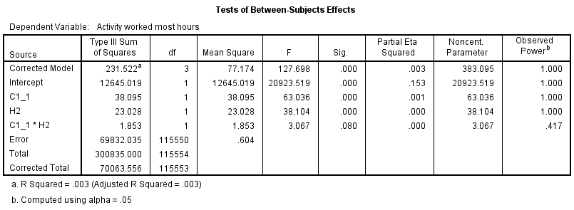

**Box Plot**

The box plot for this two way ANOVA shows a couple of different items that are important to look at. First, it did show that there was no interaction between the two independent variables, neither ordinal nor disordinal. It also showed that the independent variables of gender and level of education both had a strong effect on the dependent variable. 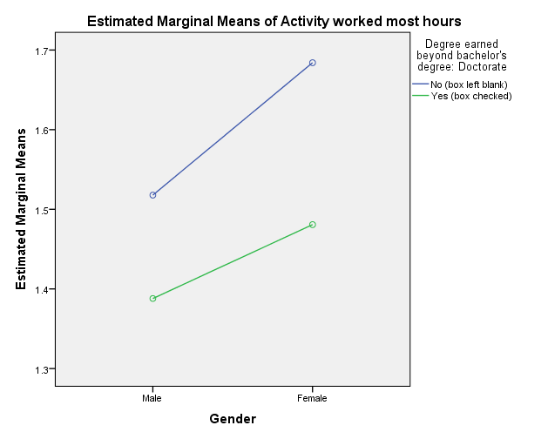

**Error Bar**

The error bar showed a couple of pieces of useful data as well. First and most important it showed that there was not an interaction between the independent variables. The second and also interest point is that it shows that the more of faculty in this data set had an earned doctoral degree than faculty that did not. This could be part of the reason why the Levene’s Test of Equality of Error Variances was not met.

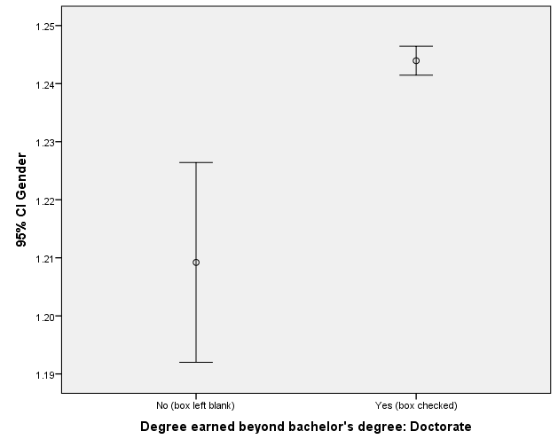

**Conclusions**

Because the “ivory tower” of academia holds a certain respect in the world. Many view it as a safe place to pursue their academic dreams and exchange knowledge with some of the greatest minds of the day. This study was created to shed light on this world and help get a glimpse of the inner workings of higher education faculty. Thus, it is of interest to many to know the workload (tasks) assigned to faculty members of higher education institutions. This is an especially important topic for anyone in academia or thinking about entering this field. Being able to see if there is a difference in tasks that genders are assigned or if it matters what level of degree you have earned can be an important influence on the decisions that students and future academics must consider to determine their next move. With this information they can have a clearer picture of what to expect.

When looking at the data collected from this study there are several conclusions that can be drawn. The first big conclusion is that there does seem to be a strong statistically significant effect between the variables of tasks assigned to faculty members and gender. This tells us that there is a difference in gender roles in the higher education faculty workplace. This may be something for students and other academics that are considering entering into this field to consider and whether it fits their desire. Second, if the faculty member has a doctorate or not also does seems to have a strong statistically significant effect on the variable of tasks assigned to faculty members. This shows that it may be important to earn the doctorate degree to be able to perform that tasks in the higher education faculty workplace that you want to do and this should be considered. However, the effects of gender on tasks may not be as significant as it seems thanks to the point made by Short as stated earlier in the literature review that female faculty members place a higher value on teaching as part of the job satisfaction than men in their role as higher education faculty (2006). So, this may not be a large problem for women wishing to enter the role as faculty.

The data in this study could be used to further develop the knowledge of the roles that gender plays in higher education. It could also help to shed some light on the importance of the level of degree in higher education. Future research on this topic could look more closely at what specific degrees are most useful to obtain what kinds of tasks as a faculty member’s primary task. One could also break down the faculty into different fields of study to see if there is a difference in what tasks are assigned to faculty by gender based on the field in which they are working. For instance, if a Biology department was more likely to have women doing research and development and the men were more likely assigned to the teaching/administrative roles. While a chemistry department did the exact opposite. This would provide a better look at the differences in gender within faculty working in higher education. It would also be interesting to add other universities and colleges into a similar study to see if that changed how the results ended up.

**Limitations**

The first important thing to take note of is that because Levene’s Test of Equality of Error Variances was not met and this means that the type 1 error rate was probably inflated. This is due to the data samples not being normally distributed. There were far more faculty members in the data that had an earned doctorate degree than not and far more men than women. This caused the data to be skewed.

This study is also limited because the data would not allow delineation between different types of advanced degrees so that it could be determined if there was a difference in tasks assigned say in someone that has a M.S. degree vs. someone that has an M.D.

The data did not include information from many other universities and colleges in the United States. These include the non-research doctoral granting universities, the non-doctoral granting universities, colleges and community colleges. This leaves out a large number of faculty in the country that could vastly change how the data appears.

References

Adams, J. S. (1965) Inequity in social exchange. In L. Berkowitz (Ed.), *Advances in experimental social psychology* (Vol. 2, pp. 267-299). New York: Academic Press.

Porter, S. (Director) (2001, May 22). Analyzing Faculty Workload Data Using Multilevel = Modeling. *Annual Forum of the Association for Institutional Research*. Presentation conducted from Association of Institutional Research, Cincinnati, OH.

Pyke, K. (2011). Service and Gender Inequity among Faculty. *PS: Political Science & Politics,* *44*(1), 85-87.

Ramirez, S. (2010). Gender Inequities in Academe and Faculty Perceptions of Family-Friendly Policies (Doctoral Dissertation). Retrieved from Proquest.

Short, H.N. (2006). Gender Disparities in Tenure-Track Faculty Job Satisfaction (Doctoral Dissertation). Retrieved from Proquest.

Toutkoushian, R., & Bellas, M. (1999). Faculty Time Allocations and Research Productivity: Gender, Race and Family Effects. *The Review of Higher Education,* *22*(4), 367-390.