Week 3 Statistical Analysis and Hypothesis Testing Report
Customer Satisfaction and Discount Status
Dataset: customer_purchase_data.csv | Sample size: 50 customers

1. Executive Summary
This report examines whether customer satisfaction differs between customers who received a discount and customers who did not. The dataset contains 50 observations, split evenly between the two groups. The mean satisfaction score was 4.52 for discounted customers and 2.52 for non-discounted customers, a mean difference of 2.00 points.
A Welch independent two-sample t-test found a statistically significant difference, t(48) = 13.87, p < 0.001. The 95% confidence interval for the mean difference was [1.71, 2.29], and Cohen's d was 3.92, indicating a very large standardized effect. The evidence therefore supports rejecting the null hypothesis.

2. Research Question and Hypotheses
Research question: Do customers who receive discounts have significantly different satisfaction scores compared with customers who do not receive discounts?
H0: There is no statistically significant difference in mean customer satisfaction between discounted and non-discounted customers.
H1: There is a statistically significant difference in mean customer satisfaction between discounted and non-discounted customers.
Significance level: α = 0.05.

3. Data and Preparation
The dataset contains customer-level information on discount receipt, satisfaction score, age, gender, purchase amount, product category, and purchase frequency. The analysis used discount_received as the grouping variable and satisfaction_score as the outcome. The supplied dataset contains no missing values in these fields, so no observations were removed for the primary analysis.
Satisfaction was also categorized for the chi-square analysis: Low (score ≤ 2), Medium (3–4), and High (score ≥ 5).

4. Descriptive Statistics
Group | n | Mean | Median | SD | Min | Max
Discount | 25 | 4.52 | 5.00 | 0.51 | 4 | 5
No Discount | 25 | 2.52 | 3.00 | 0.51 | 2 | 3
Both groups contain 25 customers. Discounted customers have substantially higher satisfaction on average (4.52) than non-discounted customers (2.52).

5. Distribution and Assumption Assessment
Shapiro–Wilk tests were statistically significant for both groups (discount: W = 0.639, p < 0.001; no discount: W = 0.639, p < 0.001). This reflects the highly concentrated, discrete satisfaction scores in this small dataset rather than a continuous normal distribution.
Because the two groups have equal sample sizes and identical sample standard deviations, the Welch t-test and the pooled-variance t-test lead to the same substantive conclusion. The Welch test was retained as the specified primary inferential method.

6. Welch Independent Two-Sample t-Test
The Welch test produced t = 13.868, degrees of freedom ≈ 48, and p = 2.073e-18. Since p < 0.05, the null hypothesis is rejected. The sample provides very strong evidence that mean satisfaction differs between discounted and non-discounted customers.

7. Confidence Interval and Effect Size
The estimated mean difference (Discount − No Discount) is 2.00 satisfaction points. The 95% confidence interval is [1.71, 2.29]. Because the interval does not include zero, it is consistent with the hypothesis-test conclusion.
Cohen's d = 3.92. Under common interpretation guidelines, this represents a very large standardized effect. Thus, the difference is not only statistically significant but also substantial relative to the observed within-group variability.

8. Chi-Square Test of Independence
Group | Low | Medium | High
Discount | 0 | 12 | 13
No Discount | 12 | 13 | 0
The chi-square test yielded χ²(2) = 25.04, p = 3.653e-06. This indicates a statistically significant association between discount status and satisfaction category.
Cramer's V = 0.71, indicating a strong association in this 2×3 table. The category counts show that discounted customers are concentrated in the Medium and High categories, while non-discounted customers have no observations in the High category.

9. Visualizations
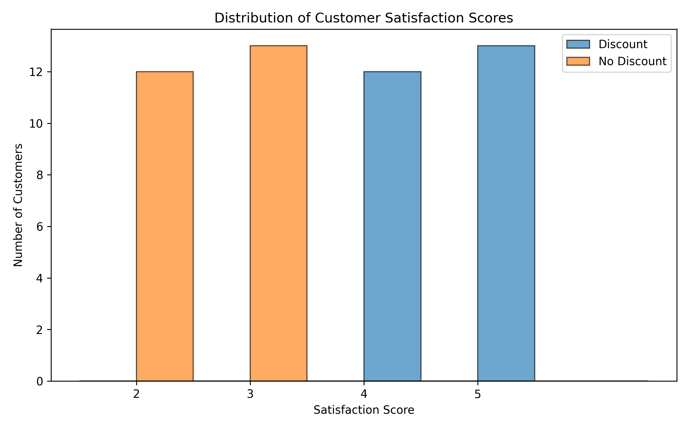
Figure 1. Distribution of satisfaction scores by discount status.
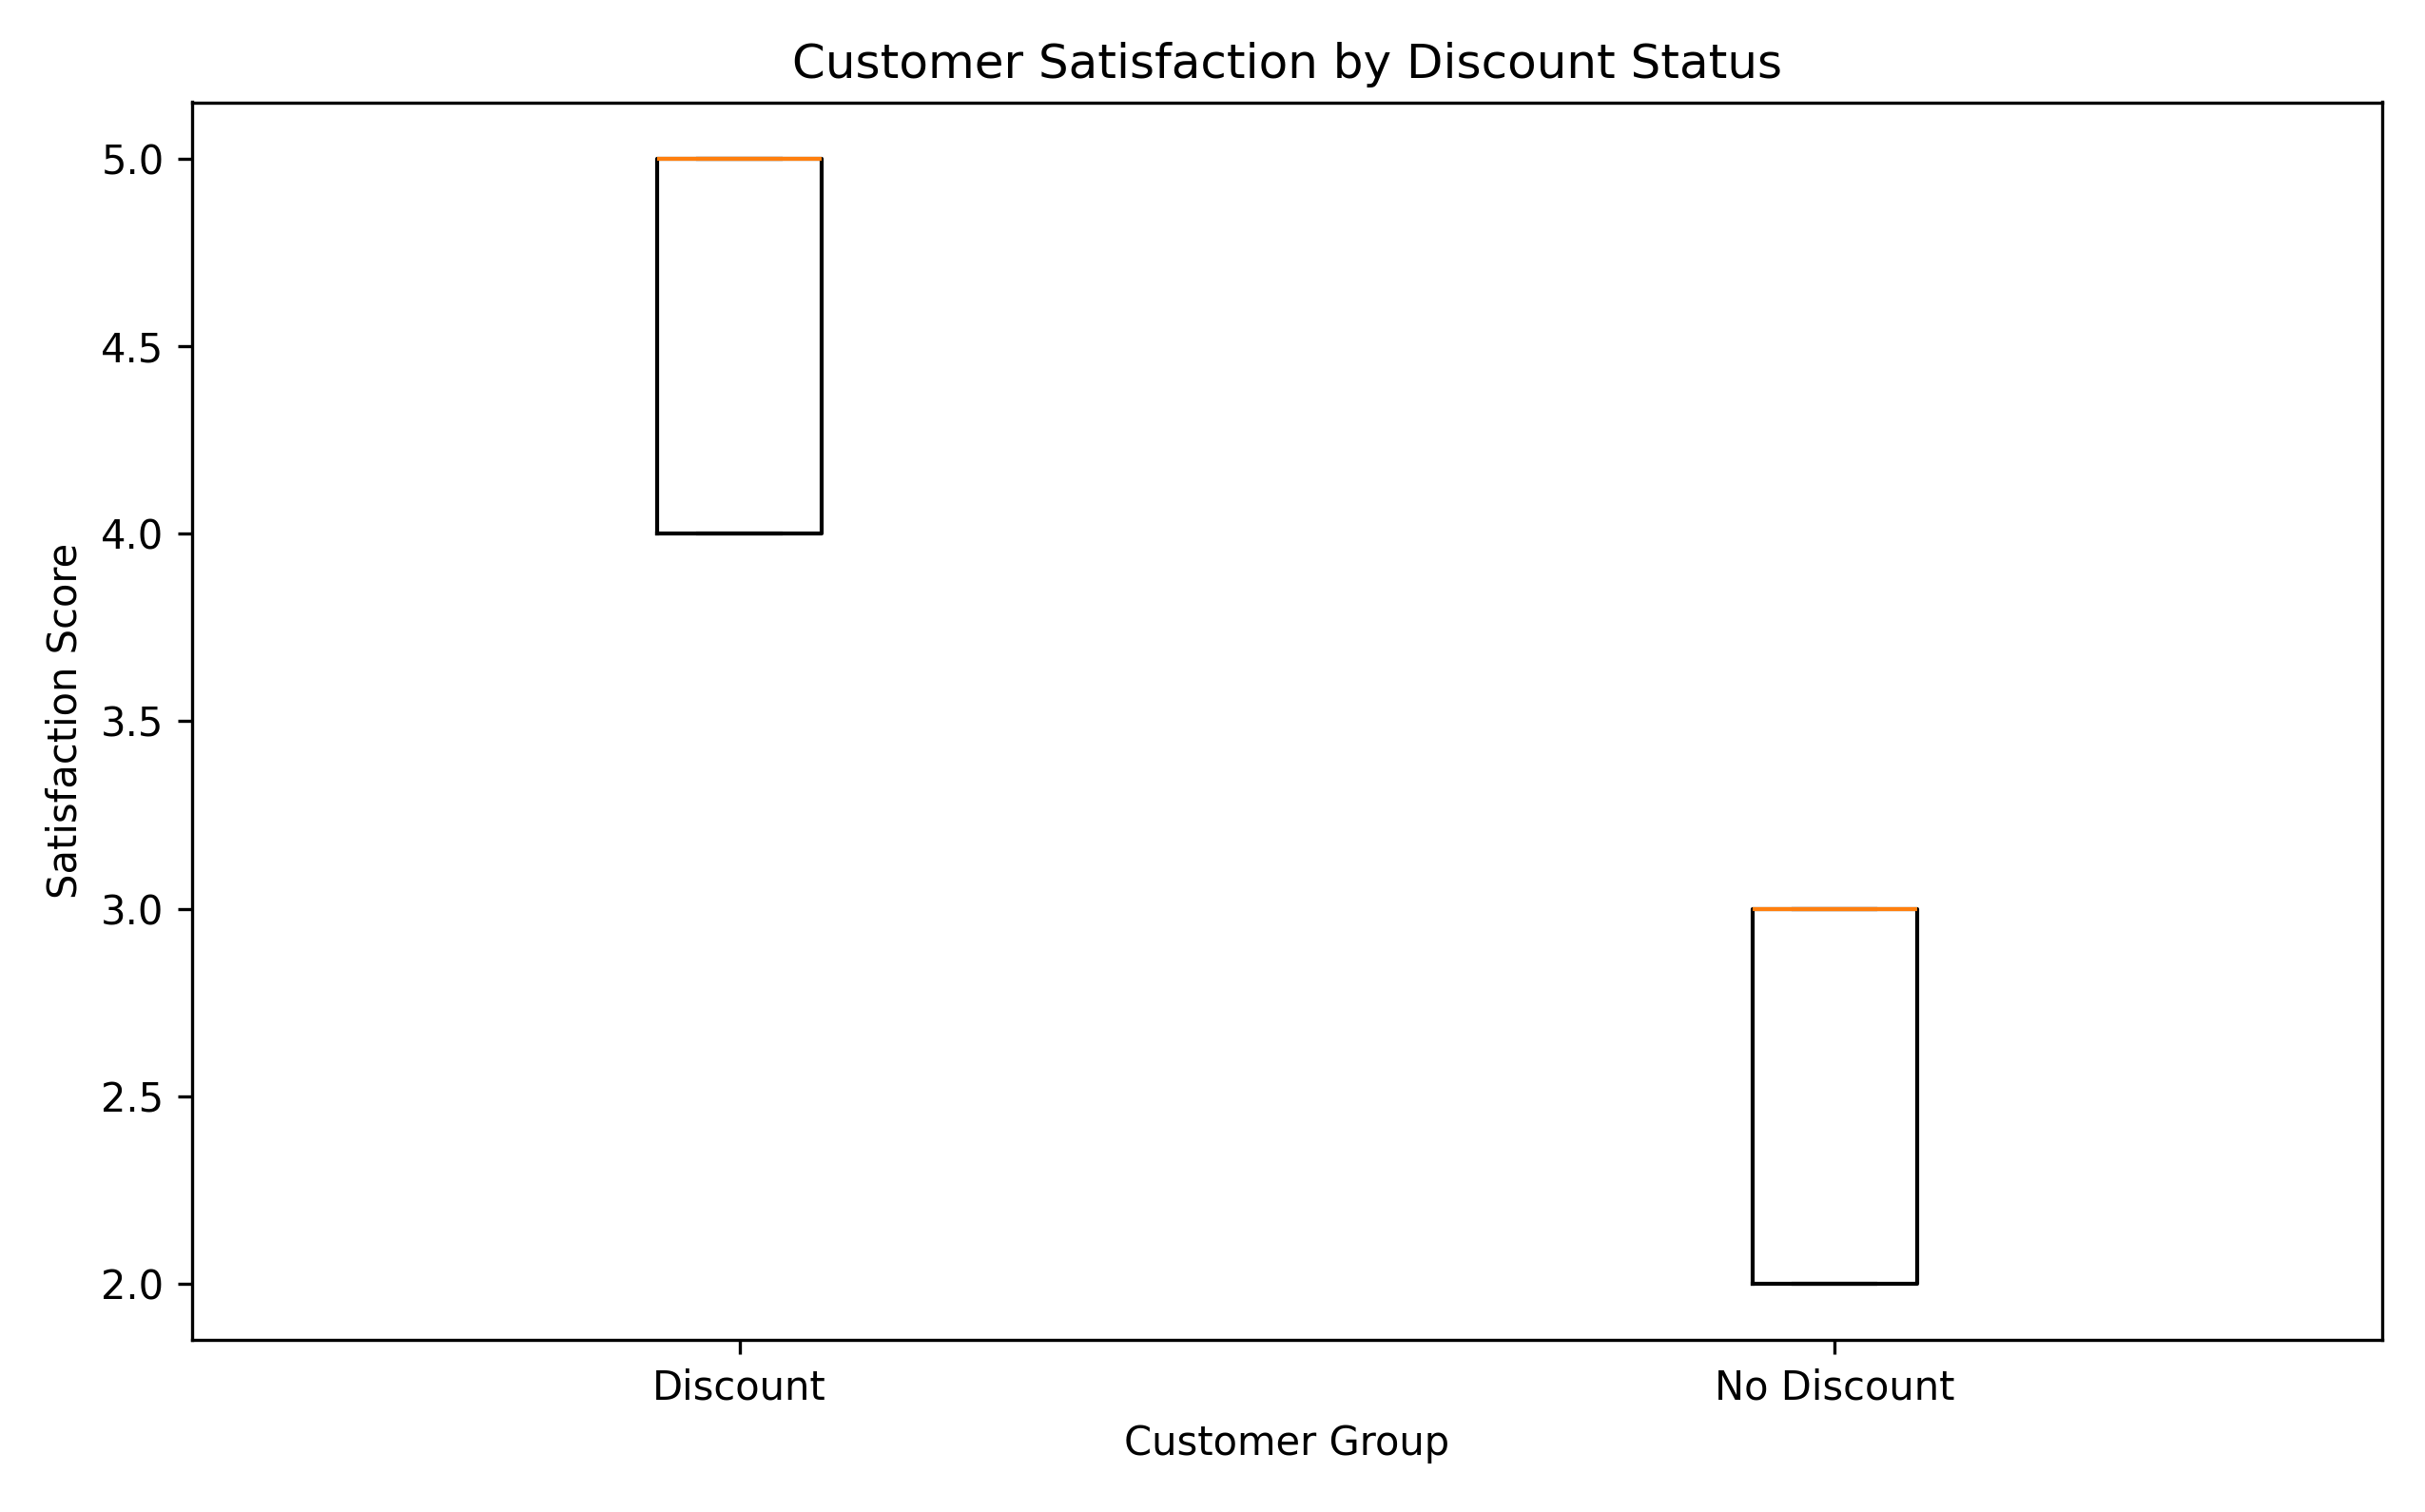
Figure 2. Satisfaction score distributions by discount status.
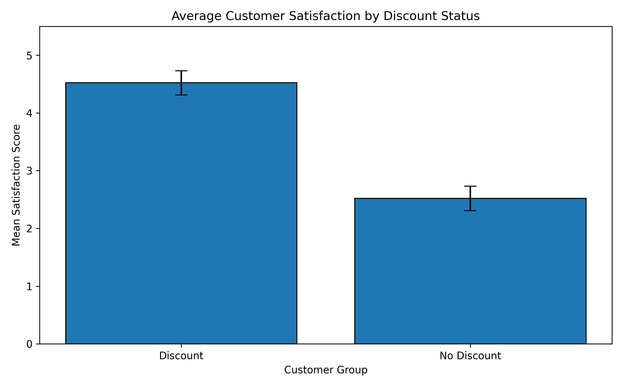
Figure 3. Mean satisfaction by discount status with 95% confidence intervals.
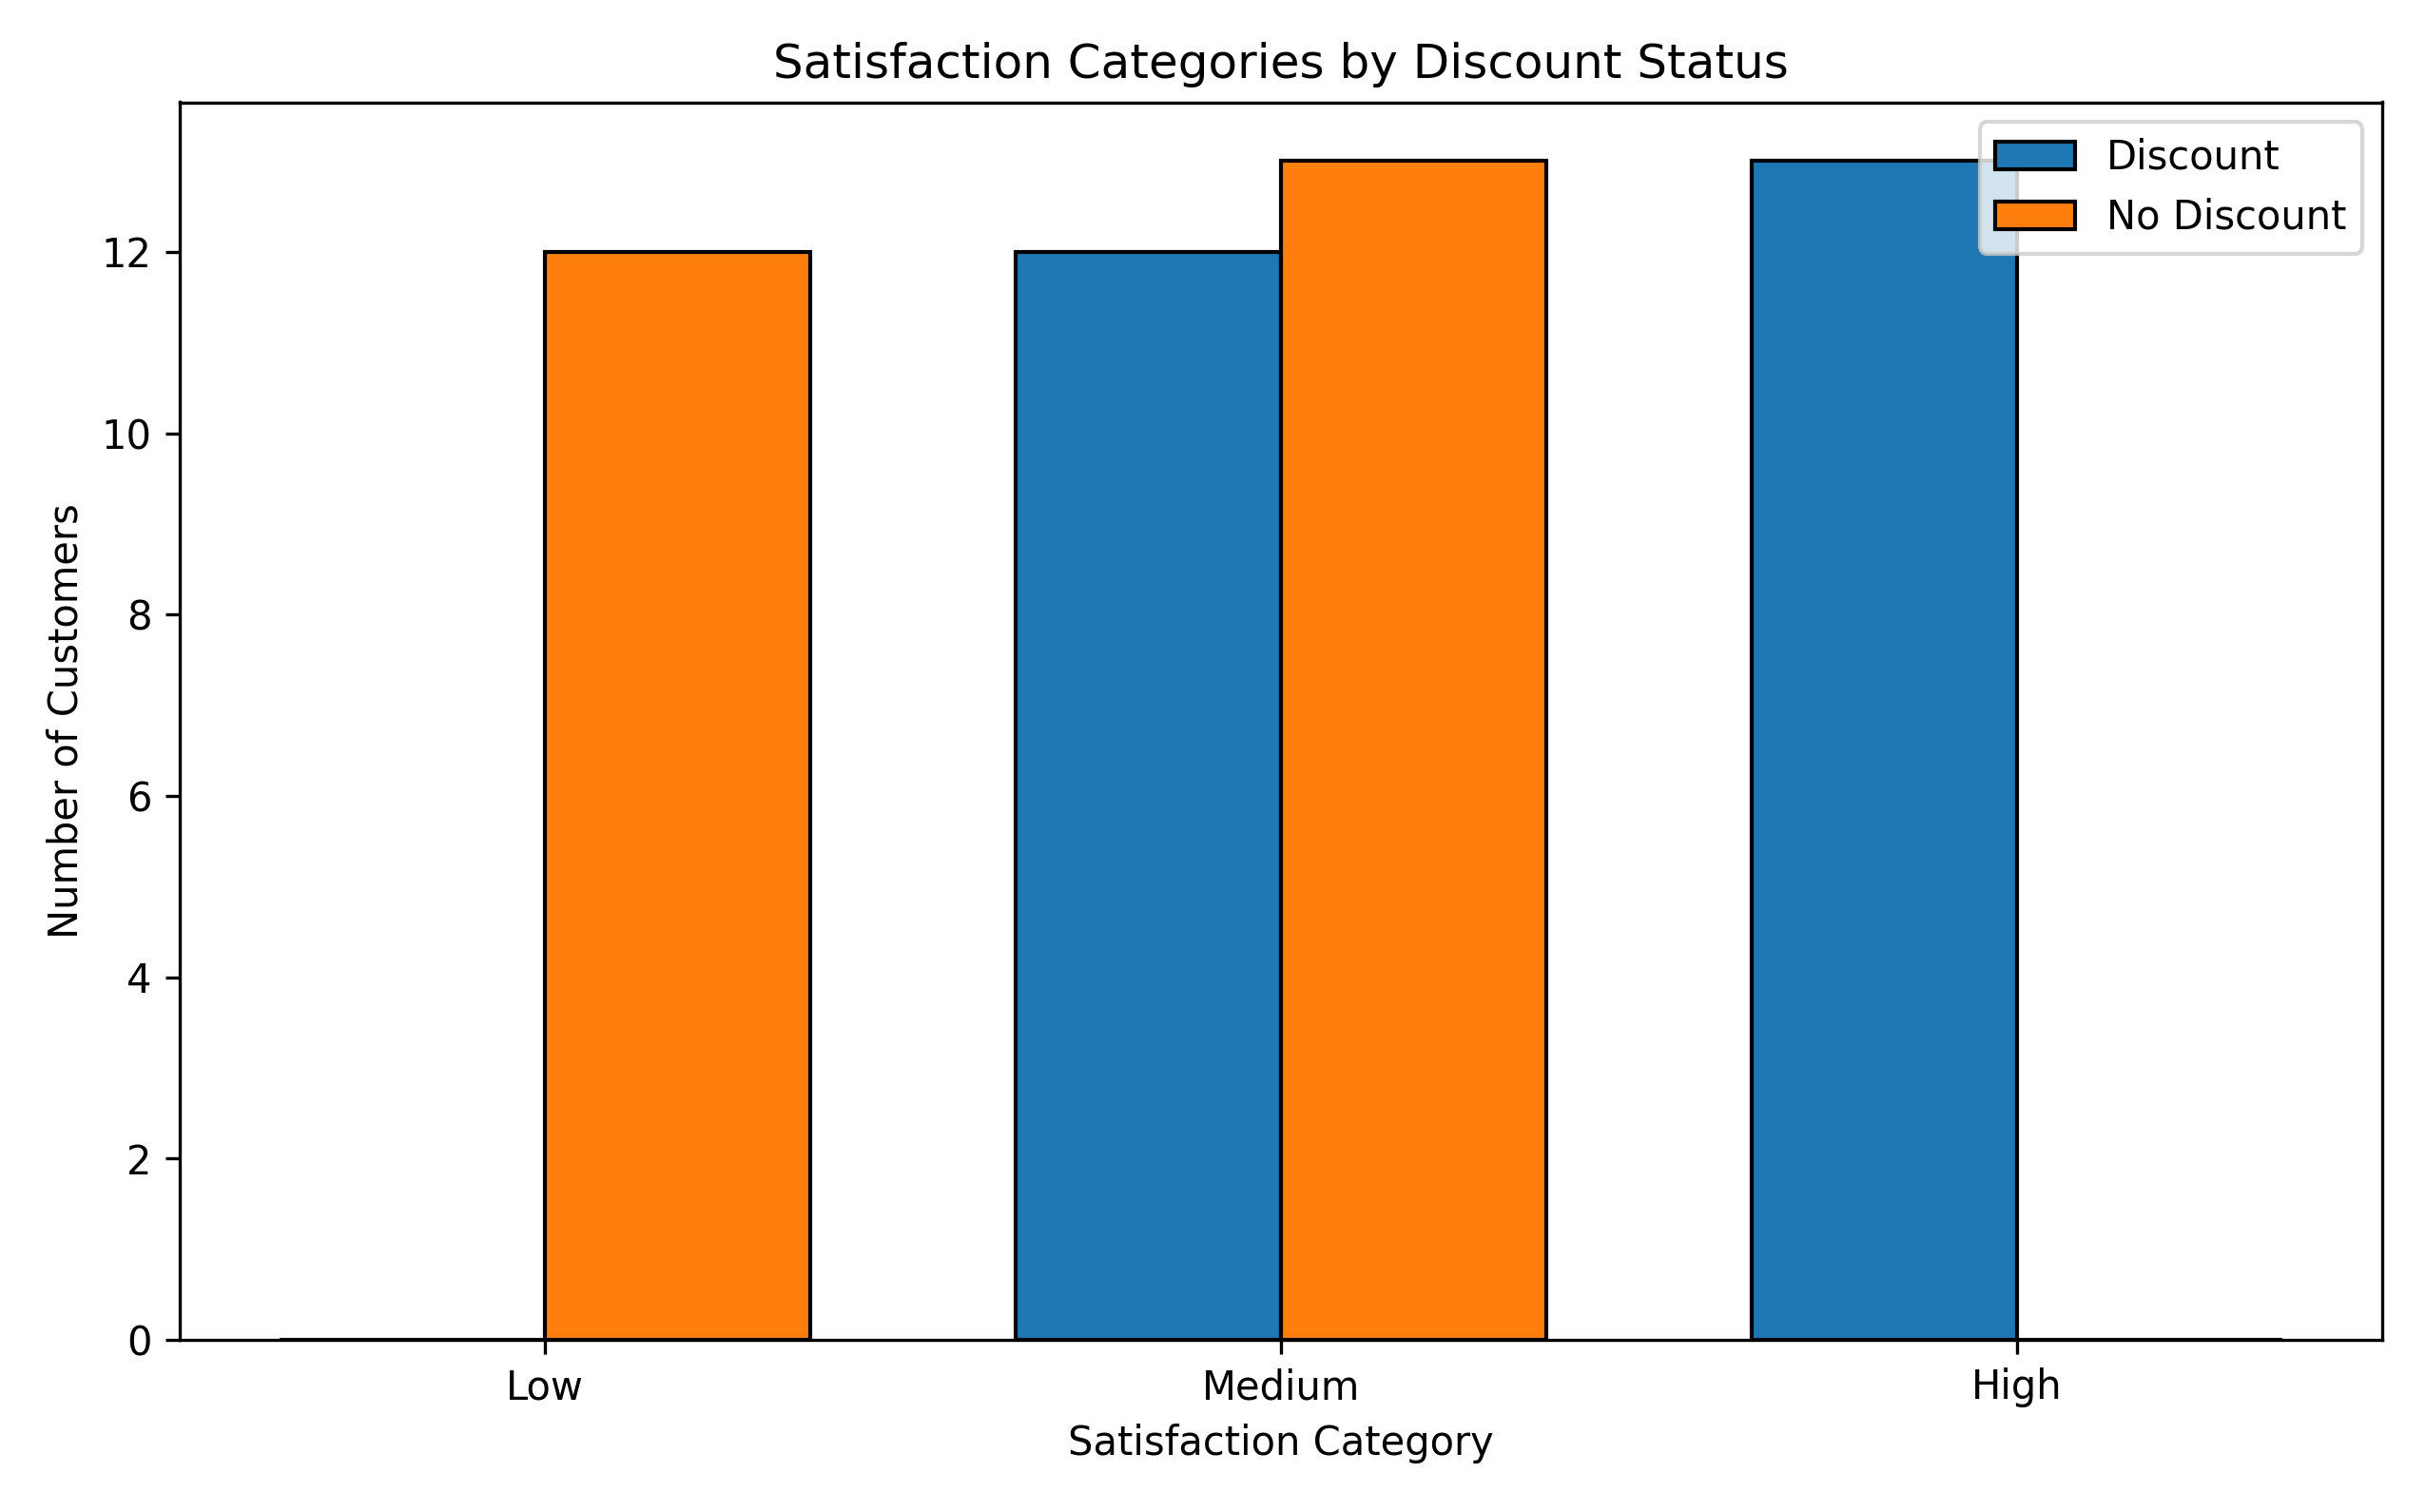
Figure 4. Counts of Low, Medium, and High satisfaction by discount status.

10. Findings and Business Interpretation
The analysis consistently indicates higher satisfaction among customers who received discounts. The difference is large in both absolute and standardized terms, and the categorical analysis reaches the same conclusion.
From a business perspective, discounts may be associated with a more favorable customer experience or may be used in situations where customers are already more engaged. However, this observational dataset does not establish causation. A discount may correlate with other factors—such as customer segment, promotion type, purchase behavior, or campaign targeting—that could also affect satisfaction.
For decision-making, the result supports further investigation of discount strategies rather than treating the observed association as proof that discounts directly cause higher satisfaction. A randomized experiment or a longitudinal design would provide stronger evidence about causal impact.

11. Conclusion
At the 5% significance level, the null hypothesis is rejected. Discounted customers in this sample have a higher mean satisfaction score than non-discounted customers by approximately 2.00 points (95% CI: 1.71 to 2.29), with a very large effect size (Cohen's d = 3.92). The chi-square analysis also finds a strong association between discount status and satisfaction category. These findings are statistically compelling, while causal interpretation should remain cautious.

12. Reproducibility
The analysis follows the workflow specified in the supplied project: data loading and validation, descriptive statistics, distribution assessment, Welch's t-test, confidence interval, Cohen's d, satisfaction categorization, chi-square test, Cramer's V, and visualization. The accompanying PNG files correspond to the four visualization outputs specified by the project.

