Week 4 – Machine Learning Model Development and Evaluation
Project Report

1. Project Overview
This project demonstrates an end-to-end supervised machine learning workflow for binary classification. The workflow includes data inspection, feature/target separation, stratified train-test splitting, feature scaling, Logistic Regression training, prediction, evaluation, and visualization.

2. Dataset
The dataset contains 40 observations, two numerical input features (feature_1 and feature_2), and a binary target. There are 20 observations in Class 0 and 20 in Class 1. The dataset contains no missing values.

3. Methodology
- Loaded the CSV dataset using Pandas.
- Separated feature columns from the target.
- Used a 75/25 stratified train-test split with random_state=42.
- Standardized numerical features using StandardScaler fitted only on the training data.
- Trained a Logistic Regression classifier.
- Generated class predictions and positive-class probabilities.
- Evaluated the model using accuracy, precision, recall, F1-score, ROC-AUC, and a confusion matrix.
- Generated confusion-matrix and ROC-curve visualizations.

4. Model Evaluation
Metric | Score
Accuracy | 1.0000
Precision | 1.0000
Recall | 1.0000
F1-Score | 1.0000
ROC-AUC | 1.0000
The test set contains 10 observations (5 from each class). The model correctly classified all 10 observations, producing a confusion matrix with 5 true negatives, 5 true positives, and zero false positives or false negatives. The ROC-AUC of 1.0000 indicates perfect separation on this particular test split.

5. Visualizations
The following visualizations are included with this report:
• Confusion matrix: shows actual versus predicted class counts.
• ROC curve: shows the trade-off between false-positive and true-positive rates across classification thresholds.
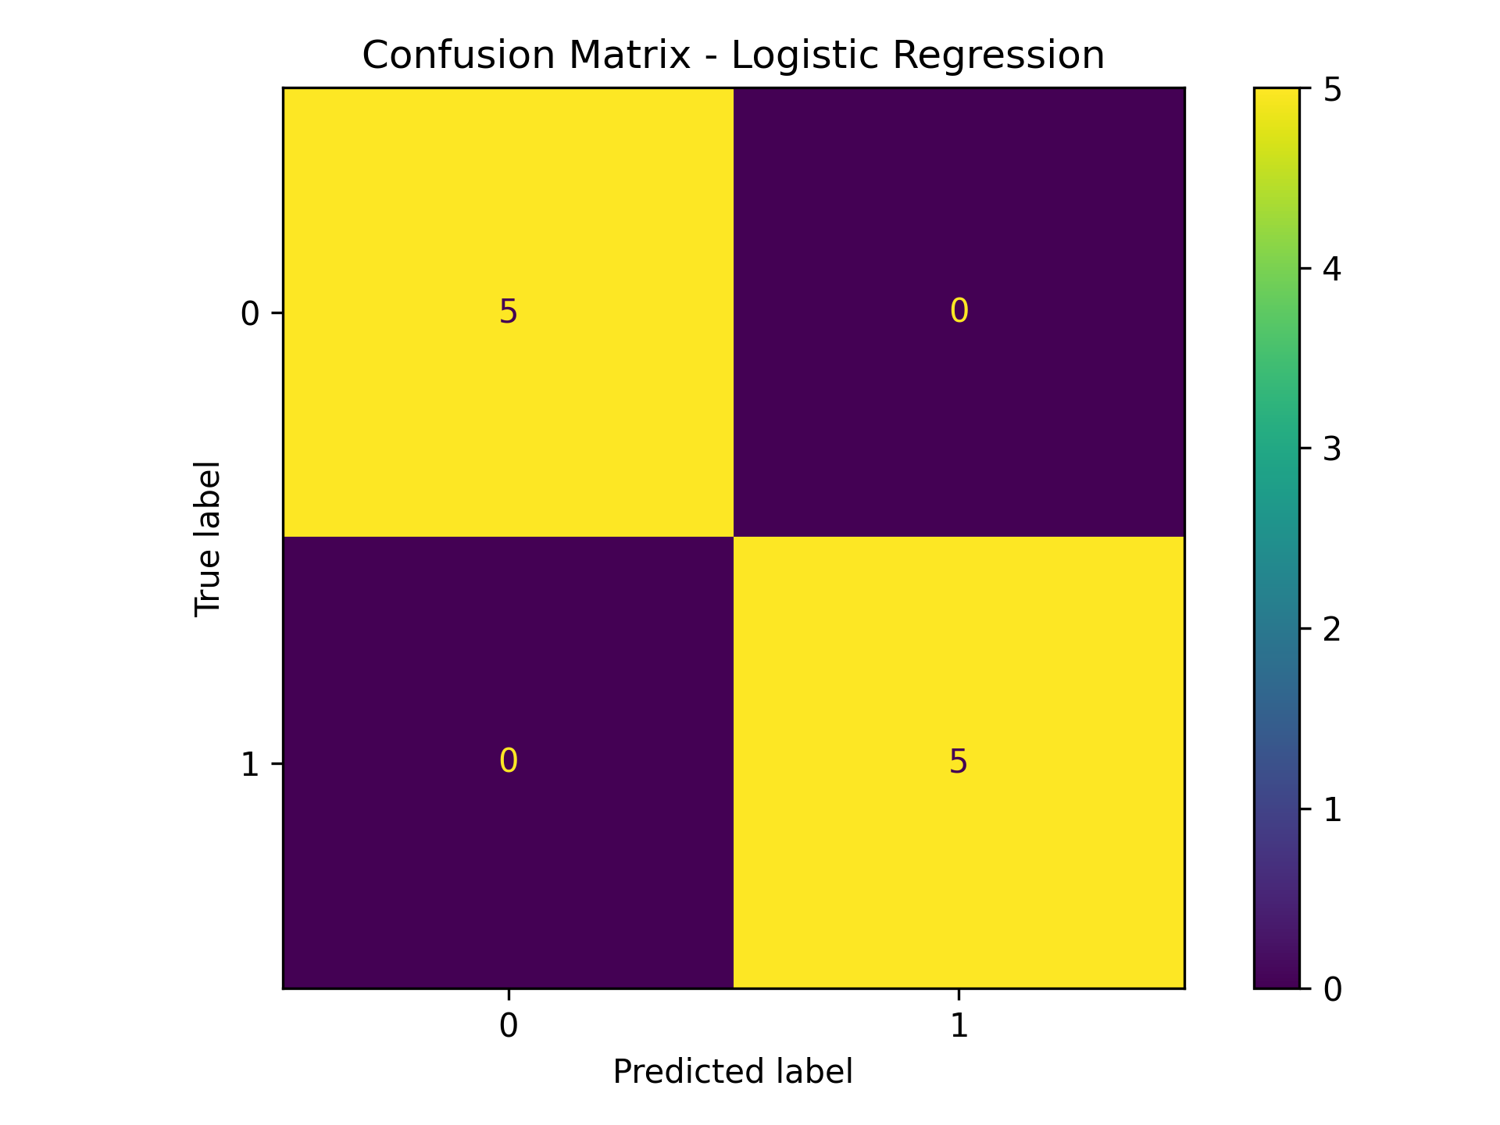
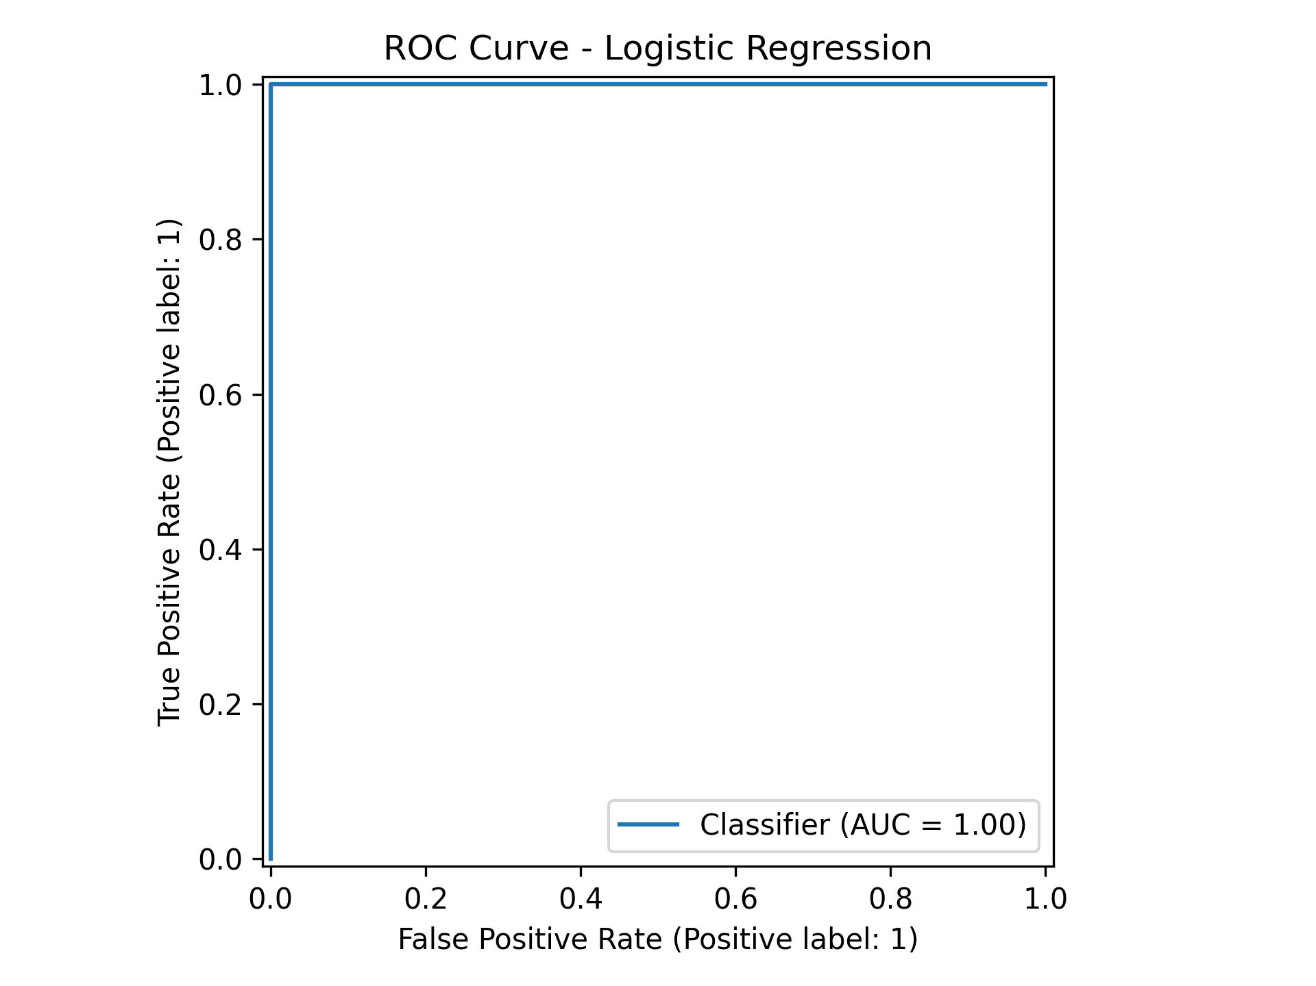

6. Error Analysis and Limitations
Although the evaluation scores are perfect, they should not be interpreted as proof that the model will always perform perfectly. The dataset is small, self-generated, and appears to contain clearly separated classes. The test set has only 10 observations, so performance estimates have high sampling uncertainty. A more realistic dataset with overlap, noise, outliers, class imbalance, and a larger sample could produce different results.

7. Possible Improvements
- Validate performance with repeated stratified cross-validation.
- Test additional classifiers and compare their metrics.
- Tune model hyperparameters using cross-validation.
- Investigate feature distributions and class separability with exploratory plots.
- Evaluate on a larger, independent dataset before deployment.
- Consider calibration and threshold selection if prediction probabilities are used for decisions.

8. Conclusion
The project successfully implements a complete binary-classification workflow using Logistic Regression. On the supplied test split, the model achieved 100% accuracy, precision, recall, F1-score, and ROC-AUC. The results demonstrate the mechanics of model development and evaluation, while the dataset's small size and strong class separation mean that broader validation is needed before drawing conclusions about generalization.

