Week 5 Data Science Project — Final Project Report
DEMO / SAMPLE REPORT — NOT ACTUAL INTERNSHIP RESULTS

1. Project Overview
This report demonstrates a complete Week 5 data-science reporting workflow using a synthetic sales dataset. The dataset, analysis, visualizations, and modeling results are sample outputs created to illustrate the expected project structure. They are not actual internship findings.

2. Dataset and Preparation
The demonstration dataset contains 240 synthetic order records and fields covering region, customer segment, category, month, quantity, unit price, discount, sales, and profit. A small number of missing values were intentionally inserted to demonstrate the cleaning process.
Cleaning included filling categorical missing values with the mode, numeric missing values with the median, and checking for duplicate rows. The resulting dataset is saved as data/processed/cleaned_dataset.csv.

3. Exploratory Analysis
In this synthetic example, South has the highest total sales among the regions, while Office Supplies has the highest total sales among product categories. These statements describe the generated demo data only and should not be interpreted as real business performance.

4. Visualizations
The visualization folder contains missing-value analysis, distribution plots, a numerical correlation heatmap, categorical sales analysis, and a regional key-findings chart.

Missing Values
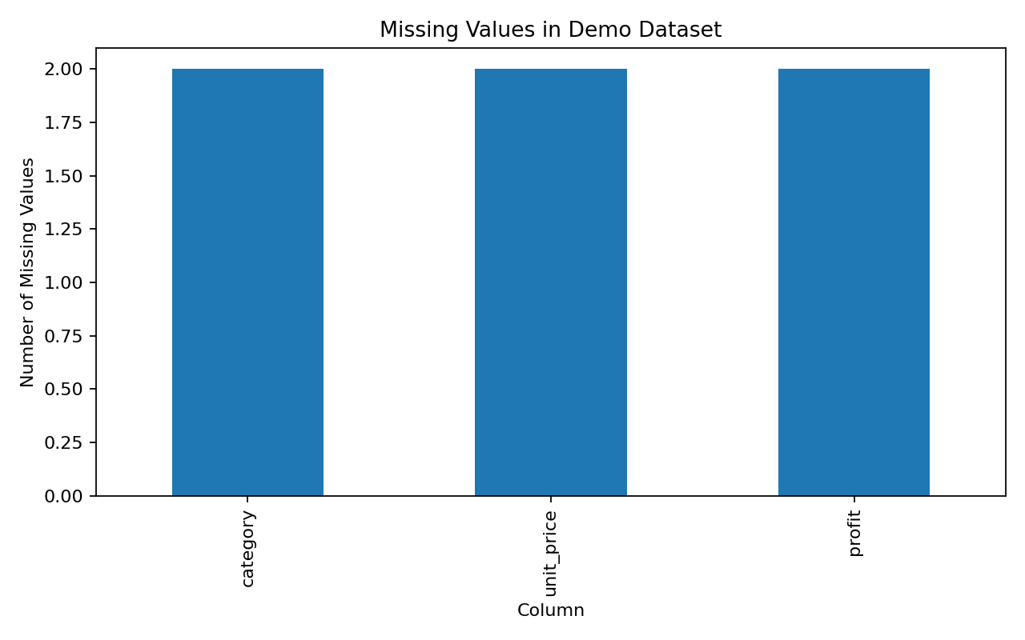

Distribution Plots
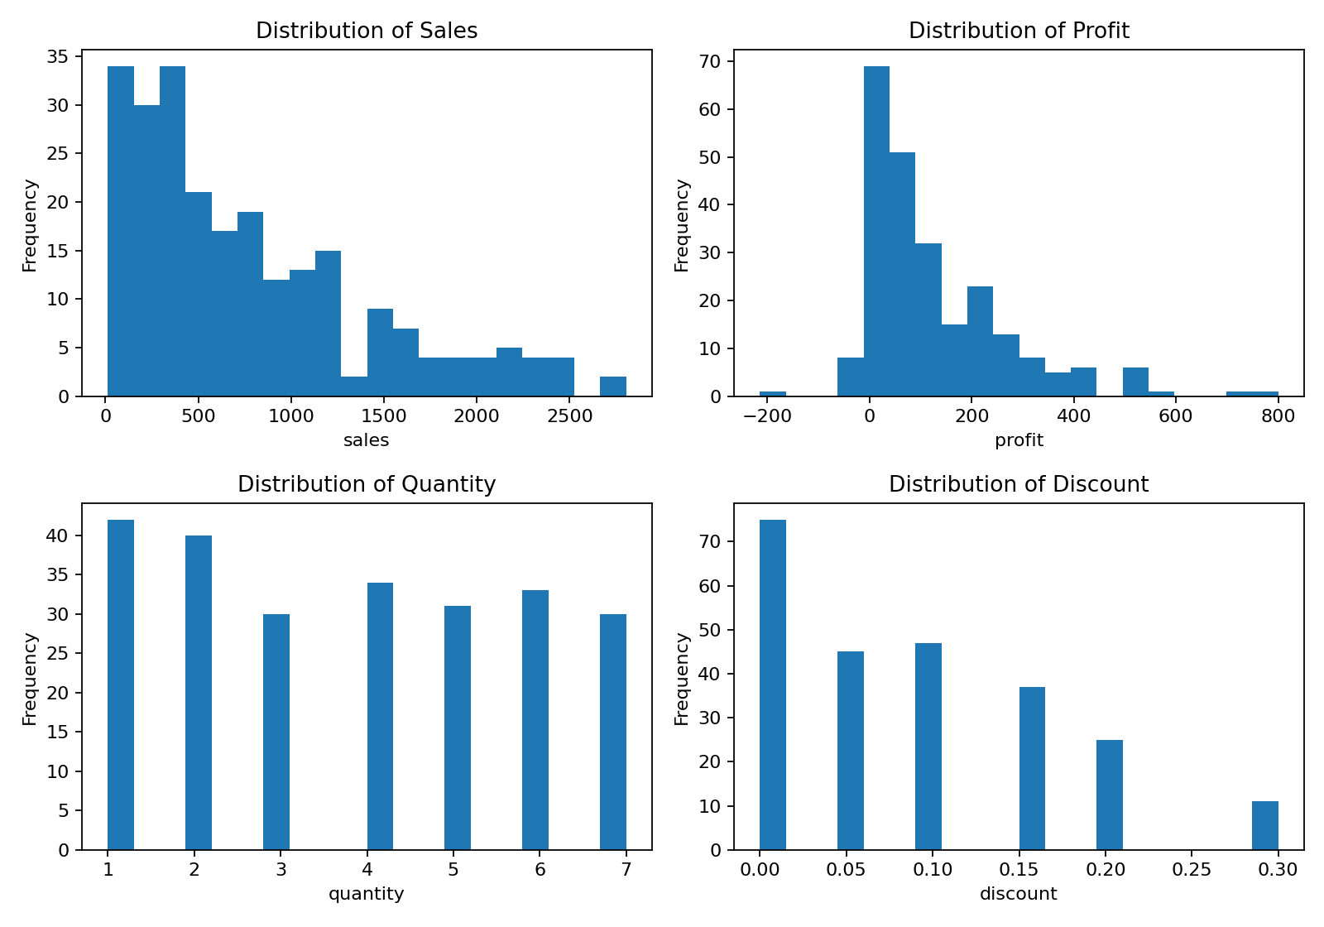

Correlation Heatmap
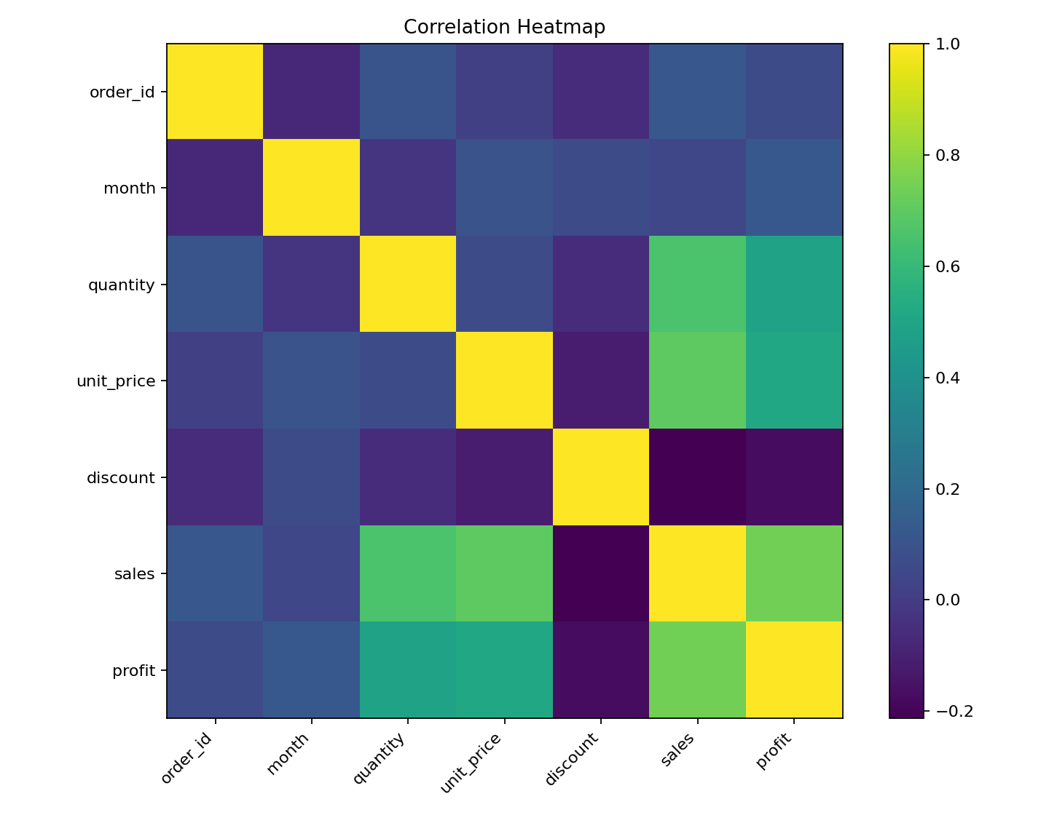

Categorical Analysis
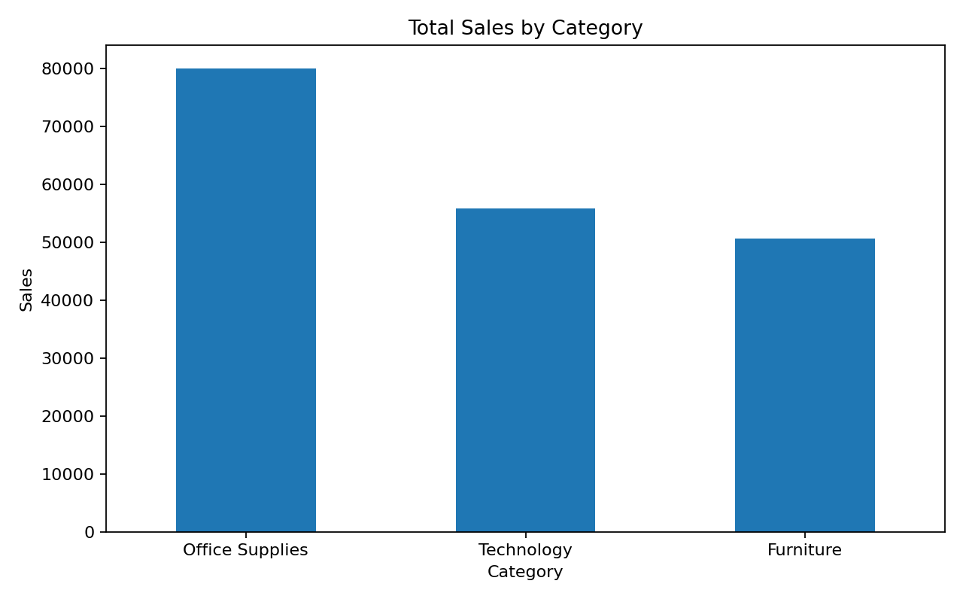

Key Findings
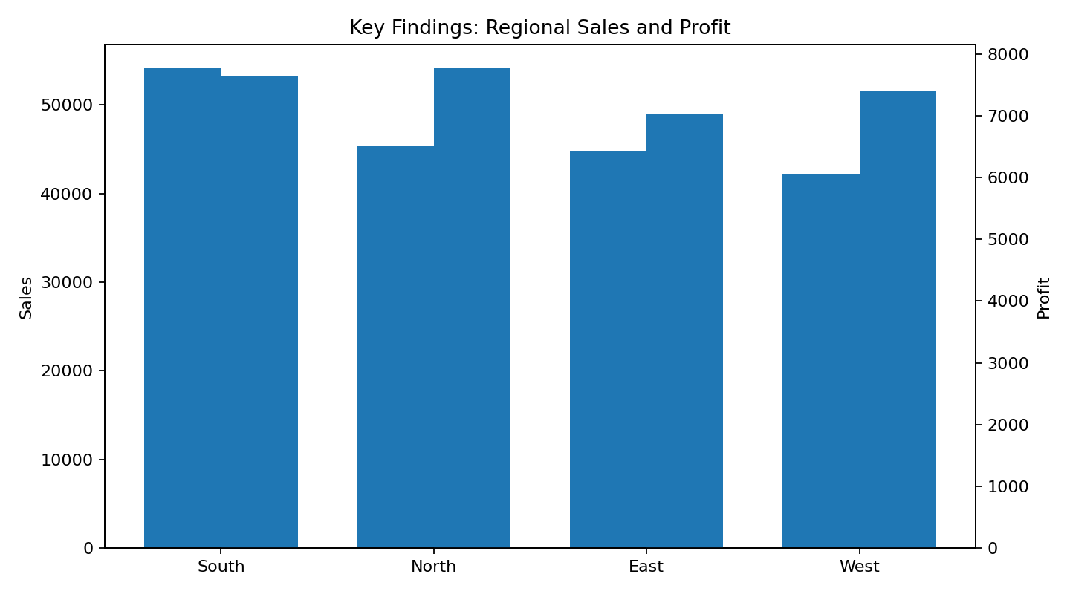

5. Analysis and Modeling
A simple linear regression model is included in notebook 04 to demonstrate a reproducible modeling workflow. It uses sales and discount as predictors of profit. Since the underlying dataset is synthetic, the resulting evaluation metrics are illustrative rather than evidence of real predictive performance.

6. Conclusion
This package provides a complete example of the expected Week 5 project-reporting structure: raw and processed data, four analysis notebooks, reproducible visualizations, and a final report. Before submission as an internship project, all synthetic data and demo findings should be replaced with the actual Week 1–4 dataset, analyses, and results.

