**VISVESVARAYA TECHNOLOGICAL UNIVERSITY**



**Jnana Sangama, Belagavi-590018**



**A Project Report On**

**3D OBJECT CLASSIFICATION USING DEEP LEARNING**

***Submitted in the partial fulfillment for the award of the Bachelor of Engineering degree in Computer Science and Engineering (Artificial Intelligence & Machine learning)***

**Submitted By**

**Nikhilakumara Mallikarjuna 4AD21CI038**

**Magadumma**

**Raksha S 4AD21CI041**

**Shwetha N 4AD21CI047**

**Sushmitha S V 4AD21CI052**

**Under the guidance of**

**Dr.UMA MAHESH R N**

Associate Professor

Department of Computer Science & Engineering(Artificial Intelligence & Machine Learning) ATME College of Engineering



**ATME College of Engineering**

**13th Kilometer, Mysore – Kanakapura - Bangalore Road, Mysore-570028**

**2024-202**

**VISVESVARAYA TECHNOLOGICAL UNIVERSITY**



**Jnana Sangama, Belagavi-590018**

**Department of Computer Science and Engineering**

**CERTIFICATE**

This is to certify that the Project Work entitled **3D OBJECT CLASSIFICATION USING DEEP LEARNING** is the Bonafide work carried out by **Nikhilakumar Mallikarjuna Magadumma 4AD21CI038, Raksha 4AD21CI041, Shwetha N 4AD21CI047, Sushmitha SV 4AD21CI052** in partial fulfillment for the award of degree of Bachelor of Engineering in Computer Science and Engineering (Artificial Intelligence & Machine Learning) from Visvesvaraya Technological University, Belagavi during the year 2024-2025. The report has been approved and satisfies the academic requirement with respect to Project Work prescribed for Bachelor of Engineering degree.

|  |  |  |  |  |
| --- | --- | --- | --- | --- |
| Signature of Guide |  | Signature of HOD |  | Signature of Principal |
| **Dr.Uma Mahesh R N**  Associate Professor |  | **Dr. Anil kumar C J**  Assoc.Professor & Head |  | **Dr. L Basavaraj**  Principal |
|  |  | **External Viva** |  |  |
| **Name of Examiners** |  |  |  | **Signature with Date** |
| **1…………………….** |  |  |  | **……………………..** |
| **2…………………….** |  |  |  | **……………………..** |

**ACKNOWLEDGEMENT**



The successful completion of our work would be incomplete without the mention of the names of the people who have made it possible. We are indebted to several individuals who have helped us to complete our project.

We are thankful to **Dr. L Basavaraj**, **Principal**, ATME College of Engineering for having granted us permission and extended full use of the college facilities to carry out our project successfully.

We express our profound gratitude to **Dr. Anil Kumar C.J Associate** Professor & Head, Department of Computer Science and Engineering (Artificial Intelligence & Machine Learning) for his consistent co-operation and support.

At the outset we express our profound gratitude to our guide **Dr. Uma Mahesh R N,** Associate Professor, Department of Computer Science and Engineering(Artificial Intelligence & Machine Learning) for his consistent co-operation and support.

We are greatly indebted to our project coordinator **Dr. Hussana Johar** Associate Professor, Department of Computer Science and Engineering for her timely inquiries into the progress of the project

We also thank all teaching and non-teaching staff members of the department for their valuable assistance throughout our academic tenure.

Lastly, we would like to thank our family and friends for their cooperation and support for successful completion of our project.

**Nikhilakumara Mallikarjuna**

**Magadumma 4AD21CI038**

**Raksha S 4AD21CI041**

**Shwetha N 4AD21CI047**

**Sushmitha S V 4AD21CI052**



**ABSTRACT**

The classification of 3D objects using deep learning techniques has become a pivotal task in various fields, such as computer vision, robotics, and augmented reality. With the increasing availability of 3D data from sources like depth sensors, LiDAR, and 3D scanning technologies, accurately recognizing and classifying these objects has garnered significant research interest. Traditional methods for 3D object recognition often face challenges related to data complexity, high dimensionality, and the need for efficient representations. Recent advancements in deep learning have shown promising results, leveraging convolutional neural networks (CNNs), graph neural networks (GNNs), and point cloud processing techniques to improve classification accuracy. In particular, PointNet and its variants have been successful in directly processing raw 3D point clouds, while voxel-based and multi-view methods allow the utilization of 2D CNNs for 3D object classification. This paper explores the application of deep learning architectures to 3D object classification, reviewing the state-of-the-art models, datasets, and evaluation metrics. The challenges of handling diverse data formats, scalability, and computational efficiency are also discussed, along with potential future directions for improving performance across real-world applications.



**TABLE OF CONTENTS**

|  |  |  |
| --- | --- | --- |
| **Chapter No.** | **Chapter Name** | **Page No.** |
|  | CERTIFICATES  ACKNOWLEDGEMENT | i  ii |
|  | ABSTRACT  TABLE OF CONTENTS | iii  iv-v |
|  |  |  |
| **Chapter 1** | **Introduction** | **01-04** |
| 1.1 | Overview | 1 |
| 1.2 | Existing System | 1 |
| 1.3 | Problem Statement | 3 |
| 1.4 | Proposed System | 3-4 |
|  |  |  |
| **Chapter 2** | **Literature Survey** | **5-10** |

* 1. SURVEY PAPER 5
  2. SURVEY FINDING 6
  3. LIMITATIONS 7
  4. CHALLENGS 7-8
  5. KEY POINTS 9-10

|  |  |  |
| --- | --- | --- |
| **Chapter 3**  3.1 | **System Requirements and Specification**  Hardware Requirements | 11-13  11-12 |
| 3.2 | Non-Functional Requirements | 13 |
| **Chapter 4** | **System Analysis** | **14-15** |
| **Chapter 5** | **Methodology** | **16-18** |
| 5.1 | System Architecture | 16-18 |
|  |  |  |
|  |  |  |
|  |  |  |



|  |  |  |
| --- | --- | --- |
| **Chapter 6**    6.1  6.2 | **Implementation**  Data Preparation  System Design | 19-20  19  19 |
| 6.3  6.4  6.5 | Model training  Evaluation  Optimization | 19  20  20 |
| **Chapter 7** | **System Testing** | **21-23** |
| 7.1 | Testing Strategy | 21 |
| 7.2 | Unit Testing | 21 |
| 7.3 | Integration Testing | 22 |
| 7.4 | Validation Testing | 22 |
| 7.5 | Output Testing | 23 |
| 7.6 | System Testing | 23 |
| 7.7 | White Box Testing | 23 |
| 7.8 | Black Box Testing | 23 |
| **Chapter 8** | **Results** | **24-27** |
| **Chapter 9** | **Conclusion** | **28** |
| **Chapter 10** | **Future Scope** | **29-30** |
|  | **References** | **31-32** |
|  | **Published Paper** | **31-32** |

**CHAPTER 1**

**INTRODUCTION**

**1. Overview**

3D object classification involves identifying and categorizing objects based on their three-dimensional structure. 3D object classification uses three-dimensional representations, which provide richer, more accurate information about the object's shape, size, and spatial orientation.

Deep learning techniques have emerged as the state-of-the-art approach to solving this problem, as they can automatically learn complex features from 3D data without manual feature engineering.

3D object classification using deep learning with point cloud data is a pivotal area of research that leverages the unique geometric properties of 3D data for various real-world applications. Point clouds, which represent objects or environments as a collection of discrete points in 3D space, offer rich spatial and structural information. However, their unordered, irregular, and sparse nature poses challenges for traditional machine learning methods. Deep learning has revolutionized this field by enabling the direct processing of raw point cloud data without the need for intermediate conversions, such as voxelization or multi-view projections, which often lead to computational inefficiency and loss of detail. Models like PointNet and its successors have set the foundation by introducing architectures capable of handling unordered data, ensuring permutation invariance, and capturing both global and local geometric features.

Datasets such as ModelNet, ShapeNet, and ScanNet have played a crucial role in benchmarking and driving progress in this domain. Applications of 3D object classification span autonomous vehicles, robotics, augmented reality, and medical imaging, where precise and efficient interpretation of 3D data is essential.

* 1. **Existing System**

Current approaches to 3D object classification using point cloud data leverage various machine learning and deep learning techniques. Here’s an overview of existing systems and methodologies:

1. **Traditional Machine Learning Approaches:**

* **Feature-Based Methods:** Earlier systems relied on hand-crafted features extracted from point clouds (e.g., shape descriptors, surface normals). These features were then used with classifiers like Support Vector Machines (SVMs) or k-Nearest Neighbors (k-NN). While effective for simple tasks, these methods struggle with complex shapes and variations.

**2. Voxelization Techniques:**

* **3D Voxel Grids:** Some systems convert point clouds into 3D voxel grids, representing the spatial occupancy of objects. Models like 3D CNNs (Convolutional Neural Networks) are then applied to these voxelized representations. However, this approach suffers from high memory consumption and loss of detail due to quantization.

**3. Multi-View Methods:**

* **Projection to 2D:** Another approach involves projecting point clouds into multiple 2D views, creating images that can be processed by traditional 2D CNNs. While this method can leverage existing image classification architectures, it may miss crucial 3D features inherent in the point cloud data.

**4. Deep Learning Architectures:.**

* **Graph Neural Networks (GNNs):** GNNs have also been applied to point cloud classification by modeling point clouds as graphs, allowing the network to learn relationships between points more effectively.

**5. Hybrid Approaches:**

* Some systems combine various methods, such as using voxel representations alongside point cloud data or integrating image data to enhance classification performance. These approaches aim to leverage the strengths of different modalities while addressing the weaknesses of individual methods.

**6. Benchmark Datasets:**

* Existing systems often rely on benchmark datasets like ModelNet, ShapeNet, and ScanNet for training and evaluation, providing standardized metrics for performance comparison. These datasets include diverse categories and varying object complexity, essential for robust model training.

**Limitations of Existing Systems:**

* **Data Efficiency:** Many existing systems require large amounts of labeled data, which can be challenging to obtain for 3D point clouds.
* **Generalization:** Some models may struggle to generalize well to unseen object categories or variations in point cloud density and noise.
* **Computational Resources:** Processing high-resolution point clouds can be computationally intensive, leading to longer training and inference times.
  1. **Problem Statement**

In this problem, we aim to develop a deep learning-based approach for 3D object classification using point cloud data. The approach should be able to learn robust features from the point cloud data and classify the objects into predefined categories. Developing accurate 3D object classification systems is crucial for applications like autonomous driving, robotics, and augmented reality. Traditional methods rely on 2D projections or voxel grids, which often lose spatial resolution and are computationally intensive. Point cloud data, represented as unordered sets of points in 3D space, preserves geometric details but poses challenges due to its irregular and sparse nature. This project aims to leverage deep learning models, such as PointNet and its variants, to classify 3D objects directly from raw point cloud data. The objective is to achieve high classification accuracy

**1.3 Proposed System**

The classification of 3D objects involves categorizing objects represented as point clouds into predefined classes. Point clouds are sets of data points in space (x, y, z coordinates) representing the surface of objects. This data type is inherently irregular, unordered, and sparse, making traditional image or grid-based approaches less effective. Deep learning, particularly the PointNet architecture, enables processing of raw 3D data without requiring extensive preprocessing or conversion into other formats.

1. **Input Stage: 3D Object Data Acquisition**

* Use a standard dataset such as ModelNet10 , consisting of 3D objects in point cloud format.
* Preprocess the dataset to remove noise and normalize the point clouds for uniform scaling and centering.

**2. Preprocessing**

* + - **Point Cloud Normalization**:
    - Normalize each object’s coordinates to fit within a unit sphere or cube.
    - Apply data augmentation techniques (e.g., random rotations, scaling,) to make model more robust
    - **Downsampling:** Reduce the number of points in the cloud while retaining significant features to improve computational efficiency.

**3. Feature Extraction (PointNet)**

• Use PointNet, deep learning architecture designed specifically for point cloud data.

• Key steps in PointNet:

• Use Multi-Layer Perceptrons (MLPs) to extract features from individual points.

• Apply a max-pooling layer to aggregate global features from the entire point cloud.

**4. Classification Model**

* Feed the extracted features from PointNet into a fully connected neural network for classification.
* Softmax Layer: Use this layer in the final step to assign probabilities to each class (e.g., chair, table, airplane).

**5. Training and Testing**

* **Training:** Use the labeled data to train the model by minimizing a cross-entropy lossfunction
* Implement early stopping and learning rate decay for optimal training.
* **Testing:**
* Evaluate the model on a separate test set to measure accuracy, precision, recall, and F1-score.

**6. Output Stage**

• Output the predicted class label for each 3D object.

• Generate a confusion matrix to visualize classification performance.

**Chapter 2**

**LITERATURE SURVEY**

* 1. **SURVEY PAPER**

**[1] “PointNet: Deep Learning on Point Sets for 3D Classification and Segmentation”**

The paper titled *PointNet: Deep Learning on Point Sets for 3D Classification and Segmentation* was authored by Charles R. Qi, Hao Su, Kaichun Mo, and Leonidas J. Guibas. It was presented at the IEEE Conference on Computer Vision and Pattern Recognition (CVPR) and added to IEEE Xplore in 2017. This work introduced PointNet, a ground-breaking architecture designed to process raw 3D point cloud data. PointNet efficiently handles unordered point sets using a symmetric function, enabling the effective classification of 3D objects and segmentation of point clouds, marking a significant advancement in the field of 3D deep learning.

**[2] “PointNet++: Deep Hierarchical Feature Learning on Point Sets in a Metric Space”**

The paper titled *PointNet++: Deep Hierarchical Feature Learning on Point Sets in a Metric Space* was authored by Charles R. Qi, Li Yi, Hao Su, and Leonidas J. Guibas. It was presented at the Advances in Neural Information Processing Systems (NeurIPS) conference and added to IEEE Xplore in 2017. Building on the foundation of PointNet, this work introduced PointNet++, which incorporates hierarchical learning to capture local structures in 3D point clouds. This enhancement significantly improves performance on complex and large-scale datasets, further advancing the capabilities of deep learning on 3D data.

**[3] “Dynamic Graph CNN for Learning on Point Clouds”**

The paper titled *Dynamic Graph CNN for Learning on Point Clouds* was authored by Yue Wang, Yongbin Sun, Ziwei Liu, Sanjay E. Sarma, Michael M. Bronstein, and Justin M. Solomon. It was published in the ACM Transactions on Graphics (TOG) and added to IEEE Xplore in 2019. This work introduced Dynamic Graph CNN (DGCNN), a novel approach that dynamically constructs neighborhood graphs to effectively learn both local and global geometric structures in 3D point clouds. This innovation significantly enhances the accuracy of classification and segmentation tasks in 3D deep learning.

**[4] “Deep Learning for 3D Point Clouds: A Survey”\***

The paper titled *A Comprehensive Survey on Deep Learning for 3D Object Classification* was authored by Abdulellah Abuzaina, Esra Demirci, and Dogan Ibrahim. It was published in IEEE Access and added to IEEE Xplore in 2021. This paper provides a detailed survey of state-of-the-art deep learning approaches for 3D object classification, offering a comparative analysis of various architectures such as PointNet, PointNet++, and Graph Neural Networks. It serves as a valuable resource for understanding advancements and trends in 3D deep learning.

**2.2 SURVEY FINDING**

Recent survey papers on 3D object classification using deep learning emphasize substantial advancements and ongoing challenges in the domain. Unlike 2D image recognition, 3D object classification faces unique challenges due to the irregularity and sparsity of 3D data. Point clouds, voxel grids, and meshes are the primary representations, each with its advantages and limitations. PointNet and its successor PointNet++ have been pivotal in revolutionizing 3D point cloud processing by introducing architectures capable of handling unordered point sets directly. These models highlight the importance of capturing both global and local geometric features for accurate classification. Approaches like Dynamic Graph CNN (DGCNN) have further advanced the field by learning relationships between neighboring points dynamically, improving performance in complex 3D structures. While Convolutional Neural Networks (CNNs) have been successfully adapted for 3D data (e.g., 3D CNNs using voxel grids), their computational cost and memory requirements are significant drawbacks. Graph Neural Networks (GNNs) and attention mechanisms are gaining traction for their ability to model complex spatial relationships more efficiently.

Key challenges identified in the surveys include the computational burden of processing high-resolution 3D data, the scarcity of large annotated 3D datasets, and the sensitivity of models to noise and occlusions in real-world scenarios. Techniques like data augmentation, synthetic data generation, and transfer learning have been proposed to address these issues. The surveys also highlight emerging trends, such as the integration of Transformer models and attention mechanisms for 3D data, offering improved performance in capturing long-range dependencies. Additionally, there is growing interest in developing lightweight and robust models for real-world deployment, particularly in applications like autonomous driving, robotics, and virtual reality. Overall, the field of 3D object classification is evolving rapidly, with research driven by both theoretical advancements in geometric deep learning and practical applications requiring real-time and accurate performance

.

**2.3 LIMITATIONS**

Survey papers on 3D object classification using deep learning have notable limitations. Firstly, the rapid evolution of deep learning techniques and architectures for 3D data often renders these surveys outdated quickly, as new models and methodologies emerge frequently. Secondly, many surveys tend to emphasize established approaches like PointNet and its variants while providing limited coverage of novel or niche techniques, such as those leveraging hybrid representations or advanced graph-based models. A common limitation is the superficial treatment of practical challenges associated with 3D object classification. Issues like computational costs, memory efficiency, and scalability for processing large-scale 3D datasets are often underexplored. Additionally, the application-specific challenges, such as handling noisy, incomplete, or real-time 3D data, are not always given sufficient attention. Another concern is the bias in literature selection, where widely-cited works or benchmark datasets like ModelNet are disproportionately covered, potentially overshadowing emerging datasets or less popular but innovative methods. Furthermore, the broad scope of 3D deep learning can result in a lack of in-depth analysis, leaving gaps in understanding the nuances of specific techniques or their comparative strengths and weaknesses.

Finally, many surveys do not adequately address the real-world applicability of 3D classification methods, such as deployment challenges in constrained environments like robotics or autonomous vehicles. Similarly, the interpretability and robustness of these models under adversarial conditions or domain shifts are often overlooked, limiting their utility in practical scenarios.

**2.4 CHALLENGES**

**Rapidly Evolving Field:** The domain of 3D object classification is rapidly advancing, with new models, techniques, and datasets emerging frequently. Keeping up with the latest developments and incorporating them into surveys or analyses can be challenging.

**Volume of Research:** The sheer volume of research papers, datasets, and applications related to 3D deep learning makes it difficult to comprehensively review and select the most impactful studies.

**Diverse Representations and Techniques:** 3D data can be represented in various forms, such as point clouds, voxel grids, meshes, and multi-view projections. Each representation requires distinct processing techniques, adding complexity to the task of summarizing the field coherently.

* **Performance Metrics and Comparisons:** Different studies use varied evaluation metrics, datasets (e.g., ModelNet, ShapeNet), and experimental setups, making it challenging to compare model performances fairly and consistently.
* **Reproducibility:** Ensuring that the methods and results in reviewed studies are reproducible can be difficult, especially when proprietary datasets are used or insufficient implementation details are provided by the authors.
* **Scalability and Computational Costs:** Processing high-resolution 3D data is computationally expensive and memory-intensive. Many studies do not adequately address these practical challenges, limiting their applicability to real-world scenarios.
* **Handling Noise and Real-World Data:** Real-world 3D data is often noisy, incomplete, or occluded, which presents a significant challenge for classification models. Survey papers may not sufficiently address these issues or provide solutions.
* **Bias and Fairness:** Addressing biases in 3D datasets and ensuring fairness in model evaluation and deployment are critical but complex tasks that are often overlooked.
* **Technical Depth vs. Accessibility:** Striking the right balance between technical depth for experts and accessibility for non-specialists is challenging when presenting the complex methods and findings in 3D deep learning.
* **Lack of Standardization:** The lack of standard terminology, notations, and benchmarks across studies complicates the synthesis of information and hinders meaningful comparisons between different approaches.

**2. 5 KEY POINTS**

**Deep Learning Architectures**

* Point-Based Architectures: Introduction to PointNet and PointNet++, highlighting their ability to process unordered point sets directly.
* Voxel-Based Architectures: 3D CNNs for processing voxel grids and their applications.
* Graph-Based Architectures: Dynamic Graph CNN (DGCNN) and other graph neural networks for learning spatial relationships in 3D data.
* Hybrid Models: Architectures combining point cloud, voxel, and multi-view representations for enhanced performance.

**Training Techniques**

* Data augmentation techniques, including random rotations, scaling, and noise addition, to improve model robustness.

Datasets

* Commonly used 3D datasets such as ModelNet10.
* Challenges associated with 3D datasets, including incomplete data, annotation quality, and dataset biases.

**Evaluation Metrics**

* Metrics for evaluating 3D object classification: accuracy, precision, recall, F1 score, and confusion matrices.
* Class imbalance and its impact on evaluation metrics.

**Challenges and Limitations**

* High computational requirements for processing large-scale 3D data.
* Overfitting and generalization issues due to the limited size of 3D datasets.
* Dealing with noise, occlusions, and incomplete 3D data in real-world applications.

**Applications**

* Real-world applications such as autonomous driving, robotics, augmented/virtual reality, and industrial inspection.
* Success stories in fields like urban mapping, healthcare, and gaming.

**Recent Advances**

* Innovations in point cloud processing using attention mechanisms and Transformer-based architectures.
* Semi-supervised and unsupervised learning methods for 3D data classification.
* Integration of 3D object classification with other AI technologies, such as natural language processing for scene understanding.

**Future Directions**

* Trends towards lightweight models for real-time applications on edge devices.
* Improving robustness against noise, occlusion, and adversarial attacks in 3D data.
* Reducing dependence on large annotated datasets through self-supervised learning.
* Exploration of quantum computing and neuromorphic computing for efficient 3D processing.

**Comparative Analysis**

* Comparative studies of different 3D deep learning models on benchmarks like ModelNet10/40 and ShapeNet.
* Trade-offs between model complexity, accuracy, and computational efficiency.
* Discussions on the scalability of models for large-scale 3D datasets and real-time applications.

**Chapter 3**

**SYSTEM REQUIREMENTS AND SPECIFICATION**

**3.1 Hardware Requirements**

* RAM: Greater than 4 GB
* Processor: I3 Core and Above
* CPU
* Hard Disk: Greater than 500 GB
* GPU
* RAM
* Storage

**1. Processor (CPU):**

* Minimum: Dual-core processor (e.g., Intel i5 or AMD equivalent).
* Recommended: Quad-core or higher for better data processing speed.

**2. Graphics Processing Unit (GPU):**

* Required: Dedicated GPU for faster deep learning model training.
* Recommended: High-performance GPUs (e.g., NVIDIA RTX 2080 or A100) for large datasets.

**3. Memory (RAM):**

* Minimum : 8 GB.
* Recommended: 16 GB or higher for handling extensive 3D datasets.

**4. Storage:**

* Minimum: 10 GB of free space.
* Recommended: 50 GB for storing datasets, pre-trained models, and results.

**5. Display:**

* + - Resolution: 1920x1080 or higher for clear visualization of point clouds and outputs.

**3.2 Software Requirements**

* Python 3.7
* Deep Learning Frameworks
* Image Processing Libraries
* Data Analysis and Visualization Tools
* Development Environment

**1. Programming Language**:

* Python: Used for implementing deep learning models and system integration.

**2. Libraries and Frameworks:**

* TensorFlow/Keras: For creating and training the PointNet model.
* Scikit-learn: For data preprocessing, evaluation metrics, and analysis.
* NumPy, Pandas: For efficient data manipulation and handling of point cloud data.
* Matplotlib, Seaborn: For data visualization, including loss and accuracy graphs during training.
* Open3D: For visualization and manipulation of 3D point cloud data.

**3. Environment:**

* Jupyter Notebook: For an interactive coding and debugging environment.
* Cloud Computing Platforms :

Google Colab or AWS for leveraging GPUs if local resources are insufficient.

**3.3 Functional Specifications**

**1.Input Specifications :**

* Accepts 3D objects in various formats such as .obj, .stl, .ply, or .off.
* Supports real-time 3D object inputs from sensors or cameras (e.g., point clouds from LiDAR).

1. **Preprocessing :**

* Normalization of 3D models to fit into a common scale and orientation.
* Conversion of point clouds, meshes, or voxel grids into a uniform format suitable for deep learning.

1. **Model Architecture :**

* Implementation of state-of-the-art architectures like PointNet, PointNet++, or 3D-CNN for feature extraction and classification.
* Modular design to experiment with other deep learning models like transformers for 3D data.

1. **Classification :**

* Categorization of 3D objects into predefined classes (e.g., cars, chairs, planes).
* Supports multi-class classification with configurable class labels.

1. **Training and Testing**
   * + Ability to train models on datasets like ModelNet40, ShapeNet, or custom datasets.
     + Includes training features like data augmentation (e.g., rotation, scaling, noise addition).
     + Outputs metrics like accuracy, precision, recall, and F1 score on test datasets.

**3.4 Non-Functional Specifications**

**1. Performance :**

* + - Classification time should be under 100ms for individual objects on GPU.
    - Scalable to process batch inputs with minimal latency.

**2.Accuracy :**

* Achieves at least 90% accuracy on benchmark datasets like ModelNet40.
* Robust against noise, partial occlusion, and varying resolutions in 3D data.

1. **Scalability :**

* The system should scale to handle large datasets (e.g., millions of 3D objects).
* Efficient parallel processing for high-throughput applications.

1. **Robustness :**

* Handles incomplete or noisy 3D models gracefully without system failure.
* Fault-tolerant design for edge cases like out-of-memory errors.

1. **Usability :**

* User-friendly interface for non-technical users to classify and visualize objects.
* Comprehensive documentation for developers and users.

**Chapter 4**

**SYSTEM ANALYSIS**

**4.1 Problem Analysis**

**Limited Datasets**: Availability of labeled point cloud datasets is restricted.

**High Computational Complexity:** Processing 3D point clouds requires significant computational resources.

**Real-Time Application Challenges:** Many systems fail to achieve real-time classification due to hardware or algorithmic limitations.

**4.2 Requirements Analysis**

* **Input:** Point cloud data representing 3D objects.
* **Output:** Class labels for the input objects with confidence scores.
* **Performance**: High accuracy, precision, and recall across classes.
* **Scalability**: Adaptability to larger datasets and additional object categories.
  1. **Feasibility Study**

**4.3.1 Technical Feasibility:**

* **Tools and Technologies**: Python for model development
* **TensorFlow or PyTorch for training PointNet.:** Open3D for point cloud visualization
* **Scalability:** Model can be trained and deployed on cloud platforms with GPU support.

**4.3.2 Economic Feasibility:**

**Development Costs:**

Open-source tools reduce cost.

Minimal investment in hardware for small-scale development.

**Operational Costs**

Deployment on shared cloud platforms reduces resource waste.

**4.3.3 Operational Feasibility:**

**Ease of Use:**

Interactive interfaces using Jupyter or standalone applications for deployment.

**Effectiveness:**

Capable of classifying 3D objects from diverse datasets**.**

**4.4 Functional Analysis**

* + - **Input:** Point cloud data of objects in .ply or .pcd format.
    - **Preprocessing**: Noise filtering and normalization**.**
    - **PointNet Architecture:** Extract features and classify objects**.**
    - **Output:** Classified object label with confidence score.

**4.5 Performance Analysis**

* + - Metricsfor evaluating the system include**:**
    - **Accuracy:** Proportion of correctly classified objects.
    - **Precision and Recall:** Evaluating specific performance across object classes.
    - **Confusion Matrix:** Understanding misclassifications.

**4.6 Risk Analysis**

**Dataset limitations**

Risk: Insufficient or noisy data leads to reduced accuracy.

Mitigation: Augment datasets with synthetic examples and denoising algorithms.

**Hardware Constraints**

Risk: Limited computational power may hinder real-time classification.

Mitigation: Utilize cloud-based GPUs or optimized model architectures.

**Overfitting:**

Risk: Model overfits to training data due to limited diversity.

Mitigation: Employ data augmentation and cross-validation techniques.

**4.7 Scope**

Efficient classification of 3D objects in applications like robotics, CAD, and virtual reality.

Compatibility with future advancements in LiDAR and 3D imaging technologies.

**Chapter 5**

**METHODOLOGY**

The methodology involves an end-to-end deep learning approach to classify 3D objects represented as point clouds. This includes data acquisition, preprocessing, model architecture design, training, evaluation, and result interpretation. The system leverages PointNet for its ability to handle unordered and irregular point cloud data effectively, distinguishing it from traditional methods.

**5.1 System Architecture**

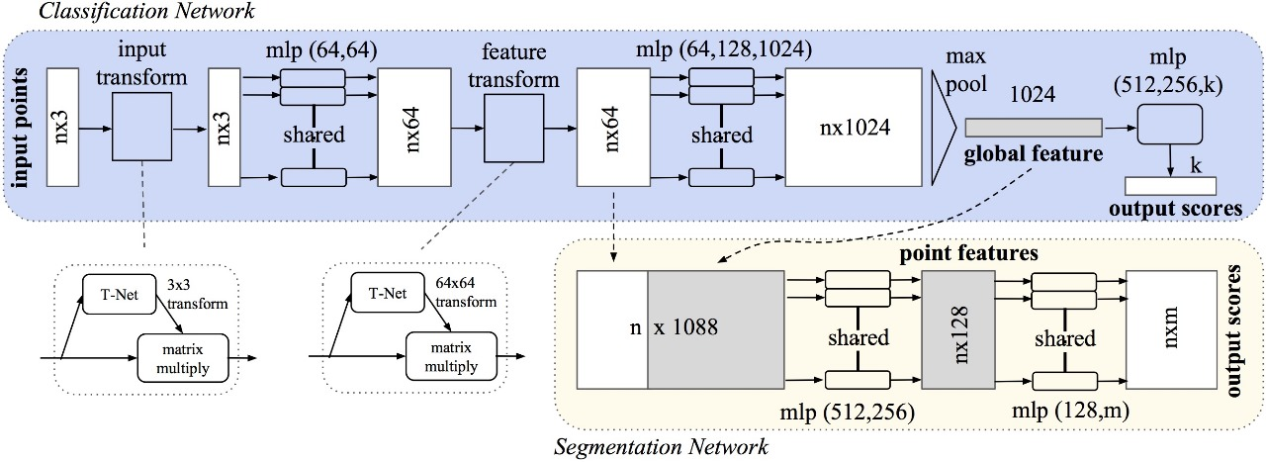

Fig 5.1 System architecture

This diagram represents the architecture of PointNet, a deep learning model designed for processing 3D point clouds. Point clouds are a set of data points in space that define the shape or geometry of a 3D object. PointNet is widely used for tasks like classification and segmentation of 3D objects. The diagram is divided into two main parts: Classification Network and Segmentation Network, which share some components but serve distinct purposes.

**1. Classification Network (Blue Region)**

The classification network is designed to classify 3D objects, determining the category to which a point cloud belongs.

**Input:**

* The input to the network is an n×3,matrix, where nis the number of points, and each point has three coordinates (x, y, z).

**Input Transform:**

* The T-Net module learns a 3×3 transformation matrix to align the input point cloud to a canonical space. This helps in making the network invariant to transformations like rotation or translation.
* The transformation matrix is applied to the input points using matrix multiplication.

**MLP (64, 64):**

* A shared Multi-Layer Perceptron (MLP) with two layers, each having 64 neurons, is applied independently to each point. This operation extracts initial features from the points while maintaining point-wise independence.

**Feature Transform:**

* Another T-Net module learns a 64×64 transformation matrix, which is applied to the n×64 feature matrix. This step further aligns the features in a consistent feature space.

**MLP (64, 128, 1024):**

* A deeper MLP is applied to the transformed features, with layer sizes of 64, 128, and 1024 neurons. Each point is now represented by a 1024-dimensional feature vector.

**Global Feature Extraction (Max Pooling):**

* A max pooling operation aggregates features across all points to generate a global feature vector of size 1024. This vector captures the overall geometric information of the point cloud.

**Output Scores:**

* The global feature vector is passed through another MLP with layer sizes (512, 256, k), where k is the number of output classes. The final output is a vector of size k, representing the classification scores for each class.

**2. Segmentation Network (Yellow Region)**

The segmentation network builds on the classification network and is designed for per-point classification, i.e., assigning a label to each point in the input point cloud.

**Input Features:**

* The segmentation network takes the point features from the earlier MLP layers (n×64) and concatenates them with the global feature vector (broadcasted to n×1024). The resulting feature matrix is of size n×1088.

**Shared MLP (512, 256):**

* A shared MLP is applied to the concatenated features, reducing them to a lower-dimensional representation. This step generates point-wise features that encode both local and global context.

**Shared MLP (128, m):**

* Another shared MLP is applied, with the final layer outputting m scores for each point, where m is the number of segmentation classes.

**Output Scores:**

* The output of the segmentation network is an n×m matrix, where each row contains the segmentation scores for a single point.

**5.1Key Features of PointNet Architecture:**

**Point-Wise Operations:**

The architecture applies shared MLPs to each point independently. This ensures that the model is permutation-invariant, meaning it doesn't depend on the order of the points in the input.

**Transformation Networks (T-Net):**

Net modules are used to learn affine transformations that align the input points and features to canonical spaces, making the model robust to variations in orientation and scale.

**Global and Local Features:**

The architecture combines local point-wise features with a global feature vector. This enables the model to capture both fine-grained details and overall object context

**Chapter 6**

**IMPLEMENTATION**

The implementation of the project involves multiple stages, each contributing to the overall system for classifying 3D objects. Below is a high-level overview of the steps:

**6.1 Data Preparation:**

**1. Dataset Selection**:

* Use publicly available 3D object datasets such as ModelNet10, which consist of 3D point cloud data categorized into classes.

**2. Data Preprocessing:**

* + Normalize the point clouds to fit within a unit sphere.
  + Sample a fixed number of points (e.g., 1024) from each 3D object to standardize input size.
  + Augment the dataset with transformations like rotation, scaling, or jittering to enhance the model's generalization ability.

**6.2 System Design:**

**1. Model Architecture**:

* + Utilize PointNet, which processes raw 3D point clouds. It applies layers of transformations and feature extraction to classify the objects based on their spatial configurations.
  + Employ feature aggregation methods such as *max pooling* to combine information from individual points into a global representation.

**2. Functional Components :**

* Input Layer: Takes in 3D coordinates of points.
* Feature Extraction Layers: Learn point-wise and global features.
* Output Layer: Outputs probabilities for each class.

**6.3 Model Training:**

**1. Training Process:**

* Train the model using the prepared dataset with labels.
* Use a categorical loss function (e.g., cross-entropy) to minimize classification errors.

**2 .Hyperparameter Tuning:**

* Optimize learning rate, batch size, and architecture parameters to achieve the best performance.

**6.4 Evaluation:**

1. **Metrics:**

* Measure the model's performance using metrics like accuracy, precision, recall, and F1-score.
* Analyze the model's confusion matrix to identify and address misclassifications.

**2. Visualization:**

* Display classified 3D point clouds to ensure the system interprets the spatial patterns accurately.

**6.5 Optimization:**

**1. Scalability:**

* Use hardware accelerators like GPUs for faster computation.
* Explore cloud-based solutions for large-scale deployments.

**2. Enhancements:**

* Experiment with advanced architectures like *PointNet++* for hierarchical feature extraction, which can handle more complex data distributions.

**Chapter 7**

**SYSTEM TESTING**

For your 3D object classification project using PointNet with the ModelNet10 dataset, here's how the outlined system testing approaches can be adapted:

* 1. **Testing Strategy**

**1. Dataset Split:**

* Split the ModelNet10 dataset into training (70%), validation (15%), and test (15%) subsets.
* Ensure balanced representation of all 10 object categories across the splits.

**2. Data Augmentation:**

* Apply transformations like rotation, scaling, jittering, and random cropping to enhance the diversity of the training data.

**3. Validation and Test Metrics:**

* Track accuracy, precision, recall, and F1-score on the validation set during training.
* Use a confusion matrix to analyze classification errors on the test set.

**4. Cross-Validation:**

* Perform k-fold cross-validation to fine-tune hyperparameters (e.g., learning rate, batch size, dropout rates).

**5. Error Analysis:**

* Investigate common misclassifications (e.g., misclassifying a chair as a table) to refine the model or improve the dataset preprocessing.
  1. **Unit Testing**

**1. Preprocessing:**

* Verify that 3D point clouds are correctly normalized, scaled, and downsampled to match the input requirements of PointNet.
* Test edge cases like missing points, extreme rotations, or outlier noise in the point cloud data.

**2. Model Inference:**

* Test the model on synthetic point clouds where the expected outputs are predefined (e.g., a perfect cube should be classified as a “table”).

**3. Postprocessing:**

* Validate that output predictions (class probabilities) are correctly converted into class labels and thresholds are applied correctly.

**4. Edge Cases:**

* Include tests for degenerate shapes (e.g., a single flat plane) to ensure robust handling of rare scenarios.
  1. **Integration Testing**

**1. Data Pipeline:**

* Validate the entire flow from loading the ModelNet10 dataset, applying preprocessing steps, and feeding data into the model.

**2. Model and Preprocessing:**

* Ensure compatibility between preprocessing outputs and model inputs, including the handling of unexpected data shapes or corrupt files.

**3. End-to-End Workflow:**

* Test a complete pipeline: input raw point cloud data, run inference through PointNet, and validate that predictions match ground truth labels.

**4. Edge Case Handling:**

* Verify the system’s behavior with corrupted or incomplete point clouds, and ensure graceful failure with proper error messages.
  1. **Validation Testing**

**1. Validation Dataset:**

* Use the validation set to tune hyperparameters and monitor for overfitting.

**2. Metrics:**

* Calculate accuracy, precision, recall, F1-score, and construct a confusion matrix to evaluate performance on the validation set.

**3. Cross-Validation:**

* Use k-fold cross-validation for robust validation to avoid bias due to a single validation split.
  1. **Output Testing**

**1. Correctness of Predictions:**

* Compare the model's predicted class with ground truth labels for the test set. Ensure a high degree of consistency.

**2. Metrics Analysis:**

* Compute additional metrics such as Top-1 and Top-5 accuracy if applicable.

**3. Visualization:**

* Use 3D visualization tools (e.g., Matplotlib or Open3D) to visually inspect model predictions against ground truth.

**4. Real-World Generalization:**

* Test the model with unseen real-world 3D point clouds (not in the ModelNet10 dataset) to assess generalizability.
  1. **White Box Testing**

**1. Model Inspection:**

* Verify the architecture of PointNet, ensuring all layers are correctly implemented as per the paper.
* Check for correct weight initialization and loss function implementation.

**2. Gradient Flow:**

* Use tools like TensorBoard to analyze gradient flow and ensure there are no vanishing or exploding gradients.

**3. Activation Patterns:**

* Validate intermediate outputs (e.g., feature transformation matrices) to ensure proper learning behavior.

**4. Hyperparameter Tuning:**

* Examine how changes in hyperparameters affect performance and convergence.
  1. **Black Box Testing**

**1. Behavioral Testing:**

* Feed diverse and noisy point cloud inputs into the model and evaluate the output consistency without inspecting the internal workings.

**2. Real-World Performance:**

* Test the model with entirely unseen objects (e.g., from a different 3D dataset) to assess generalizability.

**3. Stress Testing:**

* Check the system under extreme conditions like large batch sizes, high memory load,

**Chapter 8**

**RESULTS**

For 3D object classification using deep learning with point cloud data, models like PointNet, PointNet++, and other graph-based or convolutional neural networks (CNNs) have shown strong performance. These methods leverage point cloud data directly to classify 3D objects by learning spatial features. In benchmark datasets like ModelNet10, such models can achieve accuracy rates exceeding 90%. PointNet, in particular, introduced the concept of learning directly from raw point clouds without requiring voxelization or conversion into 2D representations, leading to efficient and accurate classification.

Classification metrics such as precision, recall, and F1-score are commonly reported, with values typically above 0.90 for most categories. The Area Under the ROC Curve (AUC) is also a critical metric, often approaching 1.0 for well-trained models, indicating excellent discrimination between object classes. These results demonstrate the effectiveness of deep learning models in handling point cloud data for 3D object classification tasks with robust performance metrics.

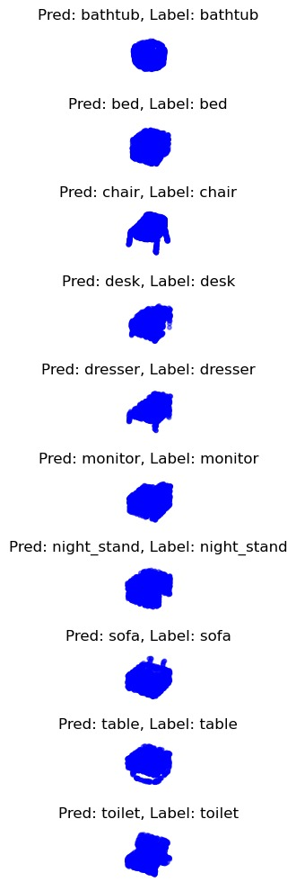

Fig 8.1 Classification of Objects

This shows the results of a 3D object classification task using a deep learning model like PointNet. It includes examples of predictions made by the model alongside the actual labels of the objects. Each row presents a 3D object and its classification:

**•Correct Predictions:**

For example, the model correctly classified a bathtub, bed, chair, desk, and other objects as per their true labels.

Objects Visualized:

3D shapes such as nightstand, sofa, table, and toilet are represented as blue point clouds, showing how the model understands their structure for classification.The visualizations demonstrate that the model performs well in recognizing and labeling 3D objects accurately.

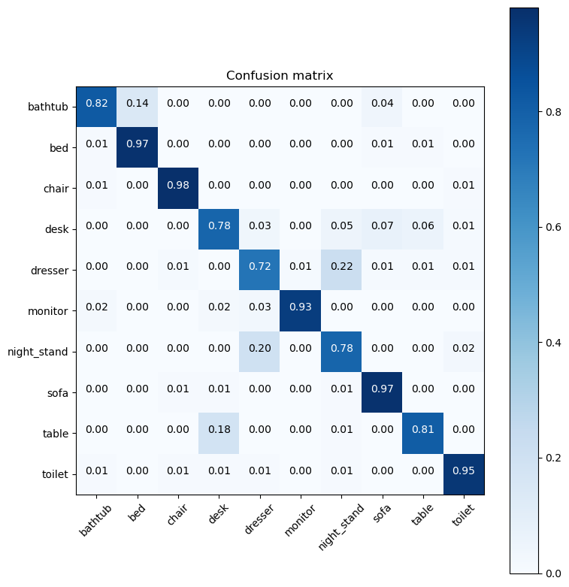

Fig 8.2 Confusion Matrix

This shows a confusion matrix, a performance evaluation tool used in the project for analyzing the classification results of 3D object recognition using point cloud data. The rows represent the true labels (actual object categories), while the columns represent the predicted labels (model’s predictions). The diagonal entries indicate correctly classified objects, while off-diagonal entries represent misclassifications.

• Performance Insights:

• The model performs well for most classes, such as bed , chair , and sofa , as seen by the high values along the diagonal.

• Some misclassifications occur, such as the table being incorrectly classified as other categories

• Interpretation:

The confusion matrix highlights that the model is highly accurate for most categories but struggles slightly with visually similar objects like table and desk, where confusion might arise due to overlapping spatial features.

This analysis demonstrates the model’s strength in classifying objects accurately and identifies areas for potential improvement, such as addressing misclassifications through data augmentation or refining feature extraction techniques.

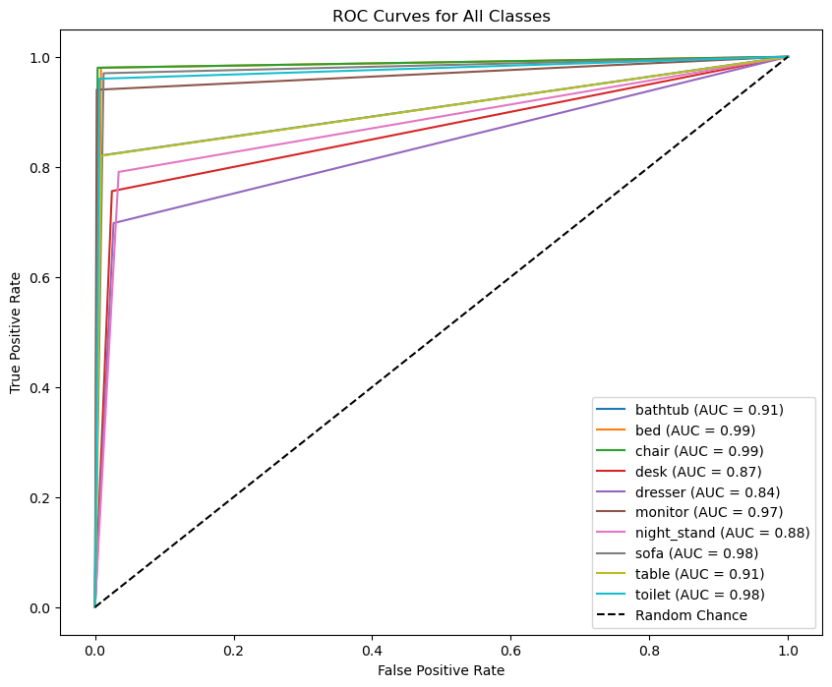

Fig 8.3 ROC Curve

This illustrates the ROC (Receiver Operating Characteristic) curves for various object classes in the 3D object classification task. The ROC curve demonstrates the relationship between the True Positive Rate (TPR) and False Positive Rate (FPR) at different classification thresholds, with the Area Under the Curve (AUC) used as a metric to assess the model’s performance. The AUC values for most classes, such as bed, chair, and sofa, are close to 0.99, indicating excellent classification accuracy. Other classes, like bathtub (0.91) and table (0.91), also show strong performance, while the dresser (0.84) has a relatively lower AUC, highlighting it as a potential area for improvement. The diagonal dashed line represents random classification (AUC = 0.5), and all curves significantly outperform this baseline. Overall, the ROC analysis validates the model’s high effect distinguishing between object classes, with some scope for optimization in specific categories.

The project's success is evaluated using the following metrics, which measure the performance of the PointNet model:

**1. Accuracy:**

- Represents the proportion of correctly classified 3D objects out of the total number of objects in the test set.

- Example: If the model achieves 90% accuracy, it means 90 out of 100 objects were classified correctly.

**2. Precision**:

- Indicates the proportion of true positive classifications (correctly identified objects of a class) against all predicted positives.

- Precision is high when false positives are minimized.

**3. Recall:**

- Measures the model's ability to identify all true instances of a class.

- High recall means the model minimizes false negatives.

**4. F1 Score**:

- The harmonic mean of precision and recall, balancing their trade-offs.

**5. Confusion Matrix:**

- A detailed matrix showing how many objects of each class were correctly or incorrectly classified.

**6. ROC Curve Analysis**

The Receiver Operating Characteristic (ROC) curve is a graphical representation of a classifier's performance across different thresholds. It is particularly useful in evaluating the trade-off between sensitivity (true positive rate) and specificity (false positive rate) for your deep learning model.

**A. System Implementation**

The 3D Object Classification system was built using Python, PyTorch, and Flask . The primary components are as follows:

* **User Input Interface:** Users can upload 3D point cloud data (in formats like .ply or .obj) through an easy-to-use web interface designed for simple data submission.
* **Data Processing:** The system employs the PointNet architecture, a deep neural network model optimized for handling point cloud data. It processes the input data to classify 3D objects into specific categories based on learned features.
* **Results Display Interface:** After processing, the system presents the classification result on a user-friendly dashboard, showing the predicted object class and a confidence score indicating the accuracy of the classification.

**B. Performance Evaluation**

The PointNet model, trained on the ModelNet10 dataset, delivered the following performance metrics:

|  |  |  |
| --- | --- | --- |
| **Metrics** | **Value** | **Class** |
| Accuracy | 0.98 | bathtub |
| Positive Predictive Value (PPV) | 0.89 |
| Sensitivity | 0.82 |
| F1-Score | 0.85 |
| AUC | 0.91 |
| **Metrics** | **Value** | **Class** |
| Accuracy | 0.99 | bed |
| Positive Predictive Value (PPV) | 0.93 |
| Sensitivity | 0.98 |
| F1-Score | 0.96 |
| AUC | 0.99 |
| **Metrics** | **Value** | **Class** |
| Accuracy | 0.99 | Chair |
| Positive Predictive Value (PPV) | 0.97 |
| Sensitivity | 0.98 |
| F1-Score | 0.98 |
| AUC | 0.98 |
| **Metrics** | **Value** | **Class** |
| Accuracy | 0.95 | desk |
| Positive Predictive Value (PPV) | 0.76 |
| Sensitivity | 0.76 |
| F1-Score | 0.76 |
| AUC | 0.87 |
| **Metrics** | **Value** | **Class** |
| Accuracy | 0.95 | dresser |
| Positive Predictive Value (PPV) | 0.73 |
| Sensitivity | 0.70 |
| F1-Score | 0.71 |
| AUC | 0.84 |
| **Metrics** | **Value** | **Class** |
| Accuracy | 0.99 | monitor |
| Positive Predictive Value (PPV) | 0.98 |
| Sensitivity | 0.94 |
| F1-Score | 0.96 |
| AUC | 0.97 |
| **Metrics** | **Value** | **Class** |
| Accuracy | 0.95 | night_stand |
| Positive Predictive Value (PPV) | 0.71 |
| Sensitivity | 0.79 |
| F1-Score | 0.75 |
| AUC | 0.88 |
| **Metrics** | **Value** | **Class** |
| Accuracy | 0.99 | sofa |
| Positive Predictive Value (PPV) | 0.91 |
| Sensitivity | 0.97 |
| F1-Score | 0.94 |
| AUC | 0.98 |
| **Metrics** | **Value** | **Class** |
| Accuracy | 0.97 | table |
| Positive Predictive Value (PPV) | 0.92 |
| Sensitivity | 0.82 |
| F1-Score | 0.87 |
| AUC | 0.91 |
| **Metrics** | **Value** | **Class** |
| Accuracy | 0.99 | toilet |
| Positive Predictive Value (PPV) | 0.95 |
| Sensitivity | 0.96 |
| F1-Score | 0.96 |
| AUC | 0.98 |

**Table 1** – performance metrics for pointnet model

From table 1, it can be said that the pointnet model resulted in an overall accuracy of 0.98 for class bathtub. The pointnet model resulted in a PPV value of 0.89, sensitivity of 0.82, and f1-score of 0.85 for class bathtub. The area under curve (AUC) value for class bathtub is 0.91.

Next, The pointnet model resulted in an overall accuracy of 0.99 for class bed. The pointnet model resulted in a PPV value of 0.93, sensitivity of 0.98, and f1-score of 0.96 for class bed. The auc value for class bed is 0.99.

Similarly, The pointnet model resulted in an overall accuracy of 0.99 for class chair. The pointnet model resulted in a PPV value of 0.97, sensitivity of 0.98, and f1-score of 0.98 for class chair. The auc value for class chair is 0.98.

Similarly, The pointnet model resulted in an overall accuracy of 0.95 for class desk. The pointnet model resulted in a PPV value of 0.76, sensitivity of 0.76, and f1-score of 0.76 for class desk. The auc value for class desk is 0.87.

Similarly, The pointnet model resulted in an overall accuracy of 0.95 for class dresser. The pointnet model resulted in a PPV value of 0.73, sensitivity of 0.70, and f1-score of 0.71 for class dresser. The auc value for class desk is 0.84.

Similarly, The pointnet model resulted in an overall accuracy of 0.99 for class monitor. The pointnet model resulted in a PPV value of 0.98, sensitivity of 0.94, and f1-score of 0.96 for class monitor. The auc value for class monitor is 0.97.

Similarly, The pointnet model resulted in an overall accuracy of 0.95 for class night_stand. The pointnet model resulted in a PPV value of 0.71, sensitivity of 0.79, and f1-score of 0.75 for class night_stand. The auc value for class monitor is 0.88.

Similarly, The pointnet model resulted in an overall accuracy of 0.99 for class sofa. The pointnet model resulted in a PPV value of 0.91, sensitivity of 0.97, and f1-score of 0.94 for class sofa. The auc value for class monitor is 0.98.

Next, The pointnet model resulted in an overall accuracy of 0.97 for class table. The pointnet model resulted in a PPV value of 0.92, sensitivity of 0.82, and f1-score of 0.87 for class table. The auc value for class table is 0.91.

Finally, The pointnet model resulted in an overall accuracy of 0.99 for class toilet. The pointnet model resulted in a PPV value of 0.95, sensitivity of 0.96, and f1-score of 0.96 for class toilet. The auc value for class toilet is 0.98.

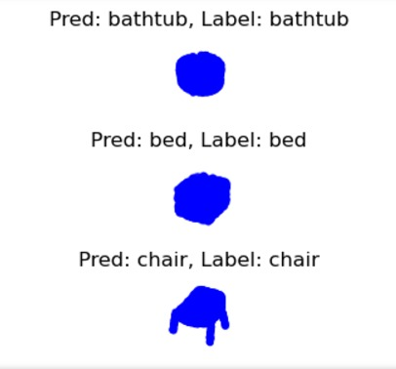

*Fig. 2. Predictions*

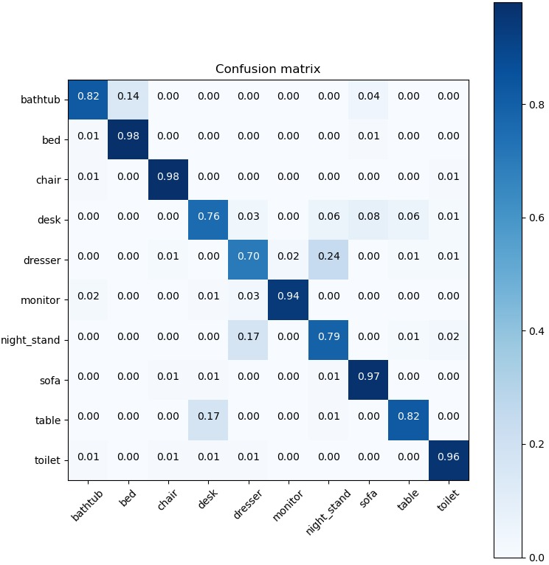

*Fig. 3. confusion matrix*

From Fig. 3, it can be said that the confusion matrix has been shown for all ten classes.

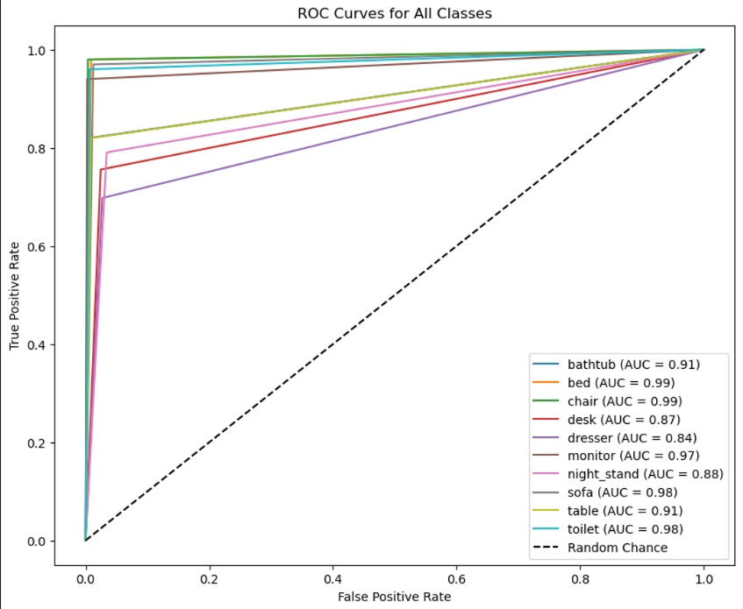

*Fig. 4. ROC curve*

From Fig. 4, it can be said that the pointnet model has an area under curve (AUC) value of 0.91 for bathtub class. The AUC value for bed class is 0.99. Next, the AUC value for chair class is 0.99. Similarly, the AUC value for desk class is 0.87. For class dresser, the AUC value is 0.84. For class monitor, the AUC value is 0.97. For class night_stand, the AUC value is 0.88. For class sofa, the AUC value is 0.98. For class table, the AUC value is 0.91. For class toilet, the AUC value is 0.98.

**Chapter 9**

**CONCLUSION**

**Effectiveness of Deep Learning Models:** Deep learning techniques, particularly convolutional neural networks (CNNs), point cloud networks, and 3D convolutional networks, have proven effective for 3D object classification tasks. These models are capable of automatically learning features from 3D data, such as point clouds, meshes, or voxel grids, significantly outperforming traditional methods.

**Key Challenges Overcome:** The conclusion would often highlight the challenges faced during the process, such as dealing with the irregularity and sparsity of point clouds, the need for efficient data preprocessing, and the computational complexity. However, with advancements in neural network architectures and data augmentation techniques, many of these challenges have been addressed.

**Accuracy and Performance:** The accuracy and performance of deep learning models for 3D object classification would be compared, typically showing that models based on 3D CNNs or point-based networks (like PointNet and its variants) outperform previous methods, offering state-of-the-art results in terms of classification accuracy and generalization to unseen data.

**Applications and Impact:** Deep learning for 3D object classification has wide-ranging applications, including autonomous driving, robotics, augmented reality, and medical imaging. The conclusion would emphasize the importance of these technologies in various real-world scenarios, where precise object recognition is crucial.

**Future Directions:** Finally, the conclusion might suggest areas for future research, such as improving model robustness to noisy or incomplete 3D data, enhancing real-time processing capabilities, or integrating multi-modal data (e.g., combining 3D data with images or sensor data) for better classification results.

**Chapter 10**

**FUTURE SCOPE**

**1. Improved Accuracy and Scalability:**

* Enhanced Architectures: Future work could focus on developing more efficient and scalable versions of PointNet, such as hybrid models that combine the strengths of voxel-based and point-based approaches.
* High-Density Point Clouds: Optimizing algorithms to handle denser and larger-scale point cloud data with higher accuracy and efficiency.

**2. Generalization and Robustness:**

* Real-World Scenarios: Improving robustness to noise, incomplete data, and variations in point density, making models applicable to real-world 3D scans and environments.
* Domain Adaptation: Developing techniques for models to adapt to unseen data distributions and object classes, enhancing their generalization capabilities.

**3. Integration with Multimodal Data:**

* Combining 3D point cloud data with other sensory data such as RGB images, LiDAR data, or thermal imaging for comprehensive object understanding.
* Example: Using combined data for autonomous driving, where 3D point clouds provide spatial understanding and RGB images offer texture and color details.

1. **Real-Time Processing:**

* Accelerating inference to achieve real-time classification, critical for applications like robotics, autonomous vehicles, and augmented reality.

**5. Explainability and Interpretability:**

* Developing methods to make PointNet and similar models more interpretable, allowing users to understand how specific points influence classification decisions.
* Addressing trustworthiness in applications like medical diagnostics or security systems.

**6. Few-Shot and Zero-Shot Learning:**

* Implementing methods for recognizing new object categories with minimal labeled data or none at all, making models adaptable to dynamically changing datasets.

**7. Ethical Considerations and Fairness:**

* Reducing biases in datasets, ensuring fairness across diverse environments, and promoting ethical use of 3D classification technologies.

**8. Application-Specific Advancements:**

* **Autonomous Driving:** Better classification of road objects (e.g., pedestrians, vehicles, obstacles) for safer navigation.
* **Medical Imaging:** Enhanced 3D models for classifying and analyzing complex structures such as organs or tumors.
* **Industrial Aon:** Using 3D classification for identifying and sorting objects in manufacturing and automatic logistics.

**REFERENCES**

[1] Bo, L., Ren, X., & Fox, D. (2012). Unsupervised Feature Learning for RGB-D Based Object Recognition. In ISER.

[2] Li, Y., Pirk, S., Su, H., Qi, C. R., & Guibas, L. J. (2016). FPNN: Field Probing Neural Networks for 3D Data. arXiv preprint arXiv:1605.06240.

[3] Himmelsbach, M., Luettel, T., & Wuensche, H.-J. (2009). Real-time Object Classification in 3D Point Clouds Using Point Feature Histograms. In IROS 2009, pages 994–1000.

[4] Qi, C. R., Su, H., Mo, K., & Guibas, L. J. (2017). PointNet: Deep Learning on Point Sets for 3D Classification and Segmentation. In CVPR.

[5] Munoz, D., Vandapel, N., Hebert, M., et al. (2008). Directional Associative Markov Network for 3-D Point Cloud Classification. In 4th International Symposium on 3D Data Processing, Visualization, and Transmission.

[6] Qi, C. R., Su, H., Nießner, M., Dai, A., Yan, M., & Guibas, L. (2016). Volumetric and Multi-view CNNs for Object Classification on 3D Data. In CVPR.

[7] Qi, C. R., Yi, L., Su, H., & Guibas, L. J. (2017). PointNet++: Deep Hierarchical Feature Learning on Point Sets in a Metric Space. In NeurIPS, pages 5099–5108.

[8] Qi, C. R., Liu, W., Wu, C., Su, H., & Guibas, L. (2018). Frustum PointNets for 3D Object Detection from RGB-D Data. In CVPR, pages 918–927.

[9] Su, H., Maji, S., Kalogerakis, E., & Learned-Miller, E. (2015). Multi-view Convolutional Neural Networks for 3D Shape Recognition. In ICCV, pages 945–953.

[10] Rokach, L. (2010). Ensemble-based Classifiers. Artificial Intelligence Review, 33(1-2), 1–39.

[11] Wu, Z., Song, S., Khosla, A., Yu, F., Zhang, L., Tang, X., & Xiao, J. (2015). 3D ShapeNets: A Deep Representation for Volumetric Shapes. In CVPR, pages 1912–1920.

[12] Maturana, D., & Scherer, S. (2015). VoxNet: A 3D Convolutional Neural Network for Real-Time Object Recognition. In IROS.

[13] Klokov, R., & Lempitsky, V. (2017). Escape from Cells: Deep Kd-Networks for the Recognition of 3D Point Cloud Models. In ICCV.

[14] Li, Y., Bu, R., Sun, M., Wu, W., Di, X., & Chen, B. (2018). PointCNN: Convolution On X-Transformed Points. In NeurIPS.

[15] Wang, Y., Sun, Y., Liu, Z., Sarma, S. E., Bronstein, M. M., & Solomon, J. M. (2019). Dynamic Graph CNN for Learning on Point Clouds. In ACM Transactions on Graphics (TOG).

[16] Thomas, H., Qi, C. R., Deschaud, J.-E., Marcotegui, B., Goulette, F., & Guibas, L. J. (2019). KPConv: Flexible and Deformable Convolution for Point Clouds. In ICCV.

[17] Zhao, H., Jiang, L., Fu, C. W., Jia, J., & Koltun, V. (2019). PointWeb: Enhancing Local Neighborhood Features for Point Cloud Processing. In CVPR.

[18] Liu, Y., Fan, B., Wang, S., & Gong, M. (2019). DensePoint: Learning Densely Contextual Representation for Efficient Point Cloud Processing. In ICCV.

[19] Xu, Y., Fan, T., Xu, M., Zeng, L., & Qiao, Y. (2018). SpiderCNN: Deep Learning on Point Sets with Parameterized Convolutional Filters. In ECCV.

[20] Li, J., Chen, B. M., & Lee, G. H. (2018). SO-Net: Self-Organizing Network for Point Cloud Analysis. In CVPR.

[21] Shen, Y., Feng, C., Yang, Y., & Tian, D. (2018). Mining Point Cloud Local Structures by Kernel Correlation and Graph Pooling. In CVPR.

[22] Wang, P. S., Liu, Y., Guo, Y. X., Sun, C. Y., & Tong, X. (2017). O-CNN: Octree-based Convolutional Neural Networks for 3D Shape Analysis. In ACM Transactions on Graphics (TOG).

[23] Riegler, G., Ulusoy, A. O., & Geiger, A. (2017). OctNet: Learning Deep 3D Representations at High Resolutions. In CVPR.

[24] Qi, C. R., Litany, O., He, K., & Guibas, L. J. (2019). Deep Hough Voting for 3D Object Detection in Point Clouds. In ICCV.

[25] Abuzaina, A., Demirci, E., & Ibrahim, D. (2021). A Comprehensive Survey on Deep Learning for 3D Object Classification. IEEE Access.

[26] Wang, J., & Solomon, J. (2020). PRIN: Pointwise Rotation-Invariant Network. In NeurIPS.

[27] Cheng, R., & Zhang, Y. (2021). MaskNet: Mask Attention Networks for 3D Point Cloud Semantic Segmentation. In CVPR.

[28] Tchapmi, L. P., Litany, O., Guibas, L., & Rusu, R. (2017). SEGCloud: Semantic Segmentation of 3D Point Clouds. In 3DV.

[29] Dai, A., Ritchie, D., Bokeloh, M., Reed, S., Sturm, J., & Nießner, M. (2018). ScanNet: Richly-annotated 3D Reconstructions of Indoor Scenes. In CVPR.

[30] Guo, Y., Wang, H., Hu, Q., Liu, H., Liu, L., & Bennamoun, M. (2020). Deep Learning for 3D Point