Lab Assignment 1
Security Analysis of a PC using the MITRE ATT&CK Framework
Name: Rahul Kumar (252IS029)

Tools and Resources Required
System utilities:
Auditd (Audit Daemon): Auditd is a background service/process that record system activities like executed commands, file access and system events.
Ps: Lists the processes.
Netstat: CLI tool to display information about the network subsystem. eg netstat -a

Crontab:Command-line utility and the file used by the cron daemon to schedule automated, repetitive tasks (known as cron jobs) in Linux. It is a tool for automating system maintenance, backups, and script execution

Syntax:
MIN HOUR DOM MON DOW CMD

Example 1: Schedule a Background Cron Job for Every 20 Minutes:
*/20 * * * * /home/rk/myscript.sh

Example 2:
*/2 * * * * echo "rk nw security" >> /home/rk/Desktop/crontest.txt

*/2 * * * *
│
└─ Minute field → run at minute 0, 2, 4, 6, …(here it is 2 min).

Note: Cron requires five separate time fields, each separated by a space.

Task 1: System Profiling

Detail | Setting
Operating System | Linux(ubuntu 24.04.2)  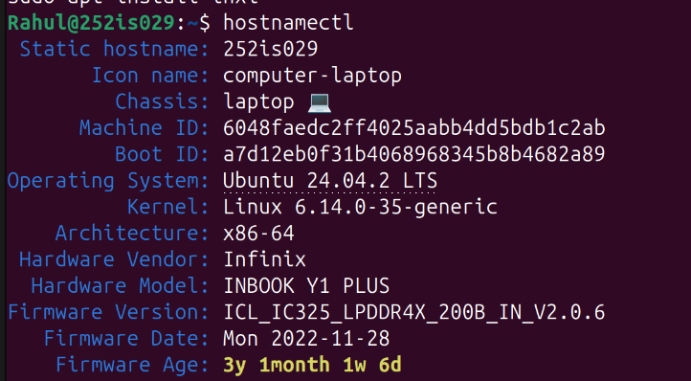
Device | Laptop
User Access Level | Administrator Privileges
Authentication Method | Password-based
Network Connection | College Wi-Fi
Security - Firewall | Disabled  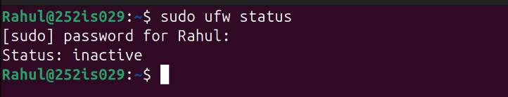
Antivirus | N/a
Disk Encryption | Not encrypted
Maintenance-OS Updates | Manually
Installed Applications | 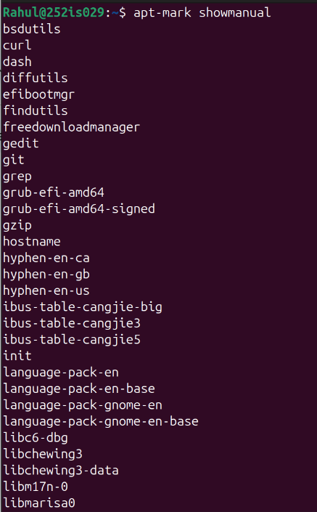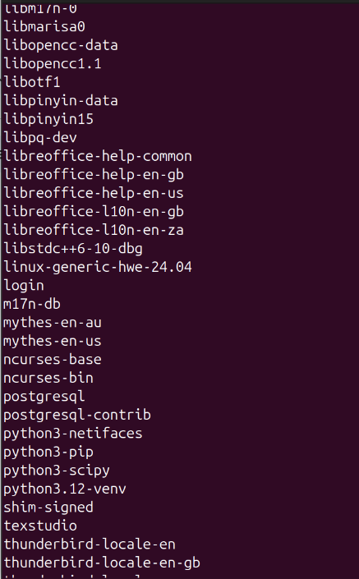  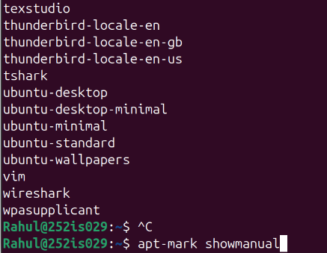  auditd  bsdutils  curl(used for transferring data to and from a server using various network protocols)  dash  diffutils  efibootmgr  findutils  freedownloadmanager(Downloads torrents via the BitTorrent protocol, files)  gedit  git  grep  grub-efi-amd64  grub-efi-amd64-signed  gzip  hostname  hyphen-en-ca  hyphen-en-gb  hyphen-en-us  ibus-table-cangjie-big  ibus-table-cangjie3  ibus-table-cangjie5  init  language-pack-en  language-pack-en-base  language-pack-gnome-en  language-pack-gnome-en-base  libc6-dbg  libchewing3  libchewing3-data  libm17n-0  libmarisa0  libopencc-data  libopencc1.1  libotf1  libpinyin-data  libpinyin15  libpq-dev  libreoffice-help-common  libreoffice-help-en-gb  libreoffice-help-en-us  libreoffice-l10n-en-gb  libreoffice-l10n-en-za  libstdc++6-10-dbg  linux-generic-hwe-24.04  login  m17n-db  mythes-en-au  mythes-en-us  ncurses-base  ncurses-bin  postgresql  postgresql-contrib  python3-netifaces  python3-pip  python3-scipy  python3.12-venv  shim-signed  texstudio(Latex Editor)  thunderbird-locale-en  thunderbird-locale-en-gb  thunderbird-locale-en-us  tshark  ubuntu-desktop  ubuntu-desktop-minimal  ubuntu-minimal  ubuntu-standard  ubuntu-wallpapers  vim(command-line text editor)  wireshark(Network Troubleshooting)  wpasupplicant  (brave, firefox,Gnome boxes)

Task 2: ATT&CK Tactic Selection

1. Initial Access
Pirated books(not official public) downloads, torrents.From 3rd-party websites books download using FDM for downloading zip files from torrent links.(most common entry point)
eg:Browser (Brave, Firefox),Free Download Manager3rd-party websites

2. Execution
Sometimes I download some crack files and install them or some tweaks(draw on screen via github).Malware can get access directly.
eg: .deb installers,pip install

3. Persistence:
Tweaks for GNOME extensions auto-load on login,and I use browser extensions which can auto load when the browser opens.
eg: GNOME Extensions,Browser Extensions

4.Priviledge escalation:
Due to using sudo to install software from file ,if it contains malicious software then it can easily get executed with administration privilege and can hide itself.

5. Defense Evasion:
Sometimes I install addons like gnome tweak or any software via terminal from file and to access them I have to type commands to access that software or feature and browser addons(from github) or extension hides.

6. Credential Access
Browsers (Brave/Firefox) =saved passwords, cookies
Wireshark/tshark =network creds sniffing
eg: browser/wireshark

7. Discovery
Linux commands: ls, ps, netstat, ip, whoami
Can check about these Files,Internet,Installed apps,Wi-Fi
Installed dev tools (git, python)

8. Command and Control (C2)
If any virus is really installed then it will become easy for that to communicate from the host,like browser extension,if python or other installed is not benign.
eg: curl, python

task 3: technique level analysis

1.Initial Access:
Technique id | Technique name | How it could be used | Detectable / Preventable
T1566.002 | Phishing: Malicious Link | Torrent and book sites often contain malicious download links or fake download buttons that redirect to malware-hosting urls. | Partially detectable  via browser protections or wifi firewall,preventable by not visiting those sites.
T1204.002 | User Execution: Malicious File | manually download and extract ZIP files using FDM and malware relies on me to execute the file (Execution scenario). | Less detectable because of no antivirus and for preventing not downloading from unreliable source and while executing need to see the logs in the terminal or wireshark.
T1195.002 | Supply Chain Compromise | Maybe gitHub repos or mirrors may be compromised | Hard to detect
2.Execution:
Technique id | Technique name | How it could be used | Detectable / Preventable
T1059.004 | Command and Scripting Interpreter: Bash | Malicious install scripts or tweaks often execute shell commands during installation. | Detectable by seeing audit logs, hard to prevent if trusted
T1059.006 | Python | pip install can execute setup.py, allowing attackers to run Python code during installation. | Low detectability unless code is reviewed
T1204.002 | User Execution | Installing cracked software requires explicit action, making execution fully user-driven. | depends,Preventable only by if i don’t install
3.Persistance
Technique id | Technique name | How it could be used | Detectable / Preventable
T1547.001/.006 | Boot or Logon Autostart Execution | If the attacker gains root access (via sudo), they could install a malicious systemd unit file that runs at boot and also GNOME extension. | Detectable by reviewing systemd unit files also gnome extensions , preventable by limiting root access
T1176.001 | Browser Extensions | Malicious extension auto-loads and addons like Hackbar | Detectable by reviewing installed extensions or addons.

4.Privilege Escalation
Technique id | Technique name | How it could be used | Detectable / Preventable
T1548.003 | Sudo | Malicious install runs as root | Undetectable mostly, prevented ? doubt
T1068 | Exploitation for Privilege Escalation | A malicious installer may exploit misconfigurations after gaining sudo. | Detectable by seeing logs
5.Defence Evasion
Technique id | Technique name | How it could be used | Detectable / Preventable
T1036 | Masquerading | Malicious tools may appear as normal GNOME tweaks or utilities. | Hard to detect visually
T1027 | Obfuscated Files or Information | Scripts from GitHub may obfuscate payloads. | Detectable by looking directly code before execution or downloaded ,like they contains malicious ip or server.
T1070.004 | File Deletion | Malware hides traces and delete install logs | Undetectable ,preventable ?

6.Credential access:
Technique id | Technique name | How it could be used | Detectable / Preventable
T1555.003 | Credentials from Web Browsers | Brave/Firefox store saved passwords and cookies locally. | Preventable with password manager
T1040 | Network Sniffing | Wireshark can capture credentials if misused. | Monitoring
T1056.001 | Keylogging | Normally it can be installed by installing malicious files and can gather passwords. | not

7.Discovery
Technique id | Technique name | How it could be used | Detectable / Preventable
T1082 | System Information Discovery | whoami, uname, can be used to get system info or file or folders. | It is like normal behavior (using ls,hostname no need to be root), hard to detect
T1057 | Process Discovery | Check running process like wireshark or security tool and can hide himself by name change. | Detectable by auditd ,which record activities.
T1016 | Network Discovery | Can find my laptop ip,open ports etc. | As it normal cmds for admin,and cannot hide network info as it is required by system to work

8.Command and control
Technique id | Technique name | How it could be used | Detectable / Preventable
T1071.001 | Web Protocols (HTTP/HTTPS) | Malware can communicate over normal web traffic because normally port for http or https remains open and not blocked by firewall(if enabled) . | Hard to detect,can use wireshark to see traffic and anlyse.
T1059.006 | Python | Python scripts can act as C2 clients. | Detectable with behavior monitoring after installing any issue like slow or etc.

Tactic | Technique id | Technique name | Current visibility | Risk level
Initial Access | T1566.002 | Phishing: Malicious Link | low/medium | high
Initial Access | T1204.002 | User Execution: Malicious File | low | high
Initial Access | T1195.002 | Supply Chain Compromise | low | high
Execution | T1059.004 | Command and Scripting Interpreter: Bash | Medium | high
Execution | T1059.006 | Python | low | high
Execution | T1204.002 | User Execution | low | medium
Persistance | T1547.001/.006 | Boot or Logon Autostart Execution | Medium | high
Persistance | T1176.001 | Browser Extensions | medium | medium
Privilege Escalation | T1548.003 | Sudo | low | high
Privilege Escalation | T1068 | Exploitation for Privilege Escalation | medium | high
Defence Evasion | T1036 | Masquerading | low | medium
Defence Evasion | T1027 | Obfuscated Files or Information | medium | medium
Defence Evasion | T1070.004 | File Deletion | low | high
Credential access | T1555.003 | Credentials from Web Browsers | low | high
Credential access | T1040 | Network Sniffing | medium | medium
Credential access | T1056.001 | Keylogging | low | high
Discovery | T1082 | System Information Discovery | low | low
Discovery | T1057 | Process Discovery | medium | medium
Discovery | T1016 | Network Discovery | low | low
Command and control | T1071.001 | Web Protocols (HTTP/HTTPS) | low | high
Command and control | T1059.006 | Python | medium | medium

Task 4: ATT&CK Coverage Matrix

Tactic | Detection capability | Prevention capability | Overall risk
Initial Access | medium | Low | High
Execution | Medium | Low | High
Persistence | medium | medium | High
Privilege Escalation | medium | low | High
Defense Evasion | Low | Low | high
Credential Access | low | Medium | High
Discovery | low | Low | Low
Command & Control | Low | medium | High

Task 5:

Top 5 Security Gaps
1. Untrusted downloads/GitHub repo
I often downloads pirated books, courses, and software.normally these files come from third-party websites and torrent sources.These sources do not check files properly. Malicious files can enter system without being noticed.
These files generally contains malicious scripts/ trojans. When opening or install them the malware runs without my knowledge.system may not detect it immediately and it can allow the attacker to gain access or control over the system.
Highest-Risk ATT&CK Tactic: Initial Access
2. file execution
Downloaded files are run mostly manually by the me.These files include installers, scripts, and appimages.The system does not block or scan them in real time ,So it can run like a normal program.
If the file is malicious so it can execute harmfull code and gain access to the system.
Highest-Risk ATT&CK Tactic: Execution
3. Weak monitoring of startup changes
GNOME extensions, browser extensions and startup apps can be changed easily. Malware can modifies GNOME extensions(if it from 3rd party) , browser extensions or startup apps. Since the system does not warn about these changes and malware can stay active and runs again after reboot.
Highest-Risk ATT&CK Tactic: Persistence
4.Unsecure password
My system password is of size two. It may look easy to crack most of the time. If a bruteforce or dictionary attack contains size two passwords, then it becomes a ease for the attacker otherwise, he may never get the password.
Highest-Risk ATT&CK Tactic: Credential Access ?
5:Experiments
I usually try some attacks like SQL, XML or other academic task and while performing these tasks I sometimes open some ports or block system security. An attacker can take advantage of these open ports or weakened protections.This makes smooth attack process.
Highest-Risk ATT&CK Tactic: Defense Evasion?
Task 6:Mitigation & Hardening Plan
Application Whitelisting: Only trusted applications from official repositories/Software(Ubuntu Snap/flatpack) are allowed to run/install. ( mitigation :Access and Execution)
Privilege Reduction: Making sudo access limited and use only when absolutely necessary ,record every sudo command. ( mitigation Privilege Escalation )
Gnome and startup monitoring: Changes to Gnome extensions, autostart entries, and shell configuration files are reviewed regularly (mitigation Persistence)
Browser Hardening: limiting browser extentions/addons. Minimising password storage. (mitigation Credential Access)
Logging and Monitoring: System logs, authentication logs, and process logs are enabled and reviewed periodically ,Enable audit rules for recon commands:ps, netstat, ip, whoami, ls (mitigating Discovery and Defense Evasion)
Backup and Recovery Controls: Regular backups of important files are maintained so data can be restored after an incident ( mitigating Impact)
Command and Control (C2) Prevention: A strict firewall policy is required to be placed for only owner allowed and trusted applications and services work without any issues. This will prevent any extra or malicious app/service use any open port as they want for communication.

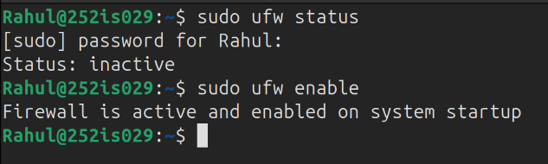

Rahul@252is029:~$ sudo systemctl enable auditd
Synchronizing state of auditd.service with SysV service script with /usr/lib/systemd/systemd-sysv-install.
Executing: /usr/lib/systemd/systemd-sysv-install enable auditd
Rahul@252is029:~$ sudo systemctl start auditd
Rahul@252is029:~$ sudo auditctl -w /usr/bin/whoami -p x -k ReconAttempt
Rahul@252is029:~$ sudo auditctl -w /usr/bin/netstat -p x -k NetDiscovery
Rahul@252is029:~$ sudo ausearch -k ReconAttempt
----
time->Tue Jan 20 21:30:41 2026
type=PROCTITLE msg=audit(1768924841.279:1072): proctitle=617564697463746C002D77002F7573722F62696E2F77686F616D69002D700078002D6B005265636F6E417474656D7074
type=SYSCALL msg=audit(1768924841.279:1072): arch=c000003e syscall=44 success=yes exit=1084 a0=4 a1=7fff5478ff30 a2=43c a3=0 items=0 ppid=13539 pid=13540 auid=1000 uid=0 gid=0 euid=0 suid=0 fsuid=0 egid=0 sgid=0 fsgid=0 tty=pts0 ses=3 comm="auditctl" exe="/usr/sbin/auditctl" subj=unconfined key=(null)
type=CONFIG_CHANGE msg=audit(1768924841.279:1072): auid=1000 ses=3 subj=unconfined op=add_rule key="ReconAttempt" list=4 res=1
----
time->Tue Jan 20 21:34:00 2026
type=PROCTITLE msg=audit(1768925040.278:1089): proctitle="whoami"
type=PATH msg=audit(1768925040.278:1089): item=1 name="/lib64/ld-linux-x86-64.so.2" inode=3272934 dev=103:06 mode=0100755 ouid=0 ogid=0 rdev=00:00 nametype=NORMAL cap_fp=0 cap_fi=0 cap_fe=0 cap_fver=0 cap_frootid=0
type=PATH msg=audit(1768925040.278:1089): item=0 name="/usr/bin/whoami" inode=3327056 dev=103:06 mode=0100755 ouid=0 ogid=0 rdev=00:00 nametype=NORMAL cap_fp=0 cap_fi=0 cap_fe=0 cap_fver=0 cap_frootid=0
type=CWD msg=audit(1768925040.278:1089): cwd="/home/Rahul"
type=EXECVE msg=audit(1768925040.278:1089): argc=1 a0="whoami"
type=SYSCALL msg=audit(1768925040.278:1089): arch=c000003e syscall=59 success=yes exit=0 a0=61e5288561b0 a1=61e5287fd6c0 a2=61e528854480 a3=61e5287fd6c0 items=2 ppid=9846 pid=13911 auid=1000 uid=1000 gid=1000 euid=1000 suid=1000 fsuid=1000 egid=1000 sgid=1000 fsgid=1000 tty=pts2 ses=3 comm="whoami" exe="/usr/bin/whoami" subj=unconfined key="ReconAttempt"
----
time->Tue Jan 20 21:34:09 2026
type=PROCTITLE msg=audit(1768925049.580:1100): proctitle="whoami"
type=PATH msg=audit(1768925049.580:1100): item=1 name="/lib64/ld-linux-x86-64.so.2" inode=3272934 dev=103:06 mode=0100755 ouid=0 ogid=0 rdev=00:00 nametype=NORMAL cap_fp=0 cap_fi=0 cap_fe=0 cap_fver=0 cap_frootid=0
type=PATH msg=audit(1768925049.580:1100): item=0 name="/usr/bin/whoami" inode=3327056 dev=103:06 mode=0100755 ouid=0 ogid=0 rdev=00:00 nametype=NORMAL cap_fp=0 cap_fi=0 cap_fe=0 cap_fver=0 cap_frootid=0
type=CWD msg=audit(1768925049.580:1100): cwd="/home/Rahul"
type=EXECVE msg=audit(1768925049.580:1100): argc=1 a0="whoami"
type=SYSCALL msg=audit(1768925049.580:1100): arch=c000003e syscall=59 success=yes exit=0 a0=5eb4d8c6bb68 a1=5eb4d8c80730 a2=5eb4d8c8e490 a3=64 items=2 ppid=13934 pid=13935 auid=1000 uid=0 gid=0 euid=0 suid=0 fsuid=0 egid=0 sgid=0 fsgid=0 tty=pts0 ses=3 comm="whoami" exe="/usr/bin/whoami" subj=unconfined key="ReconAttempt"
----
time->Tue Jan 20 21:35:45 2026
type=PROCTITLE msg=audit(1768925145.817:1479): proctitle=617564697463746C002D77002F7573722F62696E2F77686F616D69002D700078002D6B005265636F6E417474656D7074
type=SOCKADDR msg=audit(1768925145.817:1479): saddr=100000000000000000000000
type=SYSCALL msg=audit(1768925145.817:1479): arch=c000003e syscall=44 success=yes exit=1084 a0=4 a1=7ffd0f089b70 a2=43c a3=0 items=0 ppid=15942 pid=15943 auid=1000 uid=0 gid=0 euid=0 suid=0 fsuid=0 egid=0 sgid=0 fsgid=0 tty=pts0 ses=3 comm="auditctl" exe="/usr/sbin/auditctl" subj=unconfined key=(null)
type=CONFIG_CHANGE msg=audit(1768925145.817:1479): auid=1000 ses=3 subj=unconfined op=add_rule key="ReconAttempt" list=4 res=0
Rahul@252is029:~$ sudo ausearch -k NetDiscovery
----
time->Tue Jan 20 21:31:23 2026
type=PROCTITLE msg=audit(1768924883.735:1079): proctitle=617564697463746C002D77002F7573722F62696E2F6E657473746174002D700078002D6B004E6574446973636F76657279
type=PATH msg=audit(1768924883.735:1079): item=0 name="/usr/bin/" inode=3270402 dev=103:06 mode=040755 ouid=0 ogid=0 rdev=00:00 nametype=PARENT cap_fp=0 cap_fi=0 cap_fe=0 cap_fver=0 cap_frootid=0
type=CWD msg=audit(1768924883.735:1079): cwd="/home/Rahul"
type=SOCKADDR msg=audit(1768924883.735:1079): saddr=100000000000000000000000
type=SYSCALL msg=audit(1768924883.735:1079): arch=c000003e syscall=44 success=yes exit=1084 a0=4 a1=7fff2b19f010 a2=43c a3=0 items=1 ppid=13625 pid=13626 auid=1000 uid=0 gid=0 euid=0 suid=0 fsuid=0 egid=0 sgid=0 fsgid=0 tty=pts0 ses=3 comm="auditctl" exe="/usr/sbin/auditctl" subj=unconfined key=(null)
type=CONFIG_CHANGE msg=audit(1768924883.735:1079): auid=1000 ses=3 subj=unconfined op=add_rule key="NetDiscovery" list=4 res=1
----
time->Tue Jan 20 21:35:59 2026
type=PROCTITLE msg=audit(1768925159.104:1489): proctitle=617564697463746C002D77002F7573722F62696E2F6E657473746174002D700078002D6B004E6574446973636F76657279
type=SOCKADDR msg=audit(1768925159.104:1489): saddr=100000000000000000000000
type=SYSCALL msg=audit(1768925159.104:1489): arch=c000003e syscall=44 success=yes exit=1084 a0=4 a1=7ffd5fc104a0 a2=43c a3=0 items=0 ppid=15982 pid=15983 auid=1000 uid=0 gid=0 euid=0 suid=0 fsuid=0 egid=0 sgid=0 fsgid=0 tty=pts0 ses=3 comm="auditctl" exe="/usr/sbin/auditctl" subj=unconfined key=(null)
type=CONFIG_CHANGE msg=audit(1768925159.104:1489): auid=1000 ses=3 subj=unconfined op=add_rule key="NetDiscovery" list=4 res=0
----
time->Tue Jan 20 21:40:33 2026
type=PROCTITLE msg=audit(1768925433.494:1508): proctitle="netstat"
type=PATH msg=audit(1768925433.494:1508): item=1 name="/lib64/ld-linux-x86-64.so.2" inode=3272934 dev=103:06 mode=0100755 ouid=0 ogid=0 rdev=00:00 nametype=NORMAL cap_fp=0 cap_fi=0 cap_fe=0 cap_fver=0 cap_frootid=0
type=PATH msg=audit(1768925433.494:1508): item=0 name="/usr/bin/netstat" inode=3285841 dev=103:06 mode=0100755 ouid=0 ogid=0 rdev=00:00 nametype=NORMAL cap_fp=0 cap_fi=0 cap_fe=0 cap_fver=0 cap_frootid=0
type=CWD msg=audit(1768925433.494:1508): cwd="/home/Rahul"
type=EXECVE msg=audit(1768925433.494:1508): argc=1 a0="netstat"
type=SYSCALL msg=audit(1768925433.494:1508): arch=c000003e syscall=59 success=yes exit=0 a0=61e5287fd3c0 a1=61e5287fddd0 a2=61e528854480 a3=61e5287fddd0 items=2 ppid=9846 pid=16616 auid=1000 uid=1000 gid=1000 euid=1000 suid=1000 fsuid=1000 egid=1000 sgid=1000 fsgid=1000 tty=pts2 ses=3 comm="netstat" exe="/usr/bin/netstat" subj=unconfined key="NetDiscovery"
Rahul@252is029:~$

