Lab 2
Analysis of Vulnerabilities Across Network Layers Using a Layered Security Model
1. Lab Environment Setup
Network Topology:Installed ubuntu,installed vm on ubuntu and window 10 in VM ,for internet ->ethernet.
Attacker Machine: Ubuntu 22.04 (VM)
Victim Machine: window 10
Network Type:Ethernet (Internal Network)
Hypervisor: Oracle

System Configuration
Ubuntu 24:16gb RAM ; intel i5
Window 10:4gb RAM, Virtualized Core,Oracle VM VirtualBox
Network Mode:Bridged / Internal
3.Setup (BRidge Adapter)
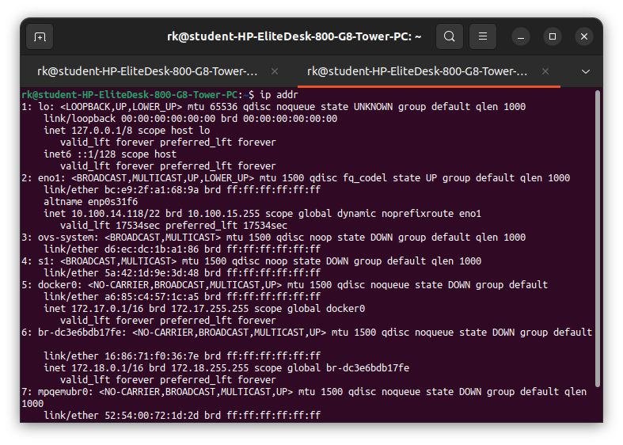

2: 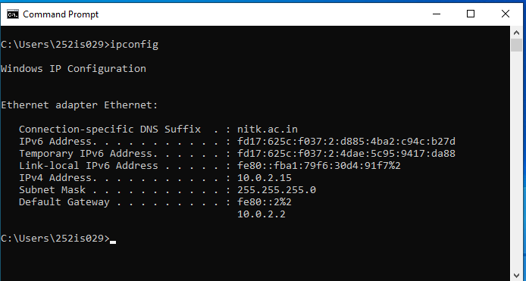
3. 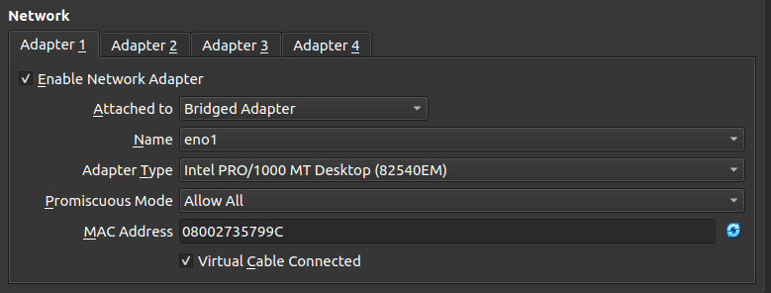

4. 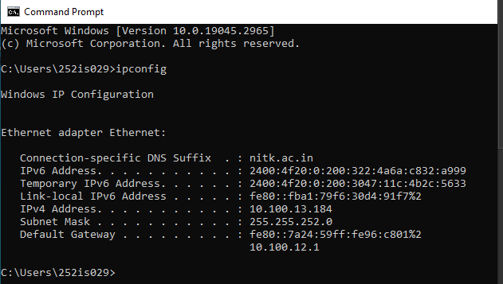
5.
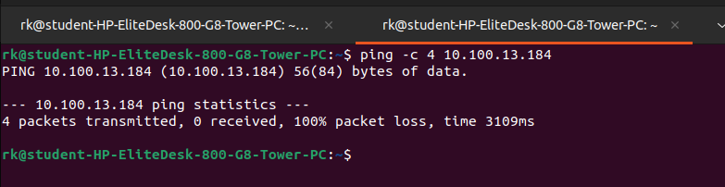

6.
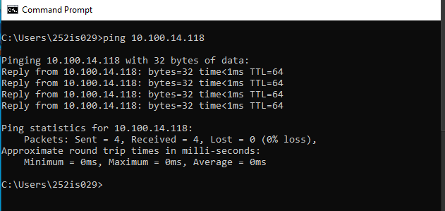

7.
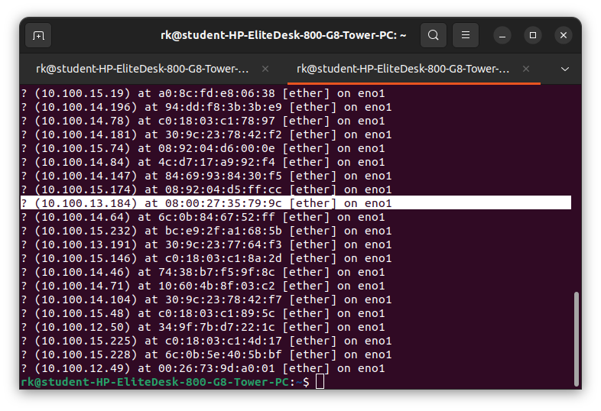

8.
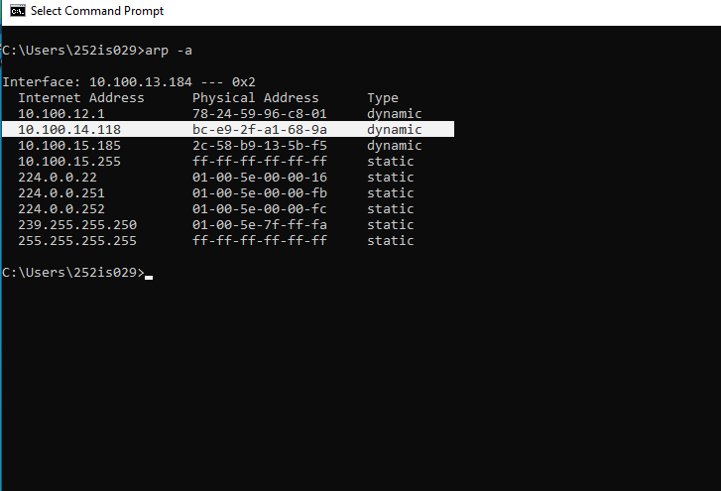

3. Attack Analysis

3.1 Physical Layer
The Physical Layer is responsible for physical connections like ethernet cables, network interface cards, and signals.In this attack, we will disables the network interface, which is similar to unplugging the ethernet cable physically.When the interface is turned off, the system completely loses network connectivity, even if all software settings are correct.
Attack Name:Interface Down (Ethernet Cable Disable / Physical Link Disruption)
Attack Performed: Ethernet Interface Disable

Steps Performed:
1.sending icmp packets to ubuntu to show initially internet working well.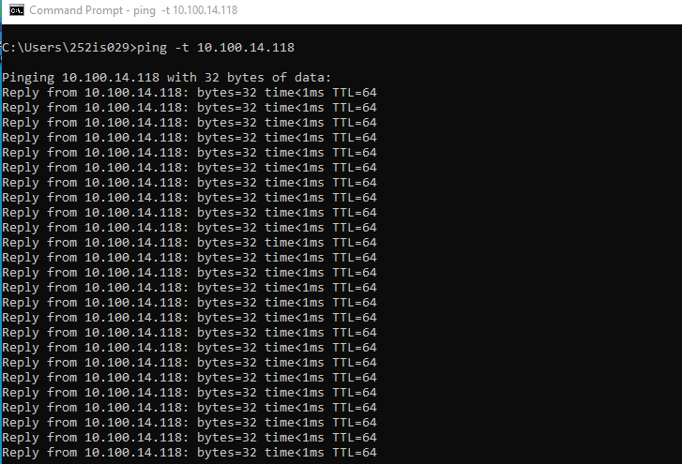

2.using tcpdump capturing 10 packets which were going through the ethernet interface eno1 by giving host ip ,here we can see that from window victim ping is working.
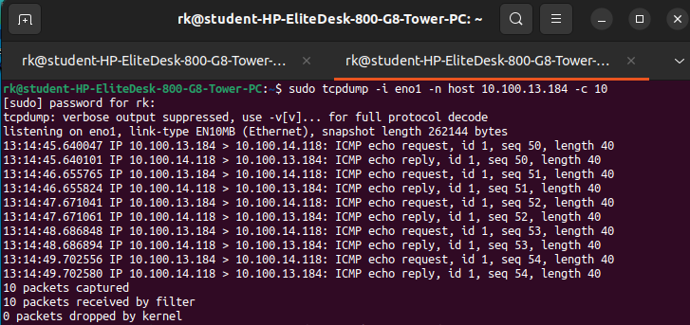
3.turning off the ethernet.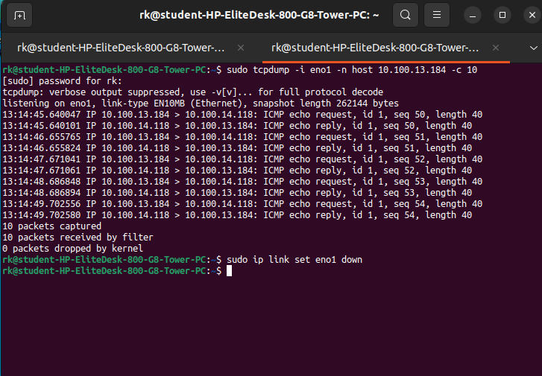

5.now here we can see on window ping is not working,means physical layer attack is successfull.
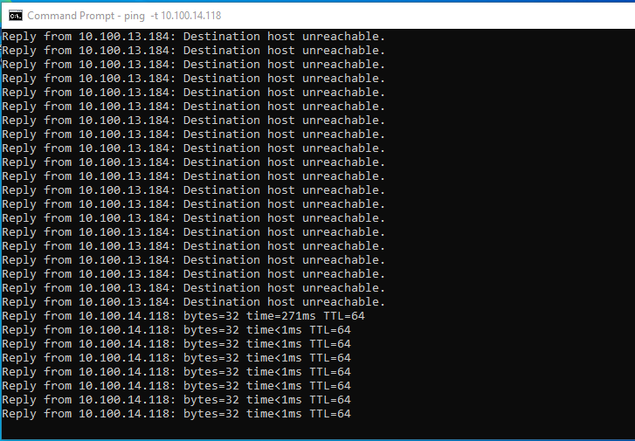
6.lets turn on the net.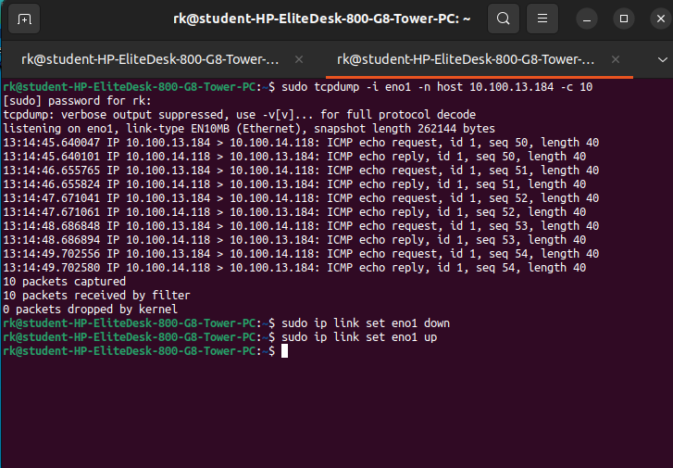
7.here its start working
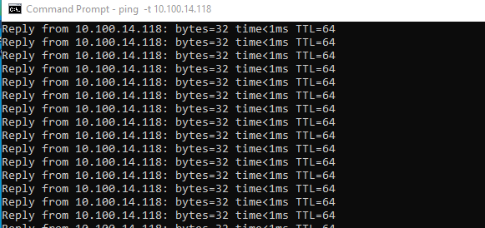

Impact Analysis
Before the attack, the network connection was working normally.During the attack, the Windows system showed request timed out messages.Packet transmission stopped completely while the interface was down.All network services failed instantly despite correct IP and firewall configuration.This resulted in loss of availability of the system.

Security Impact
Availability: Severely affected

Mitigation Strategies
Secured Cable Routing,Network Link Monitoring

3.2 Data LInk layer
The Data Link Layer is responsible for MAC addressing and communication inside a local network.ARP (Address Resolution Protocol) is used to map IP addresses to MAC addresses.In an ARP spoofing attack, the attacker sends fake ARP replies to the victim and the gateway.This makes both systems believe that the attacker is the other device, allowing the attacker to intercept traffic.
Attack Performed: ARP Spoofing / ARP Poisoning (MITM)
Steps Performed:
1. Lets see the MAC address of the gateway before the attack.
For ubuntu
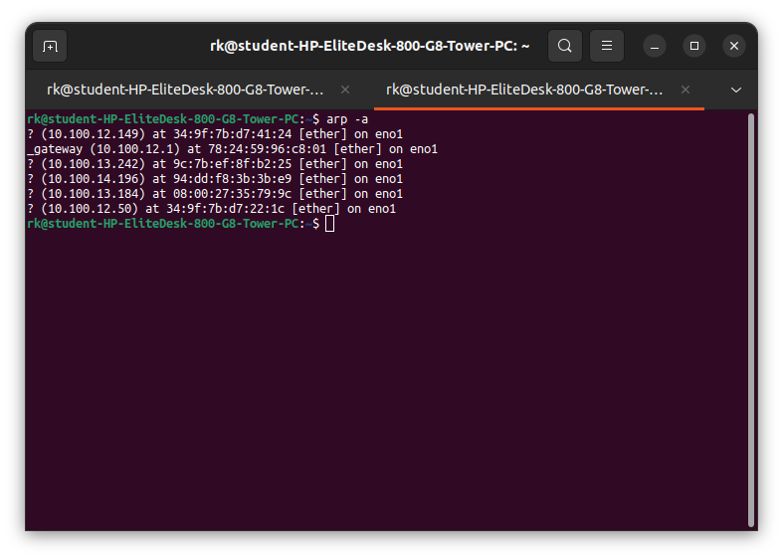
2. For window
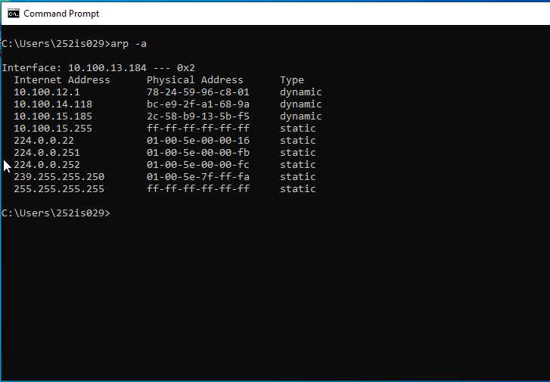
3.sudo sysctl -w net.ipv4.ip_forward=1,This command allow attacker system to forward packets between the victim and the gateway ,for this time we need to install dsniff tool ,(it contains arpspoof from one of the tool that Redirects traffic on a local network by forging ARP replies (Mitm))
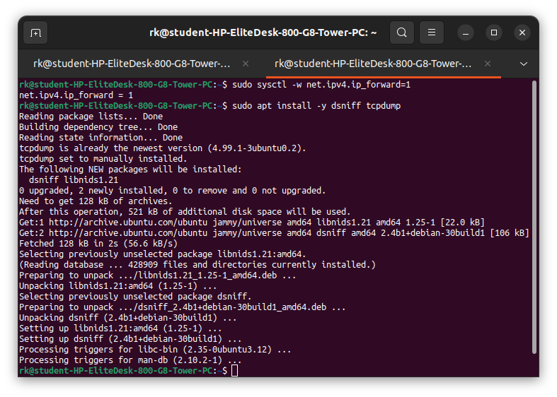
4.ARP Poison Victim (Ubuntu Terminal 1)
sudo arpspoof -i eno1 -t 10.100.13.184(host1) 10.100.12.1(host2)
Host2 is gateway, this cmd means i’m saying to host1 that i’m the host2 or i.m with that ip.
This command tricked the Windows victim into thinking the attacker is the gateway.
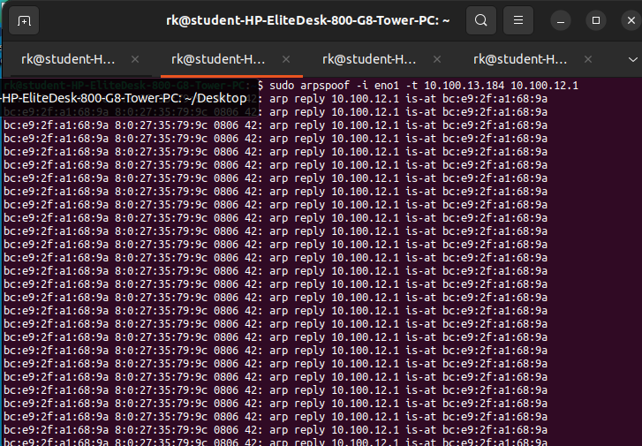
5.ARP Poison Gateway (Ubuntu Terminal 2)
sudo arpspoof -i eno1 -t 10.100.12.1 10.100.13.184
This command tricked the gateway into thinking the attacker is the victim.
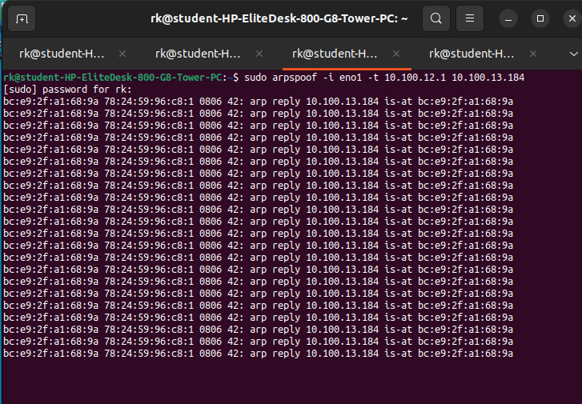
6.Packet Capture During Attack (Ubuntu)
sudo tcpdump -i eno1 -n host 10.100.13.184
This will captured all victim(window) traffic passing through ubuntu & we can see the packets
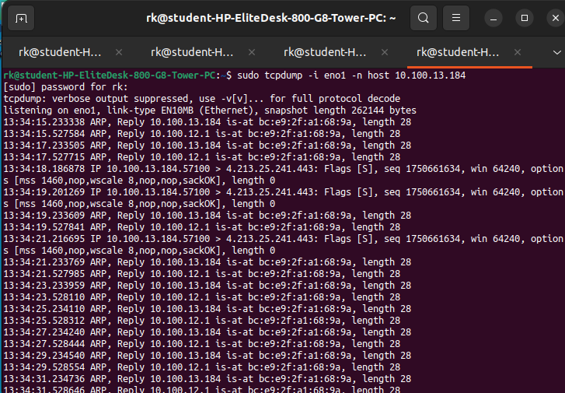
7.here gateway ip now mapped to the ubuntu’s MAC address, confirming a successful MITM attack.
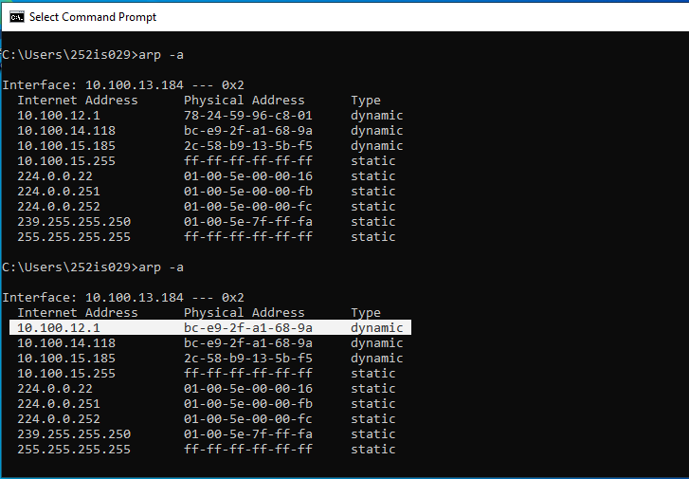

After closing those two terminals( double sided arp spoofing),mapped to normal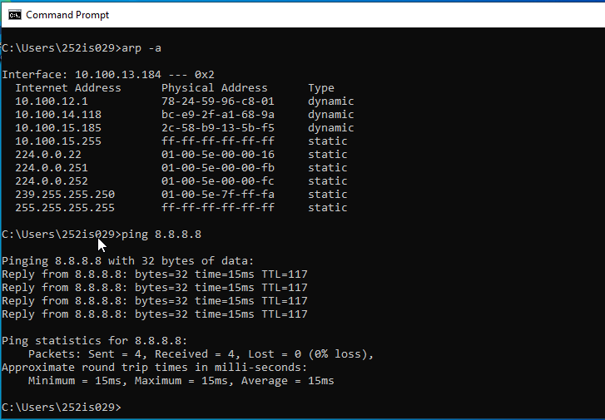

Impact Analysis
The attacker successfully positioned itself between the victim and the gateway.All victim network traffic passed through the attacker system.The attacker could sniff, modify, or block packets.This attack affected confidentiality, integrity, and availability.
Security Impact
Confidentiality: Compromised (traffic interception)
Integrity: Compromised (packets can be modified)
Availability: Partially affected (traffic disruption possible)
Mitigation Strategies
Switches should validate ARP packets to prevent spoofing attacks.
Static ARP Entries:Critical systems can use static ARP mappings for important devices.

3.3 N/w layer
The Network Layer is responsible for logical addressing (IP addresses) and routing of packets.ICMP (Internet Control Message Protocol) is commonly used for network testing using ping.In an ICMP flood attack, the attacker sends a very large number of ICMP echo requests to the victim.This overloads the victim’s network and CPU, making the system slow or unreachable.
Attack Name:ICMP Flood (Ping Flood – Denial of Service)
Attack Performed:ICMP Flood (Denial of Service Attack)

Steps :
1.Baseline Connectivity Check (Before Attack)
ping -c 4 10.100.13.184
lets verify that the Windows victim is reachable and responding normally before the attack , but here packet 100% loss mostly window’s firewall blocks all icmp packet by default.
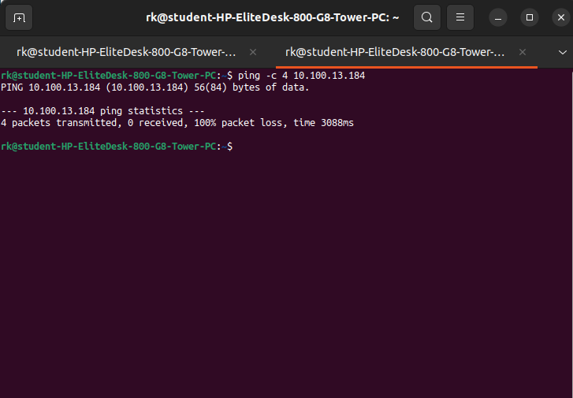
2.lets install tool hping3 for flooding and also used for advanced ping like specific port or we can also use this for spoofing.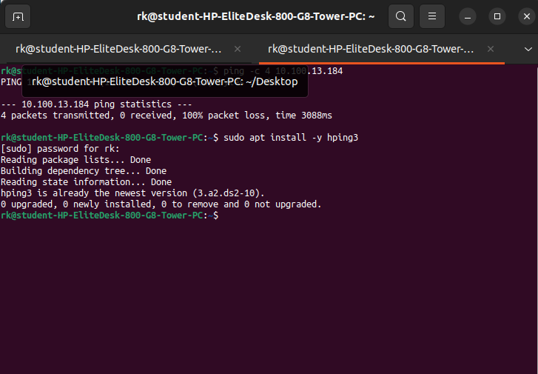
3.here lets run the ping to check the window cpu usage,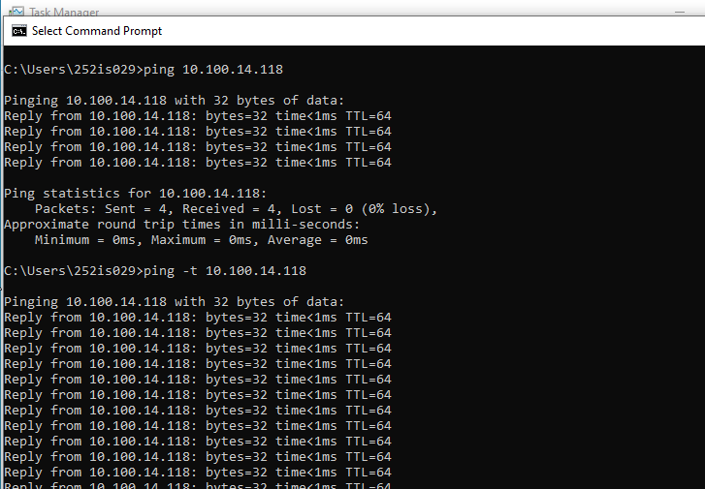
4.here is on 1 %,before attack for that ping command. And this verify that the Windows victim was reachable and responding normally before the attack.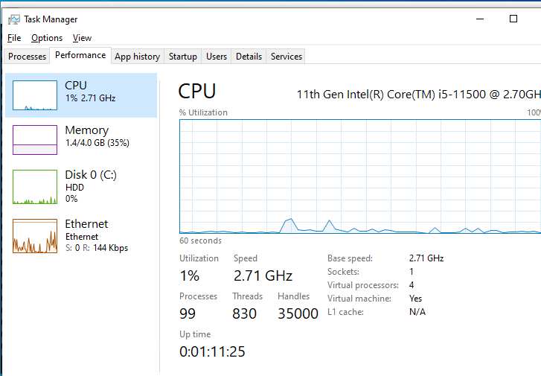
5. ICMP Flood Attack (Ubuntu – Attacker)
sudo hping3 --flood -1 10.100.13.184
This will sent a continuous flood of ICMP echo requests to the Windows victim at a very high rate.
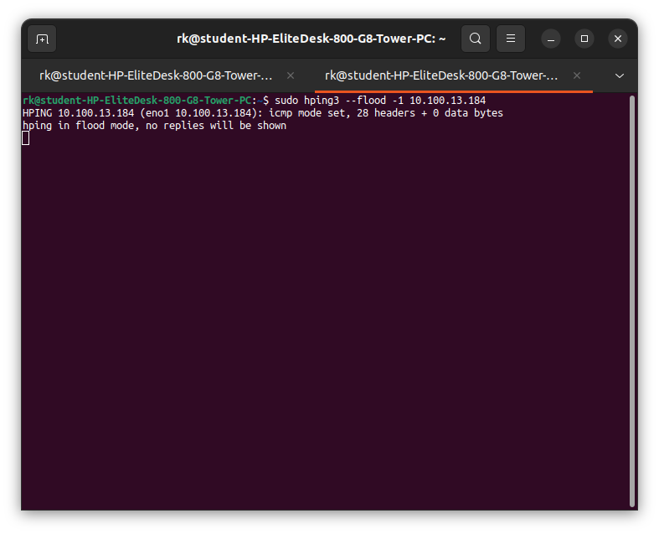
6.we can see that the “general failure “ it is due to flood,and cpu usage goes to 15%.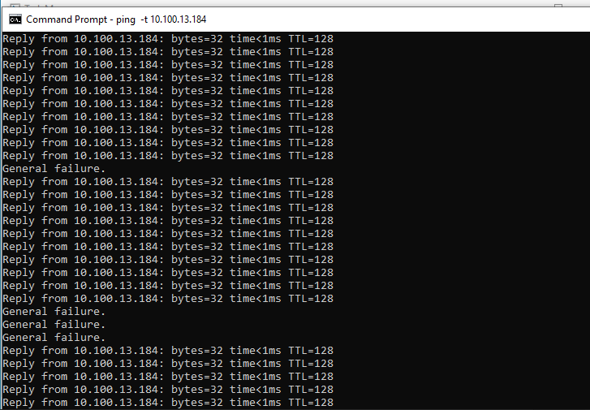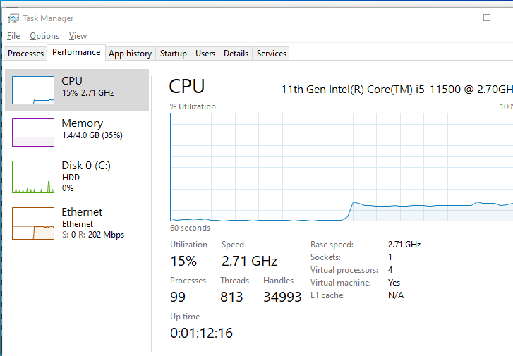
7. By stoping the flood ,cpu utilisation dropped.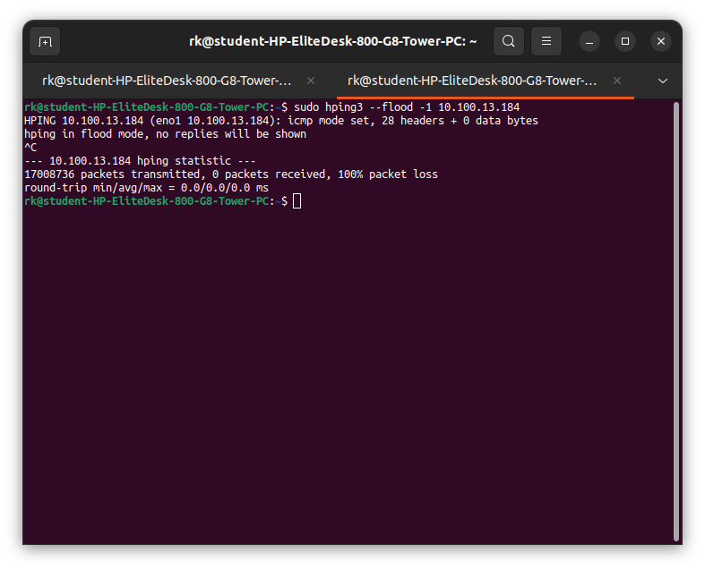
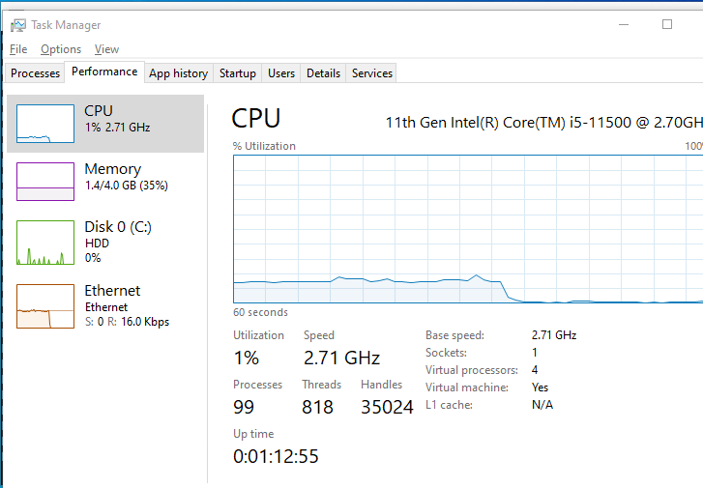

Impact Analysis
Before the attack, the system responded normally to ping requests.During the attack, the victim experienced packet loss and delayed responses.Network resources were overloaded due to excessive ICMP traffic.This caused a Denial of Service, affecting system availability.

Security Impact
Availability: Severely affected

Mitigation Strategies
ICMP Rate Limiting,Firewall Filtering,Intrusion Detection Systems (IDS)

3.4 Transport Layer
The Transport Layer is responsible for end-to-end communication using protocols like TCP and UDP.TCP uses a three-way handshake (SYN, SYN-ACK, ACK) to establish a connection.In a SYN flood attack, the attacker sends a large number of SYN packets but never completes the handshake.This fills the victim’s connection table and prevents legitimate users from connecting.
Attack Performed:TCP SYN Flood (Denial of Service Attack)

Steps:
1. If firewall is active.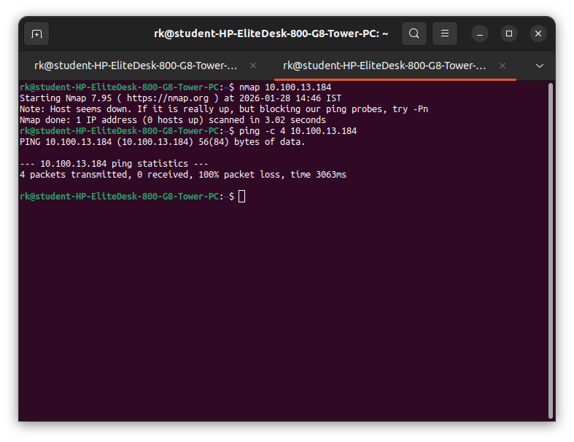
2.after firewall disable ,ping is working and scanning the opent ports of window using nmap.
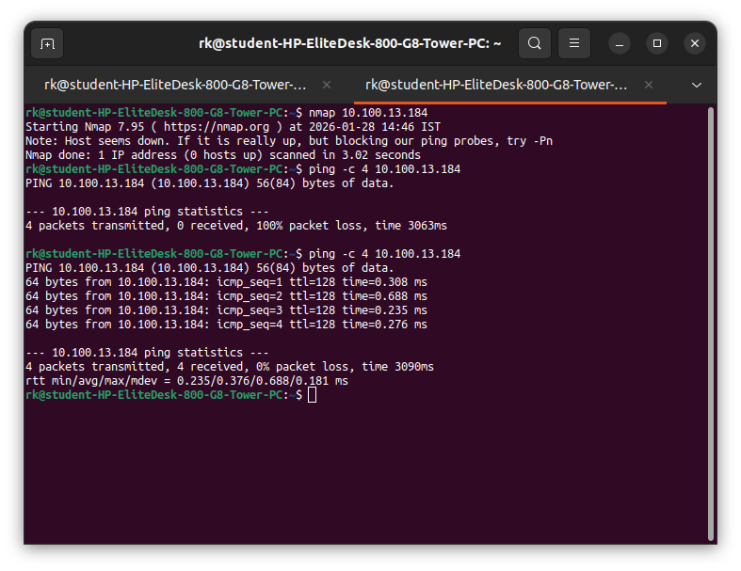
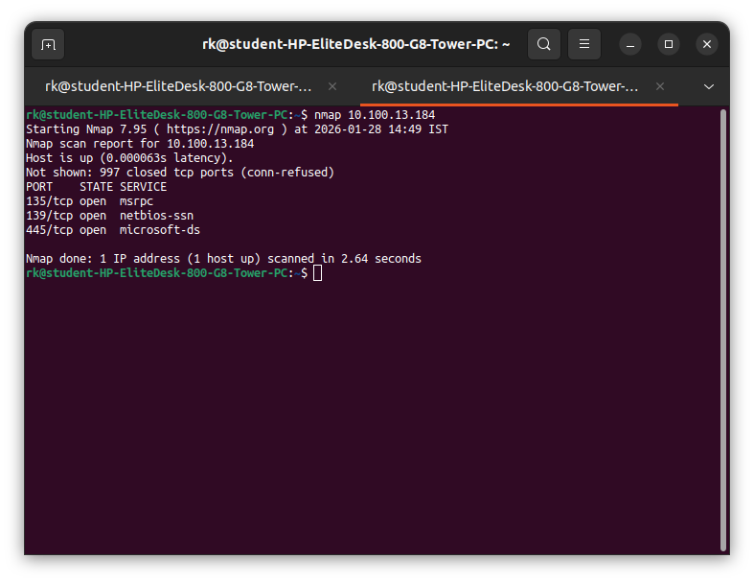
3.netstat -an
This command show normal TCP connection states before the attack.
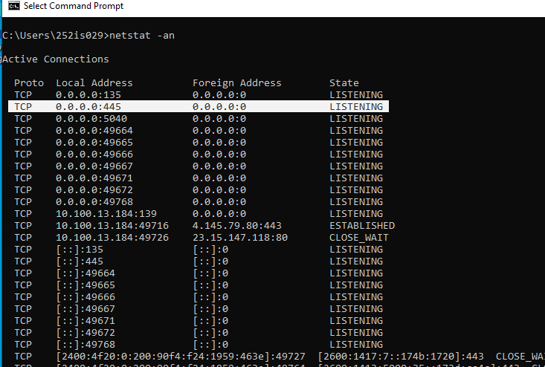
4.SYN Flood Attack (Ubuntu – Attacker)
sudo hping3 --flood -S -p 445 10.100.13.184
This sent a large number of TCP SYN packets to port 445 without completing the handshake.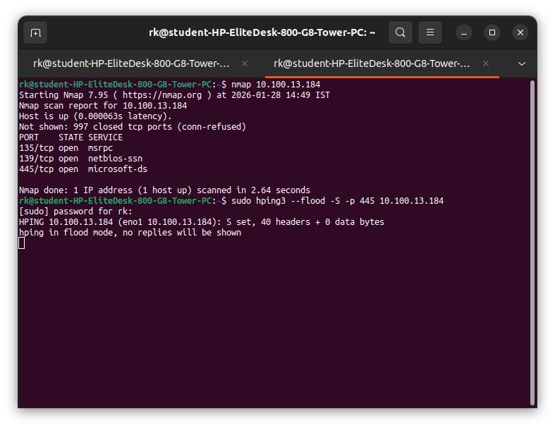
5.ping become failed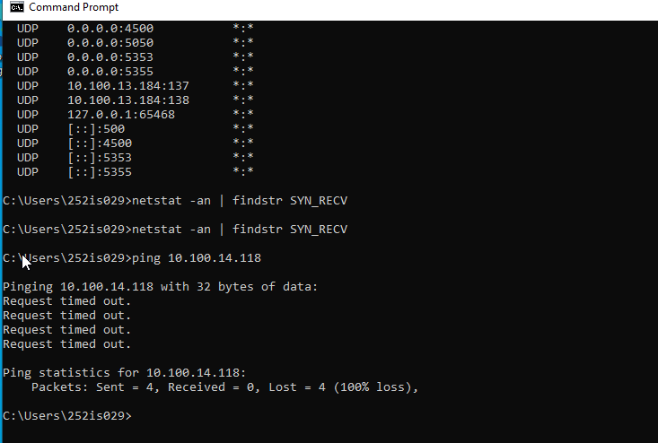
6. on window on port 445 lets see which connections are open.here this verify our attack.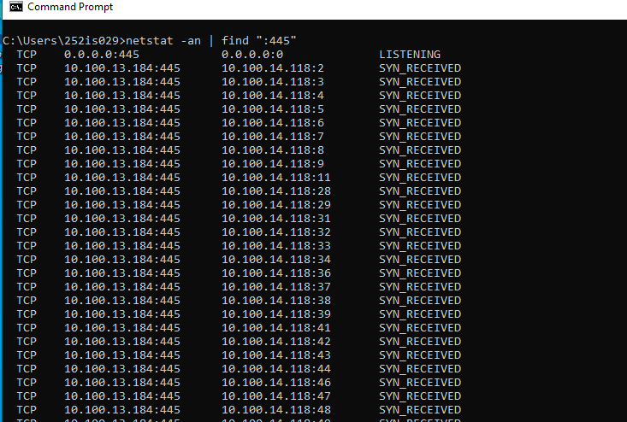
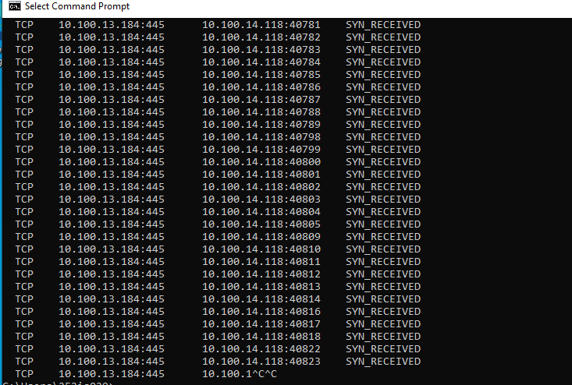

Impact Analysis
The victim’s TCP connection queue was stressed by half-open connections.Legitimate connection attempts were delayed or dropped.This resulted in Denial of Service at the transport layer.Modern Windows systems reduced visible impact using SYN protection, but traffic flooding was still confirmed.

Security Impact
Availability: Affected
Mitigation Strategies
SYN Cookies:Enable SYN cookies to prevent exhaustion of TCP connection tables.
Firewall Rate Limiting,Intrusion Prevention Systems (IPS)

3.5: Session Layer
The Session Layer is responsible for establishing, managing, and terminating sessions between two systems.In Windows networks, SMB (Server Message Block) manages authenticated sessions for file sharing and communication.Even when login access is restricted, SMB services may still disclose session-related metadata such as hostname, domain name, SMB versions, and security settings.In this attack, the attacker attempts to enumerate session information without valid credentials.
Attack Performed: Unauthenticated SMB Session Enumeration
Steps:
1.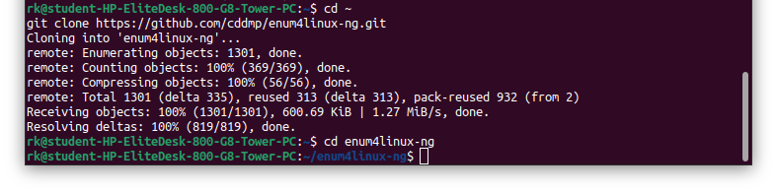
2.This confirmed that SMB and NetBIOS session services were running on the Windows victim.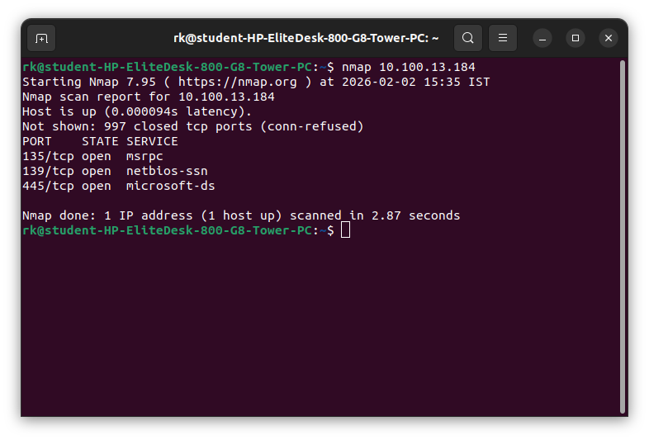

3.SMB Session Enumeration (enum4linux-ng)
python3 enum4linux-ng.py -U 10.100.13.184
This command attempted to enumerate user and session information over SMB,it just simply ask ip who are your registered users.
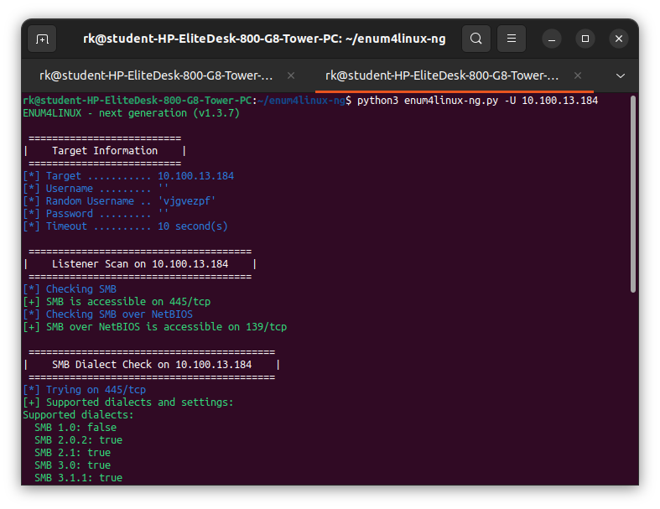
Observed Results:
SMB service accessible on ports 445 and 139
Hostname disclosed: WIN10
DNS domain: win10
Workgroup membership identified
SMB versions supported: SMB 2.x and SMB 3.x
SMB signing status disclosed: SMB signing not required
Null session and guest access were blocked
Even though authentication was denied, session metadata was still exposed.
4.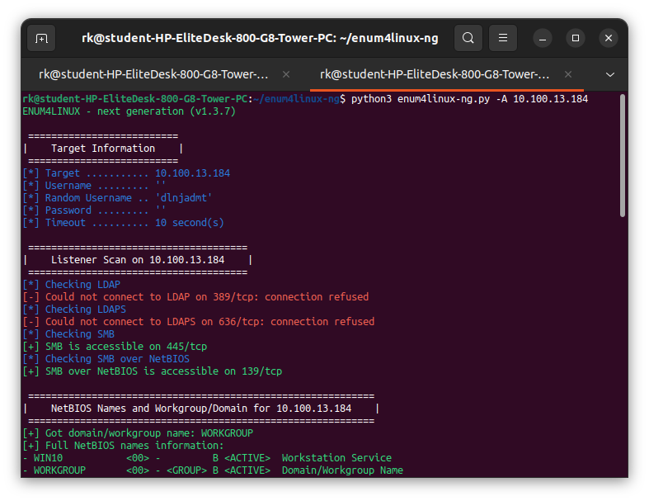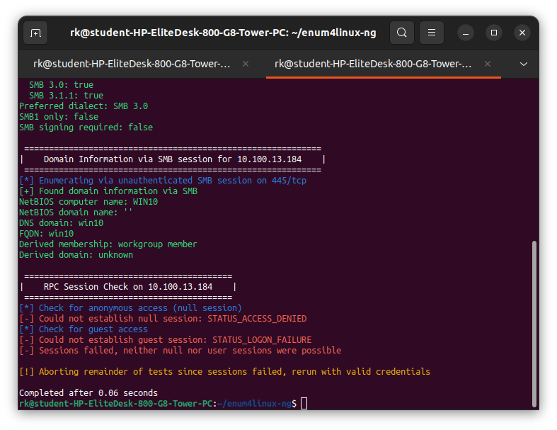
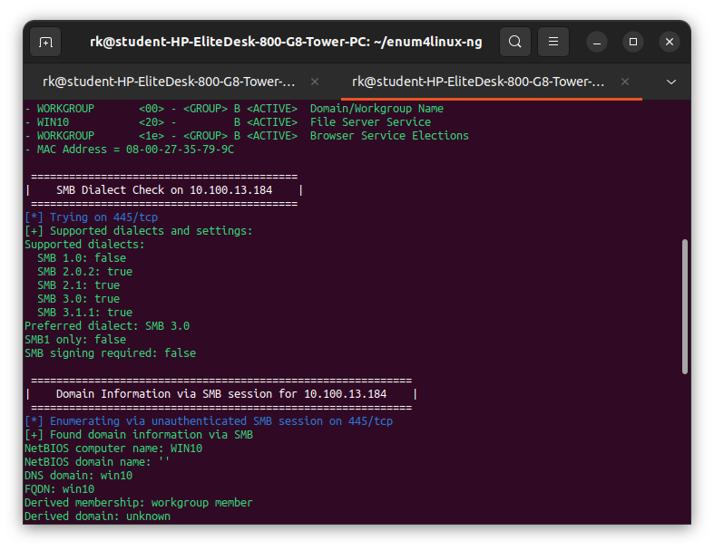
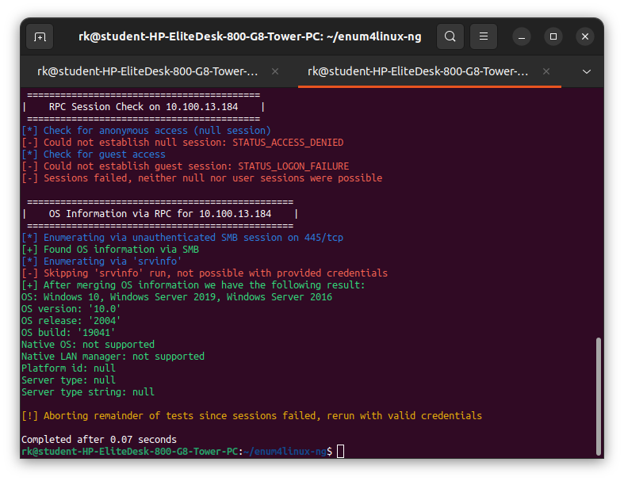

1.SMB & NetBIOS services exposed
445/tcp open (SMB)
139/tcp open (NetBIOS)
2.Session-layer services reachable
3.OS / Session metadata leaked
NetBIOS computer name: WIN10
DNS domain: win10
FQDN: win10
Workgroup member
4. Session information disclosure
(OS name, domain, hostname)
Even without authentication, session metadata, dialects, and domain info were disclosed.

Impact Analysis
The attacker successfully identified SMB session services on the victim system.Hostname, domain name, workgroup, and SMB protocol versions were disclosed.SMB signing configuration was exposed, which is valuable for further attacks such as MITM or NTLM relay.Although user login was blocked, session-level information leakage still occurred.

Security Impact (CIA Triad)
Confidentiality: Affected (system and session metadata disclosure)
Integrity: Not affected
Availability: Not affected

Mitigation Strategies
Enforce SMB Signing,Restrict SMB Exposure,Disable Unused SMB Services

3.6 Presentation layer
The Presentation Layer is responsible for data formatting, encryption, and encoding before transmission.In Windows networks, NTLM is used for authentication in protocols like SMB.If encryption and authentication protections are weak, credential information (NTLM hashes) can be exposed on the network.In this attack, the attacker uses a Man-in-the-Middle technique to capture NTLM authentication data.

Attack Performed:NTLM Hash Capture using Responder

Steps
1.lets do initially double sided arp spoofing so that packets go through our ubuntu system.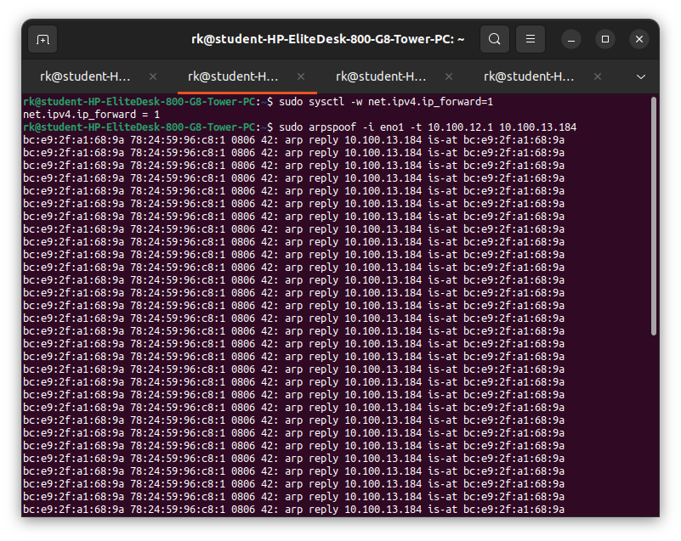
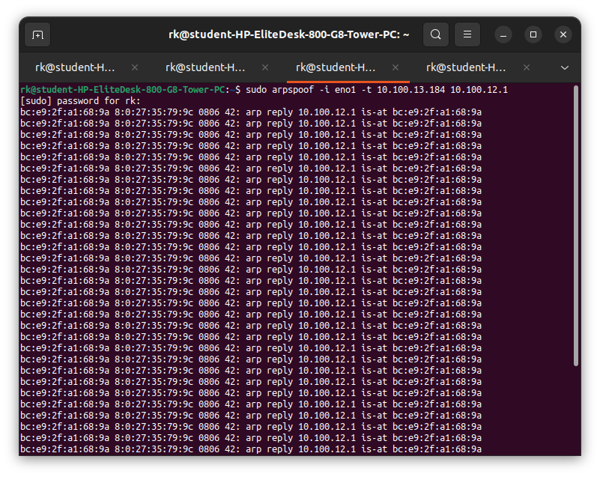
2.tcpdump -i eno1 -n -vvv port 445 or port 139
This cmd allow me to see window file sharing and authentication activity (SMB and NetBIOS traffic)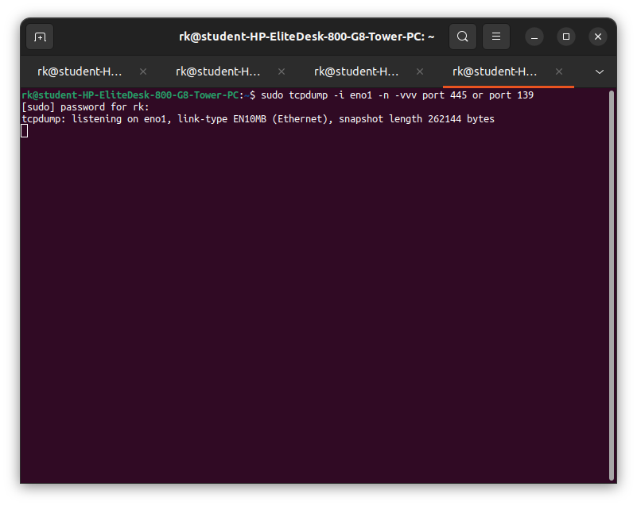
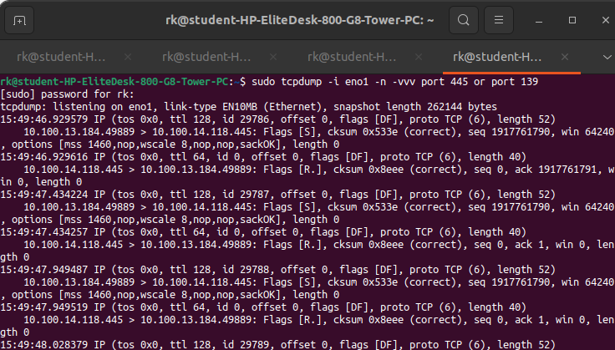
3.installation commands for responder tool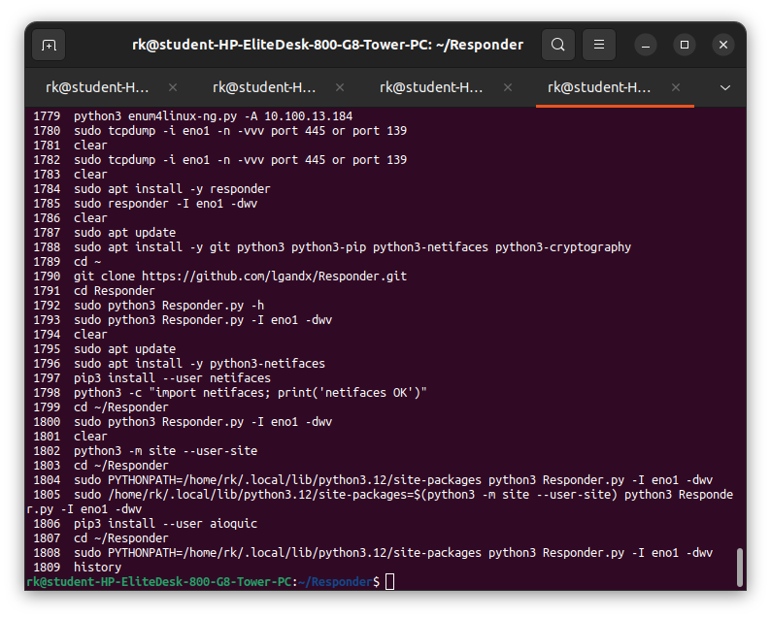4.Start Responder Tool (Ubuntu – Attacker)
sudo python3 Responder.py -I eno1 -dwv
Responder was started to emulate network services like SMB and HTTP.
It listens for authentication requests and captures NTLM credentials.
It works like it setup fake proxy server and when want something that we not found like error then it ask that stuff with entire network via LLMNR/NMT-NS protocols then fake proxy server says that me and responder ask to send the password for verification.
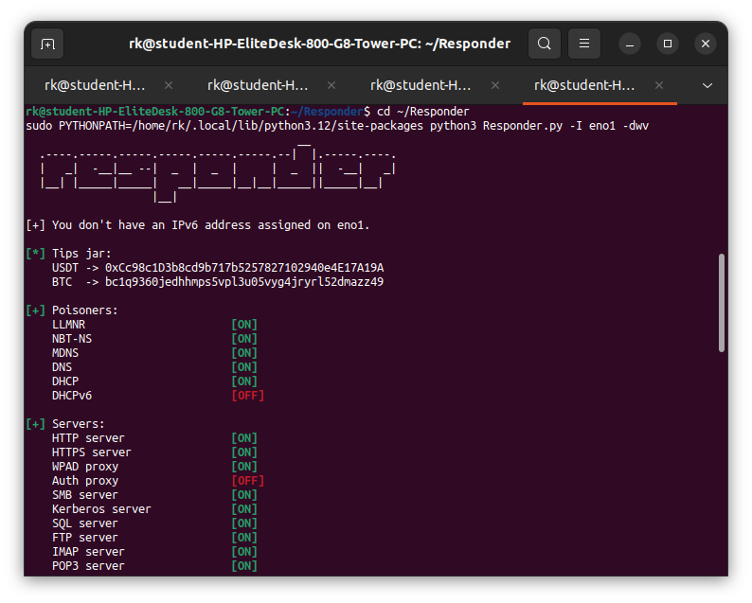
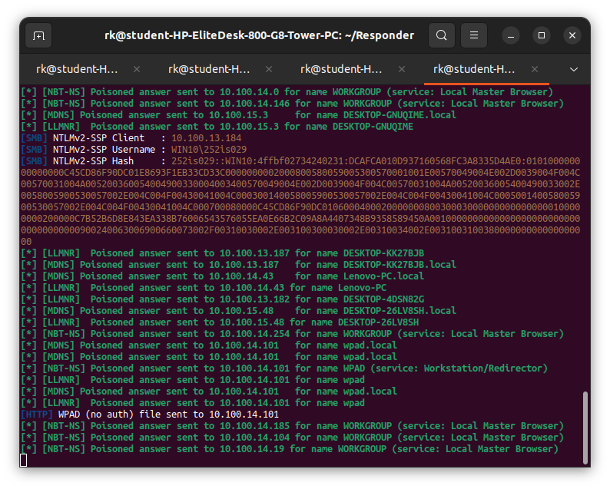
5.lets try to open a fileserver i.e. the ubuntu ip , here window try to connect to ubuntu now responder behave like fake SBS server and open a form to fill username and password which is generated by responder.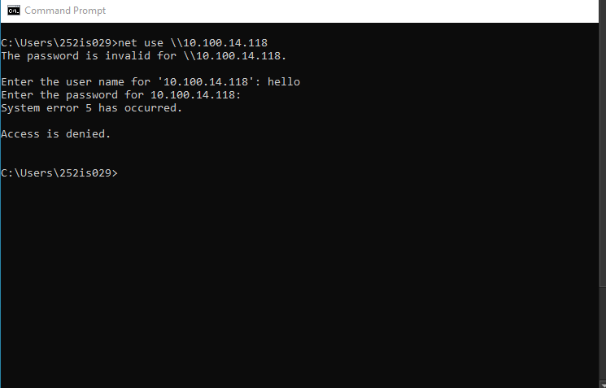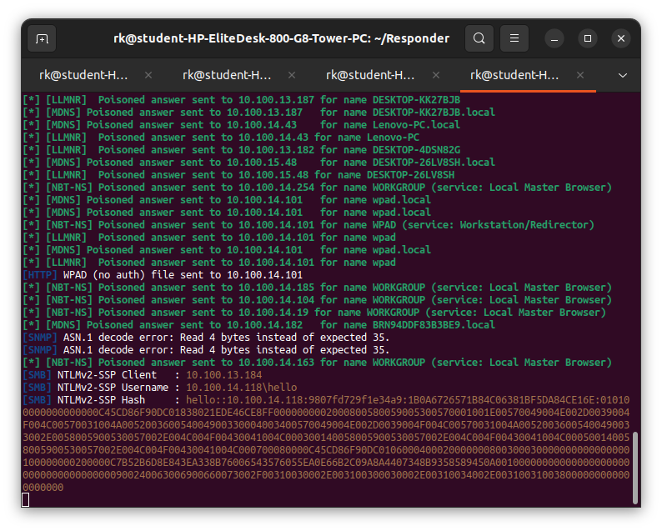
Impact Analysis
NTLM authentication data was exposed on the network.Even though the password was not in plaintext, the hash can be reused or cracked offline.This demonstrates weak protection at the presentation layer.Captured credentials can be used for further attacks such as credential replay or brute force.

Security Impact
Confidentiality: Severely affected (credential exposure)

Mitigation Strategies
Disable NTLM Authentication,Enable SMB SigningUse Strong Network Authentication

3.7 Application Layer
The Application Layer is the topmost layer of the OSI model and is responsible for user-facing services such as file sharing, email, and remote login.In Windows systems, SMB (Server Message Block) is an application-layer protocol used for file sharing and authentication.If proper protections like account lockout or strong passwords are not enforced, attackers can abuse authentication mechanisms to guess or reuse credentials.
Attack Name :SMB Authentication Abuse (Brute Force / Login Abuse)
Attack Name:SMB Authentication Abuse (Brute Force / Login Abuse)

Steps:
1.Prepare Username and Password Lists (Ubuntu)
printf "administrator\nuser\ntest" > users.txt
printf "password\n123456\nadmin" > pass.txt
These two custom files contained list of commonly used usernames(administrator,user,test) and weak passwords for testing .Also installing hydra tool as it is used for bruteforce or dictionary attack.
1.2 SMB Authentication Attempt using Hydra
hydra -L users.txt -P pass.txt smb://10.100.13.184 -t 1
This command attempted to log in to the SMB service using files with combinations.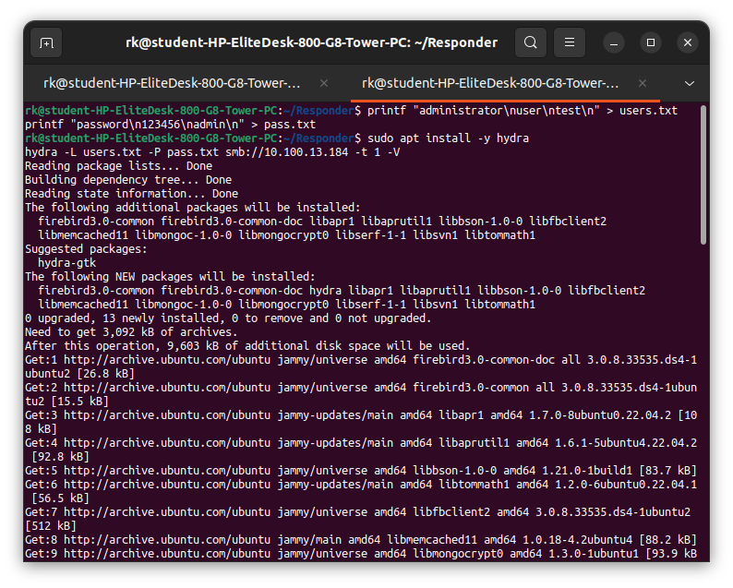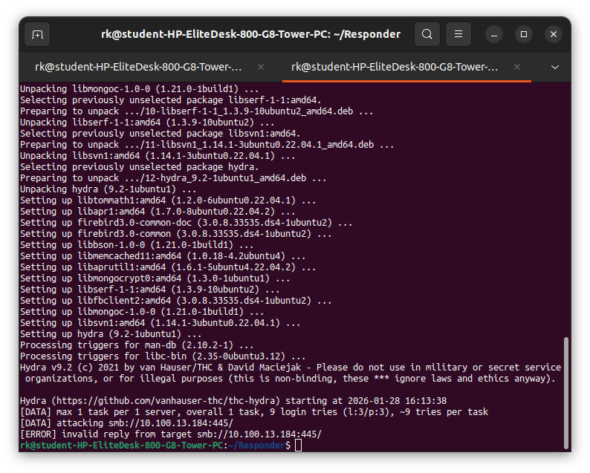
2.Observation on Window
Multiple failed login attempts were recorded.Windows Event Viewer logged Event ID 4625 (Failed Logon).This confirmed that the application layer was processing malicious authentication requests.
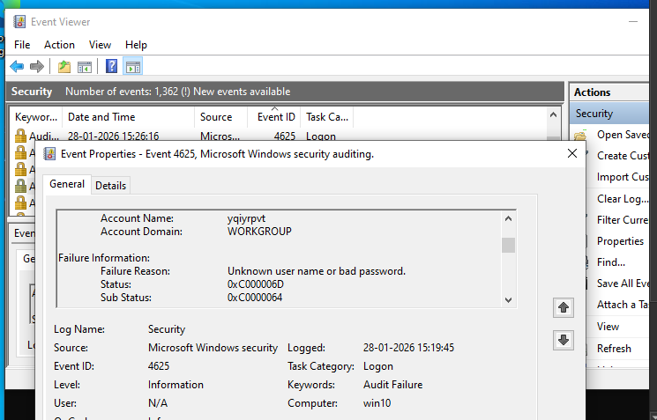
Impact Analysis
The attacker was able to repeatedly access the SMB authentication interface.Even though no login was successful, the attack showed that the service is exposed.Weak passwords or missing lockout policies could lead to account compromise.This demonstrates a direct application-layer attack.

Security Impact
Confidentiality: Potentially affected (account compromise risk)
Integrity: Potentially affected (unauthorized access possible)
Availability: Partially affected (account lockout risk)

Mitigation Strategies
Strong Password Policy,Multi-Factor Authentication (MFA),Restrict SMB Access

