Lab 2

1.

i. grep

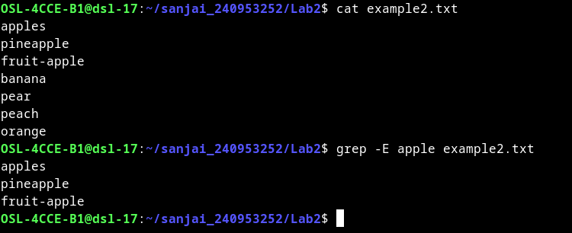
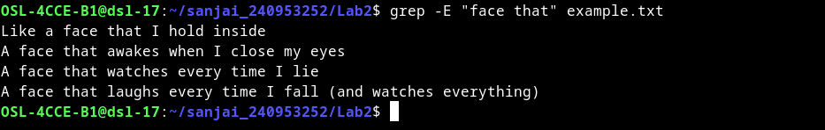
ii.sort
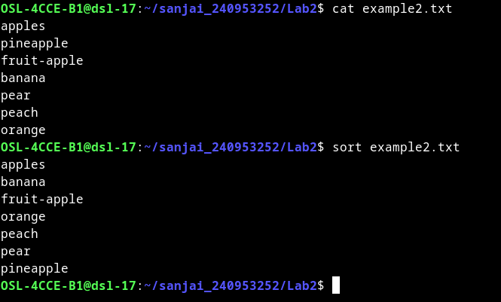

iii.wc(word count)
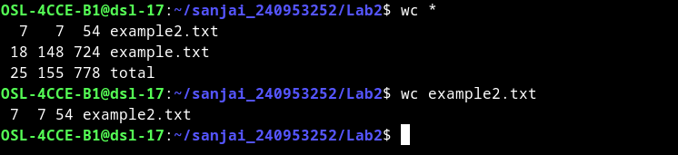
iv.cut
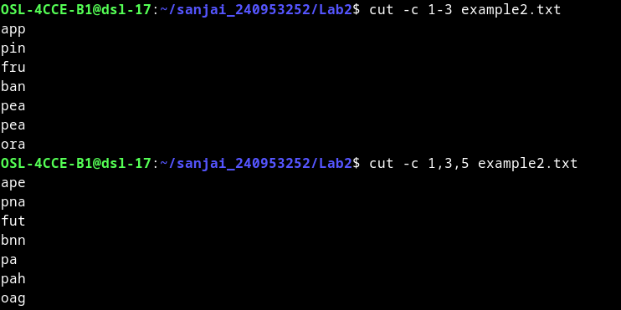
v.sed
vi.tr (translate)
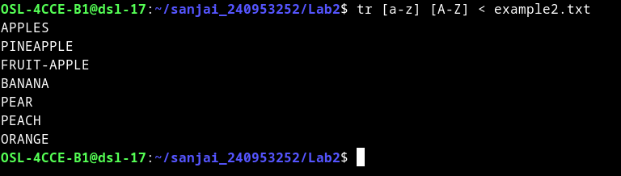
Process Management commands

vii.ps
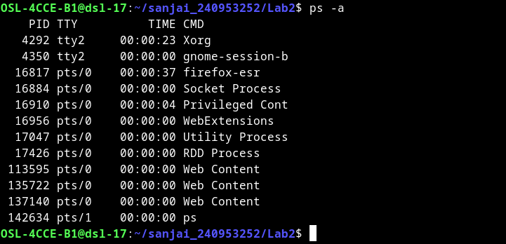
viii.kill
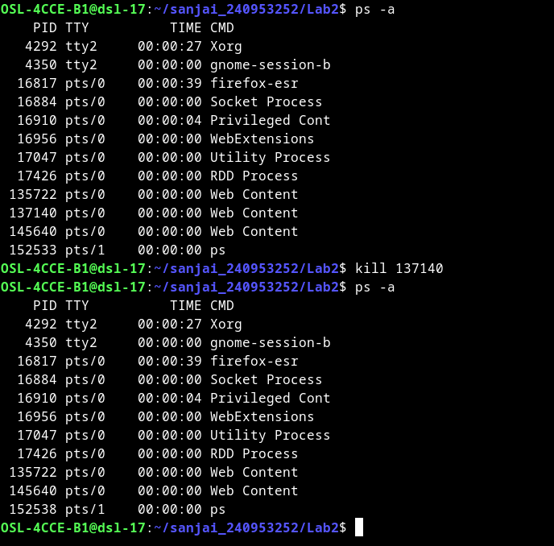

File permission commands
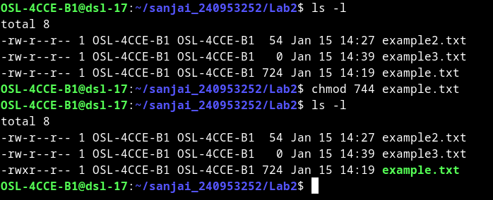
ix.chmod (change mode)
chmod with other methods
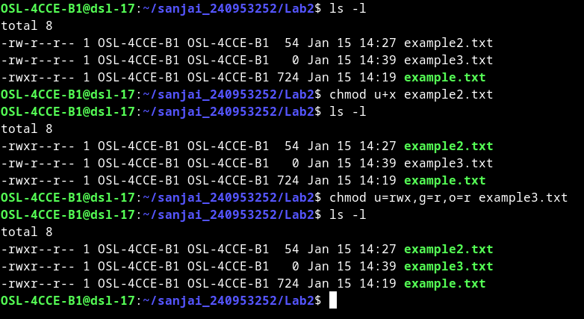
x.echo
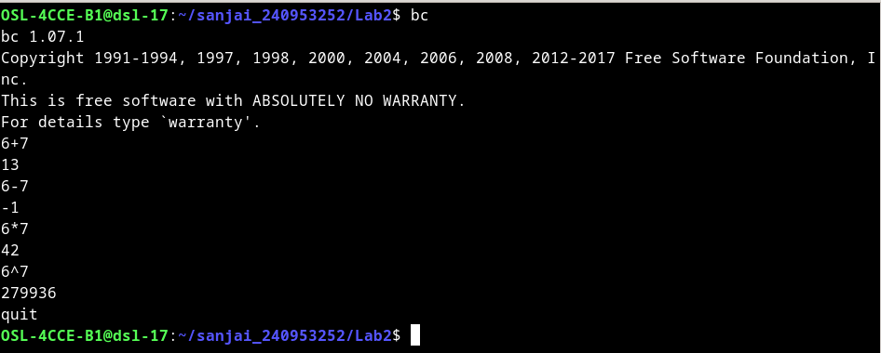
xi.vi editor uses
xii.bc (basic caluculator)

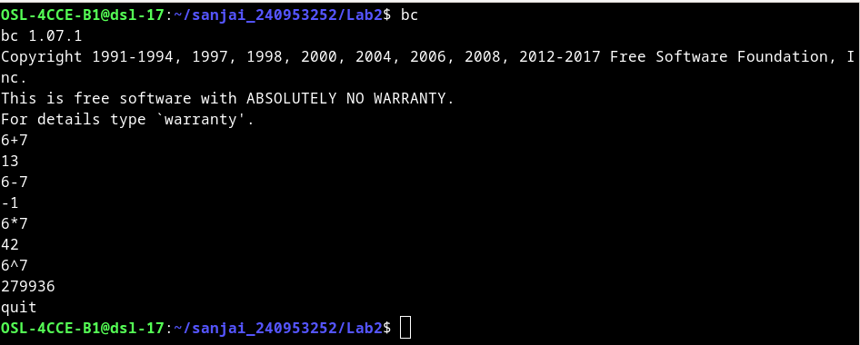
2.Write grep commands to do the following activities:
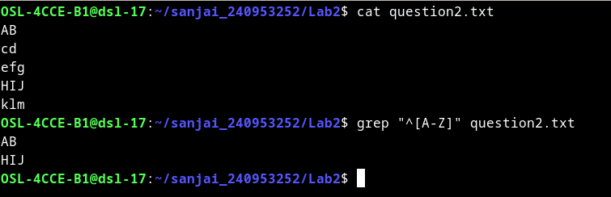
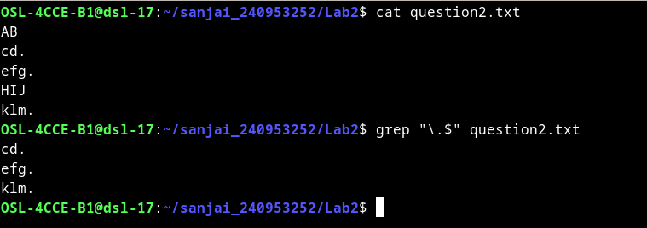
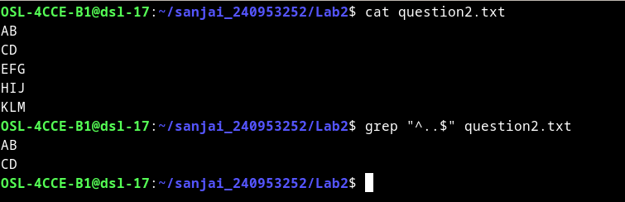
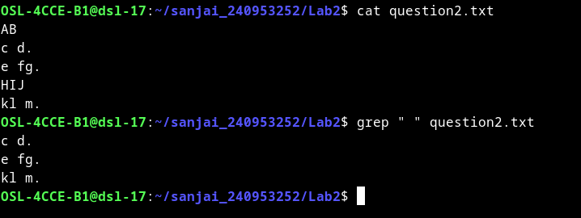
• To select the lines from a file that have exactly two characters.
• To select the lines from a file that start with the upper case letter.
• To select the lines from a file that end with a period.
\ is the escape character used for “ . ” (period)
• To select the lines in a file that has one or more blank spaces.
• To select the lines in a file and direct them to another file which has digits as
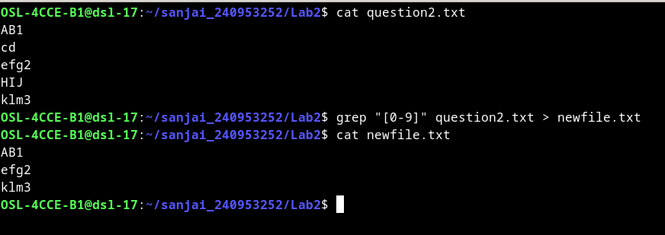
one of the characters in that line.
3. Create file studentInformation.txt using vi editor which contains details in the
following format.
RegistrationNo:Name:Department:Branch:Section:Sub1:Sub2:Sub3
1234:XYZ:ICT:CCE:A:80:60:70 … (add atleast 10 rows)
i) Display the number students( only count) belonging to ICT department.
ii) Replace all occurrences of IT branch with “Information Technology” and save
the output to ITStudents.txt
iii) Display the average marks of student with the given registration number
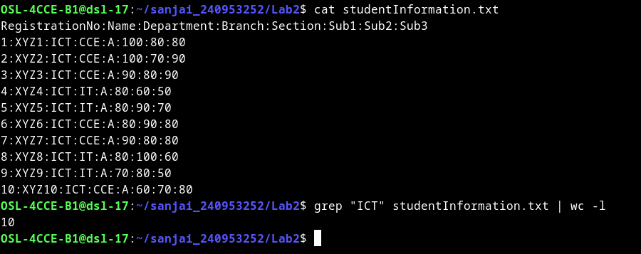
“1234” (or any specific existing number).
i)

ii)
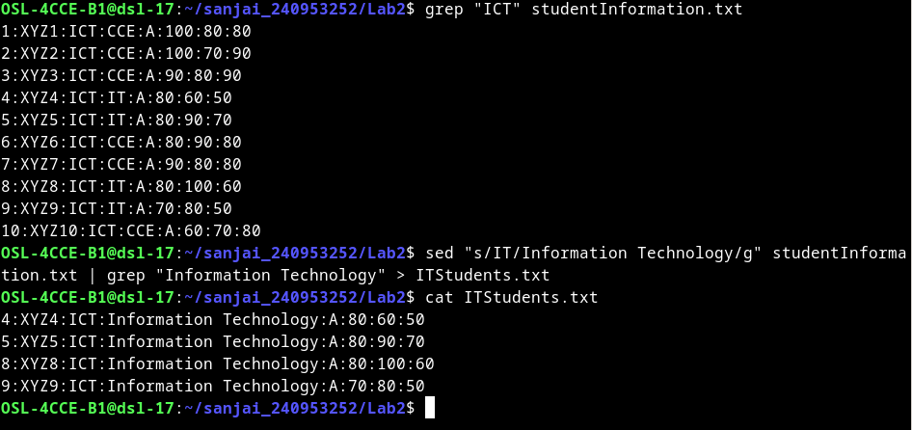
iii)

