1. Consider the following snapshot of the system. Write C/C++ program to implement Banker’s
algorithm for deadlock avoidance. The program has to accept all inputs from the user. Assume
the total number of instances of A,B and C are 10,5 and 7 respectively.

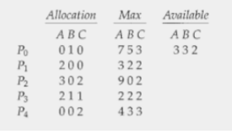

(a) What is the content of the matrix Need?
(b) Is the system in a safe state?
(c) If a request from process P1 arrives for (1, 0, 2), can the request be granted immediately?
Display the updated Allocation, Need and Available matrices.
(d) If a request from process P4 arrives for (3, 3, 0), can the request be granted immediately?
(e) If a request from process P0 arrives for (0, 2, 0), can the request be granted immediately?

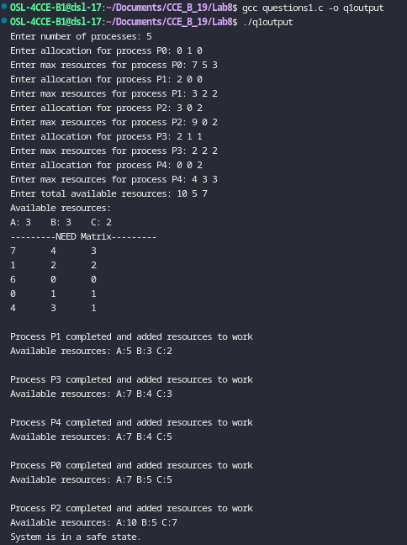

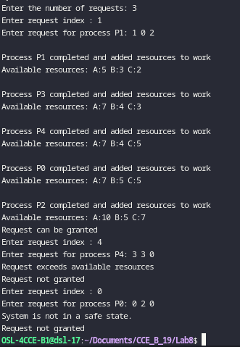

2. Consider the following snapshot of the system. Write C/C++ program to implement deadlock
detection algorithm.
(a) Is the system in a safe state?
(b) Suppose that process P2 make one additional request for instance of type C, can the
system still be in a safe state?

