Lab – 1 OSL

Question 1 :

Create a folder with your <name >_registration number in the /home folder. Use this
folder to save rest of lab exercises. For each lab create a separate folder ex: Lab1, Lab2…
Lab11.

Explanation :

For this questions , i created a new directory using the mkdir command (which is used for creating new dir) and entered the complete path+directory name. After creating this, i made new sub directories inside the sanjai_240953252 named Lab1,Lab2,.......,Lab11.

(I also use ls(Used to list directories in the mentioned path) command in this to check if the folders were created)
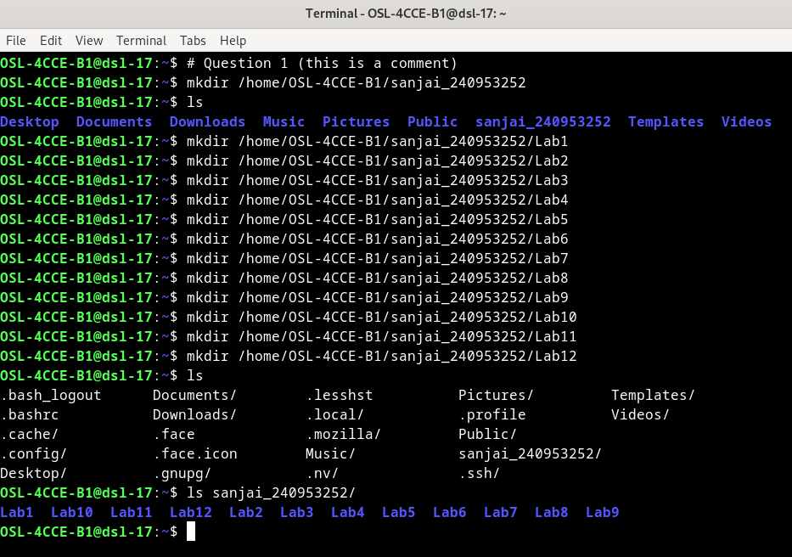
Question 2 :

Execute and write output of any 5 important commands explained so far in this manual.
Save the output in Lab1_1.txt . Commands and the output I copied from the command prompt.

Explanation :

The commands used for this question were touch (used to create a file), pwd (prints the current working directory), ls(used to list items, i meantioned the path “/” so it listed the root items), man(shows the manual of whatever command we specify), head (displays the first few lines of the file), tail (displays the last few lines of the text file) and finaly cat to read the contents of the file. I used > and >> to redirect the output of each command to the file Lab1_1.txt. > will overwrite the complte file while >> appends the content to the mentioned file (so i used > for the first command and >> from there one after).
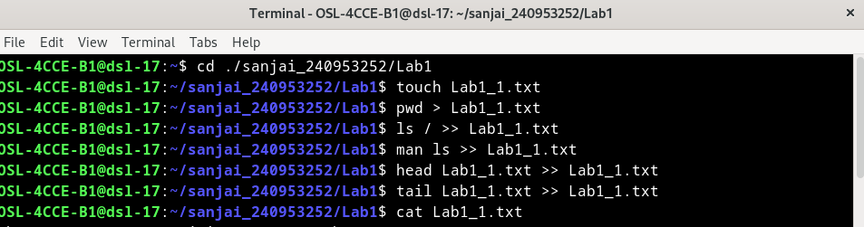
Contents of the file :

/home/OSL-4CCE-B1/sanjai_240953252/Lab1
bin
boot
dev
etc
home
initrd.img
initrd.img.old
lib
lib32
lib64
libx32
lost+found
media
mnt
opt
proc
root
run
sbin
srv
sys
tmp
usr
var
vmlinuz
vmlinuz.old
LS(1) User Commands LS(1)

NAME
ls - list directory contents

SYNOPSIS
ls [OPTION]... [FILE]...

DESCRIPTION
List information about the FILEs (the current directory by default). Sort entries
alphabetically if none of -cftuvSUX nor --sort is specified.

Mandatory arguments to long options are mandatory for short options too.

-a, --all
do not ignore entries starting with .

-A, --almost-all
do not list implied . and ..

--author
with -l, print the author of each file

-b, --escape
print C-style escapes for nongraphic characters

--block-size=SIZE
with -l, scale sizes by SIZE when printing them; e.g., '--block-size=M'; see
SIZE format below

-B, --ignore-backups
do not list implied entries ending with ~

-c with -lt: sort by, and show, ctime (time of last modification of file status
information); with -l: show ctime and sort by name; otherwise: sort by ctime,
newest first

-C list entries by columns

--color[=WHEN]
color the output WHEN; more info below

-d, --directory
list directories themselves, not their contents

-D, --dired
generate output designed for Emacs' dired mode

-f list all entries in directory order

-F, --classify[=WHEN]
append indicator (one of */=>@|) to entries WHEN

--file-type
likewise, except do not append '*'

--format=WORD
across -x, commas -m, horizontal -x, long -l, single-column -1, verbose -l,
vertical -C

--full-time
like -l --time-style=full-iso

-g like -l, but do not list owner

--group-directories-first
group directories before files; can be augmented with a --sort option, but
any use of --sort=none (-U) disables grouping

-G, --no-group
in a long listing, don't print group names

-h, --human-readable
with -l and -s, print sizes like 1K 234M 2G etc.

--si likewise, but use powers of 1000 not 1024

-H, --dereference-command-line
follow symbolic links listed on the command line

--dereference-command-line-symlink-to-dir
follow each command line symbolic link that points to a directory

--hide=PATTERN
do not list implied entries matching shell PATTERN (overridden by -a or -A)

--hyperlink[=WHEN]
hyperlink file names WHEN

--indicator-style=WORD
append indicator with style WORD to entry names: none (default), slash (-p),
file-type (--file-type), classify (-F)

-i, --inode
print the index number of each file

-I, --ignore=PATTERN
do not list implied entries matching shell PATTERN

-k, --kibibytes
default to 1024-byte blocks for file system usage; used only with -s and per
directory totals

-l use a long listing format

-L, --dereference
when showing file information for a symbolic link, show information for the
file the link references rather than for the link itself

-m fill width with a comma separated list of entries

-n, --numeric-uid-gid
like -l, but list numeric user and group IDs

-N, --literal
print entry names without quoting

-o like -l, but do not list group information

-p, --indicator-style=slash
append / indicator to directories

-q, --hide-control-chars
print ? instead of nongraphic characters

--show-control-chars
show nongraphic characters as-is (the default, unless program is 'ls' and
output is a terminal)

-Q, --quote-name
enclose entry names in double quotes

--quoting-style=WORD
use quoting style WORD for entry names: literal, locale, shell, shell-always,
shell-escape, shell-escape-always, c, escape (overrides QUOTING_STYLE envi‐
ronment variable)

-r, --reverse
reverse order while sorting

-R, --recursive
list subdirectories recursively

-s, --size
print the allocated size of each file, in blocks

-S sort by file size, largest first

--sort=WORD
sort by WORD instead of name: none (-U), size (-S), time (-t), version (-v),
extension (-X), width

--time=WORD
change the default of using modification times; access time (-u): atime, ac‐
cess, use; change time (-c): ctime, status; birth time: birth, creation;

with -l, WORD determines which time to show; with --sort=time, sort by WORD
(newest first)

--time-style=TIME_STYLE
time/date format with -l; see TIME_STYLE below

-t sort by time, newest first; see --time

-T, --tabsize=COLS
assume tab stops at each COLS instead of 8

-u with -lt: sort by, and show, access time; with -l: show access time and sort
by name; otherwise: sort by access time, newest first

-U do not sort; list entries in directory order

-v natural sort of (version) numbers within text

-w, --width=COLS
set output width to COLS. 0 means no limit

-x list entries by lines instead of by columns

-X sort alphabetically by entry extension

-Z, --context
print any security context of each file

--zero end each output line with NUL, not newline

-1 list one file per line

--help display this help and exit

--version
output version information and exit

The SIZE argument is an integer and optional unit (example: 10K is 10*1024). Units
are K,M,G,T,P,E,Z,Y (powers of 1024) or KB,MB,... (powers of 1000). Binary prefixes
can be used, too: KiB=K, MiB=M, and so on.

The TIME_STYLE argument can be full-iso, long-iso, iso, locale, or +FORMAT. FORMAT
is interpreted like in date(1). If FORMAT is FORMAT1<newline>FORMAT2, then FORMAT1
applies to non-recent files and FORMAT2 to recent files. TIME_STYLE prefixed with
'posix-' takes effect only outside the POSIX locale. Also the TIME_STYLE environ‐
ment variable sets the default style to use.

The WHEN argument defaults to 'always' and can also be 'auto' or 'never'.

Using color to distinguish file types is disabled both by default and with
--color=never. With --color=auto, ls emits color codes only when standard output is
connected to a terminal. The LS_COLORS environment variable can change the set‐
tings. Use the dircolors(1) command to set it.

Exit status:
0 if OK,

1 if minor problems (e.g., cannot access subdirectory),

2 if serious trouble (e.g., cannot access command-line argument).

AUTHOR
Written by Richard M. Stallman and David MacKenzie.

REPORTING BUGS
GNU coreutils online help: <https://www.gnu.org/software/coreutils/>
Report any translation bugs to <https://translationproject.org/team/>

COPYRIGHT
Copyright © 2022 Free Software Foundation, Inc. License GPLv3+: GNU GPL version 3
or later <https://gnu.org/licenses/gpl.html>.
This is free software: you are free to change and redistribute it. There is NO WAR‐
RANTY, to the extent permitted by law.

SEE ALSO
dircolors(1)

Full documentation <https://www.gnu.org/software/coreutils/ls>
or available locally via: info '(coreutils) ls invocation'

GNU coreutils 9.1 September 2022 LS(1)
/home/OSL-4CCE-B1/sanjai_240953252/Lab1
bin
boot
dev
etc
home
initrd.img
initrd.img.old
lib
lib32
/home/OSL-4CCE-B1/sanjai_240953252/Lab1
bin
boot
dev
etc
home
initrd.img
initrd.img.old
lib
lib32

Question 3 :

Explore the following commands along with their various options. (Some of the
options are specified in the bracket)

a. cat : this command is used to read the contents of the file

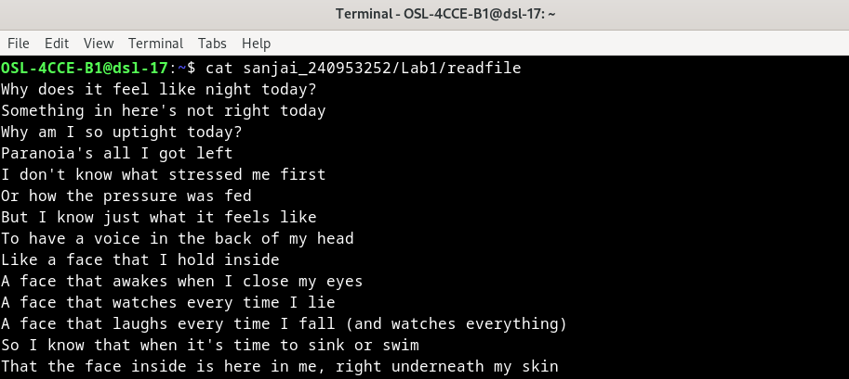

b. head and tail(-n,-c) :

Head and tail is used to read first few lines (head) and last few lines (tail)

-n : when used with -n we can mention the number of lines
-c : when used with -c we can mention the number of bytes

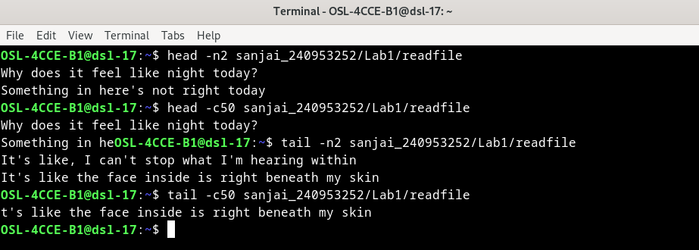

c. cp (-n,-i,-f)

cp is used to copy files and directories to a specific location

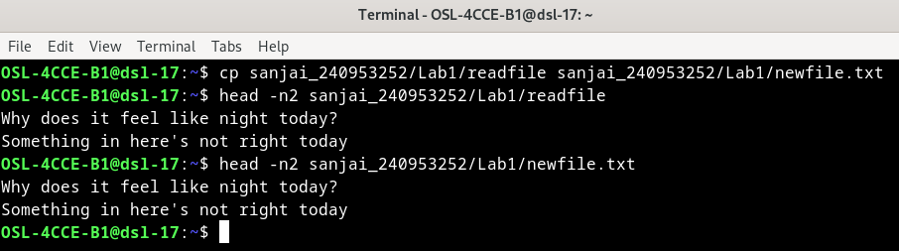

when used with,
-n : does not overwrite an existing file

for this file it didnt overwrite because it already had some contents inside

-i : asks for user confirmation
-f : if an existing destination file cannot be opened it will remove it and try again
(man defenition : Forces the copy operation by removing an existing destination file if it cannot be opened for writing )

d.mv (-f, -i) :

mv is used for moving or renaming some files or folders

-i : asks for confirmaition before overwriting an existing file
-f : it will overwrite an existing destination file without asking confirmation

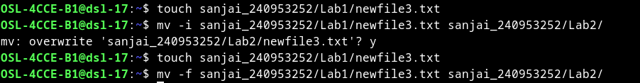

e. rm (-r, -i, -f):

this command is used to remove a file or directory(if mentioned -r)

-r : used erase entire content of directories and the data it contains
-i : asks for confirmaition
-f : forces and doesnt ask for confirmation

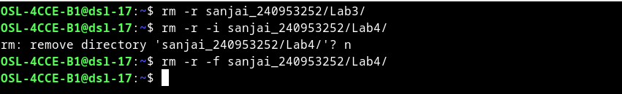

f. rmdir (-r, -f):

this command is used to remove directories but those which are empty
-r and -f was not there in man rmdir maybe it is not there for debian systems

g.find (-name, -type):

used to search for files and directories

-name : is used for searching using name
-type : we can mention type of what we are searching like r for dir and f for file

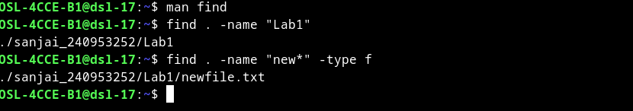

4. 3. List all the file names satisfying following criteria

a. has the extension .txt.

* : i used * here which acts as a placeholder

b. containing atleast one digit.

[] : i used [] in which we can mention char or numbers and it displays those files including those

c. having minimum length of 4.

? : ? is used as a placholder for a single character, using it 4 times with * can give those with minimum 4 letters in name.

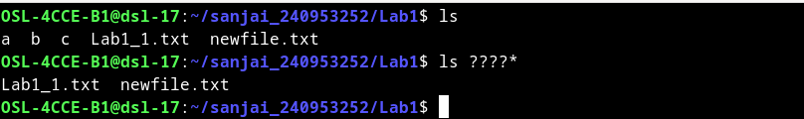

d.does not contain any of the vowels as the start letter.

! : this excludes those characters mentioned within [].

