1. Consider the following set of processes, with length of the CPU burst given in
milliseconds:

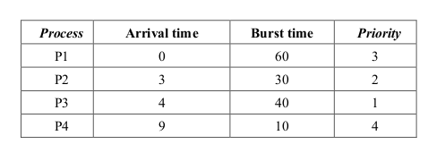

Write a menu driven C/C++ program to simulate the following CPU scheduling algorithms.
Display Gantt chart showing the order of execution of each process. Compute waiting time and
turnaround time for each process. Hence, compute average waiting time and average turnaround
time.
(i) FCFS (ii) SRTF (iii) Round-Robin (quantum = 10 ) iv) non-preemptive priority (higher
the number higher the priority)

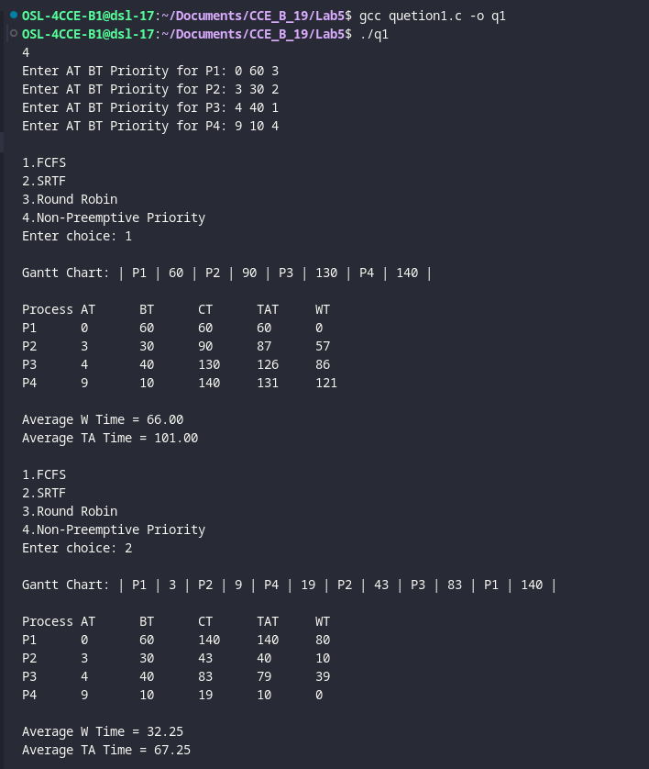

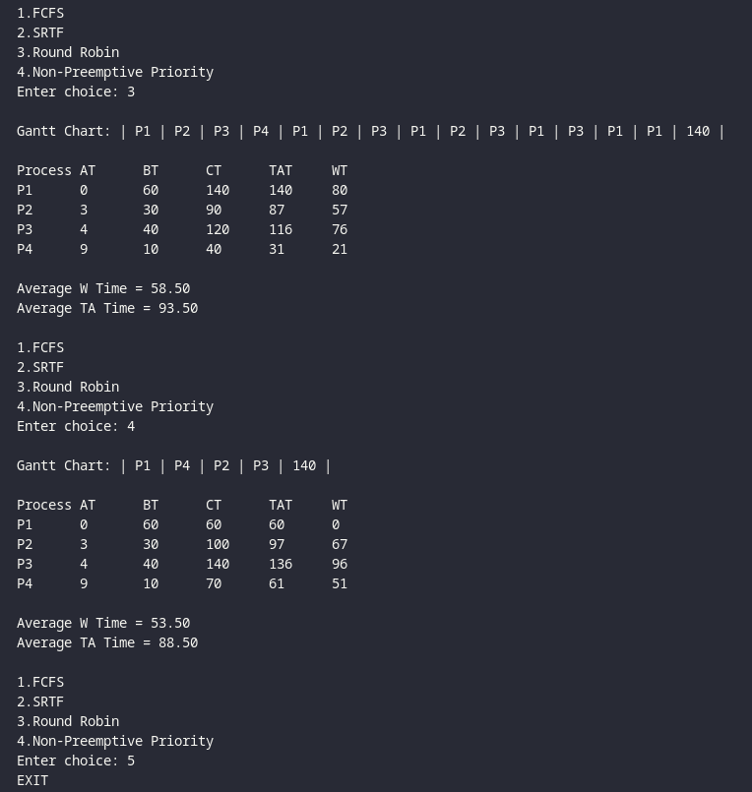

2. Write a C program to simulate multi-level feedback queue scheduling algorithm.

