WEEK 6

1. Process A wants to send a number to Process B. Once received, Process B has to check
whether the number is palindrome or not. Write a C program to implement this interprocess
communication using message queue.

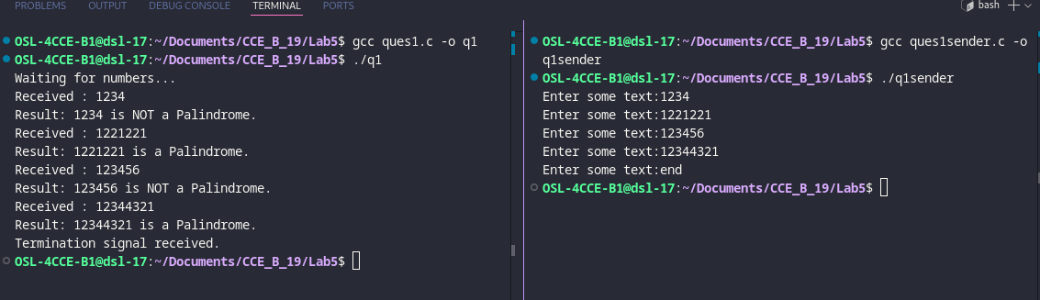

3. Implement a parent process, which sends an English alphabet to child process using shared
memory. Child process responds back with next English alphabet to the parent. Parent
displays the reply from the Child.

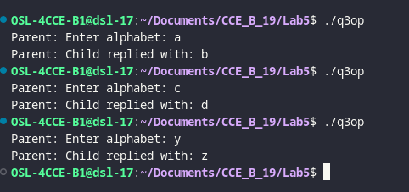

4. Write a producer-consumer program in C in which producer writes a set of words into shared
memory and then consumer reads the set of words from the shared memory. The shared
memory need to be detached and deleted after use.
