WEEK 1

1. Write a shell script to find whether a given file is the directory or regular file.

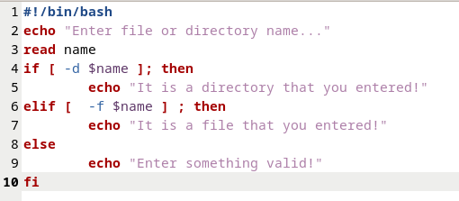

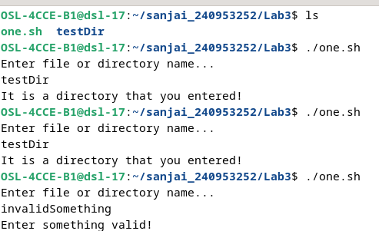

2. Write a shell script to list all files (only file names) containing the input pattern
(string) in the folder entered by the user.

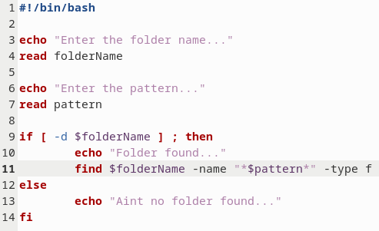

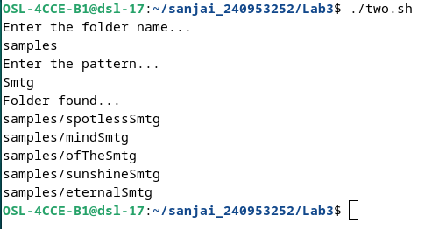

3.Write a shell script to replace all files with .txt extension with .text in the current di-
rectory. This has to be done recursively i.e if the current folder contains a folder
“OS” with abc.txt then it has to be changed to abc.text ( Hint: use find, mv )

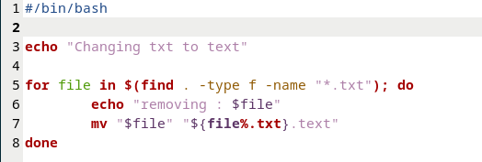
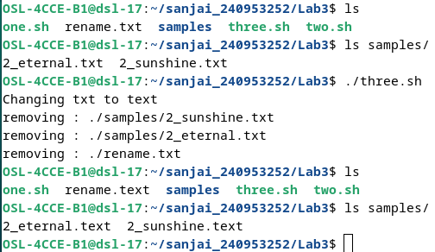

4. Write a shell script to calculate the gross salary. GS=Basics + TA + 10% of Basics.
Floating point calculations has to be performed.

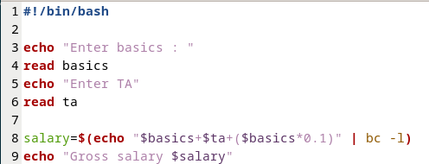

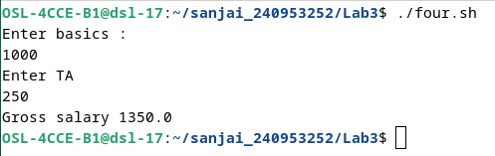

5. Write a program to copy all the files (having file extension input by the user) in the
current folder to the new folder input by the user. ex: user enter .text TEXT then all
files with .text should be moved to TEXT folder. This should be done only at single
level. i.e if the current folder contains a folder name ABC which has .txt files then
these files should not be copied to TEXT.

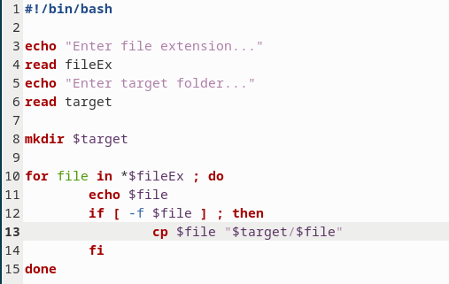

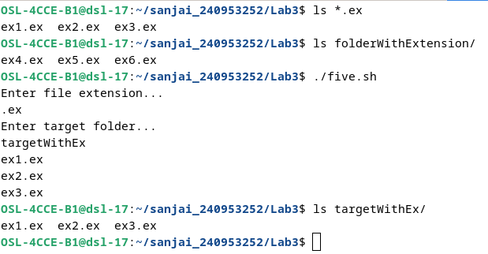

6. Write a shell script which deletes all the even numbered lines in a text file.

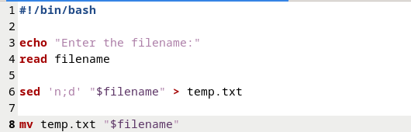

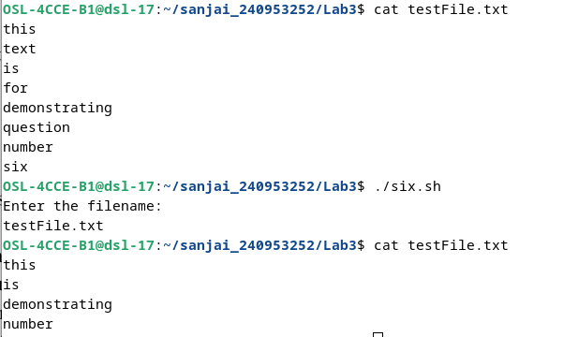

7.Write a shell script to modify all occurrences of “ex:” with “Example:” in all the filespresent
in current folder only if “ex:” occurs at the start of the line or after a period (.). Example:
if a file contains a line: “ex: this is first occurrence so should be re- placed” and “second
ex: should not be replaced as it occurs in the middle of the sen-tence.”

