Preparation and Exploratory Data Analysis of the ANSUR Anthropometric Measure Dataset

Sarah Cook
3 March, 2026
PBHLT 6101: Data Management, Analytics, & Presentation
Introduction
From 2009 to 2011, an anthropometric survey was conducted in cooperation with the US Army and US Marine Corps. The purpose of this was to document the range of size and proportion of US service-men and -women in order to appropriately develop uniforms, protective gear, and workstations. 94 dimensions corresponding to discrete variables were taken for each of ~13,000 soldiers and 3,600 marines. Here, a selection of that raw data is cleaned, explored, and analyzed.

Data Preparation

Data Analysis Plan:
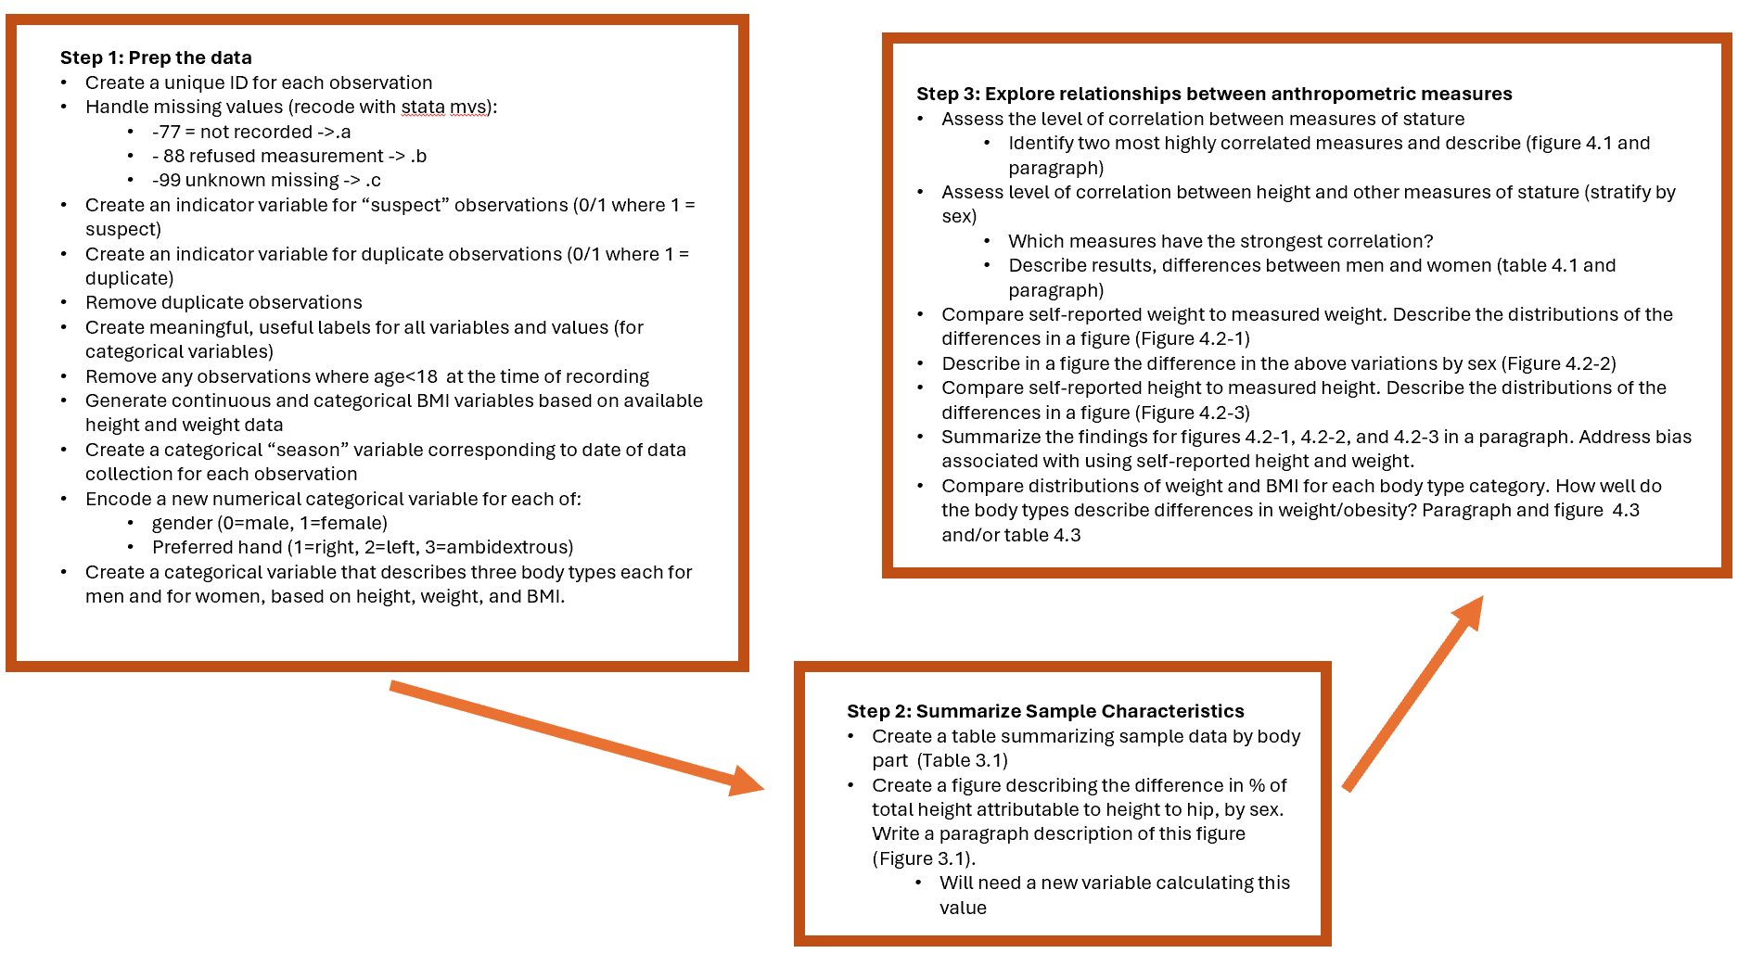

Sample Characteristics
Anthropometric Characteristics
Table 3.1 | Min | 25th percentile | Median | 75th percentile | Max | Mean | Std Dev | Total Observations n(%) | Missing Observations n(%)
n=6,097
Measures of Trunk Circumference
Chest Circumference (cm) | 69.5 | 95 | 102.1 | 109.2 | 146.9 | 102.2 | 10.1 | 6,096 (99.98%) | 1 (0.02%)
Waist Circumference (cm) | 61.1 | 82.9 | 90.75 | 99.2 | 137.9 | 91.5 | 11.4 | 6,096 (99.98%) | 1 (0.02%)
Hip Breadth (cm) | 26.4 | 33.2 | 34.7 | 36.4 | 47.3 | 34.8 | 2.5 | 6,096 (99.98%) | 1 (0.02%)
Hip Breadth, sitting (cm) | 28 | 36.4 | 38.4 | 40.6 | 54.1 | 38.6 | 3.2 | 6,096 (99.98%) | 1 (0.02%)
Bicristal (pelvic) Breadth (cm) | 19.7 | 26.2 | 27.4 | 28.8 | 36.2 | 27.5 | 1.9 | 6,096 (99.98%) | 1 (0.02%)
Measures of Stature
Measured Height (cm) | 140.9 | 165.2 | 172 | 177.9 | 199.3 | 171.5 | 9 | 6,096 (99.98%) | 1 (0.02%)
Knee Height (cm) | 34.6 | 45.2 | 47.6 | 49.7 | 61.2 | 47.6 | 3.3 | 6,096 (99.98%) | 1 (0.02%)
Height to Neck Cervical (cm) | 118.4 | 141.8 | 148.4 | 153.7 | 173.8 | 147.8 | 8.4 | 6,096 (99.98%) | 1 (0.02%)
Height to Hip (cm) | 66 | 84.5 | 88.2 | 91.8 | 109.5 | 88.3 | 5.4 | 6,096 (99.98%) | 1 (0.02%)
Waist Height (cm) | 80.5 | 98.8 | 103.3 | 107.6 | 124.5 | 103.2 | 6.3 | 6,096 (99.98%) | 1 (0.02%)
Functional Leg Length (cm) | 83.5 | 105.5 | 110.4 | 114.9 | 131.6 | 110.2 | 6.9 | 6,096 (99.98%) | 1 (0.02%)
Foot Length (cm) | 19.8 | 25.1 | 26.4 | 27.6 | 32.3 | 26.3 | 1.7 | 6,096 (99.98%) | 1 (0.02%)
Forward Arm Reach (cm) | 60.2 | 75.3 | 79.2 | 82.7 | 934 | 80.1 | 30.3 | 6,096 (99.98%) | 1 (0.02%)
Arm Span (cm) | 132.3 | 168.7 | 177.1 | 184.2 | 212.1 | 176.4 | 11.1 | 6,096 (99.98%) | 1 (0.02%)
Measured Weight (kg) | 35.8 | 68.25 | 78.6 | 89.8 | 1083 | 81.8 | 42.1 | 6,096 (99.98%) | 1 (0.02%)

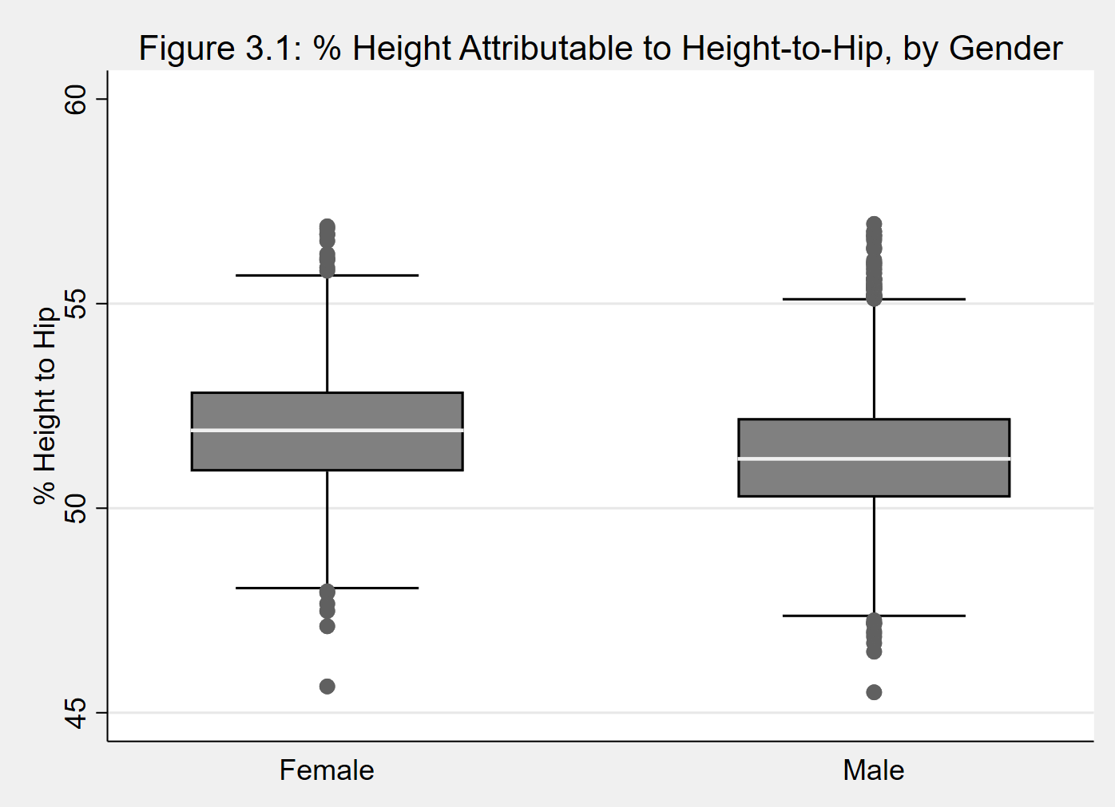

Figure 3.1 shows the distribution of percent of height attributable to height to hip, broken out by gender. There do appear to be some differences between the two populations. The median percentage is higher for females than males. The overall distribution for women is slightly more compact than for men, with lower min and higher max values in the male group, suggesting greater overall variability in the percentage of height attributable to height to hip amongst male soldiers.

Data Quality Assessment

A number of data quality issues were identified during the exploration and analysis of this data set: 932 duplicate observations were identified and removed. There also appear to be some integrity issues with some of the data; the variables for measured weight and forward arm reach both included values that were not within the bounds of realistic human scale (these values have been flagged as suspicious). There were also two sets of observations belonging to minors (age 17) included with the set. These observations were removed, as approval for this survey only included participants of age 18 or older.

Relationships Between Anthropometric Measures

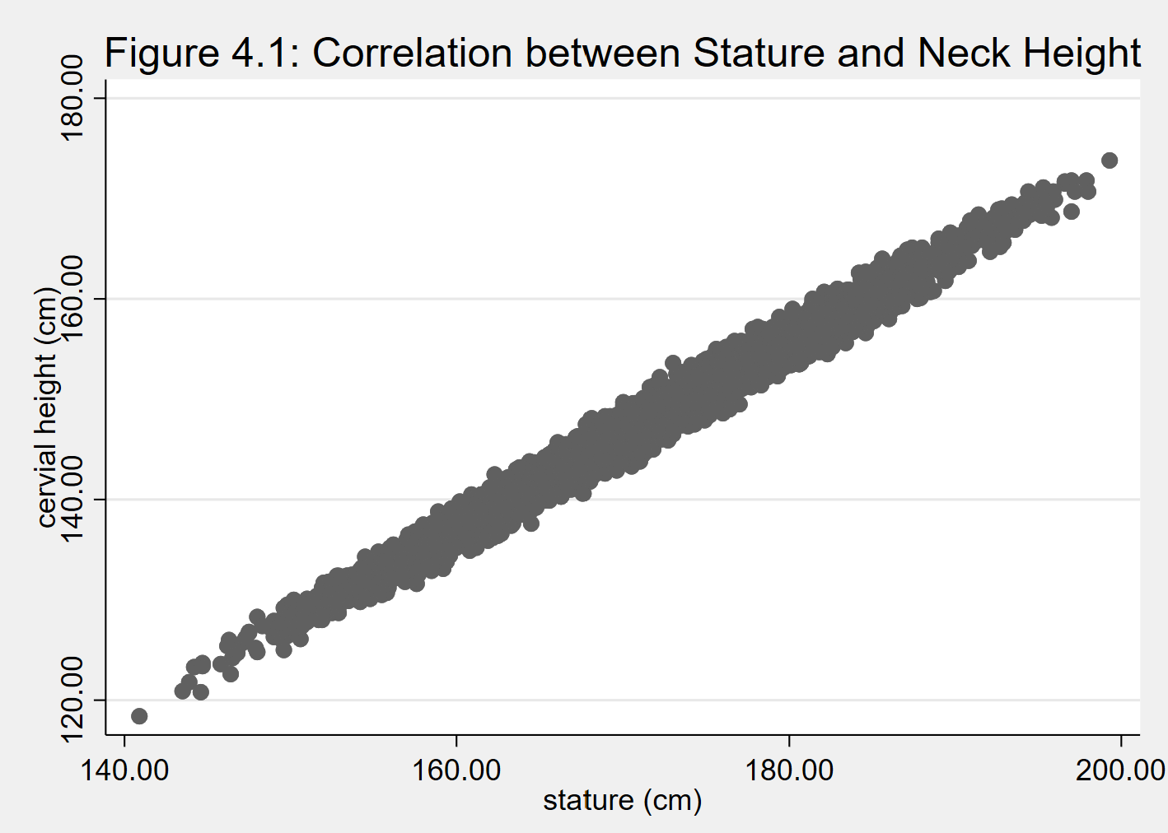

Figure 4.1 (above) describes the correlation between stature and height to neck – unsurprisingly, these two metrics are very closely positively correlated (99.12%).

Table 4.1 above shows differences in correlation between stature and various measures of stature stratified by male and female. Across the board, the correlations are higher for females than males, with the exception of arm span. Most of the correlations are very similar between the two groups, with the greatest differences in functional leg length and forward arm reach (both measures of stature correlate more closely with stature for females than males).

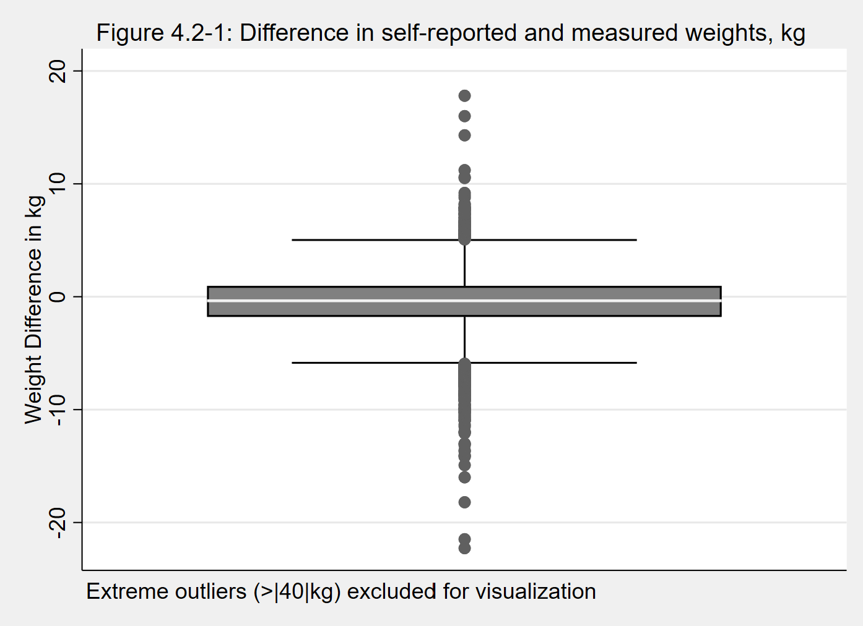

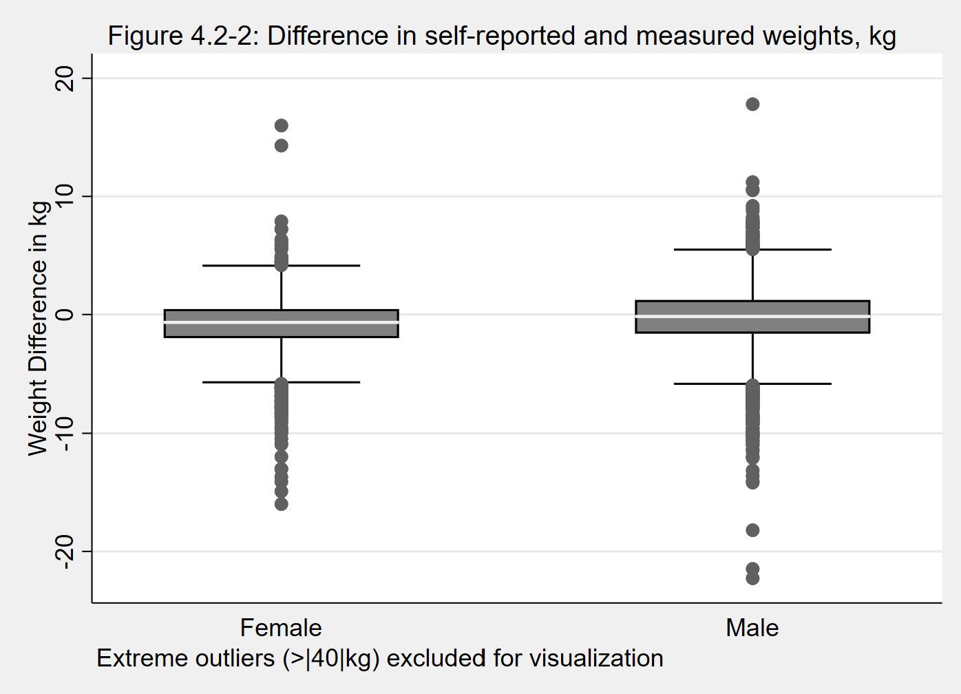

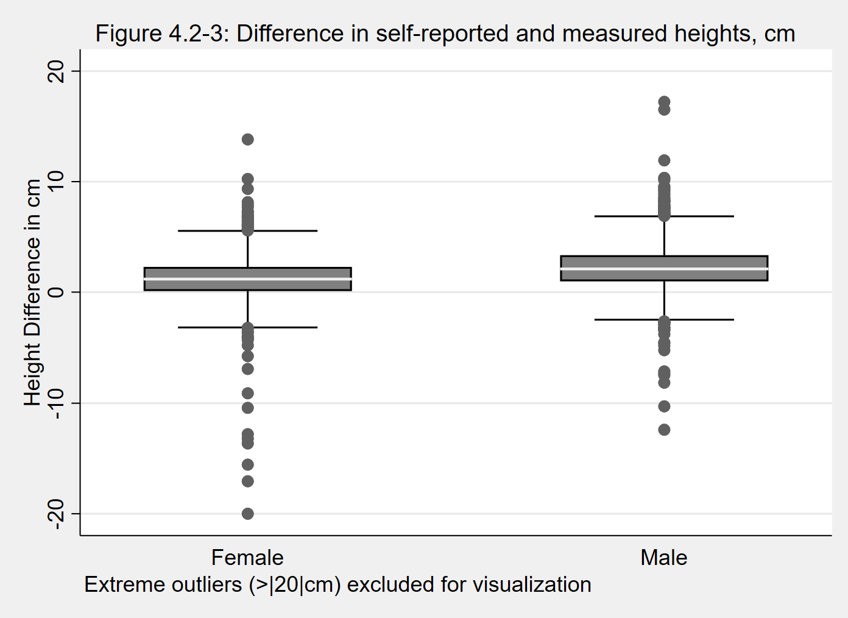

Tables 4.2-1 through 4.2-3 depict differences in measured weight (4.2-1 and 4.2-2) or height (4.2-3) subtracted from self-reported weight or height, respectively; thus, positive values indicate a measured value less than self-reported, while negative values indicate that the measured value was greater than the self-reported value. This, of course, has different implications for height and weight based on conventions about fitness and which traits are physically desirable (generally, people want to be tall and lean). Figure 4.2-1 shows that the median is slightly negative, indicating that the majority of survey participants reported a lower weight than how they actually weighed in. Figure 4.2-2 shows this same figure stratified by gender; here, the female group has a lower median than the male group, which is close to zero. This suggests that males are more likely to accurately report their body weight, while females are more likely to underrepresent it. This is consistent with tremendous social pressure for women to be thin, but creates negative bias, particularly for women, from self-reported weight. Figure 4.2-3 again depicts values stratified by gender. Here, both genders have a positive median, indicating that both males and females self-report a height that is taller than their measured height. The median for men is higher than women; this suggests a positive bias, and a stronger bias for men than for women, is present if self-reported height is used for analysis.

Table 4.3 | Ectomorph n(%) | Mesomorph n(%) | Endomorph n(%) | TOTAL
BMI Class
n=6,097
Female
underweight | 13 (0.65%) | 0 (0.0%) | 0 (0.0%) | 13 (0.65%)
healthy weight | 411 (20.65%) | 524 (26.33%) | 0 (0.0%) | 935 (46.98%)
overweight | 0 (0.0%) | 401 (20.15%) | 449 (22.56%) | 850 (42.71%)
obese | 0 (0.0%) | 0 (0.0%) | 189 (9.5%) | 189 (9.5%)
missing | 0 (0.0%) | 0 (0.0%) | 3 (0.15%) | 3 (0.15%)
TOTAL | 424 (21.3%) | 925 (46.48%) | 641 (32.21%) | 1,990 (100%)
Male
underweight | 9 (0.22%) | 0 (0.0%) | 0 (0.0%) | 9 (0.22%)
healthy weight | 818 (19.92%) | 246 (5.99%) | 0 (0.0%) | 1024 (24.93%)
overweight | 0 (0.0%) | 1629 (39.66%) | 281 (6.84%) | 1910 (46.51%)
obese | 0 (0.0%) | 0 (0.0%) | 1109 (27.0%) | 1109 (27.0%)
missing | 0 (0.0%) | 0 (0.0%) | 15 (0.37%) | 15 (0.37%)
TOTAL | 827 (20.14%) | 1875 (45.65%) | 1405 (34.21%) | 4,107 (100%)

Three body types are described in Table 4.3: Ectomorph (low BMI, narrow hips and shoulders), Mesomorph (narrow waist and joints, wider shoulders), and Endomorph (wide hips, shorter limbs), with slightly different criteria for males and females, based on the stratified distributions of various anthropometric measurements by gender. The algorithms didn’t capture every individual; there were 544 healthy weight individuals who didn’t fall into any of the categories above; they were assigned to body type Mesomorph based on BMI. The BMI classes (underweight, healthy weight, overweight, or obese) were defined based on the CDC’s cut points. The body type definitions seem to have worked, in that the underweight and some of the healthy weight individuals were classified as Ectomorphs, the rest of the healthy weight and some of the overweight individuals were classified as Mesomorphs, and the rest of the overweight and all of the obese individuals were classified as Endomorphs – so the programming logic at least appears to be consistent all the way through. In recent years, BMI has aroused suspicion as an accurate standalone measure of health relative to weight; it seems suspect that less than half of the soldiers involved in the survey can be considered healthy weight.
Appendix (Stata code)

*****TITLE: DMAV Project 1
*****AUTHOR: Sarah Cook
*****DATE: 24Feb2026
*****PURPOSE: Preparation and Exploratory Data Analysis of the ANSUR Anthropometric Measure Dataset

use "C:\Users\cooks\OneDrive\Documents\DMAV26\Proj1\ansur2allV2_raw.dta

*Generate unique ID for each observation

generate id = "ID" + string(_n, "%05.0f")

*Recode placeholders with smvs:

ds, has(type numeric)
mvdecode `r(varlist)', mv(-77=.a \ -88=.b \ -99=.c)
label define missing_vals .a "missing: not recorded" .b "missing: refused measurement" .c "missing: unknown"
ds, has(type numeric)
label values `r(varlist)' missing_vals

*Convert measurements from mm to cm:

replace thumbtipreach = thumbtipreach / 10

replace span = span / 10

replace footlength = footlength / 10

replace kneeheightmidpatella = kneeheightmidpatella / 10

replace waistheightomphalion = waistheightomphalion / 10

replace functionalleglength = functionalleglength / 10

replace cervicaleheight = cervicaleheight / 10

replace trochanterionheight = trochanterionheight / 10

replace stature = stature / 10

replace waistcircumference = waistcircumference / 10

replace chestcircumference = chestcircumference / 10

replace bicristalbreadth = bicristalbreadth / 10

replace hipbreadth = hipbreadth / 10

replace hipbreadthsitting = hipbreadthsitting / 10

format thumbtipreach span footlength kneeheightmidpatella waistheightomphalion functionalleglength cervicaleheight trochanterionheight stature waistcircumference chestcircumference bicristalbreadth hipbreadth hipbreadthsitting %9.2f

*Label everything!

label var id "unique ID"

label var dodrace "self-reported single race"
label define race 1 "white" 2 "black" 3 "hispanic" 4 "asian" 5 "native american" 6 "pacific islander" 7 "missing: unknown" 8 "other"
label values dodrace race

label var ethnicity "self-reported ethnicity"

label var gender "gender (male or female)"

label var age "age in years"

label var component "military component"

label var branch "military branch"

label var writingpreference "preferred writing hand"

label var installation "installation where measurement occurred"

label var test_date "date measurement was taken, in string form"

label var weightlbs "self-reported weight in pounds"

label var heightin "self-reported height in inches"

label var thumbtipreach "thumbtip reach (cm)"

label var span "span (cm)"

label var footlength "foot lenght (cm)"

label var kneeheightmidpatella "knee height, midpatella (cm)"

label var waistheightomphalion "waist height (omphalion) (cm)"

label var functionalleglength "functional leg lenght (cm)"

label var cervicaleheight "cervial height (cm)"

label var trochanterionheight "trochanterion height (cm)"

label var stature "stature (cm)"

label var waistcircumference "waist circumference (cm)"

label var chestcircumference "chest circumference (cm)"

label var bicristalbreadth "bicristal breadth (cm)"

label var hipbreadth "hip breadth (cm)"

label var hipbreadthsitting "seated hip breadth (cm)"

label var weightkg "measured weight in kg"

label var date "date the participant was measured"

label var strdate "date the participant was measured, in string form"

*remove minors:

list age id if age<18
/*
| age id |
|---------------|
2786. | 17 ID02786 |
5594. | 17 ID05594
*/

drop if age == 17

///ID02786 and ID05594 removed due to age<18

*create a mechanism for flagging observations with suspicious values:

generate suspect = 0
label var suspect "observation contains at least one suspicious value"
label define suss 0 "no" 1 "yes"
label values suspect suss

*and one for flagging duplicate observations:

generate duplicate = 0
label var duplicate "observation is a duplicate"
label define dupe 0 "no" 1 "yes"
label values duplicate dupe

duplicates report *

*Determine duplicate criteria

duplicates report dodrace ethnicity gender age thumbtipreach span footlength kneeheightmidpatella chestcircumference

/*
Copies | Observations Surplus
----------+---------------------------
1 | 5165 0
2 | 1864 932
*/

*label duplicates with flag variable
bysort dodrace ethnicity gender age thumbtipreach span footlength kneeheightmidpatella chestcircumference: replace duplicate = 1 if _n > 1

*move duplicate values to a new dataset
preserve
keep if duplicate == 1
save "duplicates_only.dta", replace
restore

drop if duplicate == 1

*Calculate BMI:

gen height_meters=(stature/100)
gen bmi=weightkg/(height_meters*height_meters)
label var bmi "body mass index"
label var height_meters "height in meters"
format bmi %9.2f

*flag high BMI values as suspicious:

summ bmi, detail
tab bmi if bmi>40 /*no bmi values exist between 44-100*/
replace suspect = 1 if bmi > 44 & bmi < .

*create a categorical variable to classify individual weight based on BMI and CDC cut points

recode bmi (0/18.5=1 "underweight")(18.5/25=2 "healthy weight")(25/30=3 "overweight")(30/99=4 "obese")(99/.c=5 "missing"), generate (bmiweight)

*Encode a new numerical categorical variable for gender

encode gender, generate(gender_num)
label var gender_num "gender"

*Encode a new numerical categorical variable for preferred hand

tab writingpreference
replace writingpreference = "Either hand (No preference)" if writingpreference == "Either han"
generate hand = .
replace hand = 1 if writingpreference == "Right hand"
replace hand = 2 if writingpreference == "Left hand"
replace hand = 3 if writingpreference == "Either hand (No preference)"
label define hand_label 1 "Right hand" 2 "Left hand" 3 "Either hand (No preference)"
label values hand hand_label
label var hand "dominant hand"

*create a variable that indicates the season the measurements were made

generate month = month(date)
generate season = .
replace season = 1 if inlist(month, 12, 1, 2) // Winter
replace season = 2 if inlist(month, 3, 4, 5) // Spring
replace season = 3 if inlist(month, 6, 7, 8) // Summer
replace season = 4 if inlist(month, 9, 10, 11) // Fall
label define seasons 1 "Winter" 2 "Spring" 3 "Summer" 4 "Fall"
label values season seasons
label var season "Season of data collection"
label var month "month of data collection"

*Create a variable that creates categories of body types based on height, weight and other measurements:

*Evaluate measures of BMI and body width/girth for males and females:

summ waistcircumference if gender_num==1, detail
summ waistcircumference if gender_num==2, detail

sum chestcircumference if gender_num==1, detail
sum chestcircumference if gender_num==2, detail

sum hipbreadth if gender_num==1, detail
sum hipbreadth if gender_num==2, detail

sum bmi if gender_num==1, detail
sum bmi if gender_num==2, detail

*****different cutoffs for males vs females, based on quartiles*****

*ectomorph(_m and _f): low bmi, narrow hips/shoulders
*mesomorph(_m and _f): narrow waist and joints, wider shoulders
*endomorph(_m and _f): wide hips, shorter limbs

generate body_type = .
replace body_type = 1 if(gender_num==2 & waistcircumference<86) //ectomorph_m
replace body_type = 2 if(gender_num==1 & waistcircumference<79) //ectomorph_f
replace body_type = 3 if(gender_num==2 & (chestcircumference>100 & (bmi>25 & bmi<30)) | (bmi>25 & waistcircumference<100)) //mesomorph_m
replace body_type = 4 if(gender_num==1 & (chestcircumference>90 & (bmi>23 & bmi<27.5)) | (bmi>25 & waistcircumference<92)) //mesomorph_f
replace body_type = 5 if(gender_num==2 & (bmi>30 | (bmi>25 & waistcircumference>100))) //endomorph_m
replace body_type = 6 if(gender_num==1 & (bmi>27.5 | (bmi>25 & waistcircumference>92))) //endomorph_f
label define body_types 1 "ectomorph_m" 2 "ectomorph_f" 3 "mesomorph_m" 4 "mesomorph_f" 5 "endomorph_m" 6 "endomorph_f"
label values body_type body_types
label var body_type "body type based on anthropometrics"

tab bmiweight if body_type==.
/*
RECODE of bmi |
(body mass |
index) | Freq. Percent Cum.
---------------+-----------------------------------
healthy weight | 544 100.00 100.00
---------------+-----------------------------------
Total | 544 100.00
*/

*recode all "healthy weight" soldiers who didn't fall into any of the above categories as mesomorphs.

replace body_type = 3 if(gender_num==2 & body_type==.) //mesomorph_m
replace body_type = 4 if(gender_num==1 & body_type==.) //mesomorph_f

*save cleaned data
/*save "C:\Users\cooks\OneDrive\Documents\DMAV26\Proj1\Project1 dataset V2.dta"*/

*create a table of anthropometric observations

summ chestcircumference, detail
summ waistcircumference, detail
summ hipbreadth, detail
summ hipbreadthsitting, detail
summ bicristalbreadth, detail
summ stature, detail
summ kneeheightmidpatella, detail
summ cervicaleheight, detail
summ trochanterionheight, detail
summ waistheightomphalion, detail
summ functionalleglength, detail
summ footlength, detail
summ thumbtipreach, detail
summ span, detail
summ weightkg, detail

*deal with suspcious values:

replace suspect = 1 if hipbreadth < 30

tab thumbtipreach if thumbtipreach>92
replace suspect = 1 if thumbtipreach>100

tab weightkg if weightkg>150
replace suspect = 1 if weightkg>500 /*this one already handled with BMI*/

*****calculate % of total height attributable to the height to hip

generate byhip = ((trochanterionheight/stature)*100)
format byhip %9.2f
label var byhip "% of total height attributable to the height to hip"

*create a figure, sorted by gender:

graph box byhip, over(gender_num, label(labcolor("black"))) box(1, fcolor(gray) lcolor(black)) ytitle("% Height to Hip") title("Figure 3.1: % Height Attributable to Height-to-Hip, by Gender") scheme(s2mono)

*****Explore correlations between measures of stature:

pwcorr stature kneeheightmidpatella cervicaleheight trochanterionheight waistheightomphalion functionalleglength footlength thumbtipreach span, sig star(0.05) listwise

*strongest correlations:
*cervicaleheight and stature (0.9912)
*cervicaleheight and waistheightomphalion (0.9414)

* weakest correlation: trochanterionheight and thumbtipreach (0.1427)

*graph correlation between cervicaleheight and stature:

twoway (scatter cervicaleheight stature), title("Figure 4.1: Correlation between Stature and Neck Height") scheme(s2mono)

*****correlation of stature with other measures of stature (by gender):

*female:
pwcorr stature kneeheightmidpatella cervicaleheight trochanterionheight waistheightomphalion functionalleglength footlength thumbtipreach span if gender_num == 1, sig star(0.05)

*male:
pwcorr stature kneeheightmidpatella cervicaleheight trochanterionheight waistheightomphalion functionalleglength footlength thumbtipreach span if gender_num == 2, sig star(0.05)

*****reported vs actual weight

generate weightdiff = (weightlbs*0.453)-weightkg
format weightdiff %9.2f
label var weightdiff "weight difference in kg (self-reported minus measured)"

*distribution of difference

graph box weightdiff if weightdiff > -40 & weightdiff < 40, box(1, fcolor(gray) lcolor(black)) ytitle("Weight Difference in kg") title("Figure 4.2-1: Difference in self-reported and measured weights, kg") note("Extreme outliers (>|40|kg) excluded for visualization") scheme(s2mono)

*graph by gender

graph box weightdiff if weightdiff > -40 & weightdiff < 40, over(gender_num, label(labcolor("black"))) box(1, fcolor(gray) lcolor(black)) ytitle("Weight Difference in kg") title("Figure 4.2-2: Difference in self-reported and measured weights, kg") note("Extreme outliers (>|40|kg) excluded for visualization") scheme(s2mono)

*****reported vs actual height

generate heightdiff = (heightin*2.54)-stature
format heightdiff %9.2f
label var heightdiff "height difference in cm (self-reported minus measured)"

graph box heightdiff if heightdiff > -20 & heightdiff < 20, over(gender_num, label(labcolor("black"))) box(1, fcolor(gray) lcolor(black)) ytitle("Height Difference in cm") title("Figure 4.2-3: Difference in self-reported and measured heights, cm") note("Extreme outliers (>|20|cm) excluded for visualization") scheme(s2mono)

*Attemting to understand the nature of discrepancies between reported and measured values:

summ heightin, detail
summ weightlb, detail

replace suspect = 1 if weightlb==0

summ stature, detail
summ weightkg, detail /*issue with measured weight for some observations*/

tab weightkg if weightkg>125
tab weightkg if weightkg>500
*17 observations have a measured weight > 500kg, which seems extremely unlikely - possibly some issue with units at the time of measurement or during data entry. Already flagged suspicious.

*****compare distribution of weight/BMI by body type:

tab bmiweight body_type if gender_num==1
tab bmiweight body_type if gender_num==2

