effective and accelerated informative frame filtering in colonoscopy videos using graphicS processing unit
Venkata Praveen Karri, JungHwan Oh
Department of Computer Science and Engineering, University of North Texas, Denton, TX 76203, U.S.A.
vpk0010@unt.edu, jhoh@cse.unt.edu
Wallapak Tavanapong, Johnny Wong
Computer Science Department, Iowa State University, Ames, IA 50011, U.S.A.

Piet C. de Groen
College of Medicine, Mayo Clinic, Rochester, MN 55905, U.S.A.

Keywords: colonoscopy, CUDA, GPU, CPU multi-threading, informative frame filtering.
Abstract: Colonoscopy is an endoscopic technique that allows a physician to inspect the mucosa of the human colon. It has contributed to a marked decline in the number of colorectal cancer related deaths. However, recent data suggest that there is a significant (4-12%) miss-rate for the detection of even large polyps and cancers. To address this, we have investigated automated post-procedure and real-time quality measurements by analyzing colonoscopy videos. One of its fundamental steps is separating informative frames from non-informative frames, a process called Informative Frame Filtering (IFF). Non-informative frames comprise out-of-focus frames and frames lacking typical features of the colon. We introduce a new IFF algorithm in this paper, which is much more accurate than our previous one. Also, we exploit the many-core GPU (Graphics Processing Unit) to create an IFF software module for High Performance Computing (HPC). Code optimizations embedded in the many-core GPU resulted in a 40-fold acceleration for our IFF software module.

1 INTRODUCTION
Colonoscopy is an endoscopic technique that allows a physician to inspect the mucosa of the human colon. It has contributed to a marked decline in the number of colorectal cancer related deaths [American Cancer Society, 2008]. However, recent data suggest that there is a significant (4-12%) miss-rate for the detection of even large polyps and cancers [Johnson, D., et al. 2007, Pabby, A., et al. 2005]. To address this, we have been investigating two approaches. One is an automated post-procedure quality measurement by analyzing colonoscopy videos captured during colonoscopy. The other is to inform the endoscopist of possible sub-optimal inspection immediately during colonoscopy in order to improve the quality of the actual procedure being performed. To provide this immediate feedback, we need to achieve real-time analysis of colonoscopy videos.
A fundamental step of the above two approaches is to distinguish non-informative frames from informative ones. An informative frame in a colonoscopy video can be broadly defined as a frame which is useful for convenient naked-eye analysis of the colon (Figure 1). A non-informative frame has the opposite definition (Figure 2). The non-informative frames are usually generated due to three main reasons: too-close (or too-far) focus into (from) the mucosa of colon (Figure 2 (a) and (b)), foreign substances (i.e., stool, cleansing agent, air bubbles, etc.) covering camera lens (Figure 2 (c) and (d)), or rapid movements through the intracolonic space. In general, non-informative frames can be considered out-of-focus frames. Our intention is not to increase the sharpness of these frames (which is commonly known as 'auto-focusing technique'), but to just filter them out.
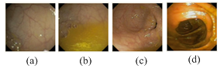
Figure 1: Examples of Informative Frames.
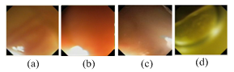
Figure 2: Examples of Non Informative Frames.
Informative and non-informative frames can be loosely termed as clear and blurry frames respectively. But, these loose definitions are not sufficient for proper frame filtering in colonoscopy. In a colonoscopy context, our deeper definition of informative and non-informative frames is slightly different from the conventional definition of clear and blurry images. We presume that a typical informative frame in colonoscopy is primarily characterized by curvaceously (circular or semi-circular) connected vivid lines (not just any lines like horizontal, vertical or broken lines), because that is the typical content of an informative colon frame (Figure 1(d)). Curvaceous connectivity means more connectivity in diagonal and circular directions. Our intention is to retain frames which satisfy this definition and to filter out the rest. The best way to completely realize this definition is firstly to detect the presence of such vivid lines, and secondly to measure the amount of curvaceous connectivity they possess. Then, with the help of a carefully chosen threshold, we identify frames which exhibit more curvaceous connectivity and classify them as informative, and vice-versa. Hence, our definition is different from the rough definition of clear and blurry images. In this paper, we propose a highly accurate algorithm for this informative frame filtering (IFF).
As already mentioned, IFF is a fundamental step for generating quality measurement of colonoscopy video for both post-prosseing and real-time. To provide automated quality measurement in real-time for colonscopy videos which are captured at 30 fps, we have only around 33ms window to process each frame and generate quality metrics. There are several steps to generate quality metrics, and if we want to design a good real-time system, we have to make sure all these steps are completed in that 33ms time frame. So, the primary design consideration of IFF software module is to consume as less time as possible (below 33ms), and to leave the more remaining time for other steps to execute.
The major contributions of this paper can be summarized as follows:
- Our previous edge-based algorithm [Oh, J., et al. 2007] is inaccurate due to lack of consideration of the deeper meaning of informative colon frames; We propose a new edge-based algorithm with higher accuracy compared to the old one;
- IFF is the first among many other steps in automated colonoscopy quality measurement; Based on our new algorithm, we propose a software solution using GPU to evaluate frame quality under real-time constraints.

2 related work
Several techniques have been published for the blurry image detection [Tsomko, E., Kim, H., 2008, Crete, F., et al. 2007, Hua, Z., et al. 2008, Ong, E., et al. 2003, Marziliano, P., et al. 2002]. We implemented and tested one [Tsomko, E., Kim, H., 2008] of those, which is related to our application. But, we found the results were not satisfactory. According to [Tsomko, E., Kim, H., 2008], they find the differences between intensities of adjacent pixels, calculate the variance of all the differences, and compute block-wise sum of variances. Then, they classify an image having more blocks of higher-variance values as clear, and the rest as blurry. This method cannot satisfy our needs because: 1) Colon frames look alike; almost all of them belong to very similar colour (i.e., brownish red), so relying on colour intensity difference of adjacent pixels can easily lead to misclassification; 2) The method in [Tsomko, E., Kim, H., 2008] is more applicable to images which stick to conventional definitions of clear and blurry images; but the definition of informative frames is slightly different as mentioned in Section 1.
Our previous IFF method [Oh, J., et al. 2007] was based on the detected edges within the frame, and used Canny Edge Detector [Canny, J., 1986] for this edge detection. Then, the detected edges represented by an edge map are post-processed to distinguish the non-informative frames from the informative ones. In the edge map post-processing, two terms were defined, isolated pixel (IP) and isolated pixel ratio (IPR) for a frame. An IP is an isolated edge pixel (edge pixel that is not connected to any other edge pixels) in a frame. IPR is computed as a percentage of the number of isolated edge pixels to the total number of edge pixels in a frame. A frame with IPR less than a certain threshold is classified informative, and vice versa. Since it was considered that non-informative frames would have more isolated pixels, high-sensitive canny parameters were used to expose every detail of the original frame in its corresponding edge map. This method is not effective enough because: 1) Canny edge detector mostly produces a lot of closed contours irrespective of sensitivity parameters due to its default design; thus it rarely reproduces isolated pixels in the edge map; 2) IPR logic results in misclassification of frames because it des not consider the intrinsic meaning of an informative frame (Figure 3, and Figure 4).

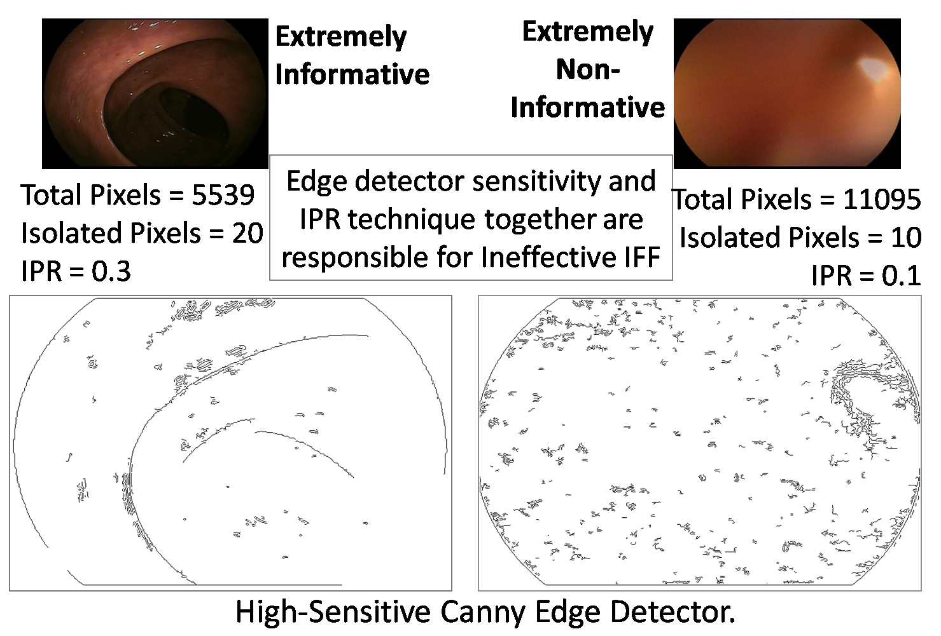
Figure 3: Example of Previous Algorithm’s IFF evaluation scheme with high-sensitivity edge detection parameters.
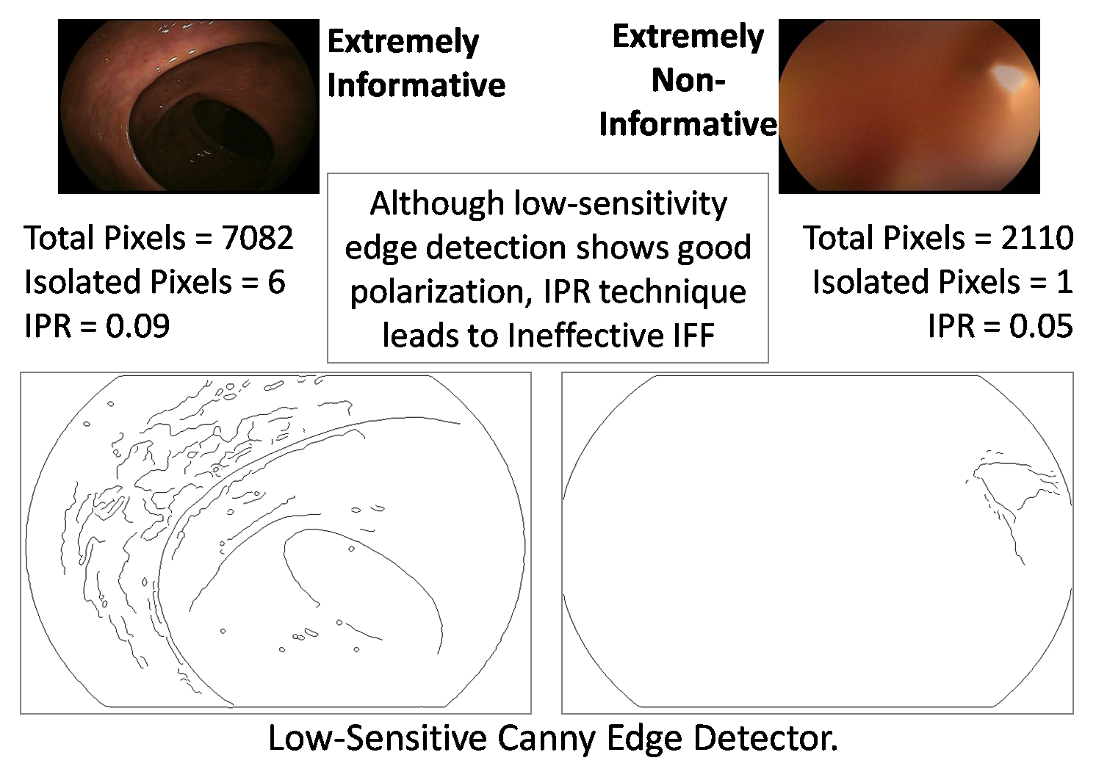
Figure 4: Example of Previous Algorithm’s IFF evaluation scheme with low-sensitivity edge detection parameters.
From the experience of our previous algorithm [Oh, J., et al. 2007], we inferred that reproducing every piece of information of original frames in their edge maps using high sensitive parameters is not a good strategy to classify the frames (Figure 3). Also, we found that despite using low sensitive parameters for edge detection, post-processing the edge map using the IPR can still lead to ineffective informative frame filtering (Figure 4). In both Figure 3 and Figure 4, the IPR of informative frame is greater than that of non-informative frame, which is leading to misclassification. We still agree that edge detection is the most suitable way to expose the connectivity presented in a frame. Also, we strongly believe that the choice of edge detector, its sensitivity parameters, and the method used to post-process the edge map are huge factors, and should be carefully selected to achieve effective IFF.

3. proposed IFF algorithm and computational cost
We propose three major requirements for effective IFF based on our new definition for informative frame (Section 1).
The first requirement is to produce an edge map which shows connectivity only when there is "information", and does not show any hints of connectivity when there is no "information". The second requirement is to estimate the amount of connectivity possessed by an edge map, and the third requirement is to quantify the percentage of connected pixels. Based on a threshold for the percentage, we make the final decision whether a frame is informative or not. Both the second and the third requirements could not be satisfied using our old IPR technique as explained before. We design our new algorithm by dividing it into three stages based on these three requirements (Figure 5).
3.1 Stage-1: Generating Edge Map
To satisfy the first requirement, we need an edge detector which can detect connected edge pixels if there is any real information. Otherwise, it should not output such edges at all. In other words, we need a very low sensitive edge detector such that it can polarize information/connectivity and non-information/non-connectivity.
Good polarization is dependent on both sensitivity parameters and type of edge detector chosen to generate the edge map. Figure 4 already proves that low-sensitivity helps for polarizing better. So, the fundamental rule of thumb for edge-based IFF is to use low-sensitive parameters for edge detection.

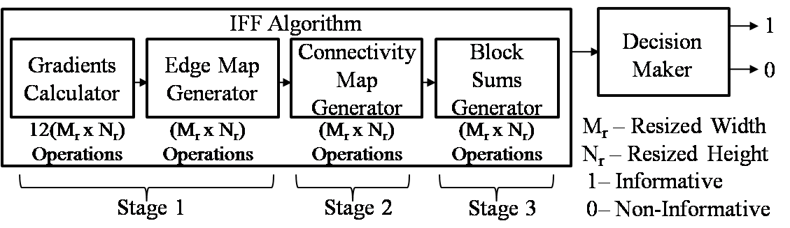
Figure 5: New IFF Algorithm Scheme

As seen in Figure 6(a), despite of low-sensitivity, Canny edge detector generates vivid lines for non-informative frame, which may be misinterpreted as information. We found Sobel edge detector [Canny, J., 1986] with low-sensitive parameters can polarize better than Canny edge detector as seen in Figure 6.

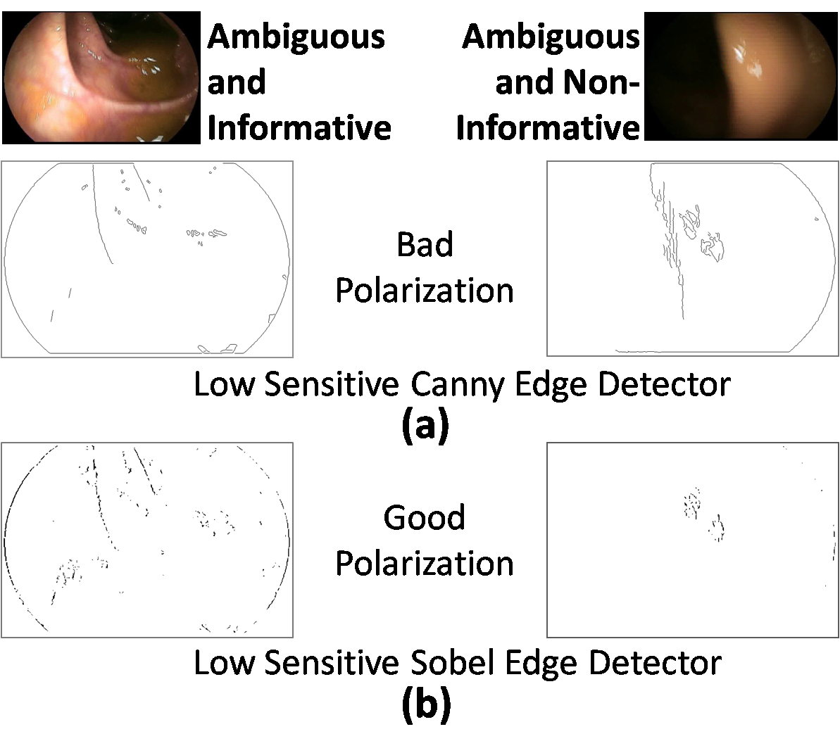
Figure 6: Examples of Good and Bad Polarization in Edge Detectors
With Sobel edge detector as the choice, we generate the edge map as follows. If p is a pixel point at the location (x, y) in a gray scale image, and q is a pixel point at the same location (x, y) in its binary edge map, then their values are represented by f(p) and e(q), respectively. The relationship between them is defined by the equation: e(q) = T[f(p)], where T is Sobel operator. With G_{x} and G_{y} as the Sobel gradient components, the actual gradient ∇f is calculated as,

The range of ∇f will be [0, 255] because that is the range of pixel intensity in our gray scale frames. Hence, if ‘ε’ is defined as a threshold for Sobel edge detector, the binary edge map at pixel ‘q’ is given by,
e (q) = 0, if 0 ≤ ∇f/255 ≤ ε
= 1, if ε < ∇f/255 ≤ 1. (2)

To ensure that the low-sensitivity rule of thumb is satisfied, we choose the threshold for Sobel edge detector, ‘ε’ as 0.33.
3.2 Stage-2: Generating Connectivity Map
In this stage, first, we generate a connectivity map to estimate the amount of connectivity from an edge map generated in Stage 1. An edge pixel’s connectivity, C_{x,y} can be described as the amount of connectivity it possesses with its neighbouring edge pixels in 8-connected neighbourhood (Figure 7(a)). According to the definition of an informative frame in Section 1, colon frames are considered more informative (or connected) if there are more diagonal connections in their edge map. If we give the same weight to both adjacent (vertical and horizontal) and diagonal connections, it will not properly quantify the amount of connectivity for the IFF. Hence, we give diagonal connection twice the weight of an adjacent connection.
Second, the connectivity at ‘q’ in edge map is calculated based on its connection to only four of its neighbouring pixels (immediate right, immediate bottom, immediate diagonal left, immediate diagonal right), and these are shown with red arrows in Figure 7(c)). This is done to avoid redundancy (redundancy is marked with light green arrows in Figure 7(c)) in the calculation of cumulative connectivity when traversing from top left to bottom right corners of the image. For easier computation of connectivity, a non-redundant connectivity mask is designed (Figure 7(b)). In an 8-connected neighbourhood, the connectivity at pixel 'q', is given by,

C _{x, y} = (z₆+2z₇+z₈+2z₉) * e (q). (3)
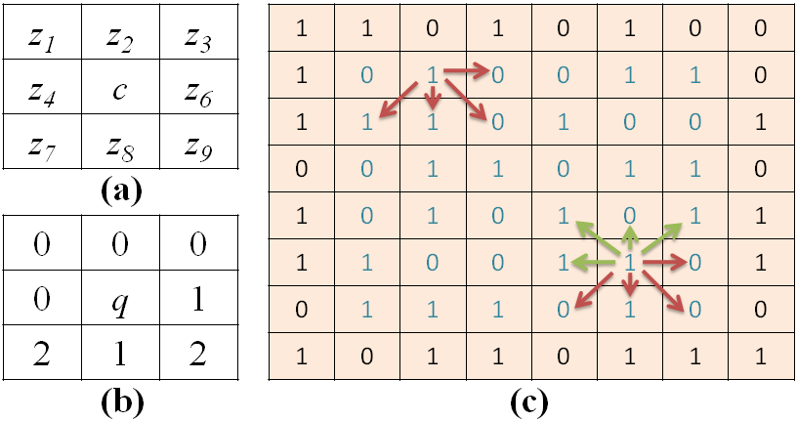
Figure 7: (a) 8-connected neighbourhood with 0 ≤ {z₁, z₂… z₉} ≤ 255 if c=p and 0 ≤ {z1, z2… z9} ≤ 1 if c=q; (b) Non-redundant connectivity mask; (c) Explanation of redundancy during connectivity calculation in an edge map.
3.3 Stage-3: Quantifying the informative portion of a Frame - Block Division and Summation
To quantify the information, the connectivity map is divided into a number of blocks, and checked for the number of blocks which have sufficient connectivity (or information). The image is resized to (M_{r}, N_{r}), such that the height and width are multiples of block size m x m. So, with a block size of m x m pixels, the total number of blocks will be, µ = (M_{r} x N_{r})/(m x m). The total connectivity of a block, B_{i}, is given by,

B_{i} = 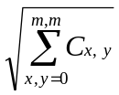 , where i = 1, 2, 3…. µ. (4)

If ‘€’ is defined as the block connectivity threshold, then a block is considered as non-informative if B_{i} ≤ €. Assume that a connectivity map has β number of informative blocks. If we define α as the ratio of informative blocks over total blocks, and ф as a threshold for informative block ratio, then α = β/µ; a frame is considered informative if α ≥ ф, and vice versa. After careful experimental analyses on many frames, the chosen set of parameters is: m = 64, ε = 0.33, € = 5, ф = 0.3. The new algorithm’s accuracy results are discussed in Section 6.2.
From Figure 5, the computational cost of IFF algorithm can be 15(M_{r} x N_{r}) since Stage 1 has 13(M_{r} x N_{r}), Stage 2 has (M_{r} x N_{r}), and Stage 3 has (M_{r} x N_{r}), which are all numerically intensive sequential iterations. We mitigate these costs by using the many-core GPU (Graphics Processing Unit).

4 Many-core GPU Architecture
For a GPU, the ‘EVGA 01G-P3-1280-RX GeForce GTX 280 1GB 512-bit GDDR3 PCI Express 2.0 x16 HDCP Ready SLI Support Video Card’ is used. This graphics card has 1 GB global memory and 256 KB L1 texture cache. From hardware standpoint, the card is viewed as a combination of 10 Texture/Thread Processing Clusters (TPCs). Each TPC holds 24 KB L2 texture cache, and evenly distributes it across three Streaming Multi-processors (SMs). Each SM has 8 scalar processors (SPs), 16 KB of shared memory, and 32 KB register file which is evenly partitioned amongst resident threads when the device is used for computing. From programming standpoint, we use the NVIDIA® CUDA™ (Compute Unified Device Architecture) programming model [NVIDIA CUDA Programming Guide 3.0-beta1, 2009] to run this device in computing mode with CUDA Compute Capability 1.2. CUDA views the device as a pool of threads and calls it a Grid.
CUDA threads run data-parallel functions called kernels. After grouping threads into blocks and launching on an SM, they are executed in an SIMT (single instruction multiple threads) [Kirk, D., Hwu, W., 2010] fashion within individual blocks, commonly termed as 'warp execution'. The smallest unit of a warp execution is 32 threads.
The ultimate goal is to obtain best performance from the NVIDIA® CUDA™ architecture using the CUDA Toolkit [NVIDIA CUDA Toolkit v3.0-beta1]. Its performance is improved by hiding latency during memory accesses, ensuring nominal instruction executions, and maximizing memory bandwidth. Instruction throughput is a performance measure for a compute-bound kernel because the bottlenecks of such a kernel include instruction overhead and latency. Memory Bandwidth Utilization is a performance measure for a memory-bound kernel because effective bandwidth utilization of memory improves speed in such kernels [CUDA Programming Best Practices Guide 3.0-beta1, 2009].

5 OPTIMIZED IMPLEMENTATION OF IFF ALGORITHM ON GPU
In this section we are implementing the IFF algorithm discussed in Section 3 on a GPU using CUDA. We make CUDA kernels for each stage of the GPU IFF Algorithm. We use three types of memories for our algorithm - Global, Texture and Shared memories. In Global memory, its size is large (i.e., 1GB as mentioned in Section 4), but it has more latency (means less speed) compared to other GPU memories. When the CUDA threads access data in global memory with an offset, the speed is further reduced [CUDA Programming Best Practices Guide 3.0-beta1, 2009] since the data is stored in a linear pattern (Figure 8(b)). In our GPU implementation, therefore, global memory is limited to only those CUDA kernels in which memory access with an offset is not present.
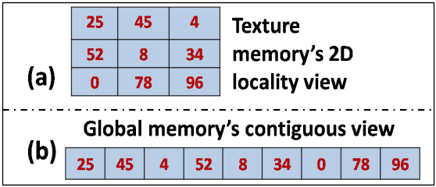
Figure 8: (a) 2-D Locality View of Texture Memory; (b) Linear or 1-D view of Global Memory
In Texture memory, data is stored in a two-dimensional pattern (Figure 8(a)). So, when CUDA threads need to access data with an offset, texture memory is preferred to global memory for better speed because it is cached and offset access will be performed in a symmetric 2-D pattern (Figure 8(a)) rather than linear 1-D pattern as in global memory (Figure 8(b)). In Shared Memory, the data is stored on the chip (i.e., the Streaming Multiprocessor (SM)) in linear pattern. It is faster than global memory because it is an on-chip memory, but it has a limited space of 16KB per SM (Section 4). It is used when the number of threads operating on a data keeps changing or when threads access the same data again and again in a loop while performing a particular operation in a CUDA kernel.
We use a particular type of memory based on its suitability to a particular CUDA kernel. Since images contain two-dimensional data, we access the image data using two-dimensional CUDA thread indices. Throughout the GPU implementation, we set the number of CUDA threads in x-direction as 16 and y-direction as 8, making it a total of 128 threads per CUDA block. We choose these numbers to ensure 100% device occupancy. 100% device occupancy means every SM and every SP (Scalar Processor) have enough work to do and are not idle at any point of time during a CUDA kernel's execution. Apart from number of CUDA threads and blocks, device occupancy is also dependent on shared memory usage per SM [NVIDIA CUDA Programming Guide 3.0-beta1, 2009]; we consider this specifically in kernel design of Stage 3 (Section 5.3). With this background, we present the GPU implementation of each stage of IFF algorithm next.
5.1 Stage 1: GPU Implementation of Edge Map Generation
The input of Stage 1 is a gray scale frame, and the output is a binary edge map comprising 0's and 1's (Figure 6). The gray scale image data is copied to global memory of the GPU. According to Section 3, we first need the Sobel component gradients in x- and y- directions. Then, based on Equations (1) and (2), we evaluate the actual gradient to output an edge map. We divide the GPU implementation into three steps here. In Step 1, we calculate the Sobel gradient in x-direction using separable Sobel masks.

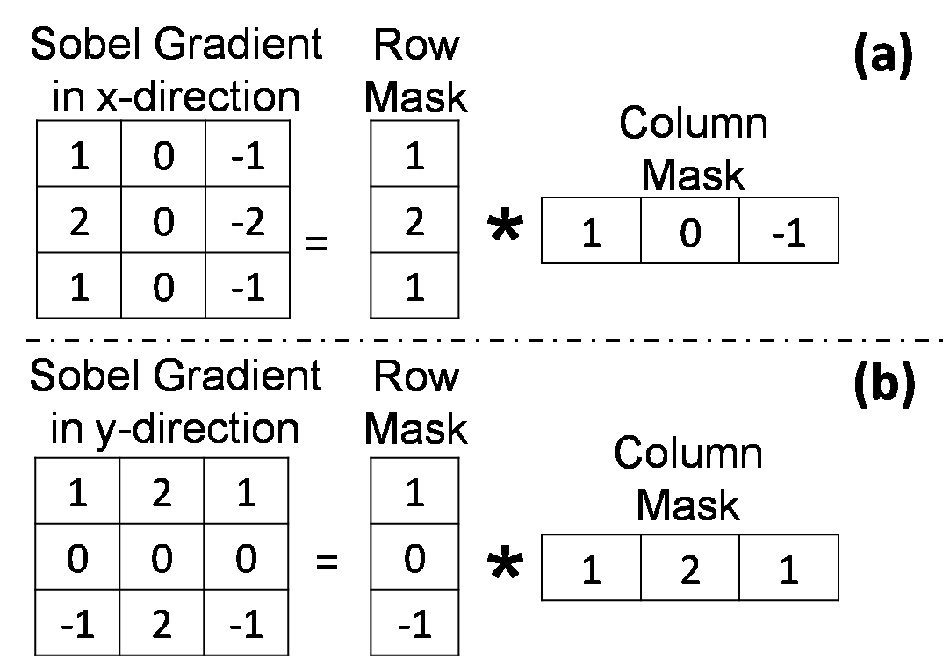
Figure 9: (a) Separable Masks for Sobel gradient in x-direction; (b) Separable Masks for Sobel gradient in y-direction
An original Sobel mask has 3x3 dimensions, and it is separable into 3x1 and 1x3 masks whose product will give us back the original 3x3 mask (Figure 9(a) and 9(b)). We call these masks as row mask and column mask for convenience. We apply row mask to the gray scale image first and then we apply the column mask to that result in order to obtain the final Sobel gradient component in x-direction. We use separable filters because the offset required to access data is less and this helps in speed up. Also, we use texture memory for these operations. That means, the gray scale image data is accessed via texture memory (which is cached) to apply the masks mentioned above. We do this for better speeds. More information about separable convolution can be found in [Podlozhnyuk, V., 2007]. In Step 2, we calculate Sobel gradient in y-direction using another set of separable Sobel masks in exactly the same way explained before for Sobel gradient in x-direction. Since texture memory is read-only, we store the gradients in the global memory. In Step 3, we compute the edge map based on Equations (1) and (2). Here, we do not need texture memory because threads do not access data with an offset. So, we perform computations of Equations (1) and (2) using GPU registers and store the final edge map in global memory. Due to the fact that we used CUDA threads and blocks with 100% device occupancy, we will obtain a good speed despite using global memory here.
5.2 Stage 2: GPU Implementation of Connectivity Map Generation
The input of Stage 2 is the edge map obtained from Stage 1. The output is a connectivity map which is obtained by applying the connectivity mask shown in Figure 7(b) and Equation (3). As we see in Figure 7(b), connectivity mask is not separable like a Sobel mask. So, we access the edge map which resides in global memory via texture memory, then perform the computations of Equation (3) using registers. The result (connectivity map) is stored back in global memory. We do not use shared memory in either Stage 1 or Stage 2, and limit our calculations to texture memory because the masks applied in both stages are of size 3x3 which is small. For larger mask size, shared memory is preferred. More details about comparison of shared memory and texture memory performance based on mask size is available in [Podlozhnyuk, V., 2007].

5.3 Stage 3: GPU Implementation of Amount of Connectivity Estimation
The input of Stage 3 is a connectivity map from Stage 2. The output is the block sums obtained by performing computations on the connectivity map based on Equation (4). In Section 3.3, we choose the block size as 64 x 64. According to Equation (4), we are supposed to calculate the square root of sum of values of all 64 x 64 pixels (i.e., a total of 4096 pixels) for each block in connectivity map. We divide this stage into two steps. Initially, the connectivity map resides in global memory. We already know that we have 128 threads per CUDA block. But, we are supposed to perform the sum of 4096 pixels. So, in Step 1, we first assign each thread in a CUDA block to add 4096/128 = 32 pixels in global memory, and store the results in shared memory. Hence, we have 128 parallel computations performed in global memory. We perform the first step in global memory because we will lose device occupancy of 100% and eventually lose speed if we use shared memory to load all 4096 pixels directly into it to perform the addition. So, now we have 128 elements in shared memory for each CUDA block.
In Step 2, we use parallel summation in shared memory [CUDA Technical Training, 2008]. We reduce the number of threads to 64 such that each thread adds two consecutive pixel values and stores it back in shared memory. Now, we have 64 values in shared memory. We reduce the number of threads to 32 and perform the same operation again. We keep doing it until we get one value which is equal to the sum of 4096 pixels. We perform Step 2 in shared memory because the number of threads keeps changing at every level of summation, and threads are accessing same locations again and again. So, shared memory is much better than global memory here. We use barrier synchronization [Kirk, D., Hwu, W., 2010] as long as the number of threads used is more than 32 for a particular operation. If the number of threads are less than or equal to 32, we do not need to use barrier synchronization because CUDA threads are already synchronized with the aid of Single Instruction Multiple Threads (SIMT) architecture [Kirk, D., Hwu, W., 2010]. Finally, we obtain the block sums of each block, and we perform a square root operation on each block sum (according to Equation (4)) while in shared memory, then transfer the results back to global memory.
At the end of Stage 3, the block sums in GPU’s global memory are copied to CPU. Now, we are required to calculate the number of blocks which are informative based on a threshold and decide a frame as informative (see Section 3.3). This is a trivial operation and does not require GPU power. Hence, we perform this operation on the CPU.
5.4 Performance of GPU IFF Algorithm
We use separable convolution filters for Sobel mask calculation on CUDA and normal convolution for connectivity mask calculations because connectivity mask is not separable while Sobel mask is separable. In both stages 1 and 2, the operations are performed on images with masks of radius one, which is low enough so we do not need shared memory for performance boost as explained in [Podlozhnyuk, V., 2007]. Hence, we opt for texture memory for both separable convolution in Stage-1 and normal convolution in Stage 2. In all the CUDA kernels related to Stage 1 and Stage 2 (which are compute-bound), we unrolled the loops to ensure instruction mix wherever required for additional performance optimization (which should be ideally done by the compiler). And we achieved 100% instruction throughput according to the CUDA Visual Profiler [NVIDIA CUDA Toolkit v3.0-beta1, 2009].
The CUDA kernel design in Stage 3 produced a memory bandwidth of 90GB/s on a GTX280 card for the largest video type (1920 x 1080 frame size). Testing the algorithm on an arbitrary image matrix (a frame is nothing but a matrix of a values) of size 4096 x 4096 elements (or pixel values), the bandwidth achieved is 132 GB/s on the same card whose designated peak performance is 145GB/s, thus resulting in 92% memory bandwidth efficiency for this memory-bound kernel. All these bandwidth measurements are reported by the CUDA Visual Profiler [NVIDIA CUDA Toolkit v3.0-beta1, 2009].

6 Experiments and Results
For our experiments, we use a machine having an Intel Quad Core CPU @ 3.0 GHz with 3 GB RAM and an NVIDIA GTX 280 card with 1 GB GDDR3. For acceleration, we compare our GPU implementation with CPU-only implementation. We are using Language C for CPU-only implementation. For effectiveness, we compare our new IFF algorithm with our previous one [Oh, J., et al. 2007].
6.1 Acceleration
We present a comparative analysis of GPU and CPU versions of the IFF algorithm on different frame types (Table 1). We chose six different video input sources with different frame resolutions, and fed them to our CPU and GPU IFF algorithm versions. Each algorithm is run over more than a 100 frames of every video type.
Table 1: IFF Software Module Results for a single frame from different video inputs
Video Type | Frame Size | GPU (ms) | CPU (ms) | Speed Up
VGA | 640 x 480 | 6.73 | 85.76 | 12.74
DVD | 720 x 480 | 8 | 94.46 | 11.81
HD 576 | 720 x 576 | 9.53 | 121.99 | 12.8
XGA | 1024 x 768 | 12.7 | 236.29 | 18.61
HD 720 | 1280 x 720 | 11.58 | 268.81 | 23.22
HD 1080 | 1920 x 1080 | 14.88 | 595.12 | 40
To accurately measure the elapsed time of the sequence of all CUDA calls in the GPU algorithm, we used ‘CUDA event’ API [CUDA Programming Best Practices Guide 3.0-beta1, 2009]. The CPU algorithm time is measured using the high-resolution CPU timer functions in Language C – QueryPerformanceCounter and QueryPerformanceFrequency. Table 1 shows the average processing times taken by the CPU/GPU IFF algorithms to process a single frame belonging to each of these video inputs.
A logarithmic graph of Table 1 is plotted in Figure 10 to show the speed-up achieved by a GPU compared to the CPU. From Table 1 and Figure 10, with the increase in the frame size, the CPU processing time increases rapidly. On the other hand, the GPU processing time increases minimally. When programmed with CUDA for numerical data intensive operations, the results are also a testimony of the instruction throughput and memory throughput achieved by the kernels we designed for our GPU algorithm. For the highest resolution frame we tested (HD 1080), we achieved up to 40x speed- up by using our new GPU IFF algorithm. The commonly used video capture resolution standard currently is DVD, but we are expecting HD videos to replace the DVD format soon.

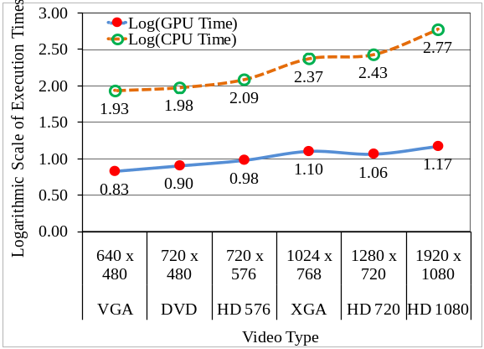
Figure 10: IFF Software Module Execution Time Graph on CPU and GPU
6.2 Effectiveness
We define four metrics (Figure 11) to evaluate the performance of the new and the previous algorithms. In Table 2, our previous algorithm [Oh, J., et al. 2007] is represented by Algorithm#1, and the new algorithm discussed in this paper is represented by Algorithm#2. We can observe that Algorithm#2 outperformed Algorithm#1. For the 10 videos, Algorithm#2 provided around 97.5% of accuracy – meaning 16.5% increase compared to our previous one – Algorithm#1 which is only 81%. We tested more than 100 videos, and found that our new algorithm has around 96% overall accuracy.

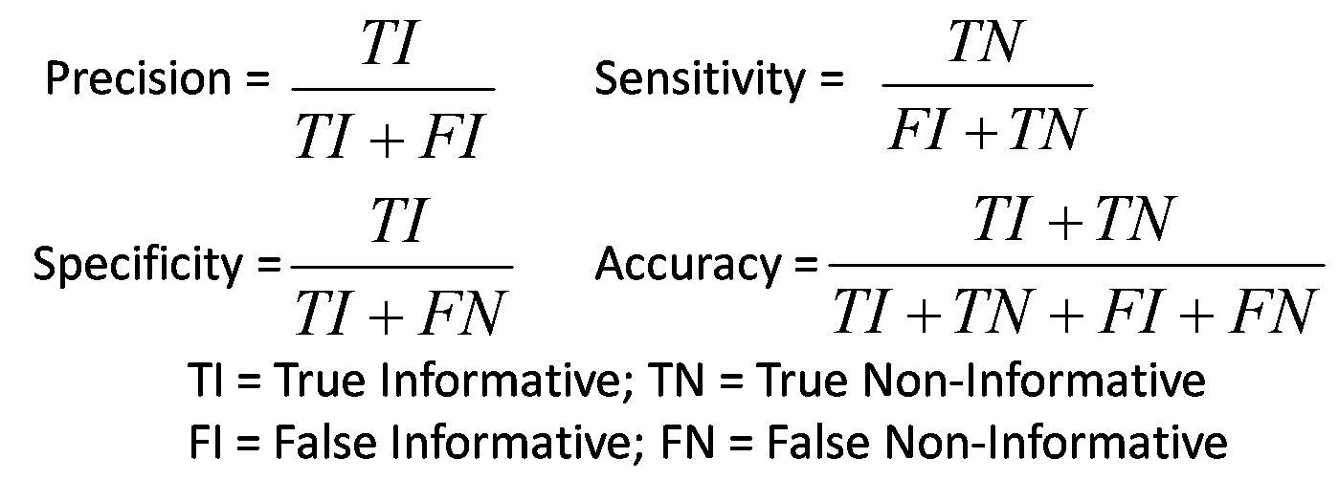
Figure 11: Performance Metrics Explanation

7 conclusions
In this paper, we discussed a new IFF algorithm which is around 15% more accurate compared to our previous algorithm. Through a proper understanding of the meaning of an informative frame, we introduced a new definition to an informative colon frame. The computing constraints which reside within the algorithm have been mitigated with our IFF software module which consumes 8 ms (Table 1) out of the total real-time constraint – 33 ms (Section 1), and provides 25 ms credit for other steps of automated colonoscopy quality measurement to complete. In comparison to CPU, our GPU algorithm is 40 times faster for a HD 1080 video. Our future work will be focused on combining multiple GPUs together to further accelerate colonoscopy video analysis.

acknowledgements
This work is partially supported by NSF STTR-0740596, National Institute of Diabetes and Digestive and Kidney Diseases (NIDDK DK083745), the Mayo Clinic, and Iowa State University Research Foundation. Any opinions, findings, conclusions, or recommendations expressed in this paper are those of authors. They do not necessarily reflect the views of the funding agencies. Johnny Wong, Wallapak Tavanapong and JungHwan Oh hold positions at EndoMetric Corporation, Ames, IA 50014, U.S.A, a for profit company that markets endoscopy-related software. Johnny Wong, Wallapak Tavanapong, JungHwan Oh, Piet de Groen, and Mayo Clinic own stocks in EndoMetric. Piet de Groen, Johnny Wong, Wallapak Tavanapong, and JungHwan Oh have received royalty payments from EndoMetric.

Table 2: Comparison of performance metrics of previous (Algorithm#1) and current (Algorithm#2) algorithms
Video ID | Algorithm#1 |  |  |  | Algorithm#2
Video ID | Precision | Sensitivity | Specificity | Accuracy | Precision | Sensitivity | Specificity | Accuracy
1 | 91.2% | 83.7% | 79.8% | 78.3% | 97.4% | 98.1% | 99.7% | 98.8%
2 | 92.3% | 86.9% | 76.2% | 84.5% | 95.5% | 98.1% | 100.0% | 98.6%
3 | 87.3% | 85.4% | 73.6% | 81.2% | 94.3% | 98.0% | 90.7% | 96.0%
4 | 90.5% | 89.6% | 78.4% | 83.4% | 99.3% | 98.4% | 98.0% | 98.2%
5 | 86.1% | 90.5% | 72.2% | 79.1% | 94.2% | 96.1% | 87.6% | 92.5%
6 | 88.2% | 88.4% | 71.8% | 80.7% | 98.1% | 96.7% | 96.8% | 96.8%
7 | 93.8% | 87.0% | 77.7% | 75.5% | 96.8% | 97.5% | 98.6% | 98.0%
8 | 90.7% | 87.8% | 75.7% | 81.5% | 98.7% | 98.2% | 98.2% | 98.2%
9 | 89.8% | 90.3% | 75.0% | 77.9% | 100.0% | 100.0% | 100.0% | 100.0%
10 | 88.6% | 84.6% | 79.1% | 86.6% | 95.5% | 98.1% | 100.0% | 98.6%
Average | 89.8% | 87.4% | 76.0% | 80.9% | 97.0% | 97.9% | 97.0% | 97.6%

References

American Cancer Society, 2008. “Colorectal Cancer Facts and Figures” http://www.cancer.org/docroot/STT/content/STT_1x_Cancer_Facts_and_Figures_2008.asp.
Johnson, D., Fletcher, J., MacCarty, R., et al. 2007. “Effect of slice thickness and primary 2D versus 3D virtual dissection on colorectal lesion detection at CT colonography in 452 asymptomatic adults”, American Journal of Roentgenology, 189(3):672-80.
Pabby, A., Schoen, R., Weissfeld, J., Burt, R., Kikendall, J., Lance, P., Lanza, E., Schatzkin, A., 2005. “Analysis of colorectal cancer occurrence during surveillance colonoscopy in the dietary prevention trial". Gastrointestinal Endoscopy, 61(3): p.385-391.
Oh, J., Hwang, S., Lee, J., Tavanapong, W., de Groen, P., Wong, J., 2007. “Informative Frame Classification for Endoscopy Video”. J. Medical Image Analysis, 11(2):110-27.
Tsomko, E., Kim, H., 2008. “Efficient Method of Detecting Globally Blurry or Sharp Images”, Ninth International Workshop on Image Analysis for Multimedia Interactive Services, WIAMIS '08.
Crete, F., Dolmiere, T., Ladret, P., Nicolas, M., 2007. "The Blur Effect: Perception and Estimation with a New No-Reference Perceptual Blur Metric", SPIE Electronic Imaging Symposium Conf Human Vision and Electronic Imaging, San Jose.
Hua, Z., Wei, Z., Yaowu, C., 2008. "A No-Reference Perceptual Blur Metric by using OLS-RBF Network", IEEE Pacific-Asia Workshop on Computational Intelligence and Industrial Application, Vol. 1, pp. 1007-1011.
Ong, E., Lin, W., Lu, Z., Yang, X., Yao, S., Pan, F., Jiarrg, L., Moscheni, F., 2003. "A no-reference quality metric for measuring image blur ", Seventh International Symposium on Signal Processing and Its Applications, Proceedings, Vol. 1, pp. 469-472.
Marziliano, P., Dufaux, F., Winkler, S., Ebrahimi, T., 2002. "A no-reference perceptual blur metric", International Conference on Image Processing, Proceedings. Vol. 3, pp. III-57 - III-60.
Canny, J., 1986. “A Computational Approach to Edge Detection". IEEE Trans. Pattern Analysis and Machine Intelligence, 8:679-698.
NVIDIA CUDA Programming Guide 3.0-beta1, 2009. www.nvidia.com.
Kirk, D., Hwu, W., 2010. “Programming Massively Parallel Processors”, Morgan Kaufmann, San Francisco.
NVIDIA CUDA Toolkit v3.0-beta1, 2009. (includes CUDA Visual Profiling Tool), www.nvidia.com.
CUDA Programming Best Practices Guide 3.0-beta1, 2009. www.nvidia.com.
Podlozhnyuk, V., 2007. “Image Convolution with CUDA”, White Paper, www.nvidia.com.
CUDA Technical Training, 2008. Vol. I: Introduction to CUDA Programming, www.nvidia.com.

