

UNIVERSITY GRADES MANAGEMENT SYSTEM

A Web-based Application for Academic Record and Performance Tracking

Members:
- IMPANO Janvier 1CUR26AK011851
- BIGIRIMANA Fiston 1CUR25AK011123
- UMUTONIWASE Agape 1CUR25AK011207
- IBYISHAKA UWABABYEYI Syvetha 1CUR25AK011120
- UMURERWA Hilalie 1CUR25AK010707
- TUYISABE Immaculee 1CUR25AK011291
- IRAHARI Theogene 1CUR25AK010936
- HATANGIMANA Benjamin 1CUR26AK011860

Lecturer: Lengo
Date: June 2026

1. INTRODUCTION
The University Grades Management System is a web-based application designed to manage academic records in higher learning institutions. It replaces manual methods such as spreadsheets and paper files with a centralized digital system.

The system is built on a relational database with five main entities:
- Users: stores login credentials and access roles.
- Students: stores student personal and academic information.
- Instructors: stores staff details and departments.
- Courses: stores course information.
- Enrollments: links students, courses, instructors, and grades.

The system uses role-based access control so that:
- Administrators manage users and system data.
- Instructors manage and update grades.
- Students view their academic performance.

2. PROBLEM STATEMENT
Traditional academic record systems have several problems:
- Risk of data loss from physical files or local storage.
- Errors in manual grade calculations.
- Slow processing and release of results.
- Weak security and lack of proper access control.
- Difficulty in accessing academic records remotely.

These issues make manual systems inefficient and unreliable for modern universities.

3. OBJECTIVES

General Objective:
To develop a secure and efficient system for managing student academic records.

Specific Objectives:
- Allow instructors to enter and update grades digitally.
- Allow students to view their results online in real time.
- Automatically calculate GPA and performance results.
- Allow administrators to manage users and system data securely.

4. BENEFITS

To Students:
- Easy access to academic results anytime.
- Ability to track performance in real time.
- Improved transparency in grading.

To Instructors:
- Easier grade management.
- Reduced calculation errors.
- Less administrative workload.

To Institution:
- Improved data security.
- Reduced paperwork costs.
- More efficient academic operations.

5. SYSTEM DESIGN AND IMPLEMENTATION

5.1 Index Page and Login Page
Firs Users show Index page then log in using email and password. The system redirects users based on their role.

5.2 Admin Dashboard
Admins manage users, students, instructors, and system data.

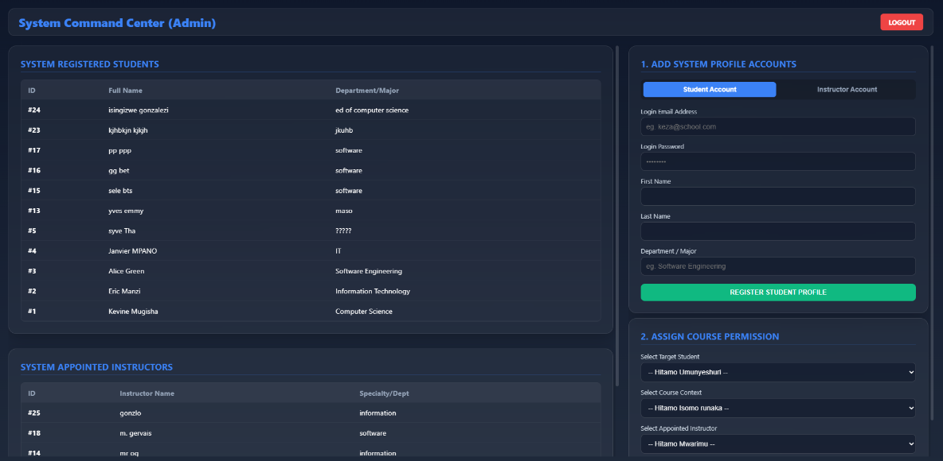
5.3 Student Management
Admins can add and update student records.
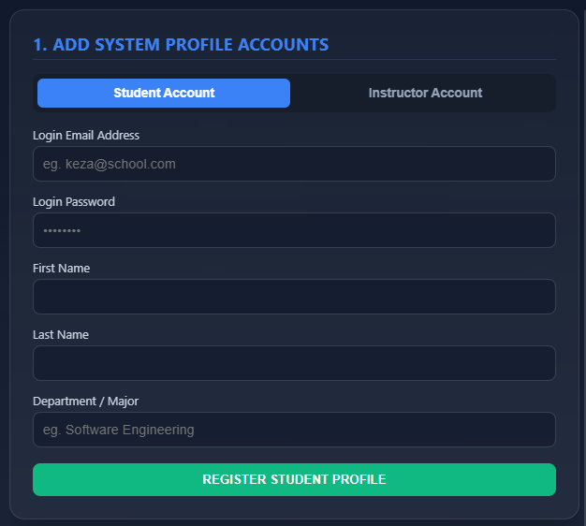

5.4 Instructor Management
Admins can register instructors and assign departments.
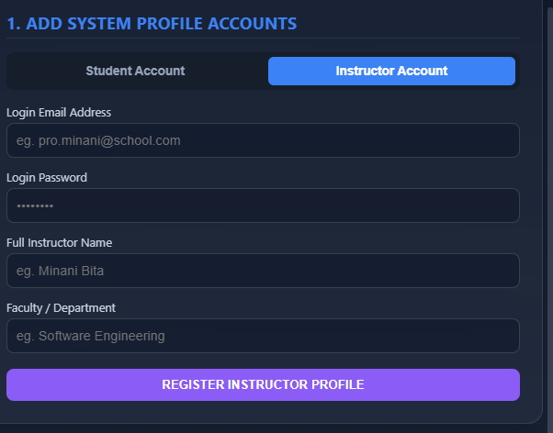

5.5 Grade Management
Instructors enter and update student grades for courses.
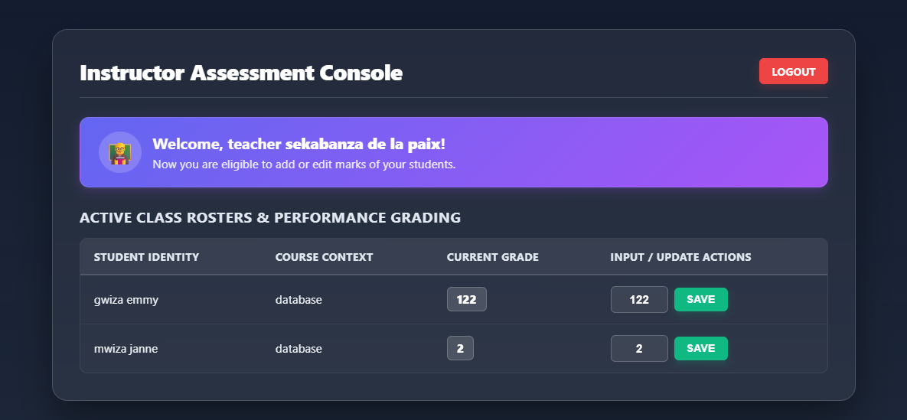
5.6 Student Dashboard
Students view courses, grades, and GPA.
